How to begin the Dynamic Purchasing System (DPS) supplier onboarding process



1. Accessing the DPS platform 3
2. Finding the agreement 4
3. Accessing the bid pack 5
4. Accessing clarification questions and answers 6
5. Access as a Supplier 7
6. Sign in 8
7. The DPS supplier terms and conditions 9
8. The appointment process 10
9. Selection questionnaire 10
10. DPSQ 10
11. Submitting your application 11
11.1 Agreeing 11
11.2 Assessing 11
11.3 Rejected 11

Accessing the DPS Platform

If you are accessing the DPS platform for the first time you will need to register.
Please go to the Supplier Registration Portal

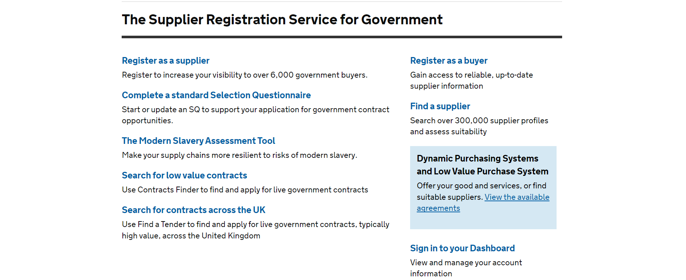

Select the link through to the DPS page.

Finding the agreement

Navigate to our ‘Space-Enabled and Geospatial Services’ DPS. This can be found by scrolling down the page, under the ‘Technology’ heading.

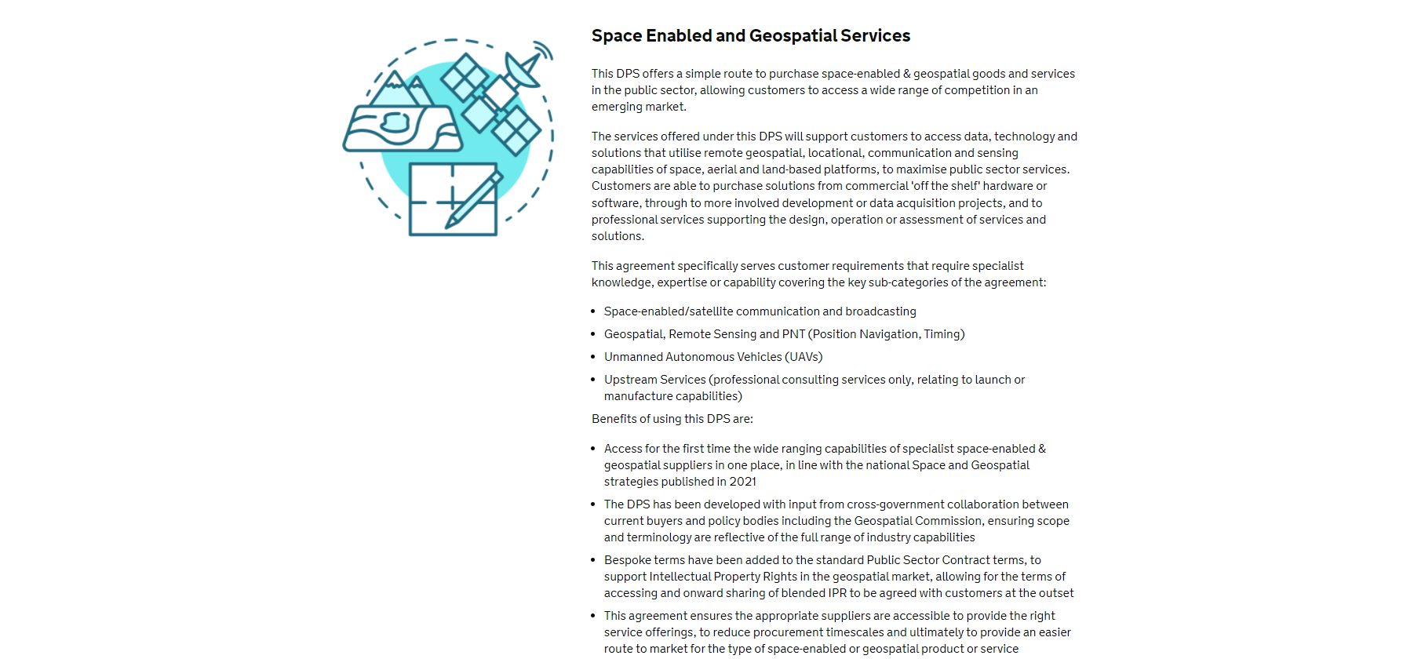

Accessing the bid pack

Click the bid pack link as circled in the screenshot below to open the bid pack and access all relevant documentation.

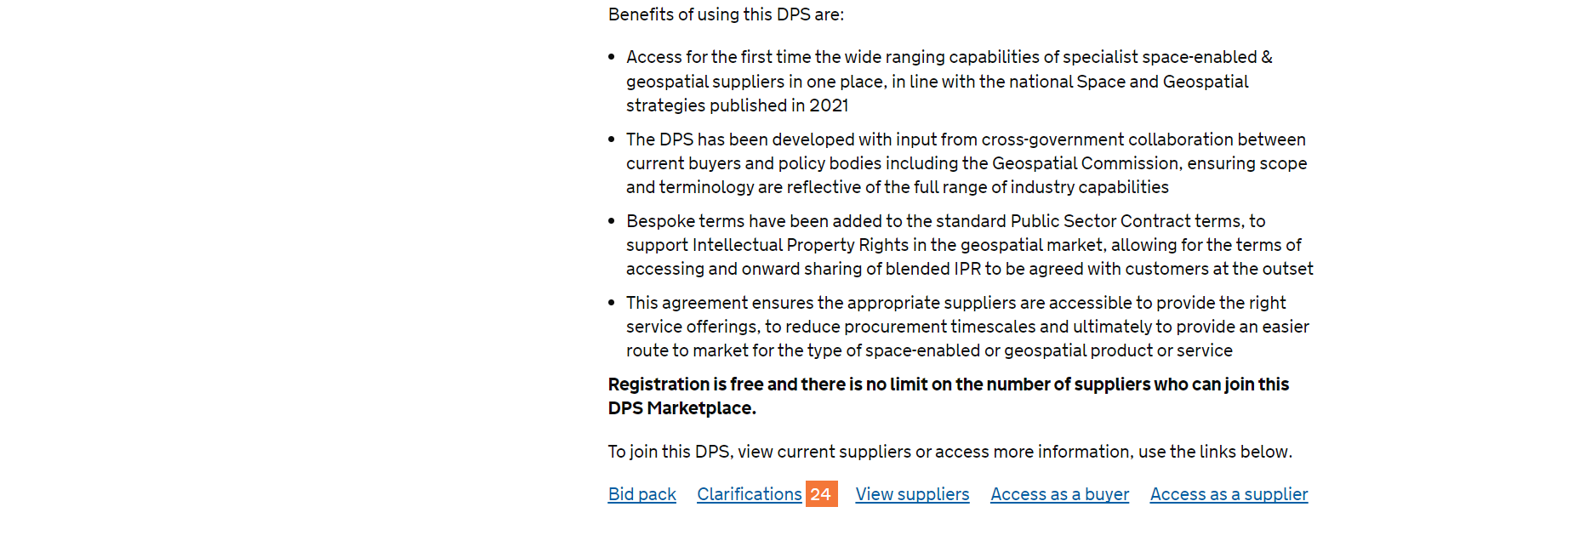

Here you can see the list of documents included within the bid pack as well as a ‘DPS needs’ document to be read first.

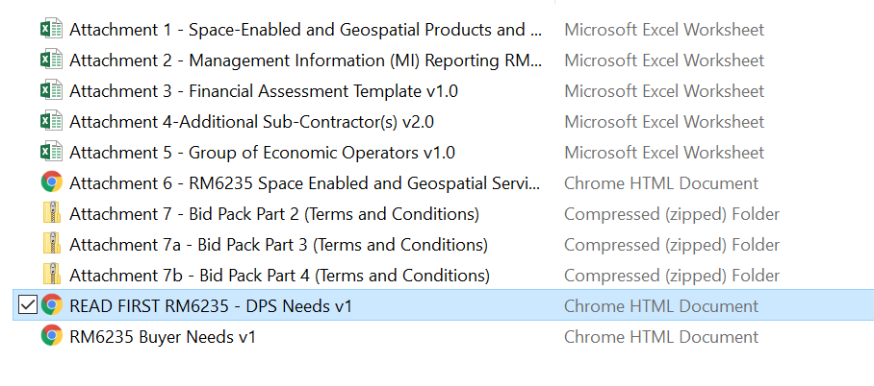

Accessing clarification questions and answers

You can access clarification questions and answers by clicking on the ‘clarifications’ link as circled in the screen show below.

This will show all questions asked by suppliers and our answers to them. You can also asked a new clarification question by clicking the ‘ask a clarification question’ link on the right hand side of the page.

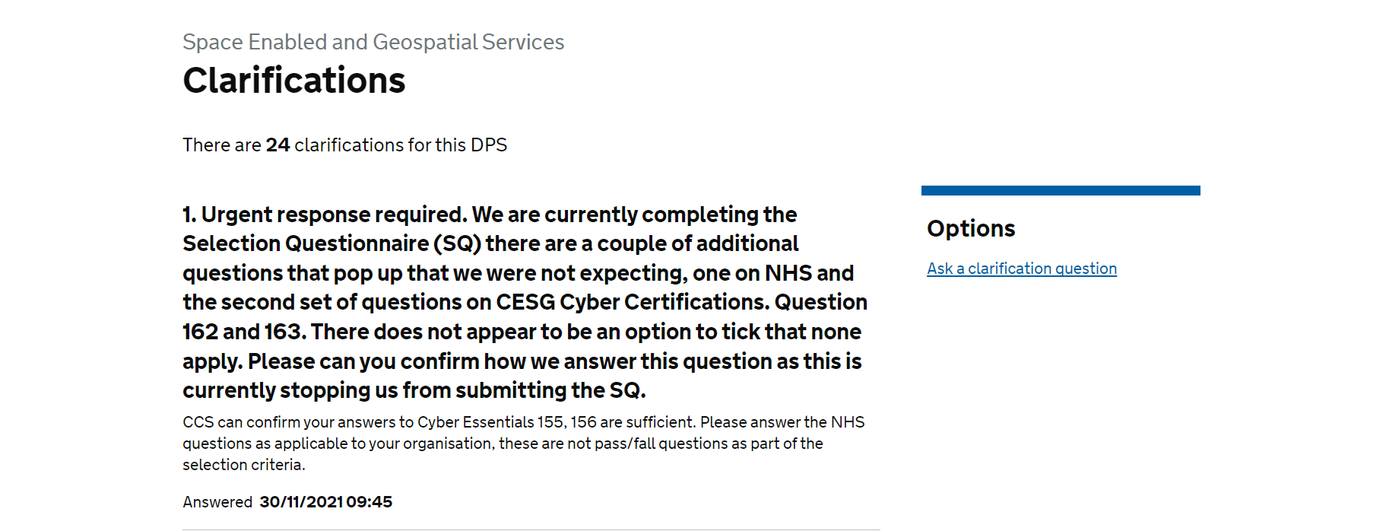

Access as a Supplier

To begin your on boarding to the DPS, click ‘Access as a Supplier’.

Sign in

This will then take you to the ‘sign in’ screen. If you are new to the DPS, you will need to register. Select ‘Register for an account’ underneath the log in section. Then proceed back to login into this DPS.
If you have already registered, please log in.

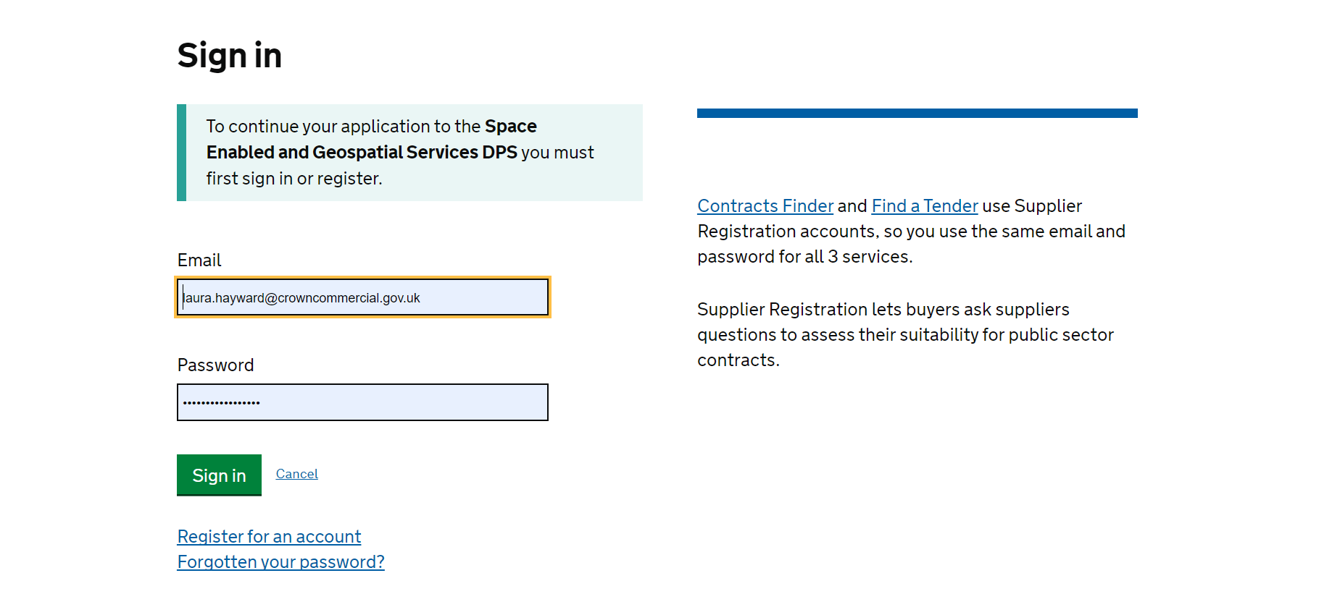

The DPS supplier terms and conditions

This will bring you to the ‘DPS Supplier Terms and Conditions’.

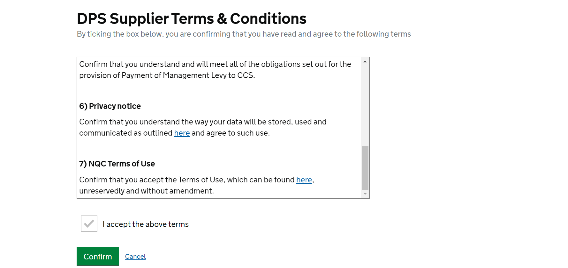

Please read this carefully. Once completed scroll down to the bottom of the text to be able to confirm acceptance.
Click the box and confirm to accept the DPS supplier terms and conditions.

The appointment process

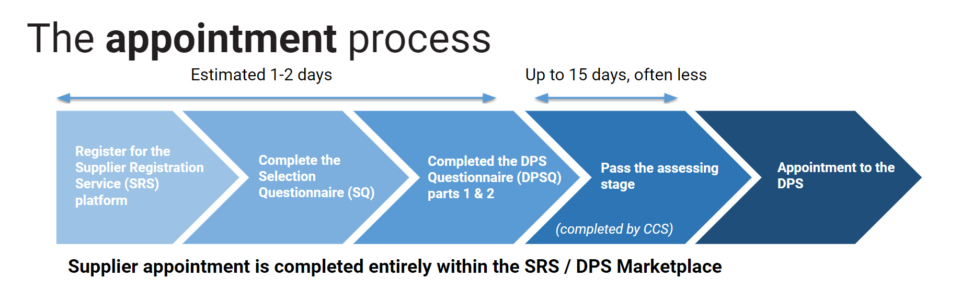

The whole supplier appointment process is completed within the supplier registration portal.
Firstly, register on the portal, then complete the selection questionnaire and the DPS Specific Questionnaire (DPSQ). This should take an estimated time of 1-2 days.
Crown Commercial Service (CCS) will then assess your application. This can take a maximum of 15 days, however it is often less.
Once you have passed the assessing stage, you will appointed on the DPS.

Selection questionnaire

This will take you through to the application process, starting with the selection questionnaire. The system should guide you through the process of applying.
The standard selection questionnaire can either be started from scratch, or you can use one you’ve completed previously.

DPSQ

Once you have completed your standard selection questionnaire, you can continue onto the DPSQ.
Here you will need to respond to questions that are specific to this agreement.

Submitting your application

Once you have completed the DPSQ you can submit your application. CCS will only be able to commence the review process once your application has been submitted.
Your application will follow one of three paths:

Agreeing
If your application has no risk flags or issues, this can automatically approved by us, which will then put your application into the ‘agreeing’ status.
This means that we are waiting for you to come back onto the system and electronically sign the DPS appointment form. This is just a tick box and once that has been done you are formally appointed to the DPS.
You will need to register for an account on the E-sourcing suite (Jaggaer) where customers may choose to run their competitions.

11.2 Assessing
If your application has some risk flags for example, your financial risk score is below the threshold of the DPS, or you have not provided a carbon net zero plan, it will be marked as ‘assessing’. This means that the DPS team will need to review your application and determine what the next steps are.
They will work with you to understand what the issue is and how you can proceed.
Once this has been done you can submit again.

11.3 Rejected
If there are significant issues with your application it will be rejected.
The DPS team will be in touch with you to explain why and work with you on the next steps if decide to apply again.

If you have any questions regarding your application or experience any issues please do not hesitate to get in touch networkservices@crowncommercial.gov.uk

