 | 

FUEL

WORKS CONTRACT

DIO SDT

BATUK

BOOKLET 3

SPECIFICATION

LUMP SUM FIRM PRICE CONTRACT FOR

KEN/GE/1704

FUEL WORKS

References

A. BS 7671: 2008 (as amended)
B. JSP 375 MOD Health and Safety Handbook
C. Electricity at Work Regulations 1989 as amended
D. BS EN 1992-1-1:2004: Euro code 2. Design of concrete structure general rules and rules of buildings
E. Provision and Use of Work Equipment Regulations (PUWER): 1998
F. Construction (Design & Management) Regulations 2015 (CDM2015)
G. BS 8000-0:2014 –Workmanship on construction sites introduction and general principles
H. Dangerous Substances and Explosive Atmospheres Regulation 2002
I. BS EN 1154:1997 Building Hardware – Controlled Door Closing Devices
J. BS EN 60529:1992+A2:2013: Degrees of protection provided by enclosures (IP Code)
K. Building Regulations 2010 BS EN 12056-3 Gravity drainage systems inside buildings. Roof, drainage, layout and calculation
L. Electricity Safety, Quality and Continuity Regulations 2002 and amended 2006
M. The building regulations 2000 Approved Document B
N. JSP 317 – Defence Fuels Policy, Organisation and Safety Regulations, Part 2, Vol 1, 3 & 4
O. Design and maintenance guide 14 (DMG14)
P. Not used
Q. PPG2: Above ground oil storage tanks
R. PPG7: Fuelling stations construction and operation
S. PPG3: Use and design of oil separators in surface water drainage systems
T. PPG19: Garages and vehicles service centres
T
U. Pollution prevention guidelines: private, commercial and military airfields: Environment Agency.
V. UK Health and Safety at Work Act 1974.
W. BS5228 – Code of practice for noise and vibration control on construction and open sites.
X. EN12874 - Flame arresters. Performance requirements, test methods and limits for use

X

Y. BS EN 858-2 - Separator systems for light liquids (e.g. oil and petrol) - Part 2: Selection of nominal size, installation, operation and maintenance

Z. PG04/12 - Specialist Mechanical Works on Petroleum Installations on MOD Property

AA. PG05/12 – Inspection, maintenance and testing of equipment installed at petroleum installations on MOD property

BB. PG06/12 - Professional Inspection of Fuel Infrastructure and Flammable Dangerous Goods Stores
CC. BS EN 60079-7:2015 - Explosive atmospheres. Equipment protection by increased safety "e"

Contractor’s Design

The Contractor is to advise the Project Manager (PM) of all design consultants / Sub-contractors who will be employed on this Contract and the areas of their design responsibility. Any Works undertaken without prior issue of full information for the necessary approvals will be entirely at the Contractor’s own risk.

The Contractor shall not commence any work in accordance with any Design Document until the PM has agreed the relevant Design Document. The Contractor shall keep one copy of each Design Document on the Site, to which the PM or his representatives may have access at all reasonable times.

Design Responsibilities

Contractor’s Design Responsibilities. The Contractor is responsible for the design of all elements contained within the schedule of Works. Where required, all designs are to be submitted to the Authority for concurrence and authorisation prior to implementation of Works. Where the nature of Works do not warrant full design, a descriptive proposal complete with proposal sketch must be submitted for concurrence.

The Contractor shall ensure all designs are in accordance with, and include the applicable requirements as contained within References A to BB and all other design documents specified within this PS. NOTE that these references are provided as guidance and minimum requirement only; the responsibility remains with the Contractor to ensure that all design and construction Works comply with the latest methods, requirements and guides, and generally accepted practice as relates to the Works, geography, climate, environment and Theatre of operations. Where there are conflicts between the Contractor’s design drawings and the Specification (Booklet 3) the PS will take precedence in all cases. Any queries should always be addressed to the Authority in the first instance. The references and specified British Standards (BS) / EuroNorms (EN), within this PS are to be used (or similar Authority approved standards) as a minimum standard, throughout the Works.

UK Building Regulations. All Works shall comply with the latest UK Building Regulations. Should any variation be required, approval from the Authority shall be obtained in writing prior to the commencement of any Works.

Health and Safety (H&S). All Works shall be carried out in accordance with the HASWA 74. The Contractor shall submit a Construction Health and Safety Plan (CHASP) to the Authority for approval, including but not limited to all risk assessments, method statements, hazardous material procedures.

Construction Drawings. All Works shall be constructed in accordance with the final approved Contractor furnished construction drawings (or written proposal in this case). Where a conflict in design is found, authorisation shall be obtained in writing prior to any changes in design. No construction shall commence prior to obtaining written approval of the final construction drawings / proposal by the Authority.

Design Life. The design life of all new FUEL and structural components and assemblies to first major overhaul, repair or replacement shall be a minimum of 25 years. The Contractor shall supply and install all components, elements and systems / structures to satisfy this requirement, and any additional Contractual requirements that may apply.

Existing Services. The Contractor is responsible for ensuring all services on or adjacent to the site that will be affected by the Works are identified, located and appropriate action taken to prevent damage before work commences. The Contractor shall ensure that any existing services and concrete slabs are reinstated to a condition at least similar to existing, with the minimum of disruption to existing facilities and services during construction. All Works that could possibly influence existing services may only commence with written approval. The Authority must be informed immediately if any unknown services are discovered that will have an impact on the Works.

The Contractor shall ensure that any existing services and affecting Works – including all connections and services tied into – are of an acceptable standard to ensure the required performance over the life of the facility. Should it be found that one or more of the services (including but not limited to existing water, sewerage, drainage and FUEL reticulation) is not considered acceptable to the requirements, the Contractor shall inform the Authority and obtain written approval / instruction prior to taking any actions to rectify or make good the pertinent unacceptable situation.

Construction Preliminaries

Existing Ground Conditions. The Contractor is responsible for confirming the existing ground conditions, which are to be taken into account whilst designing and compiling the CHASP.

Obstructions. As the proposed Works are to be carried out around existing infrastructure and surrounding areas, there are obstructions in the form of fences and buildings etc, the Contractor is to review the site before commencing Works.

H&S Restrictions, Precautions and Monitoring. The Contractor shall implement the requirements described in the HASWA 74 to protect members of the public and persons visiting the site from risks arising from the use of equipment, materials or substances defined therein.

Control of Noise and Vibration. The Contractor shall comply with the recommendations for practical measures to reduce noise set out in BS 5228: Parts 1, 2 and 4 - Code of practice for noise and vibration control on construction and open sites.

It is expected that the Contractor will not require a forward resources area other than the site. Should one be required a location shall be made available, as agreed by the PM. Packaging shall be to a good standard capable of withstanding transportation and handling loads. The Contractor shall be solely responsible for storage and movement of all equipment to site. The Contractor shall remain at all times responsible for the security of equipment including prevention of theft.

Scope of the Overall Works
Introduction

- The design, installation and commissioning shall comply with IEC BS / EN Standards and Regulations. The following specification is for the fuel works in the following locations:

  - Task No. 1 - Laikipia Air Base (LAB) EAST Mechanical Transport Fuel Installation (MTFI) in Nanyuki. Replacement of the kerbside pumps with suitably rated ATEX equipment for the DSEAR classification.

  - Task No. 2 - Kifaru camp in Nairobi POL Point Interceptors No. 64 & 64A. Upgrade works as per Practitioner Guide (PG) 06/12 inspection report, Pollution Preventive Guideline (PPG) No. 3 and JSP 317 to achieve Class 1 Forecourt separators.

- Key Project Details. The key project details are as shown below:
Contract title:  Site location: | ITT 1704 – Fuel works  Kifaru camp in Nairobi and LAB EAST camp in Nanyuki
Proposed start date: | TBC
Proposed completion date: | TBC
Retention: | 5% (reduced to 2.5% if completion achieved on planned date)
Defects liability period: | 12 Months – Note that an inspection must take place 3 – 4 weeks prior to the end of the defects liability period. The retention payment will not be paid until this, and any works arising from that inspection, have been completed.
Design life: | 25 years
Scope of works

- The Specification for this project is Concept and the contractor is to provide detailed designs, calculation (where required) and detailed specifications for the Authority.

Task No. 1

- Replacement of the dispensing pumps in LAB EAST MTFI, Nanyuki. The MTFI in LAB EAST camp was first built and commissioned in 2013. It consists of 2 Nos. DPMTFI stations A & B with 20,000 litres double skinned surface installed diesel tanks (Figure 1) and each DPMTFI station has 1 No. dispensing unit with twin fuel dispenser nozzles as shown in figure 2 below. The existing dispensing pumps are enclosed within the MTFI which are electrically operated and fuel counter is manually reset. Electrical distribution board and the isolators for the dispensing pumps are located in Petroleum Oil Lubricants (POL) office nearby which is controlled by the Operating Authority (AO).

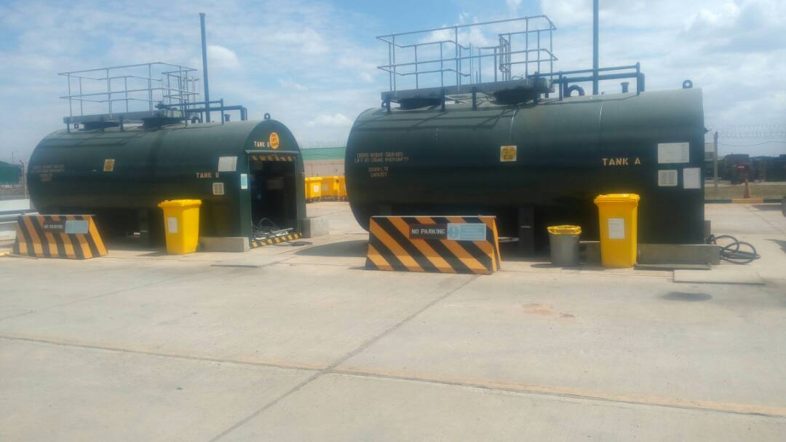

Figure 1. Existing MTFI station A & B in LAB East.

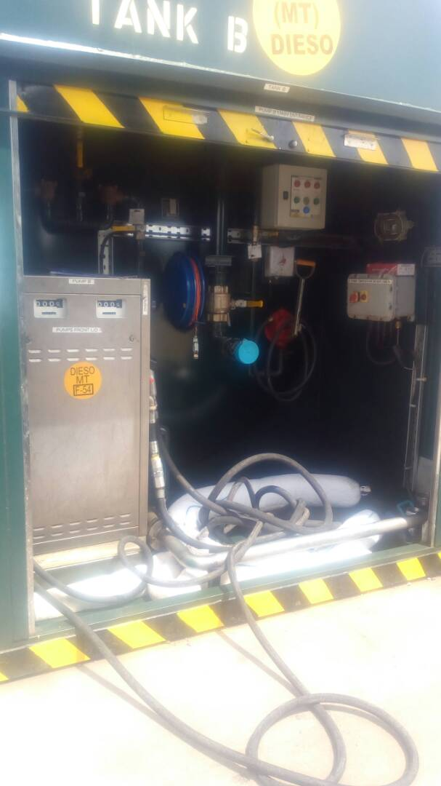

Figure 2. Existing dispensing pump enclosed within the MTFI.
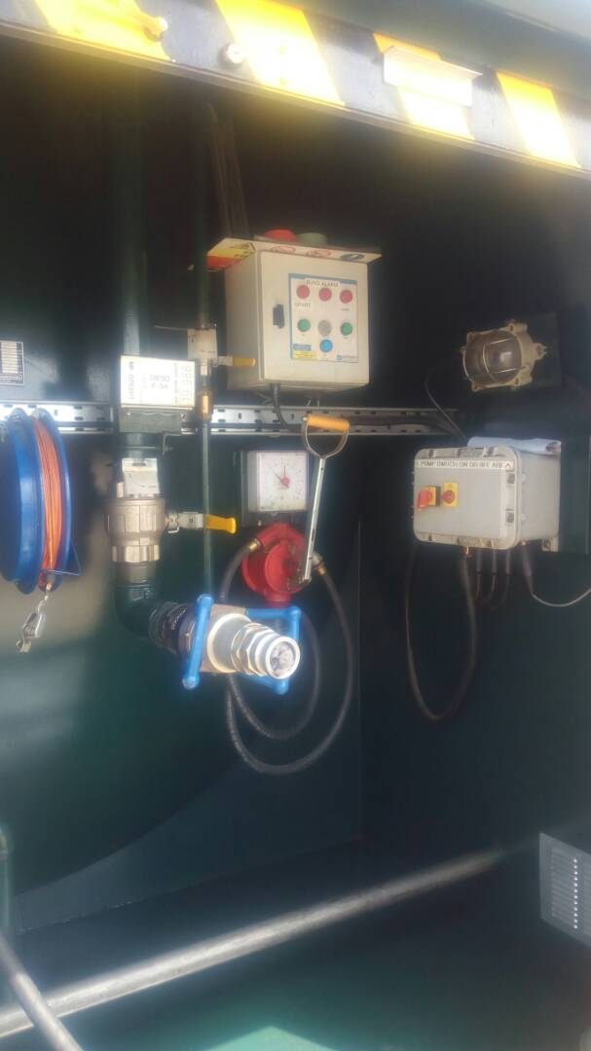

Figure 3. Filling point in the existing MTFI

  - More details on MFTI stations are shown below:

MTFI station A
Tank capacity: | 20,000 ltrs
Tank type: | Double skinned metal tank
Tank tested date: | 15 Sep 12 by Envirotanks UK
Next due date: | 15 Sep 22
Pump serial No. | 10189
Manufactured by: | Pumptronics Europe ltd
Dispensing hose No. 1 | 1” 30ft
Dispensing hose No. 1 | 3/4” 30ft

MTFI station B
Tank capacity: | 20,000 ltrs
Tank type: | Double skinned metal tank
Tank tested date: | 15 Sep 12 by Envirotanks UK
Next due date: | 15 Sep 22
Pump serial No. | 10190
Manufactured by: | Pumptronics Europe ltd
Dispensing hose No. 1 | 1” 30ft
Dispensing hose No. 1 | 3/4” 30ft

Requirements

- The proposed 2 Nos. dispensing pump unit with twin dispenser nozzle are to have minimum of the followings built in mechanisms:

  - Auto sensing built in and auto cut off mechanism when tank is full to prevent over flowing of fuel, automatic nozzle.

  - Flow rate of 10 – 80 litres/minute.

  - Auto fuel counter resetting.

  - When built in safety mechanism (i.e. auto cut off switch) is detected faulty, dispensing pump must not operate.

  - Illuminated liquid crystal volume display indicating litres only.

  - Electric auto reset.

  - Memory backup for the computer display to maintain a display for 15 minutes during a power failure

  - Facility for devices to limit volumes as required by the installation.

  - Non-resettable volume totaliser.

  - Drip tray.

  - Dry break couplings at the housing and at the nozzle.

  - Check valve.

  - Impact valve for positive pressure delivery systems.

  - Industrial quality hose, of minimum length 3.3 m.

  - Totally enclosed flameproof motors to BS EN 60079-7:2015

  - The equipment should IP67.

  - The equipment pump and motor should be ATEX certified; gas group IIA and temperature classification T3.

  - Support/base plates.

- Metering pumps/dispensers shall be island mounted inside the DPMTFI Station Canopy.

- Metering pumps/dispensers shall be of twin pump construction.

- Diesel metering pumps/dispensers shall be of two speed designs to cater for the refuelling requirements of both cars and heavy goods vehicles.

- Disposing of unwanted materials. Any unwanted construction sites materials removed which are contaminated with fuels are to be disposed of appropriately away from the task site in compliance with UK Health and Safety and NEMA. The contractor holds liabilities for damages caused by contaminated materials from the construction site within or out of task site.

- Risks of fuel contamination. Due to the nature of work carried out, there is risk of fuel spillage contaminating other services such as water distribution and open drainage system within the LABE camp. Contractor is to carry out necessary risk assessments and produce method statement to avoid these on site prior starting work.

- Reference documents. Contractors are to be familiar with all the key UK publications relevant to POL site, fuel pump installation, Environment protection act, Health and Safety (H&S) document, DMG 14 and Policy Instruction (PI) 06/12 etc.

Electrical works

- All electrical isolation will be carried out by Authority’s approved skilled person electrical upon request. Switches are to be locked in the off position using safety locks and appropriate warning sign is to be fitted at all points of isolation as per JSP 375 Vol 3 Ch 3 safe systems of works.

- Contractor is to submit risk assessment and method statement to authority prior starting the work for approval.

- Permit To Work (PTW) will be issued by the authority upon receiving of pre-requisite documents.

29 a. Electrical installation and connection shall be completed by a competent engineer qualified in accordance with IEC Ex modules 1-4 and IEC 60079 – 14 & 17.

Mechanical works

- All the Mechanical isolation is to be carried out by Authority skilled person Petroleum.

- Disconnect the existing 2 Nos. dispensing pumps from the current location minimising damages to the pumps and to the existing / surrounding structures.

- Supply 2 Nos. kerbside fuel dispensing pumps meeting above requirements.

- Obtain PTW from the authority.

- Dispose of disconnected 2 Nos. kerbside fuel dispensing pumps away from the task site.

- Install 2 Nos. new supplied kerbside pumps in compliance with PG 05/12 and JSP 375, Pt 2, Vol 3, Ch 5.

- Commission newly installed 2 No. kerbside pumps.

- Test and commission the newly installed 2 No. kerbside pumps and supply test certificate to Authority enclosed in H&S handover file.

Task No. 2

- Kifaru camp in Nairobi. POL Point Interceptors 64 & 64a. Upgrade works as per PG 06/12 inspection report, Pollution Preventive Guideline No. 3 and JSP 317 to achieve a class 1 Forecourt separators. Figure below is the existing Oil Water Interceptor (OWI) in POL point, Kifaru camp.
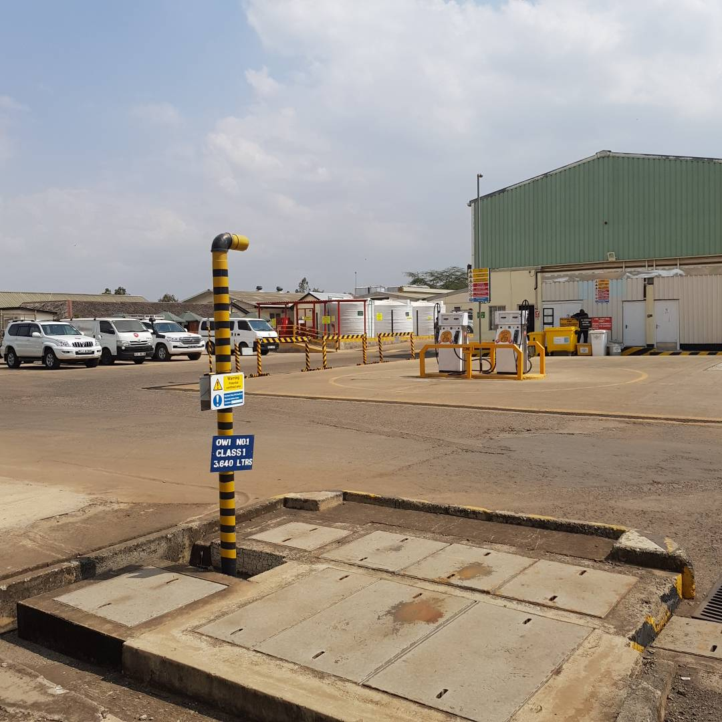
Figure 4. Existing Oil Water Interceptor No. 64 located in Kifaru camp, Nairobi
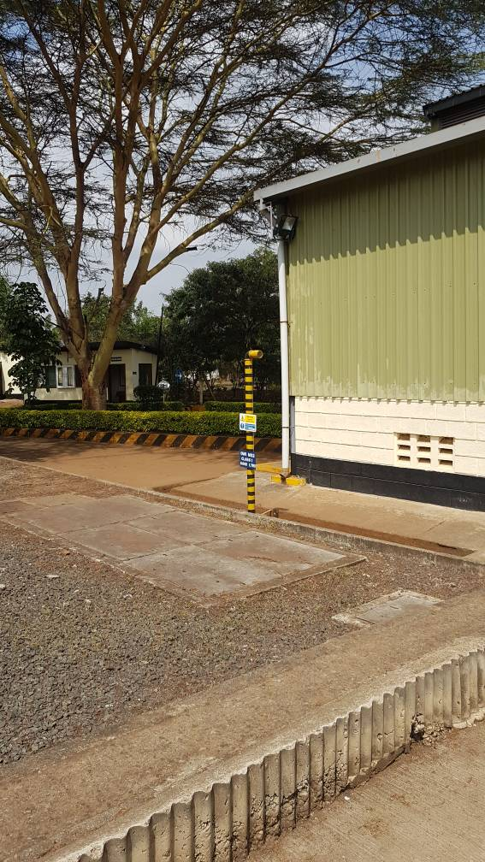

Figure 5. Oil Water Interceptor No. 64A located in Kifaru camp, Nairobi

- More details on the existing oil interceptors are as shown below:

Oil Water Interceptor No. 64
Class type: | Class 1
Holding capacity: | 3,640 ltrs
Construction material: | Concrete with steel cover
Vent diameter: | 2 inches
Vent height: | 2.2m
Automatic closure fitted: | No
Alarm fitted: | No

Oil Water Interceptor No. 64A
Class type: | Class 1
Holding capacity: | 8,660 ltrs
Construction material: | Concrete with steel cover
Vent diameter: | 2 inches
Vent height: | 2.2m
Automatic closure fitted: | No
Alarm fitted: | No

Requirement

- The contractor is to design the 2 Nos. Oil Water Interceptors (OWI) 64 & 64A as per the Pollution Preventive Guideline No. 3, JSP 317 and as outlined in the Practitioner Guide (PG) 06/12 inspection report. Minimum of the following is to be achieved:

  - For Class 1 separator. Designed to achieve or have:

    - Coalescing devices which draw the oil droplets together and facilitate the separation.

    - A discharge concentration of less than 5 mg/litre of oil under standard test conditions.

    - Discharging to surface water drains.

  - For Forecourt separator. Designed to achieve or have:

    - That treats the full flow that can be delivered by the drainage system. The ‘full flow’ is normally equivalent to the flow generated by a rainfall intensity of 65 mm/hour.

    - Designed large enough to serve the catchment area of the site and have a sufficient oil storage volume to retain any foreseeable spillages. 122%

    - Meet the requirements of BS EN 858-2, clause 4.3.6.

    - Compartment size of the fuel tanker that delivers fuel is 2,000ltrs. Standard fuel tanker capacity is 10,000ltrs.

  - Closure devices. The separators must be provided with an automatic closure device that will prevent flow passing through the separator when the quantity of oil in the separator exceeds the oil storage volume (V).

  - Automatic Warning Devices/Alarm systems. The Separators must be provided with a robust device to provide visual and audible warning (if necessary to a remotely located supervisory point) when the level of oil reaches 90 per cent of the oil storage volume (V) under static liquid level conditions. This automatic warning device indicates that the separator is in need of immediate emptying for it to continue to work effectively.

  - Labelling of the oil water interceptor. The separators to have visible and durable label that can be read after installation and which contains the following information:

    - Manufacturer’s reference number and year of manufacture.

    - Unique Identifier for the design of separator (name or number).

    - Oil level warning device details.

    - Depth of oil storage.

    - Oil storage capacity.

    - Volume of separator.

    - Bypass/full retention.

    - Silt storage capacity.

    - Class of separator.

    - Closure device details.

    - Nominal size.

  - The vent pipe of the separator is to be of correct sized and to have a minimum of 2.4 metres high from the Floor Finished Level (FFL), with an elbow faced down on top.

  - The manhole covers for the separator should be steel fabricated and lockable.

  - Marking the separators clearly on the drainage plans and identify the separator on the ground by marking the manhole cover ‘SEPARATOR’.

  - Any electrical device used within a separator or used to monitor sensors placed within a separator must be compliant with DSEAR and suitably rated under ATEX regulations. The location of the monitoring device, such as the alarm or ‘separator management system’ control panel, must be located within a safe area outside DSEAR classified zones where practical to enable BS / EN standard industrial fittings and conform to the requirements of BS EN 60079-10.

  - The interceptor should be a Glass Reinforced Plastic (GRP) made.

- Carryout necessary risk assessment and produce pertinent method statement.

- Obtain Statement of Known Services / Hazards for task area from the Authority prior commencing work.

- The authority will be using the POL while the upgrade works being carried out, therefore the contractor shall takes these into consideration while carrying out risk assessment.

- Work to be carried out in accordance with design, installation and commissioning Pollution Prevention Guidelines (PPG) 3.

- Care must be taken while digging ground as there might be number of other unknown services installed underground. Therefore excavate must be carried out with appropriate tools only.

- All contaminated soil and other site materials are to be disposed of appropriately away from the camp.

- Testing and commissioning of the separator and test certificate and results must be included in the H&S folder during project handover.

General points

- The following general points have been identified as potential issues:

  - Communication will be key in planning and conducting concrete works, excavation works, design works, final connection, new connections to existing systems, electrical installation and during commissioning.

  - All personnel employed to work on the above tasks should be suitably qualified and must have their CV submitted to the authority. They may also be interviewed by the authority to confirm their competency.

  - Before any work is performed, pertinent risk assessments and method statements should be issued to the authority. The authority will then issue the appropriate permits to work if required. The contractor must sought Statement of known hazards from the authority prior starting and excavation on site.

  - All work to be carried out in accordance with the relevant Safety Rules and Procedures.

  - All detailed design drawings, cable sizing calculations, pipes sizing calculations, drainage sizing, concrete mixing ratios, materials data safety sheets and samples for materials are to be submitted to the authority for approval beforehand.

  - All removed spare or unused parts are to be returned to the authority for disposal.

  - Authority will issue the necessary paperwork’s for transportation of goods in the camp i.e. gate pass.

  - All working at height works should be carried-out as per JSP375 Vol3 CH6 safe system works.

  - Any Scaffolding ladders to be used in the tasks are to be serviceable and where required presented to the Authority for inspection and permission to use.

  - Any electrical works (final connection of the cables to the existing system) work will be carried out as per JSP375 Vol 3 Ch 3 (Permit to work).

  - Under no circumstances trench digging works will be carried-out without a statement of known hazards.

Restrictions / Constraints

- Access to the site. This is to be agreed in detail with the PM prior to start on site. Passes may be required and the contractor should submit the details and ID of any technicians that will be working on the contract within the tender return.

- Notice. The contractor is to provide notice to the authority in writing (or through email), minimum of 3 working days prior to the work on site. The notice must include the date and expected time of arrival, name and ID No of the workforce, and contact telephone no for both the contract manager and the workforce.

- Working hours. The contractor may choose to work in his/her suitable hours; however assistance from the authority will only be available 0800-1600 hrs Mon – Fri. For any assistance from the authority, the contractor must submit request with a minimum of 24hrs notice.

- Permits to Work. Permits to work applicable for this task are as follows:

  - Statement of Known Services / Hazards.

  - Electrical work.

  - Working at Height.

  - Confined Spaces.

  - Petroleum Installations.

Annexes:

A. Generic Points - Pre-Contract.
B. Generic Points - Pre-Construction.
C. Generic Points - During construction.
D. Generic Points - Post construction.

Generic Points - Pre-Contract

Designers
- This project is a Design and Build contract, meaning the contractor must fulfil the role of both the designer, and the Principle contractor. The design work must be carried out by a qualified and competent person. The contractor shall ensure all designs are in accordance with, and includes the applicable requirements contained within references and all other design documents specified within this Performance Specification. If the contractor is not competent to carry out some aspects of the design work, a qualified person or consultancy firm should be sub-contracted to carry out that portion of the work. The Contractor is to inform the PM of all design consultants/sub-contractors who will be employed in this project and the areas of their responsibility.

- Where design work is required to be carried out by a professionally qualified person, details of their qualifications and experience, registration with the Engineers Board of Kenya and copy of their professional liability insurance needs to be submitted to the authority.

- Pre-Construction Information Pack (PCIP). All the pre-construction information is contained within this Booklet 3. If any additional information is required the contractor is to request a copy in sufficient time to affect any changes prior to tender submission.

Contractor’s design
- The contractor is to ensure that their design meets the parameters outlined within this Specification.

- Site visit. The Contractor shall acquaint himself completely with the exact conditions relating to access and site environment, along with the layout, conditions and positions of the existing services, the full extent of the works required, and the supply and conditions affecting labour, carriage, carting, unloading, storage, tools, scaffolding etc. as well as any security and access constraints.

- Existing ground levels. The Contractor shall confirm or identify all existing site levels required prior to any construction works.

- Ground water level. The ground water level has not been established but it is not expected to impact on any of the works. It is the Contractors responsibility to take into account the ground water levels when submitting technical and commercial proposals.

- Existing record drawings. The Contractor will upon request, be supplied with copies of all available and relevant as built drawings. The Contractor during tender stages shall fully acquaint himself with the nature and extent of all existing services within the area of the contract works.

- The responsibility remains with the Contractor to ensure that all design and construction works comply with the latest methods, requirements and guides, and generally accepted practice as relates to the works, geography, climate, and environment. Where there are conflicts between the design drawings and Detailed Specification the Detailed Specification will take precedence in all cases. Any queries should always be addressed to the Authority in the first instance.

Use of design codes and specifications
- All designs must conform to the most current editions of British Standards (BS) or Euro Norms (EN). Other Design Codes may, on occasion, be used provided that they meet the minimum requirements and the Contractor shall submit proof of equivalency to the Authority for approval of use. The Authority can be approached for clarification of the relevant BS if required. On no account is the contractor to use any design information other than that stated or approved by the Authority.

- All Contractors will be required to certify their designs for conformity to the specification and to the relevant BS/EN. Only appropriately qualified and experienced engineers are to certify the designs.

  - Design conformity. The design engineer is to produce a letter to state that the design conforms with all applicable legislation, most current editions of BS or EN, and best practice. The letter is to have the company header (of the design agency if sub-contracted) and to be signed by the lead designer with his name, contact details and qualifications detailed in the signature block.

  - Construction inspections. Prior to the start of construction, the contractor, designer and authority shall agree key stages at which the works are to be inspected by the designer for compliance with the design.

  - Build conformity. At the end of the project, the lead designer is to confirm in writing that the works have been built correctly, in accordance with his design.

- Design life. The design life of all new works to first major overhaul, repair or replacement is 25 years. The Contractor shall supply and install all components, elements and systems/structures to satisfy this requirement and provide documentary evidence.

Generic Points - Pre Construction

Detailed design and planning

- Additional design information. The Contractor is to submit any additional design information to the Authority prior to commencement of the construction phase. The PM will examine design documentation and shall be entitled to reject a design as unsatisfactory where it is not in accordance with the specification, statutory regulations or if it would be unfit for purpose.

- A copy of all construction drawings are to be provided by the Contractor to the PM prior to commencing Works. Amended or updated drawings are to be provided as necessary. The minimum design information to be provided by the Contractor shall include the following:

  - Any additional design calculations for the works.

  - Any additional general layout plans for the site and the structures.

  - Any additional detailed structural design, calculations and drawings.

  - Any additional foundation plans shall (as a minimum) indicate: all footing locations and dimensions, screeds and / or ground slabs or plinths, as applicable.

  - Any additional services layouts and calculations.

  - Any additional detailed Electrical, Mechanical drawings and calculations.

  - Manufacturer product details including safety data sheets.

  - Designers risk register.

  - Project Programme to be regularly updated or upon request by the Authority and provided electronically on Microsoft Project or equivalent in a regularly basis or on request.

Design responsibilities (under CDM)

- The designer has the following responsibilities under CDM 2015:

  - Eliminate hazards and risks during design. Designers are to analyse the risks posed during the construction, daily use, maintenance and ultimate demolition of the facility. Once identified, these risks should, where practicable, be designed out.

  - Provide information on remaining risks. Remaining risks after the design process are to be compiled onto a designers risk register and submitted with the final design.

Provision of information

- Unless otherwise specified the following is to be provided:
  - Three copies of all information, including valid certification, in respect to work, goods and materials proposed by the Contractor, shall be supplied to the Authority. Where the original document is written in a language other than English, it shall be accompanied by an English translation.
  - Information and certificates shall be supplied at least two days prior to the use of the work, goods or materials in the Works.
  - Three copies of detailed working and fabrication drawings and calculations shall be submitted to the Authority for reference purposes. Such submittal shall in no way relieve the Contractor of his responsibilities for the work under the contract.

- The Authority reserves the right to request copies of all calculations and drawings for analysis prior to the commencement of any construction on site. The contractor will provide copies of all calculations and ‘As Built Drawings’ for the Health and Safety File.

- The signed and approved drawings shall be used as the construction drawings on site for all work purposes and to satisfy the requirements as specified by the Construction, (Design and Management) Regulations 2015 (CDM 2015) & appropriate ACOP.

Construction phase plan

- Under the requirements of CDM, the contractor is to prepare a construction phase plan detailing how they will safely conduct the works. Risk assessments are to be included for all elements of work and method statements are required for any works that are out of the ordinary or high risk. The Construction Phase Plan must cover the following area’s (where applicable):

  - Safety risks:

    - Protecting the public. The public is any persons not involved in the works. Particular attention should be paid to area’s where children are likely to have access to the site outside of working hours.

    - Traffic routes. Traffic routes for delivery of stores and equipment should be clearly highlighted and controlled. Movement of plant and machinery on site should be organised in a way that minimises risk to the workforce and any visitors to site. Care must also be taken to minimise risk from existing traffic routes.

    - Existing buried and overhead services. Some of these may be identified in the permit to dig process, however care must be taken to identify and avoid any damages on existing services.

    - Adjacent land use. The use of adjacent land and properties will affect the level of protection for things such as noise and dust suppression etc.

    - Stability of nearby structures. Care must be taken that works do not affect the stability of nearby structures.

    - Demolition works. Demolition work is a particularly dangerous task and careful planning must be conducted. Method statements for all aspects of demolition will be required by the authority.

    - Work equipment. Work equipment must be inspected and in a suitable condition not to cause a hazard on site.

    - Electrical safety. Electrical works will be conducted in accordance with the JSP and CDM recommendations.

    - Preventing falls. Falling from height is one of the biggest killers in the construction industry. Even when not working under a permit, it is expected that the correct equipment and management methods are utilised to prevent falls.

    - Working with or near fragile materials. Fragile materials should be identified prior to work commencing and appropriate action must be taken.

    - Control of lifting operations. Lifting operations are to be carefully planned and controlled on site.

    - Excavations / confined spaces. All excavations inside buildings where work is to be conducted are to have the appropriate level of shoring / protection. Where an area is deemed a confined space, a permit may need to be issued to control the works. If permit is not issued, the contractor is to have a suitable system in place with appropriate paperwork i.e. risk assessment and method statements associated to the work being carried out.

    - Working on or near water. If working on or near water the contractor is to plan the works to minimise the risk drowning.

  - Health risks:

    - Temperature / weather protection. Protection from the elements for the workforce.

    - Substance misuse. The misuse of drugs or alcohol by the workforce.

    - Manual handling. Correct lifting techniques, lifting equipment etc.

    - Dust. Dust suppression and removal.

    - Noise. Reduction and suppression of noise. Management of timings for noisy activities etc.

    - COSHH. The correct storage and use of hazardous substances. Appropriate protective equipment must be worn when handling COSHH materials. Safety data sheets must be available on site at all time.

    - Asbestos. Identification and appropriate management of Asbestos.

  - Provision of:

    - Welfare facilities. Water, food, shade, toilet facilities etc.

    - First aid. There should be at least one qualified first aider with appropriate medical equipment on site at all times.

    - Emergency procedures. Procedures for response to incidents such as Fire, major and minor injuries, security incident etc.

    - Reporting of accidents, incidents or near misses. Procedure for reporting and follow-on actions to prevent re-occurrence.

    - Waste management. Management, storage and disposal of waste and arising from the site.

    - Fire prevention, detection and firefighting. Methods to prevent the start and spread of fire, and to identify any fire that does start. There must also be appropriate firefighting equipment available and access to the site for firefighting services.

Pre-Start meeting.

- Prior to the commencement of any works, a Pre-Start meeting is to be held with the contractor, lead designer and chaired by a representative from the authority. The following topics are to be discussed as a minimum:

  - Mobilisation plan

  - Site setup

  - Health and safety

  - Required permits

  - Access and security

  - Programme

Generic Points - During Construction

Facilities/temporary works/services
- Locations. The Contractor is to agree with the PM of the intended siting of all spoil heaps, temporary works and services in advance. The Authority shall verify with the Contractor which site features are to be removed and protected during construction works.

- Survey and setting out. The Contractor will be responsible for all setting out and levelling during construction. The Contractor shall keep updated schedules and drawings of all bench marks used in setting out of the site; these must be made available to the Authority when required. A minimum of 2 survey control stations are to be constructed, one visible from the site at a distance of 50 m and the other 200 m away from the first but in line of site.

- Record drawings. The Contractor shall record details of all grid lines, setting out stations, bench-marks and profiles on the site setting out drawing. Retain on site throughout the contract and hand to PM on Completion.

- Signage. The Contractor shall supply and erect all applicable and appropriate signage to the site. This shall include as a minimum all H&S signage, directions and location of site office and emergency contact details of the Contractor’s representative on site. Temporary warning signs and careful demarcation of works areas must be undertaken with care to ensure compliance with any and all requirements.

- Lighting and power. The Contractor shall provide all lighting and power for his works. No facility will exist on site from the general base infrastructure.

- Communications. The Contractor shall provide his workforce with adequate means of communications throughout the duration of the Contract period in order to carry out the work specified.

- Temporary services. The Contractor shall provide temporary service connections to both mechanical and electrical systems. All temporary service connections are to be in accordance with current UK regulations.

- Use of the site. The Site shall not be used for any purpose other than undertaking the specified works. The Contractor may erect the site office and storage compound in a location agreed with the Authority. No storage of materials, parking of vehicles, temporary accommodation or any other use of areas beyond the boundaries shall be permitted. Under no circumstances shall it be permissible for the Contractor to cause an obstruction to normal pedestrian or vehicular movements within the vicinity of the site.

- Restrictions to the works. The Works are to be undertaken without interfering with everyday running of the Authority’s operations within the area. The demarcation of the Site boundary is to be obvious and clearly marked to restrict access to the Site whilst the Works are being undertaken.

Project management

- The authority. The Project Support Officer (PSO) has overall authority on this project. For the purpose of this specification, the PM is the only person from within the authority acting on behalf of the PSO, or Superintending Officer (SO) in most cases.

- The Contractor shall not commence any work in accordance with any Design Document until the PM has agreed the relevant Design Document.

- Buried services. Prior to carrying out any excavation work, the Contractor must:

  - Obtain a Permit to Dig (Statement of Known Services) and all drawings relating to existing services that may interfere with the proposed works. A copy of the Permit to Dig must be given to the Authority prior to any works commencing.

  - Identify all local services and take adequate precautions to protect such services from damage for the duration of the works.

  - Inform the Authority immediately if any unknown services are discovered that will impact on the works.

- Supervision. The Contractor shall accept responsibility for delivery, co-ordination, supervision and administration of the Works, including all subcontracts. They shall arrange and monitor a programme with each subcontractor, supplier, local Employer and any statutory undertaker, and obtain and supply information as necessary for co-ordination of the work.

- Site diary. The Contractor shall keep an up to date daily site diary. This document is to be used to record all decisions made on site both verbally and written. The document is also to be used to record visits to site and note anything, which has a direct effect on the project in terms of cost and extensions to time, or any other occurrence that affects the project programme. This document will be used as the audit trail in light of any disputes, concerning the project.

- Contractor’s site meetings. The Contractor is to hold meetings with appropriate subcontractors and suppliers shortly before site meetings with the Authority to facilitate accurate reporting of progress.

- Site meetings. The PM, or his representative will hold regular site meetings to review progress and other matters arising from the administration of the Contract. It will be the Contractors responsibility to ensure the availability of accommodation and attend all such meetings.

- Liaison with the authority. The Contractor shall designate a site manager from within his organisation who will be responsible for liaising with the PM, PSO or his representative (SO) on a day to day basis and as the need arises. At all times the Contractor shall ensure that the Site Manager presents on site that has the capability of reading, writing, speaking and receiving instructions in the English Language, including being able to understand and interpret technical drawings and specifications. The Site Manager must be able to explain the work operations to person performing the work in a language that those performing the work are capable of understanding. The PM shall have the right to determine, whether the proposed representative has sufficient technical and linguistic capabilities.

- Approvals. Where products or work are specified to be approved or the PM instructs or requires that they are to be approved, the same must be supplied and executed to comply with all requirements.

- Access. The Contractor shall provide at all reasonable times, access to the Works. The Contractor shall supply the PM or his representative with copies of any documentation and drawings, which may reasonably be required for the purposes of monitoring the work performed under this or any sub-contract.

- Regulations. It is the Contractor’s responsibility to be fully conversant with all local/MOD regulations and requirements in respect of fire, safety, security and occupational health, etc. These are to be fully complied with throughout the contract period.

Health and Safety

- Health and Safety (H&S). All works shall be carried out in accordance with the Health & Safety at Work Act 1974 (HASWA).

- JSP 375. The contractor shall comply with the Client’s permit to work system and the JSP 375, Volume 3, (details of which are obtainable from the Authority SO), including the provision of method statements, risk assessments, switching/isolating safety programmes, permit to dig, etc.

Permits to work

- Permit to dig. If any excavation or breaking of ground is to be carried out, the contractor must request a permit to dig at the Pre-Start meeting. Should any excavation be conducted without a permit, the contractor may be removed from site.

- Hot works permit. The contractor is to establish at the Pre-Start meeting if hot work permits will be required for his location of work.

- APs. The following table shows details of Authorise Person (AP) in their respective discipline.

Discipline | CAP | Contact No
Electrical | Mr Ezekiel | 0719197643
Mechanical | SSgt Ambohang | 0702659971
Petroleum | Mr Ezekiel/SSgt Ambohang | 0719197643 / 0702659971
Confined Spaces | Mr Mbilo | 0720015852
Working at Height | Mr Mbilo | 0720015852

- Skilled Persons & Persons in Charge (PIC). Any works required to be completed under a JSP 375 permit must have a dedicated PIC and the work carried out by registered skilled persons. At the Pre-Start meeting the contractor must establish if any of his works require a permit, and if so arrange for currently registered personnel to conduct the works, or registration of the contractors personnel.

- CDM 2015. The Contractor shall submit a pre-construction H&S file to the Authority for approval, including all risk assessments, method statements, hazardous material procedures etc to comply fully with Construction, Design Management Regulations 2015 (CDM 2015) & appropriate ACOP.

Quality of work

- Quality standards/control. The contractor will provide evidence to the PM of his quality standards and controls, and will produce a plan detailing Quality Control (QC) activities in order for the PM to plan for witnessing of critical activities.

  - General quality of products. All products shall conform to the following subparagraphs:

    - Products to be new unless otherwise specified by the Authority.

    - For products specified to a BS or EN obtain certificates of compliance from manufacturers when requested.

    - Where a choice of manufacturer or source is allowed for any particular product, the whole quantity required must be of the same type, manufacture and/or source unless otherwise approved. Produce written evidence of sources of supply when requested by PM.

    - Ensure that the whole quantity of each product required to complete the work is of consistent kind, size, quality and overall appearance.

    - Where consistency of appearance is desirable ensure consistency of supply from the same source. Do not use different colour batches where they can be seen together.

    - If products are prone to deterioration or have a limited shelf life, order in suitable quantities to a programme and use in appropriate sequence. Do not use if there are any signs of deterioration, setting or other unsatisfactory condition.

  - Proprietary products. All products shall conform to the followings:

    - Handle, store, prepare and use or fix each product in accordance with its manufacturer’s current printed or written recommendations/instructions. Inform PM if these recommendations/instructions conflict with any other specified requirement. Submit copies to PM when requested.

    - The tender will be deemed to be based on the products specified and recommendations on their use given in the manufacturer’s literature current at the date of tender.

  - Obtain confirmation from manufacturers that the products specified and recommendations on their use have not been changed since that time. Where such change has occurred inform PM and do not place orders for or use the affected products without further instructions.

  - Checking compliance of products. The Contractor shall check all delivery tickets, labels, identification marks and where appropriate the products themselves to ensure that all products comply with the project documents. In particular, check that the products comply with the following sub-paragraphs.

    - The sources, types, qualities, finishes and colours are correct, and match any approved samples.

    - All accessories and fixings that should be supplied with the products have been supplied.

    - Sizes are correct. Where tolerances are critical, measure a sufficient quantity to ensure compliance.

    - The delivered quantities are correct, to ensure that shortages do not cause delays in the work.

    - The products are clean, undamaged and otherwise in good condition.

    - Any products with a limited shelf life are not out of date.

  - Protection of products. All products shall be protected to ensure that they remain in the condition they are required to be in. In particular the contractor is to ensure that products are to be prevented from overstressing, kept clean, protected from the elements and kept in original wrappings until required for the project.

- Prohibited products. The Contractor shall not employ on or incorporate in the Works any of the following products and shall impose a like obligation upon all Sub-Contractors.

  - Asbestos materials as described in the Asbestos Prohibitions Regulations 1985 and the Asbestos Products (Safety) Regulations 1985.

  - Lead or any products containing lead for use in connection with drinking water.

  - Materials that are generally composed of mineral fibres either manmade or naturally occurring which have a diameter of 3 microns or less and a length of 200 microns or less or which contain any fibres not scaled or otherwise stabilised to ensure that fibre migration is prevented.

  - Other products or substances generally known to be deleterious to health and safety at the time of use or to the durability of the property in the particular circumstances in which they are being used.

- Hazardous, aggressive or unstable materials. The Contractor is not to import or use fill materials which would either in themselves or in combination with other material or ground water, give rise to health hazards, damage buildings or structures. The construction materials should not include any finishes that may lead to shedding of particles.

- Defects in existing construction/services. This shall be reported to the PM without delay. Obtain instructions before proceeding with work which may be covered up or otherwise hinder access to the defective construction, or be rendered abortive by the carrying out of remedial work. This is particular relevant in relation to the expansion of the existing service runs.

- Proposals for rectification of defective work/products. As soon as possible after any part(s) of the work or any products are known to be not in accordance with the Contract, or appear that they may not be in accordance, the Contractor is to submit proposals to the PM for opening up, inspection, testing, making good, or removal and re-execution. Such proposals may be unacceptable to the PM and he may issue contrary instructions.

- Quality control. The Contractor is to establish and maintain procedures to ensure that the works, including the work of all Subcontractors, comply with specified requirements. This is to include all testing of materials that are to be incorporated into the project (e.g. concrete). The Contractor is to maintain full records, keep copies on site for inspection by the PM, and submit copies of particular parts of the records on request. The records must include the following:

  - Identification of the element, item, batch or lot including location in the works.

  - The nature and dates of inspections by the Contractor or PM, tests and approvals.

  - The nature and extent of any non-conforming work found.

  - Details of any corrective action.

- Materials testing. It is the Contractor’s responsibility to carry out all materials testing and present all test results to the Authority on request and within the H&S file. The Authority will carry out concurrence quality control material tests at regular intervals.

- Notification. The Authority requires to be informed in writing at least 10 days in advance of any tests and commissioning being carried out. Access must be available to the Authority to carry out testing as deemed necessary by the Authority.

Generic Points - Post Construction

Completion / handover

- Commissioning period. Within the tender submission the Contractor shall submit a Works Commissioning Plan, setting out his commissioning proposals including the preparation of handover documentation.

- Notice of completion. The Contractor is to provide the PM at least five days notice of the anticipated dates of Practical Completion of the whole or parts of the Works.

- Mechanical and electrical services. Mechanical and Electrical Services must have final tests and commissioning carried out by the Contractor so that they are in full working order at Practical Completion. This includes buried but not connected cables and pipelines.

- Timing of tests and inspections. The Contractor is to agree dates and times of tests and inspections with PM four days in advance, to enable the PM and other affected parties to be present. On the previous working day to each such test or inspection the Contractor is to confirm to the PM that the work or sample in question will be ready or, if not ready, agree a new date and time.

- Test certificates. The Contractor is to submit a copy of each certificate to PM as soon as practicable and keep copies of all certificates on site. Copies should be included in the Health and Safety File on handover of the works.

- Work at or after completion. The Contractor is required to undertake the following works prior to handover.

  - Make good all damage consequent upon the work.

  - Remove all temporary markings, coverings and protective wrappings unless otherwise instructed.

  - Clean the works thoroughly inside and out including all accessible ducts and voids; remove all splashes, deposits, efflorescence, rubbish and surplus materials consequent upon the execution of the work.

  - Cleaning materials and methods to be as recommended by manufacturers of products being cleaned, and to be such that there is no damage or disfigurement to other materials.

- Security at completion. The Contractor is to leave the Works secure with all accesses locked. Account for and adequately label all keys and hand over to PM with itemised schedule, retaining duplicate schedule signed by PM as a receipt.
- Making good defects. The Contractor is to make arrangements with the PM and give reasonable notice of the precise dates for access to the various parts of the Works for purposes of making good defects. The PM is to be informed by the Contractor when remedial works to the various parts of the Works are completed and ready for approval.

- Inspection, testing and commissioning. The installations shall be tested and inspected in accordance with but not limited to the current CIBSE Codes, BS7671:2008+A3:2015 Requirements for Electrical Installations, IEE Wiring Regulations 17th Edition, 3rd amendment where appropriate, etc. Advance notice of tests shall be given (minimum of 7 days prior to notification).

- Test and inspection certificates are to be approved by the Authority, preferred document templates will be provided by the Authority on request. Test certificates shall serve as a record that the item referred to has been shown under test to meet the requirements of the specifications and of British Standards as applicable and shall be dated, numbered and clearly referenced to the item tested by means of serial, chassis or other manufactures reference number permanently marked in a conspicuous position.

- The calibration certificates for the testing of the equipment are to be available on request to be shown to the Authority for scrutiny. The Contractor shall ensure all calibrations are in date. The Authority reserves the right to have an independent electrician available during the test and inspection phase.

- Any defects of workmanship, materials or non-compliance with the specifications or other irregularities which become apparent during the tests shall be rectified by the Contractor, at his own expense, until the whole work is free from defects and in full working order to the complete satisfaction of the Supervising Officer.

- All materials used for construction of permanent works shall have suppliers’ specifications and/or testing certificates available. Where materials are used as part of a whole or in conjunction with other materials, and in any case where site testing is required by best practice, verification of quality and specifications should be allowed for the parts / items / products (suppliers’ specification) as well as the whole (site testing).

- Defects liability period. A defects liability period shall apply for the works as detailed above. The Contractor will be responsible for making good at his own expense any defects in the works arising within that period. The contractor is to ensure that a defects inspection is conducted 2-4 weeks prior to the end of the liability period in order to release the contract retention.

- Operations and maintenance documentation. Upon completion of the works the Contractor shall forward all manufacturers’ details relating to equipment/materials used to the Authority for inclusion into the O&M Manual/H&S File. Refer also to Construction, (Design and Management) Regulations 2015 (CDM 2015) & appropriate ACOP, this documentation less ‘As Built Drawings’ is to be made available at the Pre Board of Officers not less than 10 days before the due project handover date. A full list of snagging items shall be produced and presented to the Authority with a rectification programme at this very same board.

Health and safety file
- Upon project completion the H&S file shall be presented to the Authority before the Board of Officers is convened and in compliance with (CDM 2015) & appropriate ACOP.

- Presentation of health and safety file. The Contractor is to provide the PM with three copies of the H&S File. The Manual is to be contained in a series of A4 size, plastic covered, loose leaf, four ring binders with hard covers, each indexed, divided and appropriately cover titled. Selected drawings needed to illustrate or locate items mentioned in the Manual, where larger than A4, are to be folded and accommodated in the binders so that they may be unfolded without being detached from the rings. The main set(s) of as-built drawings will form Annex(es) to the Manual.

- The health and safety file. The Contractor shall be required to complete the Project Health and Safety File on completion of the works, three copies of which will be provided to the Authority at handover. Advice can be sought from the Authority if required. The H&S File provides information required for future construction work, which includes cleaning, maintenance, alterations, refurbishment and demolition. The Manual is to consist of the following parts, sub-sectioned as appropriate.

  - Section 1: H&S. The Contractor is to provide a description of the site and the buildings thereon. This is to include details of construction methods and materials, which may present significant residual hazards in the future.

  - Section 2: Certificates. The Contractor is to provide a copy of all Test Certificates (including but not limited to electrical circuit tests, start and commissioning tests) for the installations and plant, equipment, valves, etc, used in the installations. Warranty Certificates and guarantees are also to be included in this section.

  - Section 3: As-built drawings. The Contractor is to provide as-built drawings recording details of all construction, electrical and mechanical work. A fire strategy for the site should also be included with drawings showing emergency escape routes, location of emergency and fire fighting systems, services shut-off valves, switches, etc.

  - Section 4: Operation & Maintenance (O&M) schedules. The Contractor is to provide recommendations as to the preventative maintenance, frequency and procedures to be adopted to ensure the most efficient operation of the systems. Manufacturer’s O&M schedules are to be included. Diagrammatic drawings of each system indicating principal items of plant, equipment, and valves are also to be included.

  - Section 5: O&M manuals. The Contractor is to provide copies of manufacturers’ current literature for all products for which the particular proprietary brand has been chosen by the Contractor, including COSHH data sheets, catalogue list numbers and manufacturers recommendations for cleaning and maintenance. The mechanical and electrical systems section shall contain a full description of each of the systems installed, written to ensure that the client fully understands the scope and facilities provided. All manufacturers technical literature for items of plant and equipment, assembled specifically for the project, including detailed drawings, electrical circuit details and operating and maintenance instructions are to be included.

- Draft health and safety file. A complete draft of the Manual must be submitted by the Contractor, not less than 4 weeks before the date for submission of the final copies of the Manual. This is to be amended in the light of any comments and resubmitted to the PM. Do not proceed with production of the final copies of the Manual until authorised to do so by the PM.

DIO SDT (B) is the Authority for this Contract.

