CROWN COMMERCIAL SERVICE
and
SUPPLIER
REF: Rm6089
Defence housing MANAGEMENT SERVICES (national)
sub-Lot 2A

FRAMEWORK SCHEDULE 1c
SPECIFICATION
DEFENCE HOUSING MANAGEMENT SERVICES (NATIONAL)
- INTRODUCTION
  - This Framework Schedule sets out the characteristics of the Services that the Supplier will be required to make available to all Buyers under this Contract.
  - The Supplier must only provide the Services for the Lot that they have been appointed to.
  - For all Lots and/or Services, the Supplier must help Buyers comply with any specific applicable Standards of the Buyer.
  - The Services and any Standards set out in this Framework Schedule 1c (Specification) may be refined to the extent permitted and set out in the Order Form, for which please see Framework Schedule 6 (Order Form Template and Call-Off Schedules) by a Buyer during a stage within the Call-Off Procedure to reflect its Statement of Requirements for entering a particular Call-Off Contract.

- STRUCTURE
  - The scope of Services together with specific Standards applicable to the Deliverables are set out as below:

Part A - Specification
Work Package A – Contract Management
Work Package B – Contract Mobilisation
Work Package C – Statutory Obligations
Work Package D – Management Information System (MIS)
Work Package E – Management of Billable Works and Additional Services
Work Package F – Accommodation Occupation and Property Management

Part B - Annexes
Annex A - Service Standards
Annex B - Legislative Standards
Annex C - Customer Service Centre Response Times
Annex D - Service Delivery Response Times
Annex E - Property Classification
Annex F - Standards

Part C - Appendices
Appendix 1 – Complaints, Failure and Recall Process
Appendix 1.1 Process Map 1 - Complaints
Appendix 1.2 Process Map 2 - Failure
Appendix 1.3 Process Map 3 - Recall
Appendix 2 – Billable Works and Approval Process
Appendix 2.1 Process Map 1 – Billable Works and Approval Process
Appendix 2.2 Process Map 2 – Issuing Quotation by Supplier Process
Appendix 2.3 Process Map 3 – Issuing Instruction for Quotation for Approved Work Order

PART A: SPECIFICATION
- SCOPE OF THE SERVICES

  - The Services to be provided under the National Accommodation Management Services (NAMS) Framework are set out below.
  - A NAMS Service Standard has been provided within the relevant Service below, where applicable.
  - Each Service states it is mandatory and whether it is to be priced at Framework or Call-Off.
  - The Buyer may amend figures in square brackets [ ] to suit their individual requirements at Call-Off stage.

SERVICE REQUIREMENTS

Work Package A – Contract Management

- Service A:1 - Integration
  - Service A:1 – Integration is Mandatory: Framework
  - In addition, the following Standards to this Service apply - SA1
  - The Supplier shall provide an integrated Service ensuring a seamless and coordinated delivery and effective synergies with the Buyer’s other Suppliers and its stakeholders to ensure the Services are delivered at all times. The Supplier shall take advantage of synergies between the different Services and the benefits that integration will bring.
  - The Supplier shall be aware that Services shall be delivered across all Buyer Premises.
  - The Supplier will work collaboratively with the Buyer to promote excellence, innovation and better value and enhance the reputation of the Buyer amongst key stakeholders across Government and within local communities.
  - The Supplier shall:
    - Focus on cross / multi-skilling of Supplier Staff to allow for efficiencies when delivering the required Services;
    - Share more efficient ways of working with the Buyer that will ensure better working practices in delivering the Services;
    - Work collaboratively with the Buyer and identify opportunities in relation to delivering the Services;
    - Procure Billable Works Services only with the sanction of the Buyer and shall use pan-Government Frameworks approved by the Buyer wherever possible. The Supplier shall be invited to review the use of such contracts and make proposals for alternative procurement routes if these can be demonstrated to provide greater value for money for the Buyer; and
    - Be alert and provide the benefits of working together to the Buyer. The Supplier shall also provide the most advantageous options in relation to the deployment of Supplier Staff in order to deliver the required Services in the most efficient, cost effective and sensible manner.
  - The Supplier shall work collaboratively with the Buyer, the Buyer's other Suppliers and third parties when establishing their Service Delivery Plan and shall focus on the use of technology, data and analytics to develop, maintain and improve the experience and value-for-money for the Buyer.
  - The Supplier shall ensure that all opportunities identified that have the potential to deliver performance, economic and social value improvements are presented to the Buyer for consideration in accordance with the Continuous Improvement Plan.
  - The Supplier shall ensure that the initiatives agreed with the Buyer are:
    - Captured within the Service Delivery Plan (SDP),
    - Recorded within the Supplier's Management Information System (MIS); and
    - Reported upon as part of the agreed contract reporting regime.
    - Further details of the requirement will be provided at Call-Off

- Service A:2 - Health and Safety
  - Service A:2 – Health and Safety (H&S) is Mandatory: Framework
  - In addition, the following Standards to this Service apply - SA2
  - The Supplier shall ensure that all undertakings, services, provisions and works will comply with all United Kingdom Health and Safety Regulations under the umbrella of the Health and Safety at Work etc Act 1974 and equivalent Northern Ireland Legislation.
  - The Supplier shall prepare and as appropriate, revise a written safety policy and statement. This safety policy and statement must be signed by the Supplier managing director or appropriate senior manager.
  - The Supplier shall ensure:
    - Their safety policy and statement aligns with the requirements of the Buyer and that throughout the Contract period, they have suitable arrangements in place to implement their safety policy;
    - The safety policy and safety management plan shall be readily available and accessible, consulted with and understood by and to all their employees and others, including the Buyer;
    - Their safety management policy, statement and safety management plan shall be reviewed and revised accordingly to take account of any changes, legislation and other factors that may affect it;
    - They have appropriate number of first aid trained personnel deployed to successfully meet their own and the Buyer’s H&S requirements.
  - If required, the Supplier shall provide a professional advice service on all matters relating to Health and Safety under UK Law.
  - The Services may be requested by mutual agreement between the Buyer and the Supplier and shall be limited to the Buyer Premises.
  - The Supplier shall notify the Buyer in writing of any potential implications of not implementing the recommendations of any advice given.
  - The Supplier shall provide a single point of contact for professional advice pertaining to Health and Safety matters as they relate to the Delivery and management of the Services.
  - The Supplier is required to provide competent Health and Safety advice through person or persons who are either a member of the Institution of Occupational Safety and Health (IOSH) or hold an equivalent qualification that is issued by a recognised organisation. Details of the professional qualifications and accreditation required will be defined at Call-Off.
  - The Supplier shall be responsible for recording and investigating all accidents, incidents, dangerous occurrences and near misses involving their staff, Sub-Contractors and others delivering FM Services on their behalf, and shall issue a written report which shall include recommendations to prevent any repeat to the Buyer.
  - The Supplier shall be responsible for ensuring that all Reporting of Injuries, Diseases and Dangerous Occurrences Regulations (RIDDOR) related incidents are reported in accordance with Health and Safety Executive (HSE) legislation and shall ensure the Buyer is notified immediately in writing.

- Service A:3 - Management Services
  - Service A:3 – Management Services Mandatory: Framework
  - In addition, the following Standards to this Service apply - SA3
  - The Supplier shall:
    - Be responsible for ensuring a change management plan is in place which shall be developed and agreed with the Buyer at the Contract mobilisation phase;
    - Ensure that they have processes in place to attract, recruit and retain appropriately skilled and experienced Supplier Staff for the duration of the Call-Off Contract. Details of the professional qualifications and accreditation required will be defined at Call-Off;
    - Develop and maintain appropriate management and staffing levels for the supply of the Services as documented in the SDP within the defined Service Standards;
    - Develop and maintain appropriate working practices, policies, procedures and methods to ensure that the Services are supplied in accordance with Service Standards.
    - Comply with all of the Buyer’s procedures and security policies and act upon the instructions of the Buyer should there be a change in the threat assessment associated with the Buyer Premises. Further details of the security requirements will be provided at Call-Off;
    - Shall ensure that all staff adopt and follow all security contingency plans as directed by the Buyer in the event of a security alert or incident;
    - Be responsible for ensuring all Supplier staff are provided with the necessary training in relation to their responsibilities and activities when changes in security status occur;
    - Ensure that Supplier Staff and sub-contractors requiring access to the Buyer’s Premises have the appropriate security clearance. It is the Supplier's responsibility to establish whether the level of clearance will be sufficient for access.
    - Be responsible for meeting the costs associated with security clearances for Supplier staff and sub-contractors, unless prior approval has been received from the Buyer.
    - Be responsible for the provision of security cleared escort services and shall meet all associated costs as required for works undertaken by the Supplier on in-scope Services, unless prior approval has been received from the Buyer.
    - Recognise that some of the Buyer’s data is protectively marked and may contain potentially sensitive information and shall ensure that management systems are in place to maintain the security of the Buyer’s data. Further information will be provided at Call-Off stage.
  - The Supplier's staff, to include all sub-contracted and supply chain staff, shall co-operate with and assist the Buyer with the implementation of all enhanced security related measures required in response to any increased level of security.
    - Be aware that the implementation of these enhanced measures may require all Supplier, sub- contractor and supply chain staff to vacate Buyer’s Premises as directed by the Buyer.
  - Where required, the Supplier shall provide, maintain and repair any furnishings, and special fittings for Supplier Personnel located at Buyer’s Premises as necessary to provide the Service.
  - The Supplier shall provide expert technical and professional advice to the Buyer upon request on issues related to the Services detailed within this Framework Schedule 1c (Specification).

- Service A:4 - Service Delivery Plan
  - Service A:4 – Service Delivery Plan (SDP) are Mandatory: Framework
  - In addition, the following Standards to this Service apply - SA4
  - The Supplier shall prepare a SDP, describing its approach to providing the required Services. As a minimum, the SDP shall contain:
    - Scope and Services objectives;
    - Approach and methodology: method statement for meeting the Buyer’s requirements;
    - Variation Procedures and additional work requests;
    - Organisation arrangements including operational and management structure, staffing proposals, details of the Buyer's offices and their locations and the approach to operational liaison with the Buyer's staff;
    - Quality Management Policy and quality statement;
    - Balanced scorecard certification
    - Strategy for the procurement of Services through third party suppliers / partners including the delivery of Billable Works;
    - The approach to sustainability taking in to account how the Supplier will meet Government Buying Standards or other relevant sustainable development policies;
    - The approach to the management of information and data, including details of their MIS, the secure storage of data and provision of Management Information and reports to the Buyer;
    - The approach to the Performance monitoring, auditing and assurance of the Services delivered through the contract, including details of how they will record and report the findings of audits and assurance activities to the Buyer and procedures to be followed to address instances of non-compliance with Service Standards or Key Performance Indicators;
    - Inspections;
    - Management arrangements;
    - H&S Policy Statement and H&S Plan, including details of staff roles and responsibilities;
    - Complaints management processes and procedures, including details of how this will be implemented and reported to the Buyer;
    - Customer Satisfaction policy and procedures, including details of how this will be implemented and reported to the Buyer;
    - Fraud Management Policy and Procedures, including details of how this will be implemented and reported to the Buyer;
    - Collaborative Working policy and procedures;
    - Risk management policy and procedures, including details of how this will be implemented and risks and issues will be reported to the Buyer.
    - Security policy and procedures, including details of how this will be implemented.

- Service A:5 - Fire Safety
  - Service A:5 - Fire Safety is Mandatory: Call-Off
  - In addition, the following Standards to this Service apply - SA5
  - Where requested to do so, the Supplier shall provide a professional advice service on all matters relating to the Fire Safety for the Buyer Premises. Provision of this service shall be treated as a Billable Work.

- Service A:6 - Accessibility Services
  - Service A:6 - Accessibility Services is Mandatory: Call-Off
  - In addition, the following Standards to this Service apply – SA6
  - The Supplier shall:
    - Provide advice relating to the Equality Act including health and safety matters;
    - Manage the procurement of specialist furniture and equipment (not IT equipment).
    - Ensure continuous interactions with the Buyer's Staff, third party suppliers and other stakeholders, including any Disability Advisor and the Occupational Health and Safety representatives;
    - Provide advice on further special needs issues including technical problem-solving regarding access and signage;
    - Provide advice on health and safety matters as they relate to those with accessibility needs. The Supplier shall also take a pro-active approach and advise the Buyer of any investment that shall be made to improve the Buyer Premises. This includes access and egress for use of those with disabilities and to comply with the Equality Act;
    - Provide advice relating to the Equality Act including Health and Safety matters.

- Service A:7 - Risk Management
  - Service A:7 – Risk management is Mandatory: Call-Off
  - In addition, the following Standards to this Service apply – SA7
  - The Supplier shall create a risk register containing risks associated with the delivery of Services for the Call-Off contract and risks will be managed in accordance with the contract management schedule. The Supplier shall have sole responsibility for the drafting and updating of the risk register
  - The Supplier shall be required to operate business unit specific risk management systems including the drafting and updating of such systems.

- Service A:8 – Customer Satisfaction
  - Service A:8 – Customer satisfaction is Mandatory: Framework
  - In addition, the following Standards to this Service apply – SA8
  - The Supplier shall ensure that:
    - They have processes in place to provide a proactive and responsive customer service, managing customer satisfaction to the service levels agreed at Call-Off and throughout the Contract Period;
    - They have processes in place for managing customer satisfaction, ensuring satisfactory customer service is provided to the Buyer, building users, occupants of Buyer Accommodation, relevant stakeholders and customers at all times;
    - Their customer satisfaction processes align with the Buyer’s Quality Management System (QMS) where appropriate. Further information will be provided at Call-Off; and
    - They administer the formal process for handling service failures, complaints and.
  - The Supplier shall conduct customer satisfaction surveys as part of their ongoing commitment to continuous improvement and performance management (in addition to ensuring value for money).
  - The Supplier's SDPs shall contain details of the proposed methodology for carrying out the customer satisfaction surveys including:
    - Survey method / medium (online, paper based etc.);
    - Approach to maximising survey responses;
    - Sample / draft questionnaire; and
    - Approach to the analysis of results.
  - Where the customer satisfaction survey results are of a score less than the agreed satisfaction level (satisfaction level to be agreed by the Buyer at Call-Off stage), the Supplier shall investigate the cause of the dissatisfaction and produce an action plan to address the root cause of customer dissatisfaction, and where appropriate carry out further investigations to establish whether the cause of the dissatisfaction has been resolved.

- Service A:9 – Reporting
  - Service A:9 – Reporting is Mandatory: Framework
  - In addition, the following Standards to this Service apply – SA9
  - The Supplier shall ensure that:
    - All data used to generate reports is held within or is accessible by the MIS;
    - They deliver a dynamic reporting capability to the Buyer via electronic interface accessible via portal and web browser facility;
    - The format, standard and frequency of reporting is developed and agreed with the Buyer and delivered in accordance with their requirements at Call-Off; and
    - The information required to report against its agreed KPIs is contained within the MIS and maintained accurately at all times.
  - The Supplier shall provide a broad and comprehensive reporting solution under the following categories:
    - Industry-standard Accommodation Management reports; and
    - Performance measurement and statistical reporting.
  - The Supplier shall provide reports relating to the performance of the Supplier and statistical information relating to the Services being provided including:
    - Reportable Incidents;
    - Real time Reporting;
    - Expert analysis reports;
    - Ad hoc reporting requirements;
    - Self-service reporting capability;
    - Performance measurement and reporting;
  - The Supplier shall inform the Buyer and, as appropriate, the Buyer's Accommodation Maintenance Supplier each time a Reportable Incident occurs. These shall be recorded on the MIS and shall include:
    - Health and Safety accidents and incidents, to include HSE RIDDOR reports;
    - Statutory compliance failures;
    - Security breaches;
    - Service failures;
    - Instances of wilful damage or vandalism;
    - Issues with the potential to disrupt energy and utility provision;
    - Staff disciplinary issues where associated with personal integrity which may have the potential to damage the reputation of the Buyer;
    - Complaints.
    - Further information on the reporting of incidents will be provided at Call-Off.
  - The Supplier shall compile and analyse a suite of specific reports which is to be agreed with the Buyer during the mobilisation period where applicable. This shall be in support of the Buyer's performance measurement and management of the Services. The Supplier shall interpret the reports and provide a written commentary of its expert analysis, as specified by the Buyer.
  - The Buyer may request the Supplier to create and generate ad hoc reports on its behalf. Where necessary and agreed, the Supplier shall provide the reports with expert commentary, as specified by the Buyer.
  - The Buyer is answerable to Parliament and, on occasion, is required to respond to parliamentary questions regarding the Buyer's Buyer Premises on an urgent basis. The Supplier shall comply with any such reasonable request in the event information is required under these circumstances.
  - The Supplier shall provide the Buyer with the ability to modify existing reports, or design and store user-specific reports on an ad hoc basis.
  - The Supplier shall report on its performance against the agreed Key Performance Indicators (KPI) and other measures reasonably requested by the Buyer. These reports shall include summaries at region, establishment, business and Service level, as appropriate and will include the following:
    - Achievement against agreed KPIs;
    - Achievement against social value initiatives;
    - Reasons for failure to meet any agreed KPIs;
    - KPI failures accruing as a result of failure to meet agreed KPIs;
    - Collate dashboard reports on levels of Statutory Compliance achieved by the Buyer's Accommodation Maintenance Suppliers;
    - Performance against Sustainability Management Plan;
    - Collate performance reports of the Buyer’s Accommodation Maintenance Suppliers performance for reactive maintenance;
    - Details of recommendations generated from Property Inspections;
    - Complaints;
    - Customer Satisfaction
    - Health and Safety accident reporting / RIDDOR reports;
    - Security breaches;
    - Progress on outstanding actions; and
    - Details of actions plans for the following Month which will be reviewed to check progress and track actions carried out to completion. The Buyer shall not unreasonably withhold or delay agreement of these action plans with the Supplier.
  - For performance measurement and reporting, the Supplier shall report against its performance through the following:
    - Calculation of Supplier performance results against Annex C Customer Service Centre Response Times, and agreed KPIs in the Supplier performance mechanism. Further information will be provided at Call-Off:
    - The Supplier shall be required to input performance data relating to the agreed KPIs into the MIS.
    - The Supplier shall collate the data required to calculate its performance against the obligations in the Call-Off performance mechanism;
    - The Supplier shall measure its performance each [Month] against each of their agreed KPIs and calculate payment mechanism scores in accordance with its Supplier performance mechanism;
    - Reporting Supplier performance data and associated information:
  - During the mobilisation period, the Supplier shall provide a report for the Buyer on a [Monthly] basis. The format will be specified by the Buyer and agreed with the Supplier;
  - The Supplier shall provide a [quarterly] report to the Buyer detailing the performance scores and associated KPI Credits calculated; and
  - The Supplier shall provide a reconciliation report to the Buyer within seven [7] calendar days following the end of each quarter.
  - For statistical information reporting, the Supplier shall provide [Monthly] comprehensive Management Information statistics and trend analysis in relation to all aspects of the Services including:
    - Inbound volume, by type and region;
    - Completed Service requests, by inbound channel;
    - Volume of duplicate Service requests;
    - Benchmarking; and
    - Volume of requests originated by the Supplier and third parties.
  - The Supplier shall provide the Buyer with any required reports, written information or statistical information in relation to the Services against all data held within the MIS. This will be in response to reasonable ad hoc requests from the Buyer.
  - The Supplier shall for Property Plans and Details:
    - Review existing Buyer Estate Agent type plans and details within the mobilisation period;
    - Produce a report containing recommendations and budget costs for the update and reconciliation of any missing or deficient information for all Buyer Premises with the aim of bringing them up to date where practicable and to enable them to be issued to the Buyer to meet Buyer reporting requirements. Further details will be provided at Call-Off stage; and
    - Ensure that the MIS has the reporting functionality to report against their contractual performance measures that will be agreed between the Buyer and the Supplier.
  - Additional Reports may be required for residential management reporting and includes, but is not limited to:
    - Expenditure and spend analysis
    - Occupation levels
    - Vacant Accommodation availability
    - Further details of the requirement will be provided at Call-Off.

- Service A:10 – Performance Self-Monitoring
  - Service A:10 – Performance self-Monitoring is Mandatory: Framework
  - In addition, the following Standards to this Service apply – SA10
  - The Supplier is required to undertake a performance self-monitoring regime which is to be agreed with the Buyer. This shall be inclusive of all Services Delivered by third party suppliers and partners.
  - Within the performance self-monitoring regime, the Supplier is required to:
    - Operate procedures and systems to record information in support of performance monitoring and to enable regular robust performance reporting;
    - Monitor the performance of the Services via a programme of internal and external audits and inspections and trend analysis of recorded data in the MIS and produce [Monthly] performance reports for the Buyer; and
    - Maintain a MIS in accordance with the buyers IS/IM strategy to analyse information on the performance of each required Service. It shall be capable of reporting performance against defined performance requirements.
  - The MIS, utilised by the Supplier, shall at all times be capable of monitoring performance of Services, notwithstanding any changes in work practices, technology and agreed performance Standards.
  - The Supplier shall be responsible for maintaining the MIS software and systems and shall ensure they use the latest software releases to maximise the benefits of new technology.
  - The Supplier shall work with the Buyer and support their internal management processes. The Supplier’s self-monitoring regime shall recognise these processes and capture feedback from Buyer audits and inspections, to include independent audits scheduled by the Buyer. The Supplier shall be responsible for taking appropriate action to Deliver agreed outcomes to identified issues and failures.

- Service A:11 - Business Continuity and Disaster Recovery ("BCDR") Plan
  - Service A:11 – Business Continuity and Disaster Recovery Plan is Mandatory: Framework
  - In addition, the following Standards to this Service apply – SA11
  - In accordance with Call-Off Schedule 8 - Business Continuity and Disaster Recovery, the Supplier shall have a BCDR Plan to Deliver the Services throughout the duration of the Call-Off Contract.
  - The Supplier shall:
    - Notify the Buyer as soon as it becomes aware of a Disaster event or a likely Disaster event. The Supplier shall collaborate with the Buyer to ensure that the BCDR Plan interfaces seamlessly to support the Buyer's business;
    - Liaise with the Buyer to ensure that appropriate communication lines are maintained;
    - Ensure that its BCDR Plan addresses the loss of or disruption to all energy supplies and shall ensure that these have been reviewed and Tested to a programme agreed with the Buyer. The Supplier shall co-ordinate the BCDR Plan with the Buyer and utilities providers;
    - Ensure its BCDR Plan is executed as planned with due expediency following the loss of one or more energy supplies. The Supplier shall inform the Buyer of all scheduled interruptions to any energy supply if it may affect the Buyer's operations; and
    - Provide its BCDR Plan within thirty [30] Working Days (or as otherwise agreed by the Buyer at 'Call-Off' procedure) following the Call-Off Start Date. The BCDR Plan shall be reviewed on a regular basis and as a minimum once every six [6] months.
  - At the request of the Buyer, the Supplier shall assist in testing the Buyer's BCDR Plan at intervals to be agreed by both Parties.
  - The Buyer may require the provision of professional advice in relation to its own BCDR Plan, including the safe evacuation of premises during an emergency and the operation of emergency systems. This advice shall be of a practical nature and shall relate to the on-going provision of the Services at each Buyer Premises. The Supplier shall note that the acquisition and setting-up of immediate replacement accommodation shall not be required as part of this Service.
  - The Buyer's BCDR Plan is confidential and the Buyer will decide which information will be divulged to the Supplier for the purpose of the contract to assist in the process. Any information divulged must be treated as confidential and shall not be issued to others without the written permission of the Buyer.

- Service A:12 – Quality Management System
  - Service A:12 – Quality Management System is Mandatory: Framework
  - In addition, the following Standards to this Service apply – SA12
  - The Supplier shall have in place ISO 9001 accreditation.
  - The Supplier shall maintain such accreditation throughout the Framework Contract Period and as instructed by the Buyer at Call-Off.
  - The Supplier shall provide the Buyer with evidence of its ISO 9001 accreditation upon request at any time during the Framework Contract Period.
  - The Supplier shall implement a Quality Management Plan in accordance with the ISO 9001 Quality Accreditation, which shall include a proposed methodology for maintaining the Buyer's existing ISO 9001 accreditation and its related systems and for delivering continuous improvement
  - The Supplier shall be responsible for undertaking an annual review of their quality management system with the Buyer to ensure compliance with ISO 9001 to ensure the management systems continue to be suitable, adequate and effective.
  - Where requested by the Buyer, the Supplier's quality management system shall be accredited by the UK Accreditation Service (UKAS). Further details of the requirement will be provided at Call-Off.

- Service A:13 – Staff and Training
  - Service A:13 – Staff and Training is Mandatory: Framework
  - In addition, the following Standards to this Service apply – SA13
  - The Supplier shall attract, recruit and retain staff to deliver the required Services and any future expansion of the required Services.
  - The Supplier shall ensure that all Supplier Staff employed on the Contract receive appropriate training to ensure the successful and safe Delivery of the Services, these shall include the SDP, quality management plan, the health and safety (safe system of work) plan and sustainability plan. The training shall be programmed such that it includes induction, refresher and awareness training.
  - The Supplier shall be responsible for the provision of training and refresher training to Buyer Staff including:
    - Use of MIS and associated IT systems;
    - Business processes;
    - Health and Safety;
    - Site Induction training.
    - Further details of these requirements will be provided at Call-Off stage.
  - The Supplier shall maintain appropriate staff records and training records for all Supplier Staff. The Supplier shall also maintain records of any training provided to the Buyer’s Staff.
  - The Supplier shall work collaboratively with the Buyer by employing the Buyer’s Staff on a secondment basis to assist their personal development by:
    - Gaining hands on work experience;
    - Receiving training;
    - Gaining professional qualifications;
    - Gaining experience of work in the private sector.
    - Details of requirements will be defined by the Buyer at Call-Off stage.
  - The Supplier shall ensure that all Supplier Staff provide evidence of their right to work in the United Kingdom in line with the Immigration, Asylum and Nationality Act. The cost of obtaining any such evidence shall be the responsibility of the Supplier.
  - Any Supplier Staff who are employed in areas where they may have contact with children or vulnerable adults must be in receipt of an enhanced level disclosure or barring check in accordance with current legislation and guidance.
  - Any Supplier Staff who has not received the clearance required by the Buyer, and who are required to be at the Buyer's Premises must be accompanied and supervised at all times by a member of the Supplier's Staff who has the appropriate level of clearance.
  - The Supplier shall provide an induction programme for all Staff and for any relevant Buyer Staff, and also participate in any relevant Buyer induction programme.
  - The Supplier shall investigate where more than one [1] substantiated complaint is made against any individual member of its Staff within any [Month]. The Supplier shall take appropriate action to mitigate future reoccurrence and include the complaint and action taken in the [Quarterly] performance reports as required through the Call-Off Contract with the Buyer.
  - The Supplier shall be responsible for the provision of all equipment, workwear, uniforms and Personal Protective Equipment (PPE) for their personnel for use on the Contract.

- Service A:14 - Selection and Management of Sub-contractors
  - Service A:14 – Selection and management of Sub-contractors is Mandatory: Framework
  - In addition, the following Standards to this Service apply – SA14
  - The Supplier is required to actively manage all aspects of sub-contract involvement in the Call-Off Contract to ensure that all Services received reflect that required under the Call-Off Contract. Key aspects of the role include the Services set out below:
    - Protecting the Buyer's agreed contractual position and ensuring that the agreed allocation of risk is maintained and that value for money is achieved from the Call-Off Contract;
    - Ensuring that all Sub-contractors operate a Safe System of Work and that all activities at the Buyer Premises are delivered in compliance with the Supplier’s H&S Policy Statement and H&S Management Plan;
    - Performance monitoring against agreed KPIs;
    - Benchmarking and market testing of Services against other Service providers;
    - Problem solving and Dispute prevention and resolution where issues exist;
    - Auditing and inspecting the Sub-contractors' work, ensuring that it fully complies with the contractual requirements on quality, H&S, environmental and legislative requirements;
    - Establish and maintain appropriate records and information management systems to record and manage the performance of the Sub-contractors;
    - Receiving, checking and authorising invoices for payment for Billable Works; and
    - Monitoring Sub-contractors' approach to rectifying defects and ensuring these are satisfactorily addressed.

- Service A:15 – Electronic Property Information Mapping Service ("e-PIMS")
  - Service A:15 – Electronic Property Information Mapping Service ("e-PIMS") is Mandatory: Call-Off.
  - In addition, the following Standards to this Service apply – SA15
  - The Buyer may require the Supplier to maintain up-to-date, accurate metrics including cost and performance data on its behalf.
  - Further details will be provided at Call-Off.

- Service A:16 – Sustainability
  - Service A:16 – Sustainability is Mandatory: Call-Off
  - In addition, the following Standards to this Service apply – SA16
  - The Supplier shall develop, maintain and implement a Sustainability Management Plan in line with the Buyer’s sustainability requirements. The content, structure and format of the sustainability management plan shall be agreed between the Buyer and the Supplier.
  - The Supplier shall submit the Sustainability Management Plan for the Buyer’s Approval within three [3] Months of the Call-Off Start date.
  - The Supplier shall ensure that the Sustainability Management Plan complies with Government Buying Standards (GBS) and all Buyer requirements, which will be defined at Call-Off stage.
  - Further details of the Buyer’s specialist management requirements are to be included in the Sustainability Management Plan and will be provided at Call-Off stage.
  - Energy, Water, Transport and Waste management requirements will be defined at Call-Off

- Service A:17 – Social Value
  - Service A:17 – Social Value is Mandatory: Call-Off
  - In addition, the following Standards to this Service apply – SA17
  - The Public Services (Social Value) Act requires public authorities to have regard to economic, social and environmental wellbeing in connection with public Services contracts and for connected purposes as well as allowing for national and local strategies around this area.
  - The Supplier shall be required to identify at Call-Off proposed social value initiatives, proportionate and relevant to the Contract. The Supplier shall be responsible for recording and reporting performance against agreed Social Value scorecards. These initiatives shall include:
    - Creating supply chain opportunities for Small Medium Enterprises (SME);
    - Appointment of apprenticeships;
    - Providing additional opportunities for individuals or groups facing greater social or economic barriers;
    - Supporting work placements to school children and young adults;
    - Recruitment of locally engaged labour;
    - Recruitment of long-term unemployed labour;
    - Recruitment of Young People Not in Education, Employment or Training (NEET) labour;
    - Recruitment of local supply chain partners;
    - Procurement and sourcing of sustainable Services and products;
    - Encouraging ethical and fair trade procurement; and
    - Encouraging community engagement.
  - The Supplier shall ensure that they adopt a positive stance on delivering Community Benefits throughout the life of the Framework Contract Period and any Call-Off Contracts.
  - The Public Sector in the UK is committed to the Delivery of high quality public services, and recognises that this is critically dependent on a workforce that is well rewarded, well-motivated, well-led, has access to appropriate opportunities for training and skills development, are diverse and is engaged in decision making. These factors are also important for workforce recruitment and retention, and thus continuity of service.
    - Public bodies in the UK are adopting fair work practices, which include:
      - A fair and equal 'pay policy' that includes a commitment to supporting the Living Wage, including, for example being a 'Living Wage Accredited Employer';
      - Clear managerial responsibility to nurture talent and help individuals fulfil their potential, including for example, a strong commitment to apprenticeships and the development of the UK’s young workforce;
      - Promoting equality of opportunity and developing a workforce which reflects the population of the UK in terms of characteristics such as age, gender, religion or belief, race, sexual orientation and disability;
      - Support for learning and development; stability of employment and hours of work, and avoiding exploitative employment practices, including for example no inappropriate use of zero hours contracts;
      - Flexible working (including for example practices such as flexi-time and career breaks) and support for family friendly working and wider work life balance; and
      - Support progressive workforce engagement, for example Trade Union recognition and representation where possible, otherwise alternative arrangements to give staff an effective voice.
    - In order to ensure the highest Standards of service quality in this Contract the public bodies in the UK expect Suppliers to take a similarly positive approach to fair work practices as part of a fair and equitable employment and reward package.

Work Package B – Contract Mobilisation

- Service B:1 – Contract Mobilisation
  - Service B:1 – Contract Mobilisation is Mandatory: Framework
  - In addition, the following Standards to this Service apply – SB1
  - The mobilisation period will be a six [6] Month period (unless otherwise agreed with the Buyer at Call-Off stage). The legal rights and obligations of the Supplier during this period are those stipulated in the Call-Off Contract.
  - During the mobilisation period, the incumbent Supplier shall retain full responsibility for all extant Services until the Service Start Date or as otherwise formally agreed with the Buyer. The incoming Supplier's full-service obligations shall formally be assumed on the Service Start Date as set out in Call-Off Schedule 22 - Call-Off Tender.
  - The Supplier shall work co-operatively and in partnership with the Buyer, incumbent Supplier, and relevant FM supplier(s) and any third parties, where applicable, to understand the scope of Services to ensure a seamless transition of Services.
  - The Supplier shall in planning for and implementing mobilisation:
    - Work with the incumbent Supplier and Buyer to assess the scope of the Services and prepare a plan which demonstrates how they will mobilise the Services;
    - Mobilise all the Services specified in the Specification within the Call-Off Contract;
    - Appoint a Supplier Authorised Representative who shall be responsible for the management of the mobilisation period. This is to ensure that the mobilisation period is planned and resourced adequately, and act as a point of contact for the Buyer;
    - Produce a Mobilisation Plan, to be agreed by the Buyer, for carrying out the requirements within the mobilisation period including key Milestones and dependencies;
    - Detail how they will work with the incumbent Supplier and the Buyer Authorised Representative to capture and load up information such as Asset data;
    - Liaise with the incumbent Supplier to enable the full completion of the mobilisation period activities;
    - Produce and implement a communications plan, to be agreed with the Buyer, including the frequency, responsibility for and nature of communication with the Buyer and end users of the Services;
    - Produce a mobilisation report for each Buyer Premises to encompass programmes that will fulfil all the Buyer's obligations to landlords and other tenants. The format of reports and programmes shall be in accordance with the Buyer's requirements. Particular attention shall be paid to establishing the operating requirements of the occupiers in drawing up these programmes for agreement with the Buyer;
    - Manage and report progress against a Mobilisation Plan;
    - Construct and maintain a mobilisation risk and issue register in conjunction with the Buyer detailing how risks and issues will be effectively communicated to the Buyer in order to mitigate them;
    - Attend Progress Meetings (frequency of such meetings shall be determined at Call-Off stage) in accordance with the Buyer's requirements during the mobilisation period. Mobilisation meetings shall be chaired by the Buyer and all meeting minutes shall be kept and published by the Supplier; and
    - Ensure that all risks associated with the mobilisation period are minimised to ensure a seamless change of control between incumbent provider and the Supplier.
  - The Supplier shall interact and collaborate fully with all stakeholders throughout mobilisation
  - The Supplier shall conduct site visits where weaknesses in Asset data have been identified, to reassess the accuracy of the data.
  - The Supplier shall familiarise itself with the Buyer Premises and the needs of the building users.
  - The Supplier shall ensure that it is appropriately equipped to deal with the level of liaison and stakeholder management, including:
    - Liaison;
    - Reporting;
    - Co-ordination and provision of Services;
    - Attendance at meetings; and
    - Management and resolution of stakeholder issues
    - Further details of the stakeholder management requirements will be provided at Call-Off stage.
  - The Supplier shall ensure that all the necessary arrangements to allow continuous occupation by the accommodation occupants are in place by the end of the mobilisation period.
  - During the mobilisation period the Supplier shall undertake routine examinations and inspections of the Buyers Premises and Services necessary to assume its duties.
  - During the mobilisation period the Supplier shall develop, validate and review the Management Information System (MIS) and:
    - Ensure that via Asset verification or by other means that all Assets held on Buyer Premises are uploaded into the MIS during the mobilisation period;
    - Work with the incumbent Supplier to facilitate a transfer of all Occupation and Asset data into the new MIS during the mobilisation period ready for Service Start Date;
    - Be responsible for undertaking a data verification exercise that shall review and establish the quality of the Buyer’s data and hierarchies as issued at Call-Off. The Supplier shall provide the results of the data verification exercise in a formal Report within three [3] months of contract commencement which shall include:
      - A summary of findings;
      - A proposed project plan to address any shortcomings identified with the data.
    - Liaise in detail with the Buyer to ensure that its proposed systems can interface with existing systems during the mobilisation period;
    - Be in continuous contact with the Buyer's IT supplier for the establishment of the MIS and for the provision of information on the Buyer's intranet. The Supplier shall provide the MIS for the Buyer and at the end of the Call-Off Contract Period, or in the event of termination of the Call-Off Contract for any reason, ownership of the Buyer's data contained within the MIS shall remain with the Buyer.
    - Be responsible for implementing the full MIS with the assistance of the Buyer's IT Supplier in accordance with the Buyer's requirements as set out in the Mobilisation Plan, during the mobilisation period;
    - During the mobilisation period verify that all business critical Assets are denoted as ‘critical’ within the MIS to ensure that the correct Customer Service Centre priorities are applied. Where this information is not available or incomplete, the Supplier shall assess the scope of the Asset and advise the Buyer where there are business critical Assets or Assets requiring maintenance;
    - Ensure that full MIS training is provided to all staff, Subcontractors, Buyer Authorised Representatives and other FM supplier(s) where applicable prior to Service Start Date;
    - Ensure that all Supplier Customer Service Centre staff are fully trained and ready to mobilise the Customer Service Centre at the Service Start Date;
    - Provide a reasonable quantity of user licences for the Buyer which shall be transferable, where the MIS is provided by the Supplier;
    - Ensure that all appropriate information required for a successful mobilisation and transition of Service Delivery is obtained from the incumbent Supplier before the Service Start Date;
    - Ensure a timely build of all IT platforms in their MIS to meet the requirements triggered by the Service Start Date of the Call-Off Contract;
    - Ensure the MIS can produce all reports required under the MI Reporting Template as provided at Framework Schedule 5 - Management Charges, and information from the Service Start Date;
    - Ensure the format, standard and frequency of reporting is developed and agreed with the Buyer and any other FM supplier(s) where applicable, and Delivered in accordance with their requirements;
    - Ensure that the full reporting capability is fully functional within the Management Information System (MIS) at Service Start Date to enable the Supplier to report against their contractual performance measures;
    - Ensure that at Service Start Date it has the ability to report on the Supplier performance;
    - Ensure that the information required to report its agreed KPIs is contained within the MIS;
    - Ensure that all Assets are referenced in two [2] hierarchical structures to include Service type and location;
    - Ensure that at the end of the mobilisation period that the MIS has the ability to perform all Services
  - During the mobilisation period the Supplier shall ensure that the Buyer’s security policies are applied
  - The Supplier shall note that it is incumbent upon them to understand the lead-in period for security clearances and ensure that all Supplier Staff have the necessary security clearance in place before the Service Start Date. The Supplier shall ensure that this is reflected in their Mobilisation Plans.
  - The Supplier shall ensure that all Supplier Staff and Subcontractors do not access the Buyer's IT systems, or any IT systems linked to the Buyer's, unless they have satisfied the Buyer's security requirements.
  - The Supplier shall be responsible for providing all necessary information to the Buyer to facilitate security clearances for Supplier Staff and Subcontractors in accordance with the Buyer's requirements.
  - The Supplier shall provide the names of all Supplier Staff and Subcontractors and inform the Buyer of any alterations and additions as they take place throughout the Call-Off Contract.
  - The Supplier shall ensure that all Supplier Staff and Subcontractors requiring access to the Buyer's Premises have the appropriate security clearance. It is the Supplier's responsibility to establish whether or not the level of clearance will be sufficient for access. Unless prior Approval has been received from the Buyer, the Supplier shall be responsible for meeting the Costs associated with the provision of security cleared escort services.
  - If a property requires Supplier Staff or Subcontractors to be accompanied by the Buyer’s Authorised Representative, the Buyer must be given reasonable notice of such a requirement, except in the case of emergency access.
  - The Supplier shall be required to detail and manage data during the mobilisation stage. This shall include:
    - Detail in a SDP any specific requirements of the Buyer during the mobilisation period including NAMS processes, Accommodation Stores (AS) services, Residential Management reporting and asset data. The SDP shall be presented to the Buyer and agreed with them.
    - Working with the Buyer’s incumbent Provider(s) to provide for all Buyer regions, an accurate schedule which plans all occupancy churn for the first twelve [12] Months of the Call-Off Contract is uploaded to the MIS.
    - Further details shall be provided at Call-Off

Work Package C - Statutory Obligations

- Service C:1 - Statutory Obligations and Requirements
  - Service C:1 - Statutory Obligations and Requirements is Mandatory: Call-Off
  - In addition, the following Standards Reference applies to this Service: SC1.
  - The Supplier shall at all times ensure that:
    - The NAMS management of the Buyer Premises are undertaken in compliance with all applicable UK legislation and legislation appropriate to the location of the Buyer’s premises as defined at Call-Off, Good Industry Practice, and where appropriate, the requirements specified by the Buyer as defined at Call-Off stage;
    - It provides any training required by the procedures and statutory provisions in respect of all Staff (whether Buyer or Supplier Staff) at the Buyer Premises;
    - It operates a Safe System of Work in accordance with their Health and Safety Policy and ensures that all risk assessments are current and accurately reflect the works and risks associated with the Services being undertaken; and
    - It ensures all activities relating to Statutory Compliance is managed through their MIS and that the Buyer has access to the data, via electronic interface or direct access to the Supplier’s MIS.
  - The Supplier shall be responsible for the production, review and update of all risk assessments and written schemes of examination to meet all statutory requirements as required as they apply to the Statutory Compliance services specified by the Buyer.
  - The Supplier shall provide paper copies of all Documentation associated with Statutory Compliance reports or Documentation for retention at the Buyer Premises. These requirements will be defined at Call-Off stage.

Work Package D – MANAGEMENT INFORMATION SYSTEM (MIS)

- Service D:1 - MIS
  - Service D:1 - MIS is Mandatory: Call-Off.
  - In addition, the following Standards to this Service apply – SD1.
  - The Supplier shall provide the MIS and associated software required to deliver the services for the Buyer.
  - The Supplier shall be responsible for recording data within the MIS which is aligned with the Buyer's information requirements.
  - At the end of the Call-Off Contract Period, or in the event of termination of the Call-Off Contract and for any reason, ownership of the Buyer’s data contained within the MIS shall remain with the Buyer.
  - The Supplier shall ensure that all performance monitoring, Services, complaints and reactive activities are managed, executed and monitored through the MIS.
  - The Supplier shall ensure that the Buyer has full access to the live MIS data at all times and shall provide the Buyer with five [5] licences for access to the MIS. The Supplier shall be responsible for ensuring that the data can be accessed electronically via the Buyers internal network i.e. a web based application which can be accessed via a web browser.
  - An application programming interface (API) or export function for the systems data should be available at all times to the Buyer.
  - The Supplier shall work closely with the Buyer during the mobilisation period to produce and maintain a contract fixed Asset register in line with the Asset information requirements schedule as defined by the Buyer. This shall be compiled from condition surveys, location surveys and all Asset register details entered into the MIS at the Buyer Premises.
  - At the end of the Contract, the Supplier shall be responsible for ensuring that all information is quality checked to ensure full compliance with the Standards of a Construction Operations Building information Exchange (COBiE). Information shall be codified in line with SFG20, Uniclass 2015 and NRM3 for quality assurance purposes for completeness and accuracy.
  - The Supplier will work with the Buyer to limit the requirement for further survey and Asset verification in the event of the coming to an end of their Contract.
  - The Supplier shall ensure that all feedback information associated with its activities and information relating to the completion of Service requests is promptly and accurately entered into the MIS.
  - The Supplier shall provide the necessary resources to maintain, extend and enhance both the quality and the depth of the information held in the MIS to the mutual benefit of both itself and the Buyer.
  - The Supplier shall ensure that:
    - All Assets are individually referenced and capable of being identified in four hierarchical structures to include service type, geographical location, NRM3 and Uniclass 2015;
    - All Assets which are scheduled for maintenance or require attention due to malfunction are clearly identified on job sheets, with respect to type and accurate location;
    - The MIS has the ability to record and track the history of reactive work on specific Assets as required by the Buyer; and
    - All response and rectification periods required by the Buyer are maintained within the MIS and the MIS has the capability to produce alerts as reactive or planned works that are about to breach their agreed KPIs.
  - The Supplier shall ensure that the MIS captures Costs.
  - The Supplier shall ensure that they are capable of interacting with the Buyer’s IT systems, the Buyer's Accommodation Maintenance Suppliers and any assurance service Suppliers where appropriate. In such a situation the Supplier shall be required to use the Buyer’s defined master data to report activities against. This will be defined at Call-Off.
  - The MIS shall have the capability to:
    - Record and report by each Buyer Premises or location;
    - Review work assignment to the Buyer's Accommodation Maintenance Suppliers;
    - Track maintenance activity, status updates and the provision of on-screen alerts;
    - Provide automated notifications of work requests;
    - Provide automatic status updates to the Buyer’s Representatives;
    - Provide search and visibility of calls and activities;
    - Provide automatic associated hazard warnings, for example, asbestos alerts;
    - Provide status reports and updates on the level of Statutory Compliance at the Buyer Premises;
    - Allocate and schedule appointment dates and times with the occupants of residential Accommodation and Buyer’s representatives within Buyer Premises for maintenance works, audits and inspections;
    - Provide online portal systems to facilitate automated online booking systems to enable the Buyer’s representatives and residential Accommodation occupants to schedule attendance for works directly online;
    - Provide automated facilities for online invoicing, hard and soft charging processes and payment processes;
    - Provide clear and proactive management of agreed KPIs;
    - Log Service requests via intranet and internet;
    - Automatically prioritise work and job escalation when appropriate.
  - The cost control functionality shall have the capability to:
    - Track costs through multi-level hierarchy of budgets and contracts;
    - Provide transparency of full facilities spend and generation of single or multi-line purchase Orders;
    - Utilise the NRM3 standard to classify the information
    - Discount purchase orders or individual line items;
    - Provide purchase order receipt acknowledgement;
    - Navigate, search and view all budget information;
    - Link trade rates to the contractual resource rates agreed with the Buyer;
    - Provide projects functionality which enables tracking of project spend, progress against the defined Royal Institute of British Architects (RIBA) outputs, key Milestone Dates and stakeholders;
    - Provide costs for all Billable Works;
    - Easily distribute information to stakeholders;
    - Ensure financial reports are available for ad hoc reporting or scheduled generation basis;
    - Navigate data tree to ensure simple management and retrieval of all facilities information;
    - Manage Service requests.
  - The property management functionality shall have the capability to:
    - Provide processes to allocate accommodation and manage the Buyer’s residential property portfolio;
    - Provide a dynamic link to property related planned maintenance activities;
    - Track the condition of the Buyer Premises including structure, fabric and mechanical elements;
    - Monitor building lifecycle costs and energy efficiency;
    - Store all Buyer Premises related documents including contracts, licences and lease agreements and health and safety documents;
    - Navigate the storage of Buyer Premises contact information;
    - Generate property management reports;
    - Utilise industry standard classification SFG20, Uniclass 2015 and NRM3 to map spaces, Assets and assign attributes; in line with the COBie structure; and
    - Ensure easy movement and tracking of Assets within the MIS.
  - The report functionality shall have the capability to:
    - Report on Customer Service Centre performance management;
    - Automatically generate reports;
    - Provide direct email distribution to stakeholders;
    - Produce specific corporate reporting requirements;
    - Analyse data;
    - Provide extensive reports as standard;
    - Provide measured performance benchmarking; and
    - Provide cost control and monitoring.
  - The Supplier shall ensure that that in line with best practice, the MIS has its own Business Continuity and Disaster Recovery Plan in place to enable continuity of service without degradation.

Work Package E – Management of Billable Works and Additional Services

- Service E:1 - Management of Billable Works and Additional Services as defined at Call-Off Schedule 4A - Billable Works and Projects
  - Service E:1 - Management of Billable Works and Additional Services is Mandatory: Call-Off
  - In addition, the following Standards to this Service apply – General requirements and SE1.
  - The Supplier shall also comply with the requirements contained within Call-Off Schedule 4A - Billable Works.
  - Where the Buyer opts for the Supplier to Deliver Services at Call-Off, the Supplier shall manage the services and projects in accordance with Buyer’s Standards
  - The Buyer shall be final arbiter on whether new works are classified as a project requiring the RIBA management approach.

Work Package F – Accommodation Occupancy and Property Management

- Service F:0 - Accommodation Requirements
  - Service F:0 - Generic Accommodation Requirements is Mandatory: Framework.
  - In addition, the following Standards to this Service apply – General Requirements
  - The Supplier shall provide a professionally managed Accommodation occupancy and property management service for the Buyer's Premises. These will include:
    - Leasehold properties;
    - PFI properties;
    - Freehold properties
    - Further details will be provided by the Buyer at Call-Off.

- Service F:1 – Applications and Allocations Services
  - Service F:1 – Applications and Allocations Services is Mandatory: Framework
  - In addition, the following Standards to this Service apply – General Requirements
  - The Supplier shall provide an Accommodation Applications and Allocation service for the Buyer’s premises.
  - The Supplier may be required to provide an Accommodation Applications and Allocation service overseas as required by the Buyer
  - Further details will be provided by the Buyer at Call-Off.

- Service F:2 – Occupancy Management
  - Service F:2 – Accommodation Management is Mandatory: Framework
  - In addition, the following Standards to this Service apply – General Requirements
  - The Supplier shall administer and manage occupancy charging.
  - The Supplier shall administer and manage all aspects of Charges In Lieu of Council Tax (CILoCT).
  - Further details of the requirement will be provided at Call-Off.

- Service F:3 – Rental Services
  - Service F:3 Rental Services is Mandatory: Call-Off
  - In addition, the following Standards to this Service apply – General Requirements
  - The Supplier shall provide a Property Rental Service for the private rental of Buyer Premises. The Buyer requires the Supplier to provide a professional management service for the letting of surplus Buyer Premises. The Buyer requires the Supplier to provide the full range of landlord management functions, including but not limited to:
    - The advertising and promotion of the Buyer’s Premise;
    - Accompanying prospective Tenants when viewing the Property;
    - Obtaining references for the prospective Tenants;
    - Preparing Tenancy agreements;
    - Collection of rent, together with any deposit payable by the Tenant.
    - Arranging for the utilities provided to the Property to be registered in the Tenant’s name for the period of the Tenancy and carrying out meter readings at the commencement and the termination of the Tenancy.
    - Registering the Tenant for Council Tax.
    - Recover of Property and serve Termination Notice
    - Update and maintain records
    - Market rent assessments
    - Recovery of any outstanding debts
    - Further details will be provided to the Supplier at Call-Off
  - Where the Buyer requires the Supplier to let surplus property this shall be managed via the Billable Works process.
  - The Buyer does reserve the right to commission the Services described above through an alternative route as deemed appropriate.

- Service F:4 – Emergency Accommodation
  - Service F:4 Emergency Accommodation is Mandatory: Framework.
  - In addition, the following Standards to this Service apply – General Requirements
  - The Supplier shall provide emergency accommodation based on entitlement and value for money when a property has non-habitable faults at move in or when it becomes uninhabitable during occupancy. The Supplier shall be in frequent contact with the affected person to manage the resolution of the issue. Further detail to be provided at Call-Off.

- Service F:5 – Occupation Management
  - Service F:5 Occupation management is Mandatory: Framework
  - In addition, the following Standards to this Service apply – General Requirements
  - The Supplier shall provide an Occupation Management service for the Buyer's Premises. This shall include:
    - Manage and undertake Applications and Allocations;
    - Verify all Move-in / Void Preparation tasks have been completed by the Buyer's Accommodation Maintenance Suppliers and third parties;
    - Organise and attend all pre-move in appointments with the Buyer's Accommodation Maintenance Suppliers, third parties and Occupants as required and undertake associated activities;
    - Organise and attend all move in appointments and undertake associated activities;
    - Manage and undertake all In-occupation activities and processes;
    - Undertake all end of occupation administration activities;
    - Organise and attend all pre-move out appointments and undertake associated activities;
    - Organise and attend all move out appointments and undertake associated activities;
    - The Supplier shall identify any Void Preparation works at Pre-move out / move out which are required to prepare the property for subsequent occupation and notify the Accommodation Maintenance Supplier of these requirements.
  - The Supplier shall be responsible for the management of the CAAS challenges, liaising with the FM Provider and occupant to validate existing survey results and ensure assurance surveys are undertaken where required and the occupant is updated on the results of the challenge review. Further details on the process will be provided at Call-Off.

  - The supplier shall undertake a CAAS check of the property at change of occupancy.
  - Further detail to be provided at Call-Off.

- Service F:6 – Housing Stock Management
  - Service F:6 Housing Stock Management is Mandatory: Framework
  - In addition, the following Standards to this Service apply – General Requirements
  - The Supplier shall manage the Housing Stock with reference to, but not limited to:
    - Condition reporting (provided by housing maintenance provider);
    - Void property management;
      - Collect addressed mail during regular visits and pass to Buyer. All other mail / leaflets to be collected, and recycled;
    - Planning (Life Cycle Replacement);
    - Forward Maintenance Register (provided by housing maintenance provider);
    - Production of property details;
    - Interface with third-party providers;
    - Further details of the requirement will be provided at Call-Off

- Service F:7 –Accommodation Stores Service
  - Service F:7 Accommodation Stores Services is Mandatory: Call-Off
  - In addition, the following Standards to this Service apply – SF7
  - The Supplier shall provide an Accommodation Stores (AS) Service to Service Families Accommodation (SFA).
  - The Supplier shall use Government procurement contracts that have been set up to supply AS items. The Supplier shall manage all interfaces between these procurement contractors. The Acquisition of AS items will be funded by the Buyer as Government Furnished Equipment (GFE) and items will remain the property of the Buyer at all times.
  - The Supplier shall carry out all ordering stock management, accounting & reporting. The service shall include maintaining an inventory of stored items and managing the receipt of new and replacement items.
  - The Supplier shall manage the storage of all AS items within Buyer provided facilities
  - The Supplier shall provide a delivery and collection service to Buyer’s Premises. The supplier shall ensure that all stored items are issued in compliance with Buyer supplied protocols and that the issue and return of all items are logged for inventory management purposes. Further details to be supplied at Call-Off
  - The Supplier shall manage the repairs, write off and disposal process, in accordance with the Buyer's policies and procedures. The Supplier shall manage all interfaces between Government procurement contracts for the repair and refurbishments. Minor repairs (such as swapping drawers/handles) shall be carried out by the Supplier.
  - The Supplier shall provide at each move in the minimum furnishing standard. Further details will be provided on any additional furnishing requirements. Prior to issue to occupants all Electrical appliances including but not limited to: vacuum cleaners, kettles, irons, and lawn Mowers require to be PAT tested.
  - Further details of the requirement will be provided at Call-Off.

- Service F:8 – Special Need or Disability Adaptions
  - Service F:8 Special Needs or Disability Adaptions is Mandatory: Call Off.
  - In addition, the following Standards to this Service apply – General Requirements
  - The Supplier shall interface with the Buyer and the Occupant to ensure that all requests associated with property modifications and adaptations linked to a special need or disability of the occupant at the Buyer Premises and leased property is managed effectively.
  - Further details of the requirement will be provided at Call-Off.

- Service F:9 – Third Party Claims
  - Service F:9 Third Party Claims is Mandatory: Call-Off
  - Where it is necessary for the Buyer to interact with an insurance company in order to make a claim from a third-party, the Supplier shall act on behalf of the Buyer and carry out all necessary actions to complete the claim and ensure that all subsequent repairs are completed satisfactory. This shall include, but not limited to:
    - Undertaking a full investigation of the incident
    - Recording full details including photographic evidence
    - Establishing details of the third party
    - Certifying that where applicable, all repairs undertaken by third-parties on behalf of the insurer fully meet and are compliant with the standards of the Buyer
    - Management of the claims process to ensure that all costs are recovered from the insurer on behalf of the Buyer as appropriate
  - Further details of the requirement will be provided at Call-Off.

- Service F:10 – Customer Service Centre
  - Service F:10 Customer Service Centre is Mandatory: Framework.
  - In addition, the following Standards to this Service apply – General Requirements and SF10
  - The Supplier shall provide a Customer Service Centre for all Applications, Allocations and Occupancy Management services under its control during the Working Hours (as agreed by the buyer at Call-Off).
  - The Supplier shall provide a Customer Service Centre linked for all property related fault reporting twenty-four [24] hours per day [365] days per year.
  - The Buyer and the Supplier shall agree a reporting function in relation to the Customer Service Centre requirements at Call-Off Stage.
  - The Supplier shall ensure that the Customer Service Centre services are capable of interacting with both the Buyer’s and the Buyer's Accommodation Maintenance Suppliers MIS / CAFM systems. Further details of the requirement will be provided at Call-Off.
  - The Supplier shall collaborate with the Buyer and the Buyers Accommodation Maintenance Suppliers to create, maintain and develop Services which deliver a common user experience for all users of the Service.
  - The Supplier shall ensure that the Customer Service Centre operates as both a strategic management and quality monitoring tool and shall also be the focus for all day-to-day operational activities across all aspects of the Service.
  - The Supplier shall ensure that the Customer Service Centre provides an interactive multi-channel (including telephone) single point of contact (free of charge for Buyer Personnel and Occupants residing in Buyer’s Premises and stakeholders from UK landlines).
  - The Supplier shall accept Service Requests from all Buyer’s Personnel, Buyer Premises Users, Occupants residing in Buyer’s residential properties and stakeholders who are requesting provision of any in scope service.
  - Where the Supplier receives Service Requests for out-of-scope Services, the Supplier shall inform the customer and forward the calls to the relevant appropriate provider and record the details on the MIS. Further details of these services shall be provided at Call-Off Stage.
  - The Supplier shall accept Service Requests raised by all viable forms of interactive media in line with industry best practice. The Supplier shall ensure that all Service Requests are logged on to the MIS without unnecessary delay and allocated a unique reference number.
  - The Supplier shall provide Service Requests to the Buyers Accommodation Maintenance Suppliers detailing reported faults or requesting provision of any FM services.
  - The Supplier shall be responsible for the issue of an acknowledgment of receipt and shall issue an update to the Buyer advising on the action to be taken once the request has been logged on the MIS or upon request.
  - The Customer Service Centre shall record details of the Service Request on the MIS, to include but not be limited to:
    - Name;
    - Contact details, to include telephone number, email address and work location;
    - Location of the Buyer Premises to which the request is related;
    - Nature of the request;
    - Date and Time;
    - The actual response time as specified within the agreed Service Level Agreement (SLA);
    - A Unique Service Request reference number;
    - Action taken; and
    - Details of progress throughout the Service Request management lifecycle.
    - Further details will be provided at Call-Off
  - The Supplier shall ensure that the person who raised the task is updated regarding the status and progress of any open Service Requests through each stage of the process, including notifications of delays, closure or completion. Further information will be provided at Call-Off.
  - The Supplier shall ensure that all necessary procedural and contact information is kept up to date at all times within the MIS and Buyer IT Systems.
  - The Supplier shall make audio recordings of all telephone conversations and record all other interactive multi-channel requests for the purpose of monitoring and auditing Customer Service Centre performance. The Supplier shall retain such records / recordings for [12] months on a rolling programme. Further details will be provided at Call-Off.
  - The Supplier shall provide appropriate staff to ensure that the Customer Service Centre can operate within the requested performance parameters as agreed between the Buyer and the Supplier.
  - The Supplier shall ensure that all staff appointed to operate in the Customer Service Centre can access and report the status of all Service Requests at any such time as requested by the Buyer.
  - The Supplier shall provide all staff appointed to operate in the Customer Service Centre with documented training, including but not limited to:
    - Training on the MIS package;
    - Customer Service skills;
    - Service call management;
    - Listening skills;
    - Escalation procedures;
    - Buyer procedures,
  - The Supplier shall ensure that all staff appointed to operate in the Customer Service Centre have the appropriate security clearance to work on a Buyer account.
  - The Supplier shall, through the Customer Service Centre, allocate and schedule appointment dates and times with the occupants of residential housing for repairs, maintenance works, audits and inspections.
  - Further details of the requirement will be provided at Call-Off

- Service F:11 – Future Accommodation Model (FAM)
  - Service F:11 Future Accommodation Model (FAM) is Mandatory: Call-Off
  - The Supplier shall provide a professional property advice and management Service for the private rental, management and purchase of Family Accommodation. The Buyer requires the Supplier to provide the full range of Property advice and management functions, including but not limited to:
    - Advising potential occupants of the accommodation options, in accordance with Buyer accommodation policy, which may include use of Buyer Premises or the private rental sector;
    - Administer accommodation allowances and payments to Buyer Personnel in accordance with accommodation policy.
    - The supplier shall procure properties from the private rental sector for Service Personnel.
  - Further details will be required at Call-Off

PART B - ANNEXES
- – ACCOMMODATION MANAGEMENT SERVICE sTANDARDS

- The Accommodation Management Standards have been developed by CCS in relation to the requirements set out in this Framework Schedule 1c - Specification.
- The Buyer should utilise and adhere to each required Standard when procuring their own Services via the Accommodation Management Framework Contract.
- This is a live document and will be subject to change as areas within the FM area develop further, either through Government policy, changes to statutory requirements or as other good practice initiatives are highlighted.
- The document will be reviewed annually and updated by CCS. Suppliers will be notified of any changes through CCS’ web portal.
- Accommodation Management Service Standards table:

WORK PACKAGE A: CONTRACT MANAGEMENT
Service Reference | Service Description | Service Standard (RM-)
A:1 | Integration | SA1
A:2 | Health & Safety | SA2
A:3 | Management Services | SA3
A:4 | Service Delivery Plans | SA4
A:5 | Fire Safety | SA5
A:6 | Accessibility Services | SA6
A:7 | Risk Management | SA7
A:8 | Customer Satisfaction | SA8
A:9 | Reporting | SA9
A:10 | Performance Self-Monitoring | SA10
A:11 | Business Continuity and Disaster Recovery (“BCDR”) Plans | SA11
A:12 | Quality Management System | SA12
A:13 | Staff and Training | SA13
A:14 | Selection and Management of Subcontractors | SA14
A:15 | Electronic Property Information Mapping Service (e-PIMS) | SA15
A:16 | Sustainability | SA16
A:17 | Social Value | SA17
WORK PACKAGE B: CONTRACT MOBILISATION
Service Reference | Service Description | Service Standard (RM-)
B:1 | Contract Mobilisation | SB1
WORK PACKAGE C: STATUTORY OBLIGATIONS
Service Reference | Service Description | Service Standard (RM)
C:1 | Statutory Obligations and Requirements SC1
WORK PACKAGE D: MANAGEMENT INFORMATION SYSTEM (MIS)
Service Reference | Service Description | Service Standard (RM-)
D:1 | MIS | SD1
WORK PACKAGE E: MANAGEMENT OF BILLABLE WORKS & ADDITIONAL SERVICES
Service Reference | Service Description | Service Standard (RM-)
E:1 | Management of Billable Works & Additional Services | SE1
WORK PACKAGE F: ACCOMMODATION OCCUPANCY AND PROPERTY MANAGEMENT
Service Reference | Service Description | Service Standard (RM)
General Requirements | General Accommodation Requirements
F:7 | Accommodation Stores | SF7
F:10 | Customer Service Centre | SF10

WORK PACKAGE A – CONTRACT MANAGEMENT
Service A:1 | - SA1: Integration
Standard | The Supplier shall provide an innovative and professional FM Service that recognises advances in technology, operational efficiencies, workforce synergies and operational improvements that will deliver improved performance and value for money for the Buyer.
Service A:2 | - SA2: Health and Safety
Legislation, ACoP or similar industry or Government guidelines | The Supplier shall be compliant with Annex B including:  - Legislative Standards;  - UK Legislation;  - BS/ISO/EN Standards;  - Guidance Notes / Codes of Practice; and  - Building Regulations (England & Wales only).
Standard | As a minimum, the Supplier shall produce and comply with the following documents:  - A forward maintenance register;  - Planned and preventative maintenance schedule;  - Accident/Incident reports (RIDDOR);  - Fire evacuation drill reports;  - Statutory inspection reports, assessments and reviews;  - Risk assessment reports and reviews;  - Compliance certificates;  - Security incident reports;  - Disability discrimination assessments and reports;  - Method statements for meeting the Buyer’s requirements;  - Health and safety policies and procedures; and  - Scope and Services objectives.  The Supplier shall at all times ensure that:  - The operation of the Buyer Premises and delivery of the Services are undertaken in compliance with all applicable UK legislation and Good Industry Practice requirements;  - It provides any training required by the procedures and statutory provisions in respect of all staff (whether Buyer or Supplier Staff) at the Buyer Premises as well as in emergency response and security procedures;  - It produces detailed procedures for a variety of emergency situations in conjunction with Buyer. These procedures shall be continually updated and reviewed as circumstances demand and at least annually;  - It develops and maintains fire and emergency procedures, systems, equipment and staff training in order to produce a safe environment for the designated site and its users. Systems will be unobtrusive where possible to assist in creating a positive building atmosphere for all users;  - It shall carry out actions associated with implementation of the procedures routinely as well as in the event of any fire or other emergencies on-site;  - It programmes and implements Health and Safety inspections of the Buyer Premises and Service delivery annually, and provides evidence to the Buyer on request;  - It conducts and reviews all risk assessments relevant to the operation of the Buyer Premises and the delivery of Services in accordance with current statutory health and safety legislation;  - It undertakes a Monthly review of all accidents occurring at the Buyer Premises whether relating to the Supplier's or Buyer's staff using the Buyer Premises or to the Supplier's delivery of Services. The report will detail the cause of each incident and any remedial actions required to prevent reoccurrence, together with timescales for implementation;  - It reviews all policies and associated documentation on a regular basis and at least annually and provide evidence of such on request by the Buyer;  - It complies with all health and safety obligations including at all the Buyer’s Properties which are occupied under leasehold arrangements;  - It shall at all times provide and maintain the first aid kits and other safety equipment and all related consumables issued to and used by Supplier staff on the Buyer Properties; and  - It provides the required numbers of staff with an appropriate first aid responder qualification and training for emergency responses in accordance with health and safety legislation, as required by legislation and risk assessment (as a minimum) and any Buyer’s specific requirements.
Service A:3 | - SA3: Management Services
Legislation, ACoP or similar industry or Government guidelines | ISO 9001: 2008 Quality Management Plan (and replacement ISO 9001:2015 when published).  Call-Off Schedule 7 - Key Staff.  Call-Off Schedule 3 - Continuous Improvement.  Call-Off Schedule 15 - Contract Management.
Standard | The Supplier shall manage the Contract in accordance with the personnel and processes as detailed in the Service Delivery Plan as agreed with the Buyer.  The Supplier shall manage the customer satisfaction, complaint and key performance indicator measurement processes to ensure agreed performance standards are fully met.  The Supplier shall produce and issue the agreed management reports and attend meetings as requested by the Buyer to maintain the agreed contractual performance standards.
Service A:4 | - SA4: Service Delivery Plans
Standard | Call-Off Schedule 13 - Mobilisation Plan and Testing.  As a minimum, the buildings and Asset maintenance management Service Delivery Plan shall contain:  - Scope and Services objectives;  - Approach and methodology;  - Asset management method statement for meeting the Buyer’s requirements, including treatment of any lifecycle / sinking funds (if applicable) and details regarding where such funds will reside, safeguards on early draw down and control of such funds;  - Variation procedures and additional work requests;  - Operational structure including resource proposals;  - Planned maintenance and Asset lifecycle replacement schedule and delivery methodology;  - Quality statement;  - Procurement of Services;  - Procurement of materials taking account of embodied carbon and recycled content;  - Management of energy use including lighting;  - Scope of Service;  - Planned preventative maintenance methodology/schedule;  - Computerised Asset management system;  - Building management system;  - Routine maintenance;  - Formulation of the planned preventative maintenance programme;  - Maintenance management, recording and reporting;  - Critical spares management;  - Inspections;  - Conservation and sustainability;  - Maintenance and renewal;  - Management arrangements;  - Quality management;  - Operational liaison;  - Reactive Maintenance Works; and  - Reactive vandalism maintenance Service.  In use and occupied space shall be maintained to appropriate Standards which are deemed ‘fit for function’ by type (i.e. office).  Vacant space shall be maintained to appropriate Standards (e.g. mothballing & re-commissioning, as BESA SFG 30).
Service A:5 | - SA5: Fire Safety
Legislation, ACoP or similar industry or Government guidelines | Fire Safety Regulations, Regulatory Reform (Fire Safety) Order 2005.  BS 7989:2001 Specification for re-circulatory filtration fume cupboards. Maintenance, testing and examination of local exhaust ventilation.  BS 5306/3: 2017 Fire Extinguishing installations and equipment on premises. Commissioning and maintenance of portable fire extinguishers.  BS/EN 16750:2017 Fixed firefighting systems. Oxygen reduction systems. Design, installation, planning and maintenance.
Standard | The Supplier shall provide professional and technical fire related advice to the Buyer upon request.
Service A:6 | - SA6: Accessibility Services
Legislation, ACoP or similar industry or Government guidelines | The Equality Act 2010.
Standard | The Supplier shall provide professional advice on accessibility, occupational health, disability and safety advice to meet the requirements of the Buyer.  The Supplier shall provide specialist furniture to meet the requirements of the Buyer. Cost for the provision of these furniture items will be managed via the Billable Works and Projects process.
Service A:7 | - SA7: Risk Management
Legislation, ACoP or similar industry or Government guidelines | ISO 31000: Risk Management where requested by the Buyer.
Standard | The Supplier shall produce and maintain a contact risk register to include contract, maintenance operational service, service continuity, supplier management and staffing risks.  The Supplier shall produce and comply with any and all risk assessments pertaining to all Services undertaken at the designated Buyer Premises. This includes risk assessments and Statutory Compliance required by or produced by third parties such as landlords.
Service A:8 | - SA8: Customer Satisfaction
Standard | Call-Off Schedule 3 - Continuous Improvement.  The Supplier shall develop the customer satisfaction process with the Buyer and shall deliver it in accordance with the specific Buyer requirements as defined in line with the agreed Service Delivery Plan.  The Supplier shall deliver a complaints management process which manage and maintain the Buyer’s customer satisfaction targets.  The Supplier shall participate and respond where appropriate to Buyer or third-party customer satisfaction outputs (e.g. net promoter score) upon request from the Buyer.
Service A:9 | - SA9: Reporting
Standard | The Supplier’s MIS will be configured to capture all elements of service provision to facilitate the production of the Management Information reporting requirements as requested by the Buyer.  The Supplier shall be responsible for the provision of all interfaces between their own and third-party MISs to facilitate the real-time transfer of data.  The Buyer’s data contained within the Supplier’s MIS shall be able to be uploaded to third-party MISs where required by the Buyer.  The Supplier shall develop the format standard and frequency of reporting with the Buyer and shall deliver it in accordance with the specific Buyer requirements in line with the agreed Service Delivery Plan.
Service A:10 | - SA10: Performance Self-Monitoring
Legislation, ACoP or similar industry or Government guidelines | ISO 9001:2015 Quality Management System.
Standard | The Supplier will deliver services and manage performance in line with the agreed key performance indicator (KPI) model.  The Supplier will manage performance using their own internal performance management systems and processes which shall align with the Buyer’s internal performance monitoring and auditing regimes as agreed within the Service Delivery Plan (SDP).  The Supplier shall provide a system to manage, control and record and report on the delivery of all Services provided as part of any Call-Off Contract.  The Supplier shall also provide a support service available twenty-four (24) hours per day for the Buyer to request the deployment of the Supplier to rectify any non-provision of accommodation or Service(s) embraced by the scope of the FM Framework Contract and within specified response times.  The Supplier will develop and agree with the Buyer the management reporting regimes for recording Statutory ompliance, performance against social value targets and balanced scorecard returns.
Service A:11 | - SA11: Business Continuity and Disaster Recovery Plans
Legislation, ACoP or similar industry or Government guidelines | Call-Off Schedule 8 - Business Continuity and Disaster Recovery.  Centre for the Protection of the National Infrastructure (CPNI).  BS 25999: Business Continuity Management.  ISO/IEC 27000:2016 Information technology–Security techniques-Information security management systems-Overarching vocabulary (fourth edition).  ISO/IEC 27001:2013 Information technology–Security techniques-Information security management systems-Requirements (second edition).  ISO/IEC 27002:2013 Information technology–Security techniques-Information security management systems-Security controls (second edition).  ISO/IEC 27003:2017 Information technology–Security techniques-Information security management systems-Guidance.  ISO/IEC 27005:2011 Information technology–Security techniques-Information security Risk Management (second edition).  ISO/IEC 27014:2013 Information technology-Security techniques-Governance for Information security.
Standard | The Supplier shall conform to the Buyer’s Business Continuity and Disaster Recovery (BCDR) Plan dealing with recovery from accident and emergency situations, and shall participate fully in the Buyer’s Business Continuity and Disaster Recovery planning for each business unit and as described in the relevant BCDR Plan.  The Supplier’s MIS shall be able to provide and support any Business Continuity scenario without any degradation in performance.  The Supplier will have its own Business Continuity and Disaster Recovery (BCDR) contingency plan in place to enable continuity of their Services without degradation.  The Supplier’s MIS facilities will have its own Business Continuity and Disaster Recovery contingency plan in place to enable continuity of the Services without degradation.
Service A:12 | - SA12: Quality Management System
Legislation, ACoP or similar industry or Government guidelines | The Supplier shall hold and maintain valid ISO9001, ISO14001 and OHSAS 18001 accreditation or equivalent at all times for the duration of the Call-Off Contract.
Standard | The Supplier shall create a quality management plan in accordance with the ISO 9001 Quality Accreditation, which shall include a proposed methodology for maintaining ISO 9001 accreditation, and its related systems. The plan shall be in place within sixty (60) days of the Call-Off Start Date.
Service A:13 | - SA13: Staff and Training
Standard | The Supplier shall manage and deliver the Services in line with the staffing profiles agreed with the Buyer within the Service Delivery Plan.  Where the Buyer has nominated management roles and/or positions as key roles on the Contract, the Supplier shall ensure their recruitment and business continuity processes comply with Buyer requirements as defined within the Service Delivery Plan.  The Supplier shall provide any training required by the procedures and statutory provisions in respect of all staff (whether Buyer or Supplier Staff) at the Buyer Premises as well as in emergency response and security procedures.
Service A:14 | - SA14: Selection and Management of SubContractors
Standard | The Supplier is responsible for ensuring that all appointed Subcontractors are eligible to work in the UK.  The Supplier is responsible for ensuring that all appointed Subcontractors possess the appropriate accreditations, qualifications, and skills.  The Supplier is responsible for ensuring that all appointed Subcontractors comply with all contractual requirements on quality, health and safety and environmental and legislative requirements.  The Supplier is responsible for ensuring that all appointed Subcontractors possess the appropriate levels of security clearances to enable access into the Buyer Properties.  The Supplier is responsible for ensuring that all Subcontractor performance is managed via use of the AGREED KPIS, customer satisfaction and complaints management processes.
Service A:15 | - SA15: ELECTRONIC Property Information Mapping Service (E-PIMS)
Standard | There is no Standard for this service. The Buyer requirements shall be fully met.
Service A:16 | - SA16: Sustainability
Legislation, ACoP or similar industry or Government guidelines | Compliance with Government Buying Standards for Cleaning Products and Services  All waste initiatives must at least meet the agreed Greening Government Commitments and any successor framework and including the edict that:  - Government is to reduce the amount of waste it generates by 25% from a 2009/10 baseline;  - Government to ensure that redundant IT equipment is re-used (within Government, the public; sector or wider society) or responsibly recycled; and  - Food waste shall be source segregated, separately collected and treated according to the best practice level of the Government Buying Standard for Catering Services.  Compliance with the Public Health England (PHE) healthier and more sustainable catering guidance and supporting tools to this list.  Appendix I - Government Buying Standards for food and catering shall be applied to Catering Services. The five broad areas are:  - Sustainable food production; meeting high standards of farming and food processing;  - Nutrition, including food procurement, menu development and provision, food preparation and food service;  - Resource efficiency; ensuring energy efficiency, efficient use of water, waste prevention and good management;  - Social and economic value – achieving wider social benefits for the community; and  - Quality of service provision.  Compliance with Government hospitality policies is essential at all times.  The Supplier shall be aware of and adhere to the zero waste events guide produced by Waste and Resources Action Programme (WRAP), inspired by the Olympics.  All timber and wood-derived products for supply or use in performance of the contract shall be independently verifiable and come from:  - A legal source; and  - A sustainable source, which can include a Forest Law Enforcement, Governance and Trade (FLEGT) licensed or equivalent source.  In addition, use of pesticides and artificial fertilisers shall be minimised, by for example switching to natural methods of controlling weeds, insects and fungi wherever possible and maintaining soil fertility. Supplier shall comply with the horticulture and park services Government Buying Standards which requires that soil improvers shall not contain peat or sewage sludge and that from 2015 plants shall not be supplied in or with growing media containing peat.  Compliance with Government Buying Standards for sustainability as they apply to scanners.  The Government Buying Standards for the sustainable procurement of furniture.  All timber signage shall comply with the requirements of the Government’s Timber Procurement Policy.  Provision and maintenance of vehicles shall be in line with the Government Buying Standard for transport (vehicles).  All space planning/management advice must comply with the above policies and with the current version of Appraisal and Evaluation in central Government and “The Green Book” Treasury Guidance.  Compliance with:  - Government carbon management strategy;  - The Mainstreaming Sustainable Development Package sets out the Government’s vision for sustainable development and measures to deliver it through the Green Economy, action to tackle climate change, protecting and enhancing the natural environment, and improved fairness and wellbeing;  - All initiatives must at least meet the agreed Greening Government Commitments and any successor framework;  - Government Buying Standards; and  - The Waste and Resources Action Programme’s (WRAP) Resource Management and Mobile Asset Management Planning tools.  The Mainstreaming Sustainable Development Package sets out the Government’s vision for sustainable development and measures to deliver it through the Green Economy, action to tackle climate change, protecting and enhancing the natural environment, and improved fairness and wellbeing.  All initiatives must at least meet the agreed Greening Government Commitments and any successor framework.  Government Buying Standards for the public procurement of sustainable goods and services are mandatory at the minimum level for the central Government estate and related agencies.  For all major refurbishments (as defined in BREEAM guidelines, and typically those over £500k) an appropriate environmental assessment process such as BREEAM or an equivalent (e.g. CEEQUAL, DREAM etc.) appropriate to the size, nature and impact of the project shall be carried out on all projects. Where BREEAM is used, all refurbishment projects are to achieve at least “very good” rating, unless site constraints or project objectives mean that this requirement conflicts with the obligation to achieve value for money. Where an alternative environmental assessment methodology is used, projects must seek to achieve equivalent ratings.  All Defra guidelines where mandatory shall be adhered to. Non mandatory requirements shall be adopted where practicable.  Waste and Resources Action Programme (WRAP) Guidance for refurbishment and fit-out professionals  Further Government Buying Standards also apply to the design and installation of equipment including air conditioning units, boilers, central heating systems, condensing units, lighting, paints and varnishes, showers, taps, toilets, urinal controls, and windows.  In addition, there are Government Buying Standards for a range of electrical goods.  All Defra guidelines where mandatory shall be adhered to. Non mandatory requirements shall be adopted where practicable.
Standard | The Supplier will develop and agree a Sustainability Plan incorporating all the requirements outlined above with the Buyer.
Service A:17 | - SA17: Social Value
Legislation, ACoP or similar industry or Government guidelines | Public Services (Social Value) Act 2012.
Standard | The Supplier will develop a Social Value initiatives and objectives with the Buyer.  The Supplier will meet the requirements of the Buyer’s Social Value requirements.  The Supplier will meet the reporting requirements to measure Supplier performance and compliance.

WORK PACKAGE B – CONTRACT MOBILISATION
Service B:1 | - sb1: cONTRACT mOBILISATION
Standard | - The Supplier will manage Mobilisation of the Contract in line with Call-Off Schedule 13 - Mobilisation Plan and Testing.

WORK PACKAGE C – STATUTORY OBLIGATIONS
Service C:1 | - sC1: Generic Statutory obligations and requirements

Legislation, ACoP or similar industry or Government guidelines | The Supplier shall comply with all Legislative Standards, Legislation, Guidance Notes / Codes of Practice, BS/ISO/EN Standards and Building Regulations at Buyer Properties.
Standard | The Supplier shall manage compliance through their MIS system  The Supplier shall recognise Buyer requirements as they affect compliance at Buyer Properties and implement processes that maintain compliance across all Buyer Properties.  The Supplier shall develop the Service with the Buyer and shall deliver it in accordance with the specific Buyer requirements.

WORK PACKAGE D –MANAGEMENT INFORMATION SYSTEM (MIS)
Service D:1 | - SD1: MIS
Legislation, ACoP or similar industry or Government guidelines | Waste and Resources Action Programme’s (WRAP) Mobile Asset Management Planning  Centre for the Protection of the National Infrastructure (CPNI).  BS 25999: Business Continuity Management.  ISO/IEC 27000:2016 Information technology–Security techniques-Information security management systems-Overarching vocabulary (fourth edition).  ISO/IEC 27001:2013 Information technology–Security techniques-Information security management systems-Requirements (second edition).  ISO/IEC 27002:2013 Information technology–Security techniques-Information security management systems-Security controls (second edition).  ISO/IEC 27003:2017 Information technology–Security techniques-Information security management systems-Guidance.  ISO/IEC 27005:2011 Information technology–Security techniques-Information security Risk Management (second edition).  ISO/IEC 27014:2013 Information technology-Security techniques-Governance for Information security.  The MIS shall have the capability to meet the requirements of Government Soft Landings (GSL).  The MIS shall have the capability to meet the requirements of Business Information Modelling (BIM) mandated requirements across Central Government (currently BIM Level 2).  PAS 1192:2 relates to project delivery within the suite of BIM standards and PAS 1192:3 relates to the management of information in operation of the Asset and aligns to ISO 55001.  The MIS shall have the capability to codify Asset to Uniclass 2015, NRM3 and SFG20 coding.  Uniclass Classification Tables.  National Rules of Measurement (NRM3).
Standard | The MIS will be bespoke by the very nature in relation to the Buyer activity. The Supplier shall automate the collection of data and thereby influence the maintenance of the built environment and the delivery of facilities management Services. Typically, they track and maintain the following core facilities activities:  - Strategic planning - real estate, business operations, headcount requirements, forecasting future space;  - Space planning & management - allocations, inventory, churn;  - Planned Preventative Maintenance Programme;  - forward maintenance register;  - People management – occupancy rates, staff;  - Maintenance management - demand (reactive) and scheduled (preventive maintenance);  - Emergency management – business continuity;  - Disaster planning – business recovery;  - Health and safety information – CDM, asbestos;  - Capital project management - construction/renovation, large scale move management;  - Lease management - property financial data (rentals and insurances);  - Asset management – equipment holdings, furniture, telecommunications, cabling management, depreciation of Assets;  - Building information management – integration and interaction with other programs;  - Sustainability – energy, water and waste performance, building certifications; and  - Building information.  While MISs have delivered real benefits and their use has grown, their value has been limited by their ability to distribute information to those beyond facility management. As a result, many MIS solutions are relegated to personal productivity or at best, a departmental tool.  The Buyer should have real time live access to the Supplier’s MIS.  Business Continuity and Disaster Recovery:  - The MIS shall be able to provide and support any Business Continuity scenario without any degradation in performance;  - In line with common industry practice the MIS facilities will have its own Business Continuity contingency plan in place to enable continuity of the Services without degradation;  - The Supplier shall ensure that the MIS can support the Buyer during any disaster or emergency situation and be able to assist in the resumption of a business as usual (BAU) service as soon as practicable; and  The MIS shall have as a minimum the following functional capability to support delivery of the Service provided to the Buyer:  - Customer Service Centre including:  - IT Support; and  - Other services as required and defined by the Buyer.  - The Customer Service Centre shall also:  - Record and report by each Buyer Property or region;  - Review work assignment to both maintenance staff and Subcontractors. Track maintenance activity, status updates and the provision of on-screen alerts automate email notifications of work requests;  - automated status updates to the Buyer;  - easily search and ensure visibility of calls/activities;  - automate associated hazard warnings, including asbestos alerts;  - allow cost allocation;  - Ensure clear and proactive management of Service Level Agreements;  - Log all Calls via interactive multimedia; and  - Automate prioritisation of work and job escalation when appropriate.  - Asset Management:  - Asset labelling is required either as a bar code or unique number linked into MIS;  - Relevant Assets shall be included in the forward maintenance register, which must then be updated during the life of the contract as Assets are added or deleted;  - Numerous elements of data storage against Assets including location, warranty, parts and maintenance records;  - Asset data to be coded to be compliant with the requirements of SFG20, Uniclass:2015 and NRM3;  - Link between facilities Customer Service Centre and planned maintenance enables full visibility of an Asset’s service history;  - Future actions and maintenance requirements will generate alerts at the appropriate time;  - Integration with other facilities Data provides detailed financial and ownership details;  - Movement and tracking of Assets within existing or external systems;  - Association of Assets to personnel departments or locations;  - Asset contract association for automatic issue of related Service Requests to maintaining Supplier;  - Easy export of Asset Data to third party applications or generation of an Asset register;  - Full Asset reporting available for automatic distribution to interested parties;  - Ability for two-way communication, import data from third party financial software or export to a data file;  - Asset lifecycle reporting including repair details and costs per Asset;  - Update of Assets with Condition Survey details to feed into an annual life cycle report for the Buyer consideration; and  - Identify Assets that are replaced or retired so that the Buyer can track against its financial records.  - Costs:  - Costs tracked through multi-level hierarchy of budgets, contracts and projects;  - Transparent views of full facilities spend and generation of single or multi-line purchase orders;  - Ability to discount purchase orders or individual line items;  - Purchase order receipt acknowledgement;  - Easy to navigate, search and view all budget information;  - Projects functionality enables tracking of project spend, key dates and stakeholders;  - Easy distribution of information to stakeholders;  - Financial reports available for ad hoc reporting or scheduled generation;  - Easy to navigate Data tree to ensure simple management and retrieval of all facilities information;  - Management of Health and Safety equipment and Service Requests; and  - Consider applying a purchase threshold over which the Buyer needs to authorise.  - Property Management:  - Dynamic link to property related planned maintenance activities;  - Storage and maintenance of hazardous element Data such as asbestos;  - Ability to track condition of building elements including structure, fabric and mechanical;  - Monitoring of building lifecycle costs and energy efficiency;  - Storage of all property related documents such as contracts, lease agreements and Health and Safety documents;  - Easy to navigate storage of all company and building contact information;  - Generation of property management reports;  - Use of familiar AutoCAD tools to detail and manage space allocation;  - Map spaces, Assets and assign attributes;  - Two-way communication between facilities drawings and the Database; and  - Easy movement and tracking of Assets.  - Management Information:  - Customer Service Centre performance management;  - Automatic generation of reports;  - Direct email distribution to stakeholders;  - Specific corporate reporting requirements easily created;  - Analyse the Data using reporting functionality;  - Extensive reports provided as standard;  - Measured performance benchmarking;  - Cost Control and monitoring;  - Ensure there is the capability to link ‘parent’ & ‘child’ Service Requests and track Service Requests through the various stages to completion; and  - Have the capability to produce alerts as reactive or planned works are about to breach their Service Level Agreement, rather than waiting for Service Requests to fail, this will enable proactive management of Service Requests.  - Reporting:  - The Supplier shall develop the format standard and frequency of reporting with the Buyer and shall deliver it in accordance with the specific Buyer requirements.  - Room Booking / Workplace Allocation:  - All bookable spaces including meeting rooms, conference rooms, community lettings, event spaces and workplace hubs shall be booked and managed by a room booking system to optimise as far as is practicable the use of space;  - The Service shall include the facility to accept electronic online bookings and confirmations;  - The system shall ensure no double bookings;  - The system shall have the capability to provide a holistic range of ancillary Services such as hospitality, room set-up and Audio Visual support; and  - Provide reporting on trends on meeting room utilisation and lettings usage and any income shall be managed through the system hospitality, room set-up and audio visual (AV) support.

WORK PACKAGE E – MANAGEMENT OF BILLABLE WORKS & ADDITIONAL SERVICES
- General Requirements
Legislation, ACoP or similar industry or Government guidelines | Compliance with Call-Off Schedule 4a – Billable Works and Projects.  MOD Joint Services Publications to be detailed at Call-Off.  DIO Standards to be detailed at Call-Off.  The Service shall be delivered in line with Annex E – Property Classification
Standard | The General Requirements for Management Services shall apply.  The Supplier shall develop the Service with the Buyer and shall deliver it in accordance with the specific Buyer requirements.
Service E:1 | - SE1: MANAGEMENT OF Billable Works & ADDITIONAL SERVICES
Legislation, ACoP or similar industry or Government guidelines | Call-Off Schedule 4a – Billable Works and Projects.  JSP Scales of Accommodation  For all minor refurbishments (as defined in BREEAM guidelines, and typically those over £500k) an appropriate environmental assessment process such as BREEAM or an equivalent (e.g. CEEQUAL, DREAM etc.) appropriate to the size, nature and impact of the project shall be carried out on all projects. Where BREEAM is used, all refurbishment projects are to achieve at least “very good” rating, unless site constraints or project objectives mean that this requirement conflicts with the obligation to achieve value for money. Where an alternative environmental assessment methodology is used, projects must seek to achieve equivalent ratings.  Further Government Buying Standards also apply to the design and installation of equipment including air conditioning units, boilers, central heating systems, condensing units, lighting, paints and varnishes, showers, taps, toilets, urinal controls, and windows.  In addition, there are Government Buying Standards for a range of electrical goods.  All Defra guidelines where mandatory shall be adhered to. Non-mandatory requirements shall be adopted where practicable:  The Service shall be delivered in line with Appendix I - Property Classification.

WORK PACKAGE F – ACCOMMODATION OCCUPANCY AND PROPERTY MANAGEMENT
- General Requirements
Legislation, ACoP or similar industry or Government guidelines | JSP 464 Tri-Service Accommodation Regulations  - Volume 1: Service Family Accommodation (SFA) and Substitute Service Family Accommodation – UK and Overseas  - Part 1: Directive  - Part 2 - Guidance  Volume 3: JSP 464 Tri Service Accommodation Regulations – CAAS and 4TG.  - Part 1 - Directive  - Part 2 - Guidance  JSP 752 Tri Service Regulations for Expenses and Allowances  JSP 315 Building Performance Standards (BPS)  Compliance with Call-Off Schedule 4a – Billable Works and Projects.
Standard | The General Requirements for Management Services shall apply.  The Supplier shall develop the Service with the Buyer and shall deliver it in accordance with the specific Buyer requirements.
Service F:7 | - SF7: accommodation stores service
Legislation, ACoP or similar industry or Government guidelines | JS/1 - Optional Furnishings for Service Families Accommodation (All Types)  JS/7 - Minimum Furnishing Standard for Service Families Accommodation (All Types)
Standard | - The Supplier shall develop the Service with the Buyer and shall deliver it in accordance with the specific Buyer requirements.
Service F:10 | - Sf10: Customer service centre
Legislation, ACoP or similar industry or Government guidelines | - The following legislation, Approved Codes of Practise (ACoP) or similar industry or Government guidelines shall apply:  - Waste and Resources Action Programme’s (WRAP) Mobile Asset Management Planning.
Standard | - The Supplier shall ensure that Supplier Staff manning the Customer Service Centre, irrespective of the time of day, are capable of handling all Service Requests across all Services likely to be required.  - The Supplier shall ensure that all Supplier Staff manning the Customer Service Centre are provided with documented training, to including but not limited to:  - Extensive training on the MIS System package;  - Buyer service skills;  - Service call management;  - Listening skills;  - Escalation Procedures;  - Buyer BCDR and Emergency procedures;  - The Customer Service Centre shall also:  - Provide a Freephone number from UK landlines to the Buyer;  - Record and report by each Buyer Property or region across all Service lines;  - Review work assignment to both maintenance staff and Subcontractors;  - Record and manage customer satisfaction processes and complaints.  - The Supplier shall develop the Service with the Buyer and shall deliver it in accordance with the specific Buyer requirements.

ANNEX B – LEGISLATIVE STANDARDS

This list of codes of practice is not exhaustive. These legislative standards must be complied with (under the “comply with applicable laws” Framework Contract provision) in any event and nothing in the Service Requirement or Standards absolve the Supplier from doing so.

From the current issue of maintenance procedures the Buyer has identified the Mechanical and Electrical Maintenance procedures and also the Building Fabric Maintenance procedures that have a mandatory, statutory and legislative requirement to undertake. The legislation, Codes of Practice, Standards etc. used as the basis of this identification are identified below:

Table 1: Legislation

No. | Title
1 | Workplace (Health, Safety and Welfare) Regulations 1992 (WHSWR)
2 | Health and Safety at Work Act 1974 (HSW)
3 | Management of Health and Safety at Work Regulations 1999 (MHSWR)
4 | Reporting of Injuries, Diseases and Dangerous Occurrences 2013 (RIDDOR)
5 | Provision and Use of Work Equipment Regulations 1998 (PUWER)
6 | Lifting Operations and Lifting Equipment Regulations 1998 (LOLER)
7 | Work at Height Regulations 2005 (WAHR)
8 | Waste Electrical and Electronic Equipment Regulations 2006 (WEEE)
9 | Construction (Design and Management) Regulations 2015 (CDM)
10 | Personal Protective Equipment Regulations 2002 (PPE)
11 | Control of Substances Hazardous to Health Regulations 2002 (COSHH)
12 | Pollution Prevention and Control (England and Wales) Regulations 2000
13 | Equality Act 2010 (Specific Duties and Public Authorities) Regulations 2017
14 | Modern Slavery Act 2015
15 | Energy Act 1983
16 | The Regulatory Reform (Fire Safety) Order 2015
17 | The Wildlife and Countryside Act 1981
18 | Boiler (Efficiency) Regulations 1993
19 | Clean Air Act 1993
20 | The Air Quality Standards Regulations 2010
21 | The Air Quality Standards (Amendment) Regulations 2016
22 | The Air Quality Standards (Wales) Regulations 2010
23 | The Air Quality Standards (Scotland) Regulations 2010
24 | The Air Quality Standards (Northern Ireland) Regulations 2010
25 | The Air Quality Standards (Amendment) Regulations (Scotland) 2016
26 | The Air Quality Standards (Amendment) Regulations (Northern Ireland) 2017
27 | Construction (Design and Management) Regulations (CDM) 2015
28 | Control of Asbestos at Work 2012
29 | Confined Spaces Regulations 1997
30 | L8 Approved Code of Practice: The Control of Legionella Bacteria in Water Systems.
31 | HSG 274: Legionella Technical Guidance
32 | Water Supply (Water Fittings) Regulations 1999
33 | Control of Noise at Work Regulations 2005
34 | Control of Pollution (Oil Storage) Regulations 2001
35 | Electricity at Work Regulations 1989
36 | Electrical Equipment (Safety) Regulations 1994
37 | EU product regulation - guidelines on the appointment of UK notified bodies: 2016
38 | Electromagnetic Compatibility Regulations 2005
39 | Energy Performance of Buildings (Certificates and Inspections) Regulations 2007
40 | Energy Performance of Buildings (Certificates and Inspections) (England and Wales) (Amendment) Regulations 2012
41 | Pollution Prevention and Control Act 1999
42 | The Environment Act 1995
43 | The Environment (Wales) Act 2016
44 | The Environmental Protection Act 1990
45 | European F-Gas Regulation
46 | F Gas Regulations 2015
47 | Factories Act 1961
48 | Food Safety Act 1990
49 | The Food Safety and Hygiene (England) Regulations 2013
50 | Fuel and Electrical (Heating) (Control) (Amendment) Order 1980
51 | Gas Safety (Management) Regulations 1996 (as amended)
52 | Gas Appliances (Safety) Regulations 1995
53 | Gas Safety (Installation and Use) Regulations 1998 (GSIUR)
54 | Pipelines Safety Regulations 1996 (PSR)
55 | Pressure Systems Safety Regulations 2000 (PSSR)
56 | Pressure Equipment Regulations 1999
57 | Simple Pressure Vessels (Safety) Regulations 1991
58 | Health and Safety (Safety Signs and Signals) Regulations 1996 (SSR)
59 | Dangerous Substances Explosive Atmospheres Regulations 2002 (DSEAR)
60 | Sustainable and Secure Buildings Act 2004
61 | Lift Regulations 1997
62 | Notification of Cooling Towers and Evaporative Condensers Regulations 1992
63 | Ozone Depleting Substances Regulations 2015
64 | Energy Performance of Buildings Directive
65 | Private Security Industry Act 2001
66 | Courts Act 2003 Section 1 (1)
67 | The Criminal Justice Act 1991
68 | Controlled Waste (England & Wales) Regulations 2012
69 | The Carriage of Dangerous Goods Regulations
70 | The Safe Management of Healthcare Waste Memorandum (HTM 07-01)
71 | Directive 2008/98/EC on Waste (Waste Framework Directive 2008)
72 | Waste list Decision 2000/532/EC
73 | The Hazardous Waste (England & Wales) Regulations 2005
74 | The List of Wastes (England) Regulations 2005
75 | The List of Wastes (Wales) Regulations 2005
76 | The Hazardous Waste (Wales) (Amendment) Regulations 2009 SI 2861
77 | The Hazardous Waste (England & Wales) (Amendment) Regulations 2009 SI 507
78 | The Waste (England & Wales) (Amendment) Regulations 2012
79 | Health & Safety Guideline (HSG) – HSG 33 (4th Edition 2012) – Health & Safety in Roof Work
80 | Health & Safety Guideline (HSG) – HSG 258 (3rd Edition 2017) – Controlling airborne contaminants at work. A guide to LEV.

Table 2: Guidance Notes and Codes of Practice:

No. | Title
1 | HSE Guidance Note PM5 1989 Automatically controlled steam and hot water boilers (and BS EN 61508)
2 | Prevention and Control of Legionellosis (Including Legionnaires’ Disease) HSE Approved Code of Practice L8 (ACOP L8)
3 | Safe use of Pesticides for Non-agricultural Purposes Approved Code of Practice L9 ACoP L9
4 | ACOP L22 & L33 - Safe use of work equipment. Provision and Use of Work Equipment Regulations 1998
5 | ACOP L122 - Safety of Pressure Systems
6 | Statutory Instrument 2002 No. 2980, The Waste Incineration (England and Wales) Regulations 2002
7 | NFPA25 – Standard for the Inspection, Testing and Maintenance of water-based fire protection systems
8 | Food and Hygiene Regulations 2005
9 | Food and Hygiene Regulations 2005
10 | HSG 250 Guidance on Permit to Work Systems
11 | Crown Premises Inspection Group [and their Scottish equivalent CIFRA (HM Chief Inspector of Fire and Rescue Authorities)] – responsible for fire safety on Crown property
12 | HVCA Internal Cleanliness of Ventilation Systems TR/19
13 | HSG 253 The Safe Isolation of Plant and Equipment
14 | ACOP L101 Confined Space Regulations
15 | ACOP L122 Pressure System Safety Systems 2000
16 | ACOP L8 The Control of Legionella Bacteria in Water Systems 2013
17 | ACOP L56 Safety in the installation and use of gas systems and appliances – 4th Edition: 2013
18 | UKPLG Code of Practice No. 7
19 | The Horticulture Code of Practice 2011 / Horticultural Code for Scotland

Table 3: BS / ISO / EN Standards:

No. | Title
1 | BS 5266 Part 1:2016 Emergency Lighting. Code of Practice for the Emergency Lighting of Premises Other than Cinemas and Certain Other Specified Premises used for Entertainment 2005
2 | BS 5839-1:2013 Fire detection and fire alarm systems for buildings. Code of practice for design, installation, commissioning and maintenance of systems in non-domestic premises
3 | BS 5588 Fire Precautions in the Design, Construction and use of Buildings 1990-2004
4 | BS 6173: 2009 (this Standard requires interlocking of mechanical ventilation systems and gas supplies for all types of appliances in commercial kitchens, preventing a gas appliance from being switched on before the ventilation system is operating)
5 | BS 6700 Specification for Design, Installation, Testing and Maintenance of services supplying water for domestic use within buildings and their cartilages 2006 & A1: 2009
6 | BS 7671 Requirements for Electrical Installations – IEE Wiring Regulations 17th Edition 2009
7 | BS 7430: Code of Practice for Earthing Protection of Electrical Systems 2011
8 | BS EN 62305 (parts 1-5) Protection against lightning
9 | BS 5306 Part 4: 2002 – Fire Extinguishing Installations – CO2 Systems
10 | BS 5306 Part 3: Fire extinguishing installations and equipment on premises. Commissioning and maintenance of portable fire extinguishers 2009
11 | BS EN 3 Portable Extinguishers
12 | BS 5839 Part 1: Fire Detection and Alarm Systems for Buildings 2017
13 | BS EN 671-1: Fixed Fire Fighting Systems 2012
14 | BS EN 131 / BS 2037 / BS 1129 / BS EN 14183 / BS EN 1004 / PAS 250 Ladder and Access Equipment
15 | BS 476 Fire Tests
16 | BS EN 795 Personal Fall Protection Equipment
17 | BS 7883:2005 – Code of practice for the design, selection, installation, use and maintenance of anchor devices conforming to BS EN 795:2012
18 | BS 12094: Fixed Fire Fighting Systems 2003-2006
19 | BS 9251: 2005 Sprinkler systems for residential and domestic occupancies
20 | BS 750: Registered Homes Act 1984 (as a FIR1)
21 | BS EN ISO/IEC 17020: 2012 General criteria for the operation of various types of bodies performing inspections
22 | BS 7036 Part 1-5: 1996 Code of Practice for safety for powered doors for pedestrian use. Revolving doors.
23 | BS 5871: parts 1-4 2005-2007 Specification for the installation and maintenance of gas fires, convector heaters, fire/back boilers and decorative fuel effect gas appliances. Inset live fuel effect gas fires of heat input not exceeding 15 kW, and fire/back boilers (2nd and 3rd family gases)
24 | BS 5837: 2012 Trees in relation to design, demolition and construction – Recommendations
25 | BS 6571 Part 4: Vehicle Parking Control Equipment 1989
26 | BS5925: 1991 Code of Practice – Ventilation Principles and Designs for Natural Ventilation
27 | BS EN 14175-2: 2003 – Fume Cupboards
28 | BS 5726:2005 Microbiological safety cabinets. Information to be supplied by the purchaser to the vendor and to the installer, and siting and use of cabinets. Recommendations and guidance
29 | BS 5726: 2005 & BS EN 12469: 2000 – Microbiological Safety Cabinets.
30 | BS 9999:2008 – Fire precautions in the design, construction and use of buildings. Managing fire safety.
31 | BS 9999:2017 – Fire safety in design, management and use of buildings. Code of practice.
32 | BS 9991:2011 – Fire precautions in the design, construction and use of buildings. Code of Practice for residential buildings.
33 | BS EN ISO 9999:2016 – Assistive products for persons with disability. Classification and Terminology.
34 | BS 6173:2009 – Specification for installation and maintenance of gas-fired catering appliances for use in all catering establishments (2nd & 3rd family gases)
35 | BS EN 795:2012 – Personal fall protection equipment. Anchor devices.
36 | TR19: Internal Cleanliness of Ventilation Systems - Guide to Good Practice
37 | TM46: Hygiene Maintenance of Office Ventilation Systems
38 | NHS Estates HTM 2025
39 | BS 7858 - Code of Practice for Security Screening of Personnel Employed in a Security Environment
40 | BS 7499 - Code of Practice for Static Site Guarding and Mobile Patrol Services
41 | BS 7984 - Code of Practice for Key-holding and Response Services
42 | BS 7958 - Code of Practice for CCTV Management and Operation
43 | BS 7960 - Code of Practice for Door Supervisors
44 | BS 8406 - Code of Practice for Event Stewarding and Crown Safety Services
45 | BS 7872 - Code of Practice for Operation of Cash-in-Transit Services (collection & delivery)
46 | ISO 9001 - Quality Management
47 | ISO 14001 - Environmental Management
48 | BS EN 16636:2015 – Pest management Services
49 * | ISO 27001 - Information Security Management System
50 * | ISO 44001 - Collaborative business relationship management systems – Requirements and framework
51 * | ISO 31000 – Risk Management

* Where required by the Buyer at Call-Off.

Table 4: Building Regulations (England & Wales Only):

No. | Title
1 | Building Act 1984
2 | Building Regulations Act 1991 2000 Part B, Approved Document B (2006)
3 | Building Regulations Act 2000 Approved Document F (2010)
4 | Building Regulations Act 2000 Approved Document G (1992) incorp 2000 amendments
5 | Building Regulations Act 2000 Approved Document H (2002)
6 | Building Regulations Act 1991 2000 Approved Document J (2010)
7 | Building Regulations Act 1991, 2000 Approved Part M (2004)
8 | Building Regulations Act 2000 Approved Part L (2010)
9 | Building Regulations Act 2000 Approved Document P (2006)

Table 5: Miscellaneous:

No. | Title
1 | At request of Fire Officer
2 | Local Act
3 | SFG 20 Guidelines
4 | Buyer specific work practices and standards
5 | RIBA (Royal Institute of British Architects) Plan of Work: 2013

(Regulations are continually being updated and amended and as such can only be considered valid prior to the day of issue)
ANNEX C - CUSTOMER SERVICE CENTRE RESPONSE TIMES
- Service requests of any nature shall be acknowledged within [15] minutes and the caller informed of the action to be taken. The response times for activities managed through the central Customer Service Centre for all Services shall be as follows:
  - Each Category of request to be available to both the appropriate Supplier and Buyer Authorised Representative within five [5] minutes of receiving the inbound Service request. Receiving is defined as the end of a call, or receipt of electronic format Service request.
  - Oral escalation to the Buyer Authorised Representative within [20] minutes of allocation to the Supplier of those Category 'A' work requests unacknowledged by the Supplier ten [10] minutes after such allocation.
  - All Category B reactive work requests and any elective work requests to be available on the Systems to the appropriate Buyer Authorised Representative within fifteen [15] minutes of receiving the inbound Service request. Receiving is defined as the end of a call, or receipt of electronic format Service request.
  - All Category C reactive work requests and any elective work requests to be available on the Systems to the appropriate Buyer Authorised Representative within thirty [30] minutes of receiving the inbound Service request. Receiving is defined as the end of a call, or receipt of electronic format Service request.
- Details on the categories will be provided at Call-Off.

ANNEX D- SERVICE DELIVERY RESPONSE TIMES
- over-arching response requirements
Details of Service Delivery response times will be provided at Call-Off stage.

Table A – Response and Rectification Times

Category | Request Type | Description | Initial Response | Interim Solution (if applicable) | Resolution

ANNEX E – PROPERTY CLASSIFICATION

Buildings and sites are categorised under one of the following 8 classification categories:

Building Category | Business & Occupational Profile | Description | Building Classification
Type B | Service Personnel Families Accommodation | 4 person 2 double bedrooms | Standard
Type C | Service Personnel Families Accommodation | 5 person 3 double & 1 single bedrooms | Standard
Type D | Service Personnel Families Accommodation | 7 person 3 double & 1 single bedrooms | Standard
Type 1 | Officers Families Accommodation | Net Space 240.0 Square Meters 3 x double & 1 x single bedroom | Standard
Type 2 | Officers Families Accommodation | Net Space 199.0 Square Meters 3 x double & 1 x single bedroom  . | Standard
Type 3 | Officers Families Accommodation | Net Space 147.0 Square Meters 2 x double & 2 x single bedrooms | Standard
Type 4 | Officers Families Accommodation | Net Space 110.5 Square Meters 2 x double & 1 x single bedroom | -Standard
Type 5 | Officers Families Accommodation | Net Space 129.5 Square Meters 2 x double & 2 x single bedrooms | -Standard

ANNEX F – STANDARDS

Further details on MOD Standards to be provided at Call-Off

Appendix 1 – Complaints, Failure and Recall Process
Appendix 1.1 – Indicative Process Map 1: Complaints

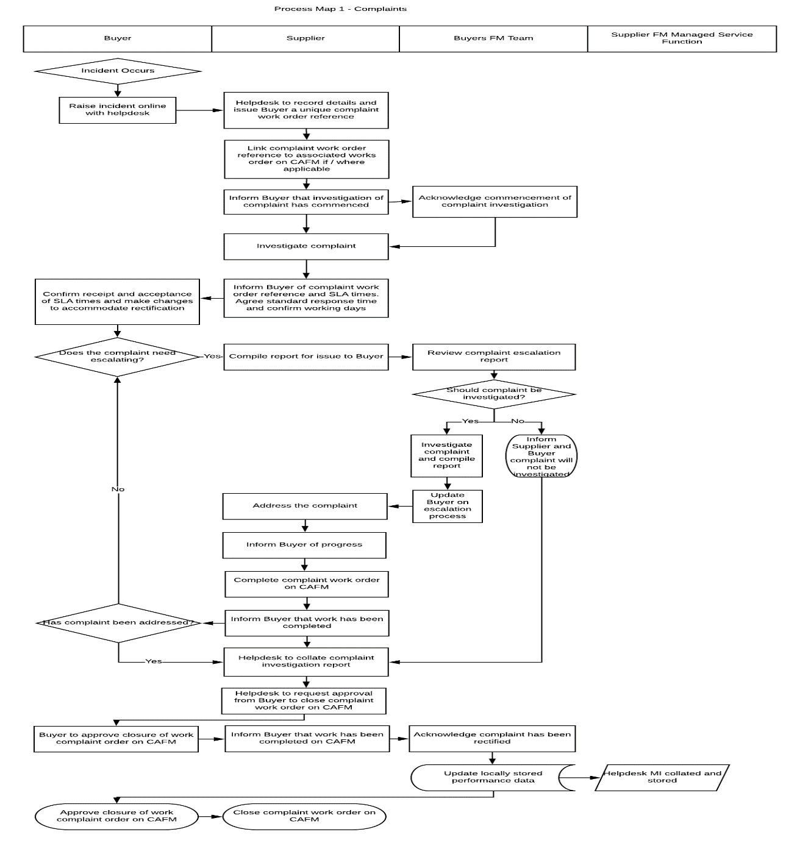
Appendix 1.2 - Indicative Process Map 2: Failure
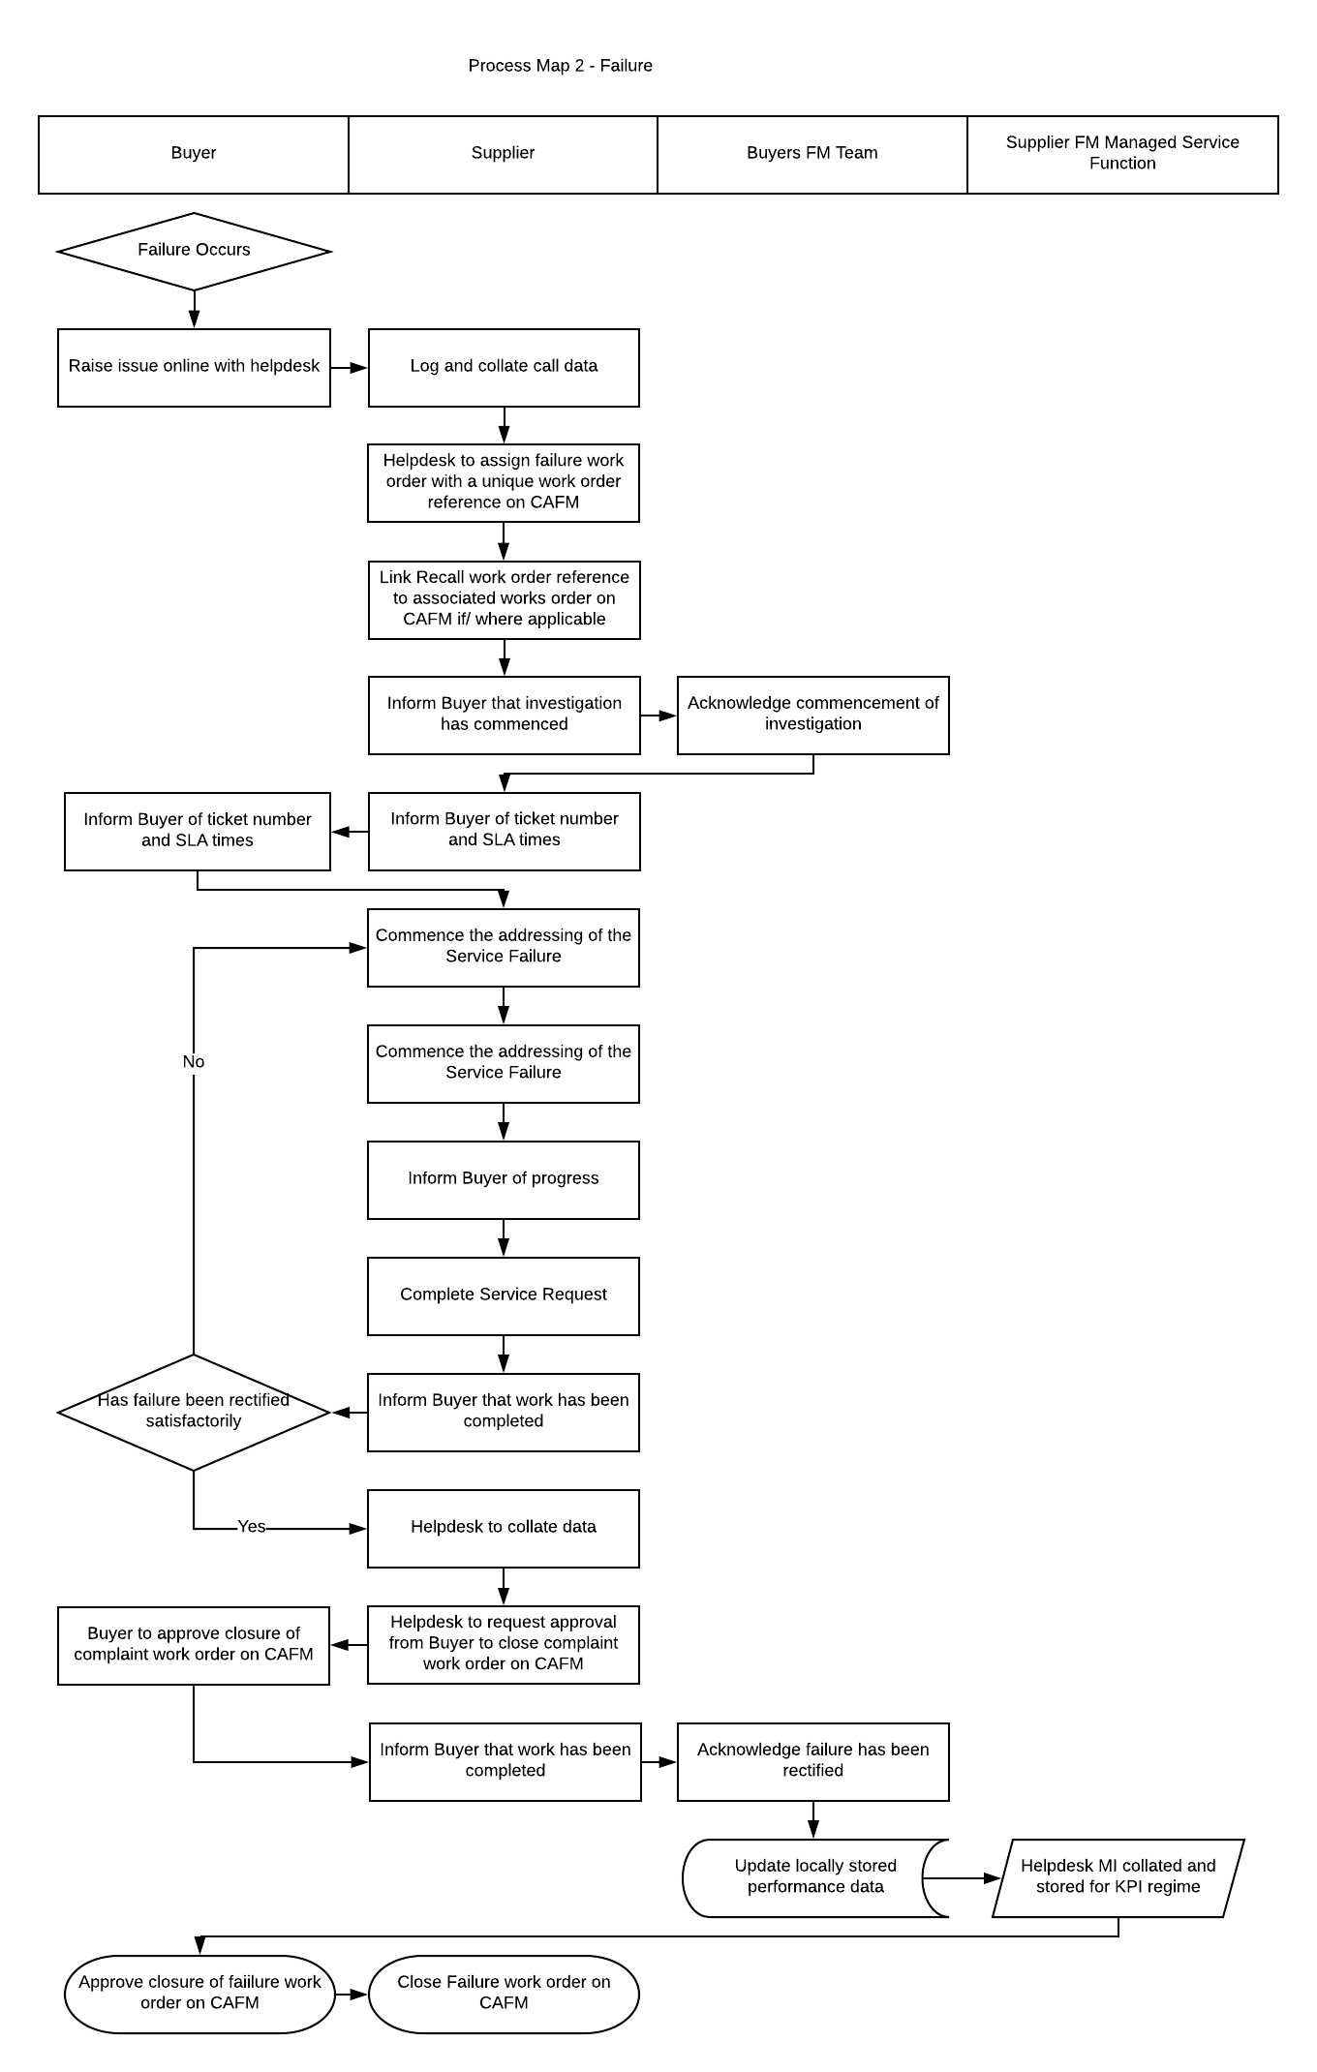

Appendix 1.3 – Indicative Process Map 3: Recall
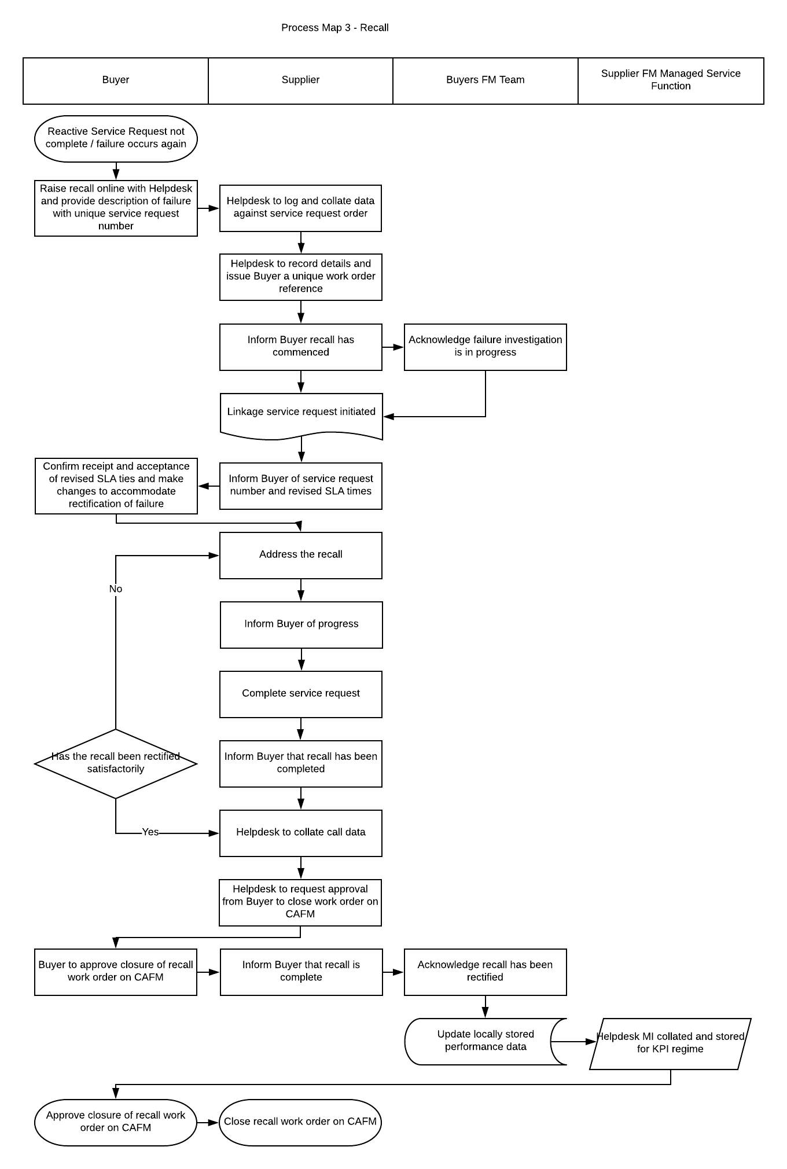

APPENDIX 2 – Billable Works and Approval Process

Appendix 2.1 – Process Map 1: Billable Works and Approval Process
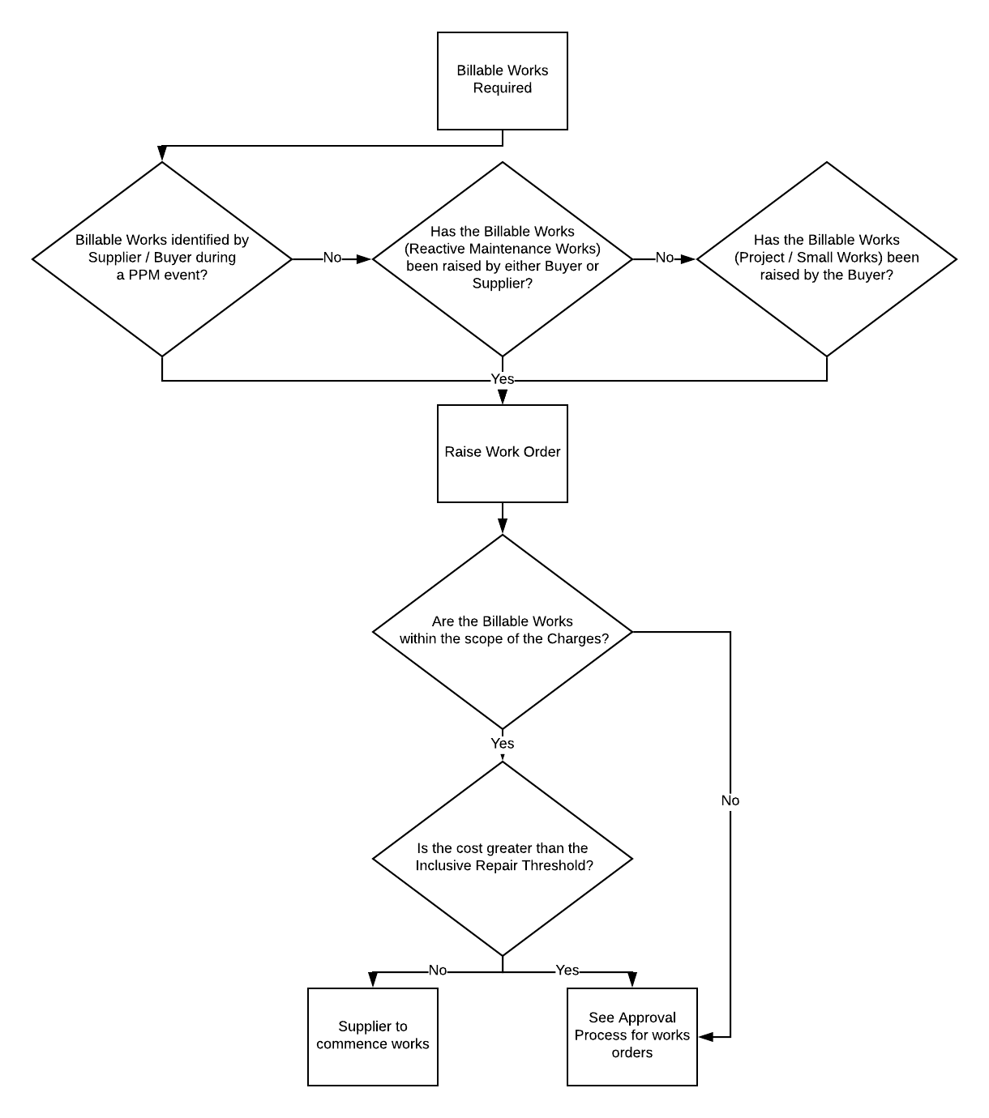

Appendix 2.2 – Process Map 2: Issuing Quotation by Supplier Process

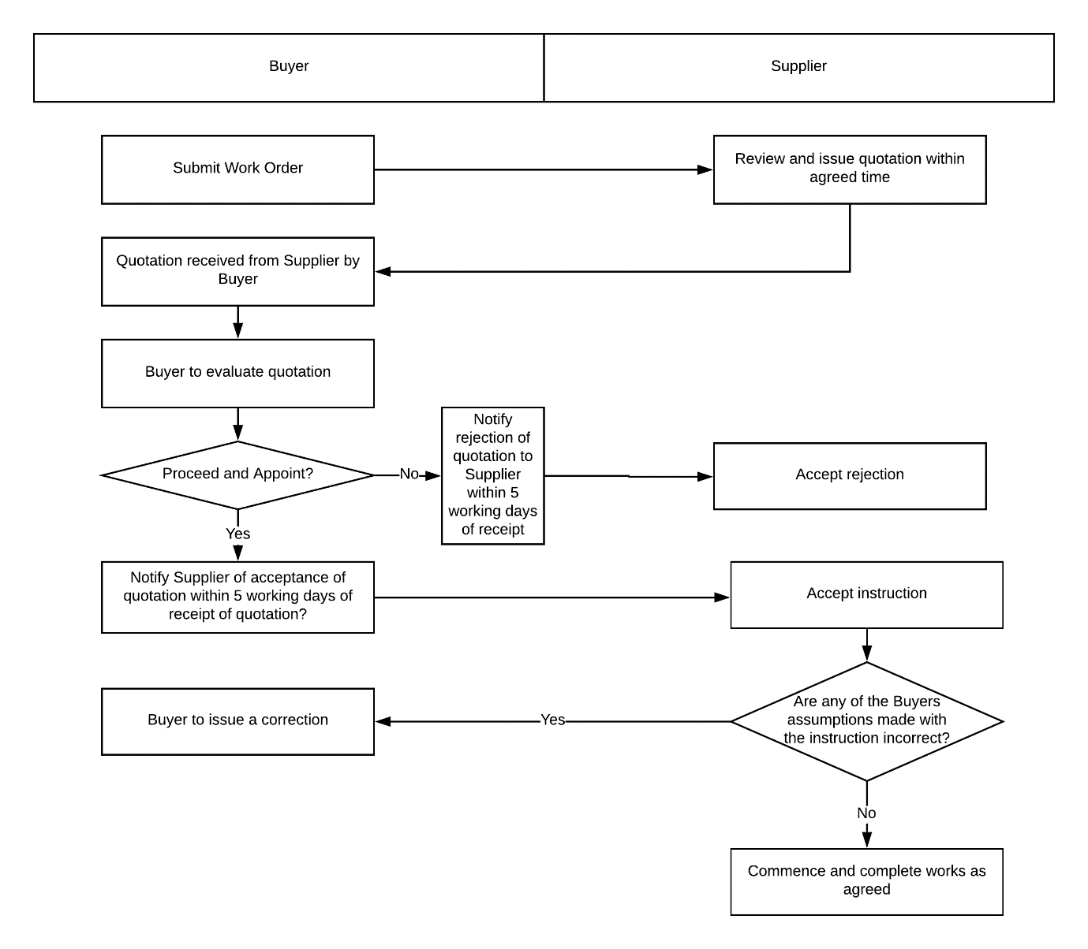

Appendix 2.3 – Process Map 3: Issuing Instruction for Quotation for Approved Work Order Process
