SWP No: 21 | Title: Inspection and entry to RCV Hopper |  | Risk Assessment:
Description: Entry to the hopper area of RCV |  | Area: Rear of RCV |  | Task: Entry to RCV Hopper

PPE:
Issued Overalls
High visibility waist coat or coat
Safety Footwear

Purpose: - to detail the safe system of work to enter the rear hopper of an RCV for the purposes of cleaning, maintenance, inspection or repairs.

No: | Description | Key Points & Diagrams
1 | Vehicle Ignition and engine  The vehicle ignition and engine needs to be turned on for this activity.
2 | Completing a Visual Check  Turn the vehicle ignition on and start engine.  Maneuver bin lifts / plates to the required position using manual switch controls  Press the EMERGENCY STOP (see photograph) to allow a visual check to be done safely. | Emergency Stop button panels are located on the left and right hand side of the bin lift & body of vehicle 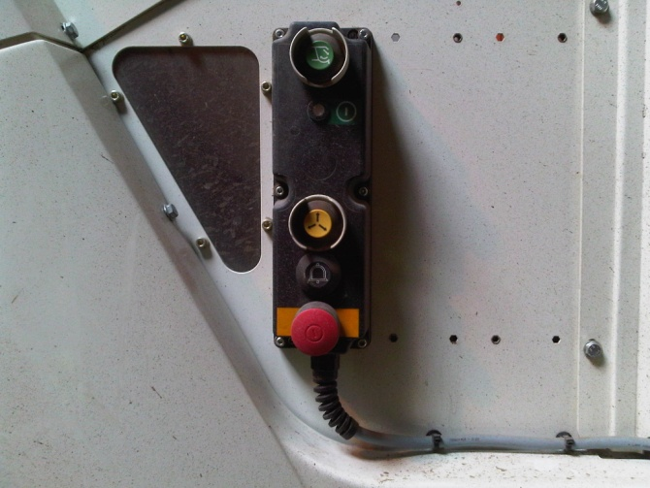  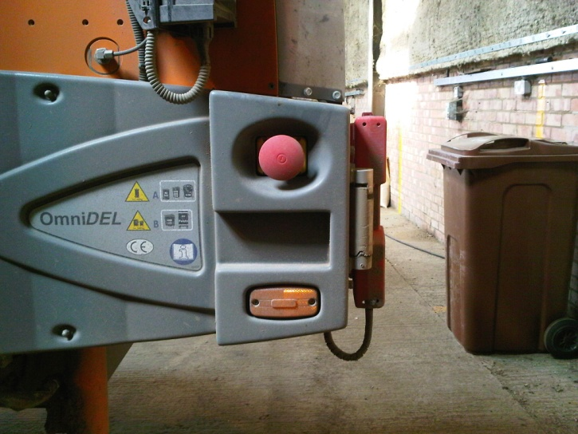The large red button needs to be pressed in (activated) to stop the hopper operation. The button needs to be turned to ‘Release’, PTO Key needs to be reset by switching on and off. to switch the hopper operation back on again.
3 | Switch off the vehicle ignition and secure keys  Before entering the rear hopper, switch off the engine and remove keys from ignition and place in overall pocket. | The second set of keys to each vehicle is kept in a locked cabinet in the vehicle workshop office.  Employees must not remove the second set of keys from the cabinet.  Communicate this requirement to all new employees.  Ignition keys are fitted with an immobilizer, therefore only correct keys will operate the vehicles.
4 | Turn off PTO using key  Turn off the PTO by rotating PTO key anticloclwise to off or ‘O’ position. | Photograph showing PTO key in Off position (RCV symbol centre of photo)  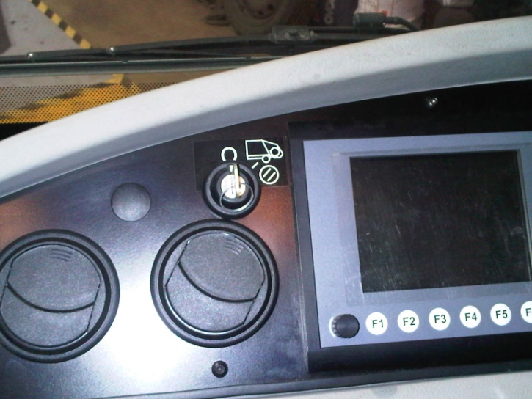
5 | Switch off Power Isolation Switch  Turn off the power isolation switch. The switch is located under the body of the vehicle on the right hand side as you face the cab. | Photograph showing the electrical power isolation switch seen in centre.  Switch ‘off’ by turning to downward position  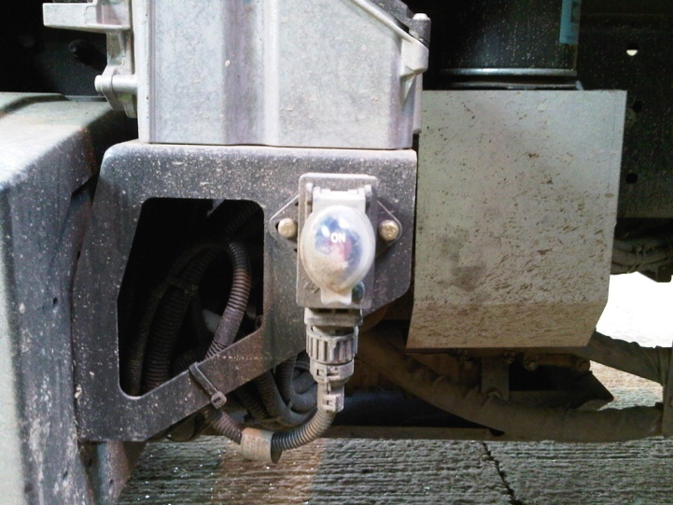
6 | Employee Safety  In the interests of safety the Vehicle Workshop employees (Mechanics) must keep their colleagues informed of their location and activities at all times.  In particualr their collegues need to be advised if they will be working in the rear of a vehicle and the planned timescale for the activity. | To prevent unauthorised access or usage the vehicle workshop must be kept locked and secured when not in use.
7 | Entry to Hopper  If entry to the hopper is necessary, this must only be carried out by a qualified mechanic.

No: | Description | Key Points & Diagrams
8 | Access to Hopper - Using Ladder  The use of a ladder is required to access the Hopper.  Prior to using any ladder it is the responsibility of the employee undertaking the task to check the ladder to confirm:  - Suitability for task i.e. adequate height  - Integrity - not damaged or faulty  - Free from contamination (mud, oil, etc)  On confirmation of acceptance the ladder must be positioned on firm and level ground.  The rungs must be placed against a solid and secure part of the vehicle.  The ladder must then be tied off to prevent movement or alternatively the ladder may be footed as a last resort.

