

**TENDER DOCUMENT**

Tender documents for the construction of a new Pump House and installation of new pumps at the Seaford Head Golf Course Greenkeepers Yard and the decommissioning and removal of the existing Pump House and pumps.

**PROJECT REFENCE NUMBER STC/SHGCPH/TJ/06/20**

This tender document has been prepared by Seaford Town Council

**09/06/20**

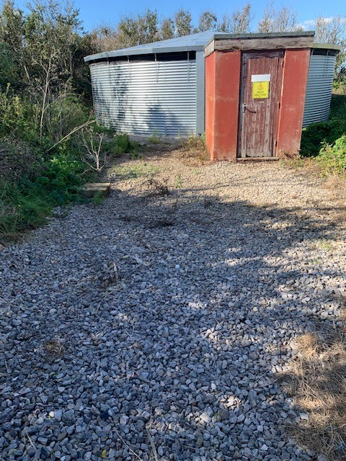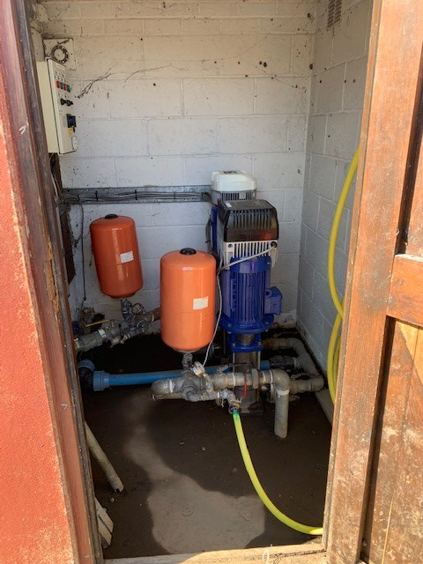

The returned tender document is to be either delivered to the following address:

Proper Officer

Seaford Town Council

37 Church Street

Seaford

East Sussex

BN25 1HG

Or

Emailed to [isabelle.mouland@seafordtowncouncil.gov.uk](mailto:isabelle.mouland@seafordtowncouncil.gov.uk)

no later than 12 noon on: Monday 13th July 2020

…………………………………………………………………………………………………………

**CONTENTS**

**Section 1** Preliminary Particulars

The general conditions and obligations that Seaford Town Council (STC), as the employer requires of the contractor when carrying out the project.

**Section 2** Quality Questions

**Section 3** The Tender Submission Checklist

**Section 4** The Description of Works for the erection of a new pump house, installation of new pumps and decommissioning of the existing pump house and pumps and removal from site.

**Section 5** The Form of Tender sum analysis and Form of Tender which shall list the breakdown of the costs of the project.

**SECTION 1 PRELIMINARY PARTICULARS**

* 1. **General**

This document sets out the requirements of Seaford Town Council to be included in the Conditions of Contract in respect of the construction of a new pump house and pumps at the Seaford Head Golf Course Greenkeepers Yard and the decommissioning and removal of the existing pump house.

* 1. **Client**

Seaford Town Council, 37 Church Street, Seaford, East Sussex, BN25 1HG.

Client’s representatives:

Simon Lambert – Head Greenkeeper

07894 514136 - [simon.lambert@seafordtowncouncil.gov.uk](mailto:simon.lambert@seafordtowncouncil.gov.uk)

Tony Jackson – Contract Administrator

07519 121454 – [tony.jackson@seafordtowncouncil.gov.uk](mailto:tony.jackson@seafordtowncouncil.gov.uk)

* 1. **Site location**

The address of the proposed works is the Greenkeepers Yard, Seaford Head Golf Course, Southdown Road, Seaford, East Sussex, BN25 4JS.

* 1. **Access to the site**

Access to the site is via the main car park servicing the Seaford Head Golf Course and The View bar and restaurant. Please note when The View is closed the main car park gate will be closed and no vehicular access will be available to the Greenkeepers Yard. At the entrance to the Greenkeepers Yard there is a double gate and a combination padlock the code for which will be issued. The Contractor is advised that the main car park is extremely busy during peak times and all precautions should be taken when traversing the car park.

* 1. **Limitations of Working Space**

The Contractor shall confine everything pertaining to the Contract within the area of the proposed works. It should be noted that the Greenkeepers Yard is exceptionally busy with vehicles, servicing the adjacent golf course, being in constant use. Whilst contractors’ vehicles can be parked on the site, no obstruction should be caused to any activities carried out on the site.

* 1. **Restrictions on working hours**

Generally, no specific restrictions will be placed upon normal working hours however weekend and bank holiday working, if required, should be approved by the Head Greenkeeper. Please note that the Greenkeeper’s hours are normally 6.00AM-3.00PM Monday to Friday, so the Contractor will be responsible for locking the yard gate and site security outside of these hours. Please also note the comment in section 1.4 above about vehicular access to the site.

The Contractor is required to state within the Tender submission the proposed working hours of this contract.

* 1. **Trespass and Nuisance**

All reasonable means shall be used to avoid inconveniencing adjoining occupiers and residents of Southdown Road. No persons employed on the works shall be allowed to trespass on adjoining properties and the Contractor shall indemnify Seaford Town Council against any claims or action for damage on account of any trespass or other misconduct of the Contractor’s employees.

* 1. **Grounds Conditions and Site Investigation**

It is the responsibility of the Contractor to satisfy themselves as to the nature of the existing ground conditions and Seaford Town Council will liaise regarding any known underground cabling and Statutory Authorities’ infrastructure at the site.

The current ground services are:

**Power**

There are two sources of mains power running to the Greenkeeper’s mess room and to the main machinery shed. These are a three-phase supply to the pump house and a three-phase supply from the pump house to the borehole pump.

**Communications cables**

There are communication cables between the mess room and the pump house.

**Mains Water**

There is a mains supply to the water tank and the mess room.

**Borehole supply**

There is a borehole supply of water to the tank with controls in the existing pump house.

**Course water supply and control cables**

There are two water supplies to the course with control cables from the pump house to each zone of the course.

**Gas**

There is no gas supply to the site.

* 1. **Site Visit**

On the award of the contract the successful Contractor will have been deemed to have undertaken their own site investigation prior to submitting their tender for the works. No claims will be expected for lack of information or inaccuracies in this respect.

To arrange a site visit, please contact Simon Lambert, Head Greenkeeper on 07894 514136 or email [simon.lambert@seafordtowncouncil.gov.uk](mailto:simon.lambert@seafordtowncouncil.gov.uk)

Site visits need to be carried out no later than Friday 3rd July 2020

* 1. **Advertisements**

All rights of advertising on site shall be reserved by Seaford Town Council and the Contractor shall take all necessary measures to ensure that no unauthorised advertising takes place.

* 1. **Publicity**

No information, either written, verbal, use of photographs or drawings concerning the contracted work shall be supplied to other persons by the Contractor without the written permission of Seaford Town Council. The use of social media or the Contractor’s website regarding the work is prohibited unless written permission is granted by Seaford Town Council.

* 1. **Method Statement and Risk Assessments**

As part of the tender submission the Contractor should provide a statement describing the proposed general and detailed arrangements and methods for carrying out the works. Risk assessments must also be provided.

The Method Statement should include details of how all stages of the works will be executed. It should detail all appropriate Health and Safety requirements and training that personnel will undergo prior to working on site.

The tender submission should also indicate areas of work that will be sub-contracted and list the details of all companies that will be employed.

* 1. **Site Meetings**

Seaford Town Council will hold various onsite progress meetings with the Contractor to include a practical handover meeting on completion of the project.

* 1. **Plant, Tools and Vehicles**

The Contractor shall provide all plant, tools and vehicles considered necessary to complete the works.

* 1. **Site Administration**

The Contractor shall allow for all necessary site administration for the proper execution of the work required. Prior to commencing work on site, the Contractor shall instruct Seaford Town Council of the name of the person in charge of the works site ensuring relevant experience to undertake the task is held. This person is not to be changed without prior agreement of Seaford Town Council.

In conjunction with the Head Greenkeeper, the Contractor shall ensure that the works and the site are properly protected and secured at all times, including any works outside of the boundary and that Seaford Town Council is indemnified against any claims for loss, damage, theft or the like.

* 1. **Site Security and protection of site**

The Contractor shall provide all temporary fencing as required and the Contractor must provide for the storing of all materials within the designated area agreed by the Head Greenkeeper. The site is to be maintained in a secure state until completion at which time all building materials and equipment are to be removed and all works made good. The site is to be left in a safe and tidy state at the end of each working day.

The Contractor must ensure that all reasonable efforts are made to close off the site during the course of the works. At no time will the public have access to the construction areas and warning signs will be supplied and maintained by the Contractor. In addition, the Contractor will provide suitable signage conveying appropriate contact details for reporting incidents, safety or security concerns.

The Contractor must take all reasonable action to ensure that all newly installed apparatus is not used until practical completion is confirmed.

Any machinery left on site overnight must be, wherever possible, immobilised.

The Contractor will be held responsible for:

1. Any damage caused to machinery/materials left on site by the Contractor.
2. Any damage caused by machinery/materials left on site by the Contractor.
3. Any vandalism caused to machinery/materials left on site by the Contractor.
   1. **Water**

A water supply for the works is available from the mains tap outside of the machinery shed.

* 1. **Power**

A power supply for the works is available from the Head Greenkeeper’s office or existing pump house.

* 1. **Safety, Health and Welfare**

The Contractor shall allow for providing and maintaining all welfare and safety measures to a standard not inferior to that laid down in statutory instruments, rules and orders and subsequent amendments thereto for all work persons employed on the site including the employees of sub-contractors.

Sanitary accommodation will be provided in the adjacent Greenkeeper’s office. Please note all muddy footwear must be removed before entering this establishment.

The Contractor must provide industrial safety helmets complying with the latest British Standards for the use of all personnel including sub-contractors. The Contractor must ensure that all authorised visitors to the site wear appropriate safety clothing in accordance with current legislation.

The Contractors attention is particularly drawn to their obligation under the Health and Safety Work Act etc., 1974.

* 1. **Control of substances hazardous to Health Regulations 1998**

Assessments carried out by the Contractor of all work which is liable to expose employees and any other person in the vicinity to hazardous solids, liquids, dust, fumes, vapours gases etc shall be made available to the Contracts Administrator and the Head Greenkeeper as soon as known.

* 1. **Maintenance of site surface**

The Contractor shall maintain all surface areas to their present condition and on completion make good any damage arising from the works and reinstate to the satisfaction of the Head Greenkeeper.

* 1. **Disposal and transportation of waste**

The Contractor must ensure that all waste materials produced during the course of the works are transported from site using waste carriers with a current Waste Carriers Licence appropriate for the type of waste being transported.

Wherever possible waste materials will be taken to appropriate waste recycling centres and where the waste cannot be recycled should be taken to the appropriate Civic Amenity Centre. The Contract Administrator may require evidence of which tipping site is being used.

* 1. **Control of Noise pollution**

The attention of the Contractor is drawn to the provision of Section 60 of the Control of Pollution Act 1974 with references to the control of noise in relation to any construction woks and must comply therewith. The Contractor is recommended to take advice from the Chief Environmental Officer in relation to proposed method and noise level resultant.

* 1. **Planning Consent and Building Regulations Approval**

Seaford Town Council can confirm no planning permission is required for the project.

If required, the Contractor shall obtain building control approval for the works from the Local Planning Authority before any works commence on site.

* 1. **Inclement Weather**

The Contractor will allow for protecting the works against inclement weather and shall include for taking all reasonable precautions to ensure regular progress of works during adverse weather conditions.

* 1. **Insurance**

Theappointed Contractor shall hold Public Liability Insurance to the value of ten million pounds. If any part of the works is subcontracted to another contractor, that contractor will also be required to hold Public Liability Insurance to the value of ten million pounds. Certificates of insurance from all contractors will be submitted to the Council prior to any building commencement.

**1.27 General**

Seaford Town Council is not bound to accept any tender in its entirety and shall accept whole or part of the summitted tender as required.

Contractors tendering do so at their own cost and their tender shall remain open for acceptance for a period of twelve weeks after the due date for submission.

The Contractor should note that after the submission of their tender, they may be required to complete an interview on site or a telephone interview to explain the tender proposal including the methods of construction, the construction programme and the proposed management of the project.

All materials will be of the best of their respective kinds and shall conform to appropriate British and or European Standards if appropriate.

**1.28 Confidentiality**

Each of the Parties undertakes to the other not to use the Confidential Information of the other party except for the purposes of the Agreement and shall not, without prior written consent of the other party, disclose the same to any person save to the extent necessary for the performance of this Agreement and except to the extent that such information of the Parties undertakes to the other to keep confidential all information (written or oral) concerning the business and affairs of the other that it has obtained or received as a result of the discussions leading up to, or entering into, or performance of, this Agreement (“the Confidential Information”)

1. is required to be disclosed by the law of any relevant jurisdiction
2. Is trivial or obvious
3. Is already in the public domain
4. Is party in the disclosing party’s possession otherwise than as a result of a breach of this clause
5. Was disclosed after the express prior written approval of the party to whom such information belongs; or
6. Is required to be disclosed by the Council for the purpose of Best Value or performance assessment and in any event subject to the disclosing party having notified the other party to this Agreement in writing prior to making such disclosure.

The Contractor shall assist the Council at no additional charge in meeting any reasonable requests for information in relation to the Freedom of Information Act 2000 or any statutory modification or re-enactment thereof or any related guidelines or codes of practise. The Contractor acknowledges that in responding to requests for information the Council shall be entitled to forward details of the information received to the persons making the request. Notwithstanding anything contained elsewhere in the Agreement, the provisions of.

**1.29 Environmental Awareness**

The contractor will adhere to the Council’s Single Use Plastic Policy (available to view here: <https://www.seafordtowncouncil.gov.uk/wp-content/uploads/2019/08/M6-Single-Use-Plastics-Policy.docx> ) and demonstrate the use of carbon neutral methodology in their work.

**SECTION 2 – QUALITY QUESTIONS**

Please answer the following questions. Feel free to add addition information (photos, recommendations etc) to back up answers

**Question 1**- Please give details of similar projects you have successfully delivered. If possible, with references.

**Question 2**- What would be the estimated timeline to complete this project?

**Question 3**-The existing pump may need to stay in operation while the new one is installed; please detail if this is possible and how you will achieve this. Also, the timeframe for change over if possible.

**Question 4**-Please confirm your experience and understanding of the requirements for the different pressures required to supply the site with its large elevation changes ensuring constant pressures at each green and tee.

**Question 5-** Please confirm your experience and understanding of the Council’s Bailroy, Gemini Irrigation Management System (GTI).

**SECTION 3 - TENDER SUBMISSION CHECKLIST**

The Contractor is to provide the following within their Contractors Proposals:

|  |  |
| --- | --- |
| **Checklist for information to be included** | **√** |
| Detailed specifications for all aspects of work |  |
| General Method Statement and Risk Assessments for the overall execution of the works |  |
| Completed Tender Sum Analysis Page |  |
| Programme of Works |  |
| The Tender/Contract Sum Analysis listing the breakdown of costs of the project |  |
| Details of all Site Supervisor(s) |  |
| Details of all Sub-Contractors that will be employed (if applicable) |  |
| Details of working hours |  |
| Drawings/Photos of proposed Pump House |  |
| Pump House/ Pump Station Manual supplied |  |
| Details of all warranties |  |
| Contractor Public Liability Insurance Certificate(s) |  |
| Sub-Contractor Public Liability Insurance Certificate(s) |  |
| Quality Questions |  |
| Details of post-install support options, including costs where necessary |  |
| Assignment of Subcontracting |  |

**SECTION 4 DESCRIPTION OF WORKS**

The decommissioning and removal of the existing pump house and the pump station within.

Replace the existing pumps with a two-pump station to deliver to all areas of the course with pressure reducing valves as required. The replacement pump house is to be of GRP construction and of a suitable size to house and work around the new pump station.

The removal and reinstatement of all borehole controls and communications between the pump station and the irrigation controls.

The pumps are currently three phase. One running at 12 bar and one running at 7.5 bar. They serve different areas of the course both above and below the location of the pump house.

The new pumps will need to be controlled automatically with existing computer controls via radio, computer and manually when required for hand watering.

Some new pipework may be required between the water tank and new pump house.

It is paramount that the Contractor demonstrates an understanding of the current pressure control system servicing the two zones operating on the golf course.

The Contractor to advise on the internal pump house electrical work required and the manifold system with a mainline Cla-Val pressure reduction.

Whilst Seaford Town Council can list its requirements it is considered that the successful Contractor is an expert in this field and the Council will be guided by the advice received as part of this tender submission.

**4.1 General**

It is paramount that the Contractor must demonstrate an understanding of Seaford Head Golf Course’s current irrigation system.

**4.2 Materials for use in building a new Pump House**

A prefabricated construction (GRP) will be considered, however it must be frost proof.

**4.3 Site Clearance**

All materials from the demolition of the existing pump house, that cannot be reused on site, must be removed and disposed of responsibly by the Contractor.

It is not known at this time whether there is asbestos in the current pump house, but it is felt unlikely that there is.

**4.4 Drawings and Manuals**

The Contractor shall provide detailed drawings and photos of the proposed construction.

Manuals for the pump house should also be provided.

The Contractor must list the drawings proposed as part of this tender submission.

**SECTION 5 FORM OF TENDER**

To: Seaford Town Council, 37 Church Street, Seaford, East Sussex, BN25 1HG.

For: The construction of a new pump house at the Seaford Head Golf Course Greenkeeper’s Yard and the decommissioning and removal of the existing pump house.

From: ...................................................................................................................(Contractor)

To the Proper Officer

I\We having read the Conditions of Contract and Employers Requirements delivered to me\us, do hereby offer to execute and complete in accordance with the Conditions of Contract the whole of the Works described within .....….........................................( insert number ) weeks from the date of possession for the sum of :

(In full) ...................................................................................................................................................

...................................................................................................................................................

(£…......…..........................................................................................................) VAT exclusive

I\We confirm that if our tender is accepted, we will require a period of .......................... weeks to obtain all necessary approvals prior to works commencing on site.

I\We further agree that this tender remains open for consideration for twelve (12) weeks from the last day of submission of tenders.

I\We note that you do not undertake to accept the lowest or any tender and that the Contractors tendering do so free of charge.

I\We declare this tender to be a bona fide tender intended to be competitive and that I\We have not fixed or adjusted the amount of the tender by or under or in accordance with any agreement or arrangements with any other person.

I\We confirm that we have visited the site before submitting this tender.

Dated this ..............................................day of ……………………….................................2020

For and on behalf of ..................................................................................................................

Signed .......................................................................................................................................

Registered Address ...................................................................................................................................................

……………………………………………………………………………………………………………

……………………………………………………………………………………………………………

……………………………………………………………………………………………………………

**FORM OF TENDER**

**Assignment of Subcontracting**

The Contractor is to state in the following schedule the names of all the Subcontractors which will be employed on the Works and their stated trades.

|  |  |
| --- | --- |
| **Description of Trade or Service** | **Name and Address of Subcontractor** |
|  |  |
|  |  |
|  |  |
|  |  |
|  |  |
|  |  |
|  |  |
|  |  |
|  |  |
|  |  |

**Value Added Tax**

The Contractor is to set out below a provisional indication of the amount of Value Added Tax the Employer will be called upon to pay under the VAT Agreement.

..............................................................................................................(£…………………........)