- INTRODUCTION

  - This document provides an overview of the methodology which will be adopted by the Authority and its Agent to evaluate Potential Provider responses to each question set out within the e-Sourcing event. It also sets out the marking scheme which will apply.

  - The following information has been provided in relation to each question (where applicable);

    - Weighting – highlights the relative importance of the question

    - Guidance – sets out information for the Potential Providers to consider

    - Marking Scheme – details the marks available to evaluators during evaluation

  - The defined terms used in the ITT document shall apply to this document.

- OVERVIEW

  - The e-Sourcing event is broken down into the following Questionnaires:
Questionnaire Reference | Questionnaire Title
1 | KEY PARTICIPATION REQUIREMENTS
2 | CONFLICTS OF INTEREST
3 | INFORMATION ONLY
4 | QUALITY - METHODOLOGY
5 | QUALITY - PROJECT SPECIFIC EXPERIENCE
6 | QUALITY - PROJECT MANAGEMENT AND STAFFING
7 | PRICE

  - Quality Evaluation Process

    - The evaluation of each response to the Quality/Service Delivery Questionnaire(s) will be conducted and consensus checked in accordance with the Consensus Marking Procedure set out in paragraph 2.3 below.

    - Each response to questions within the Quality/Service Delivery Questionnaire(s) will be marked in accordance with the table below:

Mark | Comment
0 | Failed to provide confidence that the proposal will meet the requirements. An unacceptable response with serious reservations.
25 | A Poor response with reservations. The response lacks convincing detail with risk that the proposal will not be successful in meeting all the requirements.
50 | Meets the requirements – the response generally meets the requirements, but lacks sufficient detail to warrant a higher mark.
75 | A Good response that meets the requirements with good supporting evidence. Demonstrates good understanding.
100 | An Excellent comprehensive response that meets the requirements. Indicates an excellent response with detailed supporting evidence and no weaknesses resulting in a high level of confidence.

    - Each mark achieved will be multiplied by the corresponding weighting to provide an overall question score.

    - When the score for each question has been determined they will be added together to provide an overall score for the Quality Evaluation (“Quality Score”).

  - Consensus Marking Procedure

    - Tenders that are scored and require evaluation will be evaluated in accordance with the procedure described in this paragraph.

    - The Consensus Marking Procedure is a two-step process, comprising of:

      - Independent evaluation; and
      - Group consensus marking.

    - During the independent evaluation process, each evaluator will separately (i.e. without conferring with other evaluators) scrutinise the quality of answers given by Potential Providers in their Tender. Each evaluator will then allocate a mark for the answer in accordance with the Marking Scheme applicable to that question.

    - The Agent will review the marks allocated by the individual evaluators before facilitating a group consensus marking meeting.

    - During the meeting, the evaluators will discuss the independent marks until they reach a consensus regarding the marks that should be attributed to each Potential Providers’ answer to the questions.
    - Once all quality responses have been evaluated in accordance with Section 8 of the Invitation to Tender the individual scores attributed to each response will be added together to provide a ‘Quality Score’.

  - Price Evaluation Process

    - Prices submitted by Potential Providers’ in the Price Schedule will be recorded and evaluated in accordance with the following process.

    - Potential Providers’ are required to provide a completed pricing schedule against the ‘Price’ Questionnaire within the e-Sourcing event.

    - Prices offered will be evaluated against the range of prices submitted by all Potential Providers for that item.

    - The Potential Provider with the lowest price for the requirement shall be awarded the Maximum Score Available. The remaining Potential Providers shall be awarded a percentage of the Maximum Score Available equal to their price, relative to the lowest price submitted.

    - The calculation used is the following:

    - = Lowest Price Tendered x Maximum Score Available
Tender price

Potential Provider | Price Submitted | Score Calculation | Maximum Score Available | Score Awarded
Potential Provider A | £1,000 | £1,000/£1,000 *100 | 100 | 100
Potential Provider B | £2,000 | £1,000/£2,000 *100 | 100 | 50
Potential Provider C | £2,500 | £1,000/£2,500 *100 | 100 | 40

  - Final score

    - The Quality Score will be added to the Price Score to determine the final score for each Potential Provider (“Final Score”).
- EVALUATION CRITERIA

  - A summary of all the questions contained within the e-Sourcing event, along with; the minimum acceptable score, maximum score available and weighting (where applicable) are set out below:

  - Questionnaires 1 and 2 contain ‘Pass/Fail’ questions and act as a doorway for progression to the following stages of the evaluation. Potential Providers are strongly advised to read and understand the specific guidance provided before responding to these questionnaires.

  - Questionnaire 3 is for information only. Although this questionnaire does not form part of the evaluation process, Potential Providers are advised to complete it in full as any omissions could affect the award process.

  - The Authority and its Agent reserve the right to challenge any information provided in response to Questionnaire 3 and request further information in support of any statements made therein.

QUESTIONNAIRE 1 – KEY PARTICIPATION REQUIREMENTS
GUIDANCE | The following questions are ‘Pass/Fail’ questions. If Potential Providers are unwilling or unable to answer “Yes”, their submission will be deemed non-compliant and shall be rejected.Potential Providers should confirm their answer by selecting the appropriate option from the drop down menu.
Question Number | Question | Max Score | Weighting (%)
1.1 | Have you read, understood and agree with Appendix A, Terms of Participation? By answering “Yes”, you are confirming your ‘Declaration of Compliance’ at Annex 1 of Appendix A, Terms of Participation. | Pass/Fail | N/A
1.2 | Have you read, understood and accepted the Invitation to Tender and all associated appendices, specifically Appendix B, Statement of Requirement? | Pass/Fail | N/A
1.3 | Do you agree, without caveats or limitations, that in the event that you are successful the Crown Commercial Service’s Terms and Conditions within Appendix C, Draft Contract Document will govern the provision of this contract? | Pass/Fail | N/A
1.4 | Do you confirm your Organisation’s e-Sourcing suite profile is complete and accurate at the time of Tendering and that any amendments made following acceptance of this event will be notified to the buyer in writing. | Pass/Fail | N/A
QUESTIONNAIRE 2 – CONFLICTS OF INTEREST
GUIDANCE | Question 2.1 is a ‘Yes/No’ question and will dictate whether or not question 2.2 needs to be answered.  Question 2.2 is a Pass / Fail question. Potential Providers are required to provide details of how the identified conflict will be mitigated. The Contracting Authority will review the mitigation in line with the perceived conflict of interest, to determine what level of risk this poses to them. Therefore if Potential Providers cannot or are unwilling to suitably demonstrate that they have suitable safeguards to mitigate any risk then their Tender will be deemed non-compliant and will be rejected.
Question Number | Question | Max Score | Weighting (%)
2.1 | Please confirm whether you have any potential, actual or perceived conflicts of interest that may by relevant to this requirement. | None | N/A
2.2 | We require that any potential, actual or perceived conflicts of interest in respect of this ITT are identified in writing and that companies outline what safeguards would be put in place to mitigate the risk of actual or perceived conflicts arising during the delivery of these services. | Pass/Fail | N/A

QUESTIONNAIRE 3 – INFORMATION ONLY
GUIDANCE | The following questions are for information only and do not form part of the evaluation. Information provided in response to these questions may be used in preparation of any Contract Award and any ommissions may delay completion of this Tender exercise.
Question Number | Question | Max Score | Weighting (%)
3.1 | Please provide the name, office address, telephone number and email address for your organisations Tender point of contract. | None | N/A
3.2 | Please confirm whether your organisation is an SME as defined within EU recommendation 2003/361 | None | N/A
3.3 | Please provide details of any sub-contractors you propose to use in order to meet your obligations should you be awarded a Contract. Your response must include their;  - Trading Name(s)  - Registered Address(es) and contact details  - Goods/Services to be provided | None | N/A
3.4 | If you are the Lead contact for a Group of Economic Operators, please provide details of all the members of the Group. Your response must include their;  - Trading Names(s)  - Registered address(es)  - Dunns Number(s)  - Role/responsibility within the Group | None | N/A

  - The following Quality/Service Delivery Questionnaires are designed to test Potential Providers’ ability to deliver the requirement as set out in Appendix B, Statement of Requirements. Potential Providers MUST answer all Quality/Service Delivery questions.

  - Potential Providers must achieve the minimum acceptable Quality Score, as described, for each of the questions below. Only those responses which achieve the minimum acceptable Quality Score will be included in the Price Evaluation Process.

  - Where only one (1) submission is received which does not meet the minimum acceptable Quality Score, the Authority reserves the right to enter into dialogue and seek assurances regarding the delivery of the requirement.

  - Potential Providers must provide attachments against each question as specified in the below point. Question text fields must be populated with detailed references to relevant attachments or sections within their attachments.

  - Suppliers should set out their response in the following format;

    - Attachment 1 - Questions 1 and 3 in PDF format.
    - Attachment 2 - Questions 2,4,5 and 6 in PDF format
    - Attachment 3 - Question 7 (Appendix E- Price Table) in an Excel file.
  - Attachment file name should be as follows; CCCC17A10 – Attachment X – QX-X – Supplier Name.

  - Potential Providers’ responses must clearly demonstrate how they propose to meet the requirements set out in the question and address each element in the order they are asked.

  - Potential Providers’ responses should be limited to, and focused on each of the component parts of the question posed. They should refrain from making generalised statements and providing information not relevant to the topic.

  - Whilst there will be no marks given to layout, spelling, punctuation and grammar, it will assist evaluators if attention is paid to these areas including identifying key sections within responses.

  - Potential providers will be marked in accordance with the marking scheme at Section 2.

  - The page limit on attachments is set at five text pages (front & back), excluding exhibits. Profile CVs should be no more than a page each . Attachments must be submitted in PDF format for all Quality questions and in Excel format for the Price question as demonstrated in Appendix E and be in Arial font size 11.

QUESTIONNAIRE 4 – QUALITY – METHODOLOGY |  |  | Weighting – 20 %
All Potential Providers MUST answer ALL the following questions
Question Number | Question | Minimum Acceptable Score | Maximum Available Score | Weighting
4.1 | How would you determine the optimum structure for the draft network code?  Please provide an example structure. | 50 | 100 | 30%
4.2 | What technical resources, expertise, guidance etc. would you draw on when drafting the network code? | 50 | 100 | 40%
4.3 | How would you ensure that, insofar as possible, the draft network code reflects good practice from other industries, particularly those where similar decision-making mechanisms have been established? | 50 | 100 | 30%

QUESTIONNAIRE 5 – QUALITY – PROJECT SPECIFIC EXPERIENCE |  |  | Weighting – 30 %
All Potential Providers MUST answer ALL the following questions
Question Number | Question | Minimum Acceptable Score | Maximum Available Score | Weighting  X%
5.1 | What experience do you have of drafting network codes or decision-making mechanisms of a similar nature? | 50 | 100 | 50%
5.2 | What experience do you have of working working with the Police? | 50 | 100 | 10%
5.3 | What experience do you have of working with bodies such as HMIC, the Home Office or other Government departments? | 50 | 100 | 10%
5.4 | What experience do you have of working with the IT industry including suppliers and trade bodies? | 50 | 100 | 20%
5.5 | Please provide CVs (of the lead partner and proposed project team who would be allocated to work on the contract throughout its duration). | 50 | 100 | 10%

QUESTIONNAIRE 6 – QUALITY – Project management and staffing |  |  | Weighting – 10 %
All Potential Providers MUST answer ALL the following questions
Question Number | Question | Minimum Acceptable Score | Maximum Available Score | Weighting X%
6.1 | Please identify the risks you can foresee and what actions you will take to mitigate these risks with regards to this requirement. | 50 | 100 | 30%
6.2 | How will you ensure the rapid progress that will be necessary in the limited time? | 50 | 100 | 40%
6.3 | How will you ensure that the quality of the draft will be sufficient for HMIC to share with the police service and other interested parties? | 50 | 100 | 30%

QUESTIONNAIRE 7 – PRICE |  | Weighting – 40 %
GUIDANCE | Potential Providers must enter costs by uploading the price schedule (Appendix E) at the question level.  Prices should be submitted in pounds Sterling inclusive of any expenses but exclusive of VAT.  Potential Providers will be marked in accordance with the marking scheme at Section 2.  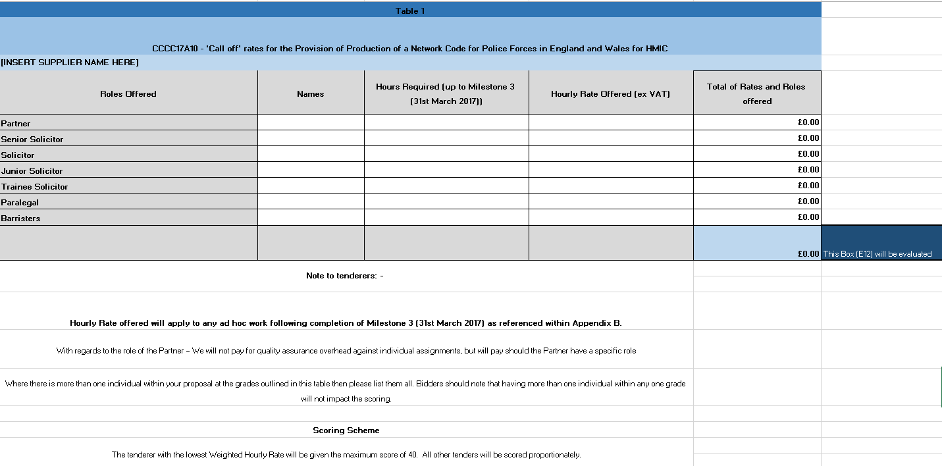
Question Number | Question | Max Score
7.1 | Please confirm, by selecting ‘YES’ that you have attached a completed Price Schedule (Appendix E) to the response to this question, at question level specifically. In so doing, you are also confirming that prices offered are inclusive of any expenses, exclusive of VAT and firm for a period of 90 days following the Deadline for Submission. | 100

