ITEM | ACTION | Comments or photo
Pod swing | Retain
Hex Tower | Retain
Springer | Retain
Wall games | Remove | 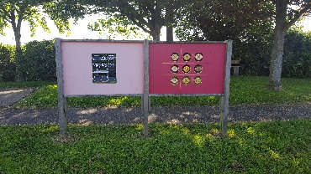
Balance spring | Remove | 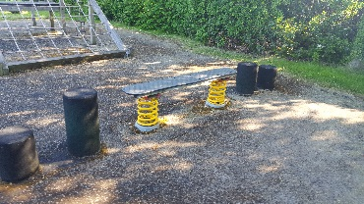
Climbing frame | Remove | 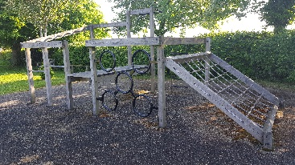
Swing | Remove | 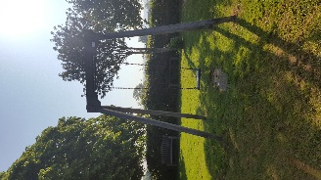
Bench, concrete base and bin in corner under trees | Remove | 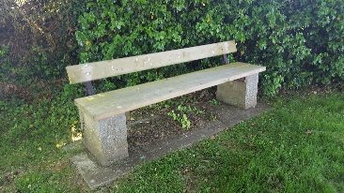
 |  | 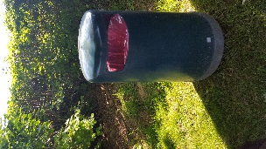
Appendix 2: List of items to be retained, removed or reuse.
Cam Green

Woodfields
ITEMS | ACTION | COMMENTS/PHOTOS
Proludic equipment | Retain
Pod swing | Retain
Rotating circle | Retain
Wooden balance trial on both sides of pod swing | Remove | 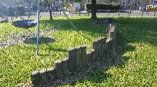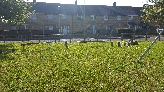
Slide on hump | Retain but re design steps | 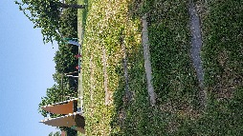
Elephant springer | Remove | 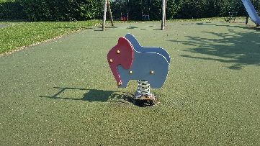
Double springer | Remove | 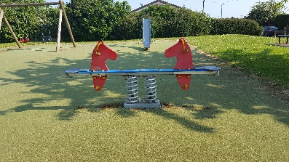
Toddler swing | Remove | 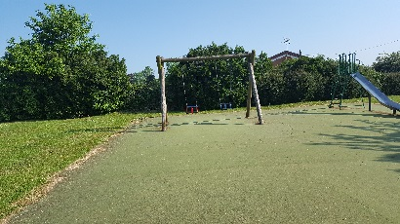
Slide | Remove, possibly re use on a mould elsewhere?? | 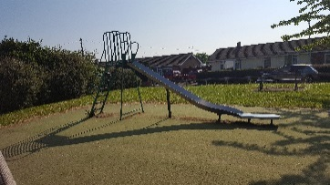
Basketball tarmac area | Retain and make into MUGA with softer surface
Carpet MUGA | Remove but maybe retain end MUGA??
Bin by carpet MUGA | Remove | 