SCHEDULE 2 – THE SERVICES

- Indicative Activity Plan

Widnes UTC indicative activity plan for Halton patients

HRG4Code2 | 2015-16 | 2016-17 | 2017-18 | 2018-19 | 2019-20 | 2020-21 | 2021-22 | 2022-23 | 2023-24
VB01 to VB06 | 521 | 668 | 548 | 542 | 536 | 530 | 524 | 519 | 513
VB07 to VB09 | 19104 | 21689 | 20232 | 20985 | 23139 | 24454 | 25760 | 27060 | 28352
VB11Z | 15436 | 14314 | 16193 | 15853 | 32754 | 32066 | 31393 | 30734 | 30088
ALL | 35061 | 36671 | 36973 | 37380 | 56429 | 57050 | 57678 | 58312 | 58953

 | 2015/16 | 2016/17 | 2017/18 | 2018/19 | 2019/20 | 2020/21 | 2021/22 | 2022/23 | 2023/24
Knowsley | 536 | 606 | 803 | 973 | 987 | 1001 | 1016 | 1031 | 1046
St Helens | 595 | 652 | 769 | 977 | 992 | 1007 | 1022 | 1037 | 1052
Warrington | 2531 | 3579 | 5155 | 6056 | 6147 | 6239 | 6333 | 6428 | 6524
West Cheshire | 255 | 230 | 237 | 181 | 184 | 186 | 189 | 192 | 195
Liverpool | 829 | 957 | 994 | 1158 | 1175 | 1193 | 1210 | 1229 | 1247
Others | 536 | 545 | 586 | 678 | 688 | 698 | 709 | 720 | 730
Grand Total | 5282 | 6569 | 8544 | 10023 | 10173 | 10324 | 10479 | 10637 | 10794
Out of Area Patients indicative Activity for Widnes UTC

SCHEDULE 2 – THE SERVICES

- Activity Planning Assumptions

Total case load for Widnes Urgent Treatment Centre is modelled to increase by 50% in the first year for Halton patients to ensure there is a reduction in inappropriate A&E attendances and conveyances as set out in NHS England Urgent Treatment Centre Principles, July 2017. However this includes a significant number of potential self-care patients which is expected that this activity will be reduced.

NHS Halton CCG and One Halton Strategy is to provide care closer to home and ensure patients are treated in the community. The UTC has a pivotal role in providing this place based care to the population. The activity planning assumptions are based on data evidence from the Health Resource Group (HRG) codes.

Below are the technical HRG descriptions:
VB01Z | Emergency Medicine, Any Investigation with Category 5 Treatment
VB02Z | Emergency Medicine, Category 3 Investigation with Category 4 Treatment
VB03Z | Emergency Medicine, Category 3 Investigation with Category 1-3 Treatment
VB04Z | Emergency Medicine, Category 2 Investigation with Category 4 Treatment
VB05Z | Emergency Medicine, Category 2 Investigation with Category 3 Treatment
VB06Z | Emergency Medicine, Category 1 Investigation with Category 3-4 Treatment
VB07Z | Emergency Medicine, Category 2 Investigation with Category 2 Treatment
VB08Z | Emergency Medicine, Category 2 Investigation with Category 1 Treatment
VB09Z | Emergency Medicine, Category 1 Investigation with Category 1-2 Treatment
VB10Z | Emergency Medicine, Dental Care
VB11Z | Emergency Medicine, No Investigation with No Significant Treatment

The codes are broken down as below:
- VB 1-6 – reduce through effective identification of activity to route to type 1 AED
- VB 7,8-9 – is the target growth area for the UTC, there is a requirement for more of same day medium acuity cases through:
  - NWAS
  - GP (in hours)
  - GP extended access
  - GP Out of Hours
  - Effective ambulatory care sensitive condition management
- VB11 - reduce through effective self care advice, management of patients through other appropriate services and use of online triage facility which links patients with other borough based services.

SCHEDULE 3 – PAYMENT

- Local Prices

Enter text below which, for each separately priced Service:
- identifies the Service;
- describes any agreement to depart from an applicable national currency (in respect of which the appropriate summary template (available at: https://www.gov.uk/guidance/nhs-providers-and-commissioners-submit-locally-determined-prices-to-monitor) should be copied or attached)
- describes any currencies (including national currencies) to be used to measure activity
- describes the basis on which payment is to be made (that is, whether dependent on activity, quality or outcomes (and if so how), a block payment, or made on any other basis)
- sets out prices for the first Contract Year
- sets out prices and/or any agreed regime for adjustment of prices for the second and any subsequent Contract Year(s).

The contract value has been set by using PBR type 3 tariff plus Market Forces Factor (MFF) which gives a current unit price of £66.15. The cost envelope baseline is £2,092,368 to a maximum of £2,510,841 based on an Outcome Contract.
The below table shows the yearly values based on achievement of outcomes.

 | 2018/19 | 2019/20 | 2020/21 | 2021/22 | 2022/23 | 2023/24
Baseline | £2.092.368 | £2.092.368 | £2.092.368 | £2.092.368 | £2.092.368 | £2.092.368
Max outcome based | £2.092.368 | £2.301.604 | £2.406.223 | £2.510.841 | £2.510.841 | £2.510.841
The graph below shows the payments available in each year.
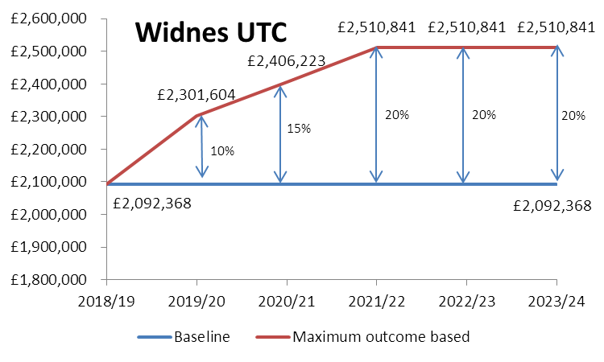

The payment will be made on outcomes and indicative KPIs are as follows:
- Reduction in type 1 A&E attendances for Halton patients
- Reduction in VB11Z codes to promote self-care
- Increase in VB 7,8 and 9 codes to ensure patients are treated appropriately
- Number of patients who required same day GP access who are seen in the Urgent Treatment Centre
- Increase in number of appointments that were pre-booked rather than walk-in
- The number of attendances where the patient had considered A&E but decided on UTC
- Number of patient booked in by NHS111, GP practices, NWAS
- A reduction in the number of possible onward referrals to A&E

There will be an opportunity for additional income based on PBR type 3 tariff from activity as described in schedule 2a Indicative Activity.

