

Wickersley Community Centre,
286 Bawtry Road, Wickersley, Rotherham.
S66 1JJ
Clerk: Carol J Lavell
01709 703270
clerk@wickersleypc.org.uk www.wickersleyparishcouncil.gov.uk

Location

Wickersley Park, off Warren Road Wickersley. S66 2HG

Paths are to be constructed to the pavement design of CD 239 as drafted by Highways England 2020 for pedestrian and cycle only (attached for information)

Image of park layout and path highlighted in BLUE attached

Image of existing pathway attached

Specification

The footpaths width 1.2m to a length of 420m²

New foot paths TARMAC finish
All work to be carried out at the above address
To install new paths for wheelchairs to use approximately 420m²

STAGE 1
∙ excavate the entire area remove and dispose of all
waste
∙ install an industrial grade membrane to the entire area
∙ install a new subbase to the entire area using a 20 mm
quarried stone this is to be levelled compacted and
Consolidated

STAGE 2
∙ install a AC6 asphalt wearing course to the entire area
this is to be laid at a depth of no less than 50mm levelled
compact and consolidated
∙ newly laid asphalt is to be rolled for a flawless finish

STAGE 3
∙ entire area is to be cleaned when finished

Project Duration

The deadline for submission of tenders is noon on Friday 30th June 2023. The Clerk will then conduct a preliminary check that all information has been submitted correctly, then presented to the Evaluation Panel consisting of Chair of Committees and the Clerks. The project has already been approved in budget to be carried out in 2023-2024.

Please provide details of availability for commence of project and duration of works should you be successful in this process.

Information

Site visits are welcomed to survey the existing surfaces to assess if suitable to form part of the base structure for reasons of economy and performance. In addition to assessing and providing guidance on the suitability of edging and any savings that may be achieved for retaining spoil. The specification is to assume the line and direction of the existing path unless required to realign to take into account hollows or camber to negate water pooling and allow for water run-off.

Please can you ensure you also supply the following;

Public Liability Insurance Policy
Health & Safety Policy
Sample Risk Assessment
Reference from a similar project completed in last 3 years

Attachments

Pavement Design CD 239 as Drafted by Highways England 2020

Pavement loading 3.10 The loading for the footway or cycleway shall be categorised as follows:
1) pedestrian/cycle-only;
2) light-vehicle; or
3) heavy-vehicle.

Pedestrian/cycle-only

3.11 The pedestrian/cycle-only category shall be used where the footway/cycleway is physically separated from the carriageway.

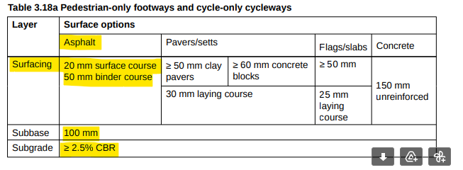

4.2 Asphalt surfacing shall be used for cycleways.

4.2.1 Where the combined design thickness of asphalt surface course and base/binder course ≤70 mm, and
to meet the minimum layer thickness vs nominal size requirements of BS 594987 [Ref 3.N], a single
layer of 20 mm dense binder course may be used.

4.3 Coarse aggregate in asphalt surface course, and in binder course where it is used as the running
surface, shall be of polished stone value category PSV50 in accordance with BS EN 13043 [Ref 1.N]

