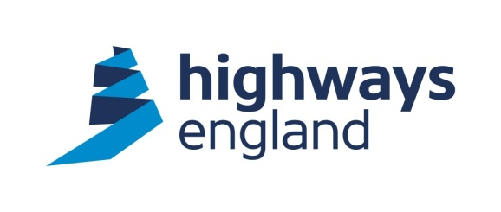  Our ref: ITT 5916  Your ref:  Benchmark Estimating  Via Bravo | Lateral  8 City Walk  Leeds  LS11 9AT  Tel: 0300 470 5628  27 January 2021
Dear Sir/Madam,

Cost Planning Service Provider Framework

Package 135:
Technology Procurement & Logistics Third Line Maintenance Contracts

I am directed by Highways England Company Limited to inform you that your Offer dated 15 December 2020 for carrying out the above named contract, is accepted in respect of your proposals for completion in accordance with the Terms and Conditions of the Contract.

The documents below, together with this letter, form a binding contract between yourselves and Highways England.

- The Cost Planning Service Provider Framework, Form of Agreement (and associated documents) dated 16 April 2019
- The Work Package Scope for P134: Update of Mathematical and Statistical Distributions Modelling of Estimates dated 26 November 2020
- Your Tender for Package Order P134: Various Schemes dated 15 December 2020

The accepted price for the package order is £53,757.88 (excluding VAT).

Please note, a Purchase Order number, under Highways England’s financial system (Oracle PFP) will be created shortly and provided to you by the Project Manager. You must quote a valid Purchase Order on each and every application for payment.

You acknowledge that any documents and information submitted by you as part of your Tender or for validation purposes, represent your proposals for meeting Highways England’s requirements, but do not in any way override or modify those requirements. You will remain liable to comply with all the obligations set out in the documents forming part of the Contract. You will not be relieved from compliance with these obligations by any:

(a) Validation, due diligence or sustainability check carried out by Highways England on any part of your Tender;
(b) Evidence, assumptions or other information provided by you with your
Tender or for the purposes set out in paragraph (a) above; or
(c) Clarification requested by Highways England and provided by you (whether orally or in writing) as part of the assessment process.

Please complete and return the acknowledgement slip below.

Yours sincerely

X
Procurement Delivery Partner

Cost Planning Service Provider Framework
Package 134: Update of Mathematical and Statistical Distributions Modelling of Estimates

We acknowledge Highways England’s acceptance of our tender for the above contract in their letter dated 11 January 2020.

Signed
Name
Position
Organisation
Date

