Clarifications:

**Q.1 – Please could you provide the addresses/locations of the buildings?**

The buildings are:

Civic 1 and Civic 2 – both at Civic Centre Victoria Avenue, Southend on Sea SS2 6ER

Civic 2 is adjacent to the car park to the

The Tickfield Centre, Tickfield Avenue, Southend on Sea SS2 6LL <http://www.southend.gov.uk/info/200453/southend_venues/742/southend_venues/2>

Civic 1 in red, Civic 2 in blue and Tickfield in green on the map extract below.

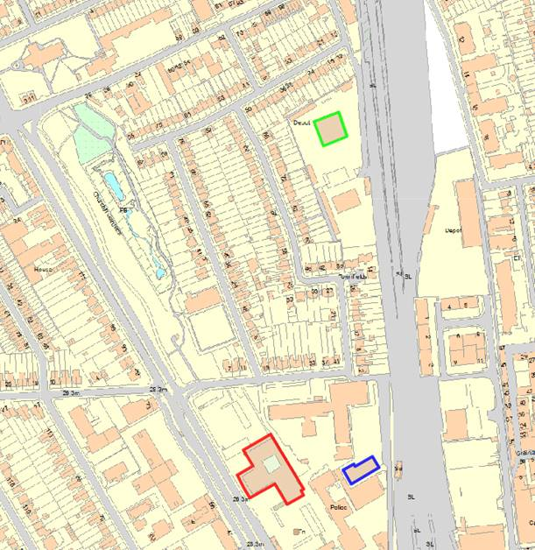

**Q.2 I was just wondering if the Council have already put aside the budget for this.**

We haven’t but it’s being driven by new CEx and director of finance who will make the budget available once a supplier and their cost is known following tender.

Q.3 It would be helpful to know the type of chairs currently used.

Current office chairs are Orangebox ARA EBA

Photographs below show part of a typical floor, meeting room and break-out area.

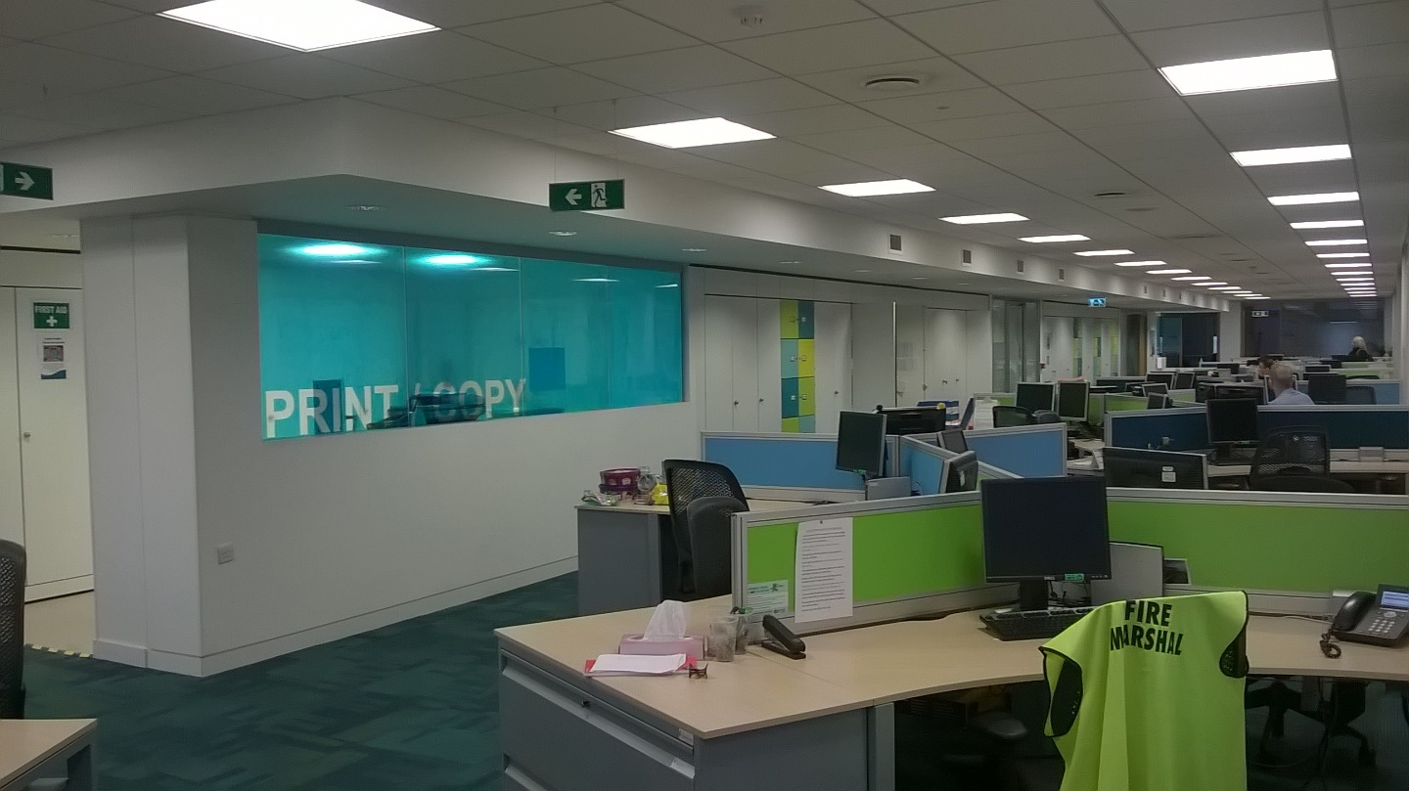

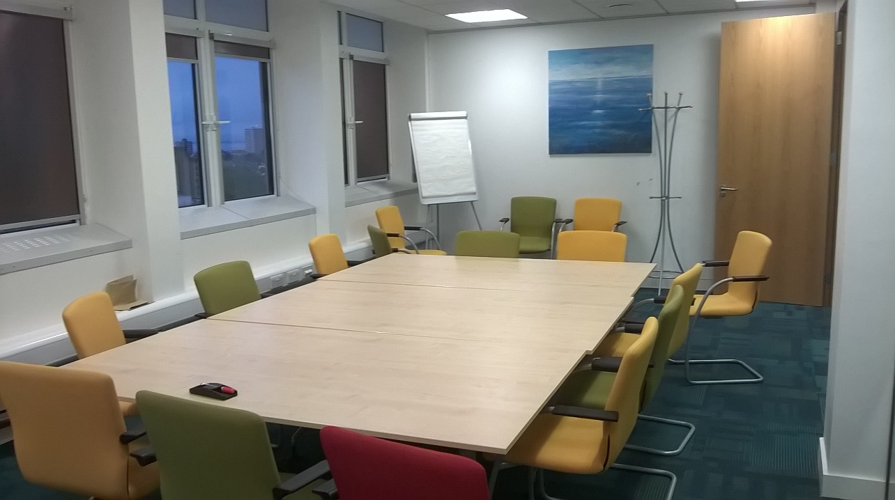

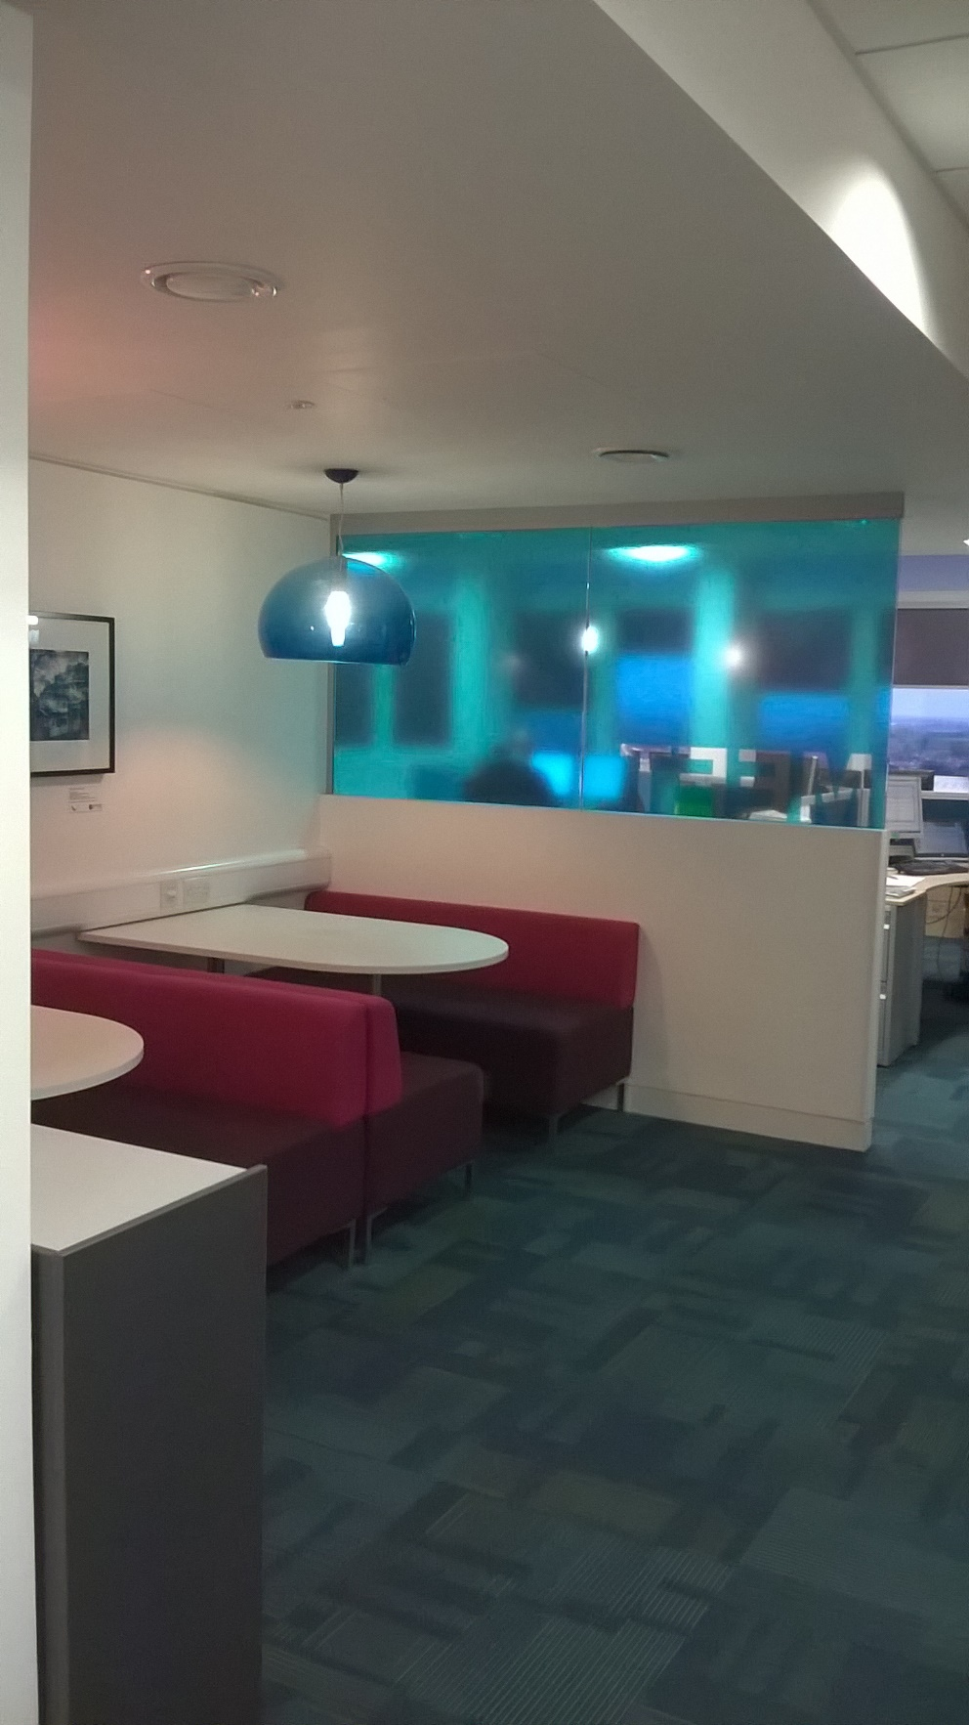

**Q.4 Do you have CAD data available for us to use for the IPMS element of the project?**

Yes, CAD plans are available and will be provided to the successful firm on appointment.

**Q.4: Could I clarify the exact scope of the part of the brief below:**

**Part 1 - To measure the buildings in accordance with IPMS and update the provided floorplans to show the current occupancy by team.**

**Are the internal layouts still broadly correct?**

**Is this a case of updating the existing CAD plans with the current desk layout and mapping the current team occupancy, or are you looking to produce new plans ‘from scratch’ for all three buildings?**

The pdf floorplans are broadly correct – some teams have moved/grown/contracted.

CAD plans and a standard desk layout in CAD will be made available to the winning bidder and it will just be a case of reporting measurements in accordance with IPMS guidance (although likely that NIA will also be required for benchmarking) and updating those with team occupancy/locations.

We will require the updated plans back when reporting in CAD and .pdf formats.

**Q.5 Regarding the Requirement for Building Measurement: Could you tell us the reasoning for undertaking an on-site building measurement survey at this stage – do you believe the plans you have to be particularly inaccurate?**

We have not updated measurements to IPMS yet so this seems to be a good opportunity to start!  We will make CAD drawings available to the successful party so much of the measurement can be done from them directly.  The plans are reasonably accurate.  My feeling is that areas will need to be recorded in NIA also to enable meaningful benchmarking.

**Q6. Utilisation Study: You still ask for a ‘full’ survey but ask for a minimum of two checks per day. Does 2 checks per day meet your definition of a ‘full’ survey?**

I am open to other methodologies however I feel this is a minimum requirement to capture data during both the morning and afternoon core hours.

**Q.7 For Part 2 – even an indicative cost is difficult because of not knowing yet what opportunities could be uncovered. Would day rates suffice at this stage?**

Details of an approach and costs built up from day rates would be ok as this stage is only indicative at this stage.