**Schedule 6 (Information Reporting) Guidance Notes**

Each Month, the Contractor is to complete the Monthly Reporting Spreadsheet (Schedule 6).

Completion of all relevant worksheets will generate the overall RAG status and invoicing position of the contract.

All tabs coloured purple (indicated below) need to be completed. This guidance document will give an overview of each worksheet, and provide more detail on how to complete them.



Please note that the images contained in this document are for reference purposes only – cells coloured white that contain text are example cells only.

**Monthly RAG**

Two cells need to be completed on this sheet. Select the ‘RAG MONTH’ using the dropdown function. Next, type in the RAG score for that month as a percentage figure i.e. 95%.

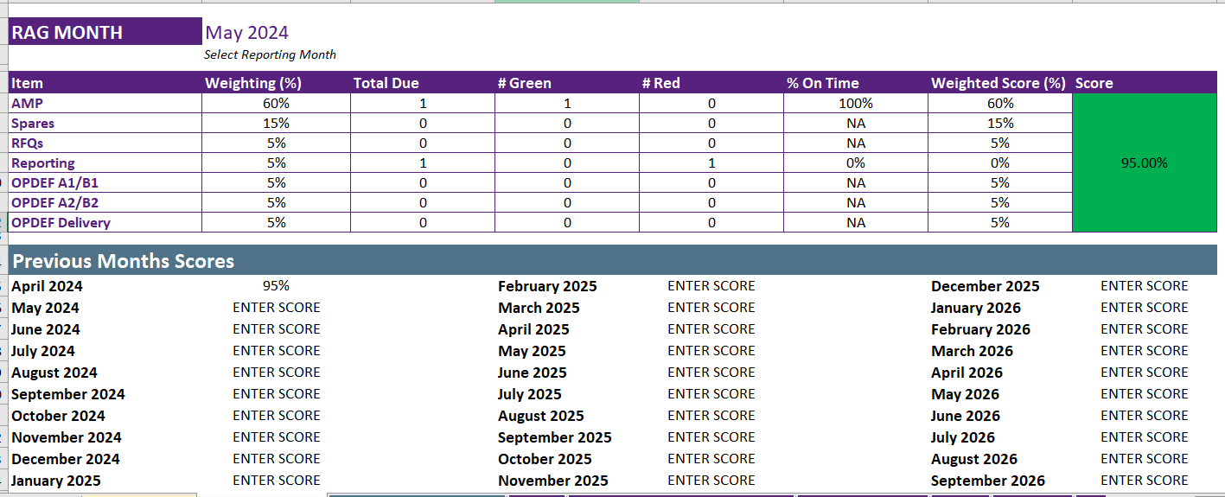

**Monthly RAG Chart (No input required)**

This sheet is automatically populated once all information has been entered, and will show the RAG status of the last 3 reporting months.

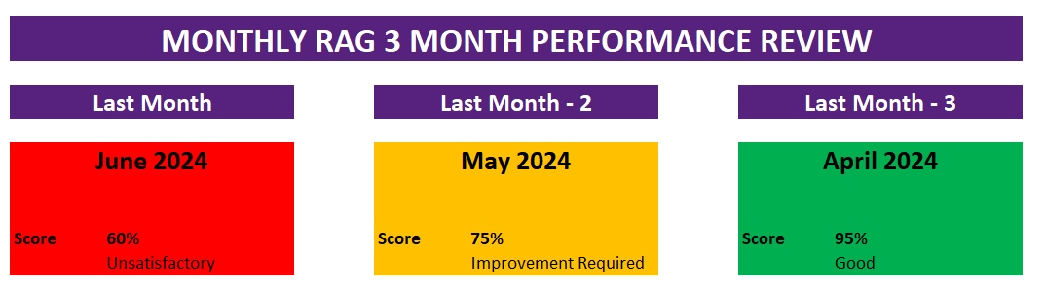

**AMP**

The Annual Maintenance Package (AMP) sheet collects details of all AMPs conducted. Cells in pale gold are automatically populated for you.





Enter your details in the next available row(s) using one row for each AMP.

* Column B: Manually enter Contractor Ref No
* Column C: Manually enter WRF Ref No
* Column D: Select Boat Class using dropdown list
* Column E: Manually enter MOD Boat Number
* Column F: Select the Status of the AMP from the dropdown list
* Column G: Enter the Start Date using 00/00/0000 format
* Early Delivery Date (the date at which an incentive payment becomes due) is populated for you
* KPI Delivery Date (the date after which Service Credits become due) is populated for you
* Column J: If Authorised Permissible Delay Days have been granted, enter the number of days here
* Column K is provided for you to manually enter when you expect the AMP to be completed
* Column L is provided for you to inform us the progress level of the AMP as a percentage
* Column M: Manually enter the Actual Delivery Date using 00/00/0000 format
* The AMP KPI Status will automatically populate
* Based on data entered, the AMP Monthly Task Report Status will be shown per row – this will feed into the overall RAG score
* Column S: Enter the Task Firm Price
* Column T: Enter the Task LOL
* Column U will be populated with the sum of the Task Firm Price and Task LOL
* Column V: Enter the Initial Invoice Charge
* Column W: Add any comments as necessary

**AMP Defect Rectification**

The AMP Defect Rectification sheet should be used if a Defect Rectification From has been issued within 3 months of the date the AMP was completed. This sheet is linked to the AMP worksheet. Cells in pale gold are automatically populated for you, unless stated otherwise.



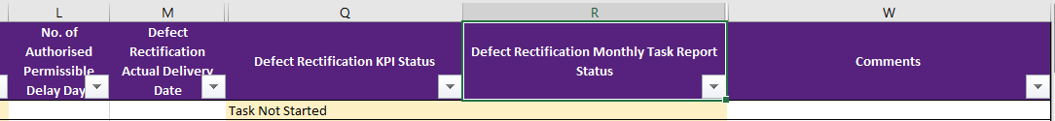

* Column A: Use the dropdown function to select the relevant AMP – this list is populated from the AMPs that were entered in the AMP worksheet
* Columns B and C will auto populate with the details entered in the AMP worksheet
* Column D: enter details from the Defect Rectification Form
* Column E: enter details from the Defect Rectification Form, or elsewhere as applicable
* Columns F and G will auto populate with the details entered in the AMP worksheet
* Column H: use the dropdown list to select the status of the work
* Column I: Enter the Defect Rectification Form Submission Date
* Column J will auto populate with the Defect Rectification Start Date which will be the date entered in column I plus one day
* Column K will auto populate. This date will be calculated by adding the time already spent on the AMP together with any days remaining of the total 44 day allowance for AMP and Defect Rectifications, plus any Authorised Permissible Delay Days.
* Column L: please enter number of days authorised for Permissible Days
* Column M: Enter the Defect Rectification Actual Delivery Date
* Columns Q and R will auto populate
* Column W may be used to capture any comments as applicable.

**Spares Orders**

To complete the Spares Orders worksheet, you will need to enter the WRF Ref No (column C) and have details of the part’s contractually agreed delivery time on hand to enter this information in columns I and J. Cells in pale gold are automatically populated for you. Please enter details in all other cells.

**RFQs**

To complete the RFQs worksheet, you will need to enter the WRF Ref No (column C). In this worksheet, column H (RFQ KPI Delivery Date) is populated for you based on 30 calendar days following issue of the RFQ. Cells in pale gold are automatically populated for you. Please enter details in all other cells.

**OPDEFs**

The OPDEFs worksheet should be used to capture all A1/A2/B1/B2 OPDEFs. This sheet captures both response times and rectification times. Cells in pale gold are automatically populated for you, unless stated otherwise. Begin input in the next available row – Column A is populated for you.





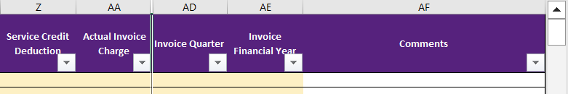

* Column B: enter details
* Column C: enter WRF Ref no.
* Column D: select the boat class from the dropdown list
* Column E: enter MOD boat number
* Column F: enter OPDEF description
* Column G: select the OPDEF level from the dropdown list
* Column H: select the Status from the dropdown list
* Column I: enter the start date
* Column J will auto populate based on the contractual delivery times for each OPDEF type
* Column K: enter the actual response date achieved
* Column M: enter the agreed OPDEF Rectification KPI Delivery date
* Column N: enter the expected delivery date
* Column O: enter the percentage of work completed
* Column P: enter the actual rectification date achieved
* Columns R to U: these columns will be automatically populated based on the data entered
* Column X: enter the Task LOL
* Column Y: enter the actual amount to be invoiced
* Columns Z to AE will be auto populated
* Column AF: is provided for you to add comments, if applicable

**Reporting**

The Reporting worksheet has been populated with all reports due over the two-year contract. Cells in pale gold are automatically populated for you. Please enter all blank cells as each report becomes due.

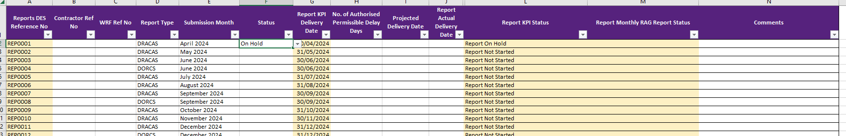

**General Tasking**

The General Tasking worksheet has been created for you to input all other work that does not form part of KPI reporting. Cells in pale gold have been populated for you. Use of this worksheet will allow for all invoicing to be included in the Invoicing worksheet.

**AMP Report (no input required)**

The AMP Report worksheet is for Authority use only. This worksheet creates a summary across the contract of all AMPs completed.

**Invoicing**

The Invoicing worksheet has been created to indicate the value of each quarterly invoice, pulling together all information entered across all worksheets in the workbook. Cell B3 contains a dropdown list that can be used to select each financial quarter. Please note that Incentive Payments will only be paid in Q4, but cell G3 contains an indicative figure of YTD Incentive Payments accrued within the current financial year.

