

**INVITATION TO PARTICIPATE**

**IN DIALOGUE (ITPD) FOR:**

**A STUDENT ACCOMODATION CONTRACTUAL JOINT VENTURE**

**TO YORK ST JOHN UNIVERSITY**

**DATE OF ISSUE: 07/07/23**

Table of Contents

1 Instructions to Bidders 4

1.1 Introduction 4

1.2 Project Vision and Purpose 4

1.3 Confidentiality 5

1.4 General 5

1.5 Timetable 6

1.6 Principal Contact 6

1.7 Terms and Conditions 6

1.8 Bidding Process 7

2 Competitive Dialogue 8

2.1 Initial Solutions (First Submission) 8

2.2 Revised Solutions (Final Submission) 9

2.3 Decision Making Methodology 10

2.4 Finalising Terms 10

3 Scope of Requirement 11

3.1 Contextual Background 11

3.2 Risk and Environmental 11

3.3 Policies 11

4 ITPD Response 13

5 Declaration 17

6 ITPD Checklist 18

7 Schedule A – Specification Document 1 “Property Register” 19

8 Schedule B - Specification Document 2 “Title Plan” 24

9 Schedule C – “Draft Joint Venture Contract” 26

10 Schedule D – “YSJ Financial Report 2021/22” 27

11 Schedule E – “York Council Planning Application” 28

# Instructions to Bidders

## 

## Introduction

York St John University (also referred to as “YSJ” or the “University”) is an academic institution that has been educating students at the heart of historic York and more recently in London, for over 175 years. Originally a teacher training college, by the mid 1970’s it had started diversifying into a growing range of subjects. Full university status was achieved in 2006, with research degree awarding powers for PhDs granted in 2015. Today, York St John University offers a wide range of Undergraduate (UG) and Postgraduate (PG) courses across five academic schools.

These factors, along with the size of the student cohort (currently circa 10,000) and the history of partnership working with local groups, have established the University’s reputation for a strong sense of community and the personal approach it takes to its students. Around a third of its students come from the lowest socio-economic groups and this reflects a commitment to social justice that has always been part of YSJ’s ethos.

It is an exciting time for the institution; in 2022 we unveiled our new campus in the heart of London (E14) which will specialise in Business and Design-led courses primarily to International PG students. We also completed a multi-million-pound investment in a new creative centre on our York campus. We have seen significant investment over the last few years, with the opening of a new student sports park as well as diversification of our academic portfolio to include exciting new courses, such as in Allied Health and Biomedical Science. The 2021/22 Annual Report and Financial Statements are attached (Schedule D).

In response to a new wave of financial challenges across the sector, and acknowledging a higher level of risk within the institution including the level of expenditure within our capital investment plan, this paper presents a recommendation for changing our approach to funding the Peppermill Court student accommodation scheme.

Supported by external advice and an initial round of soft market testing, a series of options were presented and assessed. The preferred approach to funding Peppermill Court is a Contractual Joint Venture, which we consider provides the best balance between cost and benefit whilst remaining affordable and banking covenant compliant.

## Project Vision and Purpose

The provision of good quality, affordable student accommodation is a critical component of the student experience. Guaranteeing first year student accommodation helps the University to meet its student recruitment targets and is vital to YSJ being an attractive destination.

The land and buildings at Peppermill Court were acquired in April 2020 for £3.055m and subsequently let to the NHS. Following a series of iterations, in November 2022, the Board of Governors gave final approval for a scheme to develop 210 student rooms on the site at a cost of £20.6m, funded by the University using financial reserves and loaned funding. It was estimated that this would achieve an internal rate of return (IRR) of 5.13%.

Design for the scheme has been completed, planning permission granted, and a preferred contractor identified. Under our current plans, a final cost should be agreed with the contract signed in late Summer 2023, and construction scheduled to begin in the autumn. The programme sees an 18-month build phase concluded in April 2025, for occupation in September 2025. Meeting this deadline is of paramount importance.

This document sets out our approach to funding Peppermill Court, a 210-bed residential scheme located on a site owned by York St John University (YSJ) adjacent to the Grange student housing village (“the Project”). It provides some background to Peppermill Court, details of how the University’s financial position has changed during 2022/23, and the implications for the Project, options for funding the scheme, and our proposed next steps.

## Confidentiality

This document is the property of York St. John University All rights reserved. This document may contain confidential information, which is not to be copied or discussed beyond those required to deliver the requirement and bid, without express authority.

All submissions will be treated as confidential by the University. However, in accordance with the obligations and duties placed upon public authorities by the Freedom of Information Act 2000 (FOIA), any of the information submitted to may be disclosed in response to a request made pursuant to the FOIA. If you consider that any parts of your submission are exempt from disclosure, please include a statement to this effect – noting the relative Exclusion clauses – along with your submission. The final decision as to what information to disclose under an FOIA enquiry rests with the University.

Where applicable, any additional pages and supporting documentation provided in your response must clearly state the name of the organisation, the tender reference/contract details and the question to which it relates.

## General

The Bidder should note that receipt of this Invitation to Participate In Dialogue (ITPD) in no circumstances implies that a contract or commitment exists between YSJ and the Bidder. Any such contract or commitment will be made in writing and duly signed by an authorised signatory of each organisation.

YSJ reserves the right to accept all or part of a response nor will YSJ be obliged to consider any late response. The Bidder should be prepared to discuss any aspect of its ITPD response and may be invited to present these in person to an evaluation panel. YSJ is not bound to accept the lowest price or any other response. The Bidder should note that this ITPD process may not result in the awarding of any business. YSJ will not accept responsibility for any costs incurred by the Bidder in relation to the preparation of the response.

This ITPD has been designed to assess the suitability of Suppliers to deliver the University’s contract requirement(s).

Whilst reserving the right to request information at any time throughout the procurement process, the University may enable the Supplier to self-certify certain requirements (e.g., Quality Accreditations; Environmental policies). The University will only obtain such evidence after the final tender evaluation decision.

## Timetable

The indicative ITPD deadlines are shown in the timetable in Table 1.

1. ITPD Timetable

|  |  |
| --- | --- |
| **Action** | **Date** |
| Publish SQ | 07/07/2023 |
| Final SQ Response Date | 06/08/2023 |
| Review SQ Responses | w/c 07/08/2023 |
| Issue ITPD (1st Round) to shortlisted bidders | 14/08/2023 |
| ITPD Response Date | 01/09/2023 |
| Review ITPD Responses | w/c 04/09/23 |
| Issue revised ITPD (2nd Round) | 08/09/2023 |
| ITPD Response Date | 15/09/23 |
| Review ITPD Responses | w/c 18/09/23 |
| Issue ITPD (3rd Round) - this is an optional round of dialogue, which may not be exercised if the University believes no further discussion is required to progress in this procurement. If this is the case, then the next step taken will be to publish the preferred bidder) | 22/09/23 |
| ITPD Response Date | 29/09/2023 |
| Review ITPD Responses | w/c 02/10/23 |
| Preferred Bidder Published | 06/10/23 |
| Contract Award | 16/10/2023 |

## Principal Contact

The principal contact method of communication for this tender is the York St John Procurement mailbox using the email address [procurement@yorksj.ac.uk](mailto:procurement@yorksj.ac.uk). All enquiries or clarifications required regarding any aspect of this ITPD should be confirmed in writing using the Message Centre and addressed to Paul Revell, Head of Commercial Strategy.

Your final submission is to be uploaded directly via Delta Procurement; the free text field should be used to clearly state it is your final submission.

## Terms and Conditions

**The Bidder is required to accept the Terms and Conditions in the bid process**.

All ITPD documents should be read and understood before confirming your intention to bid.

If Bidders have queries regarding the ITPD, they are to be submitted in writing to the Principal Contact as shown in section 1.6. No alterations or qualifications to any of the ITPD documents shall be made unless YSJ has notified them in writing. The Bidder response is to be submitted by completing the ITPD Response to the principal contact in 1.6 by the date shown in Table 1. The Bidders submission will be reviewed by a cross functional evaluation panel who will assist in all decisions relating to this ITPD.

## Bidding Process

This ITPD document is being made available on the condition that the information contained within it is used solely in connection with the competitive tender process to procure the requirement defined by this document on behalf of the University. Whilst reasonable care has been taken in preparing the ITPD, neither the University nor any of its advisers accepts any liability or responsibility for the adequacy or completeness of any information or opinions stated in this ITPD. No representation or warranty, express or implied, is or will be given by the University or any of its representatives, employees, agents or advisers with respect to the ITPD or to any information on which it is based. Any liability for such matters is expressly disclaimed.

In so far as it is compatible with any relevant laws, the University reserves the right,

without prior notice, to change the basis of, or the procedures for, the competitive

process for the award of the contract or to reject any or all Tenders and to terminate discussions involving (directly or indirectly) Bidders at any time. In no circumstances

will the University incur any liability in respect of this.

This ITPD represents the beginning of the first stage of the Competitive Dialogue process. The purpose of the dialogue is to identify the optimum solution and Bidder which can best meet the University’s Requirements. In summary, the aim of this ITPD stage is to enable the University to glean an understanding of the range of Bidders’ potential solutions that may be capable of meeting the Requirement together with Bidders’ indicative costs proposals and to initiate dialogue with Bidders in relation to the Initial Solutions proffered.

# Competitive Dialogue

## Initial Solutions (First Submission)

The Dialogue is a process during which Bidders discuss with the University their solution and the contractual documents, with a view to reaching a solution and a set of contract documentation which can form the basis of a final tender. The University has been able to develop it strategic thinking around the dialogue process to enable its ability to meet the key imperative of having an operational facility in place for the start of the academic year 2025. It is envisaged that sharing this openly with bidders will provide clarity to the process. The University envisages that the following key elements, inter alia, will be subject to dialogue;

* The balance of ownership between the University and the investor, and by definition the balance of the income associated with this site. The University is open to all proposals where the investor owns at least a 50% stake.
* The Investor return on the site.
* The extent to which the investor is seeking a fixed guaranteed return, versus and element of fixed and profit share based on final occupancy and income.
* The use of the site when not occupied by students, and who is responsible for this, and how financial benefits are shared.
* The extent to which the investor takes any construction cost risk.
* The timescales, terms and conditions associated with the University having the ability to buy back the investor share of the scheme.
* The timescales, terms and conditions associated with the University or the investor being able to sell their share of the scheme to a third party (noting that a ‘first refusal’ principle would be required by the University).
* The timing of the financial investment and when financial returns commence.
* The reporting, governance and dialogue required between the two parties in the finalised JV.

The University envisages that the following key elements **will not be subject to dialogue;**

* The design, specification and number of rooms (210) in the scheme.
* The site would be owned as Tenants in Common.
* The investor will hold at least a 50% stake in the scheme.
* The choice of contractor, with Robertson’s procured via fully compliant and competitive process.
* Contract form i.e. Design and Build.
* Target timescales to enable the development to be fully operational for the academic year 2025/26.
* That the University would brand the building in keeping with the rest of its’ estate.
* That the University would be responsible for operating, managing and maintaining the building, and for securing student occupation. An assumed cost for maintaining the building annually, plus making significant alterations on a longer-term basis, will be developed through the CD process.
* The ability for the University to control the rent payable by students.
* The University secures insurance arrangements for the site.

The University will consider incorporating proposals for change which are based on, for example, improving workability or value for money, but does not guarantee to do so. The intention is to work towards a single common set of contract documents (so far as possible) upon which the Final Tenders are to be based.

Initial Solutions will form the basis of dialogue with each Bidder. Bidders will have the opportunity to engage with the University to raise any clarifications in advance of submitting their Initial Solutions.

The University may, at its discretion, give feedback to Bidders in respect of their Initial Solutions. Where any Bidder appears to have significant deficiencies in their solution which might make their solution unacceptable at Final Tender stage unless addressed, the University reserves the right to inform that Bidder of the deficiency / gap and offer that Bidder the option of withdrawing. The Bidder is not bound to do so and there will be no prejudice to the Bidder if it decides to continue – this is intended purely as an honest indication of the position at an early stage so that Bidders who are trailing may, at their discretion, take the option of saving costs and withdrawing.

Bidders need to ensure they have appropriate legal, technical and financial support personnel available during this stage of the procurement and maintain continuity of these personnel throughout the process. Bidders need only provide solutions for those element of the requirement that ate clearly marked as being open to dialogue.

## Revised Solutions (Final Submission)

A detailed dialogue plan and Rules of Engagement will be provided to each Bidder in

due course. The University reserves the right at any time not to continue the second dialogue Stage with any of the Bidders, to extend or shorten the Stage including the number of meetings / rounds of dialogue to be held.

In preparation for this Stage, the University will issue a revised Contract. Changes incorporated into the revised Contract from the previous dialogue Stage will be implemented across the board for all Bidders; in other words there will be a standard Contract so far as possible.

Bidders will get this second and final opportunity to respond to the University, with points which must be either related to points they have raised before, or arise from drafting changes, or are minor typos/gap filling. Entirely new points (unless they result from the revised drafting) will not be discussed at this stage.

This second and final submission will allow Bidders to submit their Final Tenders. The Final Tenders must be based on the solution(s) identified at the conclusion of the Dialogue and should meet all the University Requirements on the solution(s) identified at the conclusion of the Dialogue and should meet all the University Requirements.

Once the University is satisfied that it has identified the solution or solutions which it

considers will meet its Requirements, it will declare the dialogue concluded and invite

Final Tenders from those Bidders still in the competition.

The University may at its discretion seek to “clarify, specify and optimise” elements of any Bidders' Final Tender, provided this does not involve changes to the basic features of the Final Tender. It must be stressed that the University will not, enter into any negotiation of any material feature or key contract term of the Final Tenders post-tender. Any activity which leads to changes to a Final Tender will not be allowed to change a material feature of a Final Tender, key contract term or distort competition.

Following the submission of Final Tenders, the University will undertake an evaluation and selection process to identify the Bidder (the “Winning Bidder”) who provides the most economically advantageous tender, to whom the University is minded to award the contract.

## Decision Making Methodology

Any contract awarded as a result of this procurement will be on the basis of the offer which is most advantageous to the University. Although the high-level criteria will remain consistent throughout the procurement process, the relative weightings of the underlying sub-criteria assigned to each of the evaluation criteria may, at the University's sole discretion, be varied during the course of the procurement process.

## Finalising Terms

Following selection of the Winning Bidder some or all aspects of the financial information provided at SQ stage may also be confirmed or re-checked at this stage. This will not be re-scored, and the process is purely to ascertain that the information given at SQ stage is still correct and that there have been no significant adverse changes.

Only once all matters are satisfactorily completed will the University choose to act upon its decision whether to award the contract to the Winning Bidder. Once the University has reached a decision in respect of contract award it will notify all Bidders of that decision and provide a standstill period of 10 calendar days before entering into a contract (the “Contract”) with the Winning Bidder.

# Scope of Requirement

## 

## Contextual Background

Following a competitive process, YSJ acquired the Peppermill Court site (Schedule B) from NHS Property Services in April 2020 for £3.055m. As the covid pandemic struck, the site was immediately leased back to the NHS for two years. Plans were initially developed for a student residential development on the site in 2021, ultimately leading to the building being demolished in Summer 2022 and the approval of a final 210-bed scheme by the Board of Governors in November 2022. A budget for the construction project has been set at £20.6m, which would lead to an estimated IRR of 5.13%. The plan at the time of approval was that the Project would be funded by the University, using a £10m credit facility and cash reserves.

The University, working with Ridge Architects has finalised a design for the scheme and in February 2023 secured full planning permission from the City of York Council. In parallel, a competitive and open procurement exercise has identified Robertson Construction as our preferred contractor, with an initial pricing proposal due by the end of June 2023 and an expectation that a final contract could be signed by late summer. Construction of the scheme is scheduled to begin in the autumn with an 18-month build phase concluded in April 2025, for occupation in September 2025. Having the facility in full operation by the start of the 25/26 academic year is mission critical for both financial and operational reasons. Increased student recruitment, domestically and from overseas at both York universities, has boosted accommodation demand and costs are spiralling within private sector provision, with new and existing providers orientating their offer towards affluent international students. In parallel, supply is being squeezed, with a draft Local Plan that will provide only limited scope for significant accommodation development in the city and many private sector landlords moving their properties from student uses to short term holiday lets in search of even higher returns.

## Risk and Environmental

Risk: This scheme impacts, and is impacted by, a number of the University’s strategic and operational risks. Most prominent risks are: financial sustainability; the capital programme; student recruitment; and accommodation.

Environmental: Regardless of the funding route chosen, the resulting buildings would need to comply with the University’s environmental standards and achieve a BREEAM Excellent rating, which is a planning condition.

## Policies

YSJ requires a data sharing agreement to be signed by the supplier and University in regards to General Data Protection Regulation (GDPR) and Privacy Impact Assessments (PIA).

YSJ requires that it’s Travel and Expenses Policy is applied to all travel undertaken by the Bidder in relation to the delivery of the services. YSJ will not accept any mark-up or surcharge on any such expenses.

YSJ considers the following items to be part of supplier’s overheads, and will not pay for them additionally:

* Secretarial, staff time or overtime (unless specifically and extraordinarily requested by YSJ.
* Staff transportation costs between home and the supplier’s office.
* Meals or refreshments.
* Telephone charges including mobile phone charges, hotel phone charges and/or in-flight charges.
* Charges for communication or deliveries between supplier’s offices.
* Office supplies including binders, folders, dividers, paper, CDs etc.
* Charges for scanning documents, CD duplication or ‘mastering’, word processing including any internal supplier charges for document production, printing, photocopying or postage.
* Any mark-up or surcharge on any disbursement.
* Any charge not taking account of any discount that supplier received from its own supplier.
* Other ‘office’ or ‘overhead’ charges.

# ITPD Response

This section of the ITPD details the information that Bidders are required to provide as part of their proposal. Submitted information will be used in the evaluation of proposals.

|  |  |
| --- | --- |
| SUPPLIER DETAILS | |
| Organisation Name: |  |
| Contact Name(s): |  |
| Email(s): |  |
| Registered Address & Company number |  |
| Telephone: |  |

1. ITPD Evaluation Criteria

|  |  |  |
| --- | --- | --- |
| A full and robust response to each question will receive up to a maximum of five points, as per the evaluation criteria detailed in Table 3. | | **Weighting** |
| **Award Criteria** | **Requirement** |
| Financial Criteria | Financial capacity and capability | 60% |
| Qualitative Criteria | Demonstrable knowledge of ethical investments | 25% |
|  | Organisational and transaction structure | 10% |
|  | Evidence of proposition to ensure partnership success | 5% |

1. ITPD Question Scoring

|  |  |  |
| --- | --- | --- |
| **SCORE** | **CLASSIFICATION** | **DEFINITION** |
| 0 | Unacceptable | No response, or totally unacceptable and does not meet the requirement in any way. |
| 1 | Inadequate | Substantially unacceptable and does not meet the expectations in some significant areas. Considerable reservations of the Bidder's relevant ability, understanding, experience, skills, resources and quality measures to provide the service required. |
| 2 | Weak | Weak response that does not fully meet the requirements. Response may be minimal with little, or no detail or evidence given to support and demonstrate sufficiency or compliance. Some minor reservations of the Bidder's relevant ability, understanding, experience, skills, resources and quality measures to provide the service required. |
| 3 | Satisfactory | Response largely covers the requirements and some, but patchy or brief, evidence is given to support the answers. |
| 4 | Good | Criteria in the specification are met and evidence is provided to support the answers demonstrating sufficiency, compliance and either actual experience or a process of implementation. |
| 5 | Excellent | Exceptional response that inspires confidence; specification is fully met and is robustly and clearly demonstrated and evidenced. Full evidence as to how the service will be achieved is provided, either by demonstrating experience or through a clear process of implementation. Response may also identify factors that will offer potential added value, and with evidence to support this. |

|  |  |  |
| --- | --- | --- |
| **Account management and key people aligned to the relationship** | | **Not Scored** |
| 1 | Bidder to provide full detail regarding its proposed account management model including as a minimum:   1. Names of key personnel that the Bidder proposes to deploy to manage YSJ’s account under this proposal with a description of the proposed account management team structure. 2. An outline of any support services (online and offline) that it will deliver as part of this proposal, including SLAs and escalation points. | |
|  | **Response:** | |

|  |  |  |
| --- | --- | --- |
| **Financial capacity and capability**  **All prices should be in GBP (sterling) and exclude VAT** | | **Weighting 60%** |
| 2 | The Bidder is asked to indicate their intended level of investment and expected return on income using the sections marked below. | |
|  | **Response:**   |  |  |  | | --- | --- | --- | | **% Share of Investment** | | **Points** | | **Partner** | **University** | **Awarded** | | 50 | 50 | 20 | | 55 | 45 | 25 | | 60 | 40 | 30 | | 65 | 35 | 35 | | 70 | 30 | 40 | | 75 | 25 | 45 | | 80+ | 20 | 50 | |  |  |  | | Partner Return % | 0.00% |  |   Please indicate your level of investment and expected return on the building’s income. The points awarded are a reflection of the desirability of each tier by the University. In the event of tied scoring, the percentage of partner return will be used to rank the bids, with the lowest figure ranked first and the highest figure ranked last. Please make it clear should you consider investment above 80% of total allowed investment. | |

|  |  |  |
| --- | --- | --- |
| 3 | Bidder to provide full detail regarding its proposed delivery methods and evidence of capability with demonstrable knowledge of ethical investments | **Weighting 25%** |
|  | 1. A full description of the delivery process and proposed implementation plan to be employed for the roll out, including the use of / standard accredited processes or the use of innovation to improve the quality. 2. Clearly articulate your capability of delivering the solution you are intending to offer. 3. Identify any elements of your proposal that are not dealt with inhouse.   The response will be scored in accordance with the scale used in Table 3, and the corresponding weighting applied. | |
|  | **Response:** | |

|  |  |  |
| --- | --- | --- |
| **Organisational and transactional structure** | | **Weighting 10%** |
| 4 | Bidder to provide full detail regarding its proposed organisational and transaction structure – including any additional management information and reporting to be used. This may include, but is not limited to, written reports, project plans or user interfaces / portals.  The response will be scored in accordance with the scale used in Table 3, and the corresponding weighting applied. | |
|  | **Response:** | |

|  |  |  |
| --- | --- | --- |
| **Manage Evidence of proposition to ensure partnerships success** | | **Weighting 5%** |
| 5 | Bidder to provide full detail regarding its proposed relationship management approach, and the methodology/practices to be deployed in order to ensure a successful partnership.  The response will be scored in accordance with the scale used in Table 3, and the corresponding weighting applied. | |
|  | **Response:** | |

|  |  |  |
| --- | --- | --- |
| **Terms and Conditions** | | **Not Scored** |
| 6 | YSJ’s draft contract for this project is attached. The Bidder will confirm their acceptance by way of their submission or add clearly marked up comments for consideration. Only comments against those clauses explicitly listed in the contract draft (Matters to be the subject of dialogue) as being open to dialogue will be considered.  All comments from all bidders will be taken into account and reviewed, dependent on them being material, reasonable, realistic and desirable to the University in achieving its overall goals. Any subsequent modifications will then be included in a revised version of the contract in the final stage of the dialogue. This will represent the final iteration of the contract.  YSJ’s mutual confidentiality agreement for this ITPD is also attached. The bidder will confirm their acceptance as part of their bid submission. | |
|  | **Response:** | |

# Declaration

|  |  |
| --- | --- |
| Submission Completed By | |
| I declare that to the best of my knowledge the answers submitted in this submission are correct. I understand that the information will be used in the process to assess my organisation’s suitability to deliver the requirement and I confirm that I am an authorised signatory on behalf of my organisation. I understand that YSJ may reject this submission if there is a failure to answer all relevant questions fully or if I provide false / misleading information. | |
| Name: |  |
| Date: |  |
| Signature: |  |
| Title: |  |
| On behalf of: |  |

# ITPD Checklist

The following is to provide guidance on documents that need to be returned and completed as part of a full and compliant ITPD response:

* Completed ITPD response
  + Completed Proposal in MS Word format
  + Copies of 2 detailed case study references of similar contracts undertaken for clients who are comparable with YSJ, delivered within the last 3 years.
  + Financial costing breakdown in MS Excel format
  + Signed Declaration
* A signed copy of the enclosed mutual confidentiality agreement
* Evidence of;
  + Employers’ liability cover not less than £5 million
  + Public liability cover not less than £2 million
  + Professional indemnity cover not less than £2 million
* A copy of your current Information Security (IS) policy
* A copy of your anti-modern day slavery policy or statement
* Any relevant copies of certification cited in your proposal.

# Schedule A – Specification Document 1 “Property Register”

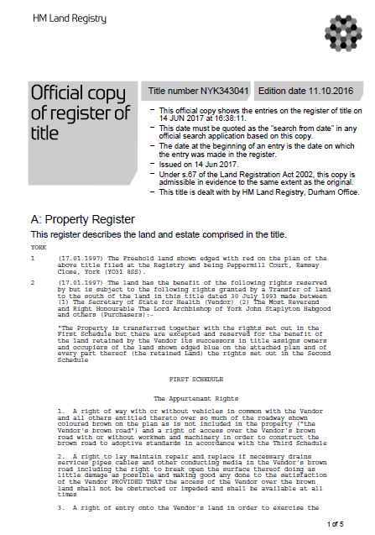

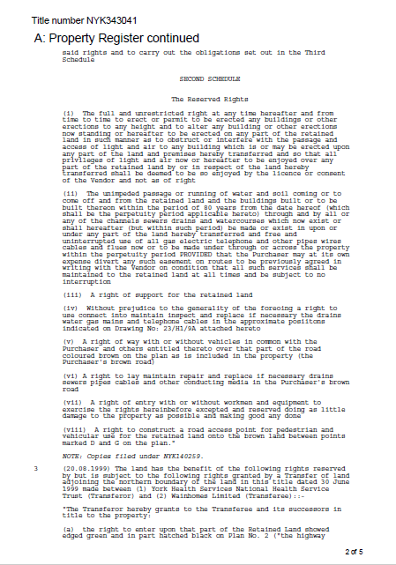

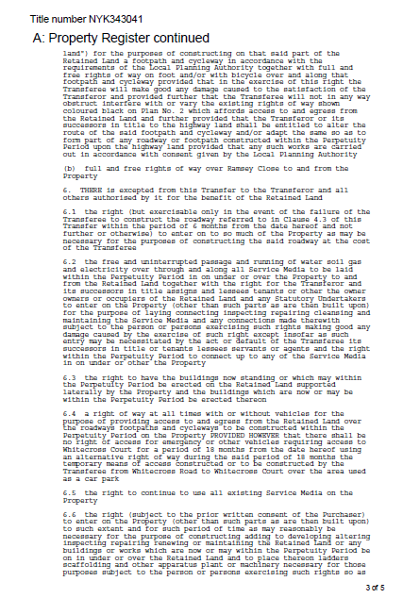

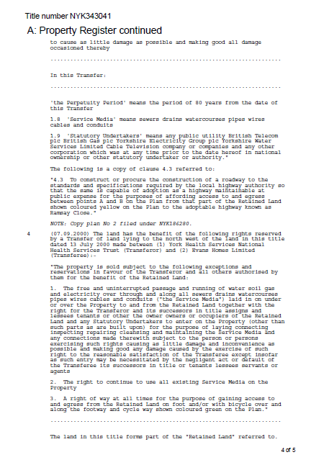

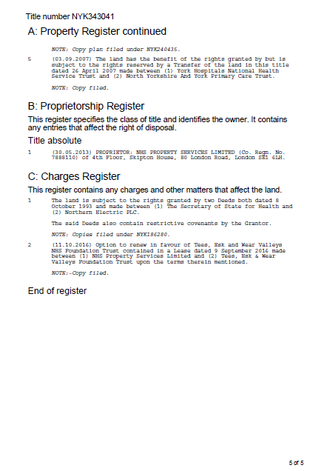

# Schedule B - Specification Document 2 “Title Plan”



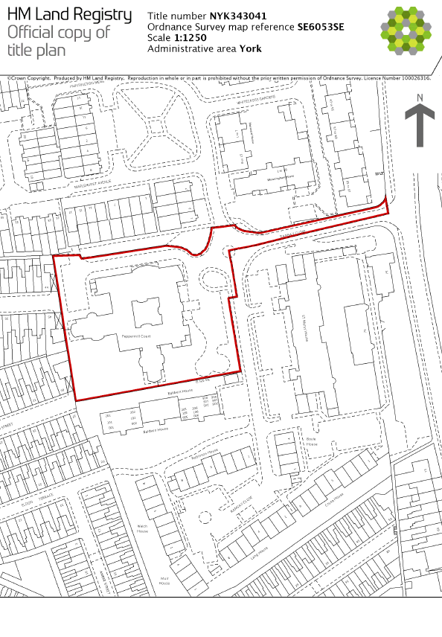

# Schedule C – “Draft Joint Venture Contract”

For convenience, two separate MS Word files are included with this document titled thusly.

6a - Joint Venture Agreement - ITPD version

6b - Joint Venture Agreement - ITPD version (Schedules)

# Schedule D – “YSJ Financial Report 2021/22”

Annual Report and Financial Statements 2021–22

<https://www.yorksj.ac.uk/media/content-assets/about/documents/ysju_annual_report_and_financial_statements_2021-22-(2).pdf>

# Schedule E – “York Council Planning Application”

Application summary for erection of 3-storey student accommodation with associated landscaping - Peppermill Court, Ramsay Close, York, YO31 8SS

<https://planningaccess.york.gov.uk/online-applications/applicationDetails.do?keyVal=RIO777SJIGQ00&activeTab=summary>