Wood Green Allotments

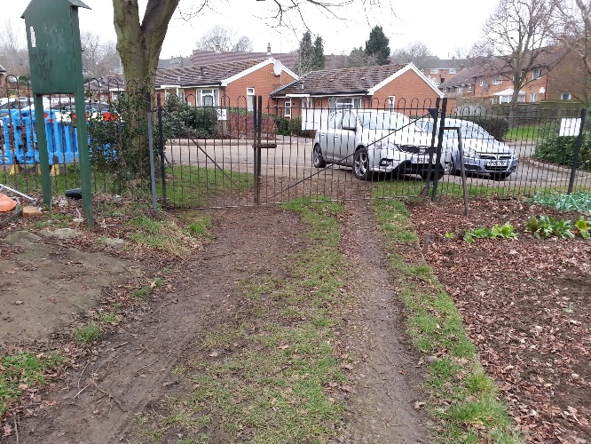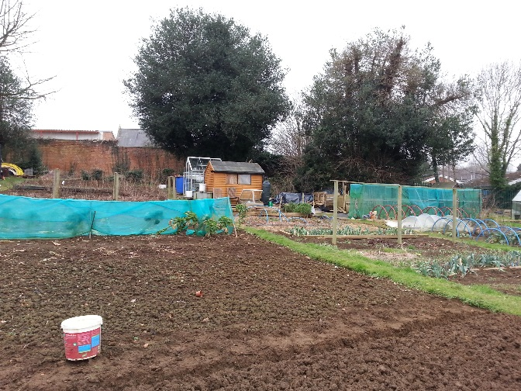
Entrance off Tithe Court – Bowtop Fencing Unfenced Section with old remains of steel post & Rail
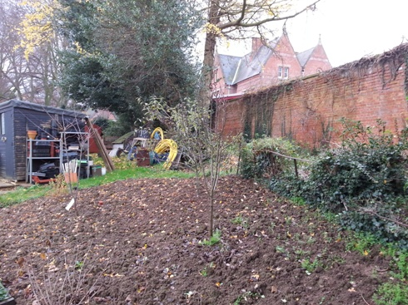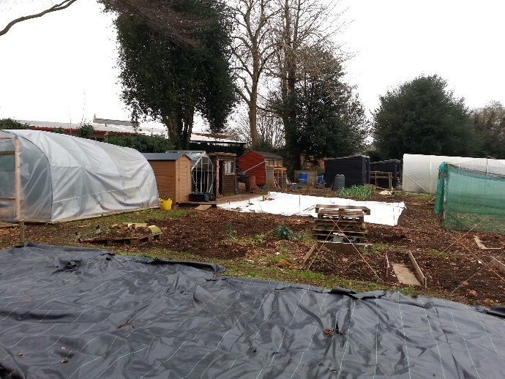
Unfenced Section with old remains of steel Post & Rail Rear school boundary
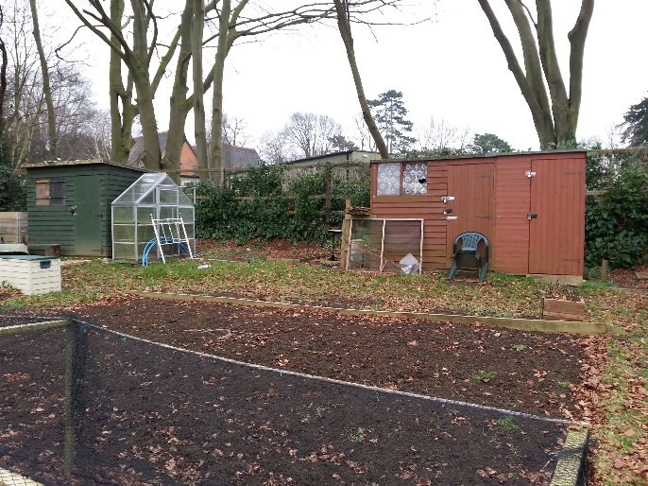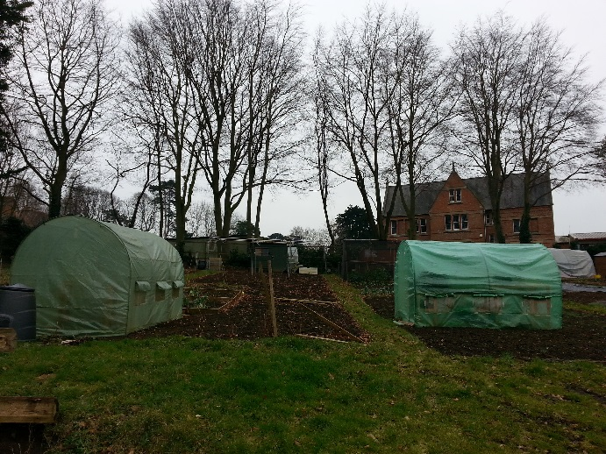
Rear school boundary Rear school boundary

