**Site Information**

in relation to *works* for

**Design and Build of a Glasshouse at Forest Research’s Northern Research Station (NRS)**

**Reference:** **CR2020/21/067**

# Site Location

1.1 Address: Northern Research Station, Bush Estate, Roslin, Midlothian, EH25 9SY.

1.2 The *site* for the replacement glasshouses comprises an open area of hard standing with access to mains water, drainage, electricity and gas – although each of these would require connection to a new facility as required.

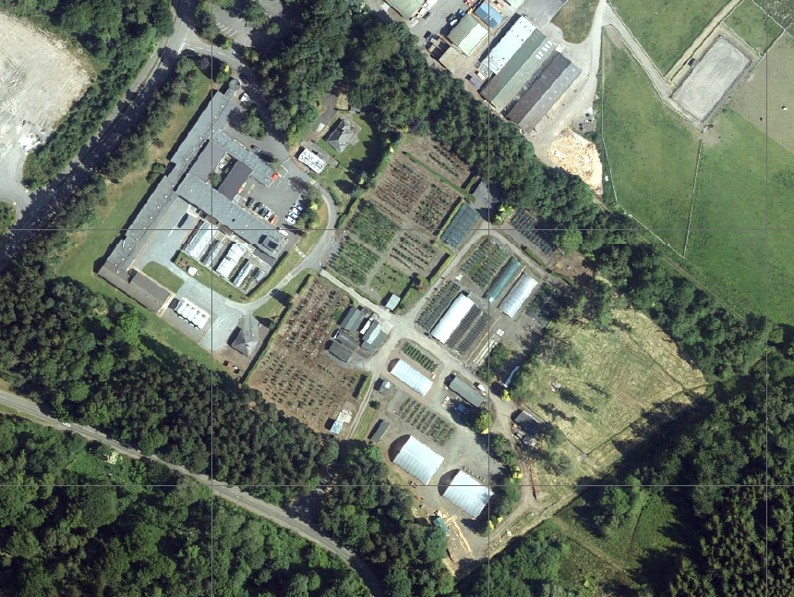

Proposed Location

Current Glasshouses

Water

Water

Water

Gas

# Access

## 2.1 Access and egress

2.1.1 NRS main entrance for vans and small vehicles.

2.1.2 All lorries and plant through double gates at side of nursery direct from the main road.

## 2.2 Traffic management

2.2.1 *Contractor* responsible for own, and in complying with any other traffic management being operated by others who may be working around the *site*.

## 2.3 Public access

2.3.1 Vehicular access for FR staff, their visitors and deliveries to NRS should not be restricted by the *Contractor*.

# Existing records and plans

* 1. Enclosed is an extract (‘civils structures’ section) from a draft report produced by the *Client’s* consultant, Pick Everard, which contains some information of relevance to the *site*.

# Site management

## 4.1 Welfare & accommodation

4.1.1 The *Contractor* is required to provide its own welfare facilities.

## 4.2 Working hours

4.2.1 Monday to Friday 0730 – 1700, unless otherwise agreed with the *Client*.

## 4.3. Coordination with others

4.3.1 The *works* are part of a wider project at NRS and the *Contractor* will be required to coordinate its activities with others who may be working at NRS/near the *site* at the same time; the *Client* will advise if this is the case.

## 4.4 Utilities and services

4.4.1 Electricity and water supplies will be available to the *Contractor* for use free of charge.

## 4.5 Fencing and signage

4.5.1 *Contractor* to provide standard signage and a barrier on the access road.

## 4.6 Waste management

4.6.1 The *Contractor* is responsible for management of all waste arising from the *Contractor* Providing the Works.

## 4.7 General storage

4.7.1 The *Contractor* will be designated space for a site compound/laydown area adjacent to the *site*.