CONTENTS

WHATS INCLUDED 1

OVERVIEW 2

LOTTING STRUCTURE 2

TIMESCALES 3

KEY DELIVERY DATES 3

CURRENT ROLES AND RESPONSIBILITIES OF THE CUSTOMER 5

TEST & DEVELOPMENT REQUIREMENTS 8

REQUIRED CAPABILITIES AND OUTCOMES OF THE SUPPLIER 8

TERMS AND CONDITIONS 10

EVALUATION STAGES, MINIMUM PASS MARKS & PRICE EVALUATION 10

# 

# WHATS INCLUDED

Customer Requirements (this document)

Appendix A – Award Questionnaire (template to be completed)

Appendix B – Supplier Pricing Matrix (template to be completed)

Appendix C – Call-Off Contract (Part A&B) (Customer specific terms)

– Call-Off Contract (Part C) (Standard Terms and Conditions)

Appendix D – Supplier List for Consortium Possibilities (if applicable)

OVERVIEW

|  |  |
| --- | --- |
| CCS Project Lead: | Emilia Cedeno |
| Customer: | Monitor UK |
| Delivery Location: | London Remote* |
| Phase(s): | Discovery, Alpha, Beta, Live |
| Project: | DS02- 075 Monitor UK |
| Required Capabilities: | Include, but are not limited to: (mark those that apply) Software engineering and On-going Support  Agile Product Design & Delivery |
| Subcontracting Permitted? | YES |
| Supplier Partnering Permitted? | YES |
| Contract Charging Mechanism (Discovery Phase): | Time and Materials |
| Contract Charging Mechanism (Alpha Phase): | Time and Materials |
| Contract Charging Mechanism (Beta Phase): | Time and Materials |
| Contract Charging Mechanism (Live Phase): | Time and Materials |
| Tender Publish Date: | 11/03/2016 |
| Tender Submission Deadline: | 29/03/2016 |
| Proposed length of phase: | 4 months |
| Proposed Commencement Date of Project: | 25/04/2016 |

LOTTING STRUCTURE

## The Customer has structured this procurement as follows:

|  |  |
| --- | --- |
| **Lot 1** | **Software Engineering and Ongoing support**   * 3 x Developer Onsite (2 Seniors / 1 Junior) * 4 x Developer Remote (2 Senior / 2 Juniors) * 1 x QA Analyst Onsite (1 Senior) * 1 x QA Analyst offsite (1 Junior) |

* These roles are subjected to change as we are working in an agile way.

TIMESCALES

The Customer or CCS may change this timetable at any time. The Potential Provider will be informed by email if there are any changes to this timetable.

## It is the Potential Provider’s responsibility to Monitor the online messaging facility (e-Sourcing).

|  |  |  |
| --- | --- | --- |
| **DATE** | **WHO** | **ACTIVITY** |
| 11/03/2016 | CCS | **Publish requirements to Potential Providers**  Clarification period starts |
| 16/03/2016 | CCS, Customer & Potential Providers | **Clarification Webinar 14:00**  Invite to webinar will be issued via the CCS eSourcing Suite. All questions and responses will be published via eSourcing Suite. |
| 21/03/2016 | Potential Providers | **Clarification Question period closes**  Please submit all clarification questions by 23:59hrs  Please note that we aim to publish all response to Q&A within 24hrs |
| 29/03/2016 | Potential Providers | **Submission Deadline**  Potential Provider must upload submission to the eSourcing suite by 12:00noon |
| 07-08/04/2016 | Potential Providers & Customer | **Demonstration, Testing and Scrutiny**  Supplier Presentation |
| 13 – 15/04/2016 |  | **Award Notification**  Publish Successful and un-successful Potential Providers. |
| 25/04/2016 |  | **Expected "Commencement Date" for Call-Off Contract/s** |

KEY DELIVERY DATES

|  |  |  |
| --- | --- | --- |
| PROJECT PHASES | START DATE | COMPLETION DATE |
| Discovery | 02/05/2016 | 03/06/2016 |
| Alpha | 06/06/2016 | 02/07/2016 |
| Beta | 03/07/2016 | 15/08/2016 |
| Live | 15/08/2016 | 30/08/2016 |

* These dates are indicative and subject to change as we are working in an agile way.

CURRENT SITUATION / BACKGROUND INFORMATION

Monitor has developed a state-of-the art data warehouse called Strategic Information Platform (SIP) which has been developed on the Microsoft APS technology. The data warehouse is populated with key healthcare datasets such as HES, Reference Costs, SUS PbR, Unify and other external/internal data sets, which range from quite small in size to some containing millions of records. The purpose of SIP is to:

* provide a single point of truth for every data set held.
* acquire data, provide quality control and have a structured data repository.
* provide efficient access to data to analyse, model and get access to business insights.
* provide an auditability and versioning capability coupled with compliance with highest levels of security.
* integrate with existing analytical applications and tools to provide a seamless and enhanced user experiences.

The high level SIP architecture is illustrated below:

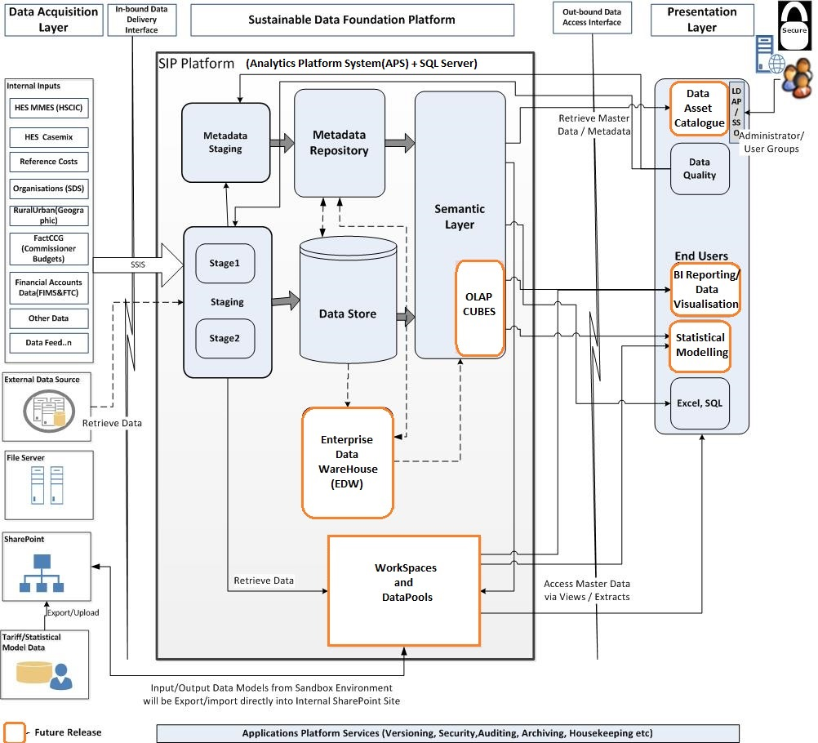

We are looking to procure development services to run from 9 May to 31 August 2016, with the expectation that these will be provided using a blended on/offshore development team.

The key stages of a development project would be:

* Initial idea of requirements (Monitor)
* Supplier undertakes business and technical analysis of the requirement
* Supplier proposes effort and timescale to undertake the development work
* Monitor approval of work package
* The supplier then develops with internal teams the solution using Agile methodology
* Supplier together with the internal teams undertakes testing prior to delivery to Monitor
* Monitor performs user acceptance testing (UAT) to the original requirements (plus any customer changes agreed)
* Monitor manages the production releases and deployment

Monitor will continue to operate a similar process as above with the selected supplier.

The supplier is expected to propose the initial size and make-up of the onsite team, to undertake the business analysis and estimating of the initial work packages. Once completed, the supplier is expected to allocate staff in an agreed model with Monitor in order to complete the work packages within the agreed timescale.

This mix of supplier staff allows the team to be flexed up or down in accordance with the work packages in flight at any given time. It is the remote team where the flexibility exists, the onsite team remains stable.

For contractors to be able to access the SIP and the data therein they will need to have a signed Monitor contract, completed Information governance training (with evidence) and access the SIP in exactly the same way as Monitor staff. Downloading/storing SIP data outside the EEA is not permitted. Therefore we would need the supplier to demonstrate staff IG awareness and training, staff vetting and Information Security assurance.

CURRENT ROLES AND RESPONSIBILITIES OF THE CUSTOMER

|  |  |
| --- | --- |
| **Role** | **Responsibilities** |
| **Senior Responsible Officer** | To own the programme at a corporate level. Guide the Programme Board on prioritization or work and financial expenditure. |
| **Project Manager** | Owns the programme plan, drives the agreed work plan and ensures a quality delivery from the programme to the business units. |
| **Product Owner** | Owns and maintains the Product Vision, and manages and sets the priorities of the Product Backlog |
| **Lead Architect** | Responsible for the overall design, integrity and robustness of the solution |
| **Front End Developer** | Front end development of the solution using Tableau and/or Alteryx |
| **User Researcher** | Work with the product owner and designers to ensure users needs are met (internal project team) |
| **Content Designer** | Work with user researcher to ensure that information is written clearly and simply (editorial/comms team member) |

CURRENT TECHNOLOGIES AND LANGUAGES

The following diagram illustrates how end users access and retrieve business insights from the SIP platform.

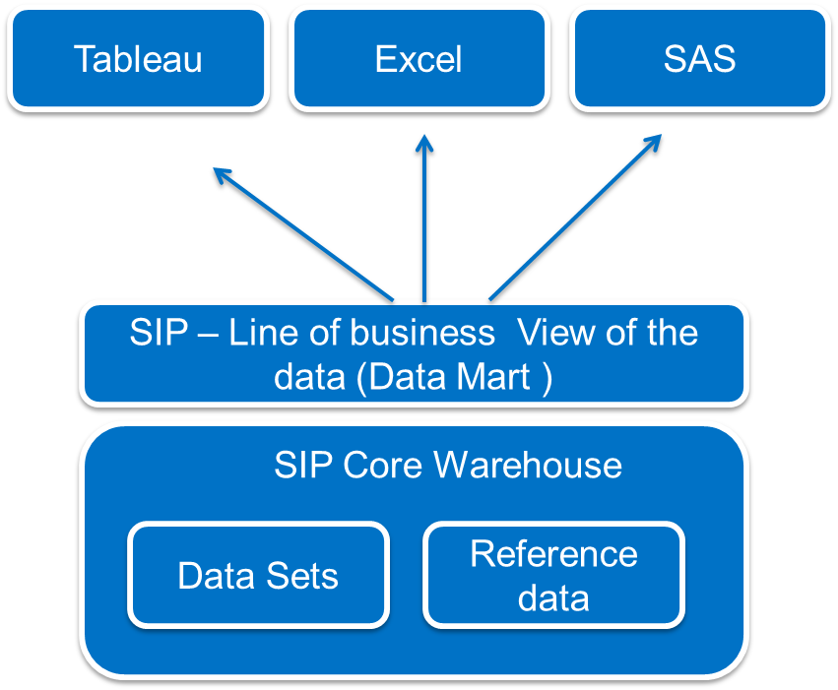

**Ecosystem of analytical and modeling tools:**

Modeling

* SAS Server – 12 Core Office Analytics with the enterprise guide
* Simul8 – Dynamic event simulation software available for discrete event modeling
* Alteryx – Data blending, data preparation, spatial, and predictive analytics
* STATA – Statistical tool (named user license)

Analytical

* Tableau – (8 Core server version 9.2) and desktop edition available on named user basis (can be redistributed)
* Cadcorp – Limited usage desktop GIS tool

**Current Dataset Repository**

* HES MMES
* SUS PbR
* HES Casemix
* Reference Costs
* FTC
* FIMS
* Ambulance Quality Indicators
* Cancelled Elective Operations
* Bed Availability and Occupancy
* Hospital Activity
* Diagnostics Waiting Times and Activity
* A&E (Situation Report)
* RTT (Situation Report)
* DToC (Situation Report)
* CCC (Situation Report)
* UOC (Situation Report)
* Winter Daily (Situation Report)
* Cancer Waiting Times
* ICD
* OPCS
* ERIC
* QOF
* ONS
* NPSD

**Technologies**

* Microsoft SQL APS (Analytics Platform System) technology.
* Data Vault and Kimball as data model
* Data Load Optimisation using Data Vault and Microsoft APS.
* Data Profiling tools like ATACAMA
* Master Data Management Solutions using Microsoft MDS (Master Data Services)
* Tableau Server and Professional
* Alteryx
* MIST and BIML frameworks

REQUIRED OUTCOMES

***Overview of requirement***

*The objective of the procurement is to engage a development partner that can help develop bespoke solutions, using our SIP platform. It is expected that Monitor will commission a number of Work Packages to the successful supplier in order to support delivery of the prioritised business analytics products in 2016/17.*

**Discovery Phase**

The scopes of this discovery will be focused on the requirements to build user insights and access to the underlying datasets. This will be delivered via user centered stories through facilitated workshops.

1. **Improved Access to Business Insights**

We are exploring the concept of providing faster turnaround times to key datasets to enable business users to access business insights quickly. The following provides a list of dashboards which will provide better business insights:

* UNIFY RTT waits
* UNIFY activity reports
* UNIFY performance reports
  + A&E real-time performance dashboard
  + A&E performance benchmarking dashboard for providers
* SUS-HES-UNIFY comparisons
* Organisation mapper (GIS for all health units)
* ESR browser
* Financial returns browser (FT and non-FT)
* Hospital Travel Time browser
* Data Quality browser for HES/SUS
* Mortality analysis dashboard
* Patient experience and safety dashboards
* Agency spending dashboard

1. **Proposals for enhancing existing Tariff modelling**

Improve and integrate the tariff model to the SIP platform using appropriate tools and methods which could include SQL, Alteryx and SAS

1. **Work with internal business users and product owners on a prioritized list of product backlog items and estimation of work and efforts**

We have released a number of products and as a result a number of requests have been raised for enhancements/fixes. These items need to be managed and delivered within the timeframe.

**Alpha Phase**

The alpha phase will consist of developing items from the discovery phases:

1. Improved access to business insights through dashboard prototypes including sourcing of datasets and:
   1. Create and develop data layers to support front end views
   2. Build prototypes of priority dashboards with Monitors project team from the list above
2. Modification and improvements to the Strategic Tariff modelling processes
3. A prioritized list of PB (product backlog) items as agreed with internal product owners and project teams with a plan for managing software development, testing and deployment plans.

**Beta Phase**

1. Development of solutions to user and stakeholder communities
2. Refine solutions based on stakeholder feedback
3. Reconcile the data against the user acceptance criteria
4. Enhancements to the Strategic Tariff modelling processes
5. Further developments of PB items with internal teams

**Live**

Releases of all the dashboards and strategic tariff modelling processes into the production environment. Transition of handover activities (documentation, training) to internal teams such as development, support and IT functions.

TEST & DEVELOPMENT REQUIREMENTS

The supplier will ensure that all software developed is tested against user stories/specifications to cover reliability, performance, and free of defects. The appropriate levels of testing must be conducted during the development life cycle (such as unit/functional/regression/performance) and provide evidence (documentations and showcases) to Monitors’ internal team.

The supplier will fix any defects and errors through development iterations and undertake regression testing within an agreed timeframe with Monitor.

All products must be delivered with the associated supporting documentation to Monitor. The quality of the documentation is part of the approval and sign-off process from Monitor.

REQUIRED CAPABILITIES AND OUTCOMES OF THE SUPPLIER

|  |  |
| --- | --- |
| Required Capabilities and Outcomes of the Supplier | |
| **Capabilities** | **Outcomes** |
| **Software Engineering and Ongoing Support**  **Developers** | Junior Developer   * Proven experience of Microsoft SQL Server development on APS platform * Proficient SQL programming ability * Experience across the full software development lifecycle * Good understanding of BIML (Business Intelligence Markup Language) framework * Good understanding of data modeling principles * Knowledge and experience of Data Warehousing/ Data Marts   Senior Data Warehouse Developer   * Proven experience of Microsoft SQL Server development on APS platform * Experience in software development with NHS datasets * Development experience in large data warehouses using Microsoft Technologies (SQL/SSIS) * Development, performance management and troubleshooting experience on the Microsoft APS platform * Need to have proven experience in software development using Data Vault and Kimball as data model running on Microsoft APS technology * Proven experience in Data Load Optimization using Data Vault and Microsoft APS. * Ability to undertake data profiling * Experience in Master Data Management Solutions using Microsoft MDS * ETL design knowledge and implementation using SQL Server Integration Services (SSIS) * Experience with BI visualisation tools (Tableau) * (Desirable) experience in data blending experience using Alteryx or similar tools * Solid understanding of BIML framework * Solid understanding of data modeling principles * Use of source control (TFS)   **QA Analyst**   * Proven experience of SQL skills * Should be familiar with APS platform * Familiar with tools like Tableau/Alteryx * Solid understanding of testing and quality assurance processes * (Desirable) test-driven development * (Desirable) test automation   **Senior Model Developer**   * Knowledge of best practice model development techniques * Proficient in SAS * Proficient in SQL, R and STATA * Knowledge of NHS dataset would be advantageous * Desirable - financial/accounting knowledge |

* Project management will be delivered by Monitor

THE METHODOLOGY

Monitor has transitioned to working with agile methodology across its portfolios. The supplier is expected to provide development activities in incremental, iterative cadences to respond to changing needs of the business. This will be led by the scrum master and the product owner and the scrum team.

Objectives for changes managed in the agile process will be agreed at a high level through the creation of work packages with the supplier.

GOVERNANCE

SIP is governed by Monitors’ control processes and has its own programme board which is accountable for the delivery of all milestones. The supplier will work with the SIP project manager to:

* Produce a weekly status report
* Attend weekly review meetings
* Attend other meetings on request
* Report progress/issues/risks

TERMS AND CONDITIONS

Please note that Customer specific Terms and Conditions apply to this agreement. Please refer to the Call-Off Contract Part A, for further information. Please note that these terms will supersede the standard terms within Call-Off Contract Part C Call-Off Terms and Conditions

EVALUATION STAGES, MINIMUM PASS MARKS & PRICE EVALUATION

## Evaluation will follow the approach below:

## Technical & Cultural evaluation

* Demonstration, Testing and Scrutiny

## Pricing evaluation

MINIMUM PASS MARKS:

## In order for Potential Providers to progress they must achieve or exceed the Minimum Pass Mark, as defined in the Award Questionnaire.

|  |  |
| --- | --- |
| Stage 1: Technical & Cultural evaluation | All Potential Providers who achieve the required Minimum Pass Mark for a Lot will be added to the Short List, and will be eligible to continue in the Further Competition. |
| **Stage 2:** Practical Demonstration, and Scrutiny of the resources proposed by the supplier | Suppliers who meet the Minimum Pass Marks specified for Part A Supplier Confirmation, and Part B1 Written Submission; will be required to complete Part B2 Practical Demonstration of a particular skill (specified within the Award Questionnaire) in order to evidence capability.  Supplier resources will be required to respond to the Scrutiny questions stipulated within the Award Questionnaire. Each shortlisted Supplier must achieve the Minimum Pass Marks identified in the Award Questionnaire to continue in the Further Competition. |
| Stage 3: Pricing evaluation | For each Further Competition the Customer has a choice as to how they wish the pricing to be evaluated. In this instance the Customer has specified Combined Evaluation as their chosen price evaluation method. For more information please see the Evaluation Guidance document held on the e-Sourcing suite. Please note that pricing will only be evaluated for those shortlisted suppliers that have met the Minimum Pass Marks for the preceding evaluation stages |