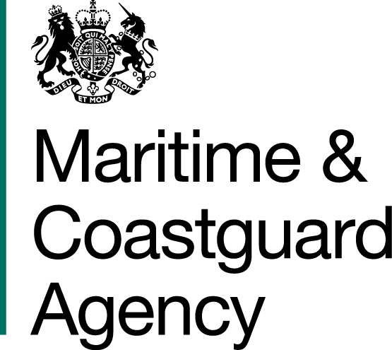 |  |  | Bay 3/21  Spring Place  105 Commercial Road  Southampton  SO15 1EG
 | To whom it may  Concern, |  | Tel:  E-mail: | +44 (0)20 381 72476  contracts@mcga.gov.uk
 |  |  | Your ref:  Our ref: |  | TCA 3/7/1112
 |  |  | First issued 18th July 2019
Dear Sirs

REVIEW OF THE RISK TO THE UK FROM MARINE OIL POLLUTION
QUESTIONS AND ANSWERS -

We have received questions for the above-mentioned tender, and to ensure that all tenderers have access to the same information, we have copied the questions and our answers to you:

Question 1: Would it be possible to view a copy of past Risk Reviews? This would help us to understand what level of detail is required in deliverable.

MCA response: The Authority agrees to provide the executive summaries and contents pages for some of these previous risk reviews which will give an idea of the scope, scale and subject matter covered in these papers. The Authority also agrees to provide a link to the National Audit Office report Dealing with Pollution from Ships, which is already publicly available online:

https://www.nao.org.uk/report/dealing-with-pollution-from-ships/

The rationale for not providing all of the papers in full is that the Authority wishes to avoid a situation where bidders interpret this provision as a desire on the part of the Authority for this risk review to replicate the methodologies used in previous risk reviews, thereby stifling the innovation we are looking for. It should also be noted that these reviews do in themselves vary in terms of approach and focus, depending on the Authority’s stated requirement for those studies and on the analysis tools available at the time.

In terms of level of detail, given the level of resource available and the timescale, the MCA understands that the data analysis carried out to inform this risk review will not be exhaustive. On the other hand, the level of detail and accuracy of the findings should be sufficient to inform the MCA’s resourcing for oil spill response, providing a reasonable basis for this planning. Striking this balance and providing a rationale for the chosen approach is the purview of the bidder and, again, the Authority encourages innovative approaches. To dictate or indicate the appropriate level of detail risks stifling any innovation.

Response

Yours faithfully,

Richard Skeats

Richard Skeats MCIPS
MCA Procurement Team

