Request for Proposal DS01-215
Clinic Portal Delivery Appendices
DS01-RM1043

RFP 5 Appendices
Appendix number | Appendix | Page number
18.1 | List of existing systems/tools (functionality) | 24
18.3 | Key user research findings | 25
18.4 | HFEA Audience Personas | 27
18.5 | HFEA Key Processes | 38
18.6 | Indicative | 43
18.7 | API Diagram | 44
18.8 | Screenshots from HFEA systems | 47

List of existing systems/tools (functionality)
This is for guidance and does not necessarily mean that all functionality will be required in the future, or needs to be delivered in the same way (i.e. we expect to design out or design in this functionality requirement)

Key user research findings
Clinics
- Key messages
  - Data submission can be tedious and distracting
  - Requirements to submit data require clinics to employ specialist staff
  - Error reports are difficult to understand
  - Clinic Portal is hard to log into and frustrating to use
  - Systems do not always integrate well
  - Consent forms are too complex and cause multiple problems
  - Lack of training materials leads to a lack of consistency
- Data submission
  - Submitting data is time consuming and difficult
  - Extra staff are being employed just to meet the demands of data submission
  - Timescales for data submission are too tight
  - Current systems do not integrate efficiently and effectively
  - Some data is difficult to input accurately
- EDI
  - Data goes into ‘a black hole’ so cannot be used
  - Clinics are reactive rather than proactive
  - Lack of validation on forms leads to errors
  - Certain features not supported (e.g., apostrophes)
- Error reports
  - Error reports can be accessed in multiple ways
  - Difficult to understand
  - Difficult to know what or where to fix - leads to clinic staff becoming detectives
- HFEA website
  - Used to access clinic areas
  - Out of date – HFEA is not horizon scanning
  - Finding information is difficult
  - Tone is clinical rather than helpful
- Clinic Portal
  - Lots of difficulties logging in
  - Passwords are shared
  - Performance indicators are frustrating
  - Staff lists are difficult to update
  - CUSUM plots are hard to understand
  - Lack of training / help available
- Choose a fertility clinic
  - Data is difficult to understand
  - Chosen data is not universally liked
  - ‘Find a Fertility Clinic’ may be more appropriate
  - Data manipulation
- Code of Practice
  - Some clinics prefer to retain hard copies
  - Online search is frustrating for some
  - Easier to read than previously but still hard to use
  - HFEA rarely give adequate clarifications
  - Would be good to share examples of good practice
- Consent forms
  - Biggest single source of clinic frustration
  - Design of forms leads to mistakes
  - Patients are not giving informed consent
  - Lots of time is spent explaining forms rather than treatments to patients
- Communications
  - No single place to find communications
  - HFEA communications are generally well received
  - Clinic focus articles would benefit from embedded links
  - Incident alerts are not as prominent (in the Clinic Focus) as they were previously
- A single place for communication would be desirable
  - A dedicated mailbox could be a feature of the Clinic Portal
  - Both private and public correspondence could be stored
  - Users may need to action items to show they have read and acted upon them
- Key themes for clinics
  - Lack of transferable knowledge between clinic staff
  - Lack of training on how to use systems
  - Systems tend to be inefficient to use rather than difficult
  - HFEA staff are considered helpful but not collaborative

HFEA Audience Personas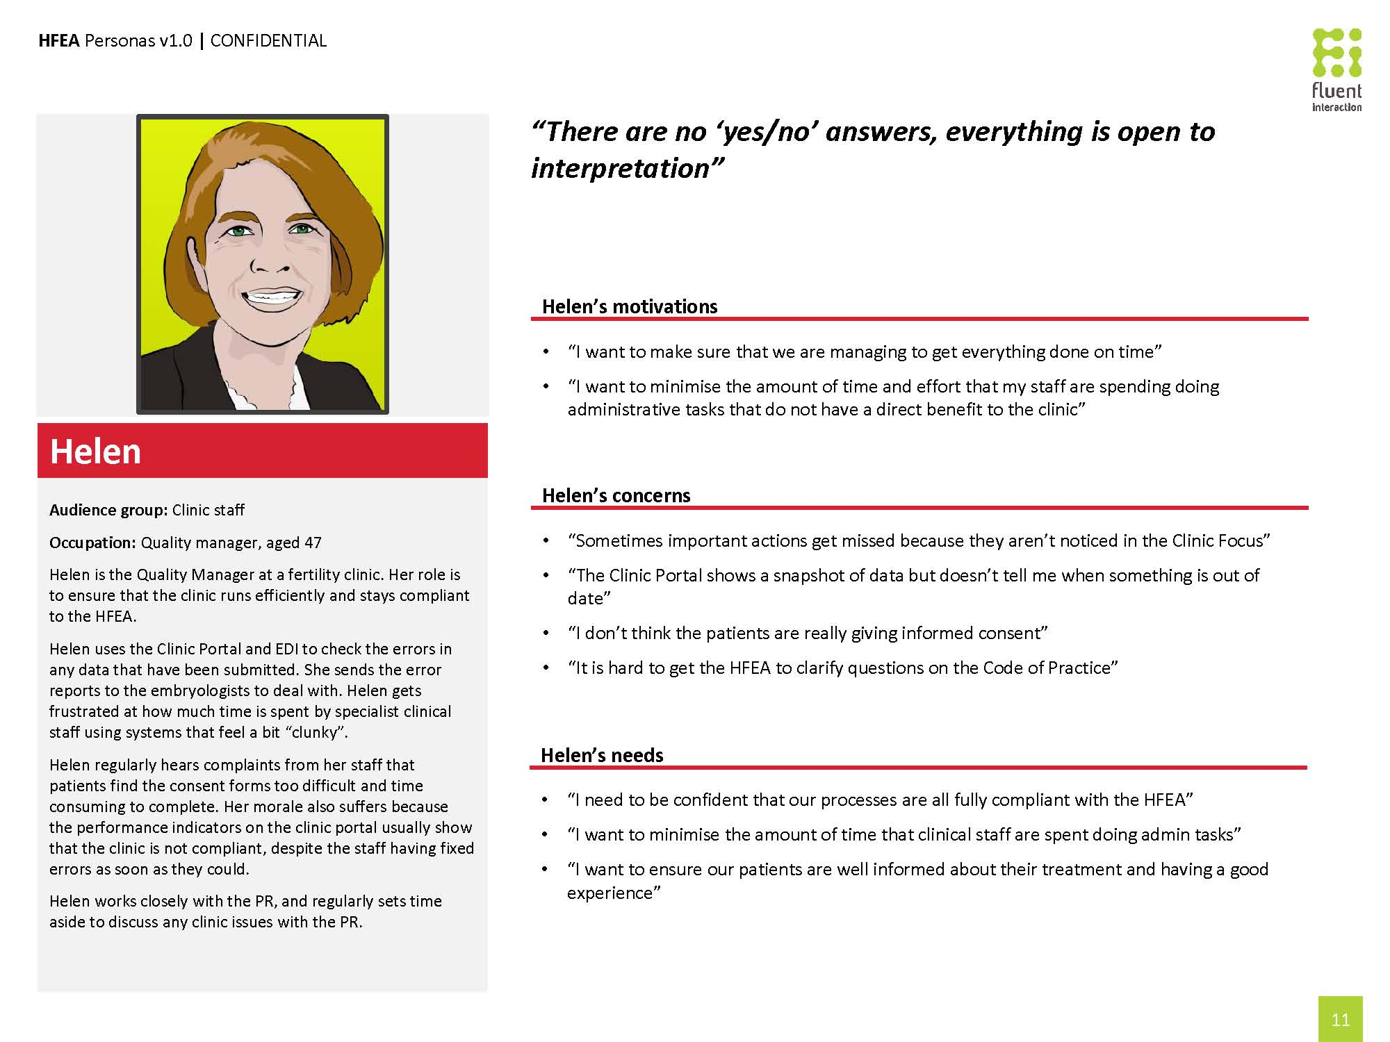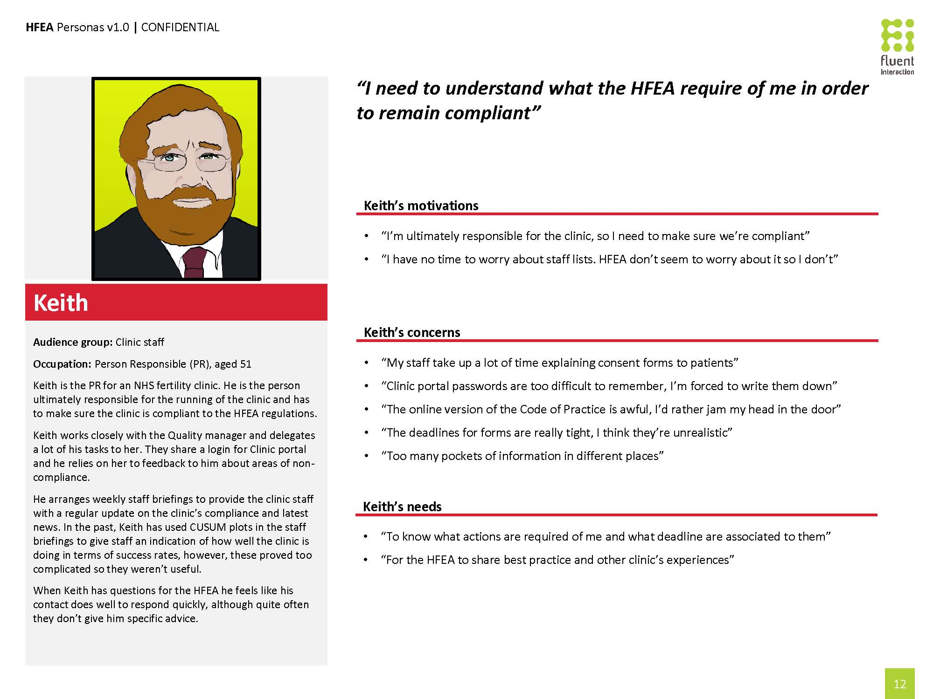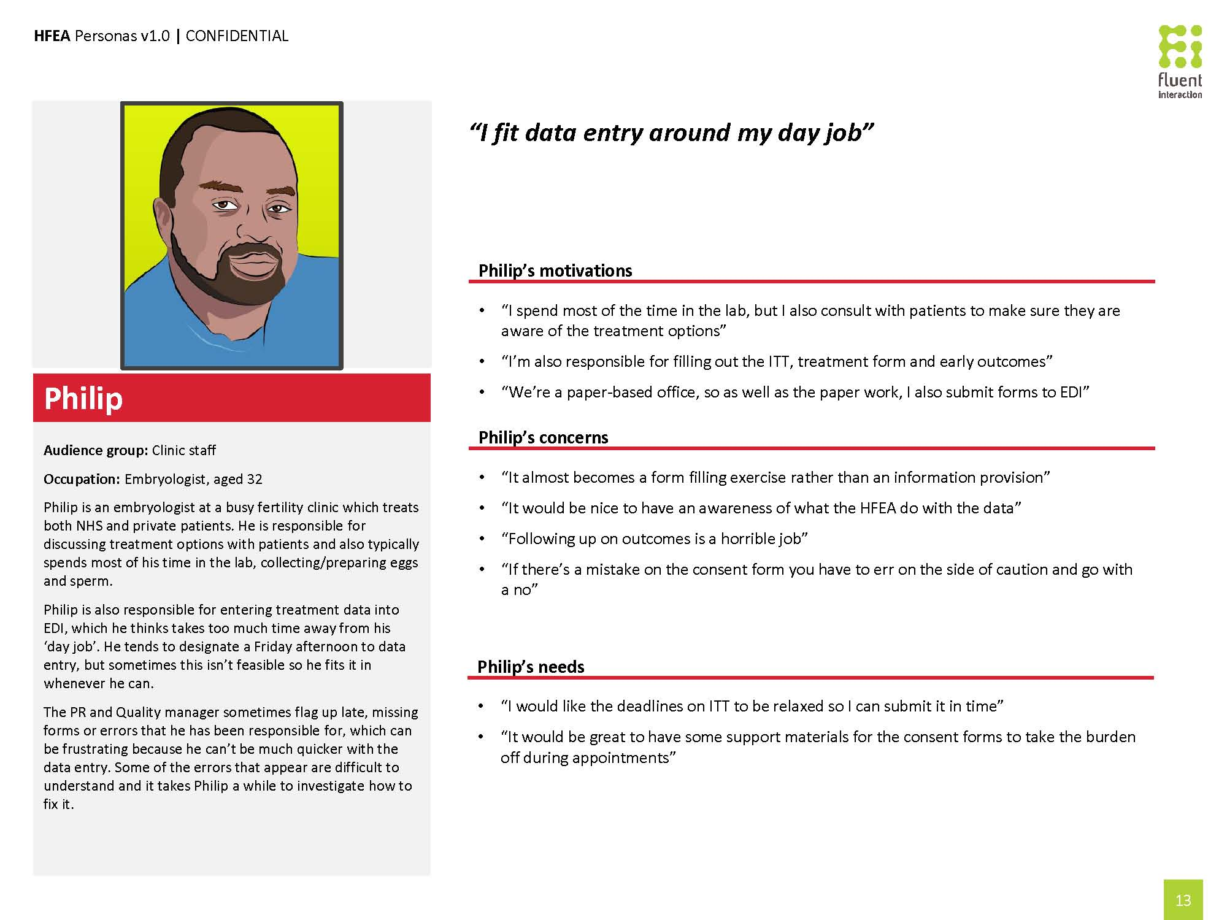

HFEA Key Processes

Introduction and Purpose
The aim of this table is to identify and list the key headline business processes covered by the systems analysis within the IfQ programme. The headline processes identified are intended to give a categorisation for the detail in the user-stories (appendix 18.6) which define the requirements for assessment and proposed future software development. They are also intended to remain independent of any implementation details so that proposed future solutions will be aligned to desired business outcomes and future strategies, and will not simply replay existing systems.

Processes
Category | Process | Description
System Administration
System Administration | Manage HFEA System User | The systems administration function for managing internal HFEA, clinic and public users  - Creation, suspension and deletion of users  - Maintenance of user profiles  - Password management  - Permissions to HFEA data  - Permissions to HFEA services / functions
System Administration | Manage Clinic User | The systems administration function for managing clinic users for the same clinic as the system administrator  - Creation, suspension and deletion of users  - Maintenance of user profiles  - Password management  - Permissions to HFEA data (subject to permissions)  - Permissions to HFEA services / functions (subject to permissions)  The aim is to allow clinics to manage the permissions for their own users.
Information Requests
Information Requests | Service FOI Request | Assessing the request, creating and distributing a response to a Freedom of Information Act request based on information held by the HFEA. Also includes the optional publication of results.  The response form is dependent on the request, e.g. data set or report.
Information Requests | DPA Request | Assessing the request, creating and distributing a response to a Data Protection Act request based on information held by the HFEA.  The response form is dependent on the request, e.g. data set or report
Information Requests | Service Parliamentary Question | Assessing the question, creating and distributing a response to a Parliamentary Question, based on information held the HFEA.  The response form is dependent on the request, e.g. data set or report
Information Requests | Provide Anonymised Research Data (Set) | Service a register research request from a licensed research centre to provide an anonymised data set for research purposes based on information held by the HFEA.
Information Requests | Produce Operational / Management Reports | Create, manage and distribute reports required to inform the management team for the on-going operation of the HFEA. Includes regularly or periodically generated standard reports.  Also covers any other miscellaneous standard reports required that are not covered elsewhere.
Information Requests | Produce Ad-hoc report | Create, manage and distribute reports that are produced in a short time-frame for a specific, potentially one-off, purpose.
Public Website
Public Website | Manage Public Content | Allows the user to create and manage content that can be surfaced on any of the specified portals. The content can be static text, images, video and may also include interactive or dynamic content.  Covers:  - Creation of content  - Review / approval of content  - Implementation of content  - Dating of content  - Removal/archiving and retention of content
Public Website | Manage CaFC/Clinic Information | Allows the surfacing and comparison of statistical and other information regarding clinics with the intent of aiding a potential participant in making a decision on which clinic to use.
Public Website | Manage Patient Feedback | Allows participants to provide feedback on clinics, articles or other items on the relevant portal. Also covers the HFEA process to handle the feedback.
Public Website | Manage Complaint (public/staff) / Contact Us | The process to receive and handle complaints, contacts or general enquiries from the public or clinic portal. Covers  - Complaints by clinic staff (whistleblowing)  - Complaints by public about clinics  - Complaints by public about HFEA  - General enquiries by public  The specific process for handling each type may differ.
Public Website | Manage Subscriptions and Events | The processes for the management of  - Subscriptions to regular publications, for example e-mail newsletters.  - Subscriptions to notifications of change on specific items, for example changes to a specific article or content item on the clinic or public site.  - Scheduled calendar events, and the notifications associated, such as public consultations, including optional indication of attendance.
Public Website | Manage Surveys | Allows the capture and processing of survey information / flash collections, so that the HFEA can ask clinic or public users for extra information on a temporary basis. Includes the storage, processing, analysis and surfacing of this information.
Public Website | Donor Sibling Link | Processes associated with the Donor-Sibling link. Allows donor-conceived people to register their details and be informed if a matching sibling has also registered their details. On a successful match, contact details may be exchanged between the registered users.
Operations
Operations | Register Person | The process of registering a person, including the capture of basic details, with the HFEA in one of a number of roles, including, but not limited to:  - Patient  - Donor  - Partner  - Parent  - Surrogate
Operations | Manage Person | The process of managing a person already registered with the HFEA. This includes  - Maintenance of details  - Change of roles  - Marking as deleted  - Merge with another user if identified as the same  - Split into two users if erroneously identified as the same
Operations | Manage Consent | Managing the consent for how information given by participants is used, including  - Creation of consent  - Variation of consent  - Revocation of consent  Managing consent includes consent for the subject person, or for children of the subject person.
Operations | Manage Donor Pen Portrait | The on-going management of the donor’s pen-portrait including  - Capture and storage of the image of the document  - Any necessary redaction of the image  - Distribution of the image
Operations | Manage Legacy Forms (Images) | The process for maintaining access to scanned images of legacy paper forms so that information submitted prior to electronic systems can be accessed.
Operations | Manage Treatments | The process to manage treatments from inception to outcome.  - Capture and storage of data  - Validation of data entry  - Association with other entities  - Reports, and surfacing of information
Operations | Manage Outcomes | The process to manage outcomes from treatment.  - Capture and storage of data  - Validation of data entry  - Association with other entities  - Reports, and surfacing of information
Operations | Manage Donor Sperm | The process for the on-going management and tracking of donor sperm, including  - Donation  - Usage in treatment  - Clinic transfers  - Import/export  - Storage  - Disposal
Operations | Manage Eggs/Embryos | The processes for the on-going management and tracking of eggs, egg batches and embryos, including  - Donation  - Usage in treatment  - Usage in research  - Clinic transfers  - Import/export  - Storage  - Disposal
Operations | Prepare and Conduct Data Audit | The process to prepare and conduct a data audit to ensure that data held by the HFEA is consistent with data held by clinics.
Operations | Manage Clinic Submission Compliance | Ensuring that clinics meet their obligations with regards to registrations, donations, treatments performed and the necessary data submissions. Includes notification to the clinic where omissions or errors are detected.
Operations | Open the Register | The process to examine the contents of the register to allow information about donors and donor conceived people to be supplied in the appropriate way.
Clinic Management
Clinic Management | Manage Clinic Information | The management of clinic information, either by the HFEA or by the clinic. This information includes (but is not restricted to)  - Contact and location details for the clinic  - Key staff lists and details  - Treatments offered  - Publication / surfacing of clinic information  This does not include the initial creation of the clinic or the process to close down a clinic. Clinics are only responsible for their own information.
Clinic Management | Manage Clinic GPI/KRI's / Stats | The capture, storage, analysis and display of a clinic’s performance information, including GPIs, KRIs and other statistics, along with the facilities to manage the performance, for example alerts.  This also includes the facility to summarise the information and drill-down to the details, to aid the understanding of the information.
Clinic Management | Complete Self-Assessment | The completion and submission of the Self-Assessment Questionnaire by the clinic, and the capture, storage and processing of the information supplied.
Clinic Management | Billing Functionality | The generation of pricing for charged activities (licence, treatment), including eSET, creation and distribution of billing summaries and integration with accounting systems.
Clinic Management | Manage HFEA/Clinic communication | The provision of facilities to manage the relationship between HFEA and Clinics. Includes notification of events, general alerts, and other communications. Also includes a moderated forum for the sharing of ideas.
Clinic Management | Manage Incidents (Clinic Reported) | The process for raising and reporting clinic incidents by clinics and the management of any follow-up actions.
Clinic Management | Maintain PGD List | The process to manage the list of PGD conditions available for testing, including the creation, modification and removal of items from the list, and the maintenance of any details.
Regulation
Regulation | Apply for Licence | The set of processes to apply for a new licence, vary an existing licence, renew an existing expiring licence, or to voluntarily surrender an existing licence.
Regulation | Determine Licence | The process of determining the licence once the application has been made. Covers up to and including the grant of the licence and the generation and issuing of any documentation.
Regulation | Create/Close Clinic | Management of the initial creation and final close-down of a clinic.
Regulation | Prepare and Conduct Inspection | The preparation and conduct of the inspection of the clinic, including the generation of any inspection documentation, and the capture and processing of any information generated during the inspection.  Also includes the generation of the inspection report, and post inspection activities (e.g. follow up actions)
Regulation | Manage Clinic Regulatory Compliance | Managing the process of raising a licence compliance issue with a clinic through action and to resolution.
Regulation | Administer Self-Assessment Questionnaire | The administration of the content of the Self-Assessment Questionnaire, including generation based on licensed activities, code of practice and other factors.

Existing HFEA products
As part of this programme we are seeking to develop the following HFEA products:

Website
The website is the HFEA’s main public communications channel. The site was launched in 2009 and has seen an increase year-on-year in unique user traffic since 2009. Between 1 January and 31 December 2014 we received 1.2 million unique visitors.
In line with wider online trends, many of the users of our existing externally facing elements are accessing the HFEA site through mobile and tablet devices (+95% and +50% respectively for Jan – Dec 2014 compared to the previous year). Our current website does not allow us to cater appropriately for these devices and their audiences.
The current platform is not stable, has slow publishing times, intermittent CMS errors, and site outages. As the CMS is end-of-life, the developer no longer invests in bug fixing on this product irrespective of a paid for service support contract.
Our ability to modify and adapt the existing website is very limited. As the RedDot CMS is developed in a proprietary coding language it means that new developments to the site cannot be made. Developer resource also cannot easily be brought in due to the obsolescence of this product/knowledge base.
The HFEA website provides information for patients about treatment options, legal requirements and points users to sources of additional support and information. The HFEA site also publishes information for donors about how to donate and what the implications are, guidance is also published for donor-conceived people and their parents about what information they can get about their donor. We aim to improve the information, so that it is more user-friendly and written in a more compassionate tone.
The website also publishes information and guidance for clinics and researchers, media information and corporate/governance information regarding our committees, senior team and non-executive members.
The site hosts a microsite called Choose a Fertility Clinic, which provides information about individual clinics (see separate lot below).
    - Website audiences
The HFEA website has a broad range of users. Primary users are:
- prospective and current patients of fertility treatment in the UK
- prospective and current egg, sperm and embryo donors
- licensed clinics and research centres
- donor-conceived people looking for information about their donor or potential siblings
- patients/parents of children conceived through fertility treatment.
The user needs of different stakeholders and user groups are provided as a series of user profiles in appendix 18.4 of this document.
    - Website volumetrics
Ref. | Description | 2014
 | Unique users to the HFEA website | 1,255,862
 | Proportion of users accessing via a desktop PC/laptop | 44%
 | Proportion of users accessing via a tablet device | 15%
 | Proportion of users accessing via a mobile device | 41%
 | Most visited page (rank 1) – hfea.gov.uk/IUI.htm | 215,678
 | Most visited page (rank 2) – hfea.gov.uk/IVF.htm | 197,739
 | Most visited page (rank 3) – hfea.gov.uk/I [homepage] | 159,461
 | Average page duration per user visit | 1min 50sec
 | Number of unique page views | 3,160,001
    - Current website technologies and languages
The existing CMS the website is built on (RedDot) is no longer supported by the developer (OpenText). We pay a fee for support but, due to the end-of-life status, we do not have tailored help for our particular product.
The coding language that RedDot uses is a proprietary one. In line with the Government Digital Services preference we are seeking an open source solution that the supplier should recommend in its proposed solution.

Choose a Fertility Clinic (CaFC)
Choose a Fertility Clinic (http://guide.hfea.gov.uk/guide/) has been designed so patients can easily find the latest and most complete information about each licensed UK fertility clinic, helping them decide which clinic best suits their treatment needs. Receiving 166,000 unique visitors each year, it is the primary user tool for patients and clinics in getting impartial, unbiased information about clinics, the treatments they offer and how successful they are. The key purpose of CaFC is to enable potential patients to make an informed choice about where they go for treatment.
The current tool enables them to find out a wide range of information including:
- the treatments and services clinics offer, including any specialist areas
- statistics on all types of fertility treatment on a national level and for each individual clinic
- inspection reports and records of licensing decisions relating to each clinic.
Our search lets users look for clinics in their area offering the treatments and services they choose. Searches can be for specific requirements, such as clinics that treat older patients.
Each clinic has an overview page that gives contact details and information about the treatments on offer and how the clinic’s success rates compare to the national average.
The information presented is supplied by clinics currently via EDI and Clinic Portal. It also presents inspection reports surfaced via an in-house document management tool (Epicentre).
    - CaFC audiences
Primary users:
- patients
- potential patients
- donors.
The user needs of different stakeholders and user groups are provided as a series of user persona profiles in appendix 18.4 of this document.
    - CaFC volumetrics
Ref. | Description | 2014
 | Unique users to the CaFC search tool | 175,692
 | Proportion of users accessing via a desktop PC/laptop | 40%
 | Proportion of users accessing via a tablet device | 23%
 | Proportion of users accessing via a mobile device | 37%
 | Most visited page - /guide/AdvancedSearch.aspx | 3205,420 (13.54%)
 | Average page duration per user visit | 4mins 14secs
 | Number of unique page views | 1,039,235

    - Current CaFC technologies and languages
The Choose a Fertility Clinic search tool is a bespoke search engine built in-house by HFEA IT developers. It has been ‘skinned’ to be visually consistent with the main HFEA website which was last designed in 2009. The site itself sits on a different subdomain due to the level of security required to protect the data.
The HFEA IT team includes a number of developers. Their coding skill-set is mainly DotNet.

Clinic Portal and EDI
Clinic Portal is an extranet which provides a secure method for licensed clinics to submit licence application forms and application fees to the HFEA. It also allows clinics to update their clinic page on CaFC with current patient services and non-licensed activities (there is currently a 24 hour delay before information appears live on CaFC).
Currently clinics ‘verify’ data every six months on Clinic Portal and EDI before it is published on Choose a Fertility Clinic (CaFC). They find this verification process cumbersome as it means trailing through six months’ worth of historical records. In some countries this is undertaken monthly and this has been found to improve data quality. However, historically the HFEA also did this more frequently (quarterly) and some in the sector felt that was too often and ‘burdensome’.
Clinic Portal provides:
- a secure method for licensed centres to submit licence application forms and other forms based data to the HFEA (eg, self-assessment questionnaires and annual returns etc.)
- a way for clinics to monitor performance
- clinics with a way to view fee invoices raised by the HFEA and billing information
- an interface for clinics to update their clinic page on CaFC with patient services and non-licensed activities
- a mechanism to manage clinic staff on the licence
- information about the clinic
- access to clinic reports (i.e. submitted form counts)
- HFEA Alerts (general alerts rather than relating to potential clinical governance incidents specific to the clinic)
- access to the Risk Based Assessment Tool (RBAT) which shows the particular clinic’s own performance against key indicators
- access to HFEA contact information
- access to the status of the particular clinic’s submitted Register data (data quality reports)
- clinics with a way to manage the Clinic Portal admin.
Currently, clinic interactions with the HFEA can be cumbersome as clinic staff are required to shift between systems (Clinic Portal and EDI) and there can be disparities between the information on the systems.
Originally, information was provided by clinics to the HFEA using paper forms. In 2006 these forms were converted to an electronic version of the forms that is called EDI. EDI was developed as a standalone application, located on clinic premises.
There are currently about 40 clinics that submit data via EDI. Other clinics have their own clinic software that provides the extensive functionality required by clinics and also provide information to the HFEA through the use of a locally installed integration service. These systems are referred to as ‘Integrator’ systems (also known as EPRS [Electronic Patient Registration Systems]). There are currently seven suppliers of these systems providing information to the HFEA which are used by an additional 50 clinics.
EDI is also used by some integrator systems (as well as EDI users) to fix data errors that are not correctable by the integrators’ own systems and to provide access to HFEA reports that the integrators are unable to surface. There is some user frustration that it is not possible to drill down from summary KPI (key performance indicator) information surfaced in the Clinic Portal to the underlying data. That is, the user needs to go from Clinic Portal to EDI to fix a problem identified in Clinic Portal. This issue affects both standalone EDI and Integrator system users. Reports in Clinic Portal are not live so the user cannot see whether they have fixed the issue until the reports are refreshed the next day. The majority of errors, for instance those not directly relating to the KPIs, are surfaced in reports in the EDI or EPRS Systems themselves, for correction in the respective systems.
Clinics complain that data looks different depending upon which system they are looking at (Clinic Portal, integrator systems or EDI) and this undermines their confidence in the data that we hold. Users also feel that they lose access to the data after they submit it because they cannot use it or report on it in ways they would like to. Particularly annoying to them is the inability to drill down from error reports to the appropriate record to resolve it. EDI contains some validation at the front-end of but a clinic can still provide incorrect information. For example, submitting treatment data before a registration record has successfully been entered in the system. To minimise this, around 500 rules have been created to trap errors and to notify the supplying clinic by way of reports in the Clinic Portal.
Once raw data from clinics is received, it undergoes a series of rules and transformation (an extract, transform and load (ETL) process) to put the data into the Register and to create a more normalised version of the data in the data warehouse (albeit structured around treatment cycles rather than being a person-centric structure based around patients and donors).
We will be seeking to significantly improve the process and experience of Clinic Portal users as part of this programme. Suppliers will be expected to identify opportunities for these improvements throughout the programme delivery.
A key process within a clinic is preparation for inspections which clinics do using a self-assessment questionnaire, which is, in essence, a form. Clinics also use up to 31 other forms to modify licences or make changes or interact with the HFEA. It is felt that this process too could be significantly improved. We will be seeking supplier input in this area.
    - Clinic Portal and EDI users
Primary users
- Clinic users (External)
- Clinic admin staff
- The ‘person responsible’
- Clinic staff involved in treatments
- Clinic staff involved in billings
- Clinic staff involved in inspections
- Clinic staff involved in audit
- Clinic staff involved in data quality
Secondary users (HFEA internal staff)
- Business Support; Inspection Team; Register Team; Finance (HFEA Internal staff)
    - Clinic Portal volumetrics
Volumetrics – Clinic Portal (Current submissions and applications forms)

Ref. | Description | Quantity (approximate)
 | No of clinics | 120
 | Self-assessment questionnaires submissions per annum | 60
 | Initial licence applications per annum | 10
 | PGD Applications per annum | 35
 | Special Directions per annum | 10
 | IUI and GIFT Annual Returns | 25

Volumetrics – Other (Planned future submissions via the portal)

Ref. | Description | Quantity (approximate)
 | Donor Registration forms (pen portrait, goodwill message) per annum | 2,500
 | Research Project progress updates per annum | 40
    - Current technologies and languages
As outlined above:
- the existing CMS is based on RedDot
- Other systems are mainly based on Microsoft technologies
- C#.NET is the main development language
- The Epicentre system is based on Microsoft SharePoint

Internal systems
    - The Register
The data from EDI and integrators is stored in the Register. The Register is a database of information relevant to treatments licensed by the HFEA, provided by clinics. The Register stores information about the donors, patients, the treatments and the outcome of treatments. We also store additional information about the movement of human sperm and eggs (gametes).
The dataset for the Register consists of about 2,000 data items. This is the historic content and a separate project to define a prospective minimal data set is currently in progress. The content and definition of what has been collected in those fields has evolved continuously over the past 20 years. The new dataset is likely to be fewer than 200 data fields.
The Register is structured around the original paper forms and is not a relational database. The database is based on SQL Server 2005.
Where a clinic needs to change treatment information or add information to previously provided treatment information it will do this using further EDI forms (or via integrator applications). Sometimes these additional submissions or error corrections create data quality issues (such as surfacing new errors in previously submitted information).A Register record therefore is currently the sum of the original form information plus any changes or modifications to that record made through subsequently submitted forms.
NB: A new dataset has been defined for data provided by clinics. The dataset consists of 200 data items. The dataset is going through an approval process by the Standardisation Committee for Care Information (SCCI) and may change slightly as a result of the approval process over the next 12 months.
    - Volumetrics – Register data submission
(Not part of the current Clinic Portal)

Ref. | Description | Quantity (approximate)
 | No of clinics using the HFEA’s EDI standalone solution to submit data | 40
 | No of clinics that use a 3rd party integrated EDI solution | 50
 | Number of rows of data in the Register | Circa 13 Million
 | Number of validation rules | 1,100
 | Number of potential ad-hoc report users within the HFEA | 12
 | Number of users within clinics that use EDI | Up to 1,000
 | Number of Enterprise reports | Up to 100
 | Number of data items in the Register | Circa 200
 | No of treatment cycles per annum submitted to HFEA | 60,000
 | No of transactions | 380,000

    - Other HFEA Systems
Although we are not planning to redevelop the following HFEA systems, the redeveloped products will need to integrate with a number of other existing and newly defined HFEA systems and processes, including:

Epicentre
- To manage the licensing and compliance functions, an application called ‘Epicentre’ was developed internally.
- Epicentre uses workflows to track key licensing and compliance processes.

Image Store
- We also store images of information such as pen-portraits from donors and images of the paper forms used to submit data to the HFEA before EDI was developed.
- Over the years we have developed new functionality and tools to address specific problems such as data quality, performance and risk (such as RBAT).

A full list of the current HFEA systems is in the appendices at 18.1.

Indicative product backlog
User stories will be determined as part of the sprint planning sessions. However these are likely to include those articulated on the attached sheet. Suppliers must base their response on all the stories being delivered albeit that an exchange control mechanism will be adopted so that if new stories are required then existing stories of equal value to be removed.

https://app.smartsheet.com/b/publish?EQBCT=34c5ecd54cec4eadbf7be80922ca677b

API Diagram
Proposed Architecture Information Flow guide
System(s) | Information flow | Description
Epicentre > Clinic Portal | Alerts/Incidents | General incident and alerts posted to the IVF community.
Clinic Portal | Annual Return | External input of treatment data involving IUI and GIFT by patient age group.
Clinic Portal > Integration Gateway > Register | Annual Return (IUIP & GIFT) Data | External input of treatment data involving IUI and GIFT by patient age group.
Clinic Portal | Centre information | External input of non-treatment related data e.g. employees, facilities, …
Clinic Portal | Corrections | External input of corrections to submitted treatment data.
Warehouse > RBAT | GPI Extracts  (Risk model/Notebook) | Treatment data extraction to produce General Performance Indicators (GPI).
RBAT > Epicentre | GPI Monitoring | Epicentre retrieves Risk Information (Key Risk Indicator (KRI), General Performance Indicator (GPI) and Compliance Rating (CR)) from the Risk Based Assessment Tool (RBAT) and populates the Risk Indicator element of a centre record.
RBAT | Inspection Notebook | Creation from template of the inspection notebook and population with previous inspection and monitoring data.
Inspection Notebook > Post Inspection Tool > RBAT | Inspection results | Internal input of information gathered and recorded during the inspection of a Clinic.
Clinic Portal > On-line Apps | Licence Applications | Licence and licence related information e.g. applications for; new licences, licence renewals, licence variation, PR, …
Clinic Portal | Licence Application Information | External input of licence and licence related information.
Epicentre > Sage | Licence Billing | Centre licence type and status information passed to Sage for Licence Billing.
Sage | Licence Billing | External output of licence invoice data.
Epicentre> Register | Licence information | New feed to provide real time validation of treatment activity against licensed activities.
Epicentre > CaFC | Licence information | Clinic licence type, status and permissible licensed activities to assist in clinic choice.
Epicentre > CaFC | Inspection Report information | Clinic inspection result information activities to assist in clinic choice.
Sage | Misc. Billing | Internal input of miscellaneous centre billing data.
RBAT > Epicentre | Monitoring items | Feedback to update responses to work requests initiated in Post Inspection/Committee Monitoring.
Epicentre > Clinic Portal | Monitoring Task List | New feed to surface monitoring task work requests in the Clinic Portal.
Clinic Portal > Epicentre > CaFC | Non-licence information  (Services offered) | Non-licence related information e.g. whether consultation rooms are available, car parking, …
HFEA Web Consultations micro site > CaFC | Patient Feedback Questionnaire | New feed to surface patient feedback/reviews of service in order to aid patients in clinic choice.
HFEA Web Consultations micro site | Patient Feedback Questionnaire | External input from patients of treatment experience.
CaFC > Epicentre | Patient Feedback Questionnaire | New feed to surface patient feedback/reviews of service in order to aid patients in clinic choice.
Epicentre > Website | PGD List | Surfacing of PGD list on website to publicise which genetic condition testing has been approved by the HFEA.
Epicentre > RBAT | Post Inspection Monitoring | Post inspection and Post Committee work requests to centres.
Register > QA App | Register data extraction | Population of the QA App with snapshot(s) of Register (treatment record) information for use in inspections.
EPRS/EDI > Integration Gateway | Register Feed | Feed from Clinics of treatment and treatment related data.
EPRS/EDI > Integration Gateway | Registrations | External input of; patient, partner, donor registrations at centres from third party EPRS systems or in house EDI.
Register > Integration Gateway  RBAT > Integration Gateway  Epicentre > Integration Gateway | Reporting | General provision of data e.g. Centre, Licence, Treatment aggregations for external consumption.
Integration Gateway and Clinic Portal | Reporting | External output of; Licence information, Treatment information, Billing information, …
Clinic Portal > On-line Apps | SAQ | ‘Self-Assessment Questionnaire’ data from a centre to aid in the production of performance indicators and inspections.
On-line Apps > RBAT | SAQ information | ‘Self-Assessment Questionnaire’ data from a centre to aid in the production of performance indicators and inspections.
Clinic Portal (EDI) | Scanned documents (donor related) | External input of electronic documents e.g. pen portraits.
Clinic Portal | Scanned documents (Application related) | External input of electronic documents  e.g. Floor layouts, CVs ,…
CaFC | Star Rating | External input of satisfaction metrics.
CaFC > Epicentre | Star Rating data | New feed clinic review rating information from patients.
Warehouse > CaFC | Success Rates | Metrics for public consumption e.g. number of successful pregnancies per treatments performed. To aid patients in choice of clinic.
Register>Billing  Register>Warehouse | Treatments | Treatment record data passed for billing purposes and to the Warehouse for analysis and reporting.
QA App > Register | Treatment Data Administration | Treatment data extraction feedback and corrections.
Integrator (EPRS) and EDI | Treatment information | External input of treatments performed at licensed clinics.
ABS > Clinic Portal | Treatment/Licence/Misc. invoice information | Billing information from the Automated Billing System (ABS).
Clinic Portal | Treatment invoice | External output of treatment invoice data.
QA | Treatment Monitoring  information | Internal output of treatment monitoring information.
QA | Treatment Monitoring  information | External output of treatment monitoring information.
Register > QA App | Treatment/Treatment Error data | Treatment data for analysis and correction.
Black – existing information flow
Red – new information flow
Blue – Changes or replacement of existing flow/system

Screenshots from HFEA systems
Below are screenshots from the current HFEA systems.

    - EDI Screenshots

Current EDI Screen Shots
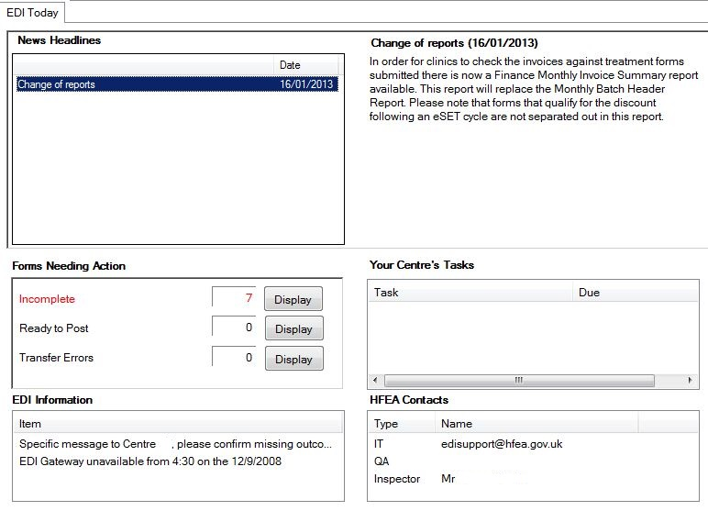
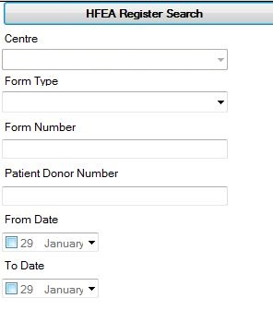
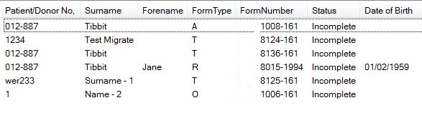
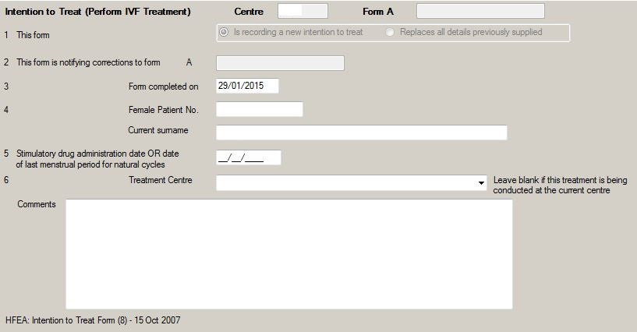
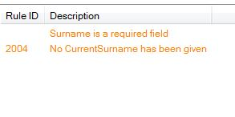
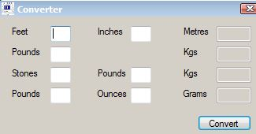
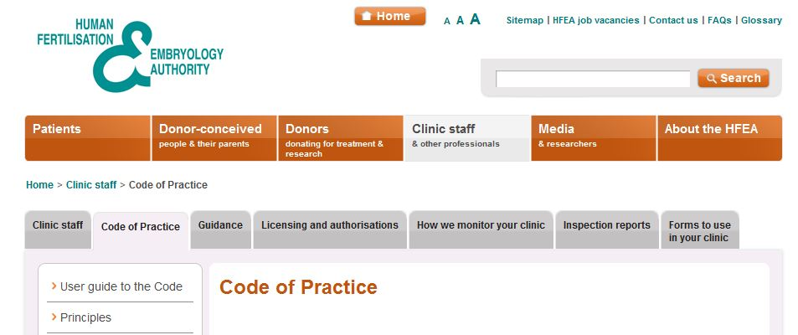

    - Clinic Portal Screenshots

Login Screen
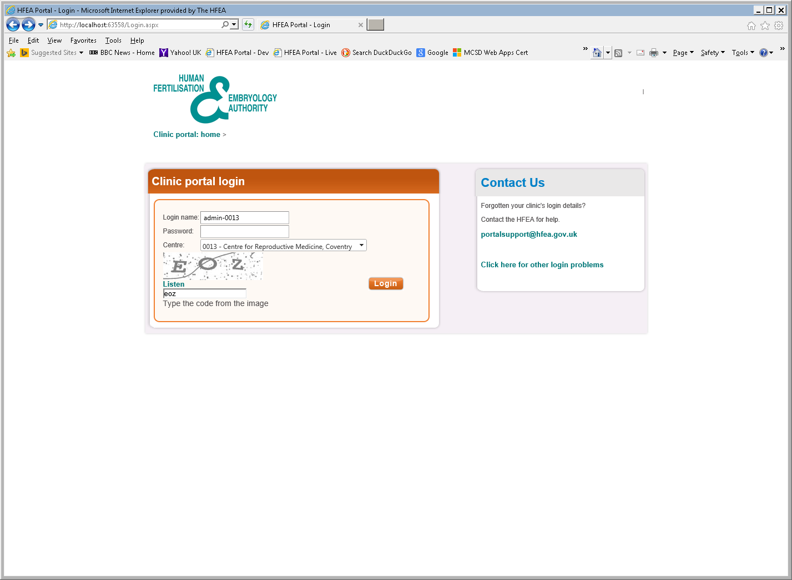
Home Screen
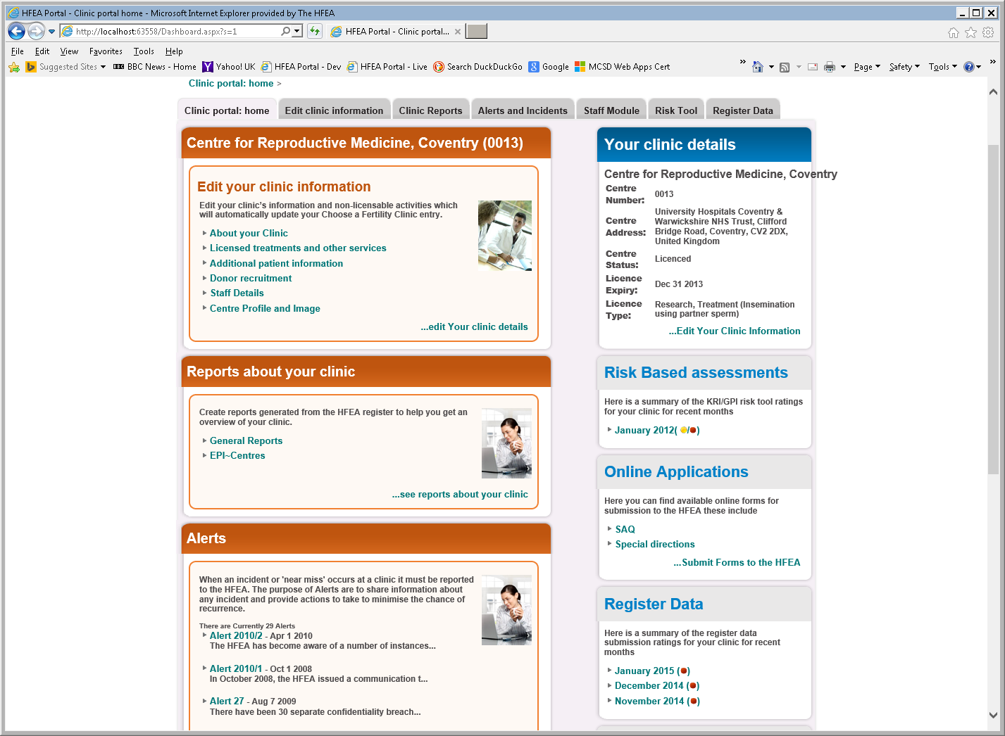

Edit your Clinic
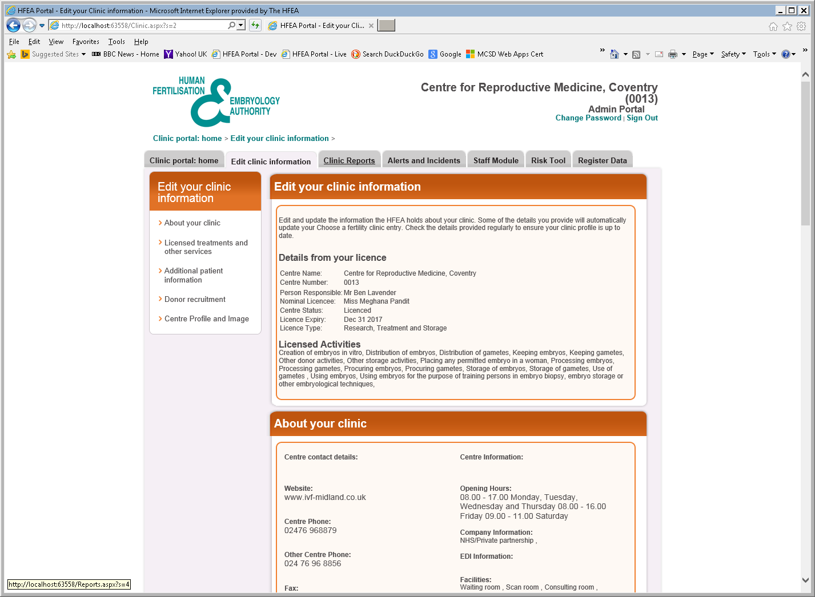
Clinic Reports
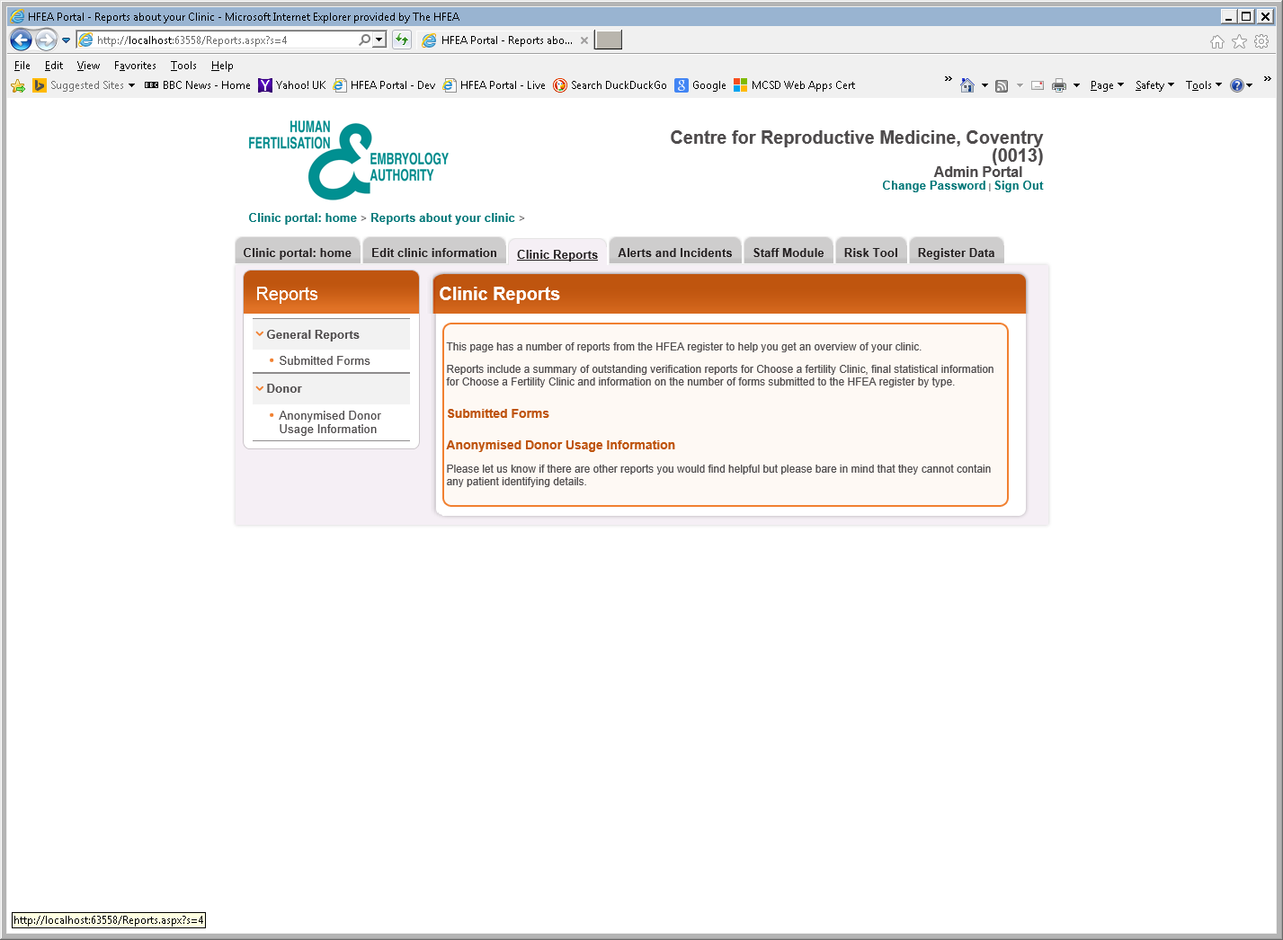

Alerts and Incidents
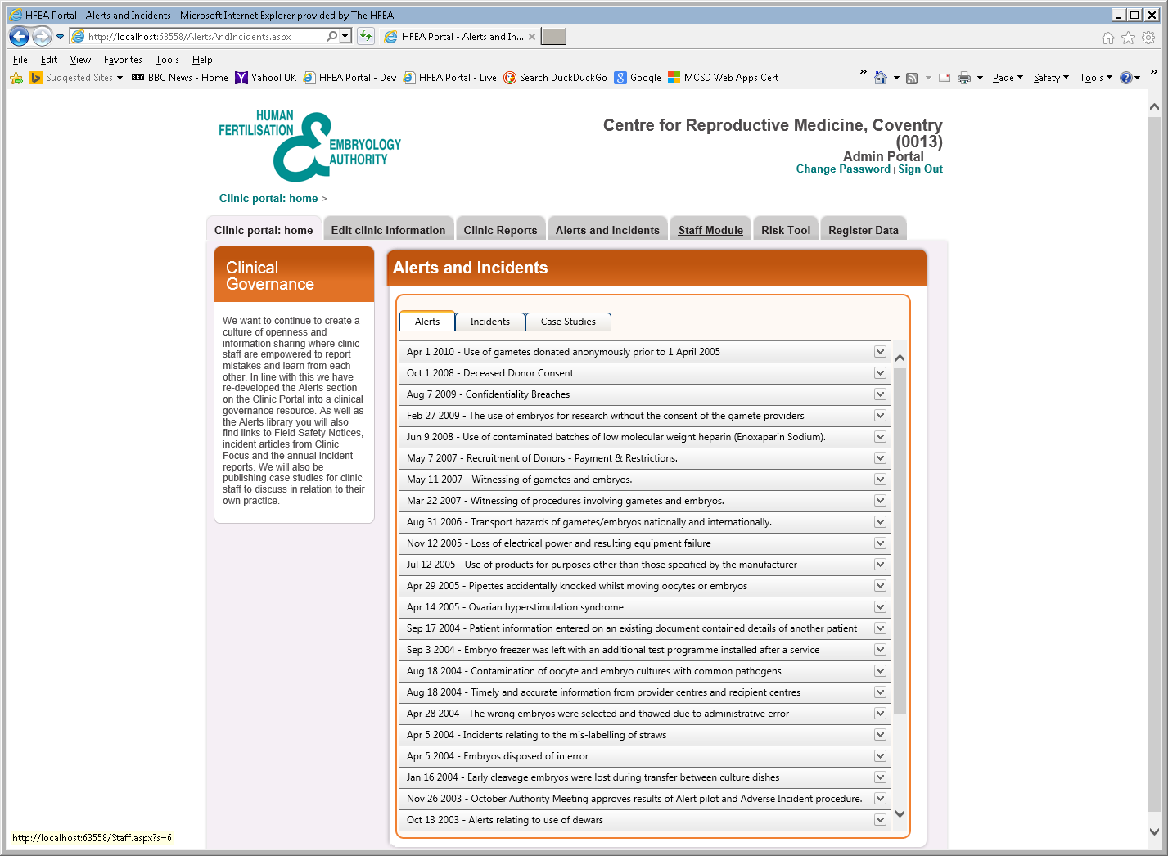
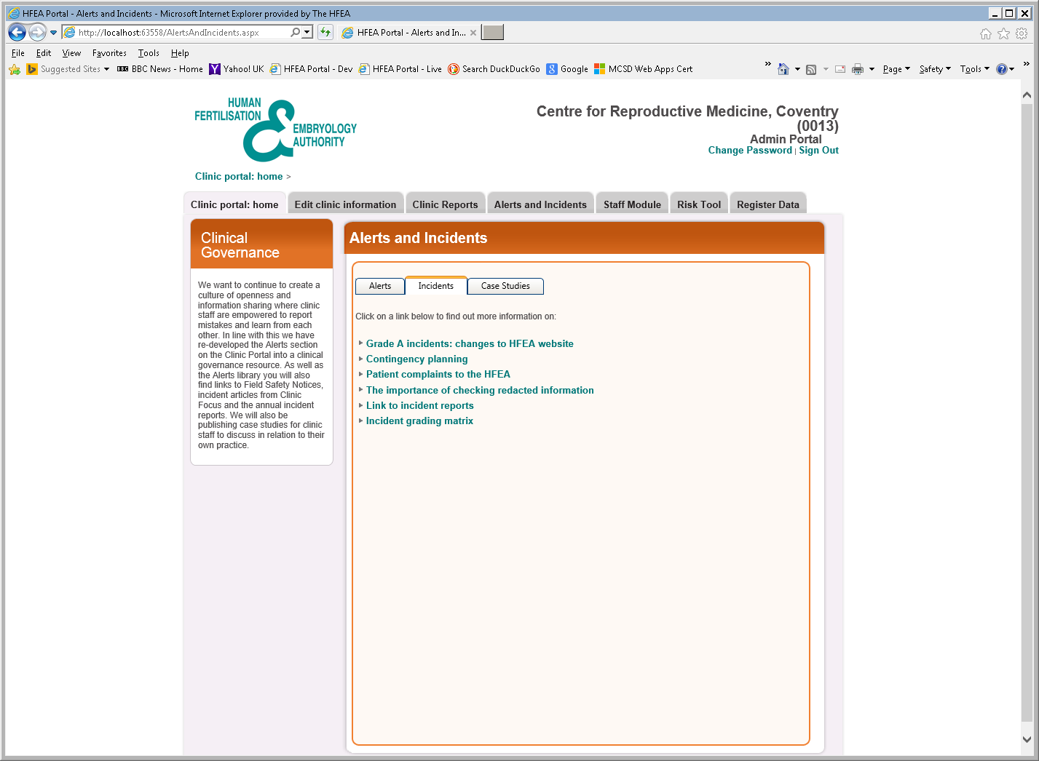

Staff Module
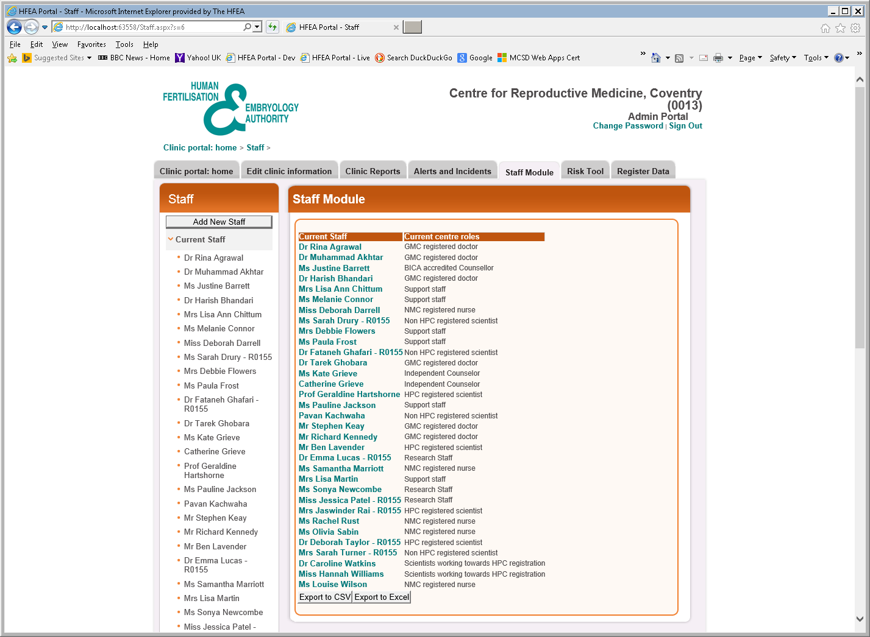
Risk Tool
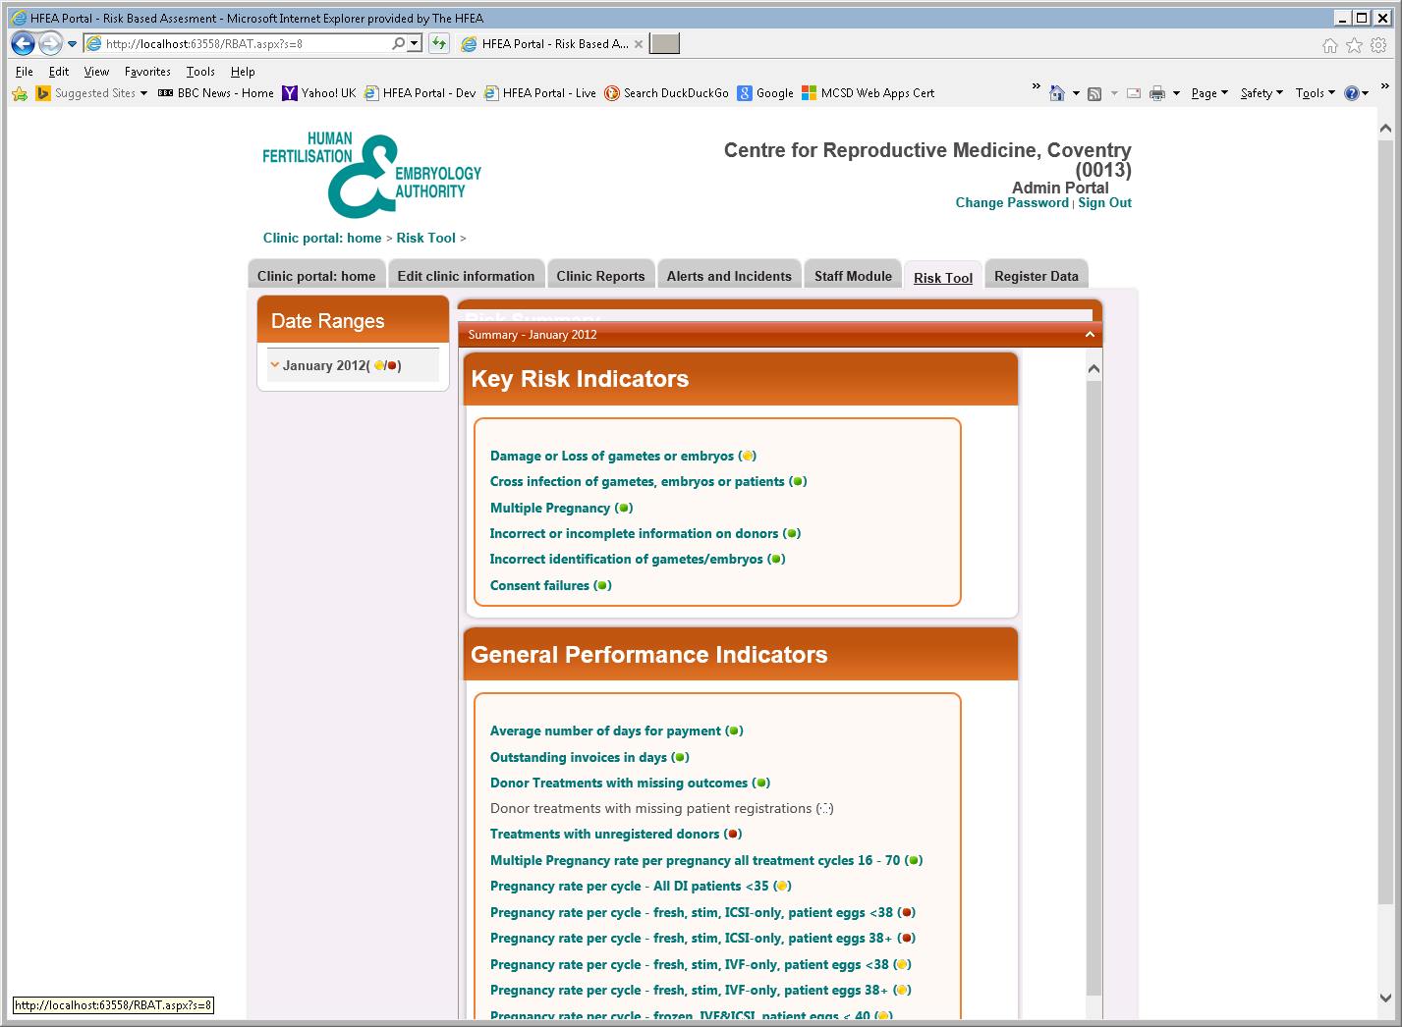
Register Data
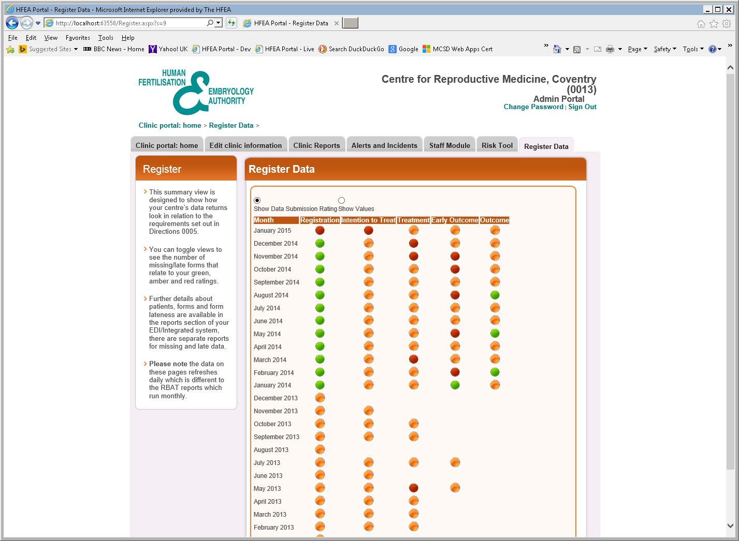
Finance
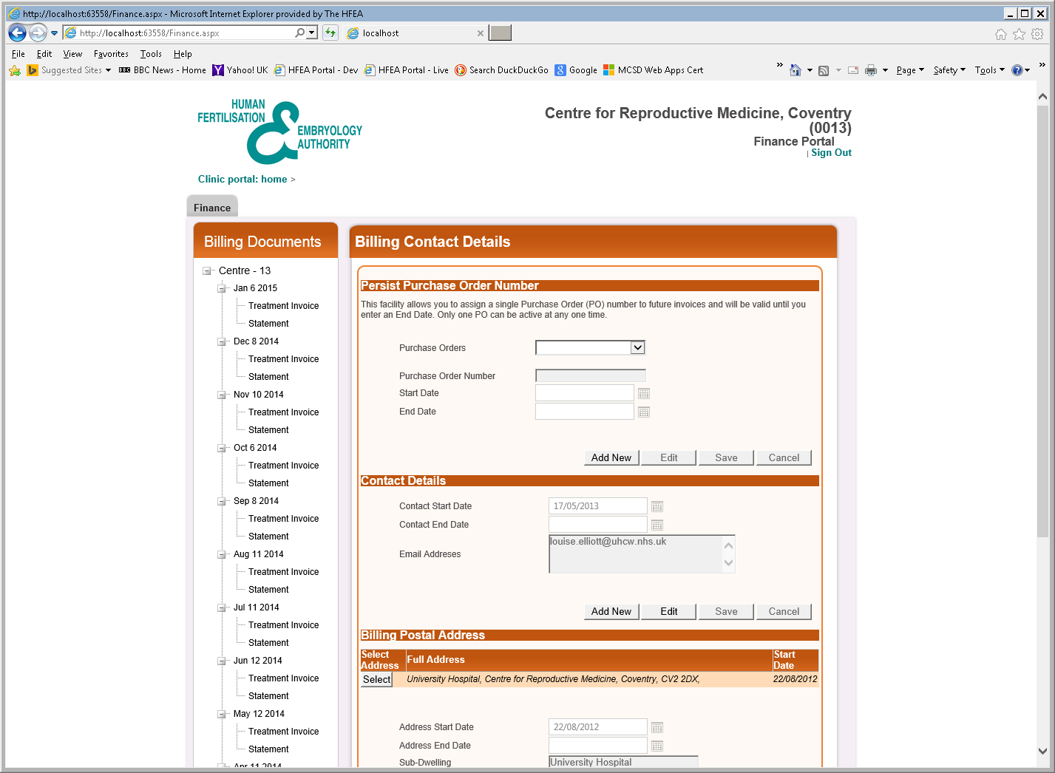

Product Backlog
https://app.smartsheet.com/b/publish?EQBCT=34c5ecd54cec4eadbf7be80922ca677b

