Site Specification

FOR

ESTATE & ENVIRONMENTAL SERVICES – CONVENT ESTATE, CLARE GARDENS – ESTATE ENTRY IMPROVEMENTS PROJECT.

RBKC-HM REF: RBKC-HM/2021/053

CONTENTS

Section Page

1 Scope of Works/Services 3

2 Specification 4

SECTION 1 – Scope of Works/Services

2.1 The Project
Name: Convnet Estate, Clare Gardens.
Nature: Estate Entry Improvements Project.
Location: Convent Estate, Clare Gardens, London, W11 1NX

2.2 Employer
The Royal Borough of Kensington and Chelsea Housing Management (RBKC-HM), 292a The Network Hub, Kensal Road, North Kensington, London W10 5BE.

2.3 Description of work

To supply labour, plant, materials and temporary materials to carry out the Estate Entry Improvements Project works to the one estate entrance way from Ladbroke Grove and two estate entrance ways on Blenheim Crescent.

Ladbroke Grove Entrance

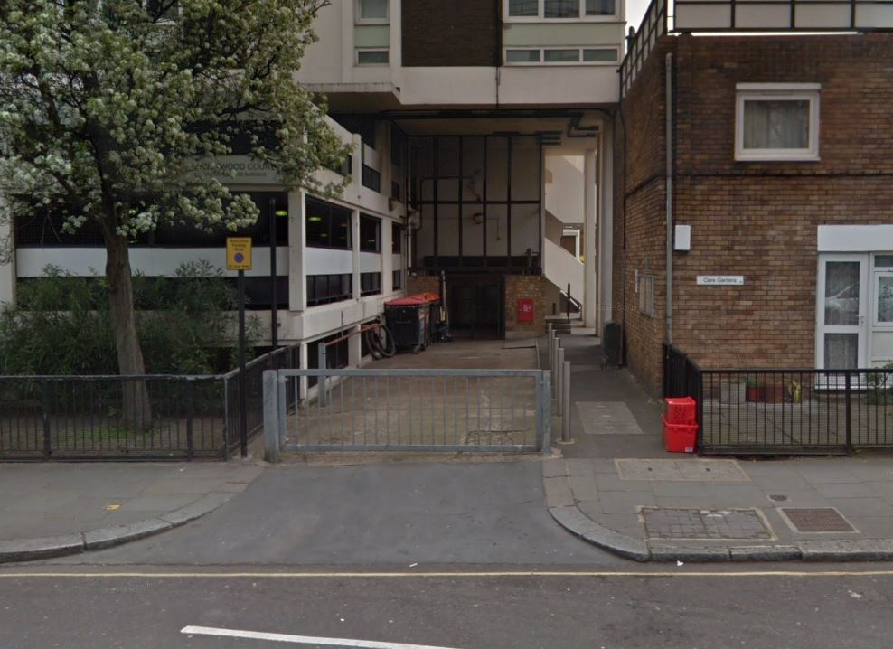

Blenheim Crescent Entrances

1st Entrance (Designated A)
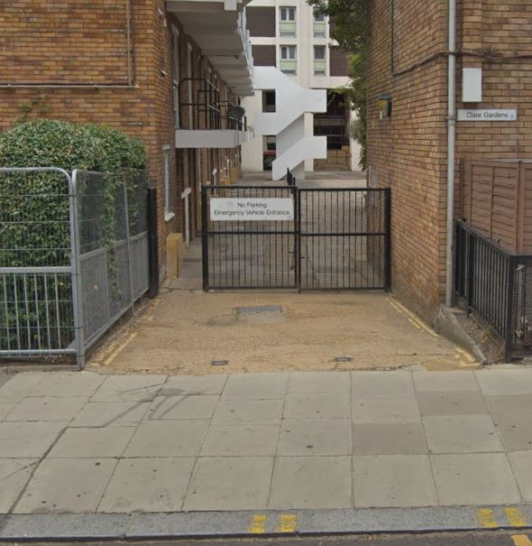

2nd Entrance (Designated B)

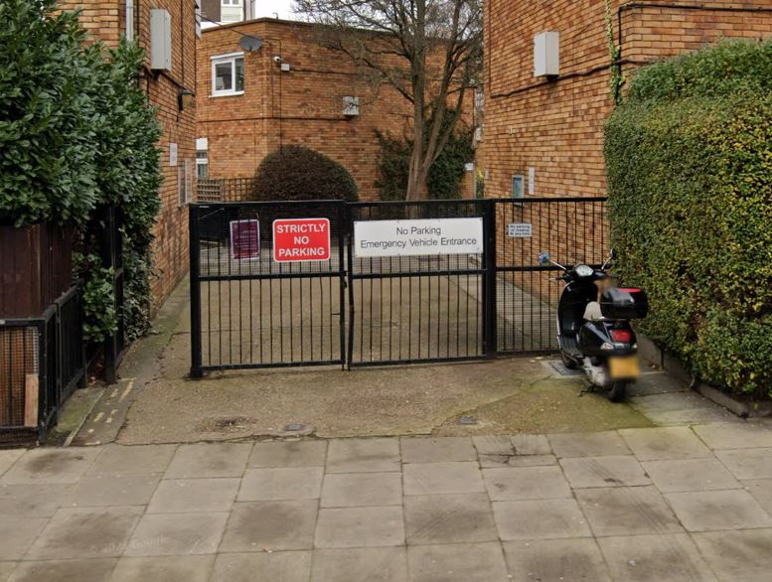
SECTION 2 – Specification

Item | Specification
1 | Undertake an onsite inspection and full site survey.
 | Lowerwood Court Entrance
2 | Undertake the removal of current arm barrier from the Lowerwood court entrance and retain for RBKC to collect and store.
3 | Undertake the fabrication and installation of two manually operated vehicle gates, as per drawing App (6b). Each gate is approx. 2899mm length x 1800mm height, with associated posts. Each gate to have drop bolts to be secured by FB Padlocks.
4 | Installation of HB Gerda Lock (number to be confirmed) upon manually operated vehicle gates for security.
5 | Undertake the fabrication and installation of pedestrian gate and associated surrounding metal works to fit location approx. 1887mm length x 1800mm height. Gate aperture to open a minimum of 1200mm, hung on the left hand side to open toward the vehicle gates into the site.
6 | Supply and instal subsurface self-closer device for gate and vertical pull/push handles to be a minimum of 300mm. Gate specified shall be an electro Mechanical low energy automatic gate operation with on door safety sensors for both opening and closing operations with finger trap protection.
7 | Supply and install new Entrotec audio door entry system, as per equipment performance specification found within App 4b, and to be inline and compatible with, and connected to the new system already installed within Lowerwood Court. Please see App 4b for further information.
8 | Supply and Instal Call Panel - 2.5mm stainless Steel to BS316 Call Panel with Mitred Bezelled back box, Call Buttons with Yellow contrasting rings (Functional call panel only), On digital system white LED contrasting rings on the digital keypad shall be used, Visual display unit, KMS Proximity Reader. Door Entry Entrotec Apex Controllers (dependant on the size of the system), with integrated KMS controller and GPRS modem, SIM card with external high gain aerial. SIM and Host fee for 24 months. Please see App 4b for further information.
9 | Entrotec PTE/EPTE/YR Push to Exit where electronic exit of the door is required, this shall be either flush or surface as the installer requires to suit the block and installation. Location to be a minimum of 1000mm from the point of exit for security. Please see App 4b for further information.
10 | New Fire switch for any MED or controlled access where the fire service will require access. Please see App 4b for further information.
11 | Supply and install Entrotec ED4+ handset, one per dwelling, totalling 37 + 5 spare. Please see App 4b for further information.
12 | The Contractor shall supply and install a complete new conduit system for the Entryphone cabling. The conduits shall be 20mm and 25mm Class 4 heavy gauge steel, surface fixed with all the proprietary accessories, e.g. boxes, adaptable boxes, saddles, couplings etc. necessary to provide a complete and satisfactory installation. All the system cabling shall be enclosed within the new conduit system to allow the system to be rewireable, except when the contractor installs cabling within the individual dwellings, which shall be installed in PVC miniature trunking. However the preferred method is a conduit to the handset location. The conduit installation shall be fully completed before any cables are drawn into it. Please see App 4b for further information.
13 | Supply and install all associated cabling, system control units and Electrical supply. Please see App 4b for further information.
 | Blenhiem Crescent (Location A)
14 | Option A (to be included within the total bid cost) – Undertake the Repair and Restoration of the vehicle and pedestrian gates currently on site.
15 | Option B (to be advised as an optional extra but NOT included in the total bid cost) - Undertake the fabrication and installation of new pedestrian and Vehicle gates as per currently on site.
16 | Installation of HB Gerda Lock (number to be confirmed) upon manually operated vehicle gates for security.
17 | Supply and instal subsurface self-closer device for gate and vertical pull/push handles to be a minimum of 300mm. Gate specified shall be an electro Mechanical low energy automatic gate operation with on door safety sensors for both opening and closing operations with finger trap protection.
18 | Supply and install new Entrotec Fob reader Only, as per equipment performance specification found within App 4b, and to be inline and compatible with, and connected to the new system already installed within Lowerwood Court. Please see App 4b for further information.
19 | Entrotec PTE/EPTE/YR Push to Exit where electronic exit of the door is required, this shall be either flush or surface as the installer requires to suit the block and installation. Location to be a minimum of 1000mm from the point of exit for security. Please see App 4b for further information.
20 | Supply and install all associated cabling, system control units and Electrical supply. Please see App 4b for further information.
21 | New Fire switch for any MED or controlled access where the fire service will require access. Please see App 4b for further information.
 | Blenhiem Crescent (Location B)
22 | Option A (to be included within the total bid cost) – Undertake the Repair and Restoration of the vehicle and pedestrian gates currently on site.
23 | Option B (to be advised as an optional extra but NOT included in the total bid cost) - Undertake the fabrication and installation of new pedestrian and Vehicle gates as per currently on site.
24 | Installation of HB Gerda Lock (number to be confirmed) upon manually operated vehicle gates for security.
25 | Supply and instal subsurface self-closer device for gate and vertical pull/push handles to be a minimum of 300mm. Gate specified shall be an electro Mechanical low energy automatic gate operation with on door safety sensors for both opening and closing operations with finger trap protection.
26 | Supply and install new Entrotec audio door entry system, as per equipment performance specification found within App 4b, and to be inline and compatible with, and connected to the new system already installed within Lowerwood Court. Please see App 4b for further information.
27 | Supply and Instal Call Panel - 2.5mm stainless Steel to BS316 Call Panel with Mitred Bezelled back box, Call Buttons with Yellow contrasting rings (Functional call panel only), On digital system white LED contrasting rings on the digital keypad shall be used, Visual display unit, KMS Proximity Reader. Door Entry Entrotec Apex Controllers (dependant on the size of the system), with integrated KMS controller and GPRS modem, SIM card with external high gain aerial. SIM and Host fee for 24 months. Please see App 4b for further information.
28 | Entrotec PTE/EPTE/YR Push to Exit where electronic exit of the door is required, this shall be either flush or surface as the installer requires to suit the block and installation. Location to be a minimum of 1000mm from the point of exit for security. Please see App 4b for further information.
29 | Supply and install all associated cabling, system control units and Electrical supply. Please see App 4b for further information.
30 | New Fire switch for any MED or controlled access where the fire service will require access. Please see App 4b for further information.
 | Extras
31 | Supply and programme of 151 KMS system fobs with 3x fobs programmed per the 27 flat (111 in total) in 3 alternative colours, plus 40 additional KMS fobs in a 4th colour. (Please see App 4b for further information)

