

**INVITATION TO TENDER [ITT]**

**Version 7 [13 Dec 2023]**

**PROPOSED SERVICES – works to refurbish the Halls of Residence and to provide wider Principal duties at Shuttleworth College; Old Warden Park; Biggleswade; Bedfordshire; SG18 9DX**

**1.0 Introduction**

Bedford College is seeking a **fixed price tender** to carryout refurbishment works to five halls of residence and the linked common room at Shuttleworth College. There are two residential blocks comprising of 80 rooms.

During the period 05/02/24 and 28/06/24; four of the five blocks plus the common room shall be occupied. Until. Work to the student residential blocks will be phased commencing with Patworth Hall. The block will remain empty during the works. Once work is completed, residents will relocate to Patworth Hall and work to Ongley Hall will commence.

Block 1 – Clayton & Edmunds.

Block 2 – Milner; Ongley & Patworth

Block 1 was partially refurbished in the summer of 2013. The bedrooms were stripped out and new loose/fixed furniture installed. The electrical system was upgraded

All blocks have had minor updating including the shower rooms.

The tender shall also include for providing site welfare and principal contractor duties for two other work packages [see Note 1 below]:

* Flat roofing & insulation works to the following buildings – The two hall of residence blocks; common room; Russell Hall [excluding the sports hall] & the LRC/IT block.
* District heating; new plant room works [adjacent to the ZEC] and heating updating [excluding the Halls of Residence].

*Note 1* – all of the preliminaries associated with the work packages above [excluding the provision of welfare are excluded from this tender.

*Note 2* - The roofing works are programmed to be carried out between 05/02/2024 and 21/06/2024. [20 weeks]

*Note 3* - The SALIX works [district heating; plant room and heating (excluding the Halls of Residence]. Works are planned to commence on 25/03/24 and be completed [including witnessing & commissioning by 30/09/24 [27 weeks]

The main works to halls of residence are scheduled to commence on 05/02/24 and be fully completed for occupation by 30/08/24 [34 weeks].

Tender should include the following.

1. All of the works to the Halls of Residence and the common room. See note 4

*Note 4* – The tender for these works shall be submitted by the addition of two contract sum analysis cost schedules [SALIX and non-Salix works (excluding the works set out in note 1]

1. Provided site welfare and principal contraor support for the additional work packages set out in *Note 1.*

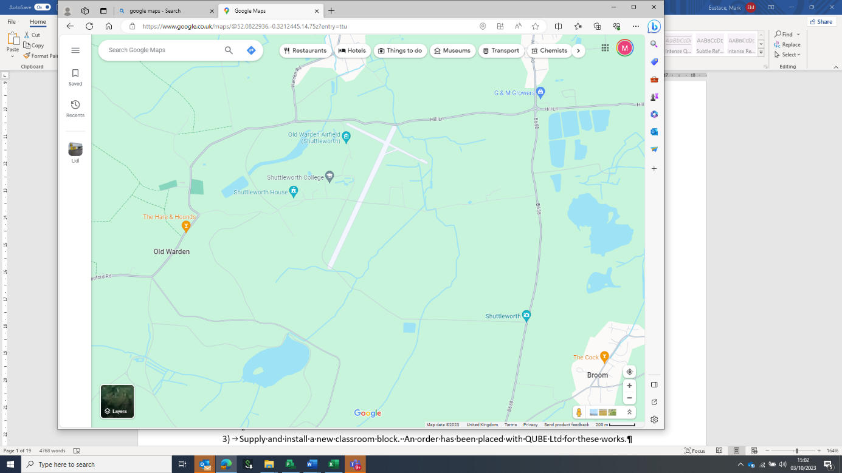

Access to Shuttleworth College from B658

Site Location

Plan A - Location of the planned works. [see note 5]

*Note 5* – all deliveries must be completed using the entrance from the B658 and not via the estate entrance from Shuttleworth village.

**2.0 Tender Information.**

The project is fully funded and supported via a government SALIX grant.

The College campus and Shuttleworth estate shall be fully operational for the entire duration of the project. Learners will be present in buildings and land adjacent to the site area during the works. Shuttleworth College is live work area that provides facilities for animal management; horticulture and agricultural studies.

Bedford College have appointed a team of consultants [see V3 PROJECT DIRECTORY 03 Oct 2023] who are delivering the project up to the handover to the turnkey contractor. The consultant team are working on the project under the employment of Bedford College.

Mark Eustace [Capital Works Project Manager - CWPM] will be the main point of contact and the sole source for answering questions and queries during the tender [**via email only** - [*meustace@bedford.ac.uk*](mailto:meustace@bedford.ac.uk)*]*

The key dates for the project are set out below in Table A.

|  |  |
| --- | --- |
| *Project Milestone* | *Key Date/Duration* |
| Release tender information – | Tuesday 12 Dec 2023. |
| Tender period | 6 weeks |
| Return the second stage tender | *12:00 on Monday 15 Jan 2024*  ***NOTE: the tender return shall be via email only*** *to tenders@bedford.ac.uk* |
| Tender award | Friday 19 Jan 2024. |
| Start on site | Monday 05 Feb 2024 |
| Completion of the works | Friday 30 August 2024 |

Table A – *Key Project Milestones*

|  |  |  |  |
| --- | --- | --- | --- |
| Task Name | Duration [days] | Start | Finish |
| REFURBISHMENT WORKS TO PATWORTH HALL | 49 | Mon 05/02/24 | Thu 11/04/24 |
| REFURBISHMENT WORKS TO ONGLEY HALL | 49 | Fri 12/04/24 | Wed 19/06/24 |
| REFURBISHMENT WORKS TO ONGLEY HALL | 49 | Thu 20/06/24 | Tue 27/08/24 |
| Complete Patworth & Ongley | 1 | Thu 20/06/24 | Thu 20/06/24 |
| REFURBISHMENT WORKS TO CLAYTON HALL | 49 | Thu 20/06/24 | Tue 27/08/24 |
| REFURBISHMENT WORKS TO EDMUND HALL | 49 | Mon 24/06/24 | Thu 29/08/24 |
| Complete Halls of Residence Refurbishment | 0 | Thu 29/08/24 | Thu 29/08/24 |
| SALIX ROOF INSULATION WORKS | 96 | Fri 09/02/24 | Fri 21/06/24 |
| Whole Campus SALIX Works | 126 | Mon 11/03/24 | Mon 02/09/24 |

Table B – *Key Durations and Dates*

Please note that Bedford College is seeking a project specific tender submission that takes full account of the project information and the nature of the client. Generic bid submissions that take no account of the ITT will be ruled invalid.

Any quote will be deemed to include supply; delivery of the works & commissioning in line with agree timetable [see Table A].

The specification for the tender is set out in the schedule of tender information in Table C

|  |  |
| --- | --- |
|  | **GENERAL INFORMATION** |
| 1 | V3 Halls of Residence Fit Out Works plus roofing & SALIX whole campus works 11 Dec 2023.pdf |
| 2 | SALIX Cost Breakdown.xlsx |
| 3 | Staff Safeguarding Leaflet - April 2022.pdf |
| 4 | V1 Site Plan 07 Dec 2023.docx |
| 5 | V3 Halls of Residence Fit Out Works plus roofing & SALIX whole campus works 11 Dec 2023.mpp |
| 6 | V3 NON SALIX WORKS Halls of Residence CONTRACT SUM ANALYSIS Shuttleworth 13 DEC 2023.xlsx |
| 7 | V3 SALIX WORKS Halls of Residence CONTRACT SUM ANALYSIS Shuttleworth 13 DEC 2023.xlsx |
| 8 | V7 ITT works to refurbish Halls of Residence and provide Principal Contractor Duties 13 Dec 2023 (2).xlsx |
| 9 | V1 Schedule of Tender Information.XLS |
|  | **ARCHITECTURAL INFORMATION** |
|  | 2211 Shuttleworth Salix - Issue Sheet - Tender 13.12.23.pdf |
| 1 | 2211-DA-00-DR-A-250_T2 GF and 1st Floor Strip Out Plan - CE.pdf |
| 2 | 2211-DA-00-DR-A-251_T2 2nd Floor Strip Out Plan - CE.pdf |
| 3 | 2211-DA-00-DR-A-252_T2 Existing GF and 1F Strip Out Plans - MOP.pdf |
| 4 | 2211-DA-00-DR-A-253_T2 Existing 2F Strip Out Plans - MOP.pdf |
| 5 | 2211-DA-00-DR-A-310_T2 Proposed GF and 1F Plans - CE.pdf |
| 6 | 2211-DA-00-DR-A-311_T2 Proposed 2F and Roof Plan - CE.pdf |
| 7 | 2211-DA-00-DR-A-312_T2 Proposed GF and 1F Plans - MOP.pdf |
| 8 | 2211-DA-00-DR-A-313_T2 Proposed 2F and Roof Plan - MOP.pdf |
| 9 | 2211-DA-00-DR-A-314_T2 Proposed Common Room Ground and Roof Plans.pdf |
| 10 | 2211-DA-00-DR-A-325_T2 Proposed Elevations 1 - CE.pdf |
| 11 | 2211-DA-00-DR-A-326_T2 Proposed Elevations 2 - CE.pdf |
| 12 | \2211-DA-00-DR-A-327_T2 Proposed Elevations - MOP.pdf |
| 13 | 2211-DA-00-DR-A-370_T2 Proposed GF and 1F RCP - CE.pdf |
| 14 | 2211-DA-00-DR-A-371_T2 Proposed 2F RCP - CE.pdf |
| 15 | 2211-DA-00-DR-A-372_T2 Proposed GF and 1F RCP - MOP.pdf |
| 16 | 2211-DA-00-DR-A-373_T2 Proposed 2nd Floor and Roof RCP - MOP.pdf |
| 17 | 2211-DA-00-DR-A-470_T2 External Window Schedule.pdf |
| 18 | 2211-DA-00-DR-A-520_T2 Internal Door Schedule.pdf |
| 19 | 2211-DA-00-DR-A-550_T2 Proposed GF and 1st Floor Finishes - CE.pdf |
| 20 | 2211-DA-00-DR-A-551_T2 Proposed 2nd Floor Finishes - CE.pdf |
| 21 | 2211-DA-00-DR-A-552_T2 Proposed Floor Finishes - MOP.pdf |
| 22 | 2211-DA-00-EX-A-200_T2 Existing Site Location Plan.pdf |
| 23 | 2211-DA-00-EX-A-201_T2 Existing Site Location Plan.pdf |
| 24 | 2211-DA-00-EX-A-220_T2 Existing GF and 1F Plans - CE.pdf |
| 25 | 2211-DA-00-EX-A-221_T2 Existing 2F and Roof Plans - CE.pdf |
| 26 | 2211-DA-00-EX-A-222_T2 Existing Elevations 1 - CE.pdf |
| 27 | 2211-DA-00-EX-A-223_T2 Existing Elevations 2 - CE.pdf |
| 28 | 2211-DA-00-EX-A-225_T2 Existing GF and 1F Plans - MOP.pdf |
| 29 | 2211-DA-00-EX-A-226_T2 Existing 1F and Roof Plans - MOP.pdf |
| 30 | 2211-DA-00-EX-A-227_T2 Existing Elevations - MOP.pdf |
| 31 | 2211-DA-DET-DR-A-410_T2 Residential Accommodation Roof Details.pdf |
| 32 | 2211-DA-DET-DR-A-411_T2 Residential Accommodation Roof Details 2.pdf |
| 33 | 2211-DA-DET-DR-A-510_T2 Window Detail Section - Residential Accomodation.pdf |
| 34 | 2211-DA-DET-DR-A-511 Detailed Sections - Common Room.pdf |
| 35 | 2211-DA-DET-DR-A-570_T2 Kitchen Details - Residential Accomodation.pdf |
| 36 | 211-471_T2_External Window Schedule.xlsx |
| 37 | 2211-521_T2_Internal Door Schedule.xlsx |
|  | **MES INFORMATION** |
| 1 | 02-15-E-LX-05 Patworth Elec Services Fit Out.pdf |
| 2 | 02-15-E-LX-11 Edmunds Elec Services SALIX.pdf |
| 3 | 02-15-E-LX-12 Clayton Elec Services SALIX.pdf |
| 4 | 02-15-E-LX-13 Milner Elec Services SALIX.pdf |
| 5 | 02-15-E-LX-14 Ongley Elec Services SALIX.pdf |
| 6 | 02-15-E-LX-15 Patworth Elec Services SALIX.pdf |
| 7 | 02-15-E-SP-99 Electrical Spec.pdf |
| 8 | 02-15-M-CSA-01 Mechanical - HOR Fit Out.xlsx |
| 9 | 02-15-M-CSA-02 Mechanical - HOR SALIX.xlsx |
| 10 | 02-15 DR-M-T00 Document register.pdf |
| 11 | 02-15 DR-M-T01 Document register.pdf |
| 12 | 02-15 M-CS-01-T00 Mechanical coversheet.pdf |
| 13 | 02-15 M-CS-02-T00 Mechanical coversheet.pdf |
| 14 | 02-15 M-LX-01-T00 Edmunds Hall heating plan.pdf |
| 15 | 02-15 M-LX-02-T00 Edmunds Hall heating BWIC.pdf |
| 16 | 02-15 M-LX-03-T00 Edmunds Hall hot & cold water plan.pdf |
| 17 | 02-15 M-LX-04-T00 Edmunds Hall hot & cold water BWIC.pdf |
| 18 | 02-15 M-LX-05-T00 Clayton Hall heating plan.pdf |
| 19 | 02-15 M-LX-06-T00 Clayton Hall heating BWIC.pdf |
| 20 | 02-15 M-LX-07-T00 Clayton Hall hot & cold water plan.pdf |
| 21 | 02-15 M-LX-08-T00 Clayton Hall hot & cold water BWIC.pdf |
| 22 | 02-15 M-LX-09-T00 Milner Hall heating plan.pdf |
| 23 | 02-15 M-LX-10-T00 Milner Hall heating BWIC.pdf |
| 24 | 02-15 M-LX-11-T00 Milner Hall hot & cold water plan.pdf |
| 25 | 02-15 M-LX-12-T00 Milner Hall hot & cold water BWIC.pdf |
| 26 | 02-15 M-LX-13-T00 Ongley Hall heating plan.pdf |
| 27 | 02-15 M-LX-14-T00 Ongley Hall heating BWIC.pdf |
| 28 | 02-15 M-LX-15-T00 Ongley Hall hot & cold water plan.pdf |
| 29 | 02-15 M-LX-16-T00 Ongley Hall hot & cold water BWIC.pdf |
| 30 | 02-15 M-LX-17-T00 Patworth Hall heating plan.pdf |
| 31 | 02-15 M-LX-18-T00 Patworth Hall heating BWIC.pdf |
| 32 | 02-15 M-LX-19-T00 Patworth Hall hot & cold water plan.pdf |
| 33 | 02-15 M-LX-20-T00 Patworth Hall hot & cold water BWIC.pdf |
| 34 | 02-15 M-LX-21-T00 Common Room heating plan.pdf |
| 35 | 02-15 M-LX-22-T00 Common Room heating BWIC.pdf |
| 36 | 02-15 M-LX-23-T00 Common Room hot & cold water plan.pdf |
| 37 | 02-15 M-LX-24-T00 Common Room hot & cold water BWIC.pdf |
| 38 | 02-15 M-SC-03-T00 Edmunds Hall heating diagram.pdf |
| 39 | 02-15 M-SC-04-T00 Edmunds Hall hot & cold water diagram.pdf |
| 40 | 02-15 M-SC-05-T00 Clayton Hall heating diagram.pdf |
| 41 | 02-15 M-SC-06-T00 Clayton Hall hot & cold water diagram.pdf |
| 42 | 02-15 M-SC-07-T00 Milner Hall heating diagram.pdf |
| 43 | 02-15 M-SC-08-T00 Milner Hall hot & cold water diagram.pdf |
| 44 | 02-15 M-SC-09-T00 Ongley Hall heating diagram.pdf |
| 45 | 02-15 M-SC-10-T00 Ongley Hall hot & cold water diagram.pdf |
| 46 | 02-15 M-SC-11-T00 Patworth Hall heating diagram.pdf |
| 47 | 02-15 M-SC-12-T00 Patworth Hall hot & cold water diagram.pdf |
| 48 | 02-15 M-SC-13-T00 Common Room heating diagram.pdf |
| 49 | 02-15 SPC-M-02-T00 Mat & Equip specification - Heating.pdf |
| 50 | 02-15 SPC-M-03-T00 Mat & Equip specification - Plumb & Drain.pdf |
| 51 | 02-15 SPC-M-T00 Mech specification.pdf |
| 52 | 02-15-E DIN1 061223.pdf |
| 53 | 02-15-E-CS-91 Electrical Details.pdf |
| 54 | 02-15-E-CSA-01 Electrical - HOR Fit Out.xlsx |
| 55 | 02-15-E-CSA-02 Electrical - HOR SALIX.xlsx |
| 56 | 02-15-E-LX-01 Edmunds Elec Services Fit Out.pdf |
| 57 | 02-15-E-LX-02 Clayton Elec Services Fit Out.pdf |
| 58 | 02-15-E-LX-03 Milner Elec Services Fit Out.pdf |
| 59 | 02-15-E-LX-04 Ongley Elec Services Fit Out.pdf |

Table C – *Schedule of Tender Information.*

The quote for the works [unless agreed by Bedford College] shall be in full accordance with Table B & C.

**3.0 Site Set Up & Welfare**

The College has identified the tennis courts as a location for the temporary site and welfare area. The principal contractor will be expected to provide facilities that are sufficient for all of the works contractors who will be on site.

There is no drainage located in the tennis court area and therefore all toilet accommodation shall be connected to waste storage. To avoid health issues for the site operatives and inconvenience to the staff and students at the college, the tanks shall be emptied on a regular basis.

Site accommodation shall comprise of the following:

|  |
| --- |
| Site Office |
| Welfare/canteen |
| Changing/drying room |
| Meeting room |
| 3 + 1 Toilet |
| Storage container |
| CCTV/site lighting |
| Heras fencing and gates |
| Haul road |

Table D – *Schedule of Site Accommodation.*

The contractor shall allow for creating the access to the temporary site set up area. Protection and full reinstatement to the fencing and playing surface will form part of the works. The PC shall allow for securing the site at all times.

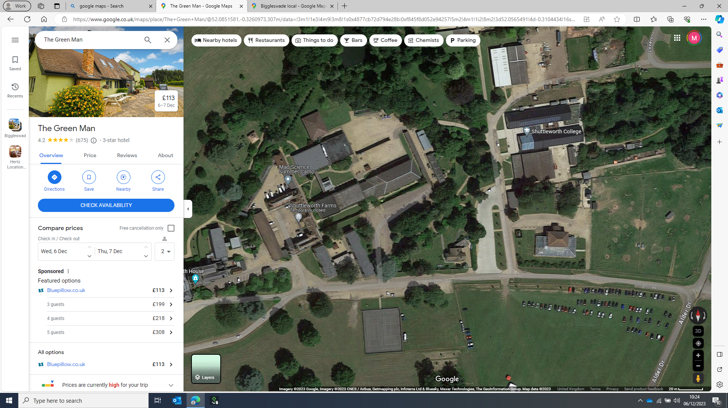

Refurbishment works – Halls of Residence/Common Room

AHHP/Plant Room

SALIX work Russell Hall

SALIX work LRC/IT teaching block

Site Compound

`

Plan B - Location of the Works

**4.0 Site Visits During the Tender Period.**

The College have allocated four site visit slots during the tender process. Visits will be agreed on a “first come, first served” basis. All visits shall pre agreed via email with Mark Eustace [meustace@bedford.ac.uk]

|  |  |  |
| --- | --- | --- |
|  | *Wednesday 20 Dec 2023* | *Wednesday 03 Jan 2024* |
| Slot 1 | 09:00 – 11:00 | 09:00 – 12:45 |
| Slot 2 |  | 11:00 – 14:45 |
| Slot 3 |  | 15:00 – 16:45 |

Table E – *Schedule of Visit Slots*

Direct unannounced visits to site will not be permitted.

**5.0` Safeguarding and DBS Checks.**

The refurbishment/SALIX works are being carried on very busy college campus and inevitability the on-site team will be working near to learners and staff. Bedford College have a published safeguarding guidance for the operation of their education sites [*Staff Safeguarding Leaflet - April 2022*]. The contractor shall always execute the works in full accordance with this guidance.

The purpose of the Bedford College safeguarding guidance is to set out the “preventative and precautionary approaches to planning and procedures that are necessary to be in place to protect all students, staff and visitors and minimise risk from any potential harm.”

Refurbishment/SALIX works are scheduled to be carried out during term time when learners will still be present on site, as well as during holidays. Therefore, the entire survey team and support management team shall be fully Enhanced DBS checked. The cost and application for the DBS checking should be organised by the contractor; the Capital Works Project Manager can request to inspect the checks at any time. Any member of the workforce who are unable to provide an enhanced DBS will be excluded from the works.

Further information on the application of the DBS system can be obtained via the following link:

<https://www.gov.uk/dbs-check-applicant-criminal-record/get-a-standard-or-enhanced-dbs-check-for-an-employee>

The entire workforce will be required to attend a safeguarding awareness session hosted by Bedford College.

**6.0 Health and Safety & Asbestos**

Due to the nature of the works, it is unlikely that the supplier will encounter any asbestos risk during the works.

All delivery staff shall always wear steel toe cap boots or shoes and clean branded hi-vis vests/jackets. The use of site hats will be subject to the method statement and RAMS.

Smoking will only be permitted in pre-agreed areas outside of the working area. The workforce shall not interact at any time with customers; members of the public, Willow Place staff, or visitors.

**See Appendix 1**- Pre-Construction Client Information [In accordance with the CDM Regulations 2015]

**7.0 Pricing Schedule & contract.**

Please include the following information in your offer letter on headed paper.

1. Prices in accordance with the combined Contract Sum Analysis [excluding VAT].
2. Preliminaries
3. Overhead and profits
4. Percentage addition to Provisional Sums
5. 12 warranty period under seal.
6. The contract will be a standard Building Contract Without Quantities [2016] with sectional completion.

|  |  |  |  |
| --- | --- | --- | --- |
| *Section* | *Location of the works* | *Start Date* | *End Date* |
| 01 | Work to Patworth Hall | 05/02/24 | 11/04/24 |
| 02 | Work to Ongley Hall | 12/04/24 | 19/06/24 |
| 03 | Work to Milner Hall | 20/06/24 | 27/08/24 |
| 04 | Works to Clayton & Edmunds Halls and connection of the SALIX works. | 20/06/24 | 29/08/24 |

Table F – *Contract Sections*

1. Liquidate and ascertained damages – £4,800/week.

**8.0 Schedule of potential suppliers/sub-contractors.**

Set out below is a schedule of supplier/sub-contractors who can be approached to provide a quotation of the works. Please note we are nomination or naming these companies.

* Decoration - [*smythsdecoratingltd@outlook.com*](mailto:smythsdecoratingltd@outlook.com)

Rodelle Dixon – Director [Mobile: 07790937885]

* Electrical Works [Lockcraft] - [*jc@lockcraft.com*](mailto:jc@lockcraft.com)

Jon Cartwright [Estimator / Project Manager]

Lockcraft Electrical Ltd.

01234 400 100

Unit 4 Manton Lane,

Manton Industrial Estate,

Bedford, Bedfordshire, MK41 7PB

* Bedroom Furniture [Wreake Valley] - *andy@wreakevalley.com*

Wreake Valley Craftsmen Ltd.  
Thrussington, Leicestershire, LE7 4UD  
Telephone: 01664 424380/424201  
E-mail: [info@wreakevalley.com](mailto:info@wreakevalley.com)

**9.0 Tender Instructions & validity**

1. Tenders must be returned via email to [tenders@bedford.ac.uk](mailto:tenders@bedford.ac.uk) at 12:00 on Monday 15 Jan 2024.
2. The tender offer shall be presented on headed paper.
3. Please ensure you allow sufficient time to submit the documents/quote/both CSA’s [in Excel format] prior to the **deadline of 12:00 on Monday 15 Jan 2024**.
4. Late tenders [or quotes sent to the wrong email address] shall be excluded from consideration.
5. All queries during the tender process shall be submitted in writing [via email] to Mark Eustace meustace@bedford.ac.uk
6. The proposal shall remain in force for a minimum of 30 days from the date fixed for the submission.
7. In submitting the proposal, the contractor shall undertake that, in the event of the submission being accepted by the College, within 30 days of being called upon to do so by the Principal or Authorised Officer on behalf of the College, the contractor will execute a formal contract.
8. Proposals shall only be submitted on the basis that they are bona fide competitive submissions.

a) shall have offered or given or agreed to give any officer or member of the College staff any gift or consideration of any kind as an inducement or bribe to influence its decision.

b) shall have communicated to any other person than the College the amount or approximate amount of the proposed submission other than in confidence in order to obtain quotations necessary for the preparation of the submission, or for insurance purposes, or

c) shall have entered into any agreement or arrangement with any person as to the amount of any proposed submission or that person shall refrain from submitting.

1. The College will exclude bidders at any time throughout the tender process should the grounds of exclusion pursuant to Public Contracts Regulations 2015 as amended be found to apply.

Please note that tenders should not be copied or submitted to any other email address. The College reserves the right to exclude any tenders that are not submitted in line with the ITT.

**10.0 Acceptance of Submission**

1. The College shall not be under any obligation to accept any proposal.
2. The College shall not be under any obligation to accept the lowest proposal.
3. The College reserves the right to cancel the entire or parts of the tender, without such an action conferring any right to compensation on the contractors.
4. At no time should the contractor, prior to submitting or following the bid submission, communicate with any person within the College in the first instance other than Mark Eustace. Failure to abide by this ruling could disqualify the contractor’s proposal from being considered.
5. The submission must be based upon the terms, conditions and specification(s) set out in these documents, otherwise it may be rejected because of being unsuitable and non-compliant.  The Form of Tender may not be modified in anyway.
6. Contractors will be notified of the outcome of their submission at the earliest possible time.
7. No submission will be deemed to have been accepted unless such acceptance has been notified to the contractor in writing.
8. In case a submission is abnormally low or high in relation to the services to be provided, the College will request a clarification in writing and/or explanation concerning its elements.  The College reserves the right to exclude a submission, if after a verification process based on the explanations and evidence received it concludes that the submission is abnormally low or high.

**11.0 Payment Terms & SALIX Grant Draw Down**

Bedford College terms are that each month’s invoices will normally be settled within 28 days. All invoices should be submitted electronically to the finance department using the email address *finance@bedford.ac.uk* quoting a valid purchase order number. Should any offer vary from the standard College payment terms then this must be agreed in writing by the Capital Works Project Manager prior to the purchase order being issued.

On a monthly basis, to assist Bedford College to draw down the SALIX grant funding, the PC shall complete the sections in yellow on the attached spreadsheet *SALIX Cost Breakdown. XLS*. The PC shall co-operate with Bedford College present invoice in accordance with the format required by the SALIX grant offer.

**12.0 Project Team**

The core project team members are identified below.

|  |  |  |  |
| --- | --- | --- | --- |
| Diane Gamble | Bedford College | Director of Estates and Facilities | [dgamble@bedford.ac.uk](mailto:dgamble@bedford.ac.uk) |
| Mark Eustace | Project Management Solutions | Capital Works Project Manager | [meustace@bedford.ac.uk](mailto:meustace@bedford.ac.uk) |
| Stuart Devonshire | Devonshire Architects | Principal Designer; design team leader and Architect | stuart@devonshirearchitects.co.uk |
| John Paul Cain | Panda CE | Mechanical & Electrical consultant | [jp@pandaces.co.uk](mailto:jp@pandaces.co.uk) |

**13.0 Tender Scoring**

Bedford College and the project team will be applying a technical/financial evaluation to determine the tender.

The tender evaluation will determine the most compliant, comprehensive and cost-effective offer.

The consultant team will review the priced schedule to determine the basis of each tender. In some cases, this may result in the request for clarification or further information to satisfy the client team that the cost is offered on a full “like for like “basis.

**APPENDIX 1**

Pre-Construction Client Information – Shuttleworth College; Old Warden Park; Biggleswade; Bedfordshire; SG18 9DX.

Pre-Construction Client Information [In accordance with the CDM Regulations 2015]

|  |  |
| --- | --- |
| Version | 6.0 |
| Date | 11 Dec 2023 |
| Author | Mark Eustace |
| Checked By: | Diane Gamble |

|  |  |
| --- | --- |
| Description of the project | Site address – Shuttleworth College; Old Warden Park; Biggleswade; Bedfordshire; SG18 9DX  The works will comprise of the refurbishment and SALIX works in the five halls of residence at Shuttleworth College. |
| [Key dates](http://www.designingbuildings.co.uk/wiki/Key_dates). | Works are planned to be carried out between 05/02/24 and 02/09/24. |
| Contact details [and roles] for the key college team | *College Project Manager [Primary Contact]*  Mark Eustace  [meustace@bedford.ac.uk](mailto:meustace@bedford.ac.uk)  07977 123039  *On Site Contact on behalf of Bedford College*  Chris Jones  [Cjones@bedford.ac.uk](mailto:Cjones@bedford.ac.uk)  Shuttleworth College Facilities Co-Ordinator |
| Principal Contractor; supervision and the operation of the works. | Bedford College will be fulfilling the role of Client/Employer for the project.  The contractor shall fulfil the role of Principal Contractor [PC].  The PC shall appoint a suitably experienced full-time non-working Senior Site Manger [SSM] for the duration of the site works.  The CWPM shall be the main point of contact for the College during the defect’s liability period. |
| The Project Team | Bedford College has appointed Project Management Solutions as Employers Agent.  The current project team structure is set out below.  The design team is being led and coordinated by Architect & Lead Designer – Stuart Devonshire [Devonshire Architects]  Mechanical & Electrical Design – JP Cain [PANDA CE]  M&E Clerk of the Works – Iain Hodkinson [PANDA CE]  Structural & Civil Engineering Consultant - Sanjay Dhanani [Waldeck] |
| The extent and location of existing information. | *The following information will be supplied in advance of the works:* |
| Project arrangements: | Working hours are as follows:  07:00– 17:00 [weekend working by prior agreement]  Smoking is only permitted on site in a pre-agreed location witing the contractors compound.  No access will be permitted to other parts of the college or the Shuttleworth Estate without prior agreement. |
| Planning and managing the construction work | The PC shall name and appoint a named supervisor for the works.  A full set of RAMS will be supplied to the College for comment/approval  A qualified non-working first aider will be supplied by the contractor at all times.  The movement of all site traffic outside of the site boundary will be subject to a maximum speed of 20 mph. |
| Communication and liaison | All communication during the works will be via Mark Eustace [Capital Works Project Manager].  The works contractor shall allow for meeting with the CWPM for a coordination meeting one a Wednesday [weekly] during the project. |
| Security; access and egress for other residents/tenants. | The contractor shall take all reasonable steps to protect the works.  No work shall be left over night in an unsafe state.  In co-operation with the CWPM, the contractor shall prepare and agree a Construction Management Plan [CMP] to ensure that all of the students; staff and visitors at Bletchley campus and occupiers of the adjacent properties continue have quiet and safe enjoyment of their demise all-times. |
| Site transport | Strict 20 mph rules are in place on the main service road. The supplier shall exercise extreme care when exiting the site.  Extreme care must be exercised during access; egress and manoeuvring on campus and in the circulation areas.  All deliveries shall be banked and adhere to the speed restrictions.  Any failure comply will result in the permanent explosion from site of the driver and vehicle. |
| Emergency procedures | For the duration of the works, the supplier will maintain effective communication with Bedford College Facilities Team. |
| Safety hazards and adjacent land uses | The college will be using a variety of vehicles on site. Extreme caution shall always be exercised.  For the entire duration of the project, leaners; staff and visitors will be present but not within the site works.  The site works will be very close to a working campus and machinery. |
| Temporary Works | The supplier shall exercise extreme care to prevent any collapse or damage to the sub strata. |
| Site Operative Health & Safety | PPE The supplier will provide fully serviced PPE for operatives or their supervisors.  All operatives must enter the site in full; clean and fully operational PPE.  Minimum PPE will be as follows:   * Safety hard hat conforming to BS EN 397, less than three years old and in good condition. * High visibility vest conforming to BS EN 471 * Steel protected footwear [to protect the toes and foot bed] to EN20345 S1-P SRC safety rating * Gloves - Life gear Green Latex Grip Builders Gloves [OSA]   Behaviour & dress  All site personnel are expected to conduct themselves in a professional manner at all times whilst on site, especially given that the site is within a busy shopping area. This includes the use of appropriate language and dress. Shorts, hooded garments and vests will not be allowed on site without prior permission. |
| Site Accommodation | The PC shall submit a temporary accommodation plan prior to the start of the works. |
| Restrictions on deliveries, waste collection or storage. | All deliveries shall be made via the entrance from the B658 |
| COVID Rules | Not applicable |
| Existing services. | The PC shall price for carrying out a full CAT scan below ground survey before commencing any excavation works. |
| R&D [Asbestos](http://www.designingbuildings.co.uk/wiki/Asbestos) [Survey](http://www.designingbuildings.co.uk/wiki/Contaminated_land) | Bedford College will provide a detailed intrusive asbestos survey during the tender. |
| [Client](http://www.designingbuildings.co.uk/wiki/Client)’s activities | Bedford College operates Shuttleworth College as a live teaching site.  Learners; staff and visitors who are totally unconnected with the project will be located adjacent to works site. Extreme care should be exercised to limit any contact or disturbance during the works. |
| CCS | CCS registration is not required |
| Storage of hazardous materials | The PC shall submit a plan for the storage of any hazardous waste. |

**Appendix 2 Conflict of Interest Declaration**

I/We warrant that:

* 1. There **would be no** conflict or perceived conflict of interest in relation to the personnel or type of work involved in this contract.

Signed:

Position/Status:

Company Name:

Address:

Date signed:

I / We warrant that:

* 1. There could be a possible conflict or perceived conflict of interest in relation to the personnel or type of work involved in this contract.

Please explain what the possible conflict or perceived conflict of interest may be and who it relates to and how it could have an adverse effect on this contract.

|  |
| --- |
|  |

Signed:

Position/Status:

Company Name:

Address:

Date signed: