

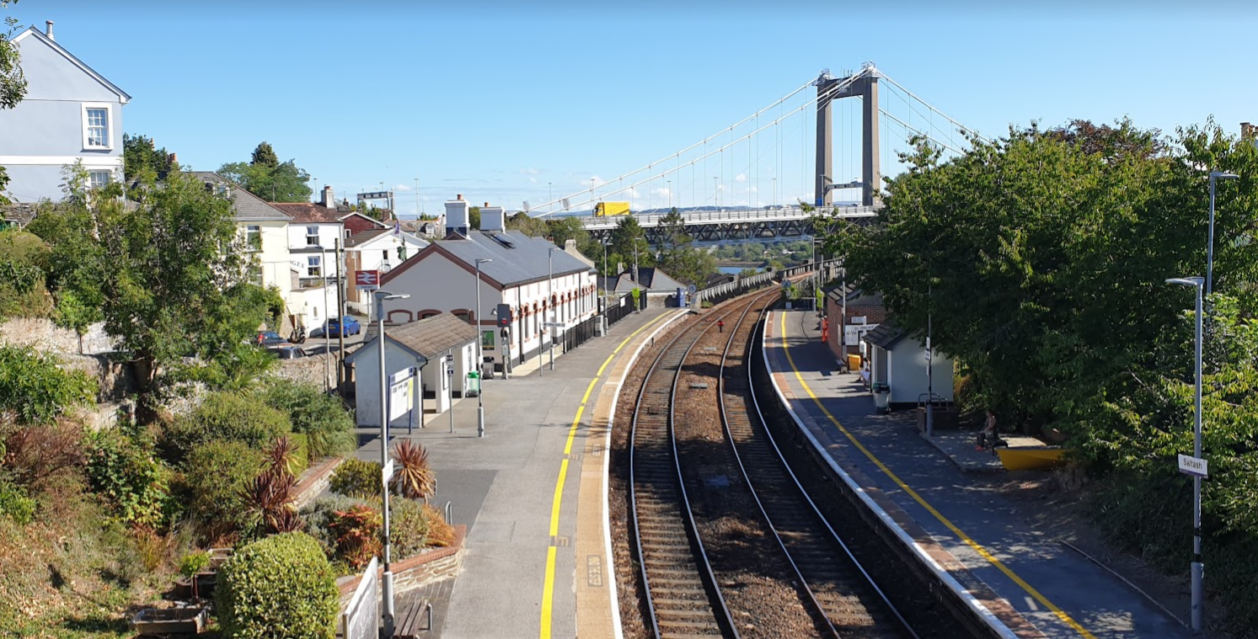

SCHEDULE 1 - CONCESSION SPECIFICATION

Isambard House Cafe Tender

Saltash Town Council

December 2022 Version (Final)

OFFICIAL: SENSITIVE

Contents
1. BACKGROUND INFORMATION 3
2. OBJECTIVES 6
3. INTRODUCING ISAMBARD HOUSE CAFE 7
4. BUDGET COMMITMENTS 14
5. QUALITY OF SERVICE / FOOD STANDARDS OVERVIEW 14
6. EQUALITIES 14
7. BRAND AND MARKETING 14
8. CONCESSIONAIRE TEAM 15
9. TRAINING 15
10. CASH HANDLING 15
11. ENVIRONMENTAL MANAGEMENT 15
12. WASTE MANAGEMENT 16
13. RECYCLING FOOD WASTE, FATS, OILS AND GREASES 16
14. OTHER RECYCLATES 16
15. DISPOSABLE PRODUCTS 16
16. PEST CONTROL, CLEANING AND DEEP CLEANING 16
17. ENTRY AND OPENING HOURS 17
18. HEADLINE TERMS 17
19. CONCESSION FEE 17
20. LIVING WAGE 18
21. SOCIAL VALUE 18
22. DEFINITIONS 19

BACKGROUND INFORMATION
To find a Concessionaire to operate a kitchen and café, waiting area and Accessible toilet providing a toilet and baby changing facility (the Concession) at Isambard House, Saltash Railway Station, Saltash. Some key features important to understand:
- Saltash Town Council owns and operates Isambard House, which is set on Platform 2 of Saltash station. Live train information can be viewed at https://tiger.worldline.global/SASH/staff;scrollbar=true The building has benefited from extensive renovation work throughout during 2019-2022. The building in its current renovated form was reopened in 2021.
- The Concession facilities (i.e. kitchen and café, waiting area and Accessible toilet providing a toilet and baby changing facility) are part of the overall Isambard House, with adjoining doorway (lockable) into a central hall area, and onwards to a further toilet and storage facilities, plus currently vacant an end room at the east of the premises.
- The central hall area of the premises is rented out by Saltash Town Council to a range of community and interest groups, along with key partners. Details of events and nature of bookings can be found in Appendix 1. (Below – Art exhibition August 22)

- Saltash station is situated on the main Penzance to Paddington, London line – the entry point from Devon accessed via Isambard Kingdom Brunel iconic grade 1 listed Royal Albert Bridge.
- The Concession Café is situated on the upward line to Paddington access from Station Road, Saltash. Footfall figures from the recent Office of Rail and Road (ORR) data that Saltash train usage has increased by 38%, meaning the Station is the best performing Station in Cornwall.
- The station is a short walk from the town centre and waterside close to Saltash Heritage Centre, Library, local transport link, cafes and bars.
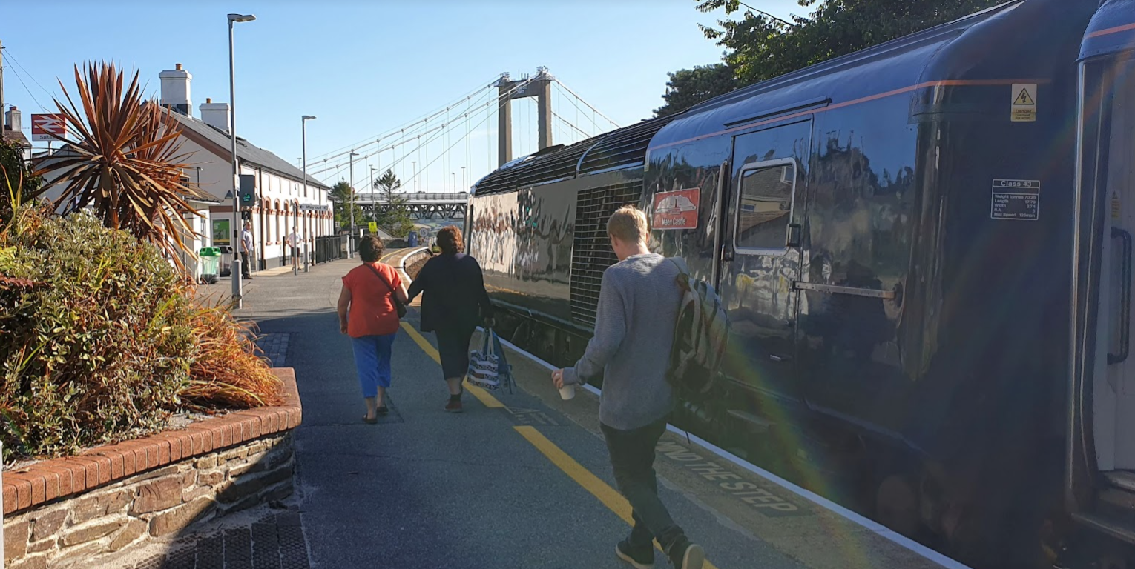
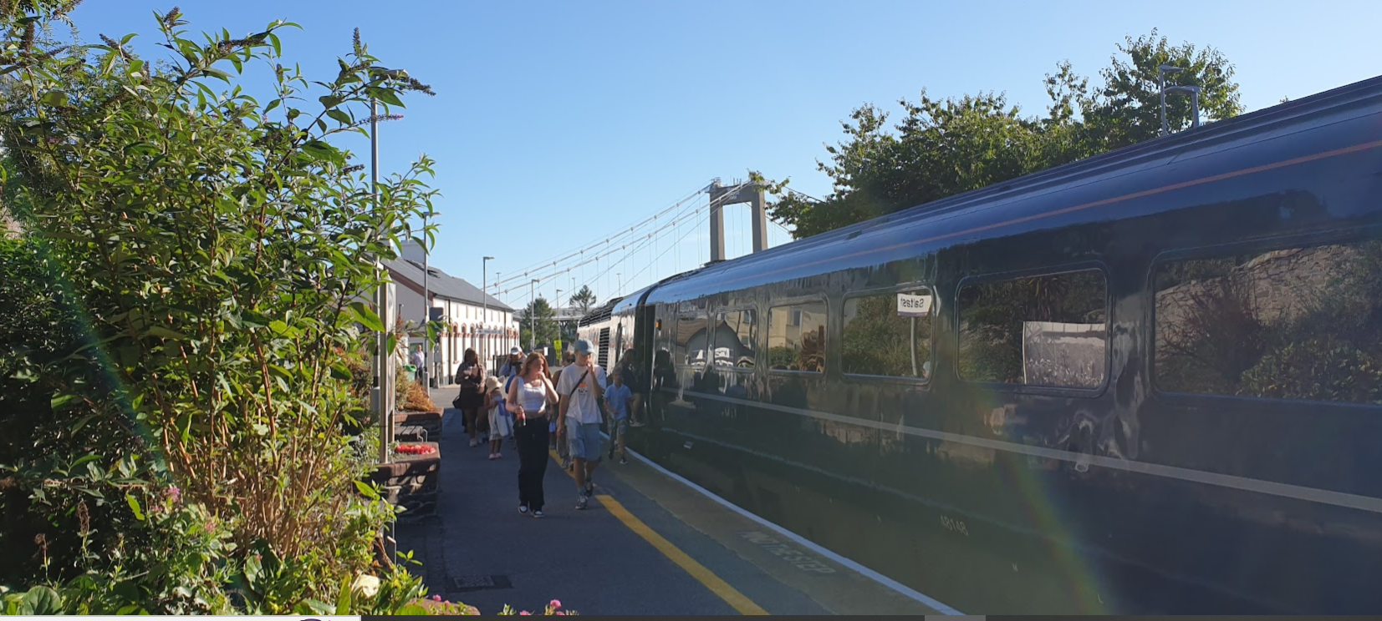
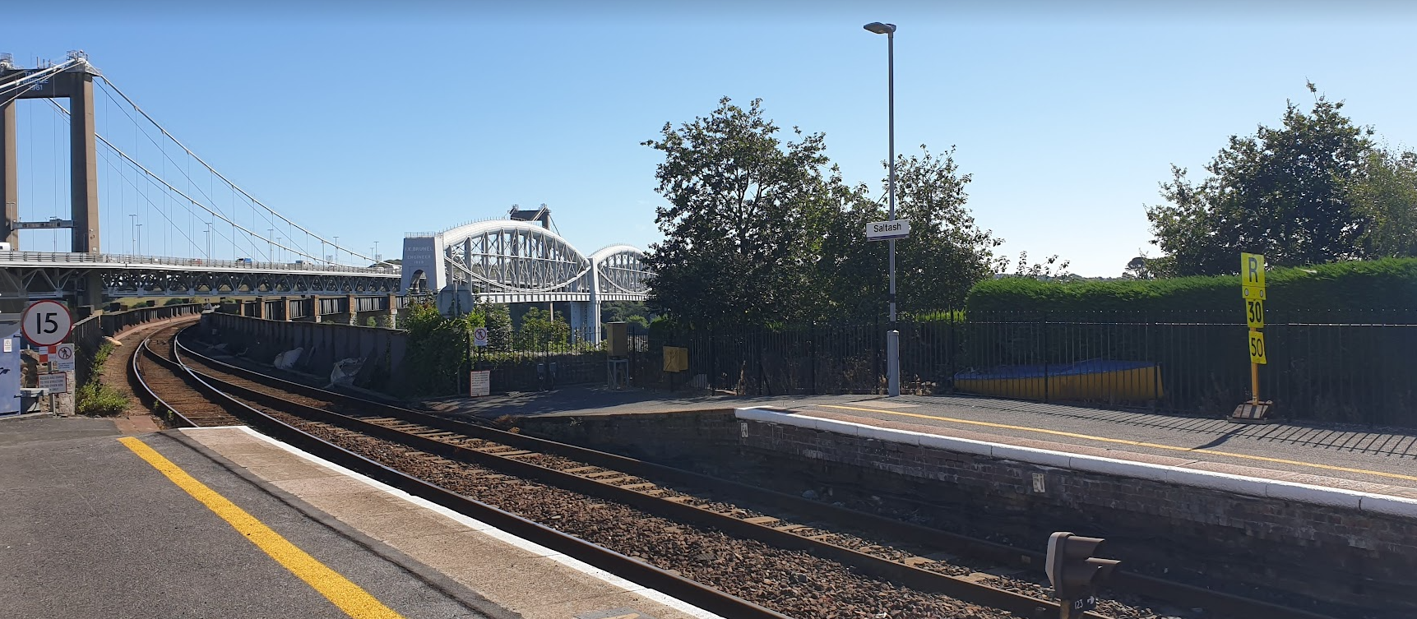

Footfall consists of:
- Rail users – First outbound train from Saltash station is 06:37 hrs with typically hourly services (outbound and return) and in peak commute times approximately every 30 minutes. The station services a number of industries for commuters from Saltash into Plymouth as well as a daily number of school and college pupils.
- Isambard House events – as noted Isambard House hosts a range of community events as outlined in appendix 1. With such events creates footfall and access to potential customers for any Concession.
- There is also opportunity to maximise special events in connection with the railway itself for example visiting steam trains or other special train services which pass through the station onwards into and back out of Cornwall.
- Pre-pandemic footfall figures were around 85,000 passenger journeys for the year 2019/20. GWR report that passenger numbers in the South West have returned to, or are better than before the pandemic, in stark contrast to the South East.
- As well as the Town Council Key partner organisation(s) which the Concessionaire would need to be mindful of are:
- GWR – who manage and operate the platform and wider station. GWR would be a key point of contact for anything on the platform and adjacent road, permissions will from time to time be required where planned actions are likely to impact on the wider operation of the station
- Network Rail – who own the underlying infrastructure, platforms, track, bridges etc.
- Cornwall Council – who have provided funding as part of the development of Isambard House and seeking public benefits such as access to waiting areas and accessible toilet providing a toilet and baby change facility. In addition, the Council are also the planning authority who’s permission would be required in event of any consideration of external modifications. Some signage additions may be allowable with permission of GWR and under permitted development rights.
- Saltash Rail Users Group - who generally promote rail use and campaign for a better rail service at Saltash.

This Specification and the accompanying tender documents are designed to enable accurate response to this opportunity, and to ensure that all parties submitting tenders have a clear understanding of the extent and quality of the services required, and the importance placed on the partnership between the parties involved.
- The Concession is offered in line with the overall Headline Terms as issued with this Tender and is offered solely under Licence.

OBJECTIVES
The specific objective of letting the Concessions Contract are:
- To create the provision of a valued community facility at the station in particular access to a publicly available accessible toilet providing a toilet and baby change facility (during operational hours of the facility) and waiting area (free to use);
- Be cost neutral or where possible provide small income / return to the Town Council;
- To have a Concessionaire who takes pride in operating from the site, including being the “eyes and ears” for the area, supporting keeping the site clean and tidy;
- Have a Concessionaire who shares the passion of the Town Council to make the overall premises a successful and valued community asset and work in partnership with the Town Council and key partners.
- To positively support the objectives of the Town Plan – https://plan4saltash.co.uk;
- Where possible support Plastic free / other sustainable objectives such as Healthy Eating;
- Be of low resource impact for the Town Council.
The Town Council would seek an area for customers to have enjoyable, value for money experiences, whether as part of commuting and using the railway or whilst enjoying the wider community assets. The Concessionaire shall deliver these objectives through:
- Working in effective partnership with the Town Council;
- Sharing knowledge and developing effective systems;
- Demonstrating agility in response to existing and potential market needs;
- Being proactive in extending the services and seeking new opportunities.

INTRODUCING ISAMBARD HOUSE CAFE
The Council is seeking to appoint a Concessionaire for the provision of a café for public food and beverage offer available at Isambard House, Saltash station, Saltash.
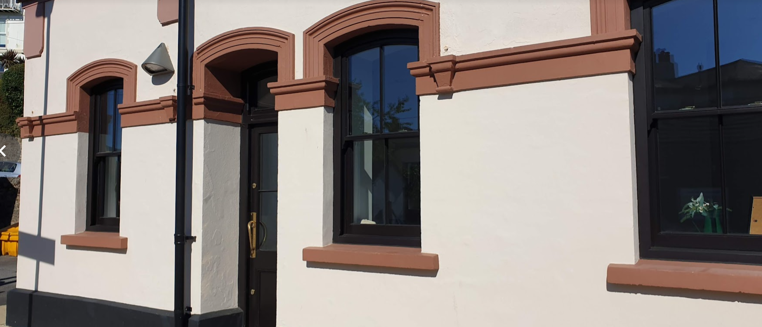
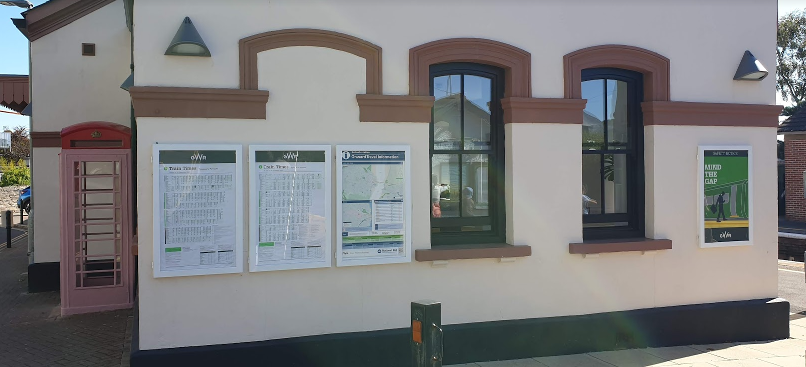
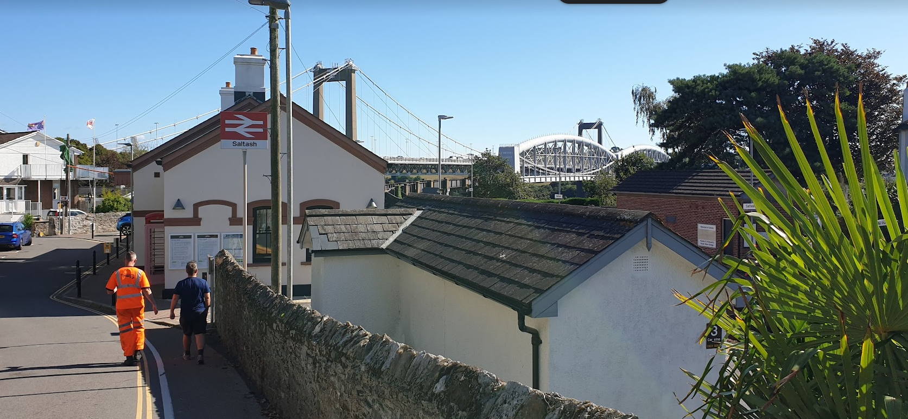
To enable the operating a Concession as a cafe facility for commuters, members of the public and visitors to the station, then the core facilities of this Concession include:
- Kitchen (3 metres by 2 metres) – The kitchen has basic fitted out cupboards / worktop, kitchen sink with hot and cold running water, electrical points (three charging sockets with 2 x 13 amp), and wall cupboard. There is a lockable access door from the central hall area and direct door and hatch access to the waiting area.
The Town Council is willing to permit the Concessionaire permission to adapt to incorporate necessary catering equipment to operate as a successful business.
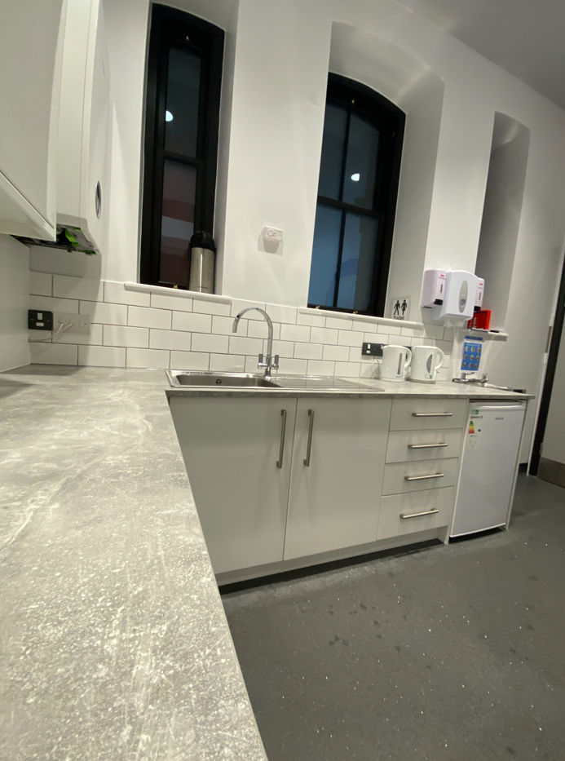 | 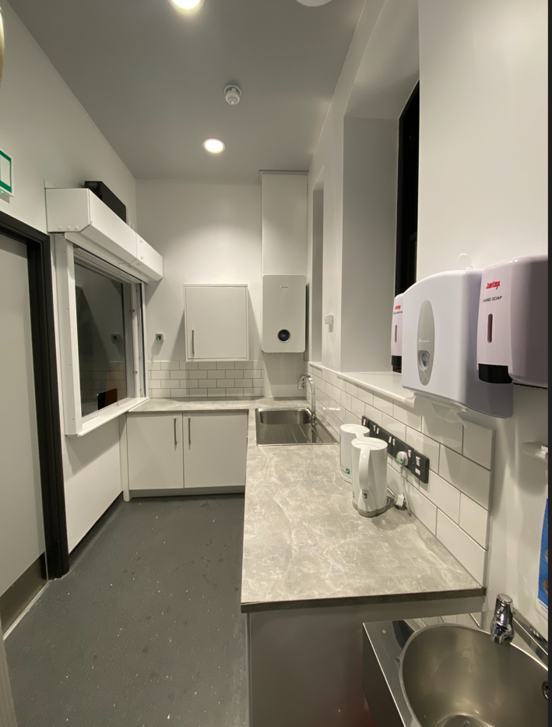
- Waiting / Café area (7 by 3 metres) - This area would be required to be open free of charge as a waiting area for the public. The Town Council is willing to permit the Concessionaire permission to situate tables / chairs / seating for serving and consumption of food plus siting of food / drink related vending machines within this space (should that be part of any plans by the concessionaire). The area has public electrical points (2x USB sockets) for charging laptops / phones plus a screen indicating train times and travel information. The Town Council acquired a decent number of small bistro style square tables and chairs that can be used if required. This currently provides for 18 covers (see pictures).
- 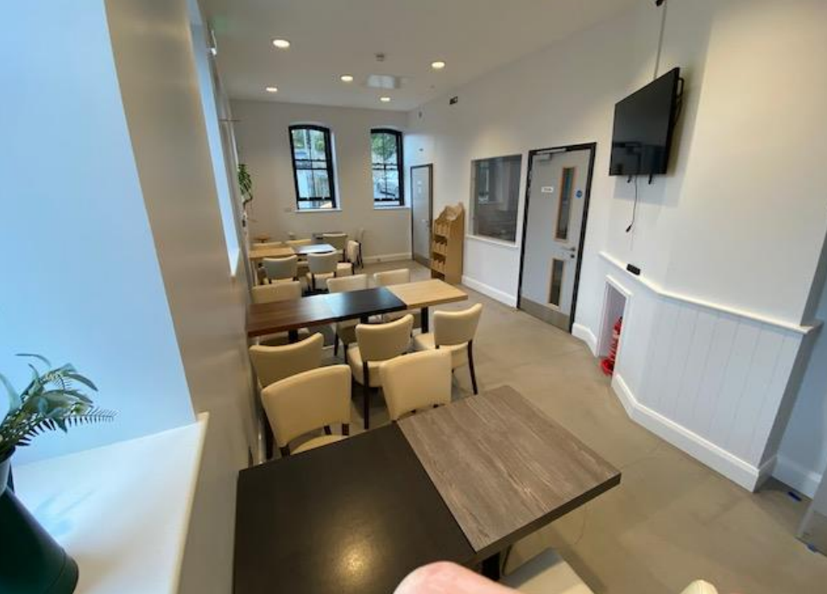
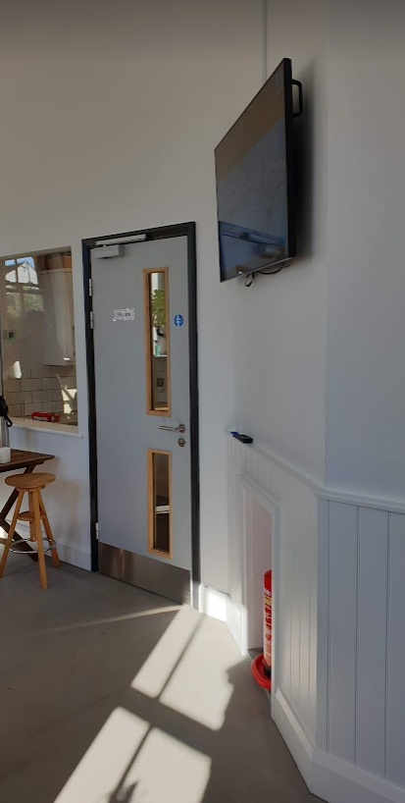

- Accessible toilet providing a toilet and baby change facility (2.5 by 2 metres) – In delivery of the cafe, providing provision of a disabled toilet for use by customers, members of the public and visitors to the station. This includes an accessible toilet providing a toilet and baby change facility / grab rails, emergency call feature, sink, electric hand dryer and hygiene sanitation facilities.
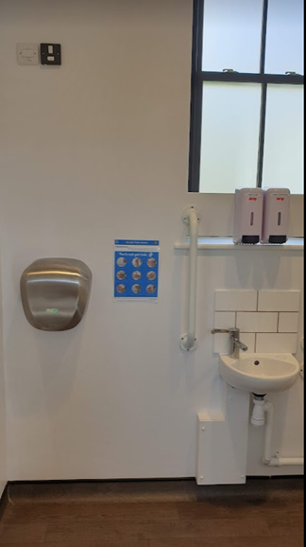 | 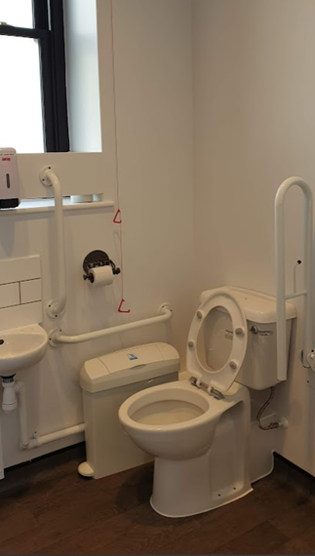
Additional space which the Town Council would consider including as part of the concession should the concessioner feel that they would be able to positively utilise would be:
- Service strip (1.2 metres wide by 5 metres) behind the railings to outside of main building fronting the platform for provision of tabled seating for customers to the café. The Town Council may wish to reserve option to have this space for use of booked events with the main hall, with agreed notice to the Concessionaire. Takeaway food and drink can be consumed anywhere on the station platform.
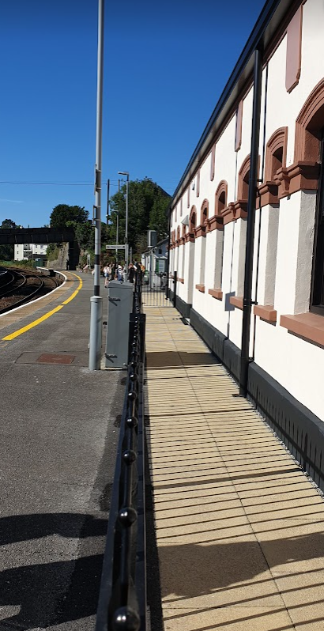 | 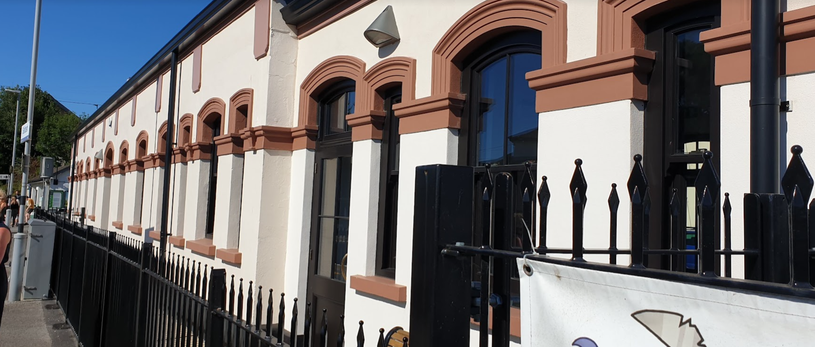
- In addition to service strip the Town Council is also willing to permit any Concessionaire to operate table facilities (or vending facilities) to the outside areas as detailed on the accompanying plan. Any such provision will require consultation with the Town Council and station operator GWR in respect of style and nature of tables, including the security of those tables.
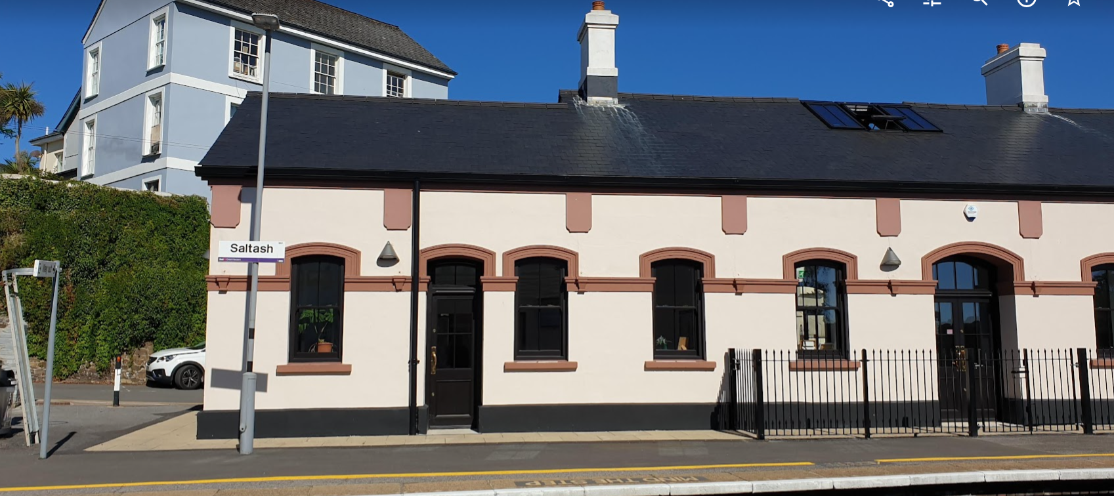
Should the Concessionaire wish to explore the utilisation of the currently vacant end room to the east of the building (5 metres x 5 metres) as part of the facilities the Town Council would be prepared to consider this but on a commercial basis. Additional, if outside normal opening hours, the Town Council might want to utilise the waiting room space to supplement the main hall usage, and at all times users of the main hall may require access through to the accessible toilet.

As noted, the Town Council hires the central hall for events. As part of any agreed concession the Town Council would willing to provide the requirement of any hiring body to seek the services of the Concessionaire should they require event catering. The Town Council would commit to work with the Concessionaire so they are fully aware of activities being held in the central hall.
The Town Council wishes to retain some rights of access to all areas in order to provide the best community resource possible, with clear agreement with the Concessionaire.
Also, if out of the agreed operating hours and the Concessioner is not providing event catering, should the hirer wish to have access to the kitchen for then this would be done in agreement and at an agreed rate with the Concessionaire (it is noted that in such cases agreement will need to be reached in order to secure any equipment / products of the Concessioner).
The tender for this opportunity is the first time that it has been put to tender and as such the concession area is vacant and unincumbered from any previous incumbent.
Utilities - The site benefits from mains water, electricity, mains drainage and mains gas to the boiler situated in the kitchen. It should be noted that at the present time there is no separate meters for the different parts of the premises. The Town Council would be prepared to provide free access to utilities to the Concessionaire for the first 12 months as a minimum and review any reasonable changes in discussion and agreement with the Concessionaire. In return the Concessionaire would be responsible for ensuring careful usage of utilities (see also Environmental and Waste Management sections). The Town Council reserves the right that to review with the Concessionaire charges during the term and adjust in light of any market changes.
The Concessionaire would be responsible for the cleaning and maintenance of the Concession (both the service kitchen but also including Accessible toilet providing a toilet and baby change facility and waiting room).
Furniture, Fittings and Equipment – The Town Council has already provided furniture (tables / chairs) within the Concession area and in working in agreement with the Concessionaire be willing to consider inclusion of some external furniture subject to it being suitable. The Concessionaire would be required to kit out the facilities to a professional quality standard this may include:
- Shelving
- Crockery / utensils
- Coffee / barista machine
- Microwave / toaster
The Concessionaire will be required to install further fixtures and fittings as they see fit.
All repairs to the premises, maintenance and statutory testing of the fabric of the building – e.g. doors, walls etc. and infrastructure e.g. fire alarms, emergency lighting etc. will be the responsibility of the Town Council who will be granted access by the Concessionaire to undertake such repairs, maintenance and statutory testing under the terms of the Licence.
Storage space is limited, and if additional space is considered necessary this will require to be in agreement with the Town Council.
In addition to the Concession as described the Concessionaire will have, in agreement and sign off by the Town Council, the opportunity to arrange, organise and run community related events on the adjoining land. The Town Council consider that there are significant potential to maximise commercial opportunity across the site and would welcome proposals to work in partnership to maximise the main hall when not booked on a commercial basis.

BUDGET COMMITMENTS
As noted the Town Council has provided furniture to the inside of the concession, any additional capital commitments will be the responsibility of the Concessionaire.
Likewise any repairing, replacing and maintaining Appliances; Furniture, fixtures and fittings; and Light Equipment will be the responsibility of the Concessionaire.
The Concessionaire will ensure all Appliances, furniture, fixtures and fittings and Light Equipment are cleaned and regularly checked and tested as per manufacturer operating manuals and Health and Safety Regulations.

QUALITY OF SERVICE / FOOD STANDARDS OVERVIEW
The Concessionaire will have freedom to operate in a manner that is commercially viable. However, in support of this the aim will be for the Concessionaire to:
- Provide a welcoming and friendly service for customers, one which is inclusive to all;
- Provide a consistent quality of service for customers, to a standard that meets or exceeds their expectations;
- Provide a clear and competitive pricing which reflects good value for money.
Price tariffs shall be presented in a format that shows the total cost to the Customer.
The Concessionaire will ensure compliance with Food Hygiene Standards. In addition, the Concessionaire will ensure clear and accurate food labelling around allergies.
Within the limitations of the site and overall Concession itself where possible the Concessionaire would look to support principles of:
- Choice;
- Grab and go nature options (noting restrictions of travellers and set train times);
- Healthy eating;
- Local sourcing / seasonality / Fairtrade;
- Dietary-specific options such as vegan, vegetarian and gluten free;
- Waste minimisation and work to reduce food waste
- Transparent food labelling;
- Maintain a five-star Food Hygiene Rating.

EQUALITIES
The Concessionaire shall support and develop equality of opportunity, diversity, inclusion and representation in the service provided to customers and the community.

BRAND AND MARKETING
The Concessionaire will be responsible for marketing and promoting of the facility, including both physical signage on site as well as social media. The Town Council is amenable to branding signage being placed to the outside of the building (subject to any necessary planning permission).
The Concessionaire shall be responsible for the costs associated with marketing the Concession. The Town Council may also contribute to joint marketing as it decides.

CONCESSIONAIRE TEAM
The Concessionaire will ensure that the services shall be performed by appropriately trained and qualified personnel, with exceptional customer service skills. The Concessionaire will make every effort to maximise local employment opportunities, as well as local produce and support principles of community inclusion / apprenticeship.

TRAINING
The Concessionaire shall be responsible for their staff training. It is recommended that all staff are trained at least to a minimum Foundation Certificate in Food Hygiene and Safety, Health and Safety and Customer Care skills.
Staff should have a sufficient understanding of special diets to provide customers with accurate advice about the options available.
Staff will be aware of any standards to which foods have been certified, and further background information about these standards will be made freely available on the premises, or on the supplier's website.

CASH HANDLING
The Concessionaire shall be responsible for all cash receipts, including VAT, from the cafe.
The management and cost of cash collection and security will be the sole responsibility of the Concessionaire.

ENVIRONMENTAL MANAGEMENT
The Concessionaire shall support the goals of environmental management, including, start-up and shutdown schedule for lights, equipment, and other energy-consuming items.
The Concessionaire shall have a maintenance checklist and records of inspections for lighting, equipment, and other energy-consuming items.
The Concessionaire shall perform and document manufacturer recommended cleaning to all Appliances on site to ensure all equipment is functioning properly and maintaining energy efficiency levels.
The Concessionaire shall have a water conservation checklist and records of inspections that include at least the following:
- Turn off taps not in use;
- Regularly check for leaks;
- Do not use running water to melt ice in sinks;
- Operate dishwashers when full, whenever possible;
- Dishwasher temperature shall be set to the lowest temperature allowed by health regulations and consistent with the type of sanitising system used.

WASTE MANAGEMENT
The Concessionaire will pay for all waste collection associated with running the Concession.
To reduce waste generation, the Concessionaire shall look to serve food / beverages using reusable cutlery, glassware and crockery, and also customer option to bring own reusable cups. Takeaway food/beverages should be served in re-cyclable materials.
Incentives should be given to Customers for utilising their own reusable cups and other ethical takeaway food storage solutions.

RECYCLING FOOD WASTE, FATS, OILS AND GREASES
Where available, used frying oil and oil from grease recovery devices shall be recycled with proven partnerships for using the oil for biodiesel production or other means of replacing fossil fuel use. Waste fats, oils and greases shall be stored in a weather and vandal resistant container with a bund of sufficient capacity to hold any leaks.
All suitable food waste shall be reused where possible through local channels – e.g. through local homeless charities.
The Concessionaire shall have clearly marked sorting mechanisms – i.e. bins – in areas where food waste is collected.

OTHER RECYCLATES
The Concessionaire shall look to maximise opportunities for recycling options. Materials to be recycled shall include, but are not limited to, aluminium and steel food and drink cans, plastics, glass, and cardboard.

DISPOSABLE PRODUCTS
The Concessionaire shall eliminate non-essential disposable products and the following items shall not be used:
- Polystyrene packaging and cups;
- PS06 (polystyrene) (e.g. utensils);
- Plastic bags (except for bin liners);
In addition, single portion condiments and disposable napkins, utensils, and straws (not plastic) shall be provided upon customer request or with single portion dispensers, where applicable. Costs of waste disposal will be the sole responsibility of the Concessionaire.
Wherever possible the Concessionaire shall look to avoid the use of Single Use Plastic.

PEST CONTROL, CLEANING AND DEEP CLEANING
The Concessionaire will be responsible for all cleaning and deep cleaning in the Concession, leaving them hygienic and ready for the next subsequent use at the end of each day.

ENTRY AND OPENING HOURS
To support the provision of access to the Accessible toilet providing a toilet and baby change facility and waiting room the Town Council would require minimum hours of access based on the following:
- Monday to Friday 07:15 hours to 14:00 hours
Beyond this the overall the opening times for the Concession will be up to the Concessionaire to set based on optimum commercial opportunity but will only be permitted seven days per week between the hours of 06:30 hours to 22:00 hours.
There is an expectation that the café should be open at regular intervals between April and September, weather conditions permitting. Whilst winter footfall may be reduced it would be important to have a waiting room café provision even if on reduced hours from the summer opening times.
Bidders should state if they consider there would be any variations during the year.
People do travel all year round although it is noted there are no trains on Christmas Day and Boxing Day. There may also be no trains during planned engineering works but this is well advertised in advance and other outages such as strike action but again this is well advertised. The Town Council would not expect the waiting room to operate on those days, however, it may be that operator wishes to open due to other trade using the service i.e. local businesses.
Weekend travel has become much more important for the railway and these are considered busy days, even if the service is less. It may be that the Concessionaire opens later at the weekend. The Town Council welcome bidders to indicate what weekend opening times look like.
The Concessionaire shall be responsible for providing clear and transparent information to customers and members of the public on opening times.
The Concessionaire will be responsible for security in regards to opening and locking of the premises aligned to the hours of operation of the Concession. This will include ensuring that the premises are empty of members of the public at time of locking.
The Town Council is willing to work with the appointed Concessionaire to review the opening hours after 6 months and 12 months of commencement of the agreement to maximise benefits from the concession and avoidance of unnecessary opening where return does not match resource inputs.

HEADLINE TERMS
The Town Council has drafted Headline Terms for the Concession. This should be read in conjunction with this Specification and will apply to the Concessionaire.

CONCESSION FEE
The Concessionaire will deliver to the Town Council the agreed commercial model as per the Contract. Where applicable and in line with the commercial model the Concessionaire will pay the Town Council all its fees either annually or quarterly (June, September, December and March).
Six months ahead of end of year will see annual review periods introduced. Agreement to extend beyond year 3 will be subject to review of overall performance of the Concessionaire and an assessment of return based on Operating Profit. The Town Council in conjunction with the Concessionaire will review the potential for commercial payback to the Town Council at end of year three based on Operating Profit.
To assist the discussions the Concessionaire would be required to provide the accounts for the concession operations on the basis of an Open Book Accounting basis.

LIVING WAGE
It should be noted that the Town Council is an employer that pays all its employees, as a minimum, the ‘Real Living Wage’. This currently stands at £10.90 per hour for all employees over 18 years of age and will only enter into a contract with a Concessionaire that do similar. Any Concessionaire tendering for the works as described in this document, by doing so, confirmed that it also pays all employees over 18 years of age the ‘Real Living Wage’.

SOCIAL VALUE
The Concessionaire’s attention is drawn to the fact that consideration on award of the Concession will include assessing how the Concessionaire will deliver Social Value in the community.
As part of the applicant’s response to the method statement they will be asked to outline how they would support Social Value in the delivery of the Concession. In relation to this contract the Town Council sees the following as being areas where through the delivery of the Services positive outcomes to Social, Economic and Environmental outcomes could be achieved, in particular:
- Within the workforce this could be supporting apprenticeships, plus arrangements to ensure that staff are fairly recompensed for work undertaken.
- Supporting environmental outcomes (including reduction of use of products / material that are harmful to the environment or working practices that minimise environmental damage), as well as making a positive contribution to the Town Council’s pledge around removing use of “single use plastics”.
- Social outcomes may also include details on how the Supplier would look to support community initiatives and / or work to make a positive outcome within the wider community.
- Social benefits to communities within the area including increasing social inclusion and breaking down social exclusion.
The above list is not exclusive or exhaustive but an indication on what are deemed to be relevant and proportional areas for Social Value consideration to this Concession.

DEFINITIONS

Appliances | In summary this shall include (but not be limited to):  Cooker, microwave, kettles / boiler, coffee maker, dishwasher etc.
Concession | Means the café and facility at Isambard House, Saltash railway station
Concessionaire | Means the organisation named in the articles of agreement
Customer | Means a third party to whom the Concessionaire provides services
Events | Means Events that are approved by the Town Council within the premises adjoining the Concession
Furniture | In summary this shall include related furniture for customers of the Concession and may include tables and chairs both within and outside of the premises.
Licence | Means the licence to occupy the premises
Light Equipment | In summary this shall include (but is not limited to):  Crockery, cutlery and glassware, display dishes, display and marketing boards, Kitchenware including pots and pans, tills and IT equipment
Operating Profit | Means operating profit is a company's profit after all expenses are taken out
Open Book Accounting | Means the Concessionaire providing transparent records of the costs they have incurred around the Concession in order to support negotiations on annual reviews from year 3 onwards
Town Council | Means Saltash Town Council and the Town Council’s representative, appointed for the purpose of managing the contract

