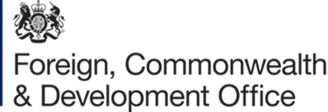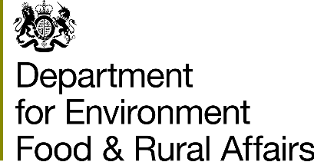

**Blue Planet Fund stakeholder information session**

Approximately three billion people rely on the ocean for their food security and livelihoods, with poor people particularly dependent on the ocean. The ocean economy is expected to grow faster than the global economy as a whole over the next decade, presenting opportunities for developing countries to grow their economies and improve the livelihoods of their people. At the same time, the ocean is facing serious and increasing threats from over-exploitation, pollution, biodiversity loss and climate change.

**Recognising the importance of ocean health to sustainable development, the Government has committed to establishing a £500 million Blue Planet Fund that will support developing countries to protect the marine environment and reduce poverty.**

# Fund Description

Financed from the UK Official Development Assistance Budget, the Blue Planet Fund will help developing countries reduce poverty, protect and sustainably manage their marine resources and address human-generated threats across four key themes: marine biodiversity, climate change, marine pollution, and sustainable seafood.

The Fund will be managed by the Department for Environment, Food & Rural Affairs (Defra) and the Foreign, Commonwealth and Development Office (FCDO) and will be launched in 2021.

UK Government context

In the recently published [Integrated Review](https://www.gov.uk/government/publications/global-britain-in-a-competitive-age-the-integrated-review-of-security-defence-development-and-foreign-policy), the UK Government has put tackling climate change and biodiversity loss as our top international priority. The ocean is a critical part of this agenda. The Blue Planet Fund will form an important tool for the UK to support developing countries with the implementation of this ambitious agenda over the next few years. The Fund will support the UK Government’s commitment to increase its international climate finance support to at least £11.6 billion over the next five years, and to focus at least £3 billion of that amount on nature-based solutions to climate change. The Fund will also build on the UK’s existing international work to support conservation and sustainable use of the ocean, such as the UK-Vanuatu led Commonwealth Clean Ocean Alliance and the Commonwealth Marine Economies Programme.

Stakeholder information session

We are hosting an information session for interested parties on Thursday 29th April 2021. You are invited to join one of the two web conferences – one at 10:00-11:00 GMT, and one at 15:30-16:30 GMT. This is to take into account the different time zones of any interested parties who are not UK-based.

We would welcome participation from governments, non-governmental organisations, the private sector and research organisations, amongst others.

The purpose of the event is to share information about the Blue Planet Fund and answer questions from interested stakeholders. The event is not part of a tendering process, although there may be such opportunities in future years. We will outline the Fund’s rationale and likely aims, objectives and priority regions.

Please register for attendance at the information event using this [Registration Link](https://bit.ly/3suD9Pk) or scanning the QR Code below. The deadline to register is 9am Tuesday 27th April. Please note that registering for the event is a separate requirement from registering your interest on the Defra or FCDO portals with regards to this programme.



Registered participants are invited to submit questions to the DEFRA email address [BluePlanetFund@defra.gov.uk](mailto:BluePlanetFund@defra.gov.uk) ahead of the event. There will also be an opportunity for attendees to ask questions during the event.

Depending on the level of interest we may have to impose limits on participants for each session. Please consider limiting the number of representatives dialling in from your organisation to a maximum of two.

Joining instructions will be sent out to registered participants on Tuesday 27th April.

Other information

The events will take place in English, and translation will not be available.

All materials used on the day will be published (in English) on Defra’s e-tendering system BRAVO and the FCDO portal following the event. Please note that expressing an interest on one of these portals is required to enable access to these materials.