HOUND PARISH COUNCIL
INFORMATION AND INSTRUCTIONS FOR TENDERING

INVITATION TO TENDER – replacement playground equipment at Butlocks Heath Recreation Ground, Woolston Road, Southampton, SO31 5FR

Tenders must be submitted in accordance with the following instructions. Tenders not complying with these instructions, in any particular way, may be rejected by the Council, whose decision on the matter is final.

Invitation to Tender

Hound Parish Council (HPC) is seeking to invite tenders for the design and replacement of play equipment for children aged from two to eleven years of age, with all equipment and surfacing conforming to EN1176 and EN1177.

1. PROJECT BRIEF
The play area is currently split at either end of a sports pitch. A budget of up to £48,500.00 has been set aside to refurbish the play area. The objective is to create a single area that is an exciting, challenging and a practical facility for children aged 2 - 11 whatever their ability. The space should be visually appealing and feel safe for children and their carers. The facilities should be capable of use all year round.

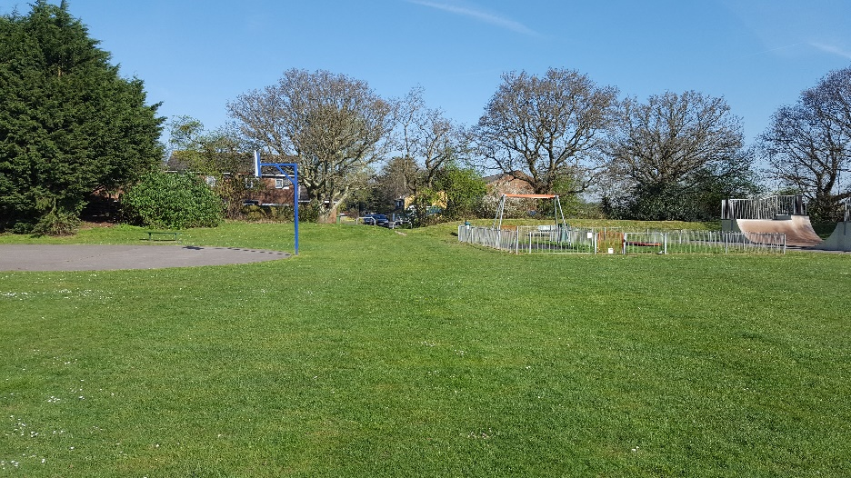

Design
The design concept should reflect the unique location of the village which is close to Southampton Water and is very close to the ancient woodland – Priors Hill Copse.

Materials
The Council is not fixed about the type of materials to be used but will be looking for products that require minimal maintenance and have a reputation for longevity. They should also have resistance to vandalism and be DDA compliant. This applies to all equipment, seating, surfacing, fencing and gates. The current equipment is 15 years old.

Removals
All existing play equipment on the proposed site should be removed and disposed of, with the exception of the fencing which can be re-used.

Surfacing
The current play equipment is located mainly on grass. As the area is predominantly flat, good grass, we would like to retain this as much as possible. Any flooring placed underneath and surrounding the equipment must comply with EN1177.

Fencing and gates
The current metal perimeter fencing will need extending or replacing with something similar to the below. The fenceline should enhance the appearance of the area whilst requiring minimal cyclic maintenance. At least two access points should be provided to allow movement through the park. They should be matching gates on self-closing hinges.

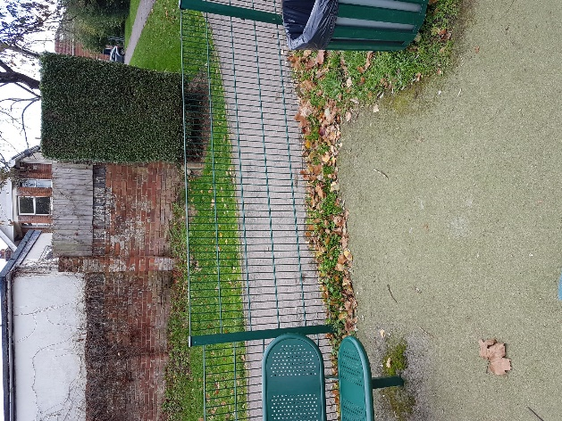

Furniture
We will provide 2 new benches for the play area, no further benches are required as part of this scope. The litter bin should be replaced however, ensuring it is matching to the design, colour and materials of the overall scheme.

Play Equipment
All equipment should comply with EN1176 and appropriate certification should be supplied with the tender. Overall, the design and choice of play equipment will be up to the supplier; however, the following should guide the selection process:

Equipment that enables:

- climbing
- balancing
- sliding and travelling
- rotating and spinning
- swinging

Equipment should cater for toddlers, juniors and those with limited mobility as well as encouraging learning, creative and imaginative play. Equipment for older children (12+) is not appropriate on this site. We would especially like to see natural hills/mounds that incorporate play equipment.

Value Added
The council encourages any additional value-added options within the proposal. These should be set out separately in the tender proposals.

CONTRACT ISSUES AND TENDER PROCESS

Performance of contract and after Sales and Service Level Agreements
Suppliers must be able to respond quickly and effectively to any post installation maintenance requirements. Tenders should confirm that they are able to meet the conditions and the penalties set out in the table below

Requirement | Details | Penalty
Completion of project on time | Other than delays due to aspects not within the control of the contractor, completion of 2 weeks beyond stated completion date | 2% of value of Project  (£1000.00)  Longer than 2 weeks - 3% of value of Project (£1500.00)

Resolution of Warranty  related defects | Beyond 4 weeks of notified defect if item is not safe to be used | 5% listed value of equipment in question
Retention | Any defects or quality issues within 12 months of installation | 5% of the value of the project to be withheld until 12 months following completion of the project (£2500.00)

Project Completion
The project will not be deemed complete until all snagging issues are resolved and the Post Installation Inspection is complete and satisfactory.

Financial Assessment

The Council will carry out an independent appraisal of the 3 shortlisted tenders to assess their financial strength.

Tender Evaluation
Tenders will be evaluated in-line with the table below. Each category has a total number of points available which reflect the importance of the activity. Tenderers should therefore identify within their tender how they meet each of the categories.

Item | Score | Detail
Overall Design | 45% | Meeting the project brief, design, layout, aesthetics of equipment and surfacing
Quality of Materials | 30% | Maintenance, expected longevity of equipment, surfacing and groundworks
Warranties | 10% | What is covered in the warranty, length of warranty for each type of material
Presentation | 5% | Quotation, quality of the visuals, general information included and format of response
Time Table and  Service Levels | 10% | Can you meet the time frames and agree to the services levels detailed in this document

Scoring System

Quality | Points | Criteria
Superior | 4 | Exceptional demonstration of the relevant ability, understanding, experience, skills, resources & quality measures required to meet the project’s aims or requirements. Response highly relevant with comparable contract value.
Good | 3 | A comprehensive response submitted in terms of detail and relevance and clearly meets most of the project’s aims or requirements with no negative indications or inconsistencies.
Below  Expectations | 2 | Minimal achievement of the requirements specified in the tender offer & presentation for that criterion. Several errors, risks, weaknesses or omissions, which are possible, but difficult to correct/overcome and make acceptable.
Poor to  deficient | 1 | Limited response provided, or a response that is inadequate, substantially irrelevant, inaccurate or misleading
Unacceptable | 0 | Totally deficient and non-compliant for that criterion.

Conformance and certification to BS EN1176 & EN1177 will be evaluated on a pass/fail basis.

The Questionnaire will be assessed on a pass/fail basis, and only those organisations that pass this stage will be considered for the project.

This evaluation exercise will be used to select no more than three tenders. These will go
forward to a decision-making stage involving a public consultation and then onto a Council Meeting. The community consultation will be an open day on a Saturday morning as a public event and also the ability to provide feedback via website. The Council will then confirm the successful bidder after having considered the community feedback.

Project timeline

Below is the project timeline. Suppliers will need to provide confirmation (or Programme of Works) that these dates for starting and finishing the project can be met within their tender response:

Action: | Date Due By:
Invitation to tender | 28.02.19
Deadline for submission of tender clarification questions | 22.03.19
Deadline for submission of Invitation to Tender  Acknowledgement Form (Appendix 1) | 29.03.19
HPC to answer outstanding questions | 26.03.19  328119
Tender Response Due | 05.04.19
Shortlist confirmation | 12.04.19
Consultation day (Hound Parish Hall) | 27.04.19
Tender selected and decision notified | 30.04.19  09.10.18
Revisions to design (if required based on consultation) | 07.05.19
Order Date and Contract issued | 08.05.19
Work to commence | 28.05.19
Completion Date | 21.06.19
All snagging / ROSPA issues resolved, fencing and storage removed, Play Area Open. | 28.06.19
Invoice for Payment (5% retention till the end of warranty period) | 05.07.19

Preparation of Tender and Tender Duties.

Tenderers will be asked to complete 3 key documents as part of their tender submission. These are attached in the appendices. They are as follows:

- Invitation to Tender Acknowledgement – Appendix A
- Form of Tender – Appendix B
- Qualification Questionnaire (plus associated documents (Appendix C)

The Tender shall be made in ink on the Form of Tender enclosed.

The Form of Tender must be signed where the Tenderer is an individual, by that individual. Where the Tenderer is a partnership, by two duly authorised partners. Where the Tenderer is a company, by two directors or by a director and company secretary, such persons to be duly authorised for the purpose.

Qualification Questionnaire should be completed and the following attached:

- Health & Safety Policy, Risk Assessments and Safe Working Procedures
- Copies of public liability, professional liability, product liability and employer’s liability
- Insurance, all of which must identify the level of indemnity
- Proposals for undertaking the replacement of the new play space
- Organisation and method of working
- Analysis of resources
- Details of any part of the replacement programme of the new play/recreation space to be sub-contracted
- A scale drawing of the proposed scheme 1:100
- Two A1 presentations of the proposed scheme
- An outline schedule of works detailing the anticipated delivery and installation period.
- Copies of the company’s certificates in relation to BS EN1176 & 1177
- Details of any proposed sub-contractors
- Details of any added value the proposals and how they might impact on whole life costs

Total cost and detailed breakdown of prices showing:

- Unit price per item of equipment
- Detailed costs of all sundry items, including fencing and surfacing
- Installation costs per item of equipment and of sundry items
- Details of any additional items /costs such as security, delivery and storage

Site Visit
Before submitting a tender for the service, bidders are advised to visit the site to ascertain all relevant conditions and means of access and to thoroughly acquaint themselves with the extent and nature of the project.

Tender Questions, Clarifications and Site Visit
Tenderers are advised to study the Conditions of Contract and Specification. Tenderers should seek to clarify any points of doubt or difficulty (including any apparent ambiguities, errors and omissions in the tender documents) with the Council prior to submitting a tender.

Any questions or matters of clarification regarding the ITT procedure, contract documentation, specification or requests for further information should be submitted by e-mail to clerk@houndparishcouncil.gov.uk. The deadline for submission of tender clarification questions is 22.03.19.

By 26.03.19 all outstanding questions and the Council’s responses, will be circulated to all Tenderers who have submitted the Invitation to Tender Acknowledgement (Appendix A).

Except in response to a query as set out above, no-one has any authority to make any representation or explanation to Tenderers as to the meaning of any aspect of this ITT pack or of anything to be done or not to be done by the successful Contractor.

Tenderers shall be deemed to have satisfied themselves before submitting their Tender as to the accuracy and sufficiency of the rates and prices stated by them in their proposal, which shall (except in so far as it is otherwise provided for in the Contract) cover all their obligations under the Contract, and shall be deemed to have obtained for themselves all necessary information as to risks, contingencies and any other circumstances which might reasonably influence or affect their proposal.

Period of Validity
Tenderers are required to keep Tenders valid for acceptance for a period of 60 days from the closing date for receipt of tenders.

Submission of Tender
Tenders shall be submitted in a plain sealed envelope / package clearly marked “Tender for Butlocks Rec Play Area”, in large bold print, by registered post, recorded delivery service to:

Clerk
Hound Parish Council Parish Parish Office
29c Station Road
Netley Abbey
Southampton
Hants SO31 5AE

The envelope must not bear any name or mark indicating the identity of the sender.
Tenders must be received by no later than 1pm on 05.04.19.
No Tender will be considered if it is received after the date and time specified, unless the Council, at its sole discretion, extends the closing date and time specified in writing.

Information supplied by Tenderers will be treated as contractually binding subject to the conditions and requirements laid down in this Invitation to Tender. The Council reserves the right to engage in a tender clarification process with one or more of the organisations who submit a proposal.

All unit rates and prices must be quoted in £ Sterling, exclusive of VAT and inclusive of all costs associated with the service.

The prices/fees to be inserted in the Form of Tender shall be the full inclusive value of the goods, works and services described (The Services). They shall represent all costs and expenses which may be incurred in order to provide the Services in accordance with the Conditions and Specification and to assume all express and implied risks, liabilities and obligations imposed by the Conditions, the Specification and all other documents forming part of the contract.

Bidders shall be deemed to have satisfied themselves before submitting their Tender as to the accuracy and sufficiency of the rates and prices stated by them in their Tender, which, shall (except in so far as it is otherwise provided for in the contract), cover all their obligations under the contract, and shall be deemed to have obtained for themselves all necessary information as to risks, contingencies and any other circumstances which might reasonably influence or affect their tender. The Council is not bound to accept the lowest or any tender.

Scope of Tender
Tenders are being invited on the basis of undertaking the whole of the Services.

Contract Period
Tenders are invited for Services which are to be completed by Friday 28th June 2019. There will be no extension to this date under any circumstances and it is a key condition of contract that the entire works and services are completed by this date.

Tender Acknowledgement & Confirmation of Intention to Submit a Tender
Please acknowledge receipt of this ITT Pack and confirm your intention or otherwise to submit a Tender by returning the form enclosed as Appendix 1 by no later than 29.03.19.

If you decide not to submit a proposal please complete and return the form enclosed as Appendix A stating your reasons for not submitting a proposal in the space provided or on a separate letter.

Please note that only those companies who confirm their intention to bid (Appendix A) by 29.03.19 will be sent any future correspondence relating to this tender including clarification information.

Tender Costs
The Council will not be liable in respect of any costs, expenses or losses incurred (of whatever nature) by Tenderers in the preparation of Tenders or any associated work effort in connection with this tender process.

Inducements
Offering an inducement of any kind in relation to obtaining this or any other contract with the Council will disqualify your proposal from being considered and may constitute a criminal offence.

Payments
Payments will be made within 28 days of receipt of an invoice subject to all Services being completed to the satisfaction of the Clerk for Hound Parish Council.

Sub-contracting
When submitting its Tender, the Tenderer must notify the Council of any parts of the services which it proposes to sub-contract. Failure to do so will invalidate any such tender.
The Council’s prior written approval must be obtained before any part of the services is sub-contracted.
The Council reserves the right to refuse such approval at its absolute discretion.

An approved sub-contractor must give a direct warranty and undertaking to the Council but the Contractor will nonetheless remain primarily liable for the provision of the Services.

Award of Contract
The Council expect to award the Contract on or about 30th April 2019. The successful Tenderer will be required to execute a formal contract in the form of a JCT Minor Works with contractor’s design 2016. Until such execution the successful Tender together with the Council’s written acceptance shall constitute the contract.

Health and Safety
Tenderers will be required to comply with the Health and Safety at Work Act 1974 and all other regulations made under the Act.
Accuracy

Information supplied to Tenderers by the Council (whether in these tender documents or otherwise) is supplied for general guidance in the preparation of the tenders. Tenderers must satisfy themselves by their own investigations with regard to accuracy of any such information and no responsibility is accepted by the Council for any inaccurate information obtained by Tenderers.

Confidentiality
All information supplied by the Council in connection with this invitation to tender shall be regarded as confidential by the Tenderer except that such information may be disclosed for the purpose of obtaining sureties and quotations necessary for the preparation of the Tender. Any data provided by the Council may only be used for the purposes of providing the Services and may not be used for any other purpose without the prior written consent of the Council

Freedom of Information
The Council is a public authority within the meaning of the Freedom of Information Act 2000. Information in relation to this Tender and all correspondence received may be made available on demand in accordance with the Freedom of Information Act 2000. Tenderers should state if and why any of the information supplied by them in response to this Tender is confidential or commercially sensitive or exempt from disclosure under the aforementioned Act. Notwithstanding the foregoing, unless an exemption under the aforementioned Act or a duty of confidence applies, information shall be disclosed in accordance with the Freedom of Information Act 2000 in response to a freedom of information request where the public interest in favour of disclosure outweighs a Tenderer’s commercial interests in maintaining non-disclosure.

Publication of Successful Tender
The Council may publish the amount of the successful tender and the name of the successful Tenderer.

Aerial View of Butlcoks Heath Recreation Ground

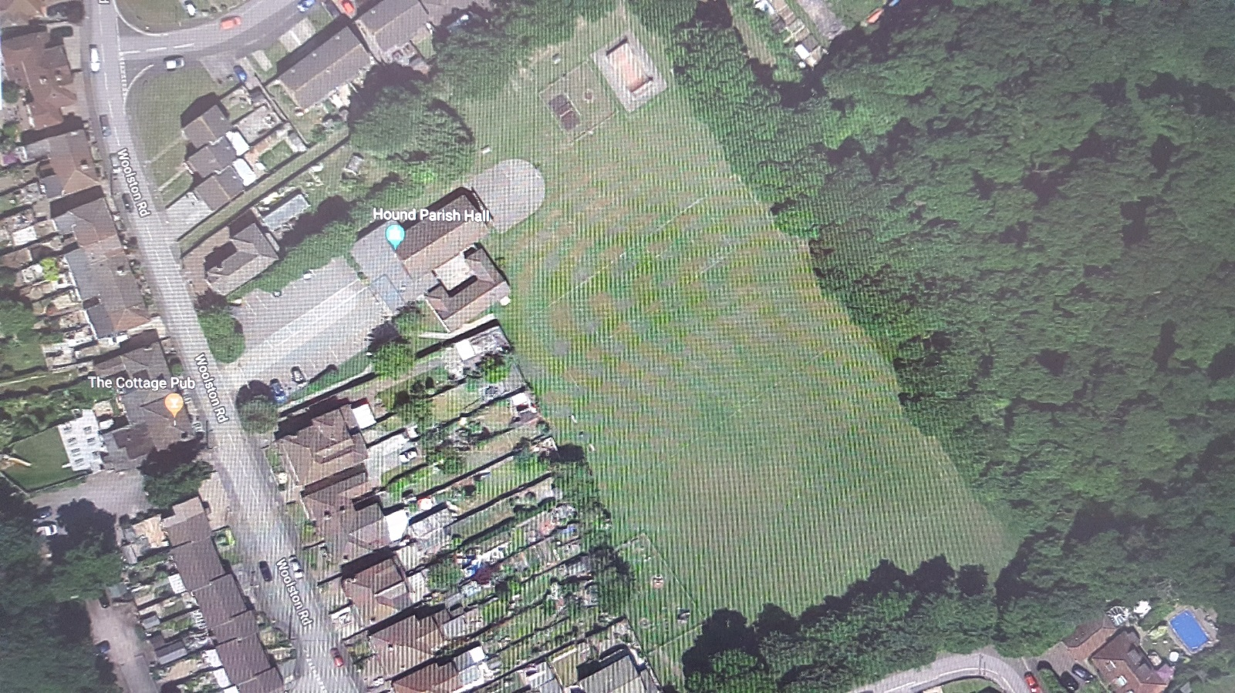

Appendix A

INVITATION TO TENDER ACKNOWLEDGEMENT

TENDER FOR THE CREATION OF A PLAY AREA AT BUTLOCKS HEATH RECREATION GROUND

*I/ We intend to submit a tender by the required date and confirm that all of the information required, will be enclosed with our formal submission.

* I/We are unable / do not wish to submit a tender and our reasons for this are set out below.

Please insert here your reasons for not submitting a tender, or include in a separate letter:

We confirm that we will treat all information supplied by the Council as confidential and will not communicate any of that information to any other party or make use of that information for any purpose other than preparation of a response to the Invitation to Tender.

Signed: Date

On behalf of:

Address:

Name (Block Capitals)

Position:

E-mail address for further Correspondence:

*Delete as appropriate

This form must be returned by no later than 25.02.19 to ensure receipt of any further correspondence including clarification responses.

To be returned by e-mail to: clerk@houndparishcouncil.gov.uk

Or by post to:

Clerk
Hound Parish Council
Parish Office
29c Station Road
Netley Abbey
Southampton
Hants SO31 5AE

Appendix B

FORM OF TENDER

TO: Clerk
Clerk
Hound Parish Council
Parish Office
29c Station Road
Netley Abbey
Southampton
Hants SO31 5AE

I/We, ...............................................................................................................................................
(insert full legal name of tenderer including ‘Ltd’ or ‘plc’ or as the case may be – please note: if the legal name is a business name not followed by ‘Ltd’ or ‘plc’ or a similar expression, please state the legal nature of the tenderer, e.g. partnership or incorporated unlimited company) hereby offer to provide the works, services and goods (‘the Services’) in accordance with the Conditions of
Contract and Specification Brief for the Fixed Sum of £………

1. I/We hereby warrant and represent to, and undertake with the Council that:-

a) I/We have not directly or indirectly canvassed any Member or Official of the Council with a view to gaining more favourable consideration of my/our Tender;

b) All information, representations and other matters of fact communicated (whether in writing or otherwise) to the Council by myself/ourselves my/our employees or agents in connection with the Form of Tender (and without prejudice to the generality hereof) are true, complete and accurate in all respects;

c) I/We have not submitted the Form of Tender or entered into the Contract in reliance upon any representations or statement (whether made orally or in writing) which may have been made by the Council or on the Council’s behalf;

d) I/We have full power and authority to enter into the Contract and to provide the Service;

e) I/We have sound financial standing and have sufficient working capital available to perform the contract in accordance with the conditions for the entire duration of the contract period;

2. I/We agree that:

a) This tender shall be kept open for 60 days from 28th February 2019
b) The Contract shall become binding upon the Council’s written acceptance of the Tender
c) The Council is under no obligation to accept this or any other Tender

Dated this day of 2019

(1) Signature Name: Authority:

(2) Signature Name: Authority:
Please complete this form in full and return it with all other items referred to in the Instructions to Tenderers. (Words defined in the Conditions of Contract and Specification shall have the same meaning in this Form of Tender)

Appendix c
QUALIFICATION QUESTIONNAIRE

Suppliers should provide the following information to determine their financial and technical competence/suitability to supply the tendered Service. Please note the Council may obtain an independent appraisal of financial strength.

1. Trading Name of Contractor:

2. Full Name of Contractor:

3. Address of Registered Office:

4. Address and telephone number of office from where the Council’s work would be carried out:

5. Person applying on behalf of the Contractor:

Position in Company:

Tel No:

e-mail:

6. Date of Formation of Company:

7. Registration Number where a limited Company:

8. Health & Safety

Hound Parish Council firmly believes that successful Health & Safety management is integral to the efficiency and effectiveness of any organisation. It is therefore essential that the following questions are fully completed.

(i) Number of people employed by your organisation:

(ii) Name and designation of person responsible for Health & Safety within your organisation:

(iii) Do you have a Health & Safety Policy? If yes please enclose.
YES/NO

(iv) Do you have risk assessments for the Services to be provided to Hound Parish Council? If yes, please enclose.
YES/NO

(v) Do you have Safe Working Procedures for the Service to be provided to Hound Parish Council? If yes, please enclose.
YES/NO

(vi) Please provide the name and qualifications of the person used for competent health & safety advice to your organisation.

(vii) Please list any improvement notices, prohibition notices or prosecutions served on your organisation within the last 5 years.

(viii) How many accidents or near misses (if any) have been reported to you, by members of your staff in the last 12 months? Please detail below:

(ix) How many RIDDOR reportable accidents (if any) have there been in the last 12 months? Please detail below:

9. Insurance

(i) Name and address of Insurance Broker

(ii) Employers Liability Insurance - Please enclose a copy of your current policy.

Limit of Cover

Insurer

Policy No

Expiry Date

(iii) Public Liability (Third Party) Insurance - Please enclose a copy of your current policy.

Limit of cover

Insurer

Policy No

Expiry Date (iv) If your Public and Employers Liability Insurance cover is for less than £5 million, please confirm that you would be prepared to make cover of this amount available in the event of your being awarded a contract.
YES/NO

(v) Professional Liability Insurance – Please enclose a copy of your current policy

Limit of Cover:
Insurer:
Policy Number:
Expiry Date:

(vi) Product Liability Insurance – Please enclose a copy of your current policy

Limit of Cover:
Insurer:
Policy Number:
Expiry Date:

10. Previous Experience
Please give details of three of your most recent or current contracts that we can contact, preferably with the public sector in the South East area. By giving these details you consent to us contacting them.

Organisation and Address | Contact Name Telephone No  & e-mail | Date | Contract  Value | Contract  Description
Name: Tel:
e-mail:
Name: Tel:
e-mail:
Name: Tel:
e-mail
13. Has your company had a contract terminated or its employment determined within the last three years?
If yes, please give details below:

