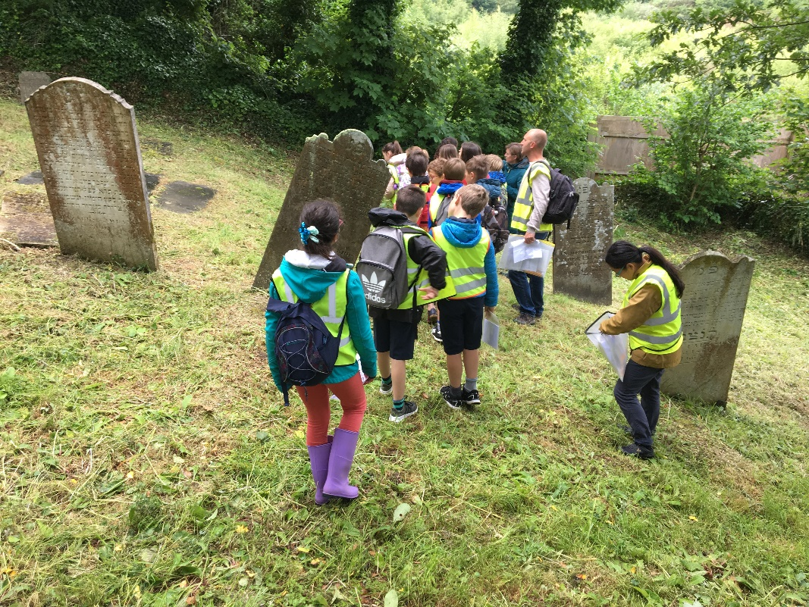

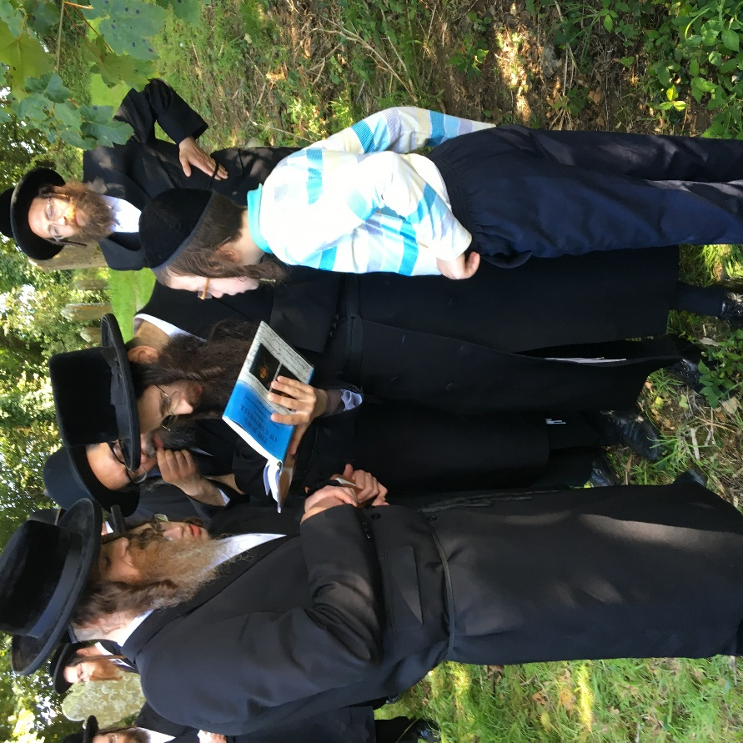

Local schoolchildren visit the Jewish Cemetery during one of the open days

Hasidic Jewish community members visit during an open day – enthralled by Keith Pearce’s 2014 book “the Jews of Cornwall” with a section on the Ponsharden cemetery.

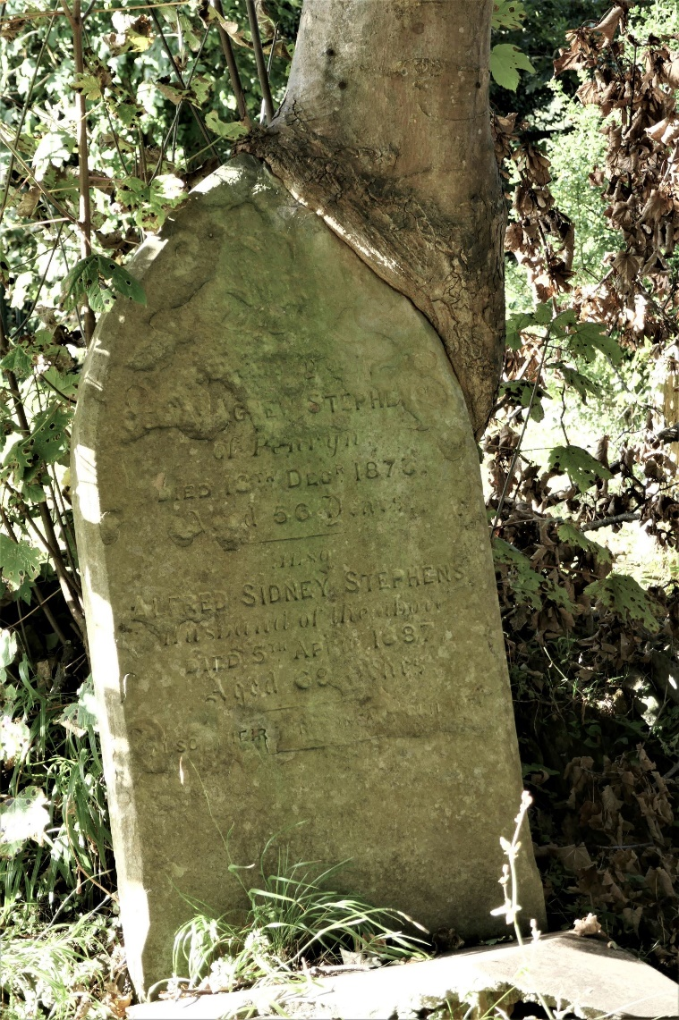

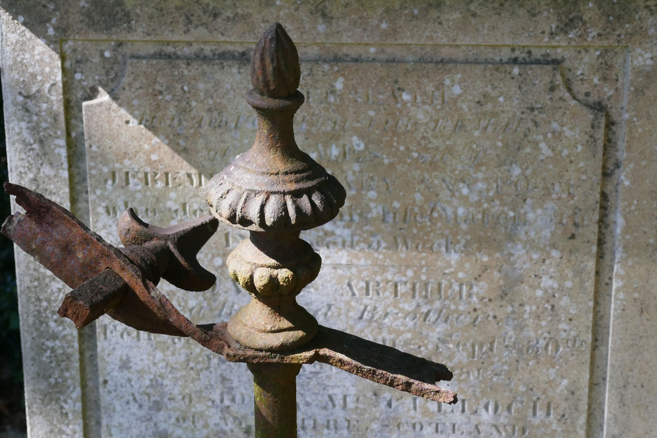

Twisted and snapped ironwork to the Poat family vault

Nature reclaims - A sycamore tree slowly grows over the Stephens gravestone in the Congregationalist cemetery

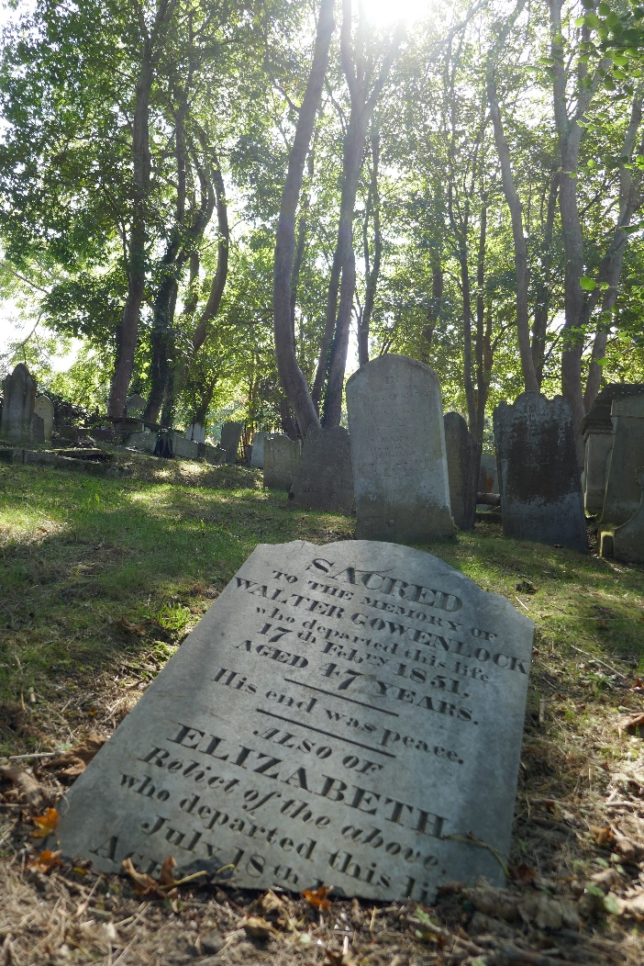

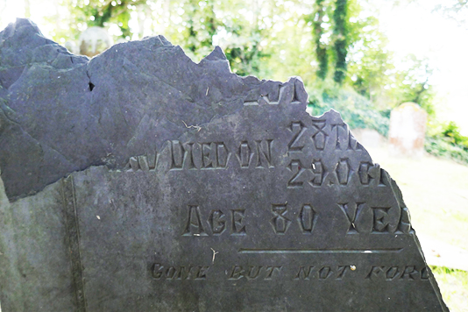

The Gowenlock headstone lies broken in the Congregationalist Cemetery

Gone but not forgotten – a vandalised slate headstone to Nathan Vos in the Jewish Cemetery. This was the last Jewish burial in 1913 but unfortunately one of the most recent examples of vandalism. Nathan Vos’s great, great-grandson recently discovered the burial and plans to visit very soon.

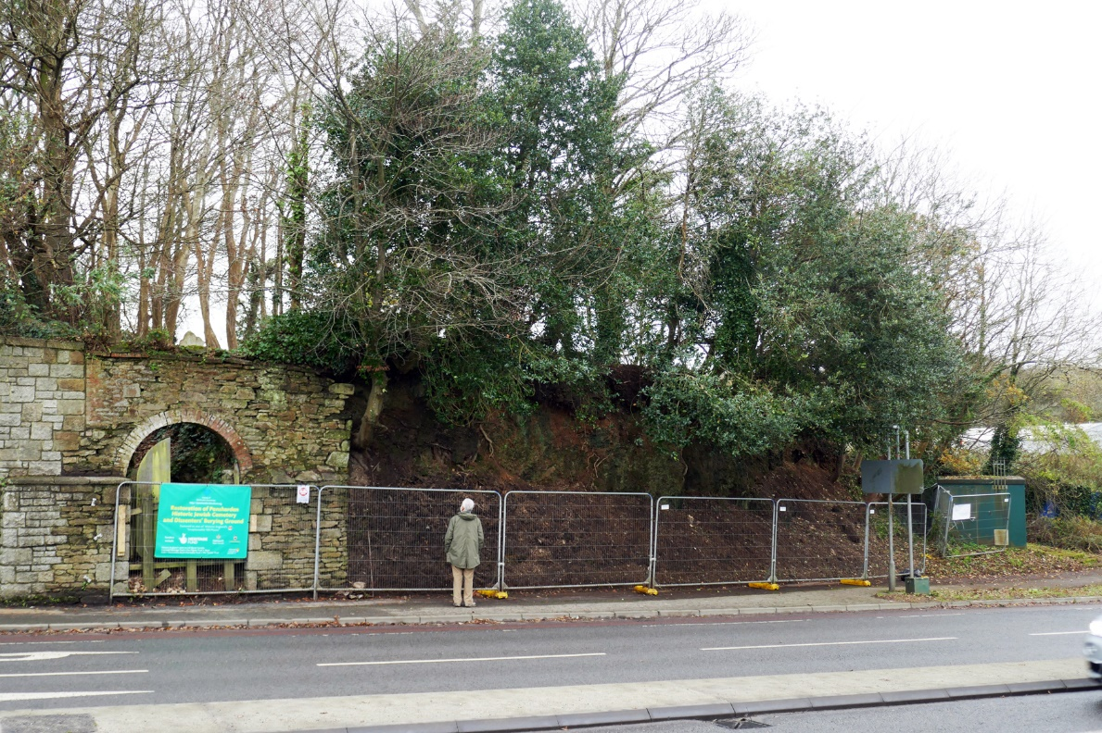

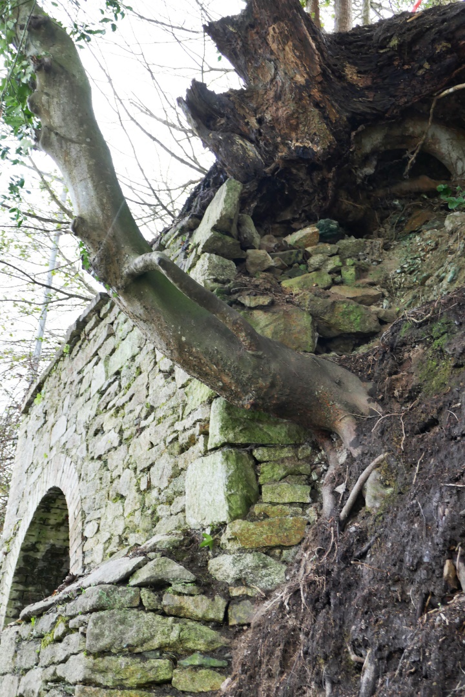

The front elevation to Ponsharden Cemeteries facing Falmouth Road. The Congregationalist stone arched entrance is on the left, the tall earth banks topped by Holly trees is in the centre and the Jewish Cemetery entrance is behind the green box to the right

Close up of the collapsing stone wall at the Congregationalist entrance and crumbling earth bank that retain historic graves in the cemeteries

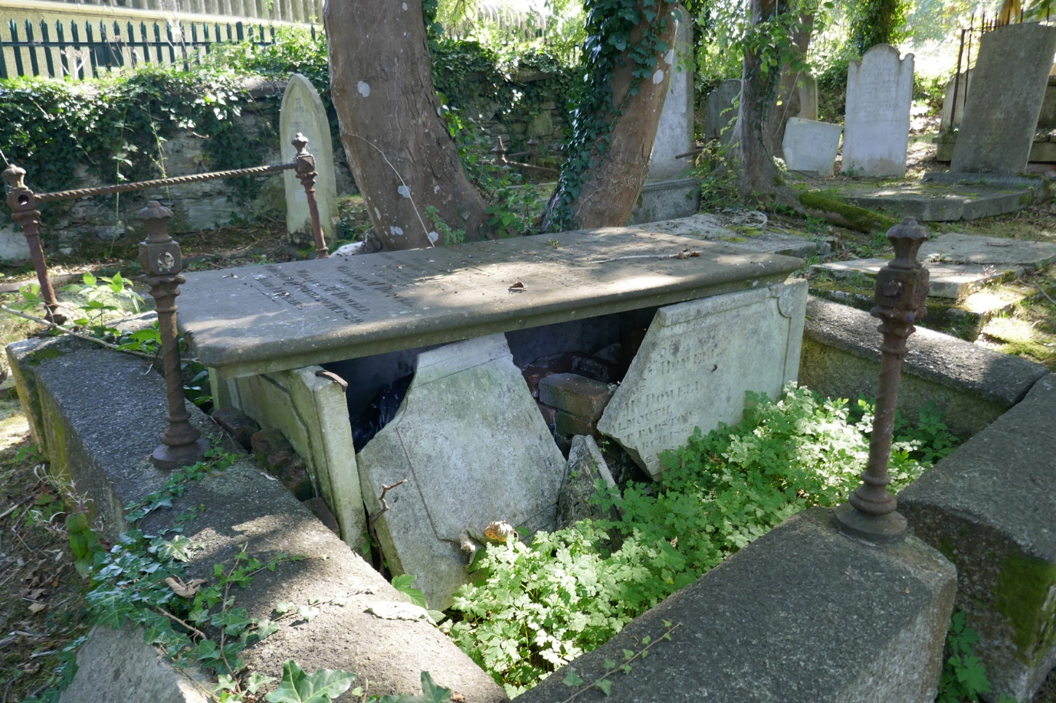

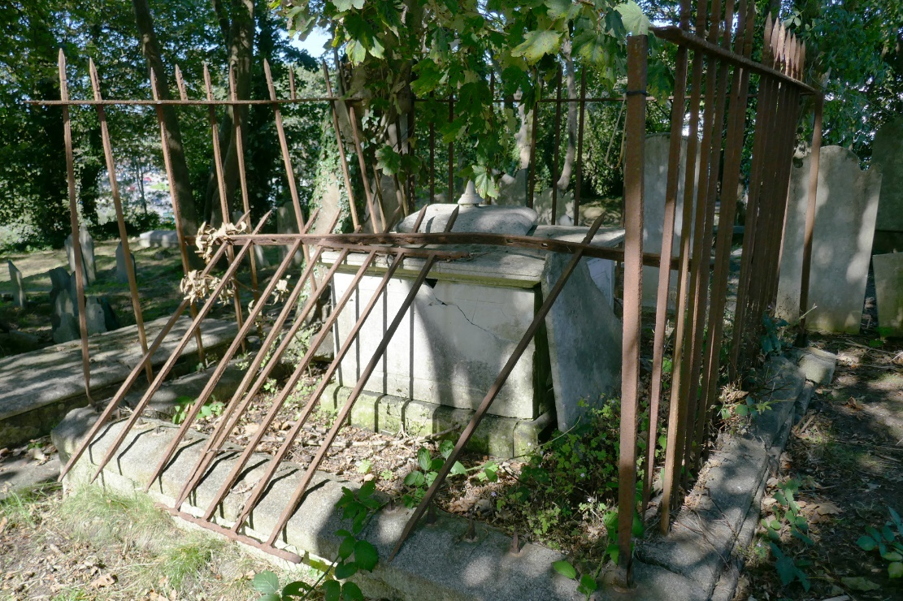

The Glasson family vault in the Congregationalist Cemetery. Restoration of the vault and ironwork will be a key feature of the project.

Vandalised chest tomb to the McDowell family in the Congregationalist cemetery

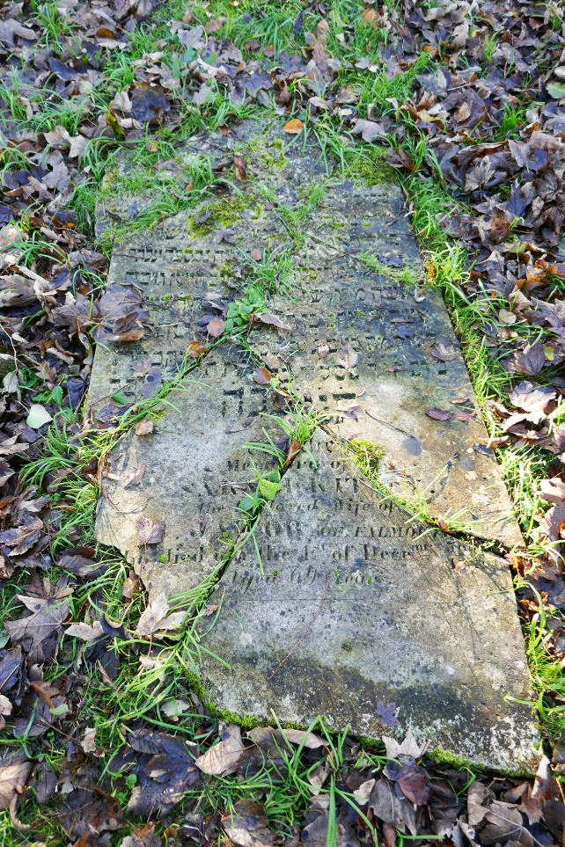

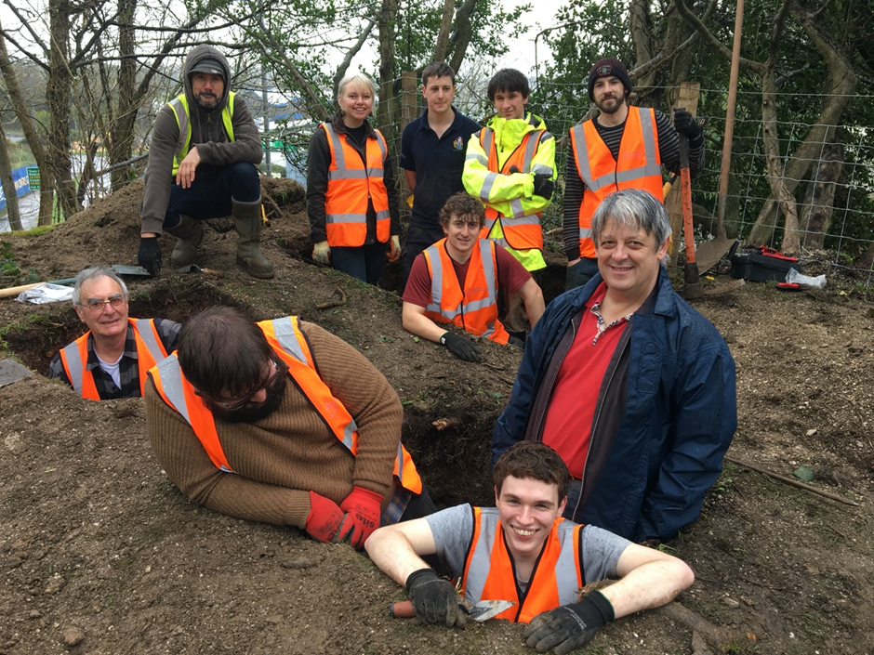

Volunteers complete the archaeological investigation in 2019 as part of the development phase, overseen by Cotswold Archaeology.

Smashed and uprooted headstone of Sarah Kitty Jacob in the Jewish Cemetery

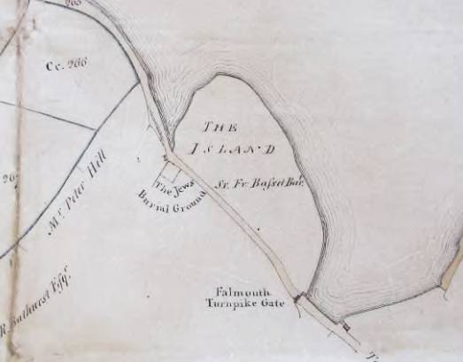

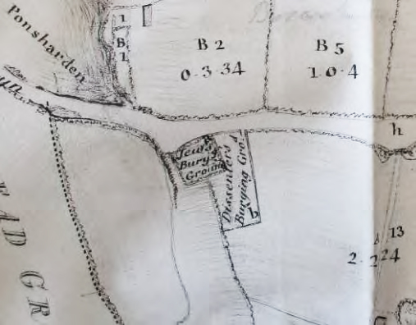

1814 Richard Thomas survey showing the Dissenter’s Burial Gound attached to the Jewish Burial Ground

Duke of Leeds Estate Map 1788 showing the Jewish Burial ground outside the Turnpike gate