


INVITATION TO TENDER
FOR
KING GEORGE’S FIELD PLAY AREA REDEVELOPMENT
FOR
WESTERHAM TOWN COUNCIL

Lot 1 – Provision and installation of new play equipment
Lot 2 – Refurbishment of retained play equipment
Lot 3 – Safer surfacing works

* Contractors may choose to tender for one/two, or all of the areas identified.

CONTENTS

PAGE

SECTION 1: PROJECT OVERVIEW 3 - 4

SECTION 2: PROCUREMENT TIMETABLE 4

SECTION 3: INSTRUCTIONS TO TENDERERS 4 - 5

SECTION 4: SUBMISSION OF TENDER 5 - 6

SECTION 5: EVALUATION CRITERIA 6 - 7

SECTION 6: DESIGN BRIEF 8 - 11

APPENDIX A: FORM OF TENDER 12 - 14

APPENDIX B: COLLUSIVE TENDERING CERTIFICATE 15

APPENDIX C: BUSINESS QUESTIONNAIRE 16 - 29

Section 1 – Project Overview

1.1 Westerham Town Council (the ‘Council’) owns the site known as King George’s Field (KGF) and has sole responsibility for the management of the playing field and facilities:
King George’s Field
Off Costells Meadow
Westerham
Kent
TN16 1BN
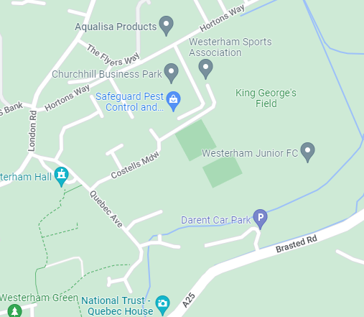

1.2 Following extensive public consultation, the Council created a Master Plan to re-develop the facilities at KGF, including the refurbishment of the play area – marked in red below:

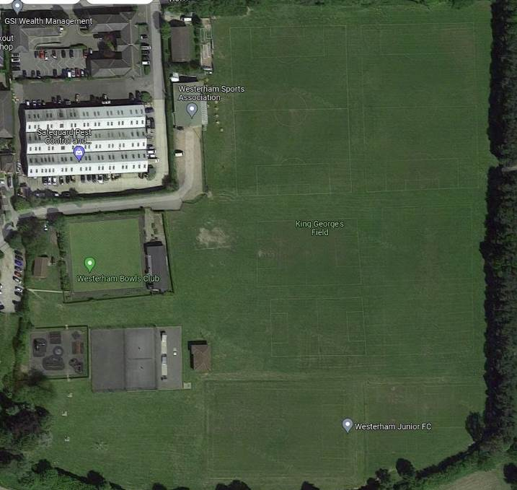

1.3 This project seeks to improve the children’s play area within King George’s Field (KGF). Community engagement has been undertaken to find out what is good about the play area at the moment and what improvements should be considered in the future. These findings have been built into this tender document. Our objective is to create a play space that will offer young people access to as wide a range of play opportunities as possible. The space should be visually appealing, exciting, challenging and stimulating. We seek to provide inclusive play equipment that can be used by all children, whatever their ability.

1.4 We are now seeking tenders for
- the provision and installation of new play equipment
- the refurbishment of retained play equipment
- safer surfacing works
from suitably experienced and qualified contractors. The contractor may quote for some or all of the areas identified. Each area will be assessed separately and the Contract may consequently be awarded to multiple contractors (although this is not desirable). Should a contractor intend to provide the whole of the services, by sub-contracting any part of the services, this must be indicated on the tender document.

Budget

1.5 The Council has agreed a budget of up to £70,000 ex VAT for the project. All pricing should be exclusive of VAT and in GBP (£). Pricing should be valid for a minimum of 120 days from the date of the tender deadline. Prices will be fixed for the duration of the contract.

Section 2 – Procurement timetable

Action |  | Date
Issue invitation to tender | The Council will publish on:  - WTC website  - Contract Finder | w/c 30th May 2022
Notification of intention to bid | Interested parties are to notify the Council by email of their intention to submit a tender | w/c 17th June 2022
Site Visits | Site visits will be conducted | 20th June 2022 AM
Deadline for questions | All questions should be submitted via email to the named contact | 30th June 2022
Deadline for submission of tenders | Any tenders received after this time and date will not be accepted | 12 noon 18t^{h} July 2022
Evaluation

Tender(s) selected and decision notified | The successful contractor(s) will be notified no later than | w/c 25th July 2022
Place Order

Playground installation date |  | To be agreed
Playground completion date | No later than end of December 2022 | To be agreed

Section 3 - Instructions to Tenderers

3.1 The Contractor shall make themselves fully conversant with the Council’s requirements by reading the invitation to tender and visiting and inspecting the site set out in the tender document. The Contractor is required to raise any issues on which they require clarification prior to submission of their tender, as no claims arising from their failure to do so will be entertained by the Council following the submission of tenders. It is the responsibility of the tenderer to obtain for themselves, at their own expense, any additional information necessary for the preparation of their tender.
3.2 Named contact: all contact should be with the named contact for the project: Debbie Marshall (Project Manager) - dmarshall@westerhamtowncouncil.gov.uk

3.3 Questions: any questions and clarifications should be emailed to
dmarshall@westerhamtowncouncil.gov.uk using the subject heading ‘KGF Play Area Tender Submission’ by Thursday 30th June 2022. The response will be sent via email.

3.4 Certificate of Collusion: contractors tendering for this contract must complete a Certificate of Collusion (see attached document). This is in regard to canvassing of the Council or its officers to gain competitive advantage. Any effort to do so will immediately disqualify any tender submitted.

3.5 Site visit: there will be the opportunity to attend a site meeting, along with other interested suppliers, on the morning of the 20th June 2022. However, this is not mandatory and suppliers are welcome to visit the site at their own convenience, without a member of staff present. Appointments can be booked via dmarshall@westerhamtowncouncil.gov.uk

3.6 Notice of intent to bid: contractors should inform us of their intent to submit a tender by 17th June 2022 via dmarshall@westerhamtowncouncil.gov.uk Failure to do so could result in your organisation not receiving updates to the Tender Process or any circulated responses to questions.

Section 4 – Submission of Tender
4.1 Tenders are to be sent by post or delivered by hand in an envelope clearly labelled ‘Private and Confidential Tender – KGF Play Area’, addressed to Angela Howells, Town Clerk, Westerham Town Council, Russell House, Market Square, Westerham, Kent, TN16 1RB, so as to be received no later than 12.00 noon on Monday 18th July 2022.
4.2 The submission must include 2 hardcopies of the tender document and 2 copies of any designs detailing the layout/new equipment for the proposed play area development. Electronic copies of the tender should be sent to dmarshall@westerhamtowncouncil.gov.uk in addition to the hard copies but not in lieu of. Electronic submissions should also be clearly titled ‘Private & Confidential Tender – KGF Play Area’.

  - Contractors are required to note that it is the Contractor’s responsibility to ensure that any tender delivered by hand in response to this invitation is actually received by WTC by the above date and time.

4.4 No tender will be considered if it is received after the date and time specified, unless the Council, at its sole discretion, extends the closing date and time specified in writing.

  - The unit prices per item of equipment are to be itemised to allow for accurate comparison between suppliers. Detailed costs of all sundry items should be provided. All prices are to be quoted exclusive of VAT.
  - Accuracy: it is the responsibility of the contractor to check that all unit rates and other information/fees entered in the tender document are accurate. If arithmetical mistakes are found after the contract has been awarded they will not be taken into account. The figure agreed at the time of contract will prevail. If WTC suspects that there has been an error in the pricing of the Tender the Council reserves the right to seek such clarification as it considers necessary from the contractor only.
  - Period of validity: contractors are required to keep tenders valid for acceptance for a period of 120 days from the closing date for receipt of tenders.
  - The Council may reject any tender not complying in any particular matter and their decision in that regards shall be final.
  - The Council is not bound to accept the lowest tender, nor does the Council guarantee that it will decide to award a contract.
  - Award of contract: the Council will contact all Contractors at the conclusion of the tender selection process advising of our decision and its rationale.
  - Confidentiality: All information supplied by the Council in connection with this invitation to tender shall be regarded as confidential by the Contractor except such information that may be disclosed for the purpose of obtaining sureties and quotations necessary for the preparation of the tender. The Tender documents are and shall remain the property of the Council.
  - Freedom of information: all information submitted to the Council may need to be disclosed and/or published by the Council in compliance with the Freedom of Information Act 2002.

4.13 Accordingly, if you consider that any of the information included in your tender response is commercially confidential please identify it and explain (in broad terms) what harm might result from disclosure/publication. It should be remembered though, that, even where you have indicated that information is commercially sensitive, the Council may disclose this information where they see fit.

Section 5 - Evaluation Criteria
5.1 All submissions will be assessed in line with Westerham Town Council financial regulations. The tenderers must be able to answer yes to the following three screening questions:
- Has the contractor confirmed that they have visited the site? YES/NO
- Has the contractor confirmed that they can meet the deadline? YES/NO
- Has the contractor provided evidence of similar projects in the past? YES/NO
5.2 The Council will evaluate all essential requirements above and disclosed in the business questionnaire (appendix C) on a ‘pass’ or ‘fail’ basis. Tenders failing any of the essential criteria will be rejected at this stage of the evaluation.
5.3 Full evaluation will then be based upon the following criteria for LOTS 1 & 3.

- Design = 80% (including functionality, maintenance, number of pieces of equipment and suitability for children with disabilities)
- Price = 20% (including total costs and discounts applied)
- The evaluation will include emphasis on quality as well as price.

LOT 2 will be evaluated simply on refurbishment specification and price.
5.4 Scoring Criteria:
CRITERIA | WEIGHTING | DETAILS
Quality of design:  Play Value  Aesthetics  Innovation | 40% | Compliance with design brief.  Variety of equipment offering imaginative play.  Quality and quantity of play values (activities).  Inclusion of equipment suitable for less able children.  Aesthetics and colour of equipment.  Layout of area/efficient use of the space available.  Quality of materials used/suitability for the environment.
Presentation | 25% | The presentation score will be assessed by the quality of the materials submitted i.e. scale plan showing location of equipment, visual design artwork. Clarity of the scheme being offered and how it will integrate with remaining equipment.
Maintenance / Warranties | 10% | Quality of materials used / expected life-span of equipment.  Maintenance requirements / estimated annual cost.  Length of warranty cover.  Deliverance of project aftercare service.
Environmental impact | 5% | The Council is committed to reducing impact to the environment. Evidence of a sustainable approach and details of recycling/disposal of equipment.
Price / Value for money | 20% | Value for money offered – cost of scheme vs quality/quantity of play opportunities offered.

5.5 Scoring System:
Each criterion will be awarded a score in accordance with the scoring scale below i.e. 0 – 5.
Score | Criteria for Award
5 | Exceptional demonstration of understanding of the project aims. Response is above expectations in meeting project requirements.
4 | High standard, but falls just short of excellent.
3 | A comprehensive response that clearly meets most of the project’s aims/requirements.
2 | Some reservations – the response suggests shortcomings of understanding/ approach.
1 | Basic compliance only – significant shortcomings to understanding/approach.
0 | Fails to meet the minimum standards (Bid rejected).

NB: The Council may reject contractors that score 0 or 1 in any of the criteria, or more than two 2s.
Section 6 – Design Brief
This project seeks to improve the children’s play area within King George’s Field (KGF).
Community engagement has been undertaken to find out what users like about the
equipment in the play area at the moment and what equipment they would like to see
changed. In conclusion, the three large pieces of multi-play equipment are to be retained,
whilst the two sets of swings and the cone are to be replaced. The surfacing is
showing signs of wear and is in need of remedial works to create a safer, single level surface,
beneficial to all users and accessible to wheelchair users/pushchairs.

The current play area caters to under 12s, with the majority of users being between pre-school
age and age 8. Our objective is to create a play space that will offer young people access to
as wide a range of play opportunities as possible. The space should be visually appealing,
exciting, challenging and stimulating. We seek to provide inclusive play equipment that can
be used by all children, whatever their ability. The contractor is expected to create a design within budget that demonstrates the best value for money. If the contractor is able to provide any discounts adding value for this project, please demonstrate this within the tender.
Whilst we are keen to install equipment that is sympathetic to the play areas’ rural setting, any
wooden pieces must be resilient with protective capping at the base to protect the
equipment. The play area is the only facility in Westerham and as such is heavily used, hence
the equipment must be robust and vandal-proof. The existing wooden fencing will be
retained, as should the bin and 2 x bench seats, although these can be relocated within the
play area, if necessary.

Lot 1 – Provision and installation of new play equipment

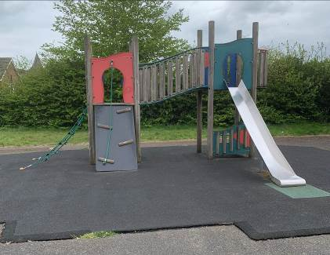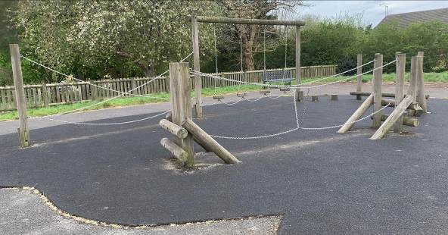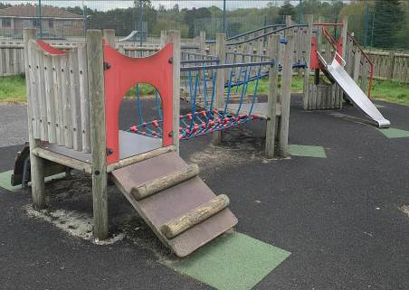Figure 1: equipment to be retained.
- Removal and disposal of the current two-bay cradle swings.

- Replacement swings to be supplied/installed in this location with:

1 bay, 2 x cradle swings and
1 bay, 1 x large basket swing, suitable for both dual play and inclusive play

- Repair/make good the impact absorbing, safety surfacing beneath the equipment to meet the requirements of BS EN1176/7 & BS EN7188.
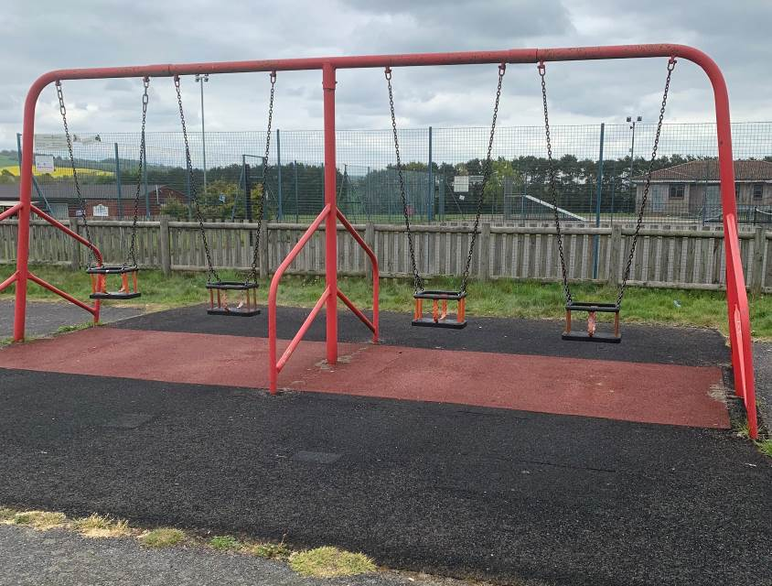 Figure 2: cradle swings to be removed/replaced.
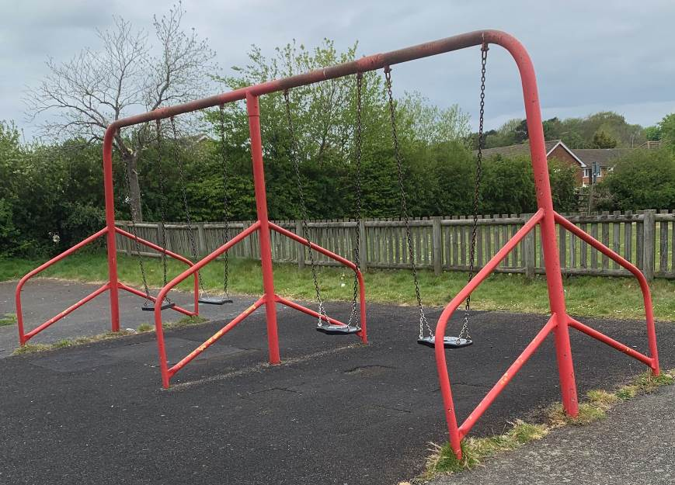
- Removal and disposal of the current two-bay junior swings.

- Replacement swings to be supplied/installed on the far side of the play area, adjacent to large multi-play unit with:

1 bay, 2 x junior swings

- Install impact absorbing, safety surfacing beneath the equipment to meet the requirements of BS EN1176/7 & BS EN7188.

Figure 3: junior swings to be removed/replaced.

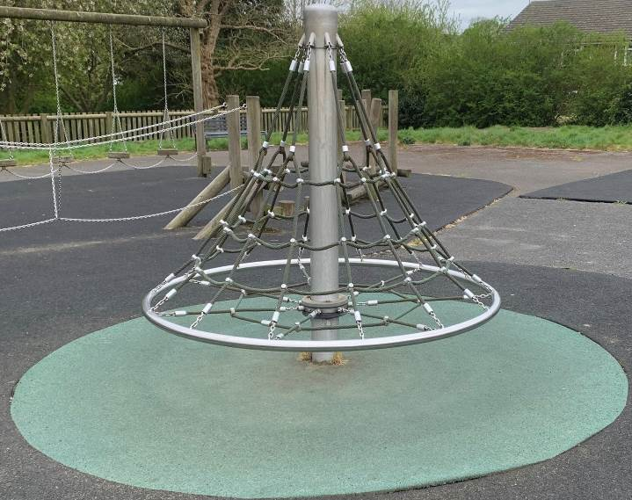
- Removal and disposal of the current cone.

- Inclusive roundabout to be supplied/installed in this location.

- Repair/make good the impact absorbing, safety surfacing beneath the equipment to meet the requirements of BS EN1176/7 & BS EN7188.

Figure 4: cone to be removed/replaced with
Inclusive roundabout.

- Item of equipment to stimulate role play and provide junior seating i.e. train/car/tractor/boat etc.

- Repair/make good the impact absorbing, safety surfacing beneath the equipment to meet the requirements of BS EN1176/7 & BS EN7188, if required.


Figure 5: space for a piece of new equipment.
- The removal of the two-bay junior swings will create an area for 1 or 2 pieces of new equipment, budget dependent.

- Suppliers to suggest equipment that will complement the other pieces in the play area – additional inclusive play would be welcomed.

- Repair/make good the impact absorbing, safety surfacing beneath the equipment to meet the requirements of BS EN1176/7 & BS EN7188.

Figure 6: junior swings to be removed.

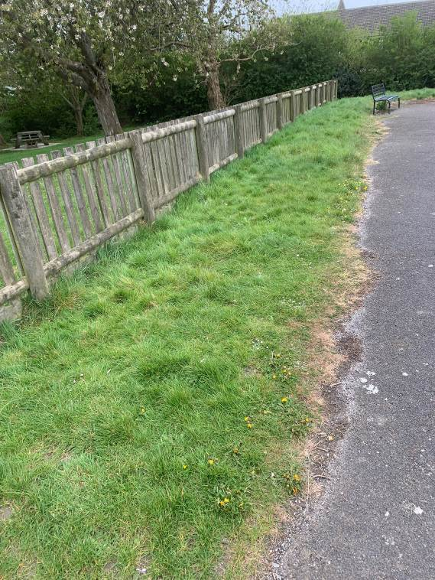
- The grassed area along the southern boundary has been identified for the supply/installation of interactive play panels – ideally 3 panels i.e. musical, game, mirrored etc.

- These should be sited so as to be accessible by wheelchair users from the surfaced area.

- During consultation the inclusion of loud speakers was popular, should budget allow.
Figure 7: area for new equipment.

Note: the repairs/making good of safety surfacing under equipment listed in figures 2 to 6 above, can take into account the minimum 20mm top layer surfacing to be applied to the whole of the play area (as specified in lot 3) when ascertaining what is necessary to comply with BS EN1176/7 and BS EN7188.

Note: the tender specification should include any necessary herras fencing and secure storage for equipment. Welfare facilities for site workers can be provided by the Council in the vicinity to the play area.

Lot 2 – Refurbishment of retained play equipment

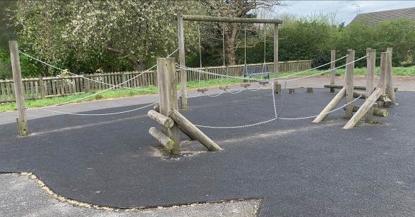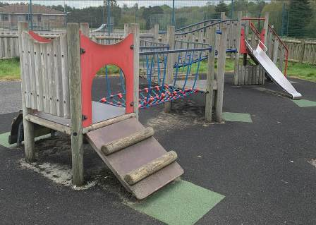

Refurbish the 3 items of retained play equipment to prolong their life and ‘spruce’ them up:

- Sand and treat the wooden timbers with wood preservative.

- Clean the coloured panels and repaint, as necessary, with hammerite paint.

Lot 3 – Safer surfacing works

We are looking to improve the safety surfacing in the play area as the existing surface is uneven with numerous trip hazards. We would like to achieve a single surface. We envisage that this is likely to be achieved by skimming over the top of the existing surfaces with EN1177 certified Wet Pour Rubber Surfacing. The area is approximately 400m² It is anticipated that this will need to be a minimum depth of 20mm, but may need to be a greater depth in areas in order to create a single surface.

We would like to use the surfacing to introduce colour to the play area, as cost effectively as possible, whether this be by:
- one coloured surface;
- introducing colour around equipment;
- and/or the addition of coloured play markings such as hop scotch or play road markings

Maintenance Costs
Maintenance instructions for each item of equipment must be supplied to the Council on completion of installation work. Contractors should also provide estimated annual maintenance costs likely to be incurred after the expiry of the warranty period.

APPENDIX A – FORM OF TENDER

LOT 1 – Provision and installation of new play equipment

Contractors are expected to provide full details of their design with pictures/photographs for each piece of equipment to be installed (preferably with visualisation boards) as a separate appendix. Data sheet information (size, heights, minimum space m² and safety surface area m²) should be included. For each item of equipment, expected age range, the maximum number of children catered for and the suitability for less able children would be helpful. Warranty periods should be included.

Please enter a breakdown of itemised costings in the pricing schedule below. Figures quoted must be the total fixed price, excluding VAT for the works concerned, including all parts, materials, labour and ancillary costs. Pricing should include the removal and disposal of the redundant play equipment, and delivery and installation of the new equipment. Site welfare facilities can be provided by the Council, but allowance should be made for onsite secure storage of materials and sufficient fencing to prevent trespass.

ITEM: | DETAIL: | PRICE (£):
 | TOTAL: | £
LOT 2 – Refurbishment of retained play equipment

Please enter a breakdown of itemised costings in the pricing schedule below for the refurbishment of the 3 items of retained play equipment identified. Figures quoted must be the total fixed price, excluding VAT for the works concerned, including all parts, materials, labour and ancillary costs.
ITEM: | DETAIL: | PRICE (£):
 | TOTAL: | £

LOT 3 – Safer surfacing works

We would like to achieve a single surface. We envisage that this is likely to be achieved by skimming over the top of the existing surfaces with EN1177 certified Wet Pour Rubber Surfacing.
Contractors are expected to provide full details of their design/specification as a separate appendix, to indicate product to be used, thickness of skim and how ‘colour’ is proposed to be introduced. Warranty periods should be included.

Please enter a breakdown of itemised costings in the pricing schedule below. Figures quoted must be the total fixed price, excluding VAT for the works concerned, including all parts, materials, labour and ancillary costs.
ITEM: | DETAIL: | PRICE (£):
 | TOTAL: | £

General Notes and guidance:
In addition to the Form of Tender (Appendix A), the Contractor is also required to complete the following documentation:
- A separate appendix outlining full details of their design (preferably with visualisation boards)
- Collusive Tendering Certificate (Appendix B)
- Business Questionnaire (Appendix C)

Note: a schedule of works, health and safety policy, risk assessments and copies of insurance documents should not be provided at this point.
LOT 1 - Having examined the Conditions of Contract and Outline Design Brief for the carrying out of the above-named works, I/we offer to complete the whole of the said Works in conformity with the above for the sum of:
(Amount in words): ________________________________________________________
(Amount in figures): ________________________________________________________
LOT 2 - Having examined the Conditions of Contract and Outline Design Brief for the carrying out of the above-named works, I/we offer to complete the whole of the said Works in conformity with the above for the sum of:
(Amount in words): ________________________________________________________
(Amount in figures): ________________________________________________________
LOT 3 - Having examined the Conditions of Contract and Outline Design Brief for the carrying out of the above-named works, I/we offer to complete the whole of the said Works in conformity with the above for the sum of:
(Amount in words): ________________________________________________________
(Amount in figures): ________________________________________________________

- I/We have full authority to enter into the contract and to provide the service.

- This tender shall be kept open for 120 days from 18th July 2022.
- The Contract shall become binding upon the Council’s written acceptance of the Tender.
- I/We are able and willing to complete the whole of the works tendered for on or before
________________________________
- I/We anticipate that the works will take ______________ weeks to complete.

Signature:

Name:

Position:

Company Name:

Contact Person:

Tel no:

Date:

APPENDIX B – COLLUSIVE TENDERING CERTIFICATE

King George’s Play Area Redevelopment
In recognition of the principle that the essence of selective tendering is that the Council shall receive bona fide competitive tenders from all those tendering.
WE CERTIFY THAT
- The tender submitted herewith is a bona fide Tender intended to be competitive.
- We have not fixed or adjusted the amount of the Tender under or in accordance with any agreement or arrangement with any other person.
- We have not done, and we undertake that we will not do at any time before the hour and date specified for the return of the tender any of the following acts:
- communicating to a person other than the person calling for those tenders the amount or approximate amount of the proposed tender, (except where the disclosure, in confidence, of the approximate amount of the tender was necessary to obtain insurance premium quotations required for the preparation of the Tender);
- entering into any agreement or arrangement with any other person that they shall refrain from tendering or as to the amount of any tender to be submitted;
- directly or indirectly canvassed any member or officer of the Council with a view to gaining more favourable consideration of our tender. Nor offered to pay/agreed to pay or give any sum of money or valuable consideration directly or indirectly to any person in relation to the tender for the said work.

DATED this ……………….. day of ......................................…………….20…..

SIGNED (as in Tender) ……………………………………………………………...........................

Duly authorised to sign for and on behalf of ……………………….................………………………...

APPENDIX C – BUSINESS QUESTIONNAIRE

1. SUPPLIER INFORMATION
1.1 Supplier Details
Name of the company
Registered company address

Registered company number
Date of formation
Registered charity number
Registered VAT number
Name of parent/holding company
Named contact/job title
Contact telephone number
Contact email address
Please mark ‘X’ in the relevant box to indicate your trading status | i. A public limited company
 | ii. A limited company
 | iii. A limited liability partnership
 | iv. A sole trader
 | v. A charity
 | vi. other (please specify)
Please mark ‘X’ in the relevant boxes to indicate whether any of the following classifications apply to you | i. Voluntary, Community and Social Enterprise (VCSE)
 | ii. Small or Medium Enterprise(SME)
 | iii. Other (please specify)
Are you applying as the lead organization in a consortium of organisations?
If yes, please state who the member organisations of the consortium are, what their roles will be and when the consortium was formed.

be
1.2 Contract details
Please mark ‘X’ in the relevant box to indicate whether you are:
Bidding as the Prime Contractor and will deliver 100% of the key contract deliverables yourself
Bidding as a Prime Contractor and will use third parties to deliver some of the services

If yes, please provide details of the areas/percentage of work being delivered by each sub-contractor and the key contract deliverables each sub-contractor will be responsible for.
Bidding as a Prime Contractor but will operate as a Managing Agent and will use third parties to deliver all of the services

If yes, please provide details of the areas/percentage of work being delivered by each sub-contractor and the key contract deliverables each sub-contractor will be responsible for.

2. GROUNDS FOR MANDATORY EXCLUSION
You will be excluded from the procurement process if there is evidence of convictions relating to specific criminal offences including, but not limited to, bribery, corruption, conspiracy, terrorism, fraud and money laundering, or if you have been the subject of a binding legal decision which found a breach of legal obligations to pay tax or social security obligations (except where this is disproportionate e.g. only minor amounts involved).
2.1 Within the past five years, has your organisation (or any member of your proposed consortium, if applicable), directors or partner, or any other person who has powers of representation, decision or control been convicted of any of the following offences? | Please indicate your answer by marking ‘X’ in the relevant box.
 | Yes | No
a. conspiracy within the meaning of section 1 or 1A of the Criminal Law Act 1977 or article 9 or 9A of the Criminal Attempts and Conspiracy (Northern Ireland) Order 1983 where that conspiracy relates to participation in a criminal organisation as defined in Article 2 of Council Framework Decision 2008/841/JHA on the fight against organised crime;
b. corruption within the meaning of section 1(2) of the Public Bodies Corrupt Practices Act 1889 or section 1 of the Prevention of Corruption Act 1906;
c. the common law offence of bribery;
d. bribery within the meaning of sections 1, 2 or 6 of the Bribery Act 2010; or section 113 of the Representation of the People Act 1983;
e. any of the following offences, where the offence relates to fraud affecting the United Kingdom’s financial interests:
i. the offence of cheating the Revenue;
ii. the offence of conspiracy to defraud;
iii. fraud or theft within the meaning of the Theft Act 1968, the Theft Act (Northern Ireland)

1969, the Theft Act 1978 or the Theft (Northern Ireland) Order 1978;
iv. fraudulent trading within the meaning of section 458 of the Companies Act 1985, article 451 of the Companies (Northern Ireland) Order 1986 or section 993 of the Companies Act 2006;
Please indicate your answer by marking ‘X’ in the
relevant box.
 | Yes | No
v. fraudulent evasion within the meaning of section 170 of the Customs and Excise Management Act 1979 or section 72 of the Value Added Tax Act 1994;
vi. an offence in connection with taxation in the UK within the meaning of section 71 of the Criminal Justice Act 1993;
vii. destroying, defacing or concealing of documents or procuring the execution of a valuable security within the meaning of section 20 of the Theft Act 1968 or section 19 of the Theft Act (Northern Ireland) 1969;
viii. fraud within the meaning of section 2, 3 or 4 of the Fraud Act 2006; or
ix. the possession of articles for use in frauds within the meaning of section 6 of the Fraud Act 2006, or the making, adapting, supplying or offering to supply articles for use in frauds within the meaning of section 7 of that Act;
f. any offence listed:
i. in section 41 of the Counter Terrorism Act 2008; or

ii. in Schedule 2 to that Act where the court has determined that there is a terrorist connection;
g. any offence under sections 44 to 46 of the Serious Crime Act 2007 which relates to an offence covered by subparagraph (f);
h. money laundering within the meaning of sections 340(11) and 415 of the Proceeds of Crime Act 2002;
i. an offence in connection with the proceeds of criminal conduct within the meaning of section 93A, 93B or 93C of the Criminal Justice Act 1988 or article 45, 46 or 47 of the Proceeds of Crime (Northern Ireland) Order 1996;
j. an offence under section 4 of the Asylum and Immigration (Treatment of Claimants etc.) Act 2004; or any offence involving Racial Discrimination
k. an offence under section 59A of the Sexual Offences Act 2003; or any offence involving Sexual Harrassment
l. an offence under section 71 of the Coroners and Justice Act 2009
m. an offence in connection with the proceeds of drug trafficking within the meaning of section 49, 50 or 51 of the Drug Trafficking Act 1994; or
n. any other offence within the meaning of Article 57(1) of the Public Contracts Directive:
i. as defined by the law of any jurisdiction outside England and Wales and Northern Ireland; or
ii. created, after the day on which these Regulations were made, in the law of England and Wales or Northern Ireland.
2.2 Non-payment of taxes
Has it been established by a judicial or administrative decision having final and binding effect in accordance with the legal provisions of any part of
the United Kingdom or the legal provisions of the country in which your organisation is established (if outside the UK), that your organisation is in breach of obligations related to the payment of tax or social security contributions?

If you have answered Yes to this question, please use a separate appendix to provide further details. Please confirm whether you have paid, or have entered into a binding arrangement with a view to paying, including, where applicable, any accrued interest and/or fines?

3. GROUNDS FOR DISCRETIONARY EXCLUSION
The Council may exclude any Supplier who answers ‘Yes’ in any of the following situations set out in paragraphs (a) to (j);
3.1 Within the past five years, please indicate if any of the following situations have applied, or currently apply, to your organisation. | Please indicate your answer by marking ‘X’ in the relevant box.
 | Yes | No
a. your organisation has violated applicable obligations referred to in regulation 56
(2) of the Public Contract Regulations 2015 in the fields of environmental, social and labour law established by national law, collective agreements or by the international environmental, social and labour law provisions listed in Annex X to the Public Contracts Directive as amended from time to time;
b. your organisation is bankrupt, the subject of insolvency or winding-up proceedings, where your assets are being administered by a liquidator or by the court, where it is in an arrangement with creditors, or where its business activities are suspended;
c. your organisation is guilty of grave professional misconduct, which renders its integrity questionable;
d. your organisation has entered into agreements with other economic operators aimed at distorting competition;
e. your organisation has a conflict of interest within the meaning of regulation 24 of the Public Contract Regulations 2015 that cannot be effectively remedied by other, less intrusive measures;
f. the prior involvement of your organisation in the preparation of the procurement procedure has resulted in a distortion of competition, as referred to in regulation 41, that cannot be remedied by other, less intrusive, measures;

g. your organisation has shown significant or persistent deficiencies in the performance of a substantive requirement under a prior public contract, a prior contract with a contracting entity, or a prior concession contract, which led to early termination of that prior contract, damages or other comparable sanctions;
h. your organisation:
- has been guilty of serious misrepresentation in supplying the information required for the verification of the absence of grounds for exclusion or the fulfilment of the selection criteria; or
- has withheld such information or is not able to submit supporting documents required under regulation 59 of the
Public Contract Regulations 2015; or
i. your organisation has undertaken to:
(i) unduly influence the decision-making process of the contracting authority, or
(ii) obtain confidential information that may confer upon your organisation undue advantages in the procurement procedure; or
j. your organisation has negligently provided misleading information that may have a material influence on decisions concerning exclusion, selection or award.
Conflicts of interest
In accordance with question 3.1 (e), the Council may exclude an applicant if there is a conflict of interest which cannot be effectively remedied. The concept of a conflict of interest includes any situation where relevant staff members have, directly or indirectly, a financial, economic or other personal interest which might be perceived to compromise their impartiality and independence in the context of the procurement procedure.

Where there is any indication that a conflict of interest exists or may arise then it is the responsibility of the applicant to inform the Council, detailing the conflict in a separate Appendix. Provided that it has been carried out in a transparent manner, routine pre-market engagement carried out by the Council should not represent a conflict of interest for the Supplier.

Please also state if any director, partner, senior manager or associate of your organisation is a relative or has any type of private or business relationship with either a Councillor, or an officer employed by Westerham Town Council, giving details of the nature of the relationship.

T a k ing Acc o un t o f Bid d e rs ’ Pas t Pe rforma n c e
In accordance with question (g), the Council may assess the past performance of a Supplier (through a Certificate of Performance provided by a Customer or other means of evidence). The Council may take into account any failure to discharge obligations under the previous principal relevant contracts of the applicant completing this Questionnaire. The Council may also assess whether specified minimum standards for reliability for such contracts are met.

In addition, the Council may re-assess reliability based on past performance at key stages in the procurement process (i.e. supplier selection, tender evaluation, contract award stage etc.). Suppliers may also be asked to update the evidence they provide in this section to reflect more recent performance on new or existing contracts (or to confirm that nothing has changed).
‘Se lf-c le a n in g ’
Any supplier that answers ‘Yes’ to questions 2.1, 2.2 and 3.1 should provide sufficient evidence, in a separate Appendix, that provides a summary of the circumstances and any remedial action that has taken place subsequently and effectively “self cleans” the situation referred to in that question. The applicant has to demonstrate it has taken such remedial action, to the satisfaction of the Council in each case.

If such evidence is considered by the Council (whose decision will be final) as sufficient, the economic operator concerned shall be allowed to continue in the procurement process.

In order for the evidence referred to above to be sufficient, the applicant shall, as a minimum, prove that it has;
- paid or undertaken to pay compensation in respect of any damage caused by the criminal offence or misconduct;
- clarified the facts and circumstances in a comprehensive manner by actively collaborating with the investigating authorities; and
- taken concrete technical, organisational and personnel measures that are appropriate to prevent further criminal offences or misconduct.

The measures taken by the applicant shall be evaluated taking into account the gravity and particular circumstances of the criminal offence or misconduct. Where the measures are considered by the Council to be insufficient, the applicant shall be given a statement of the reasons for that decision.

4. FINANCIAL INFORMATION
Please indicate that you are able to provide one of the following to demonstrate your financial standing – DO NOT PROVIDE THE DOCUMENTS AT THIS STAGE. The Council will request the evidence to be submitted to ensure the any potential contractor has sufficient financial resource to undertake the contract if they are successful at contract award stage.
4.1 | Please indicate your answer with an ‘X’ in the relevant box.
 | a. A copy of the audited accounts for the most recent two years
 | b. A statement of the turnover, profit & loss account, current liabilities and assets, and cash flow for the most recent year of trading for this organisation
 | c. A statement of the cash flow forecast for the current year and a bank letter outlining the current cash and credit position.
 | d. Alternative means of demonstrating financial status if any of the above are not available (e.g. Forecast of turnover for the current year and a statement of funding provided by the owners and/or the bank, charity accruals accounts or an alternative means of demonstrating financial status).
4.2 | (a) Are you part of a wider group (e.g. a subsidiary of a holding/parent company)?  If yes, please provide the name below:
4.2 | Name of the organisation
4.2 | Relationship to the Supplier completing the Questionnaire
4.2 | If yes, are you able to provide parent company accounts?
4.2 | If yes, would the parent company be willing to provide a guarantee if necessary?
4.2 | If no, would you be able to obtain a guarantee elsewhere (e.g. from a bank?)
5. TECHNICAL AND PROFESSIONAL ABILITY
Relevant experience and contract examples
Please provide details of up to three contracts, in any combination from either the public or private sector, that are relevant to the Council’s requirement. Contracts for supplies or services should have been performed during the past five years. The named customer contact provided should be prepared to provide written evidence to the Council to confirm the accuracy of the information provided below.

Consortia bids should provide relevant examples of where the consortium has delivered similar requirements; if this is not possible (e.g. the consortium is newly formed or a Special Purpose Vehicle will be created for this contract) then three separate examples should be provided between the principal member(s) of the proposed consortium or Special Purpose Vehicle (three examples are not required from each member).

Where the Supplier is a Special Purpose Vehicle, or a managing agent not intending to be the main provider of the supplies or services, the information requested should be provided in respect of the principal intended provider(s) or sub-contractor(s) who will deliver the supplies and services.
 |  |  | Contract 1 | Contract 2 |  |  | Contract 3
5.1 | Name of customer organisation
5.2 | - Name of contact in customer organisation  - Position in the organisation  - E-mail address
5.3 | - Contract start date  - Contract completion date  - Contract Value
5.4 | In no more than 500 words, please provide a brief description of the contract delivered including evidence as to your technical capability in this market.
5.5 If you cannot provide at least one example for questions 5.1 to 5.4, in no more than 500 words please provide an explanation for this e.g. your organisation is a new start-up.
6. ADDITIONAL INFORMATION
Suppliers who self-certify that they meet the requirements for these additional modules will be required to provide evidence of this if they are successful at contract award stage.
a. Project Specific questions to assess Technical and Professional Ability
Please indicate your answer by marking ‘X’ in the relevant box. |  |  |  |  |  | Yes |  | No
Does your organisation require your staff and your sub- contractor’s staff to undergo a Disclosure and Barring Service (DBS) check to the standard level.
Please self-certify that your organisation has a Safeguarding Policy or would be willing to ensure that one is in place upon award of the Framework Agreement that complies with current legislative requirements.
b. Insurance
Please self-certify whether you already have, or can commit to obtain, prior to the commencement of the contract, the levels of insurance cover indicated below Please indicate your answer by marking ‘X’ in the relevant box. |  |  |  |  |  | Yes |  | No
Employer’s (Compulsory) Liability Insurance = min. £5,000,000
Public Liability Insurance = min. £5,000,000
Product Liability Insurance = min. £5,000,000
Professional Indemnity Insurance = min. £1,000,000
- Compliance with Equality Legislation
For organisations working outside of the UK please refer to equivalent legislation in the country that you are located.
(Please indicate your answer by marking ‘X’ in the relevant box): |  |  |  |  |  | Yes |  | No
In the last five years, has any finding of unlawful discrimination been made against anyone within your organisation by an Employment Tribunal, an Employment Appeal Tribunal or any other court (or in comparable proceedings in any jurisdiction other than the UK)?
In the last five years, has your organisation had a complaint upheld following an investigation by the Equality and Human Rights Commission or its predecessors (or a comparable body in any jurisdiction other than the UK), on grounds or alleged unlawful discrimination?

If you have answered “yes” to one or both of the questions above, please provide, as a separate Appendix, a summary of the nature of the investigation and an explanation of the outcome of the investigation to date.

If the investigation upheld the complaint against your organisation, please use the Appendix to explain what action (if any) you have taken to prevent unlawful discrimination from reoccurring.

You may be excluded if you are unable to demonstrate to the Council’s satisfaction that appropriate remedial action has been taken to prevent similar unlawful discrimination reoccurring.
If you use sub-contractors, do you have processes in place to check whether any of the above circumstances apply to these other organisations?
d. Health and Safety
Please indicate your answer by marking ‘X’ in the relevant box. |  |  |  |  |  | Yes |  | No
Please self-certify that your organisation has a Health and Safety Policy that complies with current legislative requirements. The successful tenderer will need to provide a copy of your organisation’s Health and Safety policy, together with a schedule of works, a risk assessment and method statement, before the contract commences.

All persons operating machinery and equipment must be appropriately trained. The Contractor shall provide, if asked, adequate proof that all operatives are well trained and conversant with Health & Safety legislation.

The Contractor is required to notify the Council immediately of any accidents, near misses or environmental incidents.

Has your organisation or any of its Directors or Executive Officers been in receipt of enforcement/remedial orders in relation to the Health and Safety Executive (or equivalent body) in the last 5 years?

If your answer to this question was “Yes”, please provide details in a separate Appendix of any enforcement/remedial orders served and give details of any remedial action or changes to procedures you have made as a result.

The Council will exclude bidder(s) that have been in receipt of enforcement/remedial action orders unless the bidder(s) can demonstrate to the Council’s satisfaction that appropriate remedial action has been taken to prevent future occurrences or breaches.
If you use sub-contractors, do you have processes in place to check whether any of the above circumstances apply to these organisations?
e. Environmental Management
Please indicate your answer by marking ‘X’ in the relevant box. |  |  |  |  |  | Yes |  | No
Please indicate your agreement to removing from site all waste materials, including, but not restricted to: grass, wood, bark, paper, metals, plastics, glass. Tenderers may be asked to indicate how they separate and dispose of the materials described in this clause.
Has your organisation been convicted of breaching environmental legislation, or had any notice served upon it, in the last five years by any environmental regulator or authority (including local authority)?

If your answer to this question is “Yes”, please provide details in a separate Appendix of the conviction or notice and details of any remedial action or changes you have made as a result of conviction or notices served.

The Council will not select bidder(s) that have been prosecuted or served notice under environmental legislation in the last 5 years, unless the Council is satisfied that appropriate remedial action has been taken to prevent future occurrences/breaches.
If you use sub-contractors, do you have processes in place to check whether any of these organisations have been convicted or had a notice served upon them for infringement of environmental legislation?
f. Quality
Please indicate your answer by marking ‘X’ in the relevant box. |  |  |  |  |  | Yes |  | No
Please self-certify that your organisation holds a quality certificate such as ISO9001 (or equivalent) or a policy that attests to your organisations’ approach to quality management.
If you use sub-contractors, do you have processes in place to check whether any of the above circumstances apply to these organisations?
g. Payment Terms
Please indicate your answer by marking ‘X’ in the relevant box. |  |  |  |  |  | Yes |  | No
Please indicate your agreement to the Council’s standard payment terms:

- The Council will only make payment against itemised supplier invoices
- Payment will be made within 30 days of receipt of invoice, by electronic transfer, unless an alternative schedule is agreed;
- Invoices received for work that has not been authorised by the Council will be rejected.
- If the supplier is declared bankrupt, is liquidated or placed into administration, the contract will immediately become nul and void.
- If the supplier is found guilty of committing fraudulent acts (whether or not associated with this contract), the Council will have the right to terminate the contract without prior notice.

6. Declaration
I declare that to the best of my knowledge the answers submitted to these questions are correct. I understand that the information will be used in the selection process to assess my organisation’s suitability to be invited to participate further in this procurement, and I am signing on behalf

of............................................................................................. Insert name of contractor

………………………………………………………………….. Name

…………………………………………………………………. Position

I understand that the Council may reject my submission if there is a failure to answer all relevant questions fully or if I provide false/misleading information. I have provided a full list of any Appendices used to provide additional information in response to questions.

