# C:\Users\MaParker\AppData\Local\Microsoft\Windows\INetCache\Content.MSO\60FF2BB0.tmp

# Pre-Market Engagement

**For**

**Fleet Climate Strategy**

**West Northamptonshire Council**

## General Requirements

The purpose of this document is to engage with the suppliers so that their expertise can be fed into the project from the outset. It can also benefits West Northamptonshire Council (WNC) by providing:

* A test for any assumptions being made by the Council;
* An insight into possible innovative approaches to the procurement;
* An assessment of what is realistically affordable given the available funding;
* An understanding of the maturity of various suppliers and their offerings;
* The level of supplier capacity;
* An understanding of the expected level of competition for service provision, which can identify when it is appropriate to develop the market, as this will influence which method of commissioning is chosen;
  1. **Please note:** this pre-market engagement exercise is **not** an invitation to tender or a request for formal expressions of interest. This document does not form any part of an invitation to tender. West Northamptonshire Council (WNC) is issuing this request for **information only**. Any supplier invited to present to WNC is doing so to support market research only and to help make any potential procurement process more focused and efficient. No supplier selection or supplier preference is implied.

## Confidentiality and Freedom of Information (FOI)

* 1. **Please note:** all information included in this Pre-Market Engagement is confidential and only for the recipients’ knowledge. No information included in this document or in discussions connected to it may be disclosed to any other party without prior written authorisation.
  2. All responses will be treated confidentially. However, please be aware that we are subject to the disclosure requirements of the FOI Act and that potentially any information we hold is liable to disclosure under that Act. For this reason, we strongly advise that any information you consider to be confidential is labelled as such. In the event that a request is subsequently made for disclosure under FOI the request will be dealt with in accordance with the legislation.

## Pre-Market Engagement Timetable

* 1. Please read this document and if you feel that your organisation is able to contribute to this exercise please complete the questionnaire at the end of this document and return, via email to procurement@westnorthants.gov.uk by **midday of 07/03/2025.**
  2. WNC will be holding a Supplier Day so that you can gain an understanding of our organisation and potential advertisement routes in line with the Procurement Regulations.

This event is an opportunity for our internal stakeholders/services to see what is available in the current market. As the event will take place on WNC newly refurbished Market Place there will also member of the public viewing products on show.

Following receipt of the questionnaires, a maximum of 5 respondents will be invited to attend separate workshop sessions to present and discuss their responses. A decision will then be made internally on the best procurement approach.

Potential responders will not be prejudiced in any future procurement processes by either responding or not responding to this Pre-Market Engagement.

* 1. Address of the Supplier Day, facilities available.

Venue: Northampton Market Square, NN1 2DN.

Event Day Parking at The Mayorhold: NN1 3AH.

There are plenty of welfare facilities around Market Square, please see below map:

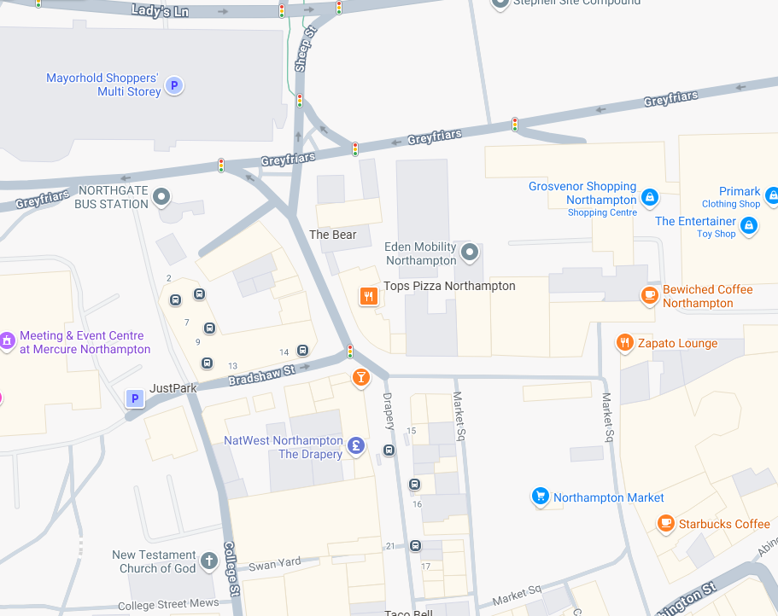

* 1. Please confirm your attendance to the Fleet Supplier Day on W/C 26/03/2025.

Details of the timetable are below:

|  |  |
| --- | --- |
| **Stage** | **Date** |
| Deadline for receipt of responses to Pre-Market Engagement. | 07/03/2025 |
| Supplier Day | W/C 26/03/2025 |

## Current Situation

* 1. West Northamptonshire, located in the East Midlands has a population of around 425,700 covering an area of 531.79 sq. mi (1,377.3 km2.) forming half of Northamptonshire.
  2. Currently there are no telematic system in use throughout the fleet
  3. West Northamptonshire Council will be inviting the motor vehicle industry to innovate and collaborate on a solution that matches with the organisational THRIVE Ambitions. These can be found on our website or here: <https://www.westnorthants.gov.uk/corporate-plan/our-vision>
  4. Significant action is being taken around reviewing current fleet arrangements from formal to ad hoc in Northampton, Daventry, Towcester, and the surrounding rural localities.
  5. Example of a journey:- Gladstone Road Resource Centre is a key service facility Day Centre where vehicles are parked overnight. They leave to pick up clients from various home addresses to attend the centre and return them back home at the end of the day.
  6. Net Zero 2030   [Clean and green | West Northamptonshire Council](https://www.westnorthants.gov.uk/corporate-plan/clean-and-green)
  7. Climate Strategy Reseach WNC’s Corporate Plan is focused on the environment: Clean and green. In working for the environment, we aspire to become the most environmentally friendly Council that our residents have ever had, with a clear ambition to become net zero. In delivering this ambition we are amongst other things committed to reducing carbon emissions and pollution to air, land and water and use resources in a smarter, more efficient way. Our corporate plan commits us to working with our partners to achieve these aspirations as we aim to be a net zero Council by 2030. A fundamental part of this journey to net zero is to update our vehicle fleet for increasingly environmentally friendly vehicles, replacing traditional combustion engine powered vehicles for hybrid and electric vehicles. We are currently about to re-sourcing our Council vehicle fleet, and this will begin the process, wherever possible, of decarbonising our fleet.
  8. Elements of WNC wider Fleet are not included in this for example refuge lorries.

|  |  |  |  |
| --- | --- | --- | --- |
| **Vehicle Make & Model** | **CO2** | **Fuel** | **Service** |
| VOLVO XC70 EST CAR | 199 g/km | Diesel | Travel Choice Team |
| RENAULT 120 BOXVAN | 144 g/km | Diesel | Travel Choice Team |
| Ford Transit (Caged Tipper) | 266 g/km | Diesel | Town Centre Management |
| Renault Kangoo LL21 Advance Blue Dci | 152 g/km | Diesel | Highways 1 |
| Renault Kangoo LL21 Advance Blue Dci | 152 g/km | Diesel | Highways 1 |
| Citroen Berlingo (Auto) | 153 g/km | Diesel | Highways 2 |
| VW Caddy (Auto) | 135 g/km | Diesel | Highways 2 |
| Kuga 2.5 DURATEC PHEV 243PS ST-LINE X CVT | 23 g/km | Hybrid | Highways 2 |
| Tucson Premium T-Gdi 160 2WD Start/Stop | 157 g/km | Petrol | Highways 2 |
| Renault Kangoo - Auto | 144 g/km | Diesel | Highways 2 |
| Peugeot Partner Profession BHDi 130 | 156 g/km | Diesel | Highways 2 |
| Peugeot Partner Profession BHDi | 148 g/km | Diesel | Enforcement |
| Peugeot Partner Professional L1 Bhdi | 142 g/km | Diesel | Enforcement |
| Citroen Berlingo 650 Enterprse Ed Bhdi | 143 g/km | Diesel | Sport & Active Lives |
| Peugeot partner van | 150 g/km | Diesel | Pest Control |
| Renault Kangoo Ml19 Advance Blue Dci | 142 g/km | Diesel | Pest Control |
| Peugeot Expert Prof Premium + L1 Bhdi | 142 g/km | Diesel | Assistive Tech |
| Renault Kangoo Ml19 Advance Blue Dci | 142 g/km | Diesel | Assistive Tech |
| Renault Kangoo Ml19 Advance Blue Dci | 142 g/km | Diesel | Assistive Tech |
| Kangoo Ml19 Advance Blue Dci A | 144 g/km | Diesel | Assistive Tech |
| VAUXHALL Vivaro 1.6cdti Bt (125ps) S/S 9 Seats | 145 g/km | Diesel | Adult Services |
| Renault Trafic Ll30 Advance Blue Dci | 186 g/km | Diesel | Adult Services |
| KIA Sportage 2 Isg | 166 g/km | Petrol | Adult Services |
| Transit 350 Leader Ecoblue | 213 g/km | Diesel | Adult Services |
| Transit 350 Leader Ecoblue | 213 g/km | Diesel | Adult Services |
| Transit 350 Leader Ecoblue | 213 g/km | Diesel | Adult Services |
| Transit 350 Leader Ecoblue | 178 g/km | Diesel | Adult Services |
| Transit Custom 320Limitd Eblue | 203 g/km | Diesel | Adult Services |
| Transit 350 Leader Ecoblue | 230 g/km | Diesel | Adult Services |
| Transit 350 Leader Ecoblue | 230 g/km | Diesel | Adult Services |
| Hyundai Tucson Se Connect T-Gdi | 151 g/km | Petrol | Adult Services |
| Transit 350 Leader Ecoblue | 213 g/km | Diesel | Adult Services |
| Peugeot Boxer 2.0 BLUEHDI 335 L3 H2 (9seats) | 163 g/km | Diesel | Adult Services |
| VAUXHALL ASTRA Sovereign | 121 g/km | Diesel | Specialist Support |
| FORD FOCUS 1.6D ECON | 99 g/km | Diesel | Trading Standards |
| TOYOTA AURIS TR | 153 g/km | Petrol | Trading Standards |
| Nissan ENV200  <3.5 ton | 0 g/km | Electricity | CCTV & Car Parks |
| SUZUKI JIMNEY | 162 g/km | Petrol | Environment, Countryside & Parks Team |
| Toyota Hilux Active D-4D 4Wd Dcb | 241 g/km | Diesel | Environment, Countryside & Parks Team |
| John Deere Gator Electric Buggy | 0 g/km | Electricity | Environment, Countryside & Parks Team |
| John Deere Gator Electric Buggy | 0 g/km | Electricity | Environment, Countryside & Parks Team |
| MERCEDES SPRINTER | 199 g/km | Diesel | Libraries |
| Renault Master Lm35 Business+ Blue Dci | 244 g/km | Diesel | Libraries |
| Vauxhall Combo 2000 EDITION P S/S | 155 g/km | Petrol | Enviromental Health |
| Ford Transit Connect | 129 g/km | Petrol | Enviromental Health |
| Ford Puma ECOBOOST MHEV 125PS TI DCT | 129 g/km | Hybrid | Home Adaptation |
| FORD FOCUS ESTATE | 99 g/km | Diesel | Home Adaptation |
| PEUGEOT RIFTER (Horizon) | 142 g/km | Diesel | Home Adaptation |
| Kia Proceed Gt Isg S-A Auto Estate | 154 g/km | Petrol | Home Adaptation |
| Kia Proceed Gt Isg S-A Auto Estate | 154 g/km | Petrol | Home Adaptation |
| Peugeot Expert Prof Premium + L1 Bhdi | 174 g/km | Diesel | Facilities |
| Partner Professional L1 Bhdi | 108 g/km | Diesel | ICT Services |
| Citroen Berlingo 1000 En-Prise Ed Bhdi | 149 g/km | Diesel | WNC IT |
| Citroen Berlingo 650 Enterprse Ed Bhdi | 145 g/km | Diesel | Southfields House |
| Citroen Relay 35 Hvy L4h3 Ent Bhdi Ss | 264 g/km | Diesel | Public Health |
|  |  |  |  |

The current fleet of vehicles (above) is provided by several different lease companies and we are looking for consolidation to a single provider. There are no telematics installed into any of the vehicles.

## The Requirements

* 1. We are looking for a solution that will:
* A fleet that matches West Northamptonshire Council’s economic, environmental, and social values which is fit for a modern, forward-thinking organisation.
* Cost-effective, meeting tight local government budgets in the interests of residents.
* Assurance services are always insurance compliant.
* Able services operate in challenging situations and environments e.g during potentially extreme weather to transport our customers

Please note: you do not need to resize the table; it will automatically adjust to fit your response.

## Section A: Organisation and Contact Details

|  |  |
| --- | --- |
| **Question** | **Response** |
| Name of your organisation |  |
| Registered office (if applicable) |  |
| Trading address (if different from office) |  |
| What if any local connections do you have with the authority? |  |
| Name of person whom any queries relating to this questionnaire should be addressed |  |
| Telephone Number(s) |  |
| Email |  |
| Address if different to above |  |

## Section B: Questions

|  |  |
| --- | --- |
| **Question** | **Response** |
| What are the new motor vehicle industry developments in supporting your companies suggests and recommendations to WNC. |  |
| What is the name of the solution you propose? |  |
| What improvements could you make on the project to help improve our current CO2 emission levels? |  |
| How long in your view do you envisage it would take your proposal to implement? Please briefly outline your reasons |  |
| If your proposal is already in use elsewhere, please give an example of your proposed solution in use and how it has met the requirements of the customer? |  |
| What are the new innovations in technology around the motor vehicle industry supporting your product/s? |  |
| What are the new innovations in technology around the motor vehicle industry supporting your product/s? |  |
| What is your view on our journey to carbon neutral by 2030 and achieving goal? |  |
| Is there anything else that you would like to add that you believe would help the council at this stage? |  |