**STRATTON ST MARGARET PARISH COUNCIL**

**Community Café Tender**

December 2023

Stratton St Margaret Parish Council is seeking proposals from qualified and experienced individuals or organisations to manage and operate a community café located within the Parish Councils Community Hub in Beechcroft Library:

Beechcroft Library, Beechcroft Road, Upper Stratton.

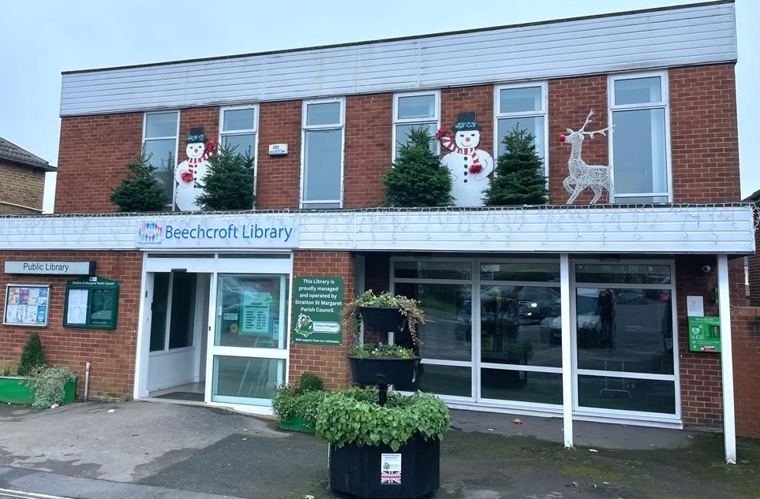

In early 2023 Stratton St Margaret Parish Council were successful in gaining a £50,000 grant from Swindon Borough Council “to improve the disability access and to create a Café area within the library”. This space is now being renovated and we are now looking for a partner to operate this café.

The aim of the community café is to provide a welcoming space alongside the Library for residents to gather, socialise, and enjoy food and beverages. We are looking for a partner who shares our commitment to community engagement, sustainable practices and service delivery.

After community consultation the biggest request from residents from the Community Hub (Library) was to create a café space, a Parish Council Working Party recommended to enter into partnership with another organisation to enable a community café provision.

The café space itself sits at the front right of the Library (when facing the Library) with bi-folding doors onto the outside space, there is a counter with storage, sink and a space for fridge/freezer. The space is approximately 54 square metres and can seat around 28 people comfortably, it will be unfurnished apart from the fixed counter, and there is a door to gain entry directly to the Library. The new café operator will need to provide the furnishings for the café seating area such as chairs and tables, the white goods (fridge, freezer and dishwasher), coffee machine and/or microwave convention oven as they see fit.

The aim is for this Community Café to be open for business in spring.

Please see below floorplan:

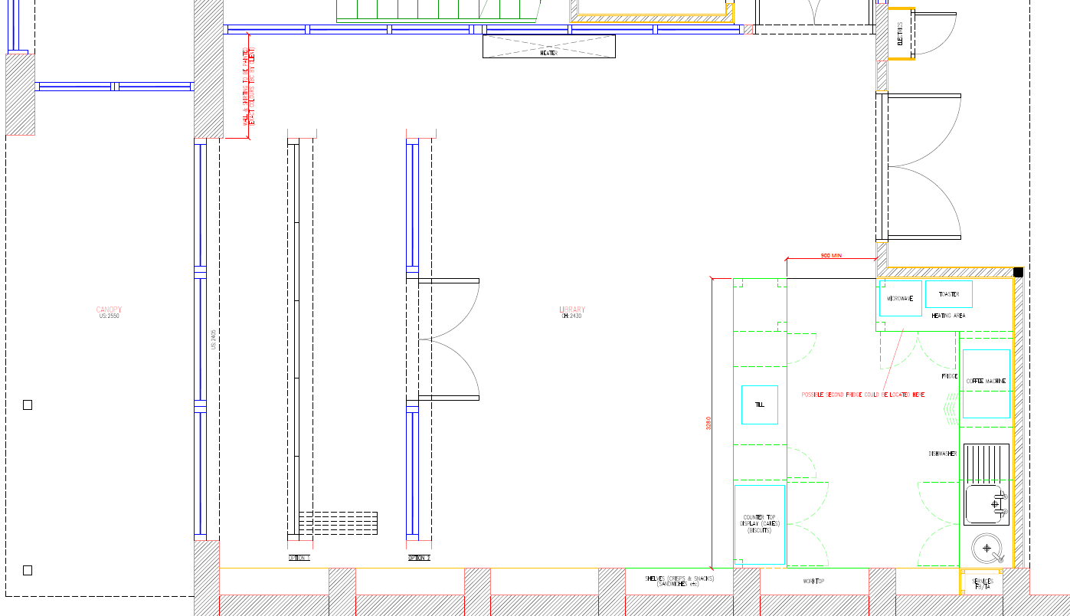

**Library Opening Hours:**

Tuesday, Wednesday and Thursday: 10am – 7pm

Friday and Saturday: 10am – 5pm

**Scope of Work:**

The successful bidder will be responsible for the management and operation of the community café.

**Key Requirements:**

Menu Development: Design a diverse and appealing menu that caters to the varied tastes and dietary preferences of the community.

Quality Assurance: Ensure the quality and freshness of all food and beverage items served.

Community Engagement: Develop and implement initiatives to foster community engagement and involvement in the café.

Partnership Working: To build a strong relationship with the Parish Council and the Beechcroft Library staff and volunteers, including involvement in local events and activities such as coffee mornings.

Sustainability: Integrate environmentally friendly practices, such as sourcing locally, minimizing waste, and promoting sustainable packaging.

Financial Management: Operate the café within budgetary constraints, providing regular financial reports to Stratton St Margaret Parish Council. To ensure that the café provision can cover the costs incurred for the usage of the building.

Staffing: Recruit, train, and manage café staff and Volunteers, ensuring a positive and customer-focused work environment

Cohesion with the Community: To ensure that the Café space is able to be used in unison with the Library space to accommodate Library users and Community Groups.

**Submission Requirements:**

Interested parties are invited to submit a tender referencing the Key Requirements and in accordance with the following requirements:

1. Profile: Provide an overview of your organisation.
2. Proposed Approach: Outline your proposed approach to managing and operating the community café, addressing key responsibilities and objectives.
3. Menu Proposal: Submit a sample menu, detailing the range of food and beverage offerings, pricing.
4. Community Engagement Plan: Describe how you plan to engage with the local community and community groups and promote the café as a part of Stratton’s Community hub.
5. Sustainability Plan: Outline your commitment to sustainable practices within the café's operations.
6. Financial Proposal: Outline the proposal with covering the costs of the café space utilities and any rental proposition for the space. Provide a detailed financial proposal, including projected revenues, expenses, and profit margins.

Visit by appointment only.

**Submission Deadline:**

All proposals must be submitted by End of January 2024.

Late submissions will not be considered.

Please address your proposal to the Clerk and Proper Officer of the Parish Council: [amy.loxton@strattonstmargaret.gov.uk](mailto:amy.loxton@strattonstmargaret.gov.uk)