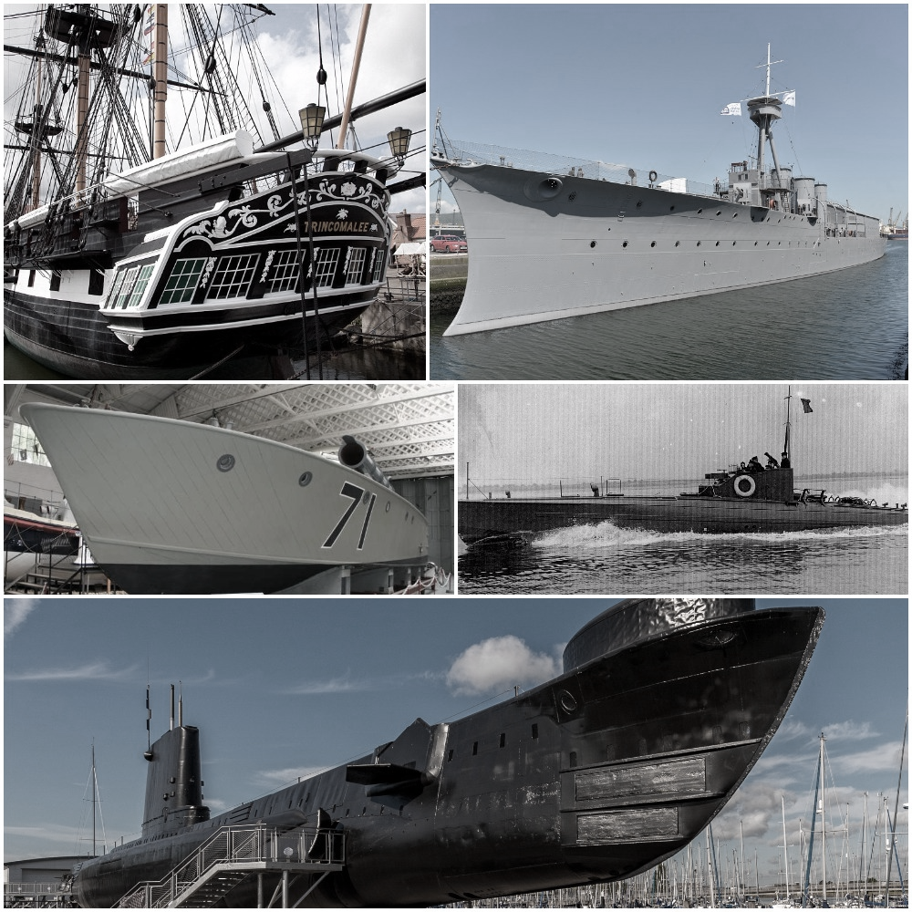
Invitation to Tender (ITT)
Brief for Analysis of the Mooring Structure Inboard of HMS Warrior
First Issued: 06/02/2019

Summary Instructions and Details of Contract

SUBJECT | DETAILS
Contract Description | A contract for a company to assess the inboard mooring system of HMS Warrior.
NMRN Contact during tender period | Clarifications and enquiries during the tender process can be sent to HST.procurement@nmrn.org.uk. Please note that this email address is different to the submission email.
Date of Tender Return | 08/03/2019: 12.00 Noon  Tender’s must be submitted to tenders@nmrn.org.uk
Content for Submission | Content requirements for tender returns are listed in Annex 2 of this ITT.
Last date for Clarifications | 27/02/2019
Annexes | Annex 1 – Tender Specification  Annex 2 – Supplier Response  Annex 3 – Pricing Approach  Annex 4 – Evaluation Criteria & Approach  Annex 5 – BMT Defence Services, HMS Warrior – Recommendations for Survey and Maintenance of Mooring Arrangements  Annex 6 – BMT Defence Services – HMS Warrior Mooring System (PowerPoint)  Annex 7 - Terms and Conditions of Contract  Annex 8 - NMRN’s GDPR Privacy Policy

Company Overview

  - The National Museum of the Royal Navy tells the story of the Royal Navy and its impact in shaping the modern world. A unique feature of the Museum is its collection of historic warships, believed to be the largest fleet of its kind in the world. Located throughout the United Kingdom, the fleet consists of ships such as HMS Victory and HMS Warrior in Portsmouth, HMS Alliance and Holland 1 submarine in Gosport, HMS Trincomalee in Hartlepool and HMS Caroline in Belfast.

Project Introduction

  - HMS Warrior was taken into the NMRN collection 1st April 2017 and following that a review was made of the mooring arrangements.

  - As a result of that review an analysis was commissioned from BMT Defence Services Ltd of HMS Warriors mooring arrangements.

  - The analysis-HMS Warrior Mooring Analysis (powerpoint) Issue 2 and the report -Recommendations for Survey and Maintenance of Mooring Arrangements issue 2-are both available for Contractors (Appendices 1 & 2).

  - The summary report -Recommendations for Survey and Maintenance of Mooring Arrangements- separated the analysis into two clear areas, those inboard of the ship and those outboard of the ship.

  - The recommendations outboard of the ship are clearly defined and dealt with elsewhere.

  - In respect of the arrangements inboard of the ship, the report made the following
observations, recommending that the structure was subjected to further analysis;

  - Survey Philosophy (extract)
3.1.7 Although included in the (original mooring) survey programme, the strength of the structure used onboard HMS WARRIOR to secure mooring lines has not been assessed. It is assumed that the structure used has adequate strength however, it is
recommended that this is confirmed.

  - Contractors are invited to propose a methodology for confirming that the mooring system inboard of the ship has adequate strength and put forward costed proposals for carrying out this work.

4. Tender Process (“Procurement Process”)

4.1 Applying before the Submission Deadline
4.1.1 Work Specification
For a full, detailed specification of the services required refer to Annex 1.
4.1.2. Consultations & Site Visits
Consultations and site visits are available for contractors before tender submission. Please contact HST.Procurement@NMRN.org.uk to arrange.

4.1.3 Timescales

Subject to any changes notified to potential suppliers by the NMRN in accordance with the Tender Conditions, the following timescales shall apply to this Procurement Process:

Activity | Date / time
Issue of Contract Notice / availability of ITT documents | 06/02/2019
Deadline for clarification questions (Clarification Deadline) | ^{27/02/2019}
Deadline for submission of ITT responses by potential suppliers (Tender Response Deadline) | 08/03/2019:12.00 Noon
Award decision standstill letters issued | 13/03/2019
Contract start date | 25/03/2019

4.2. Instructions for Submitting Tenders
4.2.1 The documents that must be submitted to form your tender response are listed in Annex 2 (Supplier Response) to this ITT.
4.2.2 Tender submissions must be sent to tenders@nmrn.org.uk before the submission deadline.
4.2.3 The following requirements should be complied with when summiting your response to this ITT:
- Please ensure that you send your submission in good time to prevent issues with technology – late tender responses may rejected by the NMRN.
- Please ensure that information provided as part of your response is of sufficient quality and detail that an informed assessment of it can be made by the NMRN.
- Do not submit any additional supporting documentation with your ITT response except where specifically requested to do so as part of this ITT. PDF, JPG, PPT, Word and Excel formats can be used for any additional supporting documentation (other formats should not be used without the prior written approval of the NMRN).
- All attachments/supporting documentation should be provided separately to your main tender response and clearly labelled to make it clear as to which part of your tender response it relates.
- If you submit a generic policy / document you must indicate the page and paragraph reference that is relevant to a particular part of your tender response.
- Unless otherwise stated as part of this ITT or its Annexes, all tender responses should be in the format of the relevant NMRN requirement with your response to that requirement inserted underneath.
- Where supporting evidence is requested as ‘or equivalent’ – you must demonstrate such equivalence as part of your tender response.
- Any deliberate alteration of an NMRN requirement as part of your tender response will invalidate your tender response to that requirement and for evaluation purposes you shall be deemed not to have responded to that particular requirement.
- Responses should be concise, unambiguous, and should directly address the requirement stated.
- Your tender responses to the tender requirements and pricing will be incorporated into the Contract, as appropriate.

4.3. Clarification Requests
4.3.1 All clarification requests should be submitted to HST.Procurement@NMRN.org.uk by the Clarification Deadline, as set out in the Timescales section of this ITT. The NMRN is under no obligation to respond to clarification requests received after the Clarification Deadline.
4.3.2 Any clarification requests should clearly reference the appropriate paragraph in the ITT documentation and, to the extent possible, should be aggregated rather than sent individually.
4.3.3 The NMRN reserves the right to issue any clarification request made by you, and the response, to all potential suppliers unless you expressly require it to be kept confidential at the time the request is made. If the NMRN considers the contents of the request not to be confidential, it will inform you and you will have the opportunity to withdraw the clarification query prior to the NMRN responding to all potential suppliers.
4.3.4 The NMRN may at any time request further information from potential suppliers to verify or clarify any aspects of their tender response or other information they may have provided. Should you not provide supplementary information or clarifications to the NMRN by any deadline notified to you, your tender response may be rejected in full and you may be disqualified from this Procurement Process.

Annex 1 - Tender Specification

This Document was prepared by Amgram Ltd, Shoreham, Sussex, U.K
www.amgram.co.uk
Document history
date | issue | by | details
14-01-19 | Issue 01 | PG/IS | First issue to NMRN
06-02-19 | Issue 02 | AR | Fist issue to Contracts Finder
Prepared by Amgram Ltd, Shoreham-By-Sea, West Sussex, UK
www.amgram.co.uk
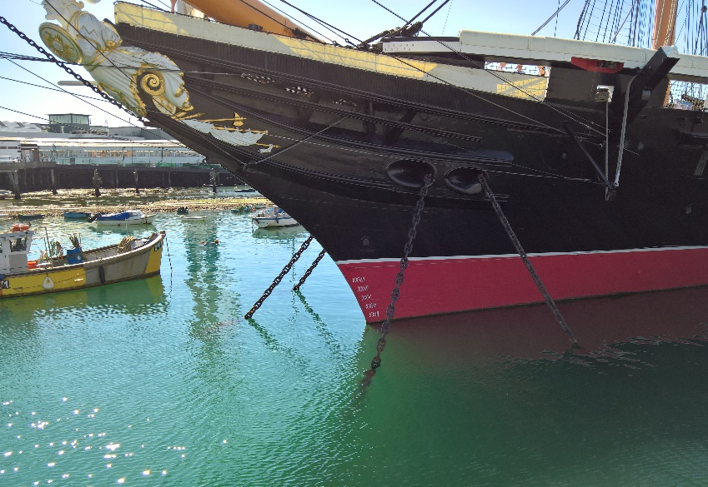

HMS Warrior

Invitation To Tender

Analysis of mooring structure inboard of the ship.

For NMRN

Table of Contents

Vessel Particulars 9
Introduction 10
The Scope of work 11
Response documents 13
General notes 12

Vessel Particulars

Vessel name: | HMS Warrior
Vessel class & type: | Museum Ship, formerly armoured frigate
Year of manufacture: | c.1860
Builder: | Thames Ironworks and Shipbuilding Company
Designer: | UK Admiralty
Principal dimensions: | Length: 128m Breadth: 17.8m Draught: 8.2 m
Displacement: | c. 9284 tonnes
Location: | Portsmouth
Owners: | National Museum of the Royal Navy (NMRN)

Introduction
HMS Warrior was taken into the NMRN collection 1st April 2017 and following that a review was made of the mooring arrangements.

As a result of that review an analysis was commissioned from BMT Defence Services Ltd of HMS Warriors mooring arrangements.

The analysis-HMS Warrior Mooring Analysis (powerpoint) Issue 2 and the report -Recommendations for Survey and Maintenance of Mooring Arrangements issue 2-are both available for Contractors (Annexes 5 & 6).

The summary report -Recommendations for Survey and Maintenance of Mooring Arrangements- separated the analysis into two clear areas, those inboard of the ship and those outboard of the ship.

The recommendations outboard of the ship are clearly defined and dealt with elsewhere.

In respect of the arrangements inboard of the ship, the report made the following observations, recommending that the structure was subjected to further analysis;

Survey Philosophy (extract)
3.1.7 Although included in the (original mooring) survey programme, the strength of the structure used onboard HMS WARRIOR to secure mooring lines has not been assessed. It is assumed that the structure used has adequate strength however, it is
recommended that this is confirmed.

Contractors are invited to propose a methodology for confirming that the mooring system inboard of the ship has adequate strength and put forward costed proposals for carrying out this work.

The Scope of work

The scope of work outlined below is not intended to be prescriptive and Contractors may consider there are better or more effective approaches. If so, these are welcomed.

Since this is an historic ship, NMRN appreciate that the analysis of the structure may reveal aspects that require discussion before further progress can be made, so welcome a Contractor who will work in a collaborative and iterative way in order to achieve the best solution.

Scope of work
Phase 1:  Initial review | Contractors are to:  - Review existing mooring arrangements inboard of ship, define and record all load bearing shipboard fittings in the mooring load path.  - Assess structural condition of all load bearing shipboard fittings and supporting ship structures.  - Carry out detailed survey of mooring installation points, including associated brackets and/or fairleads, paying attention to connections.  - Carry out detailed survey of supporting ship structures in way of mooring installations.  Contractors may well have initial ideas, at this stage, about changes to the existing shipboard arrangements that may be considered to improve the current provisions and are invited to put these ideas forward early, to limit the amount of iterative work.
Phase 2:  Load bearing capacity evaluation | Contractors are to:  - Evaluate the load bearing capacity of shipboard fittings and supporting ship structures inboard of ship. The evaluation should refer to the existing mooring arrangement, or any agreed modified arrangement (as noted above).
Phase 3:  Certification | Contractors are to:  - Propose, justify and agree an accepted industry standard against which to evaluate the mooring system; e.g. OCIMF Mooring Equipment Guidelines, GL Noble Denton, IACS etc.  - Assess the determined load bearing capacity with respect to the selected standard.  - Demonstrate that adequate factors of safety exist.  - If following the analysis, it is found that the installations do not meet those requirements, then the Contractors are required to propose such measures or modifications to the installations that would be required in order to support the design load within the allowable stress limit.
Phase 4:  Documentation | Contractors are to:  - Fully document all work in electronic format.  - Provide certification that the mooring system inboard of ship is capable of sustaining the design load.  - Clearly identify in a sensitivity study or similar, what level of degradation mooring installations and supporting structures could withstand whilst maintaining the minimum required structural strength.  - Note: NMRN wish to have full ownership of all information, FEA models, drawings, test information etc., in case further work with a different contractor is required.

General notes
- The BMT report at 3.2.3 identifies some typical actions that should be carried out in the survey and inspection process.

- Contractors should refer to the BMT documents HMS Warrior Mooring Analysis (powerpoint) Issue 2 and the report -Recommendations for Survey and Maintenance of Mooring Arrangements issue 2 and use the loads defined in this analysis for this work (Annexes 5 & 6).

- Contractors are invited to propose methods and methodologies for this work that they consider to be appropriate and cost effective.

- Material assessment techniques may include Non-Destructive Testing, material sampling, or other techniques at the discretion of the Contractor and as considered appropriate. Clearly NDT methods are strongly preferred by NMRN and Contractors should note that any sampling methods will require approval.

- Analysis methods may consist of any of the following, or some combination thereof, or any other methods considered appropriate by contractors.
- 3d Finite Element Analysis (FEA)
- Physical testing of installations
- Monitoring of load and deflection over a period of time

- If theoretical methods are to be used for analysis, such as 3d FEA modelling, then a clear explanation should be provided of how practical validation or verification of results from a theoretical model will be obtained. This validation/verification could, for example, be combined with physical testing and/or monitoring of component parts and adjacent structures.

- NMRN are especially concerned that this work should form a basis for future monitoring. It is important that Contractors document all work and analysis in the form of accurate drawings, test data, photographic references. Work should be to a level that will provide useful information for future survey and inspection programmes, and facilitate further monitoring and/or analysis. For example, if load monitoring is proposed, then it would be expected that as a minimum that sensors were left in place, so that future monitoring could be rapidly carried out from the established baseline data.

Annex 2 – Supplier Response

Confirmation
Contractors are asked to confirm within 1 week if they intend to bid.
Contractors queries and site visit:
Potential contractors are invited to visit HMS Warrior if they wish to familiarise themselves with the ship and mooring system. Potential contractors may also contact the NMRN for any queries relating to the work. Please contact us at hst.procurement@nmrn.org.uk (Please note this is a different email to the submission email).

Response documents
In response to this Tender Contractors should provide:
- Company information
- Background information and relevant references for this type of work.
- CV for the lead consultant/s
- Technical response document
- Commercial document including the commercial terms and conditions
- Outline project plan.
- A lump sum cost (excl. VAT), including travel, subsistence and accommodation.
- A breakdown of daily fees, incl. travel, subsistence and accommodation.
- Insurance certificates for the extent of professional insurance or indemnity cover
Confidential/Commercially Sensitive Document Template
Below is a recommended template to allow potential suppliers to indicate any confidential/commercially sensitive information in accordance with the requirements of the Confidentiality and Information Governance section of this ITT.

Specify the precise elements which are considered confidential and/or commercially sensitive
Why do you consider an exemption under the POIA or EIR would apply?
Specify the estimated length of time during which the exemption will apply

Annex 3 – Pricing Approach

Template

- A breakdown of costs for the works specified within this ITT

The following is a template for the fee proposal breakdown. It is recommended that this breakdown should include reference the scheduled works programme, bringing in milestones and dates. Please note this template is a guidance document and therefore is not all encompassing. Stages and Tasks can be added or removed by tenderers where seen fit:

Item | Description | Staff Member | Days | Cost (£)  (Lump Sum) | Program & Milestone
1 | Stage 1
1.1 |  |  | 0.25 | £X | Week commencing (w/c)
1.2 |  |  | - |  | w/c -
2 | Stage 2
2.1 |  |  |  |  | w/c
2.2
2.3
 | Half-way stage invoice
3 | Stage 3
3.1 |  |  |  |  | w/c
3.2
4 | Stage 4
4.1
4.2
5 | Stage 5
5.1
 | Final invoice
TOTAL LUMP SUM (EXC. VAT) |  |  | X Days | £X | w/c – w/end

- A breakdown of hourly costs for the supplier and any subcontractors, including travel, subsistence and accommodation.

Below is a desired template of daily rate costs from the supplier and their sub-contractors:

Staff Member | Daily Rate (£) | Travel (per day or per visit) (£) | Accommodation (per night) (£) | Subsistence (per day) (£)
 | £X | £X | £X | £X
 | £X | £X | £X | £X
 | £X | £X | £X | £X

Annex 4 – Evaluation Criteria & Approach
- You will have your tender response evaluated as set out below:
Stage 1: Tender responses will be checked to ensure that they have been completed correctly and all necessary information has been provided. Tender responses correctly completed with all relevant information being provided will proceed to Stage 2. Any tender responses not correctly completed in accordance with the requirements of this ITT and/or containing omissions may be rejected at this point. Where a tender response is rejected at this point it will automatically be disqualified and will not be further evaluated.
Stage 2: If a bidder succeeds in passing Stage 1 of the evaluation, then it will have its detailed tender response to the NMRN’s requirements evaluated in accordance with the evaluation methodology set out below.
- Award Criteria – Responses from potential suppliers will be assessed to determine the most economically advantageous tender using the following criteria and weightings and will be assessed entirely on your response submitted:

Criteria | Weighting
Quality of Method & Approach | 70%
Commercial/ Value for Money | 30%

- Scoring Model – Tender responses will be subject to an initial review at the start of Stage 2 of the evaluation process. Any tender responses not meeting mandatory requirements or constraints (if any) will be rejected in full at this point and will not be assessed or scored further. Tender responses not so rejected will be scored by an evaluation panel appointed by the NMRN for all criteria other than Commercial using the following scoring model:

Points | Interpretation
0 | Very Poor (does not meet any of the requirement) or Very High/Extreme Risk  The response is significantly below what would be expected because of one or all of the following:  • The response indicates a significant lack of understanding  • The response fails to meet the requirement
1 | Poor (meets some of the requirement) or Above Average/High Risk  The response meets elements of the requirement but gives concern in a number of significant areas. There are reservations because of one or all of the following:  • There is at least one significant issue needing considerable attention  • There is insufficient evidence to demonstrate competence or understanding  • The response is light and unconvincing
4 | Fair (meets most, but not all the requirement) or Average Risk  The response meets most of the requirement, but there is a least one significant issue of concern or several smaller issues. These would require some further clarification or attention later in the procurement process and may arise through lack of demonstrated capability and/or appropriate evidence. The response therefore shows:  • Basic understanding of the requirements  • Sufficient competence demonstrated through relevant experience  • Some areas of concern that require attention
7 | Good (meets the requirement) or Low Risk  The response broadly meets what is expected for the criteria. There are no significant areas of concern, although there might be limited minor issues that need further exploration or attention later in the procurement process. The response therefore shows:  • Good understanding of the requirements  • Sufficient competence demonstrated through relevant experience  • Some insight demonstrated into the relevant issues.
9 | Very Good (exceeds the requirement) or Very Low Risk  The response exceeds what is expected for the criteria. Leave no doubt as to the capability and commitment to deliver what is required. The response therefore shows:  • Very good understanding of the requirement  • Considerable competence demonstrated through relevant experience  • Considerable insight into the relevant issues  The response is also likely to propose additional value in several respects above that expected

- Quality & Method of Approach Evaluation – The Quality & Method of Approach will be evaluated using the following criteria by the evaluation panel:
- Relevant skills and experience
- Understanding of the Brief
- Quality of Method Statement and Approach.
- Commercial Evaluation – Your “Overall Price” (as calculated in accordance with requirements of Annex 3 (Pricing Approach) for the goods and/or services will be evaluated by the evaluation panel for the purposes of the commercial evaluation. Prices must not be subject to any pricing assumptions, qualifications or indexation not provided for explicitly by the NMRN as part of the pricing approach. In the event that any prices are expressed as being subject to any pricing assumptions, qualifications or indexation not provided for by the NMRN as part of the pricing approach, the NMRN may reject the full tender response at this point. The NMRN may also reject any tender response where the Overall Price for the goods and/or services is considered by the NMRN to be abnormally low following the relevant processes set out under the EU procurement rules. A maximum offer score will be awarded to the tender response offering the lowest “Overall Price”.
- Moderation and application of weightings – The evaluation panel appointed for this procurement will meet to agree and moderate scores for each award criteria. Final scores in terms of a percentage of the overall tender score will be obtained by applying the relevant weighting factors set out as part of the award criteria table above. The percentage scores for each award criteria will be amalgamated to give a percentage score out of 100.
- The winning tender response – The winning tender response shall be the tender response scoring the highest percentage score out of 100 when applying the above evaluation methodology

