Clarifications – CLOSED

**Q.1 – Please could you provide the addresses/locations of the buildings?**

The buildings are:

Civic 1 and Civic 2 – both at Civic Centre Victoria Avenue, Southend on Sea SS2 6ER

Civic 2 is adjacent to the car park to the

The Tickfield Centre, Tickfield Avenue, Southend on Sea SS2 6LL <http://www.southend.gov.uk/info/200453/southend_venues/742/southend_venues/2>

Civic 1 in red, Civic 2 in blue and Tickfield in green on the map extract below.

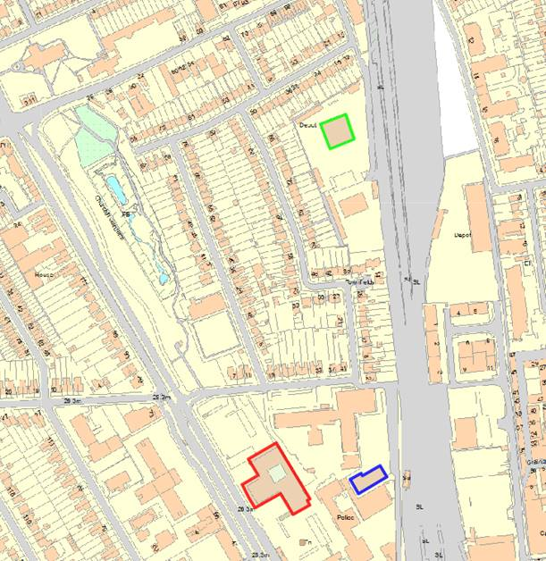

**Q.2 I was just wondering if the Council have already put aside the budget for this.**

We haven’t but it’s being driven by new CEx and director of finance who will make the budget available once a supplier and their cost is known following tender.

**Q.3 It would be helpful to know the type of chairs currently used.**

Current office chairs are Orangebox ARA EBA

Photographs below show part of a typical floor, meeting room and break-out area.

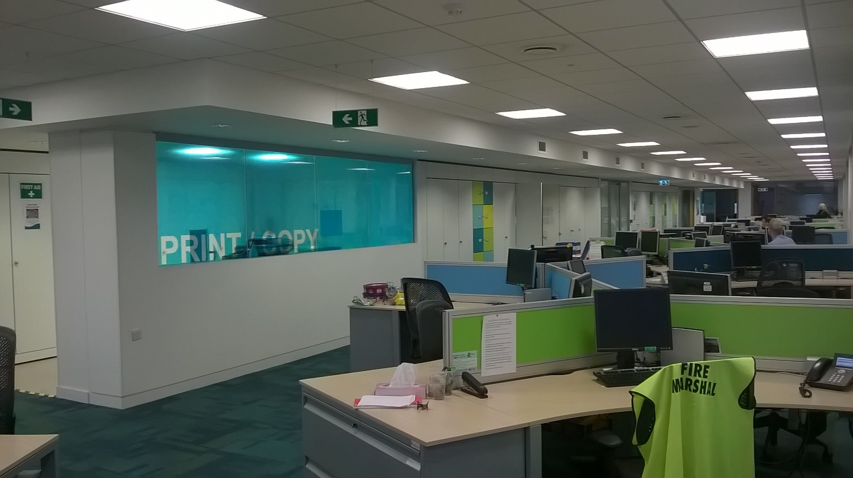

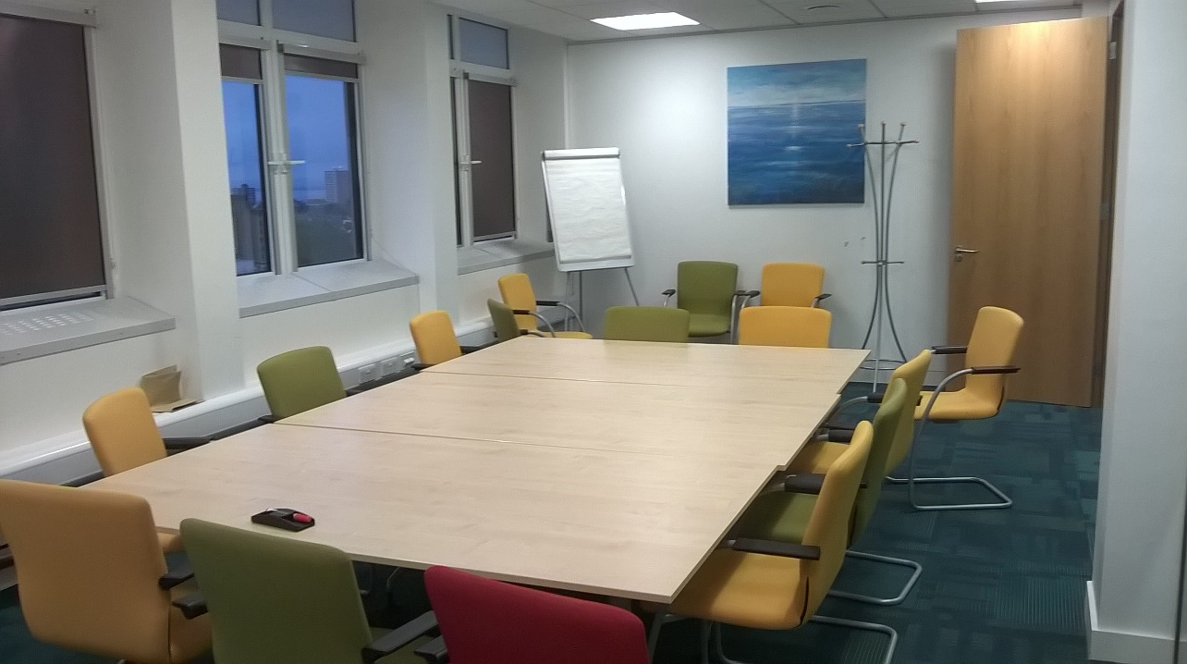

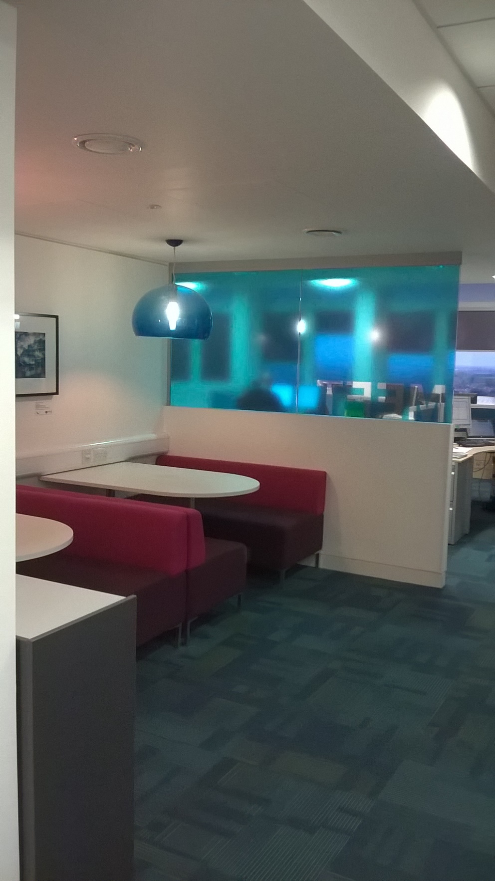

**Q.4 Do you have CAD data available for us to use for the IPMS element of the project?**

Yes, CAD plans are available and will be provided to the successful firm on appointment.

**Q.4: Could I clarify the exact scope of the part of the brief below:**

**Part 1 - To measure the buildings in accordance with IPMS and update the provided floorplans to show the current occupancy by team.**

**Are the internal layouts still broadly correct?**

**Is this a case of updating the existing CAD plans with the current desk layout and mapping the current team occupancy, or are you looking to produce new plans ‘from scratch’ for all three buildings?**

The pdf floorplans are broadly correct – some teams have moved/grown/contracted.

CAD plans and a standard desk layout in CAD will be made available to the winning bidder and it will just be a case of reporting measurements in accordance with IPMS guidance (although likely that NIA will also be required for benchmarking) and updating those with team occupancy/locations.

We will require the updated plans back when reporting in CAD and .pdf formats.

**Q.5 Regarding the Requirement for Building Measurement: Could you tell us the reasoning for undertaking an on-site building measurement survey at this stage – do you believe the plans you have to be particularly inaccurate?**

We have not updated measurements to IPMS yet so this seems to be a good opportunity to start!  We will make CAD drawings available to the successful party so much of the measurement can be done from them directly.  The plans are reasonably accurate.  My feeling is that areas will need to be recorded in NIA also to enable meaningful benchmarking.

**Q6. Utilisation Study: You still ask for a ‘full’ survey but ask for a minimum of two checks per day. Does 2 checks per day meet your definition of a ‘full’ survey?**

I am open to other methodologies however I feel this is a minimum requirement to capture data during both the morning and afternoon core hours.

**Q.7 For Part 2 – even an indicative cost is difficult because of not knowing yet what opportunities could be uncovered. Would day rates suffice at this stage?**

Details of an approach and costs built up from day rates would be ok as this stage is only indicative at this stage.

**Q.8 - Is a key fob/swipe card entry/exit provided on the buildings at present and could this data be made available to the successful bidder?**

We do have entry cards for Civic 1 and Civic 2 and some reports can be produced from this to record the numbers and times of swipe-ins. Reliance should be limited though as there are no styles so lots of ‘tailgating’ at busy times. There is no exit data.

**Q.9 - The Part 1 brief refers review against benchmarks for other Local Authorities. Will Southend on Sea provide this data? Or is the successful bidder to provide this data?**

The successful bidder is expected to source relevant benchmarking data.

**Q.10 - Is there an existing electronic booking system for meeting rooms and could this data be made available to the successful bidder?**

There is an electronic room bookings system and data/access can be provided for the study period.

**Q.11 - Are the floor plans generated from the survey to be issued on 2D CAD or 3D Revit format?**

2D CAD is fine and current CAD plans will be provided to the winning bidder to work with so these need not be drawn from scratch.

**Q.12 - With regards the draft programme, please can you advise anticipated start date for the 3 week study and dates of the Christmas break?**

Start dates can be negotiated with the winning bidder – they need to be timed to get a true occupancy picture.  Essex Christmas school holiday dates are available here: <http://www.southend.gov.uk/info/200175/schools_colleges_and_the_university_of_essex/51/term_dates>

**Q13 Which parts of the Tickfield building will be in scope? Can you please clarify which areas will need to be measured and included in the utilisation study?**

All in scope but this is essentially all meeting/conference rooms so falls in to that part of the brief.

**Q14 Could you please provide an estimate of how many Directors, Group Managers and key officers should be interviewed during the study?**

Please allow for 3 days as set out in the brief – I would envisage around 10 interviews and their analysis although it’s important the successful bidder is able to speak to those people they consider important as well as those we consider relevant.

**Q.15 What are the surface areas of the buildings?**

Tickfield is c.873.4sqm GIA

VOA measurements below for an indication

Civic 1 and 2 (referred to below as Margaret Thatcher House)



Address of property:

OFFICES CIVIC CENTRE, VICTORIA AVENUE, SOUTHEND-ON-SEA, SS2 6BU

Rating list:

2010 (Current)

With effect from:

19 Apr 2013

Description:

OFFICES AND PREMISES

Billing authority:

SOUTHEND-ON-SEA

Billing authority reference:

22000074599900

Special category code:

203 - Offices (Inc Computer Centres)

Basis of measurement:

NIA

Valuation scheme reference:

[119056](http://www.2010.voa.gov.uk/rli/en/basic/find/scheme)

Unadjusted £ m2/unit:

£51.00/m2

Valuation

| **Ref.** | **Floor** | **Description** | **Area m2/unit** | **£ m2/unit** | **Value** |
| --- | --- | --- | --- | --- | --- |
| 1 | Basement | Workshop | 94.50 | £13.39 | £1,265 |
| 2 | Basement | Unclassified Area | 155.40 | £26.78 | £4,162 |
| 3 | Basement | Internal Storage | 118.50 | £17.85 | £2,115 |
| 4 | Lower Ground | Office | 245.00 | £40.16 | £9,839 |
| 5 | Lower Ground | Office | 158.10 | £38.25 | £6,047 |
| 6 | Lower Ground | Office | 149.80 | £38.25 | £5,730 |
| 7 | Lower Ground | Workshop | 85.70 | £19.13 | £1,639 |
| 8 | Lower Ground | Internal Storage | 423.80 | £26.78 | £11,349 |
| 9 | Lower Ground | Kitchen | 115.20 | £38.25 | £4,406 |
| 10 | Ground | Office | 782.70 | £51.00 | £39,918 |
| 11 | Ground | Office | 431.60 | £53.55 | £23,112 |
| 12 | Ground | Office | 153.30 | £53.55 | £8,209 |
| 13 | Ground | Office | 264.70 | £53.55 | £14,175 |
| 14 | Ground | Office | 23.50 | £53.55 | £1,258 |
| 15 | Ground | Office | 22.90 | £53.55 | £1,226 |
| 16 | First | Office | 651.00 | £61.58 | £40,089 |
| 17 | First | Office | 539.20 | £53.55 | £28,874 |
| 18 | First | Office | 475.00 | £53.55 | £25,436 |
| 19 | First | Office | 15.30 | £53.55 | £819 |
| 20 | First | Internal Storage | 42.30 | £35.70 | £1,510 |
| 21 | Second | Office | 651.00 | £61.58 | £40,089 |
| 22 | Second | Office | 541.90 | £53.55 | £29,019 |
| 23 | Second | Office | 136.70 | £53.55 | £7,320 |
| 24 | Second | Internal Storage | 8.10 | £35.70 | £289 |
| 25 | Second | Public Gallery | 196.90 | £53.55 | £10,544 |
| 26 | Third | Office | 651.00 | £61.58 | £40,089 |
| 27 | Fourth | Office | 651.00 | £61.58 | £40,089 |
| 28 | Fifth | Office | 651.00 | £61.58 | £40,089 |
| 29 | Sixth | Office | 651.00 | £61.58 | £40,089 |
| 30 | Seventh | Office | 651.00 | £61.58 | £40,089 |
| 31 | Eighth | Office | 651.00 | £61.58 | £40,089 |
| 32 | Ninth | Office | 651.00 | £61.58 | £40,089 |
| 33 | Tenth | Office | 651.00 | £61.58 | £40,089 |
| 34 | Eleventh | Office | 651.00 | £61.58 | £40,089 |
| 35 | Twelth | Office | 651.00 | £61.58 | £40,089 |
| 36 | Thirteenth | Office | 651.00 | £61.58 | £40,089 |
| 38 | Ground | Office-Margaret Thatcher House | 482.20 | £53.55 | £25,822 |
| 39 | First | Office | 482.20 | £53.55 | £25,822 |
| 40 | Ground | Canteen Was Courtyrad | 115.33 | £56.10 | £6,470 |
| Total area: | | | 14722.83 | Subtotal: | £817,532 |

|  | **Spaces** | **Area m2** | **Value** |
| --- | --- | --- | --- |
| Plant: | | | £1,228 |

|  |  |
| --- | --- |
| Total value: | £818,760 |
| Rateable value: | £ 815,000 |