Background to Natural England
Natural England is the government’s advisor on the natural environment. We provide practical advice, grounded in science, on how best to safeguard England’s natural wealth for the benefit of everyone.
Our remit is to ensure sustainable stewardship of the land and sea so that people and nature can thrive. It is our responsibility to see that England’s rich natural environment can adapt and survive intact for future generations to enjoy.
Natural England was formally established on 01 October 2006 following the successful passage of the Natural Environment and Rural Communities (NERC) Act 2006 through Parliament. We are an independent statutory Non-Departmental Public Body.
The NERC Act sets out Natural England's purpose: to ensure that the natural environment is conserved, enhanced and managed for the benefit of present and future generations, thereby contributing to sustainable development.
The Act states that this purpose includes:
- ​​​​​promoting nature conservation and protecting biodiversity
- conserving and enhancing the landscape
- securing the provision and improvement of facilities for the study, understanding and enjoyment of the natural environment
- promoting access to the countryside, open spaces and encouraging open air recreation
- contributing in other ways to social and economic wellbeing through management of the natural environment

Our vision
Our vision is of Thriving nature for people and planet.
Our ambition is not just to improve nature, but to see it thriving everywhere. This is because we recognise that a healthy natural environment is fundamental to everyone’s wealth, health and happiness.
Our definition of nature encompasses:
- natural beauty
- wildlife
- the geology that underpins natural character and habitats
- our cultural connections with nature
- We include the whole natural world on earth and at sea and in towns and cities as well as the countryside.
Our mission
Our mission is Building partnerships for nature’s recovery. This reflects the need for us to work with and through a wide range of people and also the need for rapid action to re-build sustainable ecosystems and thereby protect and restore habitats, species and landscapes.
Our goals
Our work over the next few years will reflect the priorities set out in the government’s 25 Year Environment Plan. It will be focused around 4 goals:
- Resilient landscapes and seas
- Sustainable development
- Greener farming and fisheries
- Connecting people with nature

Recovery Rates of Studland Seagrass after Impacts by Mooring and Anchoring
Background to the specific work area relevant to this purchase
Introduction
The Studland Seagrass Recovery Survey is being commissioned by the Wessex Marine Team at Natural England to investigate the recovery rates of Zostera marina after damage associated with boat anchoring and mooring has caused deterioration of the seagrass bed.
As anchor and mooring damage within the bay remain a contentious issue with some stakeholders with regard to the level and / or significance of such impacts, it was recommended in Doggett & Northern (2022) that “Aerial (drone) surveys could be completed quickly and efficiently several times over the spring and summer to map the level and extent of the present impacts and, over time, record the efficacy of any management policies introduced. Drone surveys can be carried out relatively quickly, causing minimal disturbance to beach and water users and offer a very cheap and effective method to quantify the extent of any impacts. Again, the data would assist with the site condition assessment.”

This study will help inform the conversation around impacts of anchoring and provide site-specific evidence of the impacts and ability of seagrass to recover from anchoring events.
Studland Bay MCZ is an inshore site that covers an area of approximately 4 km2. It is located on the south coast of Dorset in the eastern English Channel, on the western edge of Poole Bay. The site encompasses Studland Bay stretching from the edge of Shell Bay in the north to Old Harry Rocks in the south. Studland Bay is a designated Marine Conservation Zone under the Marine and Coastal Access Act, 2009. The designated features include:
- Intertidal coarse sediment
- Long-snouted (or spiny) seahorse (Hippocampus guttulatus)
- Seagrass beds
- Subtidal sand

Studland Bay has a gently sloping, shallow, east-facing, sandy seabed and is sheltered from prevailing southwest approaching waves by the Isle of Purbeck but exposed to easterly and south-easterly waves generated in the English Channel (Poole & Christchurch Bays Coastal Group, 2011), (Jackson et al., 2013). The bay is also sheltered from prevailing winds from the south and southwest, allowing seagrass Zostera marina to colonise and form large beds (Jackson et al., 2013). This, in turn support both species of seahorse found in UK waters, the long-snouted (or spiny) seahorse Hippocampus guttulatus and the short-snouted seahorse Hippocampus hippocampus (Garrick-Maidment et al., 2013). The same conditions make it a popular anchorage for boat users, and its proximity to the port of Poole increases this usage further. As a result of this popularity, there are bare patches in the seagrass habitat which have been associated with boat anchoring and traditional mooring (Collins et al., 2010). It is unknown how long these patches take to recover after anchoring impacts. Therefore, assessing this is fundamental to the long-term management of the seagrass bed. The seagrass beds themselves are an important nursery for a variety for juvenile fish including bass, Dicentrarchus labrax and endangered undulate rays, Raja undulata.

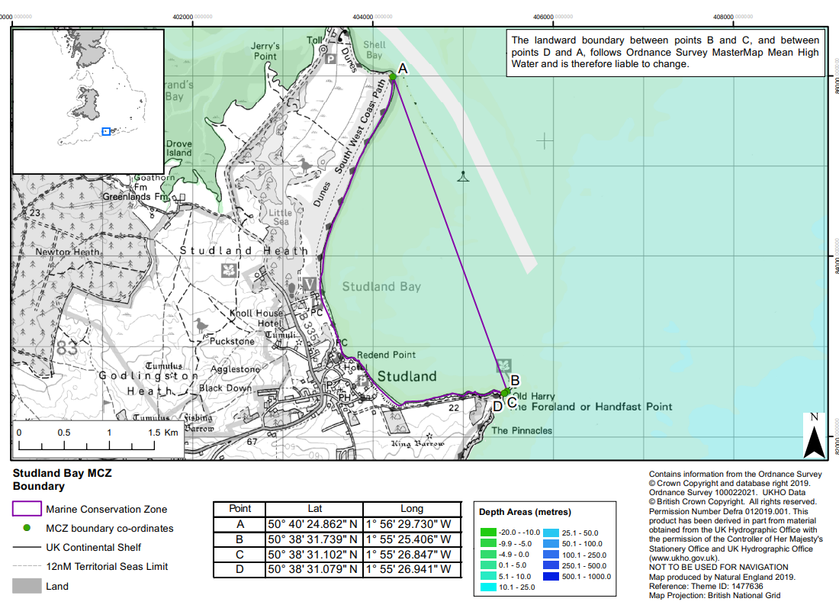
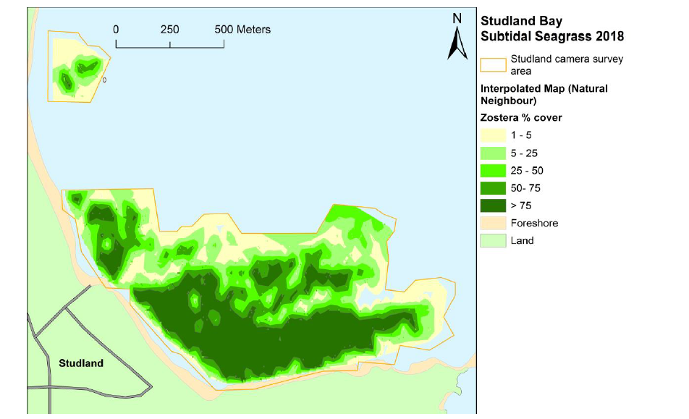
Figure 1: Studland Bay MCZ designation map produced by Natural England (Gov.uk, 2019)

Figure 2: Interpolated map (using Natural Neighbour algorithm) of subtidal seagrass density from the 2018 drop-camera survey of Studland Bay. (Environment Agency Studland Bay Subtidal Seagrass Survey, Green, 2018)

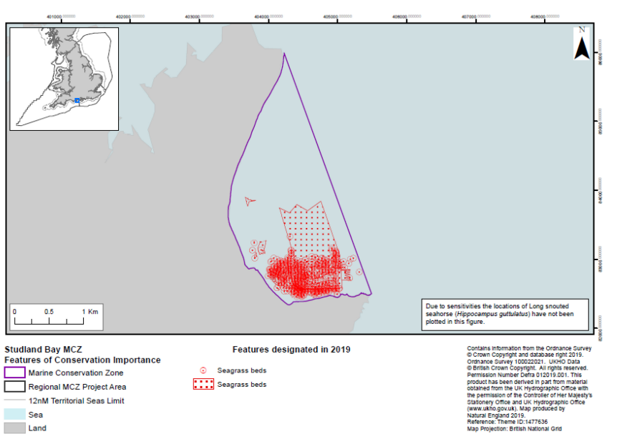
Figure 3: Studland Bay MCZ designated features map outlining location of seagrass beds, produced by Natural England (Gov.uk, 2019).

Survey area
The survey area will cover the subtidal seagrass beds off South Beach. This is the location of highest pressure from anchoring and mooring, as the highest concentration of boats are often recorded here. It is critical that the study focuses on where these pressures have the most impact on the seagrass beds. Specific survey sites should be identified based on the prevalence of mooring and anchoring scars.
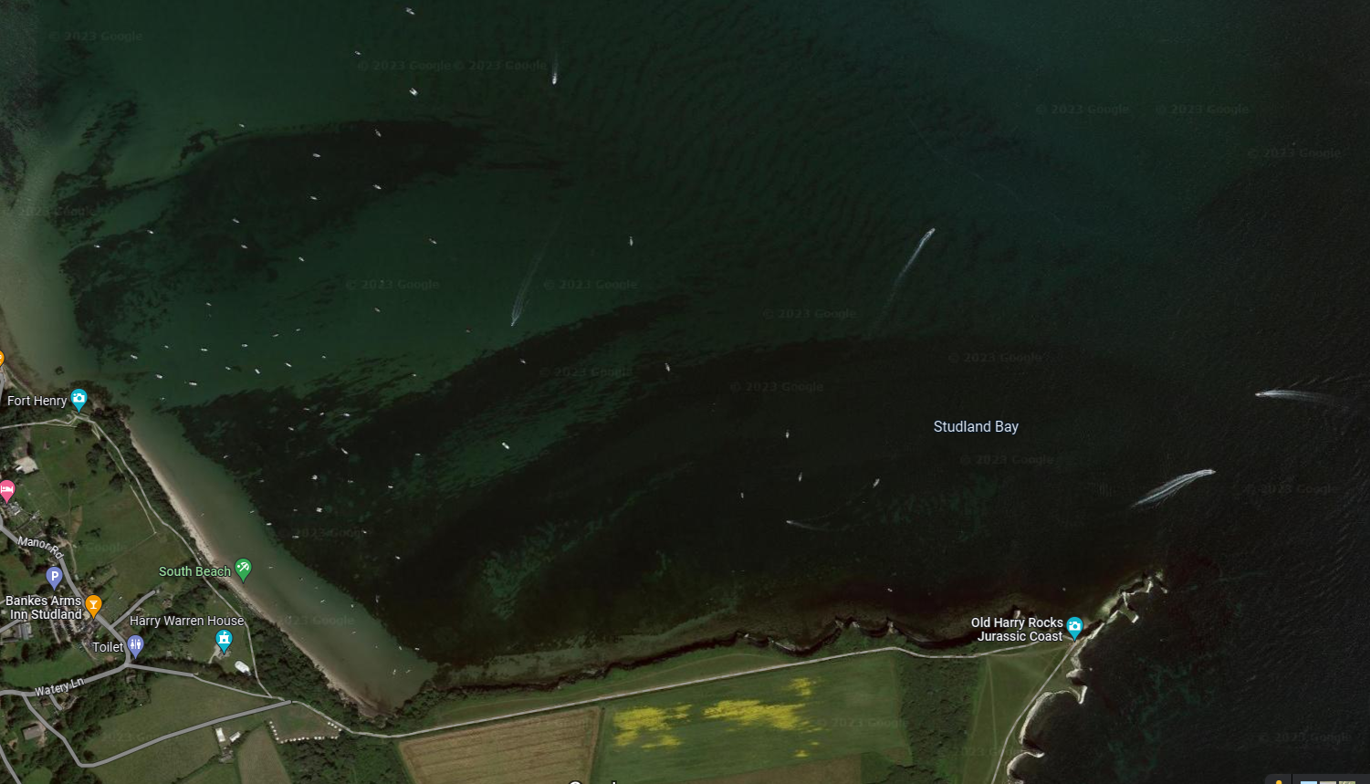
Figure 4: Ariel photograph of Studland Bay. South Beach, where mooring and anchoring pressures are high, can be seen marked in green (Google Maps, 2023).

Previous surveys
There have been previous surveys undertaken to monitor various aspects of the seagrass beds at Studland Bay. Most recently:
- Doggett, M. & Northen, K.O. (2023) Studland Bay Marine Conservation Zone (MCZ): Subtidal Seagrass Monitoring Survey 2021. NECR449. Natural England https://publications.naturalengland.org.uk/publication/4786688017825792
- Environment Agency (2022) Studland Bay Subtidal Seagrass Survey 2022. This report is in the draft stages and is expected to be published soon.
Please see Table 1 for a summary of previous surveys prior to 2021.

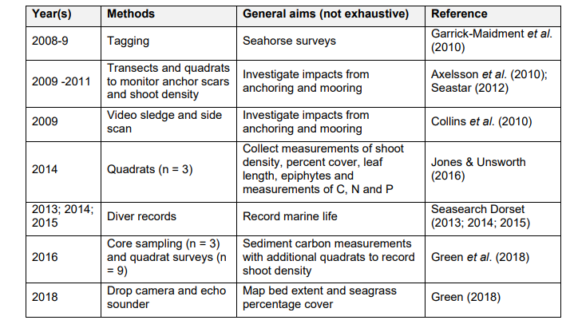
Table 1: A summary of previous monitoring studies undertaken in Studland Bay (Doggett & Northen, 2023)
Please note that, where possible, these datasets should be used to plan your proposed survey design. The outputs of this survey may be used by Natural England for several different purposes and applications, including Condition Assessment, the formulation of Conservation Advice and to improve our understanding of Ecosystem Assets pursuant to the Natural Capital approach. Therefore, ideally datasets should be comparable with historic data and methodologies to enable analyses, however different and novel approaches will be welcomed where a rationale is provided.

Requirement
Aims and Objectives
Aims
Natural England wishes to commission ecological survey work during summer 2023 and spring 2024, and possibly beyond to gather robust evidence on the specific recreational anchoring pressures on the seagrass beds within Studland Bay MCZ, and the rates of recovery of the seagrass bed from scarring. To that end NE wishes to investigate and develop a simple and remote method for identifying anchor scars in shallow seagrass beds to assess change over time i.e. seagrass recovery.
The speed at which the seagrass bed can recover from scarring is a fundamental element to this work. An appropriate definition of “recovery” is required to be created and applied to this survey and the results of this may be used in the future to inform management practices within the MCZ in relation to recreational pressures from anchoring and mooring. It is hoped that this project might serve as a pilot study, creating a suitable methodology and initial dataset allow future repetitions of the project to be delivered with comparisons made year on year.
It was recommended in Doggett & Northern (2023) https://publications.naturalengland.org.uk/publication/4786688017825792 That “Anchor and mooring damage within the bay remain a contentious issue with some stakeholders with regard to the level and / or significance of such impacts. Aerial (drone) surveys could be completed quickly and efficiently several times over the spring and summer to map the level and extent of the present impacts and, over time, record the efficacy of any management policies introduced. Drone surveys can be carried out relatively quickly, causing minimal disturbance to beach and water users and offer a very cheap and effective method to quantify the extent of any impacts."
Considering the above, it is proposed that ariel imagery could be used to survey certain areas of the bay where recreational pressures are highest, such as the area off South Beach, as this is an anchoring hotspot. Anchoring hotspots should be pre-identified and then surveyed over a predetermined period, with sufficient time between visits to allow for potential recovery of seagrass within the anchor scars. A time series of images of specific anchor scars, between the time this contract is awarded and next spring, should be created so that comparisons can be made across the study and for reference in potential future studies. A potential suggestive timeframe for images could be: once in the months of August, September, which will reflect the change during the busiest part of the boating season, and thus when there is the most pressure on the seagrass bed. Then once in October where it will be quieter, giving the seagrass opportunity to recover, then again once in March to assess if there has been any growth and recovery over the winter season where boating activity is severely reduced due to inclement weather. However, NE is open to discussions around the best way to assess these changes and the short-term recovery of seagrass.
Ground-truthing will be required alongside aerial imagery to ensure that the recovery of anchor scars is not being misconstrued as the accumulation of macroalgae instead of seagrass in recovery. It can be difficult to differentiate between seagrass and macroalgae from aerial surveys due to the dark green appearance of the two when seen from above. It should be noted that the use of a dive survey would not be appropriate due to the scope of resources available to this study.
An additional ask that Natural England would like to investigate if resources allow is the recovery of seagrass around the private moorings present in the bay. Many of these moorings have 20ft of ferry chain bedded into the seabed, and the traditional chain riser has been swapped out for a Sealite Synthetic Riser to decrease the impact of the moorings on the seagrass bed. Most of these moorings have been present in the bay for many years and so the impact of scour may be greater, potentially meaning recovery may take longer than one season. If possible, it would be an interesting addition to the study to investigate these moorings due to the differences in structure and potential affects.
It is important to highlight that there is the opportunity for alternative method suggestions to be made, in addition to the ones detailed here. This is of particular importance in case the proposed method is not deemed suitable by the consultants due to being unable to detect any scars, and any subsequent recovery. A minimum mappable scar size should be identified in line with the proposed methodology. It should be noted that any suggested variations on the method above should not differ greatly in terms of required use of resources and time.
The survey design for this tender should achieve the following aims:
- Acquire high quality biological and spatial data of suitable resolution to allow detailed analyses of anchor scars in Studland Bay.
- Use the data gathered to assess whether it is possible to identify anchor scars in the seagrass beds using remotely gathered data e.g. aerial imagery.
- Develop a mechanism for assessing what recovery looks like from an aerial view.
- Gather sufficient evidence to assess how swiftly the seagrass bed is able to recover from the anchoring event, i.e. how long does it take for seagrass to recolonise the scar. Images of the same location should be collected repeatedly over the time frame to allow for direct comparison.
- Investigate if there is any evidence of the INNS Sargassum muticum affecting seagrass recolonisation of anchor scars.
- Use ground-truthing alongside remote imagery as a tool for robust data collection to ensure anchor scar recolonisation is definitely seagrass regrowth, compared to the accumulation of macroalgae.
- Develop a methodology to assess the recovery of seagrass beds after pressures and impacts from anchoring and mooring, that is repeatable in the future.
- If possible, NE would also be keen to better understand anchoring pressure/intensity at anchoring hotspots so data gathered can help us understand the cumulative impacts of anchoring events on the seagrass beds.
In brief, Natural England are seeking potential contractors to pay particular attention to survey design so that quantitatively robust data is acquired which will permit rigorous analysis and inform the evidence-based on the impacts of anchoring and the ability of seagrass to recover.
Objectives
The specific objectives of this contract are to:
- Identify hotspots of anchoring activity and assess if the resultant scars can be accurately mapped. The highest anchoring pressures occur mainly off South Beach (Figure 4).
- Identify the recently upgraded moorings (Natural England can provide GPS coordinates for these).
- Carry out the survey, in the form of repeated visits using aerial imagery (potentially from drone footage) to take photographs of the seagrass beds at regular sites to map the level and extent of the present anchoring and mooring impacts and if any recovery takes place at locations which have been scoured by anchoring or mooring.
- Complete the analysis of the data gathered, including GIS analysis of anchor scar recovery and map subsequent changes in seagrass cover.

Under this specification contractors must:

- Develop, agree, and implement, in collaboration with Natural England, a survey plan to collect data suitable for undertaking the assessment of impacts and rates of recovery of seagrass beds as a result of anchoring and mooring pressure identified under this specification.
- In agreement with Natural England, implement a statistically robust survey design to enable future collection of compatible data, permitting quantitative long-term analysis.
- Provide fully detailed “standard operating protocols” for the work undertaken, ensuring that methods can be repeated in the future.
- Produce a concise, evidence-based technical report detailing the work undertaken, reporting the survey and analytical findings, discussing the recovery rates of seagrass and efficiency of survey design.
- In discussions around the findings of this work, observations made regarding condition, drawing upon “expert judgement”. In addition to the collected and analysed data, must be clearly identified and presented separately from the core results of this survey work.
- To provide raw data and metadata in appropriate format e.g. appropriate GIS data, Marine Recorder and MEDIN outputs.
- Provide all data to the relevant standards set out in section 4.1.

Methods
Development of a suitable sampling design
A sampling design needs to be developed for this work. This method should enable temporal comparisons to be made within this dataset collected, as well as future datasets.
This project differs to previous surveys in that it will use aerial images of the site to inform analysis of the recovery rates of seagrass after impacts by anchoring and mooring. Locations, extent, and recovery rates of scarring from anchoring impact may be comparable to the two previous surveys “Investigating Impacts from Anchoring and Mooring” by Axelsson et al. (2010), Seastar (2012) and Collins et al. (2010), listed in Table 1 and used to compare against future repetitions of the study.
Recognising this as an innovative pilot survey, Natural England would expect the successful contractor to ensure data gathered is robust. Natural England would, therefore, expect a level of ground-truthing to occur.
Natural England envisage this could be done using a small number of locations, where activity and pressure is at the highest. It needs to be an area big enough area to cover possible anchoring events whilst maintaining manageability within the scope and resources of the project.
In developing an appropriate sampling strategy, contractors should not be bound to simply repeat the previous methodology undertaken; rather they should seek to implement an improved approach which enables a comparison with existing data but at the same time delivers Natural England’s requirements for a more statistically robust approach outlined as above.

Pre-survey deskwork
Before the survey is carried out the contractor will discuss any pre-survey work with the Nominated Officer, including:
- Clarification of roles, responsibilities, and expectations
- Acquisition and checking of sources of relevant information and gathering of local advice in preparation of a project plan
- Review existing information provided by Natural England or any datasets known to the contractor.
- Ways of working and close collaboration with NE in developing project plan, particularly selection of survey sites, taking account of NE/EA pre-survey scoping work, and finalising survey design and methodologies.
- Ensure that up-to-date charts are used to position sample sites away from cables, pipelines, or any other coastal infrastructure. Should any coastal infrastructure exist within an area to be sampled then a buffer should be used to ensure that sampling activity does not cause damage. This should be clearly displayed within the survey plan. Should coastal infrastructure be found during the fieldwork then any sample sites should be relocated, and the Nominated Officer informed.
- Liaise with National Trust and Studland Bay Management Partnership.

Site access
The Nominated Officer should be contacted prior to commencement of any fieldwork.
All drone work should be operated in accordance with Civil Aviation Authority (CAA) rules and the user should be registered as an operator with the CAA.
Natural England will obtain permission from seabed owners or leaseholders for survey work on the seabed and will supply a copy of this permission to the contractor. Each member of the survey team must carry a letter from Natural England to confirm that they are doing this work on the behalf of Natural England. Survey work will not be able to begin until access permissions have been obtained by Natural England.
Contractors should allow for the inclusion of Natural England staff on surveys wherever feasible. The Nominated Officer will liaise with the contractor regarding the availability of Natural England staff to join the survey, where available.

Field survey
Natural England envisages that the drone surveys should be carried out over repeated visits during 2023/24. Data could be collected over part of the year to ascertain the relevant changes.
Each survey should cover the same sites so direct comparisons can be made throughout the time series. Specific areas of the seagrass bed should be revisited and each survey, focusing on the where the highest density of boats anchor as this will be where the seagrass bed is impacted most.
Natural England envisages that the required survey work under this specification should be completed within a handful of days assuming these are repeated visits over a period of time.
Natural England envisages data being collected in August, September and October, and then finally in March due to wanting to capture data from the busiest boating season, and then subsequent recovery when those pressures are removed over the winter. Although other ideas are welcomed.
Contractors must clearly state their availability and capability to carry both this single contract and any other projects they may consider bidding for in combination within the given timescales.
Surveys will be carried out in accordance with the technical specification provided above. Alternative approaches will be considered if they meet the aims and objectives of the contract, if they demonstrate efficiencies, and are agreed with Natural England prior to survey commencing.

Data Analysis
Data analysis will be undertaken by the successful contractor as set out in the aims and objectives.

Invasive Non-Native Species
Invasive non-native species (INNS) are considered to be one of the top five pressures directly driving biodiversity loss globally. Prevention is the key focus, particularly in marine environments. The contractor shall be aware of and work in accordance with standard good practice biosecurity measures to avoid spread of INNS:

- Equipment, clothes and boots should be clean before carrying out any work on site
- When on or near water it is important that equipment is drained after use and as far as possible dried
- Boats to be used in survey work should have their hulls cleaned on a regular basis. Best practice guidelines should be followed as outlined by The Green Blue

INNS species previously recorded in this region and/or to particularly look out for during this survey include:
- Sargassum muticum (Wireweed)
- Crepidula fornicata (Slipper limpet)
- Didemnum vexillum (carpet sea squirt)
- Grateloupia turturu and other filamentous and foliose red algae. These may affect seagrass mapping.
The contractor must report any records of INNS observed on site on Marine Recorder and to the Natural England project officer as part of the survey report. Any species currently listed as ‘alert’ species should be flagged immediately to the GB Non-Native Species Secretariat http://www.nonnativespecies.org/alerts/index.cfm. More information and guidance including ID guides can be found at www.nonnativespecies.org and the Marine Aliens Project.

H & S Requirements
All risk assessments need to be seen and signed off by the Nominated Officer (ideally when presented with then project plan), as part of the contract management process.

Weather downtime & contingency
Survey windows should be allocated in accordance with the best tides available. Contractors will be expected to check weather regularly (daily) prior to agreed survey windows. If contractors have 48 hours’ notice of impending poor weather then they will be expected to make alternative arrangements for the duration of the poor weather and reschedule survey work to be completed at a later date. If contractors have not yet mobilised, then Natural England does not expect to be charged for any weather downtime. It is the responsibility of the contractor to contact Natural England in the event that impending poor weather is putting the survey at risk. Natural England does not envisage paying for downtime or contingency time for intertidal contracts, but in the event of unforeseeable weather events, a maximum of 1 day may be paid.
In the event of uncertainty or other unforeseen events that impact upon the ability of the contractor to undertake the survey, the Natural England Nominated Officer should be contacted immediately.
Reporting and analysis
Draft reports should be provided in electronic MS Office Word *.DOCX format for comment. A template and guidance exists for writing Natural England commissioned reports and will be sent to the contractor upon award of the tender. All reports should retain a clear suggested citation stating that it is a ‘Report to Natural England’.
Data must be interpreted, analysed and presented in light of the overarching hypotheses stated above. Contractors should pay particular consideration to the data and GIS required formats for information compatibility including MEDIN metadata standards and Marine Recorder provision:
- All sample data (grab sample analyses, video/still photography analyses, diver survey species, PSA analysis and biotope lists etc) need to be entered into Marine Recorder and delivered with the final reports. Natural England will provide licence keys for Marine Recorder to the winning contractors for use in this contract. A Snapshot file of the data should also be provided. https://www.esdm.co.uk/marine-recorder. Guidance ‘Marine Recorder Evidence for Contractors’ will be provided to the winning contractor.
- All GIS datasets need to be provided in ESRI ArcGIS format compatible with ArcGIS 10.2 and have attached metadata
- If not included in the GIS data layers listed above all sampling locations, vessels tracks, and links to data obtained should also be included as a single GI layer.
- Copies of the original data spreadsheets or databases are to be provided in the appropriate Microsoft Office format.
- Copies of the original drop down videos and drone imagery are to be provided on DV tape and on indexed DVDs or USB compliant external hard drives.
- Stills photographs to be provided in their raw format on CD/DVD or USB compliant external hard drives.

Copies of the original data spreadsheets or databases are to be provided in the appropriate Microsoft Office format. However please be aware that using MEDIN marine biodiversity data guideline spreadsheets (available online under the marine biodiversity tab at MEDIN data guidelines) will ensure that biological taxon data is prepared correctly for entry into Marine Recorder and will facilitate the efficient entry of data into this system and the data archiving process in general. Natural England welcomes and supports the provision of raw data spreadsheets in the MEDIN format and expects that all raw datasheets will contain the mandatory fields in the MEDIN guidelines, regardless of their format.
High quality imagery which has been selected to form part of the image reference collection for the survey need to be labelled appropriately, including the habitat/species which is represented. These should be provided as a separate folder on the storage device to the standard survey imagery.
All data products and electronic files must be appropriately named so they sufficiently describe the contents and are not purely a numerical value. All products should be named appropriately so that they can be clearly linked to the report/project.
Any species lists submitted will be compliant with current taxonomic names and synonyms (e.g. Marine Species of the British Isles and Adjacent Seas (MSBIAS), World Register of Marine Species (WoRMS))
Video and still camera filenames must include the recording start date and time. Position data must be included within the overlay information.

Sustainability
Defra Group protects and improves the environment and is committed to reducing the sustainability impacts of its activities directly and through its supply chains. We expect the Contractor to share this commitment and adopt a sound, proactive sustainable approach in keeping with the 25 yr environmental plan/our commitments compliant with all applicable legislation. This includes understanding and reducing direct and indirect sustainability impacts and realising opportunities, including but not restricted to; resilience to climate change, reducing greenhouse gas emissions, water use and quality, biosecurity, resource efficiency and waste, reducing the risk of pollution, biodiversity, modern slavery and equality, diversity & inclusion, negative community impacts.
As a delivery partner, the successful contractor is expected to pursue sustainability in their operations, thereby ensuring the Contracting Authority is not contracting with a supplier whose operational outputs run contrary to the Contracting Authority’s objectives. The successful contractor will need to approach the project with a focus on the entire life cycle of the project
Sustainability covers environmental, economic and social value impacts. As a delivery partner, the successful contractor is expected to pursue sustainability in their operations, thereby ensuring the Contracting Authority is not contracting with a supplier whose operational outputs run contrary to the Contracting Authority’s sustainability objectives. The successful contractor will need to approach the project with a focus on the entire life cycle of the project.
The Supplier/Contractor will provide such evidence of addressing its sustainability impacts and compliance with the contract requirements when the Authority reasonably requests.

References
Axelsson, M., Allen, C., Dewey, S. and Drabble, R. 2010. Survey and monitoring of seagrass beds at Studland Bay, Dorset – first seagrass monitoring report. Report to The Crown Estate by Seastar Survey Ltd and ABPmer, November 2010, 45 pages.
Collins, K.J., Suonpaa, A.M. and Mallinson, J.J. 2010. The impacts of anchoring and mooring in seagrass, Studland Bay, Dorset, UK. International Journal of the Society for Underwater Technology, 29(3), 117-123
Davies, J., Baxter, J., Bradley, M., Connor, D., Khan, J., Murray, E., Sanderson, W., Turnbull, C. & Vincent, M., (2001) Marine Monitoring Handbook, 405 pp, ISBN 1 85716 550 0. Available online at: http://jncc.defra.gov.uk/page-2430
Doggett & Northern (2023) Studland Bay Marine Conservation Zone (MCZ): Subtidal Seagrass Monitoring Survey 2021. Available online at: Studland Bay Marine Conservation Zone (MCZ): Subtidal Seagrass Monitoring Survey 2021 - NECR449 (naturalengland.org.uk)
Environment Agency (2022) Studland Bay Subtidal Seagrass Survey 2022 – Summary Report. To be published soon.
Green (2018) Studland Bay Subtidal Seagrass Survey September 2018 - Summary Report.
JNCC (2004), Common Standards Monitoring Guidance for Marine, Version August 2004, ISSN 1743-8160. Available online at: http://jncc.defra.gov.uk/page-2236
Seastar 2012. Survey and monitoring of seagrass beds, Studland Bay, Dorset. Second seagrass monitoring report. A report by Seastar Survey Ltd. for The Crown Estate and Natural England, June 2012. Report No. J/09/169, 71 pp

Outputs and Contract Management
Action | Date
Date of issue of RFQ | 12th July
Deadline for clarifications questions | 19th July
Deadline for receipt of Quotation | 25th July
Intended date of Contract Award | 28th July 2023
Intended Contract start Date | 28th July 2023
Intended Delivery Date / Contract Duration | First week of August 2023- End of March 2024
Start-up meeting and finalise sampling design | 9th August 2023
Produce final project plan | 11th August 2023
Ground survey to be completed by | 31st August 2023
Submission of brief field report by | 22nd March 2024
Draft final report and associated products to be provided by | 29th March 2024
Final report (in standard NECR format), and agreed outputs to be delivered by | 28th June 2024

