
Dodington Parish Council
Finch Road, Chipping Sodbury, BS37 6JZ
01454 866546 / clerk@dodingtonpc.org.uk
www.dodingtonpc.org.uk

Tender Brief for Woodchester Play Area Improvements

Dodington Parish Council wants to upgrade and improve the facilities on offer for children at Woodchester Play Area in Yate, near Bristol. We want to deliver this in two phases, which have been chosen as priorities by our Councillors –

- Phase 1 – Refresh of toddler play area

- Phase 2 – Refresh of recreational area

We are inviting play equipment companies to tender for both phases of this project, with tender bids to be considered by our Councillors in January 2019. Interested companies are welcome to bid for either or both of these phases of the project.

Phase 1 – Refresh of toddler play area

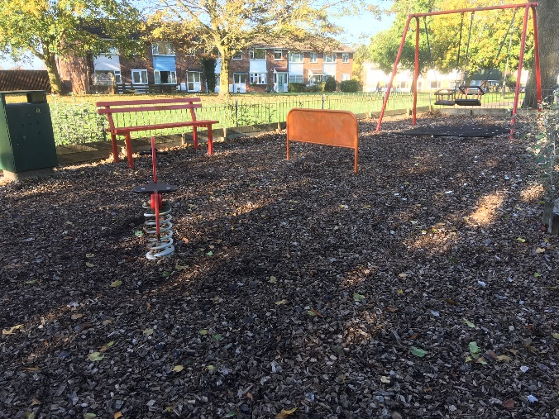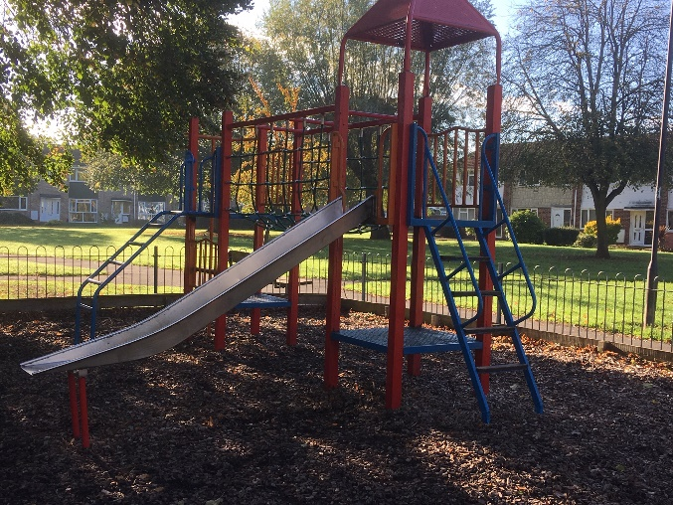

Dodington Parish Council took over the lease of Woodchester toddler play area from South Gloucestershire Council earlier this year. We want to refresh the equipment on offer for toddlers as some of it is showing signs of age.

Funds available – up to a maximum of £30,000

Timescale – Tender bids to be reviewed in January 2019, build to be started in March 2019, to be completed in time for the Easter break.

Must haves –
- Supply and install a new toddler multiplay, replacing the one we currently have. Must include a slide and a play panel/sensory board
- Update of current swing set, replacing the two baskets and sets of chains (keeping the current frame in place, if possible)
- Play area surface – we currently have a bark surface and welcome suggestions as to what could replace it
- Safety matting – we will require appropriate safety matting to be installed under any new equipment.

Nice to haves –
- A ‘memory swing’ to replace one of the current basket swings
- If space allows, we would like to add a small playhouse, play panel or spring toy to the toddler area.

Phase 2 – Refresh of the recreational area at Woodchester Play Area

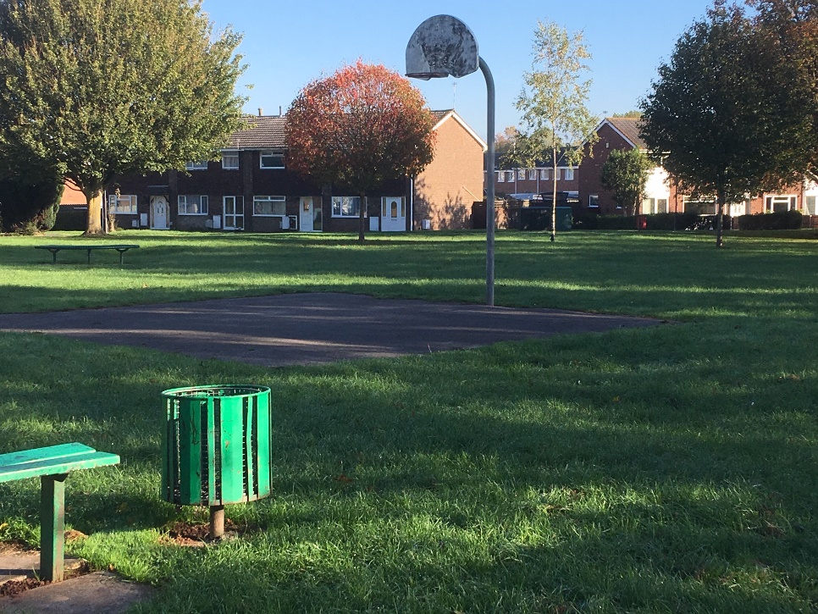

We currently have a small recreational court with one football goal and a single basketball hoop. We would like to refresh this area so that we can offer improved facilities for local children.

Funds available – up to a maximum of £15,000

Timescale – Tender bids to be reviewed in January 2019, build to be completed during May 2019, to be completed before the half-term school break (w/c 27th May 2019).

Nice to haves -
- Supply and install two combination football goals and basketball hoops (MUGA-type goals) to replace current separate football goal and basketball hoop and post.

Details about the site –

Address: Woodchester Play Area, Yate, BS37 8TX. Accessible from the residential streets of Woodchester or Maisemore, Yate. The area can be accessed at all times to view.

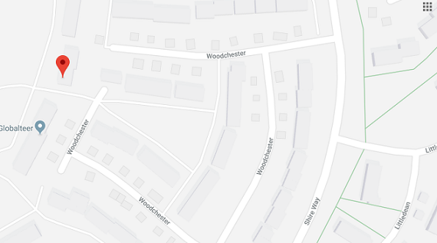

Further information / next steps –

We would like to see some design ideas of what could be achieved within the budget and timescale. Tender bids will be accepted until midnight on Tuesday 8th January 2019. We also plan to hold an open session at Woodchester Play Area on Wednesday 12th December from 10:00am – 12:00pm, which you are welcome to attend if you would like to visit the site and ask questions to help with your tender bid.

We would be interested in seeing a similar build that your company has completed within the last couple of years. Please let us know whether there is anything we could go and view anything locally to us. If this isn’t possible, we would like to read a testimonial from a Parish Council or similar organisation that you have done work for recently.

Should you require further information at this stage, please contact the Parish Clerk, Hannah Saunders or Liz Hazelby, Admin Assistant at the contact details at the start of this brief.

