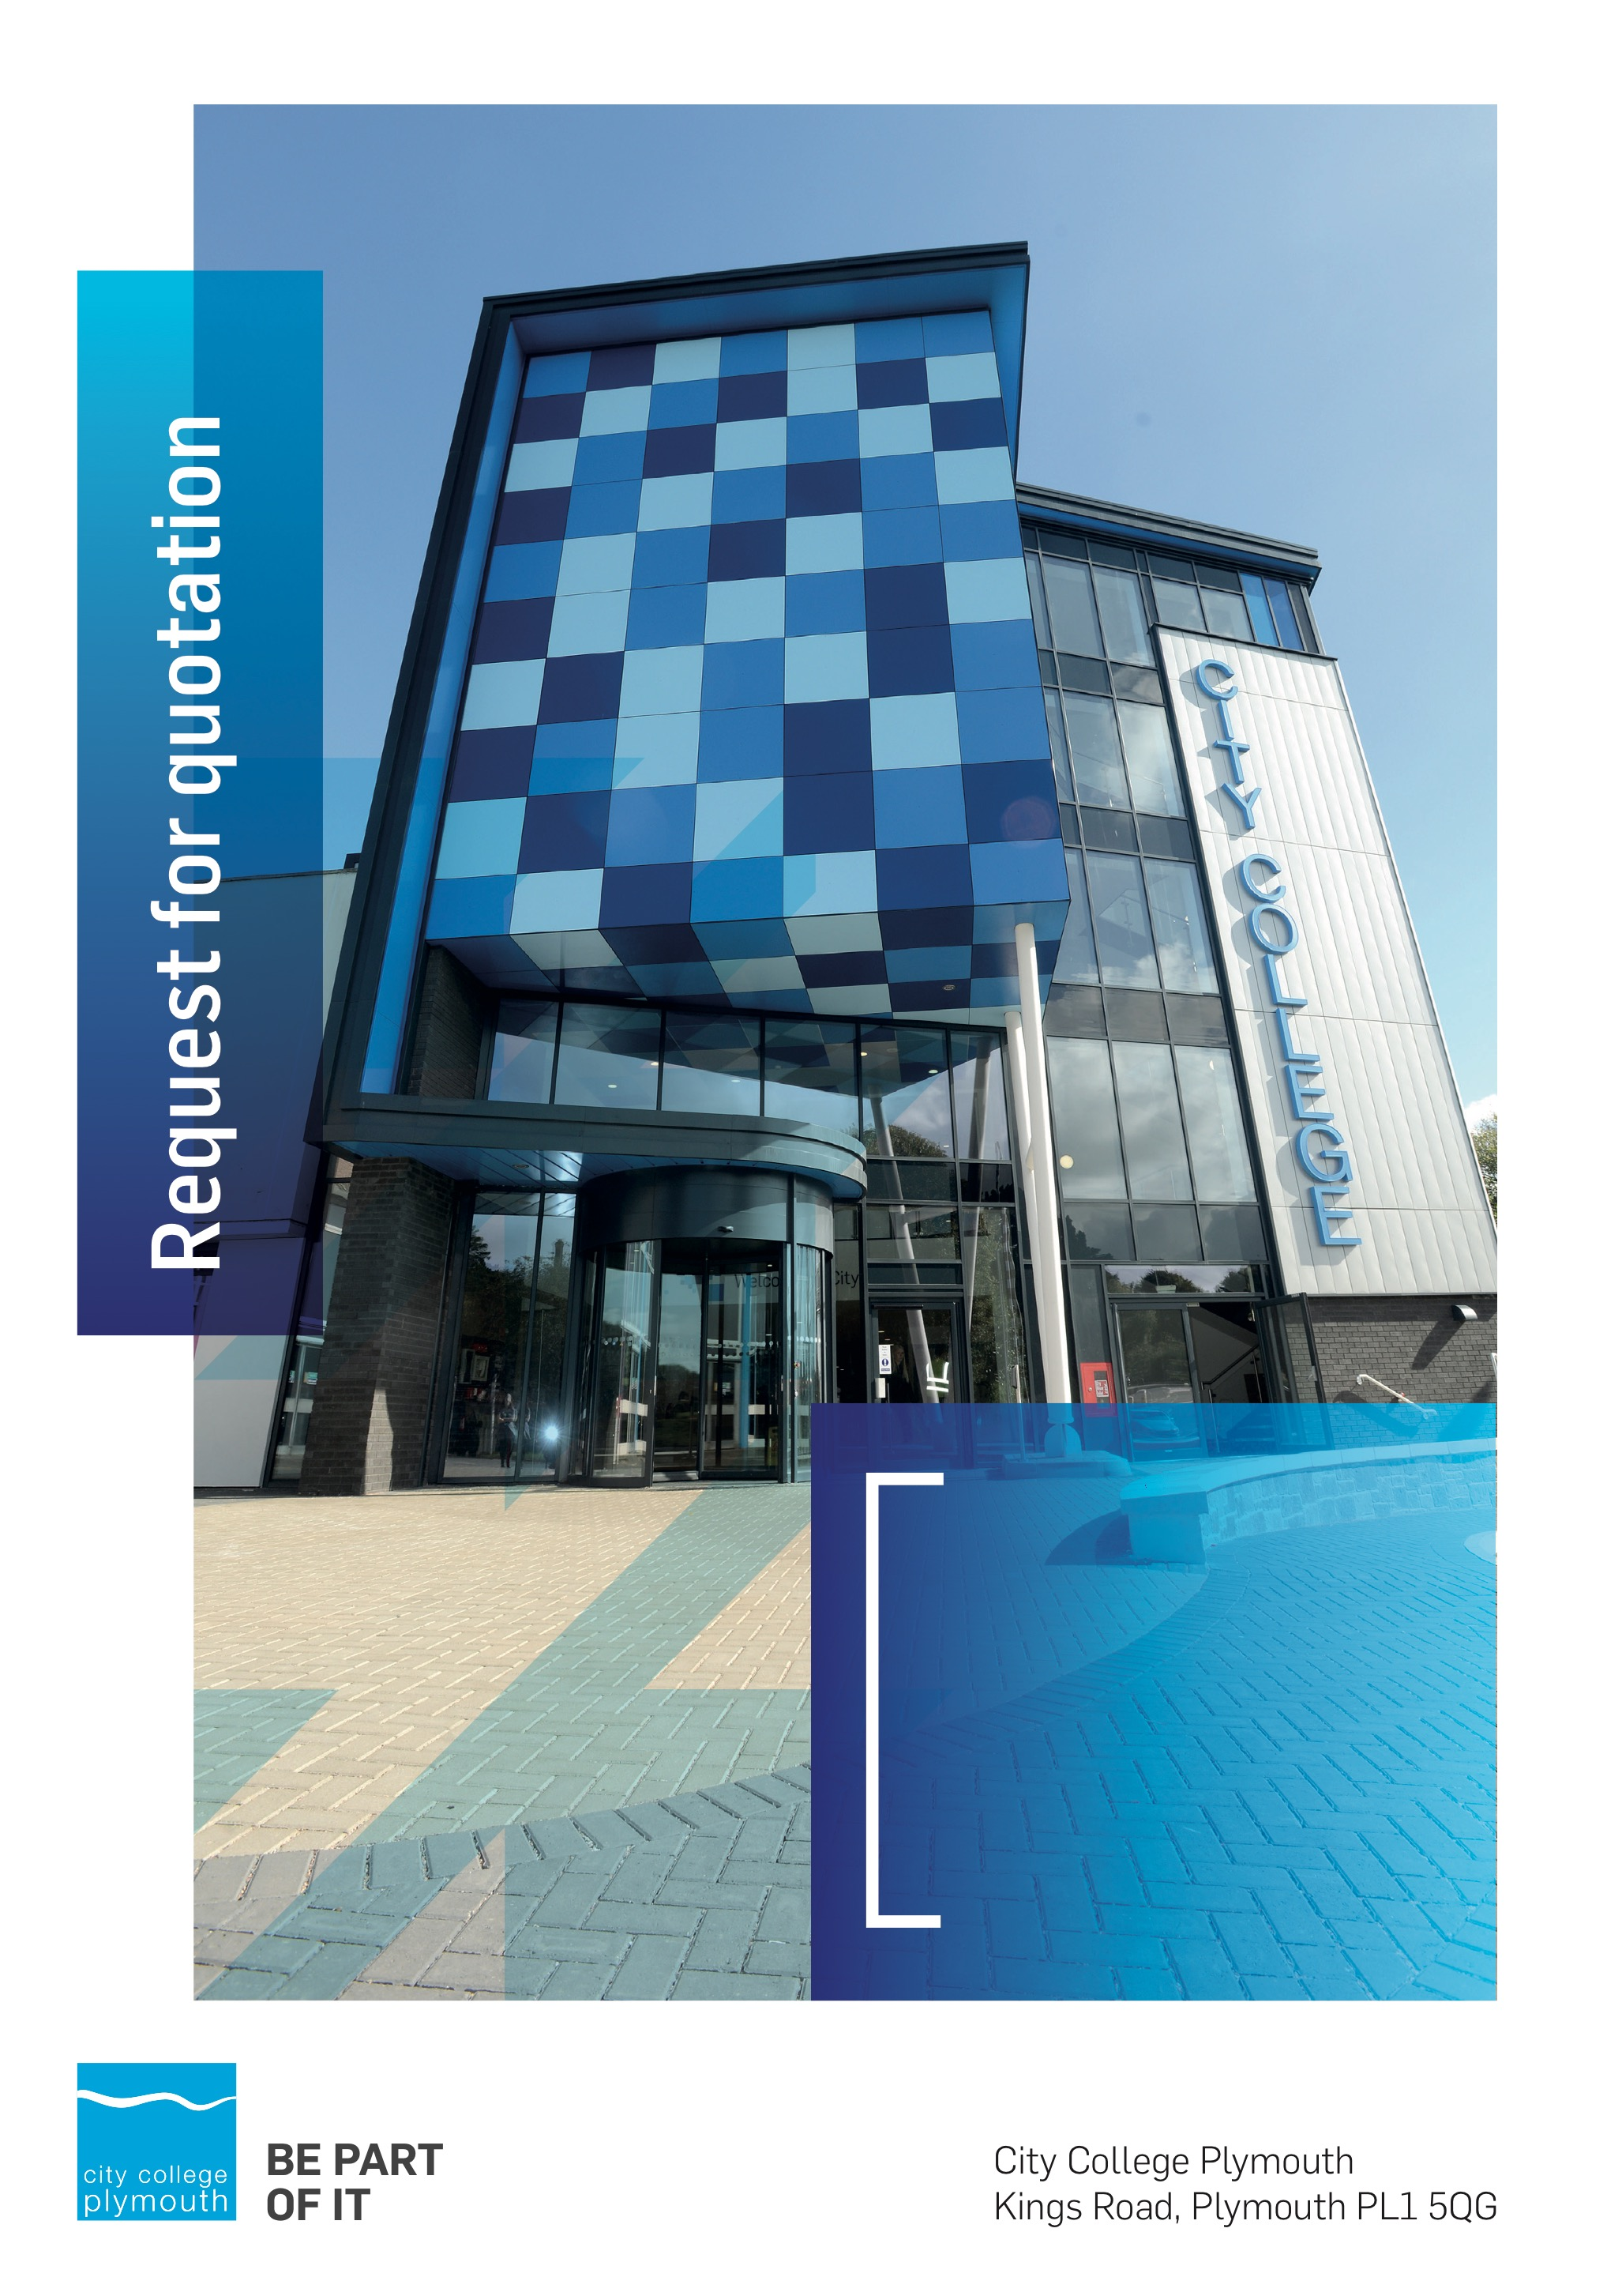

**Request for Quotation**

**RFQ191 Website Design and Build**

**Issued 25/03/2022**

# Table of Contents

Table of Contents……………………………………………………………………………2

Table of Contents 2

Confidentiality Statement 3

Open Procedure 4

Submission Details 4

Submission Deadlines 4

Submission Questions and Clarifications 4

Electronic Submissions 5

Introduction and Executive Summary 5

Business Overview & Background 6

Our Guiding principle 6

Our Vision 6

Our CORE VALUES 6

Our CULTURE 7

The Way Forward - our Priorities 7

Detailed Requirement 7

Current Website 8

Target Audiences 9

New Website Requirements – Written Submission 9

Pricing (25%) 9

essential elements (60%) 10

Look and feel (10%) 12

User requirements (5%) 12

7. Hosting, Maintenance & Support 12

Timescales 13

Selection Criteria 14

Award Price 14

Written submission scoring 14

Assessment of Quotations 15

Terms and Conditions 15

Validity 16

Safeguarding 16

Freedom of Information Act 2000 16

General Data Protection Regulation (GDPR) 2018 16

Agreement Conditions Acceptance and Declaration 16

Supporting Documentation 17

# Confidentiality Statement

This document, and any attachments thereto, regardless of form or medium, is intended only for use by the addressee(s) and may contain legally privileged and/or confidential, copyrighted, trademarked, patented or otherwise restricted information viewable by the intended recipient only. If you are not the intended recipient of this document (or the person responsible for delivering this document to the intended recipient), you are hereby notified that any dissemination, distribution, printing or copying of this document, and any attachment thereto, is strictly prohibited and violation of this condition may infringe upon copyright, trademark, patent, or other laws protecting proprietary and, or, intellectual property. In no event shall this document be delivered to anyone other than the intended recipient or original sender and violation may be considered a breach of law fully punishable by various domestic and international courts. If you have received this document in error, please respond to the originator of this message or email him/her at the address below and permanently delete and/or shred the original and any copies and any electronic form this document, and any attachments thereto and do not disseminate further.

Thank you for your consideration, City College Plymouth.

Where no notice is given, all information contained herein is Copyright 2022 City College Plymouth.

# Open Procedure

The College fully adheres to the requirements of the Public Contracts Regulations 2015, including for opportunities which are under threshold amounts.

Any Contractor who directly or indirectly canvasses any Member or Officer of the Institution, or advisor concerning the award of the contract for the provision of the services, or who directly or indirectly obtains or attempts to obtain information from any such member or Officer concerning any Tender or proposed Tender for the service will be disqualified from having his/her Tender considered.

# Submission Details

## Submission Deadlines

All submissions for responding to this Request for Quote must be submitted electronically as stated below, no later than:

**22nd April 2022**

**12:00 Noon**

Any submissions received after this date will not be considered.

## Submission Questions and Clarifications

You may contact the following person if you have any questions or require clarification on any topics covered in this Request for Quotation: 15th April.

**Adam Baker**

Procurement Officer

Phone: 01752 505313

Email: tenders@cityplym.ac.uk

All correspondence during the Tender should be channeled via the Procurement Officer using the above details only. Bidders found to have gained an unfair advantage shall be disqualified from the current opportunity and future opportunities with the College for a minimum of four (4) years.

## Electronic Submissions

Electronic submissions in response to this Request for Quotation are required and must meet the following criteria:

Sent via email to: [tenders@cityplym.ac.uk](mailto:tenders@cityplym.ac.uk)

Document standards:

* Text must be in Microsoft Word format;
* Supportive evidence may additionally be submitted in PDF format;
* Images, Designs, and other supporting evidence may be in either JPEG or PDF format
* Completed Appendix B Suitability Assessment & Selection Questionnaire (Including Mandatory & Discretionary Exclusions) Parts 1, 2 and 3. - *Please note this suitability assessment will not be viewed unless you are the winning tenderer. Failure at this stage may prevent the contract from being awarded.*
* Signed Agreement Acceptance and Declaration.

*Please note that the College is able to accept submissions sent in a compressed or “.zip” file format, so long as the files contained meet the standards described above.*

**WARRANTY**:

By submitting your tender bid, you are warrantying to the College that you have not breached our canvassing or soliciting clause.

If any successful tenderer awarded a contract is found to have provided an inaccurate warranty, then the College reserves the right to terminate the awarded contract with immediate effect and re-tender the contract from which the successful tenderer will be excluded from re-bidding and shall be disqualified from any future opportunities for a period of four years.

# Introduction and Executive Summary

In order to continue to engage positively with its target audiences - 16 to 18s and their key influencers (parents, employers and schools) and 19+ students - City College Plymouth is seeking to contract with a single supplier for the one-off provision of a bespoke website re-design and build for the core College website.

The current website is viewable at [**www.cityplym.ac.uk**](http://www.cityplym.ac.uk).

The anticipated value of the supply contract will exceed £25,000. Therefore, as per the Public contracts Regulations 2015 the opportunity will be advertised on the government portal ‘Contracts Finder’.

.

# Business Overview & Background

City College Plymouth is a leading provider in vocational and technical education, preparing thousands of students every year to join a variety of industries as a result of the high-quality learning that is offered by the College’s vastly experienced lecturers.

City College seeks to be the learning destination of choice that develops talented, confident and resilient workers who will enjoy successful careers and in turn support the region’s employers, driving growth and prosperity. Recognising the need to support the region’s developing digital capabilities, digital education is embedded throughout the curriculum and all students benefit from access to some of the latest technologies.

The College was awarded the Teaching Excellence Framework (TEF) Gold award for its university-level provision and its most recent Ofsted inspection confirmed that the College continues to be ‘Good’ with many outstanding features.

City College Plymouth is also one of the first Institutes of technology in the UK Working in collaboration with education providers and employers across the South West to improve the training in science, technology, engineering and maths in order to address skills gaps within these industries and support regional growth.

City College supports the region’s employers with their award-winning Apprenticeship provision, as well as providing a range of courses and bespoke training programmes which enable employees to upskill or retrain to better support their business’ requirements.

The College operates on two main sites within the city, serving 12,500 students and employing over 600 staff. The College operates year round, with opening times from 0800-2100 on some days.

## Our Guiding principle

City College Plymouth has a learning environment and organisational culture that impacts positively on the health, wellbeing and sustainability of our community and enables all of our students and staff to achieve their full potential.

## Our Vision

To be the learning destination of choice

## Our CORE VALUES

Respect, ownership, integrity.

## Our CULTURE

Nurturing a passion for teaching and learning

Enriching our community through knowledge, experience and skills

Enabling every student to be the best that they can be

## The Way Forward - our Priorities

• Staff - our most important investment

• Students - our purpose

• Community - making a difference

• Achievement - reputation for success

• Wellbeing - infusing health into every day

# Detailed Requirement

Proposed project Budget £45-50,000 inclusive of vat

The College is seeking to complete a two-stage process to appoint a company to design and build a new website. Based on scores awarded for the written submissions, up to a maximum of three agencies will be short-listed and invited to present a creative pitch to include design proposals on Friday 6th May via Zoom.

The College requires a new website to promote its full range of courses and services providing up-to-date, accurate information and engaging content. The site needs to account for the College’s diverse target audiences and the increasing demand for digital (graphic and video) content, whilst promoting an inclusive and aspirational environment.

Most importantly, there needs to be a clear “purchase path” from landing to enquiry/application. College can be seen as an intimidating place for some potential students who are leaving school or returning to education as an adult, so the website presence must be clear, approachable and accessible to all its target audiences. The design needs to account for the range of platforms and devices that are used for web browsing.

The website needs to allow for complete in-house maintenance and control, allowing for development and customisation where required. It must incorporate all of the essential functionality listed below, and offer a dynamic and easy-to-navigate experience to our customers.

Our current website is built on Wordpress, however, we are open to discussions on the most suitable platform for our requirements.

The successful agency will be required to undertake focus group testing with our key target audiences to justify their designs, and pitch final concepts to the College’s Executive Leadership Team and Website Project Team.

## Current Website

* Average 28,377 unique visitors per month.
* 57.9% access our site via a desktop, 40.29% via a mobile,and 1.8% via tablet.
* New users access the website the most via the following channels: direct (48.8%) organic search (41%), and social media 4.4%. A very small number access the site via other methods such as Buzzfeed and SnapChat but these channels haven’t been utilised by the Marketing team in the past 12 months.

The current website was built in 2016 using Wordpress and is driven by a MySQL database. The site uses html, javascript, jquery and php to provide information to users.

The current website has a custom theme which includes a custom course page to display course information and to route the user to application, enquiry or online shop.

There are a number of purchased Wordpress plugins to deal with SEO, calendars and custom forms.

The current website now uses Advanced Computing Ltd ProSuite to feed its custom course pages having recently migrated its student record system away from Tribal Technologies EBS system. The data is displayed using rules written for EBS. This means that all course information in ProSuite has to be mapped to both the Wordpress page ID and to what would have been the course code when EBS was used. A nightly cron job is used to pull this data from ProSolution where date conversion takes place. This course data is inserted into a truncated bespoke table in the Wordpress DB. This is far from ideal and has caused many issues over the last academic year. Any failure of this cron job, can leave the website without correct course data.

**Primary areas for improvement identified:**

* outdated design, not fit for individual target audiences - standard page layout rather than designed to appeal to specific audiences
* improved course search functionality
* too much support information sitting in different sections
* accurate coding to pull information from the College’s Pro system (course information including selling points, fees, start dates, etc and linking to the online application system)
* integration of digital content such as videos, augmented reality, allowing for easy display on a range of browsers and mobile devices
* improved section for recruiting College staff and promoting vacancies
* improved section for promoting Apprenticeships to both future apprentices and employers
* lack of ability to produce reports from the site.

## Target Audiences

The College’s key target audiences fall into the following categories:

* 14 to 18-year-olds/school leavers
* 19+ adult learners
* apprentices (this can include 16 to 18s and 19+, but is a separate offer)
* international students
* employers
* key influencers (parents, schools, referral agencies, careers advisors, etc).

# New Website Requirements – Written Submission

You are invited to submit your written submission which should detail how your proposal will meet the relevant criteria outlined below. The scores for each element are shown in brackets (xx%) and are also available on pages 11 and 12 of this document. All elements outlined should be included within your quote price. Any elements which would incur an additional cost must be disclosed, as these will be discounted from the initial analysis in the interests of fairness.

Please also feel free to comment on how the website will hit the target audiences described above, meet the requirements and help improve upon the areas currently identified as needing improvement.

## Pricing

The anticipated value for the design and build is £45,000 to 50,000 (inclusive of VAT). You are invited to submit your price within your return which should cover all elements of your offer, in pounds sterling (£).

The price submitted should take into account any travel costs where appropriate, as the College will ***not*** make additional payments outside the agreed price under this tender.

## essential elements (60%)

* **Branding and design in line with the College’s corporate identity guidelines and legislation:**
* the website must have a clean, modern and easy to navigate structure, allowing for additional pages and content to be added easily without compromising design
* pages targeting specific audiences should be designed with them in mind
* the site must be Disability Discrimination Act (DDA) and Web Accessibility Initiative (WAI) compliant and in line with appropriate legislation
* the focus of the navigation path needs to account for some potential students already knowing which course they want to study, and others who need further information to make a decision.
* **Content:**
* If a suggested design for the new website requires essential content (ie, pages built around an interactive video or loop videos) should include production costs in the budget if possible, or a breakdown of required assets to allow for time/cost allocation.

* **Mobile responsive:**
* as 40% of the College website traffic comes from mobile devices and as this is expected to become the dominant route through which potential customers will access the site we would require the website design and functionality to be constructed on a mobile first principle.

* **Development site for work to be pushed to live:**
* We would prefer a solution that allows us to work solely on a development site and then, when changes are ready/approved, they should be pushed to the live version. We would prefer not to have to make any alterations to a live version.

* **Link with College’s curriculum offer in Pro and in-house online application system and tables:**
* All course information is held in ProSolution, this includes fees, start dates etc. In addition there is a marketing facility that allows a more friendly marketing approach to course names and course descriptions. Ideally, this should be used for specific course information, whereas a CMS could be used for generic course information.

* **Content management system:**
* for a structured website with a set of corporate templates for each target audience.

* **Publishing rights:**
* delegation of draft publishing rights for sections, and central approval of updates/new pages
* **Version control with the ability to roll back to previous versions:**
* pages on the website, particularly course pages, undergo regular changes and so we need to be able to see what changes were made and when, with the ability to restore a previous version if required.

* **Search facilities:**
* the search function will need both a site search and a course search, to include an advanced search of courses by sector, level, full/part-time and course code (some additional fields may be required depending on focus group feedback).

* **Integration with current courses database:**
* the existing website uses data pulled from a separate SQL-server database to link the course with its respective start date and fees information. Currently, a nightly job is used to pull that data into a Wordpress table. This has been problematic. Direct integration with the ProSolution marketing facilities would be a necessity
* course data from ProSolution will need to be pulled by the most secure and efficient method. Options could be an API, a direct DB link to ProEnrolment toolkit DB, which is in the DMZ and contains all the relevant data. Or, a tasked upload to the College website
* Pro is written in .NET using SQL-SERVER. We are currently starting to produce systems in house in the .NET environment in order to improve integration with ProSolution. Though not completely essential, as we can maintain systems written on most platforms, there are many quality extensible CMS in .NET, such as umbraco, which may fit the bill for this project
* though we would expect a CMS to be used, some bespoke modules will be required. These will need to be extensible and easily maintained by the agency and our in-house developer
* we currently host our website on a College server which is maintained by ourselves. We believe an external managed host would be preferable.

* **Tie-in to our online application system:**
* all course information is held in ProSolution, this includes fees, start dates etc. In addition there is a marketing facility that allows a more friendly marketing approach to course names and course descriptions. Ideally, this should be used for specific course information, whereas a CMS could be used for generic course information. From a page displaying fees, course description and start dates, a button containing a link with a unique course identifier will call the online application system.

* **Online enquiry facility with data capture:**
* simple online enquiry form, not requiring log in, with data capture facility that feeds the enquiry section on Pro with relevant information to create an enquiry record.
* **Events section(s):**
* with online registration facility with information feeding Pro, and automatic archiving of past events.
* **Fundamental functionality:**
* search engine optimisation (SEO)
* metadata options to enhance SEO, fully editable in the content management system (CMS) - Google Analytics, Google Maps, image/video library
* case studies database - back end system to allow for case studies that can be assigned to appropriate courses and searchable in the CMS
* photo galleries with assignment of images/case studies to sector/course pages
* social media sharing - links on relevant pages to allow social media sharing to relevant sites
* webform builder
* reservation/booking system for College commercial venues, for example restaurant and beauty/hairdressing salons
* ability to produce reports to show course information viewed by the customer, for example to identify which courses are not showing start dates or fees.

## Look and feel (20%)

* Adhering with the College’s corporate identity guidelines.
* Fresh, engaging, aspirational and easy to navigate.
* Clear, vibrant page layouts designed to appeal to the relevant target audiences.

## User requirements (10%)

The new CMS should allow the Marketing and Student Recruitment team (and possibly other College staff) to create and edit the content on all pages. The website build needs flexibility to allow our in-house technical team to be able to customise modules and layouts as the needs of the College evolve.

## Knowledge OF FE SECTOR (10%)

Please can you describe your past experience of working in the FE sector and how that knowledge will help with our project.

# 7. Hosting, Maintenance & Support

Please can you also provide details of the following indicating in your return any of the costing for the elements outlined.

**Hosting:**

* the proposed website should be fully hosted by a cloud solutions provider
* the cloud solutions provider should be Cyber Essentials certified as a minimum
* the hosted website must be accessible with full admin rights by the College's IT team.

**Maintenance:**

* ideally, the website should be fully maintained by the agency, including:
* any plugin/CMS/software updates
* security updates (should maintain compliance with Cyber Essentials)
* any bug fixes/issues with the CMS
* regular backups to the website
* the College requires the ability to undertake essential maintenance in-house as required.

**Support:**

* the agency will need to provide a contract of support detailing aspects of support provided with SLAs
* support should be provided for no less than 12 months, with the option to renew annually
* seamless integration with ProSolution and any necessary support to maintain a trouble free data-link between ProSolution and the website
* training provided to College staff on all aspects of the CMS, including a detailed operating manual with screenshots.

# Timescales

|  |  |
| --- | --- |
| **Action** | **Date** |
| Tender Issued | 25/03/2022 |
| Deadline for Queries | 15/04/2022 |
| Tender Response Date | 22/04/2022 |
| Shortlisting of tenders | w/c 24/04/2022 |
| Presentations | 06/05/2022 |
| Award Date | 09/05/2022 |
| Website Launch | 31/08/2022 |

# Selection Criteria

The successful supplier will have provided the Most Economically Advantageous Tender (MEAT) to the college. It should be noted that the bidder with the lowest submitted prices will not necessarily be down-selected. All bidders will be notified via email of the results of the outcome no later than 90 days from the date of submission. The date of contract award will be provided within that email.

The marking criteria follows:

|  |  |
| --- | --- |
| Category | Weight |
| Essential elements | 60% |
| Look and feel | 20% |
| User requirements | 10% |
| Knowledge of FE Sector | 10% |

Please see table below for more details on the scoring method.

## Award Price

Lowest quote price divided by quote price multiplied by 100

## Written submission scoring

|  |  |  |
| --- | --- | --- |
| **Assessment** | **Score** | **Interpretation** |
| **Excellent** | 4 | *Comprehensive response supported by examples*  *Description fully supported by details that demonstrate the applicant’s ability to provide the required services.* |
| **Good** | 3 | *Broad response supported by relevant examples.*  *Description well supported by details that demonstrate the applicant’s ability to provide the required services.* |
| **Satisfactory** | 2 | *Reasonable response supported by some evidence.*  *Description adequately supported by details that demonstrate the applicant’s ability to provide the required services.* |
| **Poor** | 1 | *Limited response not well supported by evidence.*  *Description inadequately supported by details that demonstrate the applicant’s ability to provide the required services.* |
| **Unacceptable** | 0 | *No response or insufficient information provided.* |

# Assessment of Quotations

Bidders must ensure that their quotation fully addresses all information requested within this RFQ document. Bidders must ensure that any quotation fully meets the specification required. The College reserves the right to discount any quotation which does not fully meet the specification.

The College reserves the right to seek clarification with bidders upon receipt of quotations.

# Terms and Conditions

The College’s normal business terms are 1-2 months from the date of invoice. Payment will become due subject to the above upon the College’s full acceptance of the goods/services. This Request for Quotation and any resulting purchase order will be subject to the College’s General Terms and Conditions of Purchase of Goods/Services – see Appendix A.

# Validity

Bidder’s offers should be open and valid for acceptance for a period of no less than ninety [90] days from the date of submission.

# Safeguarding

The College requires that all contractors, prior to undertaking work on the College site, will have been subject to a (DBS) English Disclosure Barring and Services check. You will be required to provide evidence of compliance before commencing work. This requirement may be suspended where works are undertaken during the college holiday breaks or outside of the main school week, providing the College is satisfied any risk to students who may be on site for revision or taster sessions is adequately managed.

All staff on site will be required to comply with health and safety requirements at all times and to wear appropriate identification.

All staff will be required to sign in and sign out when on College premises.

# Freedom of Information Act 2000

Under the Freedom of Information Act 2000 the College cannot guarantee that information provided by bidders during the course of this RFQ procedure or any resulting contract will be held a confidential. The College will not routinely release information to interested parties unless required to do so in order to meet our statutory obligations.

# General Data Protection Regulation (GDPR) 2018

All bidders must comply with the General Data Protection Regulation (GDPR) 2018 in respect of using and processing personal information. Bidders must have in place technical and organisational safeguards to protect personal data from unauthorised use, disclosure or loss.

The College reserves the right to request a copy of your privacy statement if you are the successful bidder.

# Agreement Conditions Acceptance and Declaration

Bidders are required to sign and return the attached Agreement Conditions Acceptance and Declaration. Appendix C

# Supporting Documentation

Appendix A: City College Plymouth Standard Terms & Conditions

Appendix B: Suitability Assessment & Selection Questionnaire

Appendix C: Agreement Conditions Acceptance and Declaration