Invitation to Quote for Stand Build
AHDB Exports Stand

Restaurant & Bar Hong Kong (RBHK),
Hong Kong Convention and Exhibition Centre, 1 Expo Dr, Wan Chai, Hong Kong

Contact Name: Event Lead: Claire Sayers-Smith Email: claire.sayers-smith@ahdb.org.uk

Company Name: AHDB Website: www.ahdb.org.uk

Address: Middlemarch Business Park, Tel: 07854 093908
Siskin Pkwy E,
Coventry
CV3 4PE

Show Name: Restaurant & Bar Hong Kong (RBHK)
Show Dates: 5th – 7th September 2023

Stand Number: 5G-F11

Stand Size: 6ft x 6ft Open Sides: 3

Budget: £32,000 GBP

Show Venue: Hong Kong Convention and Exhibition Centre, 1 Expo Dr, Wan Chai, Hong Kong – show website

Deadlines: Latest date for questions/clarifications – 22nd June 2023

Quotation to be received by 29th June 2023

Award notification date – 6th July 2023

Contract Period: 6th July – 8th September 2023

- Introduction

This document outlines the requirements for the AHDB Exports stand at Restaurant & Bar Hong Kong (RBHK), 5-7 September 2023.

AHDB Exports are part of AHDB (the Agriculture, Horticulture Development Board) and based in Warwickshire, England. We are a non-departmental Government public body working to promote (Beef, Lamb & Pork) both at home and abroad.

For more information about our work visit www.ahdb.org.uk or https://meattheukexporters.com/

2. Event Objectives

To provide a platform for our levy paying meat producers and dairy producers to create new business relationships with international meat buyers.

3. Stand Build Requirements

The AHDB stand measures 6ft x 6ft, a total floor-space of 36sqm and is open on 3 sides.

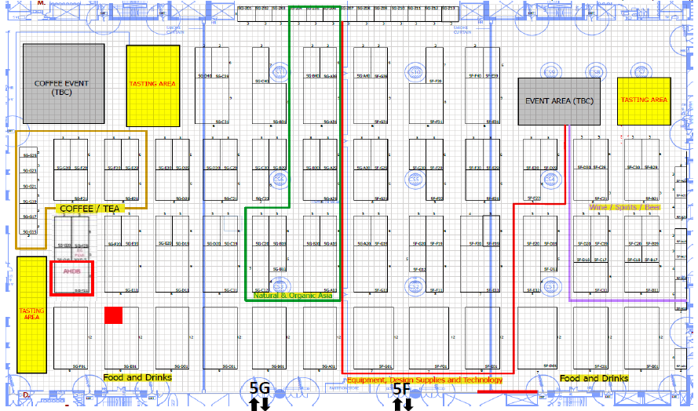

The AHDB stand measures 6m x 6m, a total floor-space of 36sqm and is open on 3 sides. The maximum stand build height in the Hall is TBC.

The stand will be shared equally between AHDB meat (Beef, Pork & Lamb) and AHDB Dairy.

Requirements include a shared networking space, shared lockable storage room and clear designated areas for both meat and dairy branding.

We also require a high-level banner / lampshade to clearly distinguish who we are, which can be seen from a distance and draw people to our stand.

All lighting should be low heat creating.

4. Stand Build Requirements

The stand needs to have the following elements and provisions.

- All electrics, (including 24 hrs electric for refrigeration units)
- Hot and cold water supplies
- Waste-water disposal
- Cleaning of the stand each evening
- Access to the internet, so provision of Wi-Fi
- Security
- TV

Refrigeration units need to be in place and must be operational by the morning of Monday 4th September ready to receive all edible consumables.

Kitchen/Storeroom
This is a shared space and needs to include. s

- Lockable door
- One small hand basin with hot and cold water for hand washing
- Countertop work services for food preparation, shelving
- 1 x H3A fridge underneath the counter (Lowe refrigeration or equivalent) for drinks – 24 hour power
- Wall shelving for literature storage
- Additional double electrical socket
- Coat hooks / rack
- Coffee machine – to provide coffee and tea services
- Space for storing luggage/valuables/laptops etc.
- Power for recharging mobile/cell phones (UK adaptors)
- Water dispenser with hot and cold water.
- Cleaning equipment
  - Hand sanitiser for each table/reception desk
  - Box of disposable latex gloves
  - Box of disposable masks
  - Cloths and teatowels for cleaning the surfaces
  - Cleaning fluids for washing equipment
  - Anti-bacterial spray
  - Waste bins and bags
  - Soap for handwashing

Dairy Networking Area:

- 1 x A1 Lowe (or equivalent) display chiller with display grass with 24 hour power
- Chiller wrap
- Welcome/ reception desk with lockage storage underneath and graphic to the front
- 2x2m space for a VR device equipment with poseur table
- Bin
- Literature rack
- Electrical sockets for charging items

Meat Networking Area:

- 1 x A1 Lowe (or equivalent) display chiller with display grass with 24 hour power
- Chiller wrap
- Welcome/ reception desk with lockage storage underneath and graphic to the front
- Bin
- Literature rack
- Electrical sockets for charging items

Other

- Shared networking area of multiples of low tables with 4 chairs each to provide meeting points. Please note the number of tables and chairs is dependent on visitors being able to walk around the stand freely and without obstruction.
- Down lighting above graphic walls
- Flooring to be wood effect padded vinyl
- TV screen mounted on stand wall

Maintenance of Stand

Maintenance, upkeep and cleaning of the stand shall be carried out daily by the successful supplier during the duration as well as prior to the start of the Exhibition. This is to include, but not limited to the below requirements:

- The cleaning of floors throughout the stand
- The cleaning of furniture including tables, chairs and work surfaces
- Emptying of bins

Hospitality package

Please provide a price for supplying the following hospitality package for the entire show:-

- Pods for coffee machine
- UHT milk
- Tea bags
- Sugar sachets
- Stirring sticks
- Water for cooler
- Cups for water, tea, coffee
- Soft drinks e.g coke, sprite
- Refuge sacks – for bins

5. Stand Management

A member of the successful supplier’s team shall be nominated and must be available during the duration of the Exhibition covering construction and dismantling of the stand, and capable of dealing with any eventuality. A nominated deputy must be available during any absence of such person. AHDB would require names of who will be in attendance.

AHDB will nominate a “Stand Manager” who will be the key contact for the successful supplier for the full duration of this project.

6. Graphics

AHDB will provide full and print ready artwork for all graphics. Please include print deadline in your response

Top level branding (lampshade / banner) needs to be seen from a distance in all directions and draw people to our stand – see Appendix.

There will need to be dedicated walls/panels for AHDB Meat and Dairy and ideally these will be either lightboxes or if walls have surrounding lights.

AHDB graphic panels

The theme will be based on Great British beef, lamb and pork and dairy using landscape images with live animals and food images.

Our key message “Quality Meat from Britain” and “Quality Dairy” – will need to be shown in a prominent position.

Our USP is based around a quality product and so graphics design needs to reinforce this message.

7. Stand Layout & Design

The visuals below illustrate previous stands of a similar size effectively combining multiple elements i.e. info counter, cookery/sampling area, store/kitchen. Note that GREAT branding and graphic panel styles shown have been updated, ensuring you refer to Section 9 and the appendix when considering your design.

We would also be open to lightboxes on the stand to help draw people into the stand – whether these have rolling images to help engage visitors or static images – this is open to interpretation.
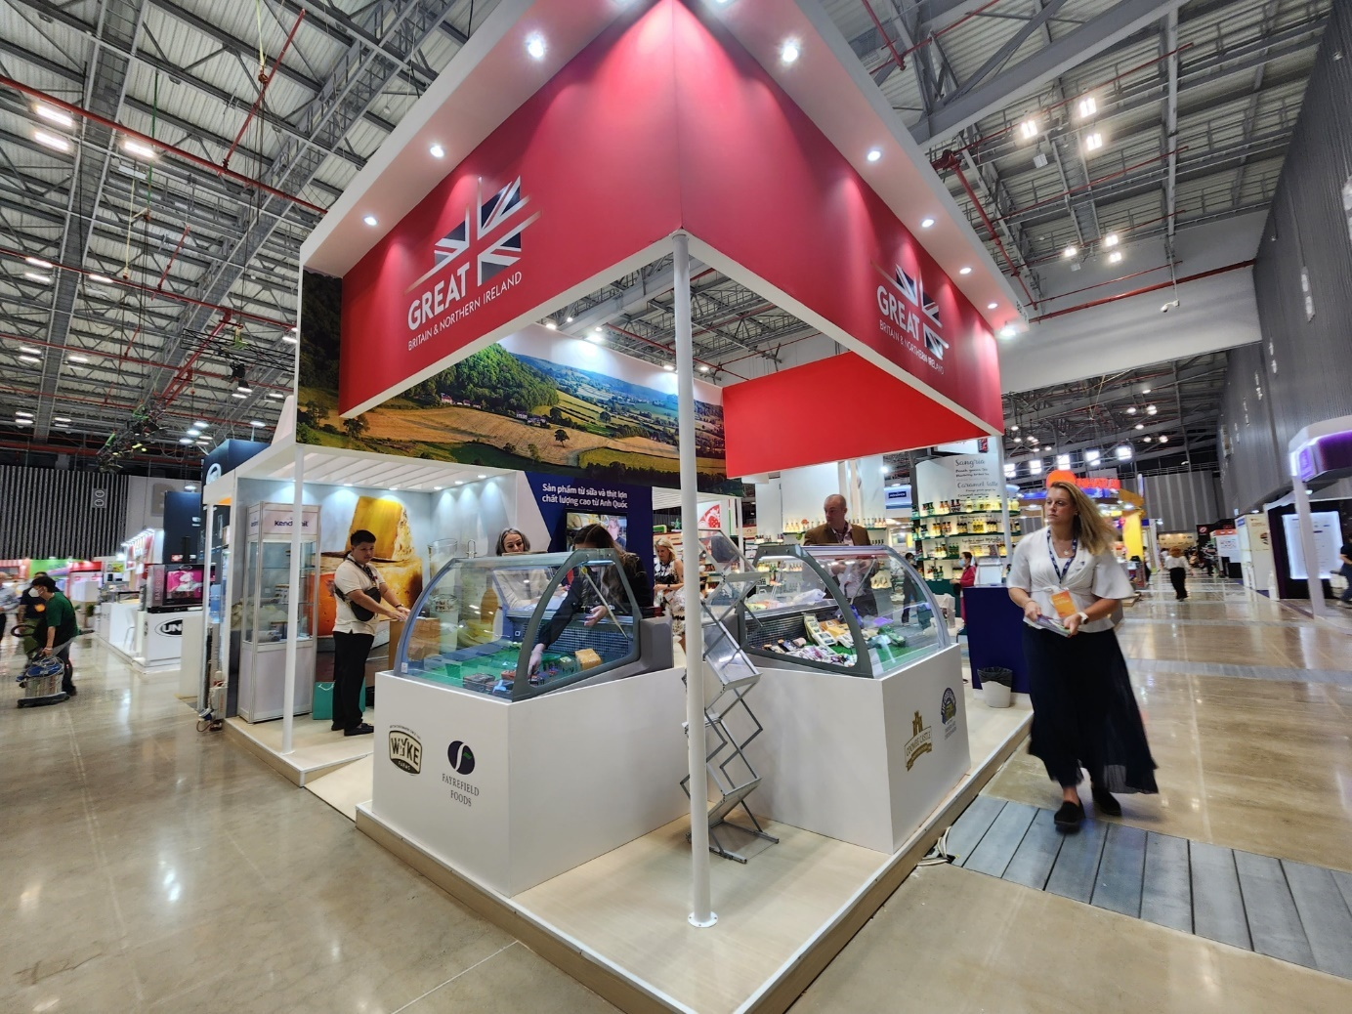

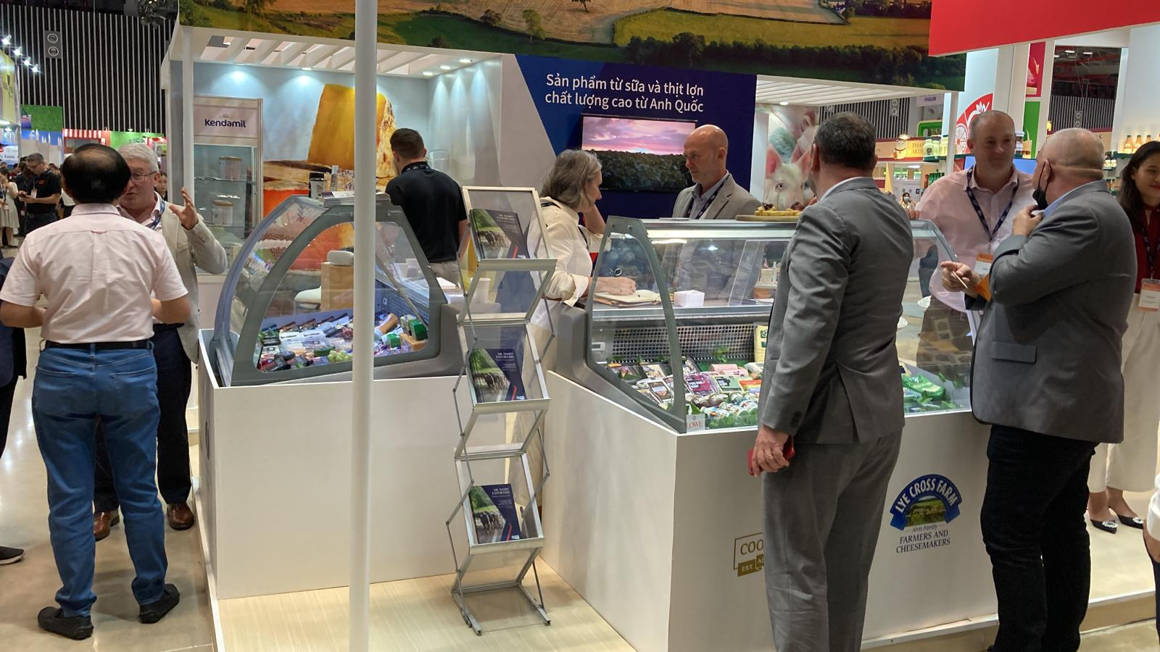

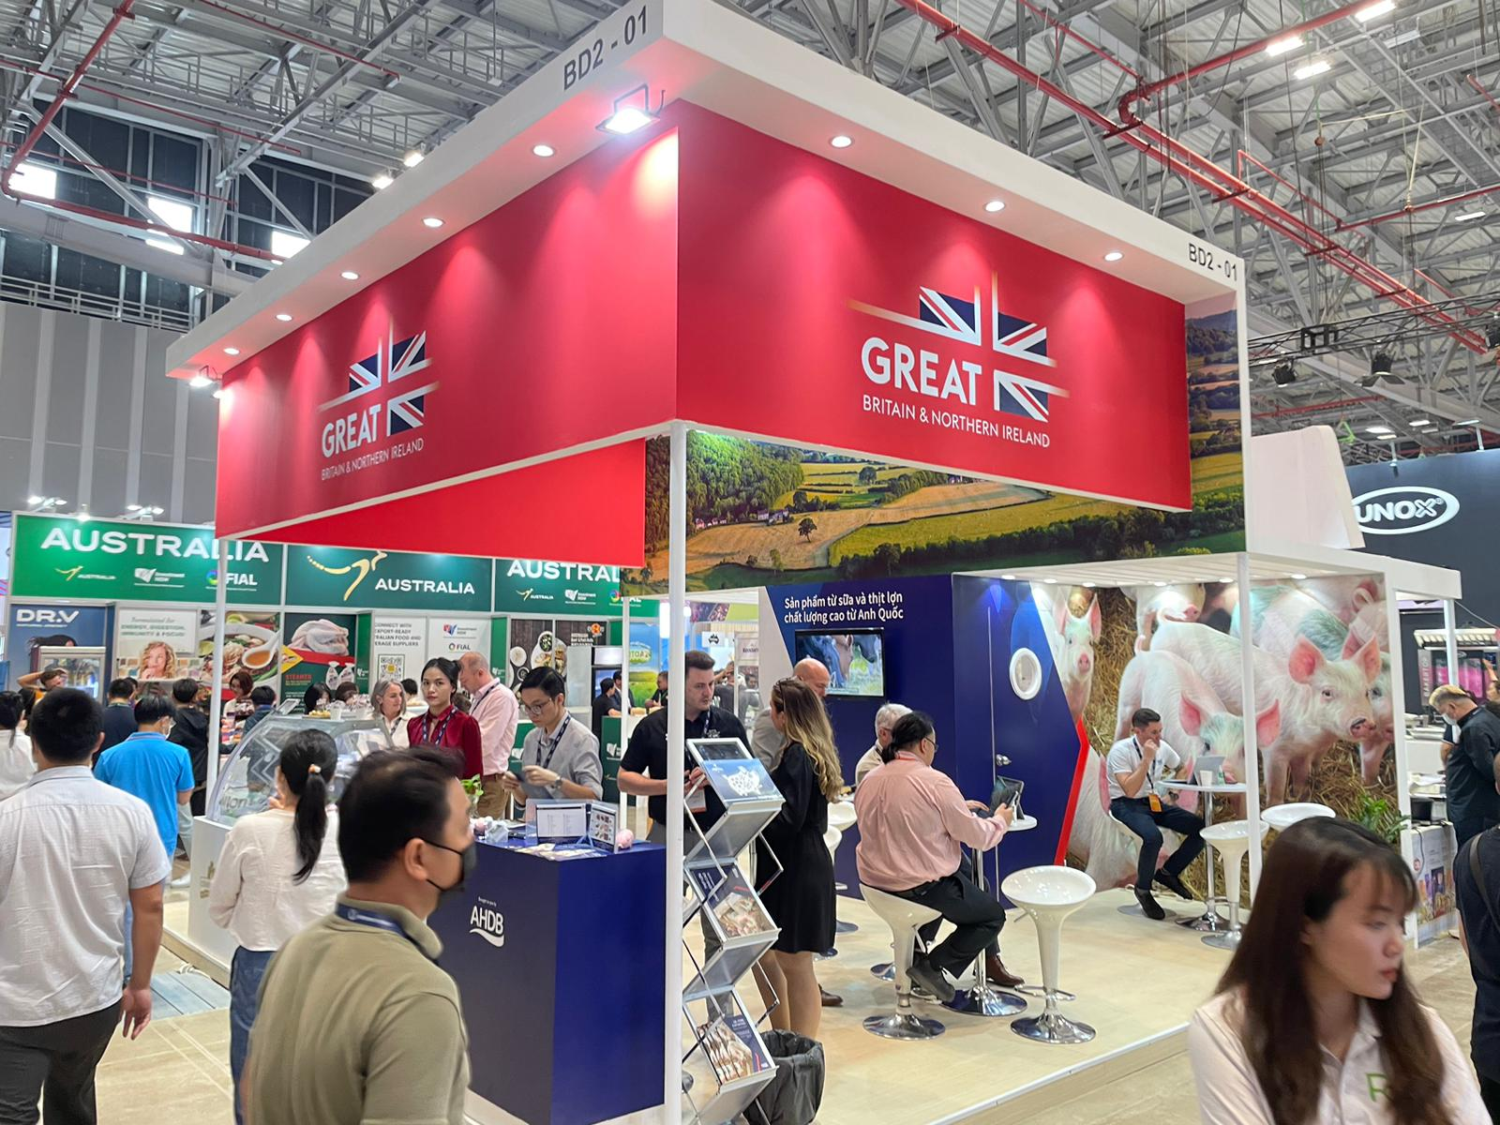

9. Useful information

Structural Height Restriction
In Hall 5G, 4.5.0m (14.7 ft) will be the absolute maximum height allowed and approved. (except perimeter booth)

All stands, irrespective of height must have at least half of any frontage facing an aisle left open or fitted with transparent (clear see-through) material to be underside of the fascia. This area must be left visibly free of obstruction. Each side of the exhibition stand should not be obstructed for more than 3 meters continuously.

Booth design with hanging banner or hanging structure will have to pay advertising fee per sqm of surface area

Stand build dates
The contractor will be responsible for completion and submission of organisers forms relating to the design and construction of the stand, including organiser design approval. A login for the exhibitor portal will be provided after the contract is awarded, and a copy of the exhibitor manual sent electronically.

GREAT Branding
AHDB have agreed the following overarching principles for use of the GREAT brand at international events.

- Where the stand design does not incorporate a lampshade, AHDB will design a column or back wall which mirrors the agreed logo and brand hierarchy with GREAT as the primary brand.

- In this instance the GREAT header fascia must be clearly separated from the AHDB panels. Ideally there should be a physical gap no less than the same dimension as the height of the header fascia.

- Where this is not achievable the GREAT header fascia must be a definite different colour. If the AHDB background colour is blue, then the GREAT header must be white (or vice versa).

- The use of the GREAT Union Jack can be used within the AHDB stand design as a low- level way finder

- The use of product imagery is a key feature on AHDB stands but must not include a superimposed GREAT logo or be close to a GREAT logo.
The only permissible messaging referencing British produce within AHDB branded panels is as follows:
Quality Meat from Britain

It is possible to use implied messaging, particularly in images, where the prominence of ‘Britain’ and the provenance of the food is more ‘loudly’ stated.

- The Union jack can only be used in the following places (only one option per stand):
  - On a header panel, with the GREAT logo, with a clearly separate design to our panels
  - A small bus stop sign in an aisle (a separate panel)
  - On the front of a counter (when none of the above options are possible)

Branding hierarchy:

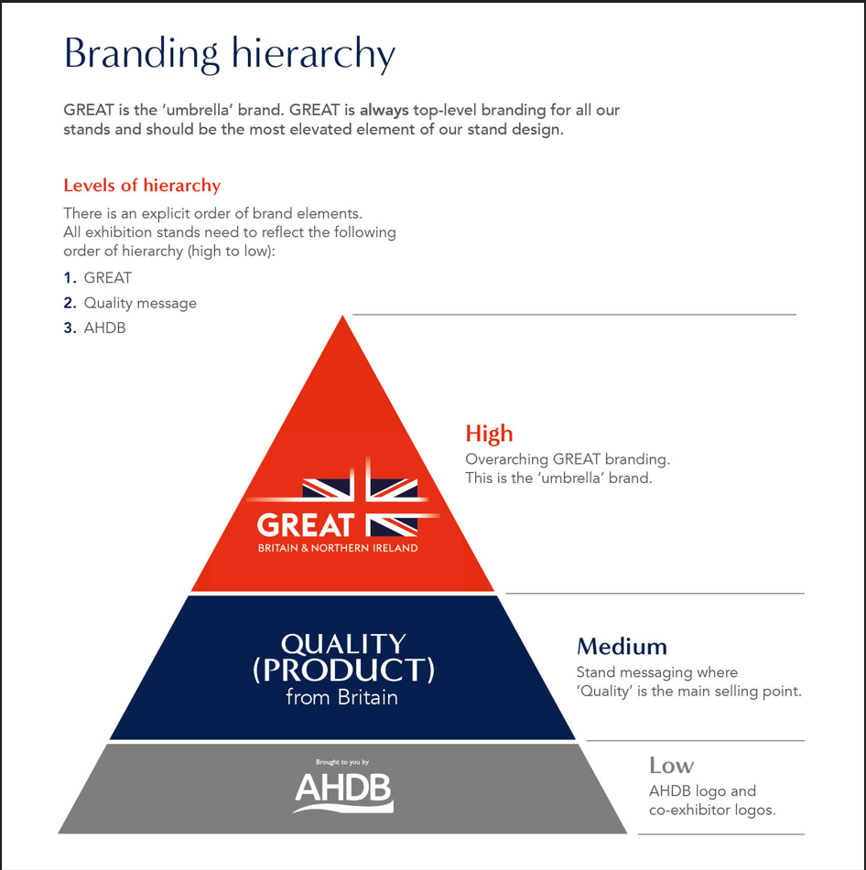

10. Tender Process

The contractor shall deliver the whole of the services, complete in all parts and furnished with every necessary detail, notwithstanding any omission or inconsistency in the specification.

The quote should include ‘to scale’ visuals of your design and be clearly itemised for all services and provision as stated in this document; where possible split by area (cooking area, storeroom, partner areas etc.) stating if any sub-contractors will be used; graphic dimensions and artwork deadline.

Except as otherwise stipulated in the specific conditions of service required, the contract shall remain at the fixed price and rates shall not be revised.

AHDB’s Event Manager can order reasonable additions to or reduce from the service specified. These amendments shall be requested in writing and agreed by both parties.

11. Budget

Our budget for the stand build which is to include graphic production is £32,000.00 GBP inc. VAT

12. Evaluation of Tenders

Your quote should include:

- “To-scale” visuals of your stand design
- Breakdown of all costs
- Note any parts that you are not able to deliver
- Graphic dimensions and artwork deadline

Our award criteria are:

- Understanding of the brief 20%
- Ability to deliver the brief cost effectively (itemised quote required covering all elements discussed in the brief) 25%
- Design, creative impression and equipment 40%
- Ability to meet event timelines, build-up and break-down 15%

Please email your design proposals to Sammy Bowen claire.sayers-smith@ ahdb.org.uk by 29th June 2023

13. Payment Terms

Please note that all invoices submitted to AHDB require a purchase order number to enter onto our payment system. Our payment terms are 30 days from receipt of the invoice.

