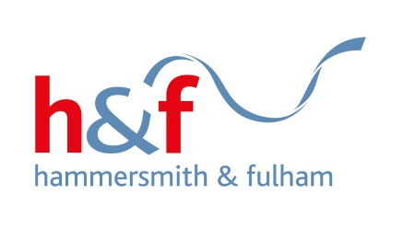

Market Engagement Event
The Hammersmith & Fulham Council Rough Sleeping/Single Homeless Services
10-12pm - 11th July 2019.
Hammersmith Town Hall, King Street, W6 0LJ, Courtyard Room (ground floor)

Background

Hammersmith & Fulham Council (the council) is passionate about ending rough sleeping and we don’t believe any one should have to sleep rough. In 2017-18, an independent Rough Sleeping Commission reviewed local services and produced a set of recommendations to help the council deliver our policy objective of zero rough sleeping in the borough. We are working with our partners, residents and other stakeholders to implement the recommendations.

https://www.lbhf.gov.uk/sites/default/files/section_attachments/171212_hascsi_pac_report_ending_rough_sleeping_in_hammersmith_and_fulham.pdf

Local Services
We have some excellent local services providing a range of innovative and good quality services to homeless people. These services have contributed to there being relatively low numbers of people counted as rough sleeping in the borough; however, we are not complacent, and we recognise we have to continuously work with our partners and members of the public to prevent rough sleeping and respond quickly and effectively to find lasting solutions to rough sleeping.

Market Opportunity
A number of contracts providing key services to prevent rough sleeping and meet the needs of homeless people are expiring in 2020. We will be tendering for a range of services including:

- Supported housing services
- Street Outreach
- Housing First
- Homeless health

If you share our ambition to end rough sleeping and are interested in delivering innovative, excellent services please come to this event to learn more about these services; the tender timetable and procurement methods.

Please let Vivien Mcknight at Vivien.mcknight@lbhf.gov.uk know if you will be attending. Places limited to two people per organisation. We look forward to meeting you.

