# **Department for Transport’s Procurement and Contract portal**

# **SUPPLIER GUIDANCE - User Accounts and Access**

**I would like to register to the Department for Transports Procurement and Contract portal, but I don’t know how?**

You will need to register your company on the portal called **JAGGAER**.

[**https://dft.app.jaggaer.com/web/login.html**](https://dft.app.jaggaer.com/web/login.html)

**I have forgotten my password and username how should I access my account?**

You can do this by clicking *I cannot access my account* on the homepage*.* If you remember your username or email address, provide that and verify. You will be able to receive the password reset link on the email address provided at the time of registration.

There is a guidance document which can assist you in recovering username or reset your password

Recovering Username and Password

**I have registered to the portal but I am still unable to access my account.**

Your account probably hasn’t been activated by the esourcing team which is why you are unable to gain access to the portal.

OR

If you have created a Duplicate account for this organisation it will be blocked. You can be added to the Active account by the Primary user of that account or JAGGAER can also add you.

**How can I create additional users?**

In order to create a New User, first click on Manager Users then navigate to the first tab *Users* then click *Create* in the top right corner.

You will then need to complete a short form with the additional users’ details – ensure you enter a correct email and a suitable username. Click *Save*, the new user will then receive an automated email containing their temporary password.

If you assign a role within the previous form you will not be required to follow the remaining steps to assign user rights. If you have not assigned a role you need to manually assign User rights to the new user account – click on *View User Rights* in the next screen click *Edit* in the right top corner - choose from the drop-downs the user rights and then click on *Save*.

**How can I change the details of my organisation?**

Can you please email ([Contracts@mcga.gov.uk](mailto:(Contracts@mcga.gov.uk))) us from the primary account holder’s email so we can change the organisation name, update email address. For more changes you can get in touch with JAGGAER and they will be able to make changes to the details.

Jaggaer helpdesk [help_uk@jaggaer.com](mailto:help_uk@jaggaer.com)

Tel 0800 0698630

You will be able to change these details: address of your organisation, phone /fax number, Email, Website, Registration/VAT Number.

You will need to do this by clicking on to your profile *User Profile* then click *Manage your Profile*. Within Registration Data tab click Edit and to change details and then click *Save*.

Esourcing team can edit the suppliers company name i.e. by loading the supplier account details into the Supplier Console, selecting Registration Data and then Edit.

**Can I please get in touch with the procurement department, I would like to discuss the service my organisation provides?**

All the Tenders over £10,000 are advertised on Contract Finder and any OJEU threshold events are advertised on Tenders Electronic Daily (TED. You can access the CF and TED Websites through the portal). The contact details of the buying organisation will be identified within the advert or contact [Contracts@mcga.gov.uk](mailto:Contracts@mcga.gov.uk).

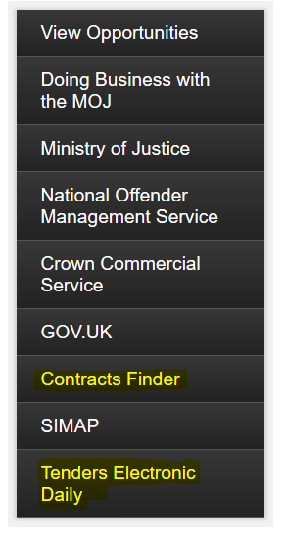

**I want to delete a user from the account, how can I do that?**

No, you will be unable to delete a user from your account, you can only change the access rights of any additional user.

Go to *User Profile, Manage Users* click on the user you wish to edit the details of, under *Detail tab* click *User Rights* and change the rights as desired.

# **SUPPLIER – PQQ/ITTs**

**I don’t seem to be getting any PQQ/ITTs open to all suppliers, why is that?**

You will not receive any notification for any event, if you are a registered supplier than Go to Home Page, On the left-hand side click ITT Open to All Suppliers and then you will be able to see all the events published.

You will only get a notification if the Buyer has invited you to a specific PQQ/ITT.

It may also be the case of access rights, if you are an additional user then you will need to contact the Primary user and ask them to give you access rights to the PQQ/ITTs.

**Can Suppliers Still Access PQQ / ITT Attachments after the Closing Date?**

Yes. Supplier visible attachments remain available to suppliers.

**How am I able to contact the buyer if I am on the PQQ/ITT?**

You can do this by sending a message through the portal. Within any PQQ/ITT there is a Messaging section. Select *Messages* and *Create Message*.

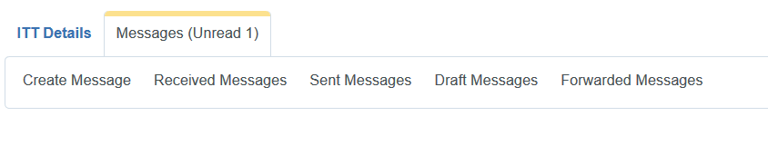**When I send a message to the Buyer can I also add attachments to it?**

1. Select the event where you need to contact the buyer(s). In the **Message tab** select *Create Message*
2. This will take you to the message window, include a subject title, add the message for the buyer in *Message.* *Select Attachments* to add a file to the message - Select Files to upload
3. Choose the file you wish to attach and select “Open”. Add relevant comments and File Description then click *Confirm.*

**I am responding to a tender and in one of the responses I have to attach multiple documents, but the system is only allowing me to attach a single document. How should I go about it?**

You can attach multiple documents by adding all your Files to a Compressed Zip Folder and then attach that folder as a single file.

**How can I download the PQQ /ITT questions?**

To download PQQ/ITT questions click on the 3 dots (…) then from the drop-down menu select Export/import Response. Choose Download and then click to Open the file.

**We have received an email saying that the ITT has been awarded, can you please tell us if ithas been awarded to us or not?**

If the email does not specify that you have been awarded the ITT then you must wait as it may still be pending an approval. Once confirmed you will be sent a message if you are successful or not. Any outcome will be sent through Message on the portal.

**How do I submit a response on an PQQ/ITT?**

Open the specific PQQ/ITT to respond, under *Detail tab* go to *‘My Response’* then select ‘*Create Response’*.

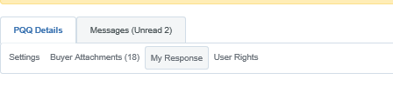 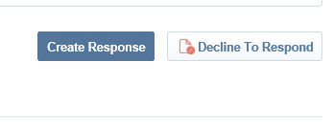

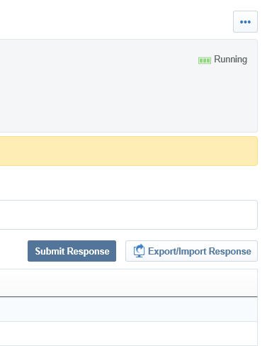

**An ITT has been published on Contracts Finder but if I go via the DfT portal I am unable to see ITT in Open to all Suppliers?**

If you are not the primary user for this account and you have restricted rights assigned to you then maybe that’s why you are unable to view the ITTs.

OR

This ITT is not Running currently.

**We are no longer bidding for this tender. How do I remove this from my portal area to stop receiving messages?**

**Delete Response**

If the answer has not been submitted, you may delete their responses at any time before an PQQ/ITT’s closing date and time. If the answer has been submitted, you may delete their responses only during the first round of sealed ITT.

To delete your response, suppliers can navigate to PQQ/ITT Details > My Response and click the Delete Response option in the More […] menu.

Once confirmed, all of your previous responses will be deleted. You are returned to the My Response page, where you have the options to Create Response or Decline to Respond.

**Withdraw Response**

After deleting a response, you have the option to withdraw from the RFx. To withdraw from the ITT, navigate to ITT Details > My Response and click Decline to Respond.

Suppliers that have withdrawn from the ITT can still submit responses any time before the ITT closing date and time. To return to the RFx response creation process, suppliers can navigate to ITT Details > My Response and click Undo Decline.

**Step-by-Step**

If you would like to withdraw from the ITT, you must delete all responses entered previously, then proceed with the following:

1. Navigate to the ITT.

2. From the My Response page, click the ... dropdown button and select Decline to Respond.

3. Enter a reason and confirm the action. The system will notify the buyer of the withdrawal.

You can still submit responses at any time until ITT Closing date. To do so, use the Undo Decline feature on the My Response page.

*\*If that does not work then please give the JAGGAER Helpdesk a call on: 0800 069 8630 and they will be able to assist.*

**I have finished my response and uploaded all the attachments, but the system is not letting me submit it/not giving me an option to submit, what should I do?**

Make sure you have answered all the mandatory questions.

*OR*

Try and use a different Browser, you can use Internet Explorer, Firefox or Google Chrome.

**We have submitted a bid for a tender, the status states responded but we still have not been notified if we are the winners?**

You need to send a message through the portal within that ITT and someone will respond to the question.