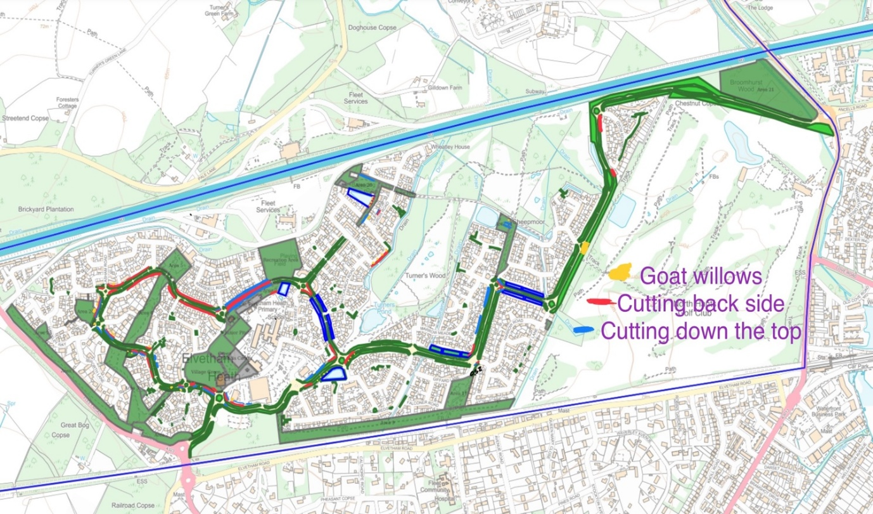

Map A – cutting back overgrown shrubs, self-seeded trees and hedges and disposing of green waste

