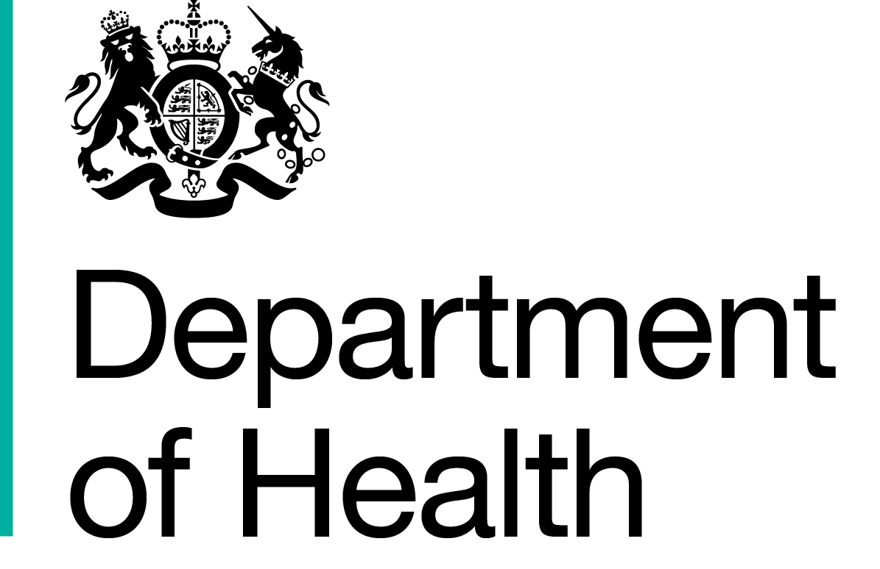

Commercial Medicines Unit (CMU)
Medicines, Pharmacy & Industry
2 Floor
Rutland House
Runcorn
WA7 2ES

www.dh.gov.uk

All messages regarding the
Offer documentation should be sent via the Bravosolution Website

[Recipient’s Name]  [Position, company]  [First address line]  [Second address line]  [Town/city Postcode] |  | 1 February 2017
Dear Sir/Madam

Proposed framework agreement for NHS Pharmaceuticals 2017_1
Offer reference number: CM/PHG/15/5490
Period of framework agreement: The total maximum duration of the framework agreement to be no more than 28 months
Potential periods of call-offs under the framework agreement:

North West & Eastern & North London: 01/05/2017 to 31/01/2018 (9 months)
South East & South London 01/05/2017 to 31/10/2017 (6 months)
& North East & Yorkshire:
Central & South West: 01/05/2017 to 30/06/2018 (14 months)

Notification of framework agreement award decision

Thank you for submitting an offer in respect of the above procurement exercise. The evaluation of the offers in relation to the procurement exercise has now been completed by the Commercial Medicines Unit on behalf of the Secretary of State for Health acting as part of the Crown (‘Authority’).

I regret to inform you that your offer dated 13 December 2016 has been unsuccessful.

The Public Contracts Regulations 2015 (the ‘Regulations’) apply to the evaluation of offers submitted by Offerors to participate in this framework agreement. As notices of this nature are being sent to all Offerors today by electronic means the Authority must provide for a mandatory minimum 10 day standstill period, before concluding the framework agreement. In accordance with the Regulations we will not conclude the framework agreement with the successful Offeror(s) before midnight on 13 February 2017.

This letter constitutes notice under Regulation 86 of the Regulations. Accordingly we attach certain information on the award decision for this procurement exercise, this notification comprises the following enclosures (if any of these are missing please contact us immediately via the Bravosolution messaging portal)

- This covering letter
- Parties appointed to the framework agreement (Appendix 1)
- Award criteria and debrief explanation
- Award debrief

We would like to thank you for the time and effort spent in submitting your offer and assure you that the fact that you have been unsuccessful on this occasion will not affect your participation in any other procurement exercise with the Authority.

Yours sincerely

Marie Thompson

Marie Thompson
Procurement Specialist

