# External remedial works at Sandford Lock house, Sandford Lock, Sandford-on-Thames, Oxford, OX4 4YD

## General

Allow for access as considered appropriate to the terrain, access to the property and tasks to be undertaken.

Contractor is to fully allow for removing and disposing of debris arising from works.

## External Remedial Works

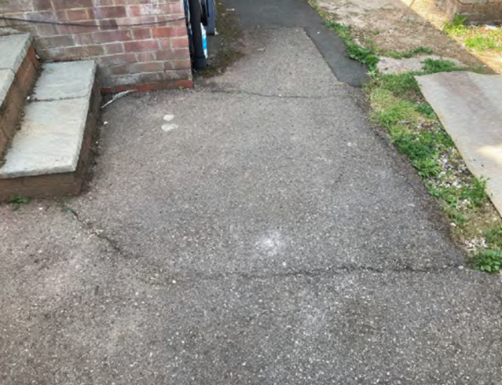

Breakout existing macadam footpath and base, where not previously repaired, to the full width of the footpath to the rear elevation. Compact and consolidate the sub-soil, lay new base with new macadam surface finish. Levels are to match the adjacent hardstanding's. Allow a provisional area of 15m2.

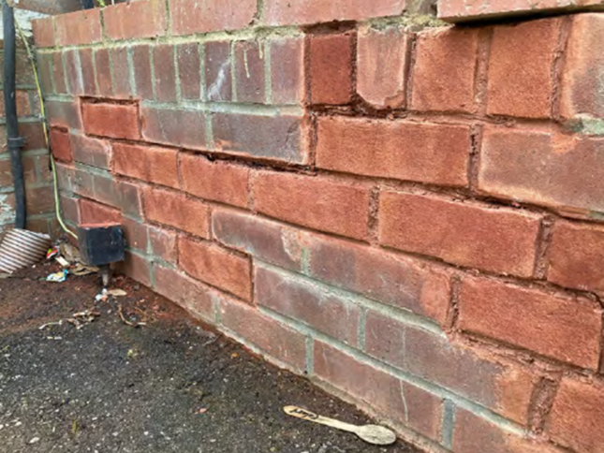

To the steps serving the rear door, supply and install new tubular aluminium balustrade with vertical uprights at centres less than 100mm. Balustrade to incorporate tubular aluminium handrail. Balustrade and handrail to be suitably fixed, and include all fixings and accessories. Submit proposals with the quotation. Allow for additional repairs to the steps. Rebuild brickwork to the side of the external stairs.