DOCUMENT TWO

PRELIMINARIES ANDSPECIFICATION
FOR
SUPPLY AND INSTALLATION OF STREET FURNITURE

Introduction
The Borough of Oadby and Wigston lies immediately to the south of the City of Leicester between the districts of Blaby and Harborough.

Wigston, at the heart of the Borough, is the largest of our three towns, serving some 32,000 residents and is the largest town in the Leicester conurbation.

The town centre forms an “L Shape”, with pedestrianised Bell Street forming the main shopping area for larger stores and Leicester Road/Long Street forming a more independent/smaller business area. Leicester Road contains a small Arcade area, with a mix of small units and a large anchor store with a pedestrian through route to a large shoppers’ car park.

As part of the UK Shared Prosperity Fund (UKSPF) a project has been established to replace and install new street furniture throughout Wigston town centre. This will be to make the area more visually appealing to visitors and give better facilities for the public.

Although some of the street furniture was replaced in 2014 along Bell Street, the Borough Council would like to replace this with something brighter and easy to maintain. At the same time, some of the street furniture that is removed will be refurbished as part of this tender and installed on Leicester Road, as there is a distinct lack of useful street furniture in this area.

An indicative design for new street furniture has been decided by Councillors and installation locations have been agreed in consultation with Councillors and Council Officers.

Pedestrian access to the area is available 24 hours a day.

This tender is for the supply and installation of new street furniture as detailed in the specification. The tenderer is free to suggest supplier so long as the supplier can match as closely as possible the indicative designs shown in the specification. The specification also includes the removal and refurbishment of existing street furniture and re-installation in new locations.

PRELIMINARIES

GENERAL

The successful ‘Contractor’ (which includes any sub-contractors) will enter into a contract with Oadby & Wigston Borough Council (hereafter referred to as the ‘Client’).

- The work is for the careful removal and making good of existing street furniture and the supply and installation of new street furniture as detailed in the specification.

- The successful Contractor must provide to the Client evidence of:

  - Public liability insurance of no less than £5 million,
  - Employers Liability Insurance and
  - Evidence of street works accreditation

- If the length of the works dictate that CDM regulations apply then, for the purposes of the Construction (Design and Management) Regulations 2015 and to comply with Health and Safety legislation, the appointed contractor will be required to undertake and fulfil the duties of the CDM Co-ordinator as part of the conditions of the contract. This should be allowed for within the tender price.

- Prior to any work commencing on site method statements, risk assessments and health and safety policies shall be provided to the Client by the Contractor.

- Working hours are to be restricted to the hours of 08:00 to 18:00 from Monday to Friday and 08:00 to 13:00 on Saturdays. No work may be carried out on Sundays, Bank Holidays or at any other time without the agreement in writing of the supervising officer.

- A competent foreman / charge hand must be present on site during working hours and should possess copies of the specification and be fully briefed on the scope and nature of the contract.

- It is the responsibility of the Contractor to ensure the safety of members of the public in the vicinity of the works, particularly with regard to the security of the area and movement of plant and equipment in and around it.

- The Contractor shall fence off the working site(s) and clearly display information / warning / hazard signs. On completion of the contract any temporary fencing and / or signage shall be removed and any damage to land made good at the Contractor’s expense.

- The Contractor shall arrange for the safe storage of materials whilst on site. A temporary storage unit MAY be allowed subject to the written approval of the Client.

- If required, the Contractor may provide and maintain a portable shelter for the protection of his workforce by prior agreement with the supervising officer. Location of any such container(s) must be agreed with the Client in advance.

- The Contractor shall at all times keep carriageways, footpaths and driveways useable and clear of materials, plant and equipment etc. Do not block private driveways or garages at any time.

The Contractor shall clear and cart away dirt, rubbish and superfluous materials as the work proceeds and shall leave the whole works and the land adjoining in a clean and orderly condition upon completion.

- The Contractor shall be responsible for liaison with the statutory undertakers concerned for the location of and provision of services. The contractor will need to make his own arrangements for mains water and power; there is no mains water or power available at the installation sites.

- The Contractor shall not allow the use of radios or other audio equipment or permit employees to use in ways or at times that may cause a nuisance.

- The Contractor will be required to attend a pre-start meeting with the Client prior to the commencement of any works. A minimum of one weeks’ notice must be given to the Client before work starts on site.

- The Client will make regular visits to site to review and monitor progress.

- Contractor’s name boards or other advertisements are not permitted on site.

INSPECTIONS DEFECTS & WARRANTIES

A defects liability period will apply for twelve months following completion of the works and any defects shall be rectified by the contractor at his own expense. This is separate from any warranties.

Warranties for the street furniture will be for a minimum of 12 months.

Manufacturers and contractors’ warranties, and guarantees shall be provided to the Client on all items of street furniture and labour.

Where appropriate, the Contractor is to provide maintenance information to the Client for all street furniture installed.

SPECIFICATION

GENERAL

- The Contractor will include within his price all issues raised in the Preliminaries set out above.

REMOVAL

- The Contractor’s price is to include the removal of all street furniture listed in the specification, including refurbishment of all benches/planters and preparation of the site for the installation of new street furniture.

- All removed street furniture that is not to be refurbished is to be taken by the Contractor to the Client’s Depot at Wigston Road, Oadby Leicester LE2 5JE.

DESIGN

- Supply and install concrete/marble seating and planters, with wood/wood effect recycled plastic. Supply and install stainless steel bins, cycle racks and directional signage. Supply and install recycled plastic bollards and grit bins all as specified in the table below.

- The photographs used in the table below are indicative of the style the Client is aiming to achieve but are not prescriptive.

- The design must NOT include:
- any traditional style benches/planters.

- The tenderer is free to obtain furniture from any supplier so long as it is of a consistent design and colour/shade unless stated otherwise within the specification.

INSTALLATION TIMETABLE

- No work is to take place during the Christmas lights Switch-On (Saturday 30th November). The Client will advise the successful contractor of dates as soon as these are known.

- All work is to be completed on site by Friday 28th February 2025 at the latest.

SUSTAINABILITY

- The tenderer should take sustainability into consideration in the choice of street furniture.

- Recycled plastic is preferred to wood.

- If wood is used in any item it should be from sustainable sources.

ON-GOING MAINTENANCE

- Items supplied should be as low maintenance as possible.

- A maintenance schedule should be supplied as part of the submission (see Question 4 of Document Three).

WARRANTIES, GUARANTEES AND SPARES

- Details of any warranties and/or guarantees should be supplied in response to Question 5 of Document Three.

MISCELLANEOUS

- Payment will be on completion of the works however, the successful tenderer may discuss stage payments with the Client if required.

Schedule:

Existing street furniture: | Ref: | Item:
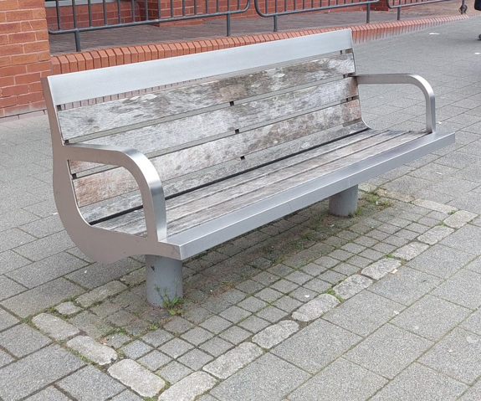 | 1.1 | Remove 12 no. existing benches currently installed in Bell Street.
 | 1.2 | Refurbish the 12 benches that have been removed.
 | 1.3 | Re-install 7 of the 12 refurbished benches on Leicester Road, Wigston
 | 1.4 | Return the remaining 5 re-furbished benches to Oadby Depot, Wigston Road, Oadby LE2 5JE for future use by the Client.
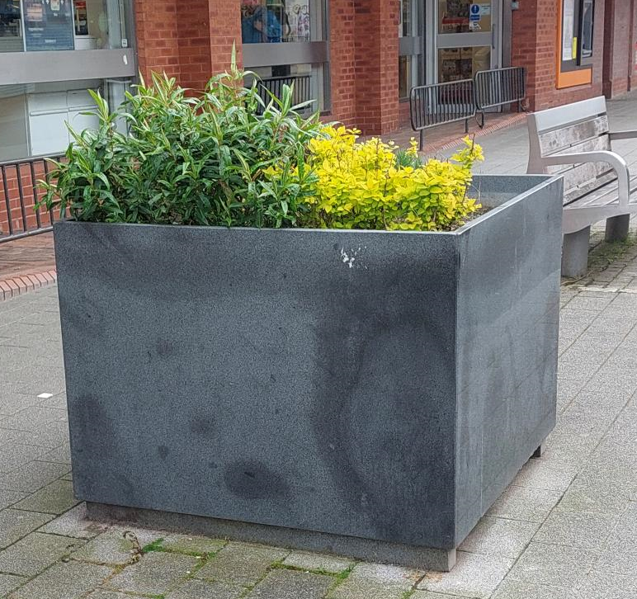 | 2.1 | Remove 7 existing planters from Bell Street and make ground good to match existing surface.
 | 2.2 | Re-install the 7 removed planters throughout town centre at locations to be specified by Client.
 | 3.1 | Remove 4 x big black bins and return to the Client’s Depot at Wigston Road Oadby Leicester LE2 5JE
 | 3.2 | Make ground good to match existing surface.
 | 4.1 | Remove 10 existing concrete bollards (see also 9.1 and 9.2)
 | 4.2 | Dispose of removed bollards to licenced tip off site (see alsob9.1 and 9.2)
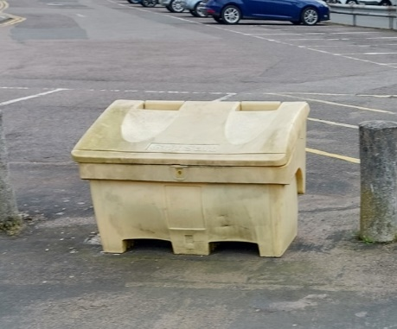 | 5.1 | Remove 2 existing yellow grit bins (see also 15.1 and 15.2 below)
 | 5.2 | Dispose of removed grit bins to licenced tip off site (see also 15.1 and 15.2 below).
New street furniture: | Ref: | Item:
. 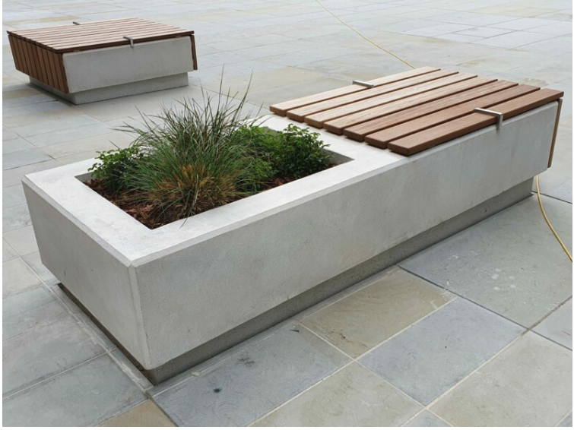 | 6.1 | Supply 8 x Benches with planters attached (concrete/marble base with wood / wood effect / recycled plastic seating). Approx 2m to 2.4m in length.
 | 6.2 | Install 8 x benches and make good surrounding ground to match existing surface.
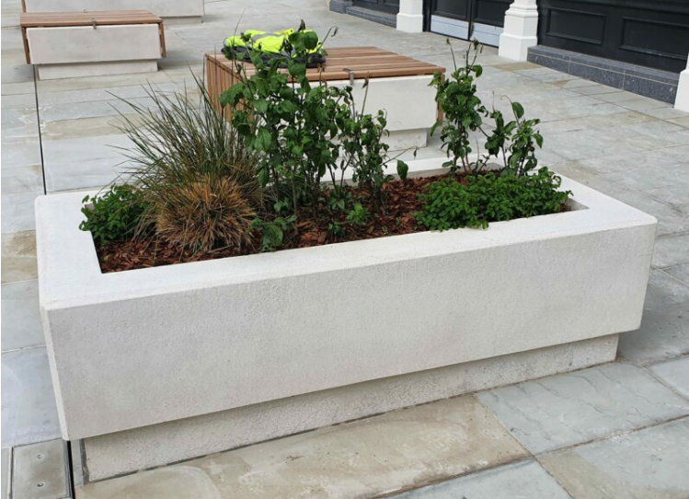 | 7.1 | Supply 3 x planters (concrete/marble base) Approx 2m to 2.4m in length if rectangular or 1m x 1m approx. if square. Including liners as required.
 | 7.2 | Install planters and make good surrounding ground to match existing surface.
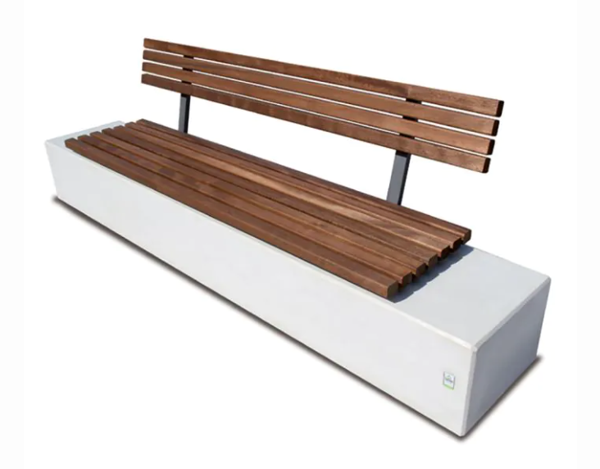 | 8.1 | Supply 5 x benches (concrete/marble base with wood / wood effect / recycled plastic seating) Length approx. 2m
 | 8.2 | Install benches and make good surrounding ground to match existing surface.
 | 8.3 | 1 x longer bench with integrated planter to match bench at 7.1 above (concrete/marble base with wood / wood effect / recycled plastic seating)
 | 8.4 | Install combined long bench/planter and make good surrounding ground to match existing surface.
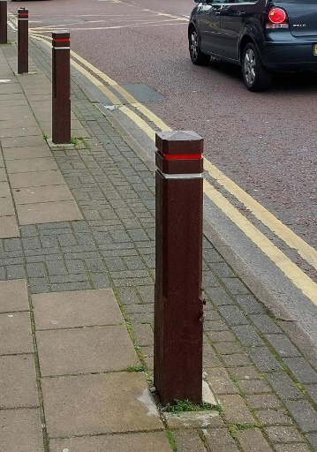 | 9.1 | Supply 10 x Recycled plastic bollards to match existing (see also 4.1 and 4.2)
 | 9.2 | Install bollards and make good surrounding ground to match existing surface. (see also 4.1 and 4.2)
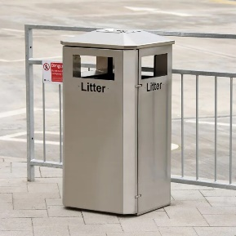 | 10.1 | Supply 9 x 120 litre stainless steel ‘Derby’ litter bin  - With pyramid top  - No ash tray  - Bolt down fixing  Supplier – to be obtained from Broxap Ltd.
 | 10.2 | Install 9 x 120 litre bins at locations agreed with Client and make good surrounding ground to match existing surface.
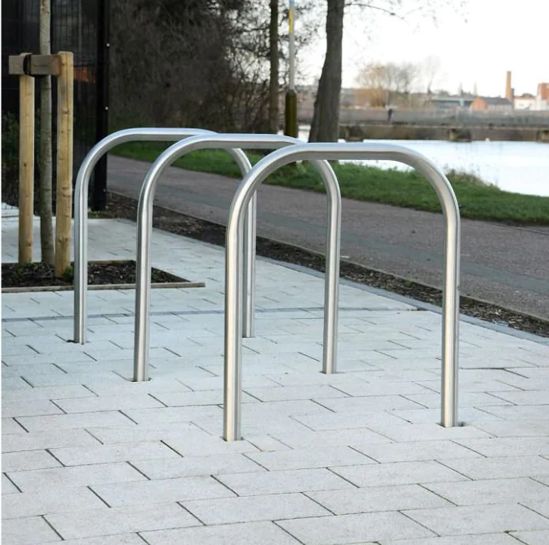 | 11.1 | Supply 8 x stainless steel cycle rack hoops similar to picture.
 | 11.2 | Install 8 x cycle rack hoops at locations specified by Client and make good surrounding ground to match existing surface.
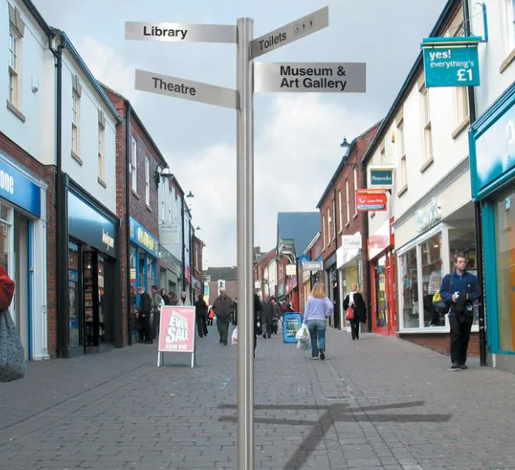 | 12.1 | Supply 4 x stainless steel, non traditional, finger posts with four ‘fingers’ to each post. Including collars.
 | 12.2 | Allowance for text on figure posts  (text to be agreed with Client post award of contract. Proofs will be required by Client for sign off before production begins).
 | 12.3 | Installation of 4 x finger posts in locations to be agreed with Client and make good surrounding ground to match existing surface.
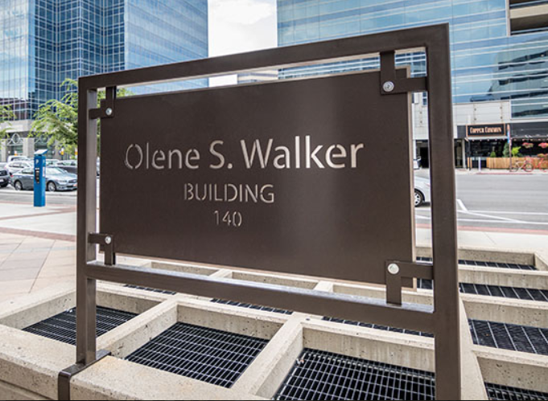 | 13.1 | Supply 2 x Bespoke welcome signs similar in design to the photograph saying ‘Welcome to Wigston’
 | 13.2 | Install 2 x ‘Welcome to Wigston’ signs at locations agreed with Client and make good surrounding ground to match existing surface.
 | 14.1 | Supply large individual steel letters up to 1.5m high each to read: WIGSTON
 | 14.2 | Install ‘WIGSTON’ letters at location to be agreed with Client and make good surrounding ground to match existing surface.
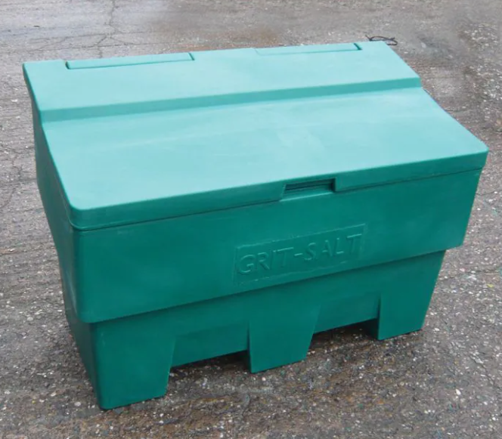 | 15.1 | Supply 2 x green 285 litre recycled plastic grit bins as per specification.
 | 15.2 | Install 2 x grit bins at locations to replace the grit bins removed (see 5.1 and 5.2 above) and make good surrounding ground to match existing surface.
Any additional costs are to be included in the pricing schedule in Document Three

