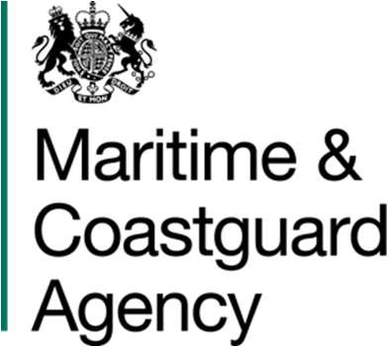Corporate Procurement Maritime and Coastguard Agency

Bay 3/19, Spring Place 105 Commercial Road, Southampton

SO15 1EG

[Contracts@mcga.gov.uk](mailto:Contracts@mcga.gov.uk)

[www.gov.uk/mca](http://www.gov.uk/mca) Ref: TCA 3/7/1264

22nd April 2025

REDACTED

HASKONINGDHV UK LIMITED

Westpoint Peterborough Business Park Lynch Wood

Bretton Peterborough PE3 8DW

Dear REDACTED

# MASTS AND TOWERS MANAGEMENT CONTRACT CONTRACT EXTENSION

Appendix – Haskoning Proposal

On behalf of the Secretary of State for Transport, acting through the Maritime and Coastguard Agency, I accept your proposal “Extension of the Masts and Towers Management Contract, reference TCA 3/7/1264”, your reference PC3476-RHD-XX-XX-PS-S-0001, dated 2nd March 2025.

The Firm Price for this extension is £56,635.60 excluding Value Added Tax. The price breakdown from your proposal is included overleaf for reference:



[REDACTED]

The new expiry date for this contract is 31st March 2026.

This letter and the original Award Letter constitute a binding contract between yourselves and the Maritime and Coastguard Agency and will be subject to the same terms and conditions as the contract awarded on 5th May 2022.

Please acknowledge receipt of this letter and acceptance of the contract extension by signing through the Jaggaer Portal Docusign system.

Invoices should be addressed as below and submitted via email. Please ensure all invoices have been approved by the Contract Manager and include a valid PO number. The MCA pays undisputed invoices 30 days in arrears:

DfT Shared Service Centre Unity Business Services Sandringham Park Swansea Vale

Swansea, Wales SA7 0EA

# [SSa.invoice@Ubusinessservices.co.uk](mailto:SSa.invoice@Ubusinessservices.co.uk)

Please acknowledge receipt of this letter and contact the Contract Manager, [REDACTED]

[([REDACTED]),](mailto:(Thomas.Ogg@mcga.gov.uk) to discuss arrangements for the commencement of the Contract extension.

Yours sincerely

[REDACTED]

Senior Procurement and Contracts Business Partner by authority of the Secretary of State for Transport