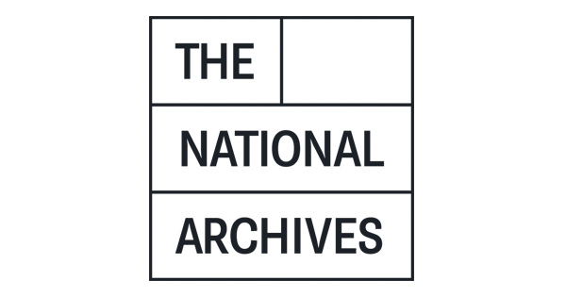

**THE NATIONAL ARCHIVES**

**OCCUPATIONAL HEALTH AND**

**EMPLOYEE ASSITANCE SERVICES**

**Additional document – current services**

The information below is based on our current annual requirements, as contracted with our current supplier.

**OCCUPATIONAL HEALTH SERVICES**

|  |  |  |  |  |
| --- | --- | --- | --- | --- |
| **Service type** | **Further description** | **Delivered by** | **Approx number of uses per annum** | **Column blank (for your unit price)** |
| Pre-Appointment Assessment | On line or paper based assessment which provides automatic clearance for the Contracting Authorities Personnel, with no onward referral for further assessments | Occupational Health Advisor | 80 |  |
| Occupational Health Assessment |  | Occupational Health Advisor (Nurse or Doctor) | 10 |  |
| Neurodiverse Assessment (Diagnosis) |  | Occupational Health Advisor | 2 but is increasing |  |
| Neurodiverse Assessment (Workplace) |  | Occupational Health Advisor | 2 but is increasing |  |
| **The services below are** **not currently provided to TNA, but we may want to introduce them in future. Prices are for information only.** | | | | |
| Pre-employment medical | For roles that have a requirement for the candidate to be physically fit as it involves lifting and carrying including some items over 10kg (lifting aids are provided) | Occupational Health Advisor |  |  |
| Regular medicals | For roles that have a requirement for the candidate to be physically fit as it involves lifting and carrying including some items over 10kg (lifting aids are provided) | Occupational Health Advisor |  |  |
| On-site Occupational Health Assessment clinics |  | Occupational Health Advisor/Nurse/  Doctor |  |  |