ITT for Kresen Kernow Design, Supply and Installation of Archive Shelving Equipment

Project organogram and programme

- Project organogram
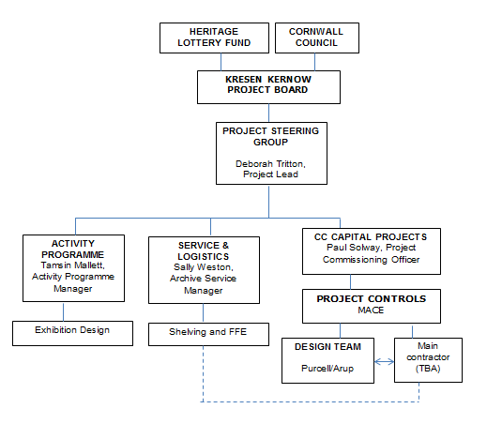
- Programme

A draft programme showing the key main build milestones is given below but it should be noted that this is indicative only and subject to change.

Kresen Kernow Building Design Client sign-off | 20 April 2016
Shelving Design Deadline | 31 July 2016
Main contractor procurement through OJEU | 4 May 2016 - 21 September 2016
Construction period | 22 September 2016 – 22 March 2018
Shelving Installation and Commissioning Deadline | 22 March 2018
Client decant and occupation | 22 March 2018 – 19 September 2018
Kresen Kernow opening | October 2018

