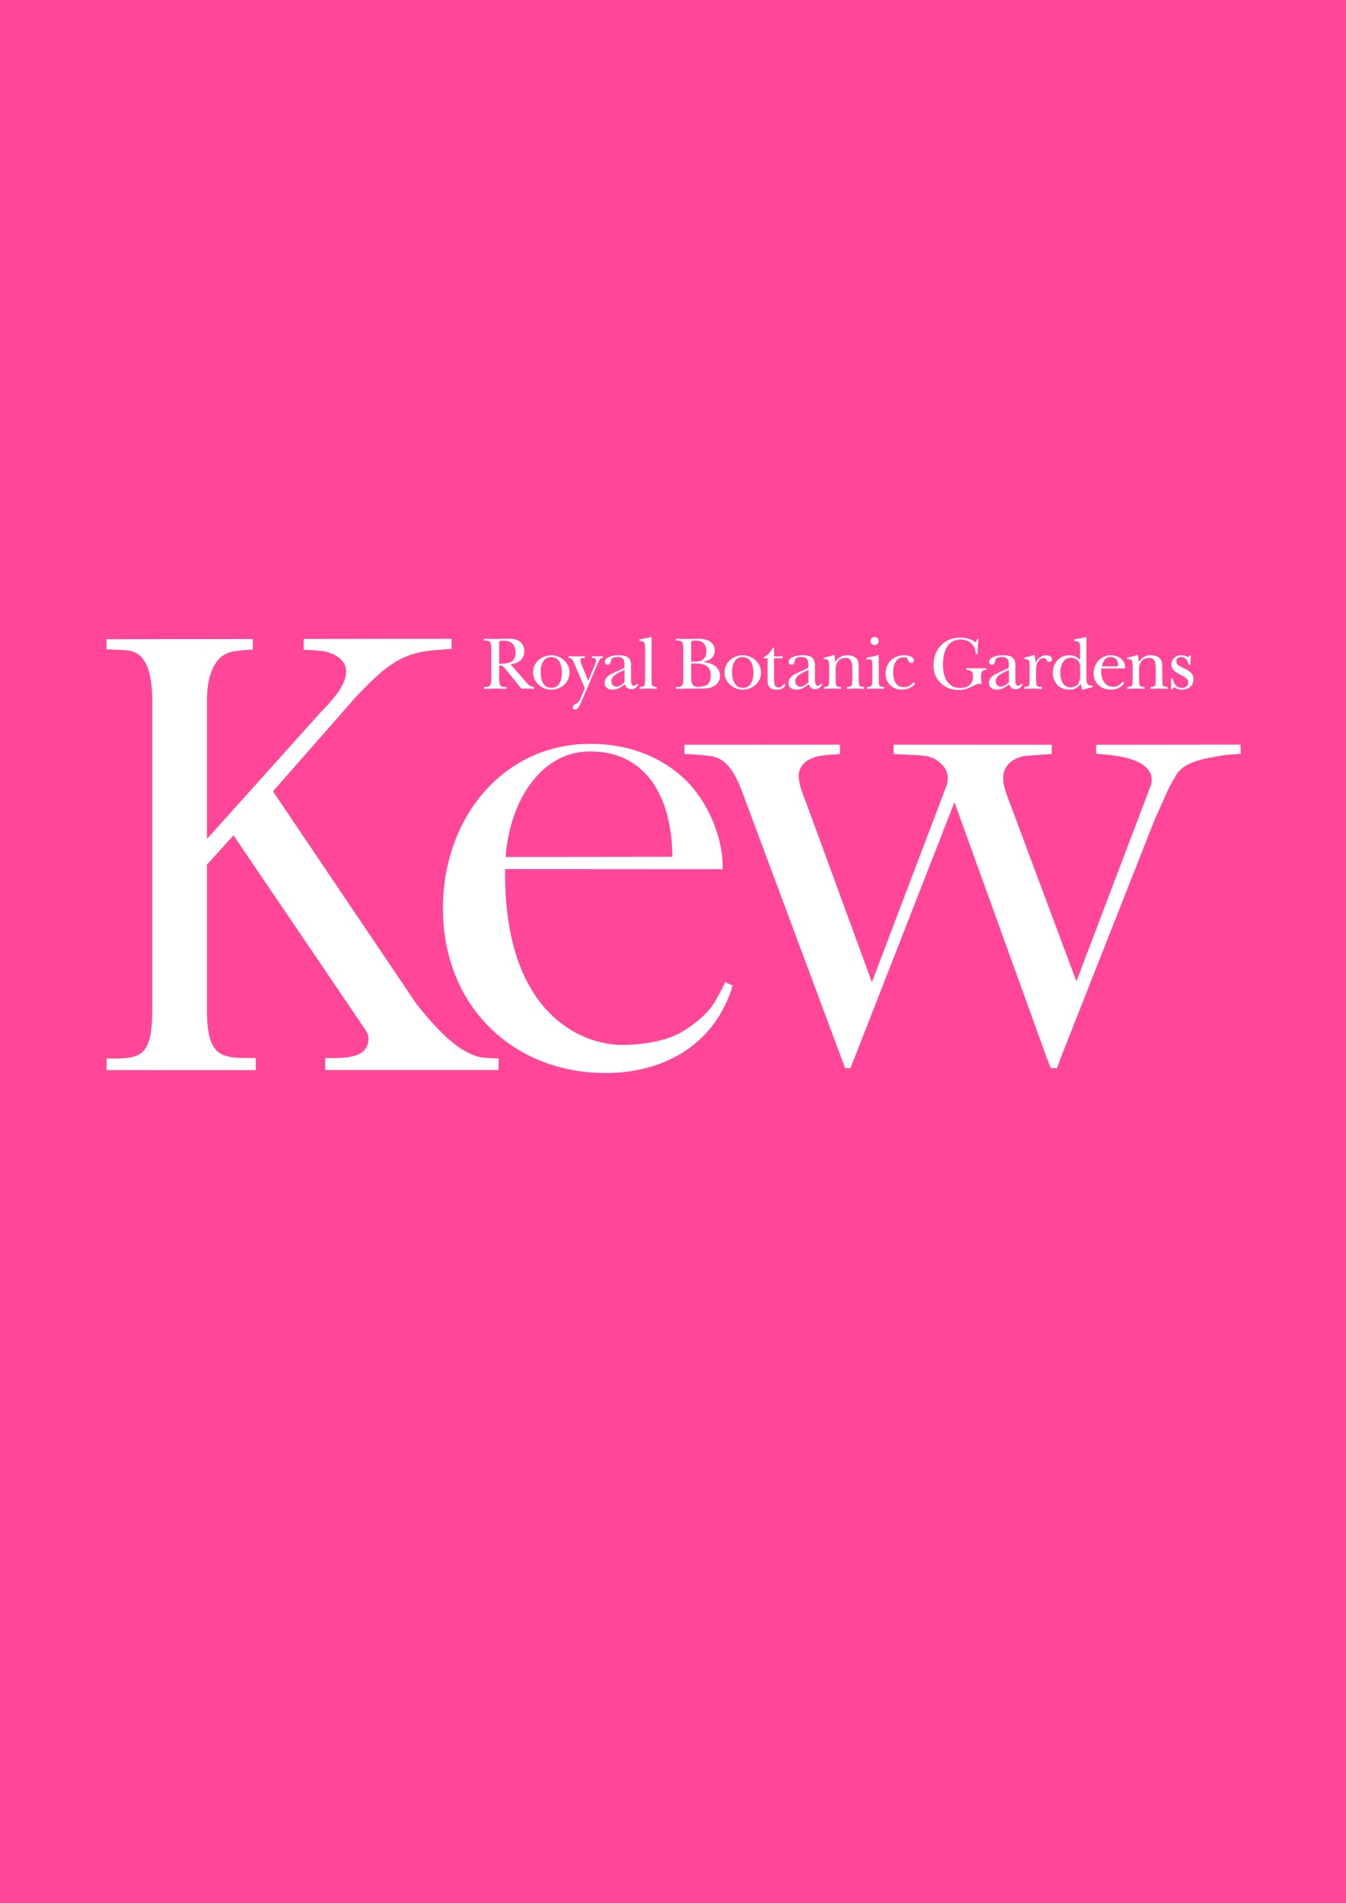
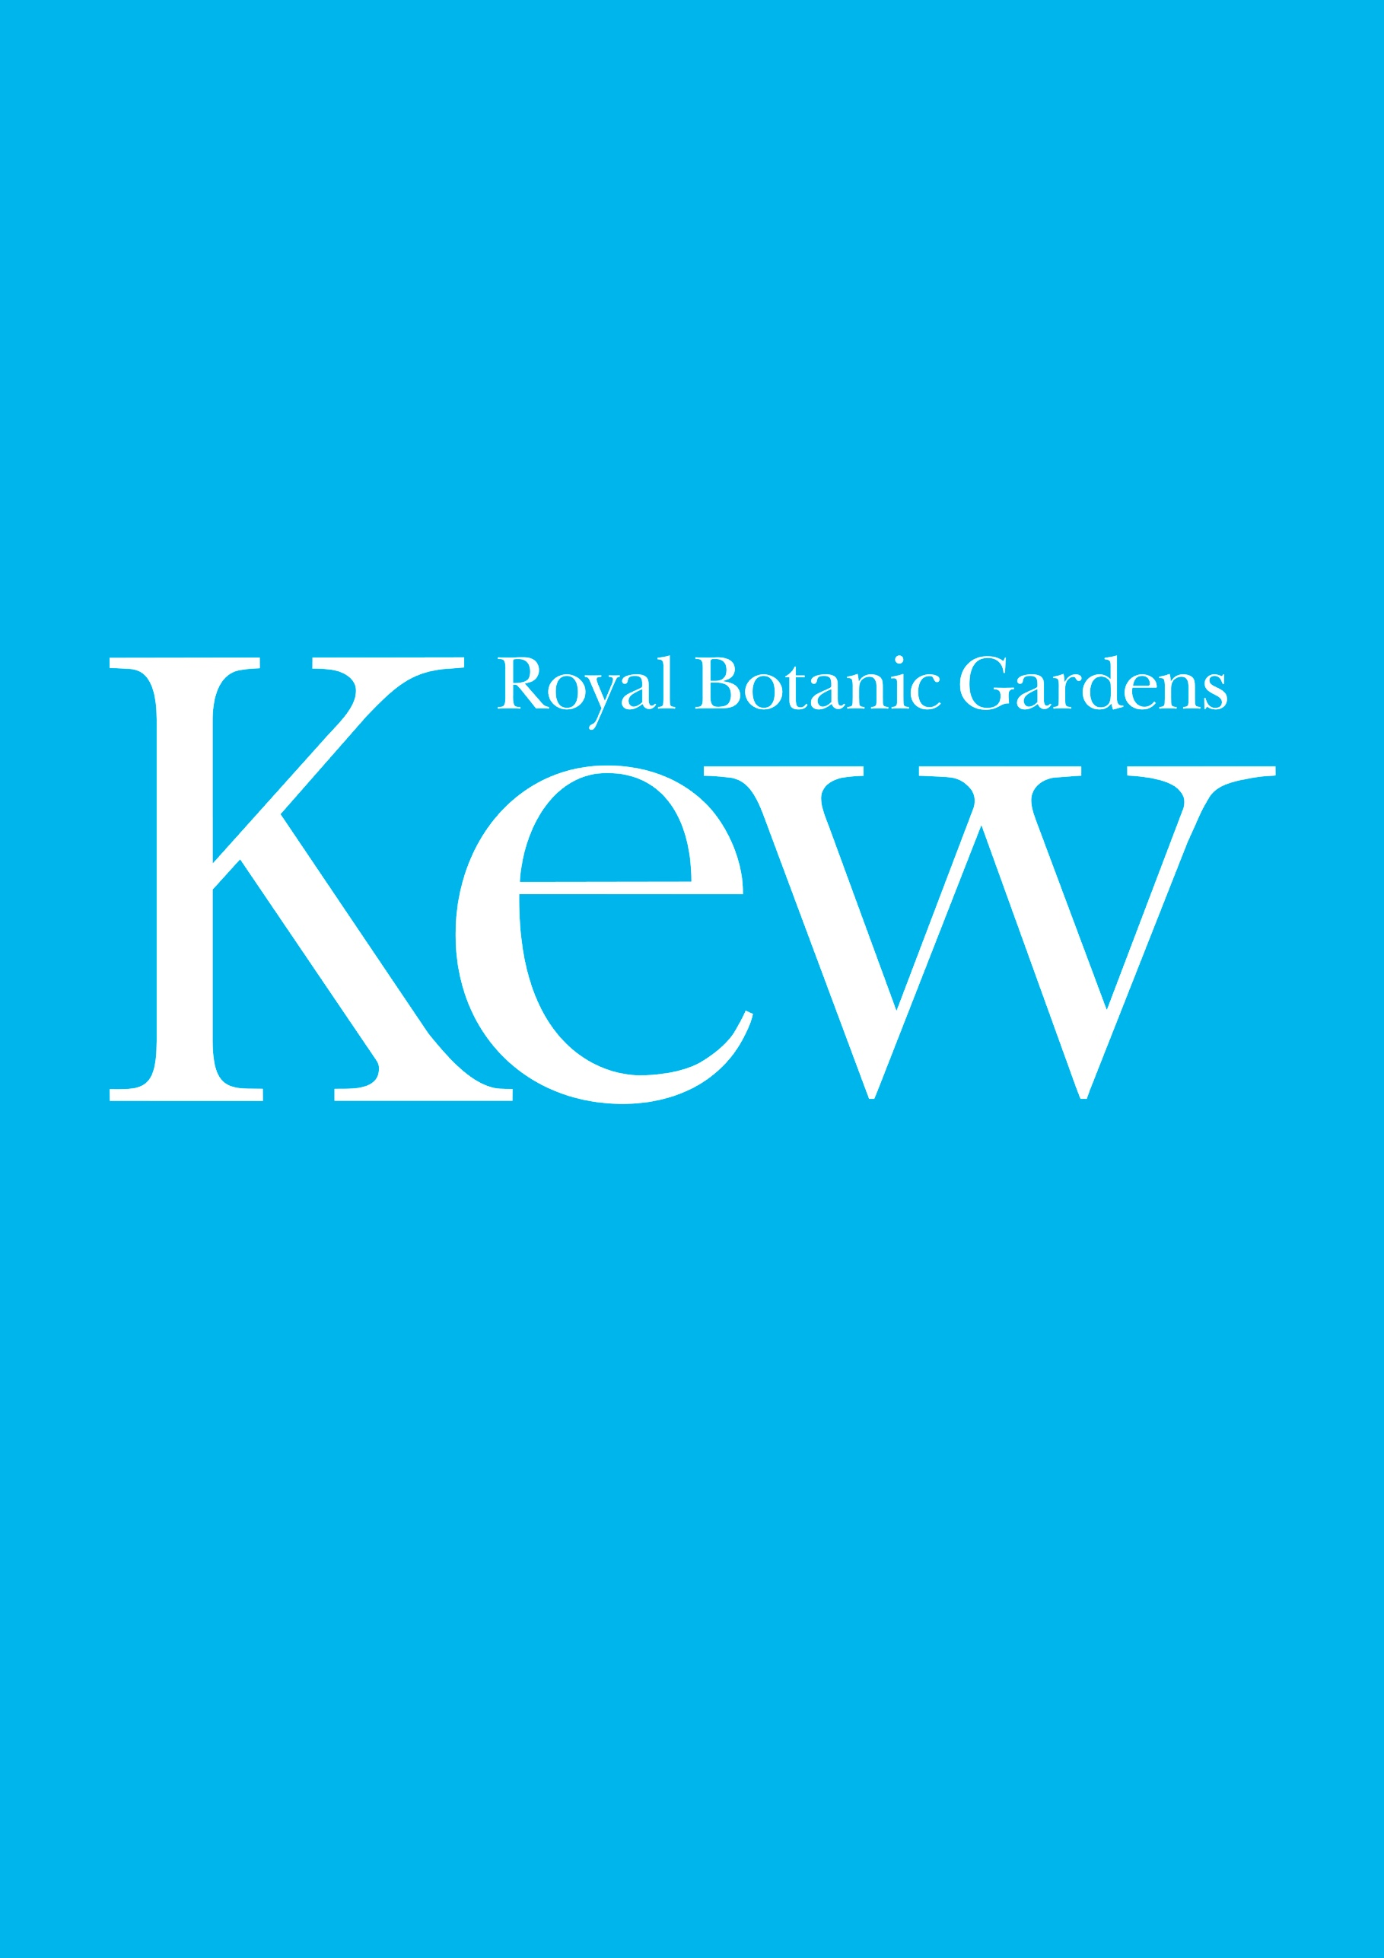

This document is for information.

Japan 2021 – Horticultural Installation
Part 2 – Specification
RBGKEW/929

Royal Botanic Gardens, Kew
Royal Botanic Gardens, Kew is a world-leading plant science institute with top class Botanic Gardens, enjoyed by a wide range of people. We are a modern, vibrant, welcoming, and bold organisation which inspires a love of plants, nature and care for the environment. Our mission is to build an understanding of plants and fungi and contribute to solving some of the most critical challenges facing humanity today.

In 2019 Kew received 2.3 million visitors, up 23% on the previous year. This placed Kew among the most visited attractions in London and demonstrates our extraordinary connection with audiences.
Our Visitor Programmes and Exhibitions team curates and produces a varied programme of festivals, exhibitions and events across the year creating exciting connections with Kew Science, Horticulture and history. We work closely with artists, horticulturists, creative practitioners and external partners to animate the Gardens for all our visitors, and we are passionate about the opportunities our site holds for unique and unexpected artistic response.

Japan Festival
This autumn we launch a new addition to our visitor programme - a contemporary festival celebrating Japan through its distinctive culture and connection to nature. We will celebrate Japan through distinct cultural programming and spectacular horticultural displays.

The festival will provide a ‘must-see’ reason to visit Kew in October and will feature a wide range of Japanese cultural programming. There will also be four After Hours events, providing an opportunity for visitors to experience the festival in the evening.
Festival themes include:
- Celebrating Kew’s existing relationship with Japan
- Japanese culture is fascinating
- The importance of the natural world in Japan
As part of the festival, Kew is working closely with the Japanese Embassy and Japan House, and has undertaken focus groups with members of the Japanese community in London to sense-check the authenticity of programming ideas.
Location: The Temperate House
The festival hub will be Kew’s iconic Temperate House, a Grade I Listed building and the largest surviving Victorian glasshouse in the world. It is home to 10,000 plants from five continents and contains some of the world’s rarest and most threatened species. The Temperate House was voted Best UK National Treasure at the 2018 National Geographic Traveler Magazine Reader Awards.
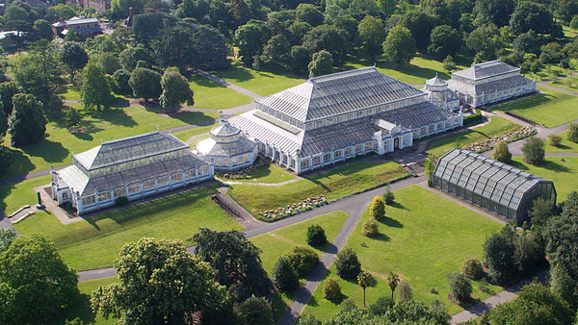
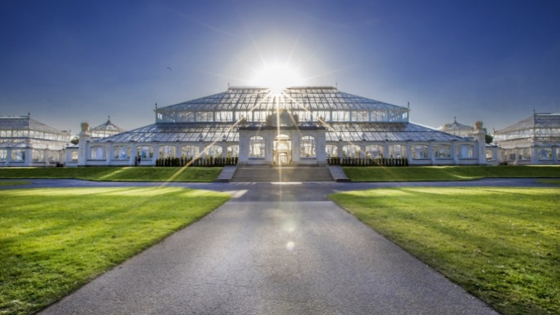
Festival Dates
Festival dates: Sat 2 - Sun 31 October 2021

Installation dates: Space available from Mon 13 September 2021 – installation should take place as close to the festival start date as possible.

Derig dates: From Mon 1 November 2021 - derig should take place as close to the festival end date as possible.

Please note that the installation of the Horticultural Installation in the north Octagon will coincide with the installation of a large-scale artwork in the centre block of the Temperate House, as well as other horticultural displays in the south Octagon.

Kew (including the Temperate House) is open as a visitor attraction 7 days a week and is unable to close completely to the public during the install and derig. However, necessary arrangements can be made to secure the working area and amend routes during opening hours.

Horticultural Installation Brief

We are seeking a proposal for an indoor Horticultural Installation which celebrates Japanese plants, showcases horticultural excellence and features an innvovative planting design to create a moment of wonder for our visitors.

This is an amazing opportunity to create a new Horticultural Installation which will be located in the north Octagon of the Temperate House and seen by many thousands of visitors. The installation should utilise the architectural height and scale of the space, offering a stunning spectacle for visitors.

Please note that we are not looking for an RHS-style show garden. We would like a contemporary response to a Japanese garden, which should be artistic and beautiful. Please avoid the use of cliches such as stepping stones, torii, Japanese-style gates and bridges, etc,.
Essential criteria
The Horticultural Installation must:
- Showcase Japanese plants*
- Demonstrate horticultural excellence and innovative contemporary planting design
- Be a contemporary response to a Japanese garden
- Utilise the scale and height of the Octagon within the design
- Create a ‘wow’ moment for our visitors with bold visual impact, providing strong PR images
- Provide an interesting concept narrative
- Last for at least six weeks
- Adhere to Grade 1 requirements of the Temperate House and the rare and endangered plants within it
- Take into account the Practical Considerations below

*We are particularly interested in seeing mosses, bamboo, bonsai, and maple.
Please do not include Chrysanthemums as these will feature in an alternative display.

Budget
£30,000 (excluding VAT)

Identity
Verdant | Beautiful | Breathtaking | Authentic | Inviting

Inspirational Images
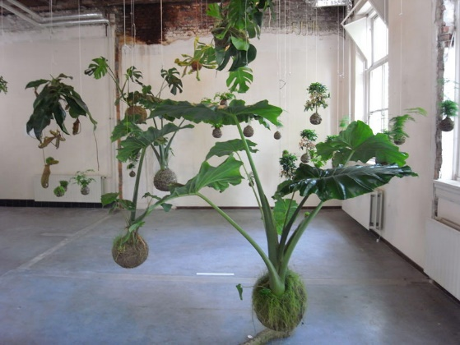
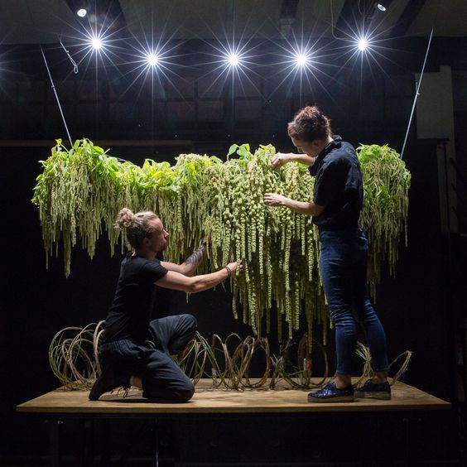

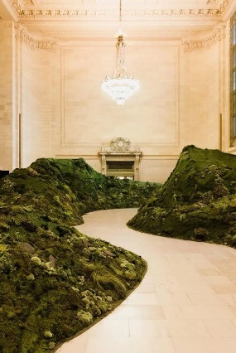
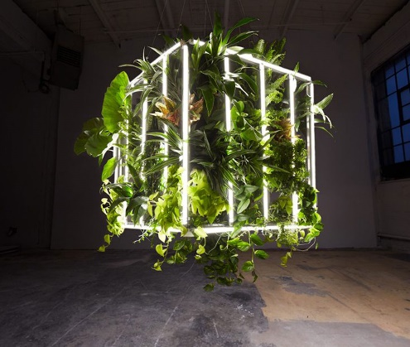
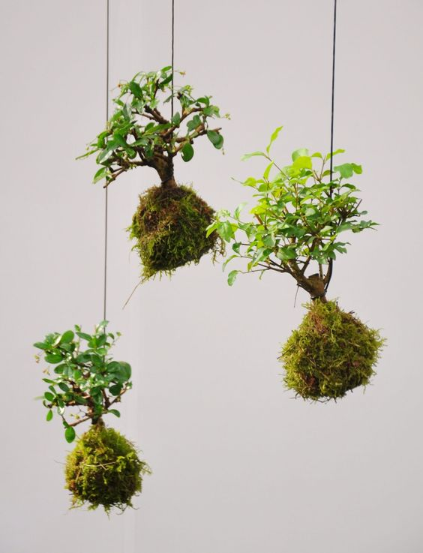
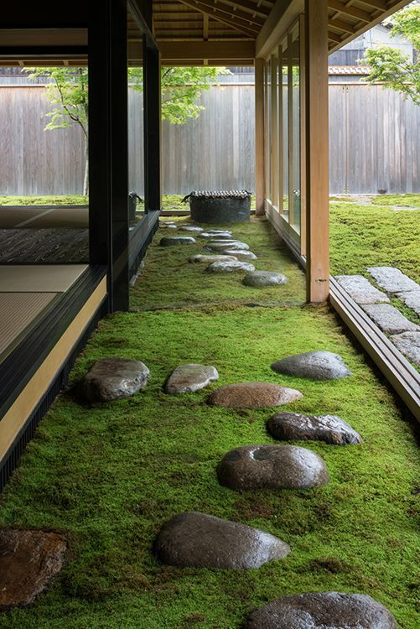
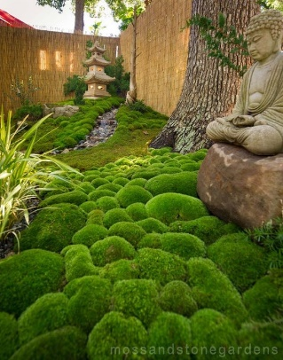

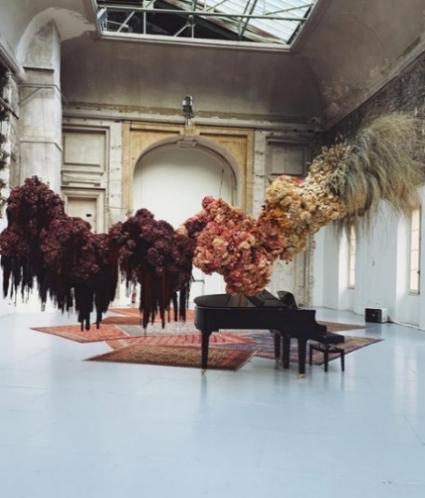
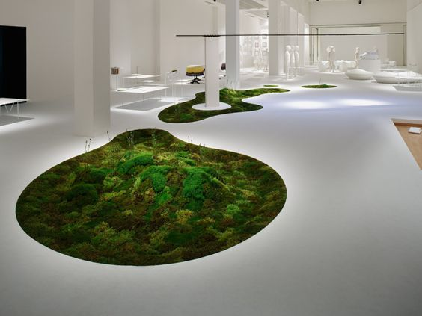

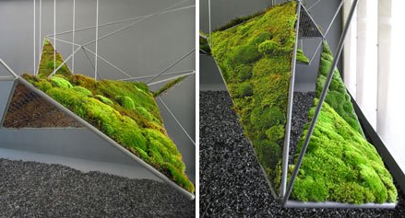
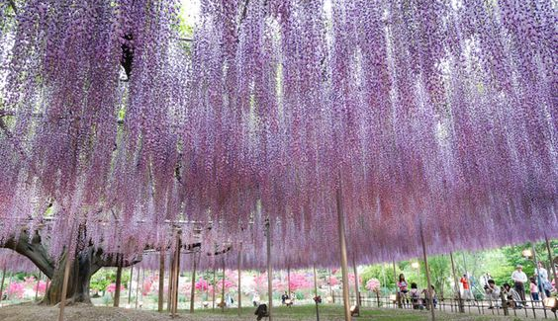

Your Proposal
Your proposal should include the following:

Example Risk Assessment and Method Statement An example of a risk assessment and method statement. This will help us to understand your Health & Safety management.

Experience Statement - Please provide a written statement detailing your past experience of similar projects. You may include photographs if you wish.

Location – Due to ongoing COVID-19 travel restrictions and Brexit related import/customs delays this tender is open to UK based Suppliers only. Please confirm that you meet this requirement.

The above are essential qualities that are required of the successful Supplier, they will be evaluated on a Pass/Fail basis.

Concept Statement – a statement summarising how your Horticultural Installation responds to the festival theme, Essential Criteria, and Identity (above).

Master Plan – 1 x 2D colour drawing (plan view) showing the layout of the Horticultural Installation in situ in the Octagon. The drawing should be clearly labelled and detail the key elements of the design, including dimensions, weight, plants, materials and any other features.

Visitor View Plans – 2 x 3D renders views of the installation and experience within the Octagon. The drawings should be clearly labelled and detail the key elements of the design, including dimensions, plants, materials and any other features.

Planting Plans
- A mood board showing photographs of the plants you will use
- A list of the plants you will use and their UK provenance (please see the note about Quarantine in Practical Considerations below)

Construction Drawings - at least one drawing which demonstrates the construction. The drawing(s) should be clearly labelled with short notes about the materials and fixing methods, etc,

Practical Information – a written statement which responds in detail to each of the ‘Practical Considerations’ below, explaining how you would mitigate against / provide for these design challenges.

Project Timeline – a critical path showing how long you think it will take to design and prepare the Horticultural Installation offsite, and the anticipated duration of install and derig.

Biosecurity Statement – Please provide a written statement detailing your approach to biosecurity and plant health at your premises and/or the premises of your horticultural suppliers. Please include a note on plant provenance and quarantine measures. You should refer to the Biosecurity Guidelines and Managing Xylella documents contained in this pack. If Covid-19 restrictions allow, Kew’s Head of Quarantine may visit your premises as part of the tendering process in order to gain a better understanding of your approach to plant health and biosecurity management.

You may need to refer to your supplier and ask that they provide the necessary documentation.

Budget – a budget of £30,000 (excluding VAT) is available. Please provide a line-by-line budget breakdown of all costs, including:
- Your fee (including all travel, subsistence, accommodation, staffing, site visits, project meetings, etc,.)
- Plants and materials
- Fabrication
- Shipping, storage and any logistical equipment
- Installation, maintenance and deinstallation
- Any other associated costs

Practical Considerations
- Kew is a UNESCO World Heritage Site, containing the world’s most extensive and diverse collections of living and preserved plants and other valuable materials. Many of the plants grown at Kew are of the highest conservation value and protection of the health of our site’s plants is of paramount importance. We do this by monitoring the introduction to site of any natural materials.
  - Any plants, flowers, raw wood, or other natural materials will be subject to checks from our Quarantine team before being permitted on site. Please provide a list detailing the natural material you propose to use and its UK provenance.
  - Live plant material supplied to RBG Kew will be, where appropriate, well rooted in the container it has been grown in, without being pot bound. Plant tissues will be sound and healthy and visibly free of pests and pathogens – both above and below ground.

- The Temperate House is a Grade I Listed Building and you are not permitted to fix anything directly to the building, including the walls, pillars or ceiling. Any structures should be free standing. You may not alter the fabric of the Temperate House in any way. You must take into account the weight you are placing on the floor of the Temperate House, and how you will protect the fabric of the floor.

- The temperature in the Temperate House Octagon in October ranges from 10 to 25 degrees celsius and you should take this into account when designing your planting scheme.

- Although the Temperate House is predominantly dry, sprays and hoses are used daily. You should consider how the design will be maintained in this environment.

- There are five taps in the Octagon: 4 for irrigation water, 1 for mains. The irrigation water comes from below-ground tanks and comprises harvested rain water topped up with reverse osmosis water which has little mineral content. The mains water is full of minerals and is hard water. A once/twice weekly plant feed is recommended to keep plants looking their best as irrigation water by itself tends to cause leaching. There is no drainage in the Octagon so water will not run off but sit on the floor.

- Please explain how you would fireproof the materials used in construction of the design.

- Please explain what equipment will be needed for installation and derig (NB The Temperate House has access limitations. Vehicle size and access to the gardens is restricted; access is provided before and after public opening hours by prior written consent.)

- If possible, parts of the design should be constructed off site, in components if necessary, in order to ensure that it can enter the site and be installed with ease. However, we appreciate that for certain elements (for example the planting) this will not be possible. You should take into consideration the height and width of doorways and gateways.

- Please provide information on the proposed installation and derig team.

- The Horticultural Installation will be in situ for up to six weeks and must endure for this length of time. You should provide details of how you propose to maintain the Installation during the festival duration. Kew horticultural staff will be able to water any plants for the duration of the festival. NB cannot accept risk or liability for the plants and/or the installation.

- Please provide details of how you would propose to undertake any necessary remedial work during the festival period.

- A soundscape will be playing throughout the Temperate House. Therefore the design should not include sound elements as these will clash with the soundscape.

- Electrics and data points are available under the perimeter shelf of the Octagon. All equipment you propose to plug in to these sockets (including tools used in construction) will need to be PAT tested and certification will need to be provided.

- Storage is limited and you should plan not to store anything on site. You will be required to remove all waste from site.

- The Horticultural Installation will not be invigilated and access (legally sufficient pathway widths) through the Octagon must be maintained.

- Visitors should not be able to touch or interact with the design and you should ensure that the design is protected from visitors.

- If your proposal is successful you will be required to enter into a contract and adhere to RBG Kew’s Contractor Code of Practice at all times whilst undertaking work at Kew

- RBG Kew is “self-insuring” as a public body and as such does not carry commercial insurance. Accordingly, you will be responsible for obtaining and paying for your own public liability insurance of not less than £5 million and submit a copy of your policy prior to working at Kew.

- You are asked to support Kew to actively reduce the environmental impact of its activities in order to exceed and embed best practice. Where we can, we must conserve the earth’s resources by borrowing, hiring, re-using or purchasing second-hand where possible; sourcing locally where possible; purchasing supplies that contain the highest percentage of recycled, recyclable and non-toxic elements whenever possible (e.g., avoid PVC, plants should be UK sourced, timber should be UK sourced and FSC certified, peat is not permitted on site) while working with RBG Kew’s procurement practices. Please tell us how you plan to help us achieve our sustainability goals.

- Please provide details regarding whether or not you would be able to give a talk(s) about the Horticultural Installation during the festival period.

Site Visits

If government restrictions relating to Covid-19 allow free unaccompanied site visits to Kew can be arranged – however please note that at the time of writing our glasshouses (including the Temperate House) will be closed to visitors until mid-May. If you would like to gain entry to Kew (Gardens only) please provide the following information via the tendering portal message facility

Please message at least two working days in advance of the date you would like to visit. Your name will then be put on a list which is held at all our public Gates. Please arrive at any of our public Gates during normal Garden opening hours and give your name to our Gate staff to gain entry. Please check the Kew website - kew.org - before your visit.

