**Parish Maintenance contract 2022-2027**

**for the Green Open Spaces in Fernhill Heath**

**Contract to be awarded for up to 5 years.**

North Claines Parish Council

[clerk@northclainesparishcouncil.gov.uk](mailto:clerk@northclainesparishcouncil.gov.uk)

The Old Library Centre

65 Ombersley Street East

Droitwich Spa

Worcestershire

WR9 8QS

**1. Invitation to Tender**

**2. Appendices**

* Appendix A Standard Conditions of Contact
* Appendix B Specification of Works
* Appendix C Schedule of Works – see attached spreadsheet
* Appendix D Site maps
* Appendix E Form of Tender
* Appendix F Questionnaire

**INVITATION TO TENDER**

1. North Claines Parish Council ("the Council") hereby invites tenders for the carrying out of the maintenance of the Parish in accordance with the Contract documents attached, which comprise: -

Appendix A Standard Conditions of Contract

Appendix B Specification of Works

Appendix C Schedule of Works attached.  
Appendix D Site Plans x 2

Appendix E Form of Tender

Appendix F Questionnaire

1. Tenders can be submitted for the entire contract. The Prices submitted must indicate the rate for carrying out each area/item individually.
2. Prospective Contractors should ensure that they are completely familiar with the nature and extent of the obligations to be accepted by them, if their tender is accepted.
3. Any queries regarding the interpretation of any part of the Contract documents should be addressed to the Parish Clerk by no later than one week before the closing date.
4. The tender shall be submitted on the Form of Tender attached at Appendix E.
5. Prospective Contractors should note that the Council is not bound to accept the lowest, or any tender. The Council’s decision is final and no correspondence will be entered into on the reasons why a tender has been rejected.
6. The successful tender together with the Council's written acceptance shall form a binding agreement in the terms of the Contract documents.
7. If having examined the tender documents you wish to submit a tender you should: -
   1. a)  Fully complete and return: Appendix E Form of Tender and the itemised schedule of works.
   2. b)  Return tenders and all related documentation by 12 noon on Monday 31 January 2022 addressed to: The Clerk at North Claines Parish Council, The Old Library Centre, 65 Ombersley Street East, Droitwich Spa, Worcestershire, WR9 8QS. Tenders received late will not be considered.
   3. c)  Please note that the package containing the tender must be clearly marked “Tender for parish maintenance” on the outside.

**Appendix A**

**STANDARD CONDITIONS OF CONTRACT**

**Contract Documents**

The Contract Documents will comprise:  
Appendix A Standard Conditions of Contract

Appendix B Specification of Works

Appendix C Schedule of Works  
Appendix D Site Plans  
Appendix E Form of Tender

Appendix F Questionnaire

**Officer**

The Officer will be the Parish Clerk.

**Extent of Work**

Generally, the work will comprise of the maintenance of the Parish of North Claines as per the attached specification.

The height of the mowing cut is to be agreed with the Parish Clerk. To also include strimming around play equipment, bins, outside furniture, trees, bushes, fences, hedges and all other authorised site fixtures and fittings. To include grass removal from all play safety surfaces and footpaths by sweeping or blower. Selective weed control if and when required. Although a set number off cuts has been set for the tender these may be varied according to seasonal grass growth and by agreement with the Parish Clerk.

**Parish lengthsman** tasks will need to be undertaken and the successful applicant will need to have attended and received the qualifications necessary to work on the highways as per Worcestershire Highways specifications.

Tasks will be as and when necessary and will include

Drainage:

Clear gully grates.  
Clear verge grips.  
Clear headwalls, outfalls.  
Advise landowners and frontagers when their ditches need cleaning.  
In especially difficult circumstances clear ditches – only with prior agreement of the Manager.

Vegetation Clearance:

Remove vegetation obstructing signs.  
Remove vegetation at junction visibility splays.  
Removal of basal tree growth from highway trees.  
Pulling / cutting of noxious weeds following site specific approval from the Manager.  
Side out footways to normal width and spread arisings on verge where possible. Negotiate with frontagers for them to cut back overhanging vegetation.

Miscellaneous:

Rotation and charging of mobile Vehicular Activated Signs (VAS) following site specific approval and authorisation from the Manager.  
Clean dirty signs and/or retighten brackets, reposition signs which have been knocked out of place where no excavation is required (except illuminated signs). Painting of heritage cast iron direction signs.

Snow clearance and gritting / salting by hand.  
Removal of illegal fly posting.  
Maintenance and repainting of highways approved visibility fencing.

**Parish Lengthsman tasks are not to be included within this contract but must be itemised and invoiced separately on a monthly basis by the successful applicant.**

**Site Details**

The sites are situated throughout North Claines Parish and the main areas are identified on the maps enclosed under Appendix D and include

* Grass verges,
* The Brum recreation ground and
* The playground on the Brum Recreation Ground,
* Public open spaces - Agatha Gardens and Danes Green open space

These all total around 3 hectares

* The Bull Meadow - This is an area of around 5.5 hectares.

Before tendering the Contractor is advised, at its own discretion, to visit the sites to satisfy itself as to the full extent of the Contract Specification. No claims arising from failure to do so will be accepted.

**Workmanship and Equipment**

The workmanship must be of the highest standard and shall conform to all relevant British Standards, Specifications and Codes of Practice. Contractor to adjust the Contract price will be considered.

**Duration of Contract**

The duration of the Contract will be up to five years, with the final decision on the duration of the Contract to be made by the Council after the tenders have been received. Tenders are to be priced on an annual basis. There will be no opportunity to alter the rates tendered during the term.

**Payment to Contractor**

The Contractor will submit a monthly account and invoice in arrears throughout the cutting season for all work carried out. Payment will be via BACs once the invoice is received.

Invoices should include a breakdown of the costs as follows:

Mowing

Bull Meadow

Brum Recreation Ground

Other open spaces

Parish lengthsman works should be invoiced separately.

**Termination of Contract**

Either party may, without reason, terminate the Contract, in writing, giving three months notice.

**Insurance**

The Contractor is required to have a minimum of £5,000,000 public liability insurance for Contracts. A current Certificate of Insurance to this effect must be produced to the Parish Clerk prior to commencement of the Contract. The Contractor shall indemnify the Council against any claim or proceedings for any injury or damage to any property or persons or animals as a result of negligence, poor workmanship or failure to notify the Council of any action likely to cause injury or damage to a third party.

**Health and Safety**

The Contractor shall accept full responsibility for compliance with the Health and Safety at Work Act and all other Acts and Regulations in respect of the work comprised in this Contract and shall submit a copy of its Health & Safety Policy to the Clerk.

**Notes to Tenderers**

a) Attention is drawn to the Form of Tender and Standard Conditions of Contract. These documents must be read in conjunction with the Specification of Works, Plans and Schedule of Works. Contractors are advised to carefully read all documentation.

b) The prices to be included in the Form of Tender are to be the full inclusive value of the work described, including all profit, costs and expenses, and all general risks, liabilities and obligations.

c) A price shall be inserted against each item on the Form of Tender for each contract tendered for.

d) No alteration to the text of the Form of Tender is to be made by the Contractor tendering. Should any alteration, amendment, note or addition be made, the same will not be recognised and the reading of the printed Schedule will be adhered to.

f) If and when weed killing chemicals are to be applied where and when agreed they must be applied by certificated staff (if this is to be contracted out – Council need to know who it is contracted out to and see relevant certificates).

g) A regular inspection will be carried out by the Council throughout the period of the Contract to ensure the work is completed in accordance with the Specification of Works.

h) Invoices presented for payment must include a schedule of the works completed including the dates of the work.

i) Contractors are asked to contact the Parish Clerk if any clarification is required.

**Appendix B SPECIFICATION OF WORKS – please see attached spreadsheet of schedule of works**

1. Prior to cutting any area, the Contractor will ensure that it is free of significantly large stones, paper, tins, bottles and other debris.
2. The Contractor will inspect each site for areas of ground sinkage/potholes and areas of potential hazard and will inform the Council immediately of any specific hazards.
3. The Contractor will at all times during the period of the Contract, ensure that all machines engaged in grass cutting operations are sharp and properly set, so as to produce a true and even cut. Any damage or areas of grass not cut to the approval of the Council from such lack of maintenance will be made good by the Contractor at his own expense and to the satisfaction of the Council.
4. The Contractor will at all times during the period of the Contract ensure that machines are properly guarded and maintained so as to present no danger to the operator, surrounding structures, vehicles or any person in the vicinity of operations. The Contractor will provide its staff with all safety equipment, (boots, reflective vests etc.), and will ensure that staff use these at all times they are engaged in work for the Council.
5. During the period of the Contract no growth regulators of any form will be applied to any area of turf without the Council sanctioning such an operation in writing, in advance.
6. All grass will be cut cleanly and evenly and without damaging the existing surface.
7. The Contractor will complete one area of grass cutting before moving onto the next, and immediately after cutting a scheduled area, the Contractor will ensure that all grass clippings and other arisings are cleared from all paved areas, playground equipment safety surfaces, memorial stones, paths and public footpaths, etc., by sweeping or using a blower.
8. Soft vegetative growth, such as clover will be deemed to be part of the Contract where it falls within large areas of grass.
9. Since it is not possible to predict accurately the precise number of mowings which may be required on any site in any one year, the Schedule of Works includes a given number of mowings, but the Contractor will be paid on a pro-rata basis for more or less than this number, dependent upon the prevailing weather conditions through the growing season.
10. Mowing will take place on the full area of grass at the site, up to the paving, fencing obstacles and any other boundaries.
11. Areas not cut to the satisfaction of the Council will be re-cut by the Contractor at the Contractor’s own expense.
12. In very wet conditions all operations involving grass cutting shall cease until conditions allow operations to recommence without damaging the surface levels and contours of the ground or grass cutting “divots” from the machine rollers or cutters.
13. Should the Contractor cause damage to the surface or levels of the ground, or create divots during grass cutting operations, the Contractor will at his own expense reinstate such damage forthwith to the satisfaction of the Council.
14. Mowing will be carried out as close as possible to fixed obstructions. Moveable obstructions can be removed to facilitate cutting and replaced before the Contractor leaves the site.
15. Mowing around obstructions including seats, trees, fence lines, posts, memorial stones and kerbs and the like, and in the proximity of margins, will be undertaken using methods, tools and machines as appropriate. The cutting of such areas will be undertaken within 24 hours of the main site being mowed and will be deemed to be included in the Contractor's rate for each location.
16. If used strimmers must not be damage any trees, shrubs etc or permanent or removable fittings.
17. All persons operating grass cutting machinery must be satisfactorily trained, and the Council reserves the right to ask the Contractor to provide adequate proof that his operators are well trained, conversant with Health and Safety legislation and competent in their operating methods.
18. None of the sites have access to running water – so contractor will need to provide own.

**Appendix C**

**GRASS CUTTING CONTRACT SCHEDULE OF WORKS – please complete the attached spreadsheet and return with the form of tender**

**Notes**

1. The first cut being in mid-late March and the final cut in late October/early November according to seasonal growth patterns.
2. The remaining cuts to be at the Contractor’s discretion, taking into account the growth of the grass, although there should be a minimum of two weeks between cuts.
3. To include strimming around play equipment and other obstructions including trees and the edges of the sites.
4. All safety surfacing at play areas to be cleaned off by sweeping or with an electric blower after each cut/strim.
5. Grass to be dispersed evenly over each site not left in mounds.

**VERGES ON HIGHWAY AND RESIDENTIAL STREETS**

Notes as above

**Appendix D - Maps of the area – Bull meadow**

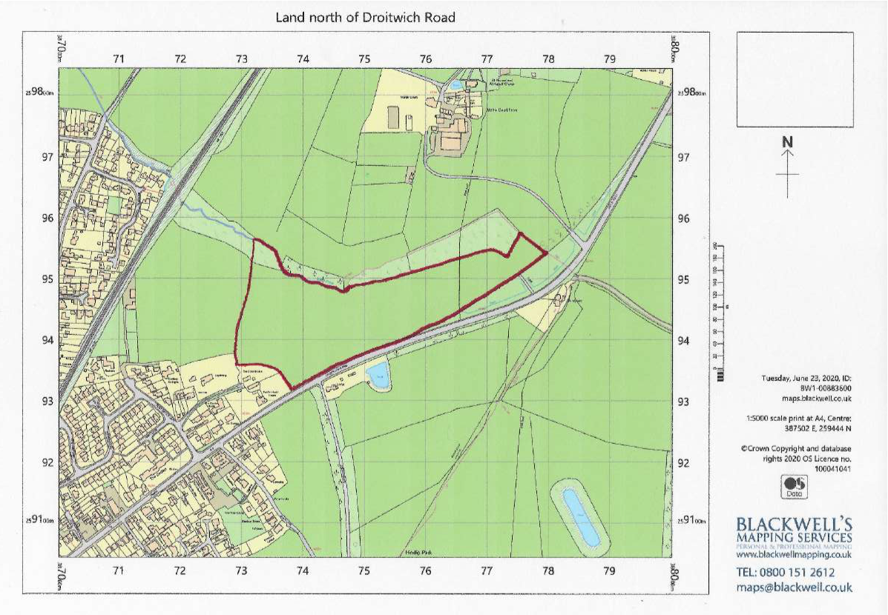

**Map showing The Brum Recreation Ground, Agatha Gardens open-space and Danes Green open-space**

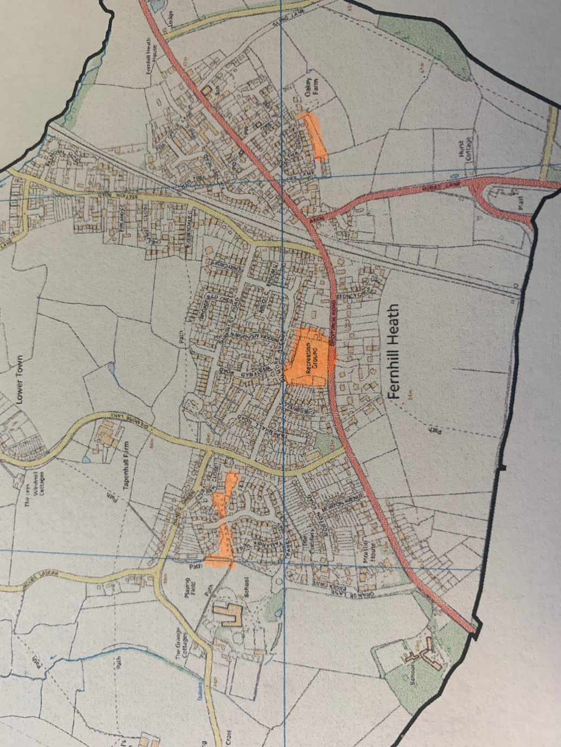

**Appendix E**

**Total cost of contract annually - £**

I/We agree to complete the work in accordance with the Invitation to Tender, Standard Contract Terms, Specification of Works, Schedule of Works and location plans.

I/We understand that North Claines Parish Council is not bound to accept the lowest or any Tender or part thereof and that the Council will not be responsible for any expense incurred in preparing this Tender.

I/We certify that the amount of the Tender has not been calculated by agreement or arrangement with any other person, firm or company and that the amount of the Tender has not been communicated to any person and will not be communicated to any person until after the closing date for the submission of Tenders.

Signed: .............................................

Name: .............................................................

Position: ..............................................

Date: ............................................................

Address: .........................................................................................

..........................................................................................................

............................................................................................................

|  |  |
| --- | --- |
| **Contract** | 2022- 2027 |

Telephone Contact number: ...................................................................

**Appendix F - GRASS CUTTING CONTRACT QUESTIONNAIRE**

Details relating to Prospective Tenderer

1. Name: ...................................................................................

2. Address: ................................................................................ ....................................................................................

3. Telephone number (landline &.mobile) ..........................................

4. Email address: ..........................................................................

5. Contact Name and Position in Company: ......................................

6. Nature of Business: ..................................................................

7. If the Business is a Company: ......................................................

Is it a Subsidiary of another Company? ..........................................

If yes, please give details: ..........................................................

8. Date of Business formation: ..........................................................

9. Are you VAT registered?

9. Please state number of grounds maintenance employees: .......................................

10. Please state which branch the Contract will be serviced from: .(if applicable).........................................

11. Please give any other details, which you feel may be relevant, for example, similar Contracts in the area or for similar authorities, etc: (using a separate sheet if necessary).

Signed: ...........................................

Position: ...........................................

Date:..........................................