Request for Quotation

Wansbeck Case Study

07/06/2024

Request for Quotation

Request for Quotation
Wansbeck Case Study
You are invited to submit a quotation for the requirement described in the specification, Section 2.
Please confirm by email, receipt of these documents and whether you intend to submit a quote or not.
Your response should be returned to the following email address by:
Email: lydia.nixon@naturalengland.org.uk
Date: 21/06/2024
Time: 17.00
Ensure you include the name of the quotation and ‘Final Submission’ in the subject field to make it clear that it is your response.
Contact Details and Timetable
Lydia Nixon will be your contact for any questions linked to the content of the quote or the process. Please submit any clarification questions via email and note that, unless commercially sensitive, both the question and the response will be circulated to all tenderers.

Action | Date
Date of issue of RFQ | 10/06/2024 at 12:00
Deadline for clarifications questions | 21/06/2024 at 12.00
Deadline for receipt of Quotation | 21/06/2024 at 17:00
Intended date of Contract Award | 28/06/2024
Intended Contract Start Date | 01/07/2024
Intended Delivery Date / Contract Duration | 01/07/2024 to 27/09/2024

Section 1: General Information
Glossary
Unless the context otherwise requires, the following words and expressions used within this Request for Quotation shall have the following meanings (to be interpreted in the singular or plural as the context requires):
“Authority” | means Natural England who is the Contracting Authority.
“Contract” | means the contract to be entered into by the Authority and the successful supplier.
“Response” | means the information submitted by a supplier in response to the RFQ.
“RFQ” | means this Request for Quotation and all related documents published by the Authority and made available to suppliers.

Conditions applying to the RFQ
You should examine your Response and related documents ensuring it is complete and in accordance with the stated instructions prior to submission.
Your Response must contain sufficient information to enable the Authority to evaluate it fairly and effectively. You should ensure that you have prepared your Response fully and accurately and that prices quoted are arithmetically correct for the units stated.
By submitting a Response, you, the supplier, are deemed to accept the terms and conditions provided in the RFQ. Confirmation of this is required in Annex 2.
Failure to comply with the instructions set out in the RFQ may result in the supplier’s exclusion from this quotation process.
Acceptance of Quotations
By issuing this RFQ the Authority does not bind itself to accept any quotation and reserves the right not to award a contract to any supplier who submits a quotation.
Costs
The Authority will not reimburse you for any costs and expenses which you incur preparing and submitting your quotation, even if the Authority amends or terminates the procurement process.
Self-Declaration and Mandatory Requirements
The RFQ includes a self-declaration response (Annex 1) which covers basic information about the supplier, as well as any grounds for exclusion. If you do not comply with them, your quotation will not be evaluated.
Any mandatory requirements will be set out in Section 2, Specification of Requirements and, if you do not comply with them, your quotation will not be evaluated.
Clarifications
Any request for clarification regarding the RFQ and supporting documentation must be submitted via email no later than the deadline for clarifications set out in the Timetable. The Authority shall be under no obligation to respond to queries raised after the clarification deadline.
The Authority will respond to all reasonable clarifications as soon as possible but cannot guarantee a minimum response time. The Authority will publish all clarifications and its responses to all suppliers via email unless deemed commercially sensitive.
If a supplier believes that a request for clarification is commercially sensitive, it should clearly state this when submitting the clarification request. However, if the Authority considers either that:
- the clarification and response are not commercially sensitive; and
- all suppliers may benefit from its disclosure,

then the Authority will notify the supplier (via email), and the supplier will have an opportunity to withdraw the request for clarification by sending a further message requesting the withdrawal of the clarification request. If not withdrawn by the supplier within 2 working days of the Authority’s notification, the Authority may publish the clarification request and its response to all suppliers and the Authority shall not be liable to the supplier for any consequences of such publication.
The Authority reserves the right to seek clarification of any aspect of a quotation and/or provide additional information during the evaluation phase to carry out a fair evaluation. Where the Authority seeks clarification on any aspect of the quotation, the supplier must respond within the timeframe requested by the Authority.
Amendments
The Authority may amend the RFQ at any time prior to the deadline for receipt. If it amends the RFQ the Authority will notify you via email.
Suppliers may modify their quotation prior to the deadline for Responses. No Responses may be modified after the deadline for Responses.
Suppliers may withdraw their quotations at any time by submitting a notice via the email to the named contact.
Conditions of Contract
The Authority’s
- Standard Goods and Services Terms and Conditions
can be located on the Natural England Website
and will be applicable to any contract awarded as a result of this quotation process. The Authority will not accept any changes to these terms and conditions proposed by a supplier.
Suppliers should note that the quotation provided by the successful bidder will form part of the Contract.
Prices
Prices must be submitted in £ sterling, exclusive of VAT.
Disclosure
All Central Government Departments, their Executive Agencies and Non Departmental Public Bodies are subject to control and reporting within Government. In particular, they report to the Cabinet Office and HM Treasury for all expenditure. Further the Cabinet Office has a cross-Government role delivering overall Government policy on public procurement, including ensuring value for money and related aspects of good procurement practice. For these purposes, the Authority may disclose within Government any details contained in your quotation. The information will not be disclosed outside Government during the procurement.
In addition, the Authority is subject to the Freedom of Information Act 2000 and the Environmental Information Regulations 2004, which provide a public right of access to information held by public bodies. In accordance with these two statutes, the Authority may be required to disclose information contained in your quotation to any person who submits a request for information pursuant to those statutes.
Further to the Government’s transparency agenda, all UK Government organisations must advertise on Contract Finder in accordance with the following publication thresholds:
- Central Contracting Authority’s: £12,000
- Sub Central Contracting Authority’s and NHS Trusts: £30,000
For the purpose of this RFQ the Authority is classified as a Central Contracting Authority with a publication threshold of £12,000 inclusive of VAT.
If this opportunity is advertised via Contracts Finder, we are obliged to publish details of the awarded contract including who has won the contract, the contract value, and indicate whether the winning supplier is a small and medium-sized enterprise (“SMEs”) or voluntary organisation or charity. A copy of the contract must also be published with confidential information redacted.
By submitting a Response, you consent to these terms as part of the procurement.
Disclaimers
Whilst the information in this RFQ and any supporting information referred to herein or provided to you by the Authority have been prepared in good faith the Authority does not warrant that this information is comprehensive or that it has been independently verified.
The Authority does not:
- make any representation or warranty (express or implied) as to the accuracy, reasonableness or completeness of the RFQ;
- accept any liability for the information contained in the RFQ or for the fairness, accuracy or completeness of that information; or
- accept any liability for any loss or damage (other than in respect of fraudulent misrepresentation or any other liability which cannot lawfully be excluded) arising as a result of reliance on such information or any subsequent communication.
Any supplier considering entering into contractual relationships with the Authority following receipt of the RFQ should make its own investigations and independent assessment of the Authority and its requirements for the goods and/or services and should seek its own professional financial and legal advice.
Protection of Personal Data
In order to comply with the General Data Protection Regulations 2018 the supplier must agree to the following:
You must only process any personal data in strict accordance with instructions from the Authority.
- You must ensure that all the personal data that we disclose to you or you collect on our behalf under this agreement are kept confidential.
- You must take reasonable steps to ensure the reliability of employees who have access to personal data.
- Only employees who may be required to assist in meeting the obligations under this agreement may have access to the personal data.
- Any disclosure of personal data must be made in confidence and extend only so far as that which is specifically necessary for the purposes of this agreement.
- You must ensure that there are appropriate security measures in place to safeguard against any unauthorised access or unlawful processing or accidental loss, destruction or damage or disclosure of the personal data.
- On termination of this agreement, for whatever reason, the personal data must be returned to us promptly and safely, together with all copies in your possession or control.
General Data Protection Regulations 2018
For the purposes of the Regulations the Authority is the data processor.
The personal information that we have asked you provide on individuals (data subjects) that will be working for you on this contract will be used in compiling the tender list and in assessing your offer. If you are unsuccessful the information will be held and destroyed within two years of the award of contracts. If you are awarded a contract it will be retained for the duration of the contract and destroyed within seven years of the contract’s expiry.
We may monitor the performance of the individuals during the execution of the contract, and the results of our monitoring, together with the information that you have provided, will be used in determining what work is allocated under the contract, and in any renewal of the contract or in the award of future contracts of a similar nature. The information will not be disclosed to anyone outside the Authority without the consent of the data subject, unless the Authority is required by law to make such disclosures.
Equality, Diversity & Inclusion (EDI)
The Client is striving to create a diverse and inclusive working environment where every individual has equality of opportunity to progress and to apply their unique insights to making the UK a great place for living. The Service Provider is expected to respect this commitment in all dealings with Natural Enlgnad staff and service users.
Suppliers are expected to;
- support Defra group to achieve its Public Sector Equality Duty as defined by the Equality Act 2010, and to support delivery of Defra group’s Equality & Diversity Strategy.
- meet the standards set out in the Government’s Supplier Code of Conduct
- work with Defra group to ensure equality, diversity and inclusion impacts are addressed (positive and negative) in the goods, services and works we procure, barriers are removed and opportunities realised.
Sustainable Procurement
Addressing global sustainability impacts and realising additional community benefits within commercial activity is core to Defra group’s approach, working with its supply chain is key to achieving sustainable outcomes. In addition to supporting Defra group to meet its outcomes we look to understand and reduce negative sustainability impacts associated with our commercial activity and realise benefits.
The Client encourages its suppliers to share these values, work to address negative impacts and realise opportunities, measure performance and success.
Suppliers are expected to have an understanding of the Sustainable Development Goals, the interconnections between them and the relevance to the Goods, Services and works procured on the Client’s behalf
Conflicts of Interest
The concept of a conflict of interest includes but is not limited to any situation where an Involved Person or Relevant Body has directly or indirectly, a financial, economic or other personal interest which might be perceived to compromise their impartiality and independence in the context of the procurement procedure and/or affect the integrity of the contract award.
We expect suppliers to mitigate appropriately against any real or perceived conflict of interest through their work with government. A supplier with a position of influence gained through a contract should not use that position to unfairly disadvantage any other supplier or reduce the potential for future competition
Where the supplier is aware of any circumstances giving rise to a conflict of interest or has any indication that a conflict of interest exists or may arise you should inform the Authority of this as soon as possible (whether before or after they have submitted a quotation). Tenderers should remain alert to the possibility of conflicts of interest arising at all stages of the procurement and should update the Authority if any new circumstances or information arises, or there are any changes to information already provided to the Authority. Failure to do so, and/or to properly manage any conflicts of interest may result in a quotation being rejected.
Provided that it has been carried out in an open, fair and transparent manner, routine pre-market engagement carried out by the Authority should not represent a conflict of interest for the supplier.

Section 2: The Invitation
Specification of Requirements

Background to Natural England
Natural England is the government’s advisor on the natural environment. We provide practical advice, grounded in science, on how best to safeguard England’s natural wealth for the benefit of everyone.

Background to the specific work area relevant to this purchase

Wansbeck Case study

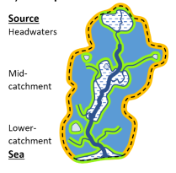

Purpose and context

The purpose of the Wansbeck case study is to further develop the Wansbeck Nature Recovery Plan in light of new ‘water for nature recovery advice for LNRS’ Local Nature Recovery Strategies & Water The Wansbeck case study will inform local LNRS priorities and sit alongside the water advice as a resource to support understanding across other Northumberland river catchments and more widely.

Catchment restoration

The Wansbeck case study NRN project will integrate water with wider habitat restoration and creation opportunities in order to enhance catchment function. The case study will identify opportunities within water, the adjacent landscape, and the wider landscape (catchment), using a source-to-sea approach.. The diagram below illustrates the relationship between catchment restoration, enhanced catchment function and catchment resilience.

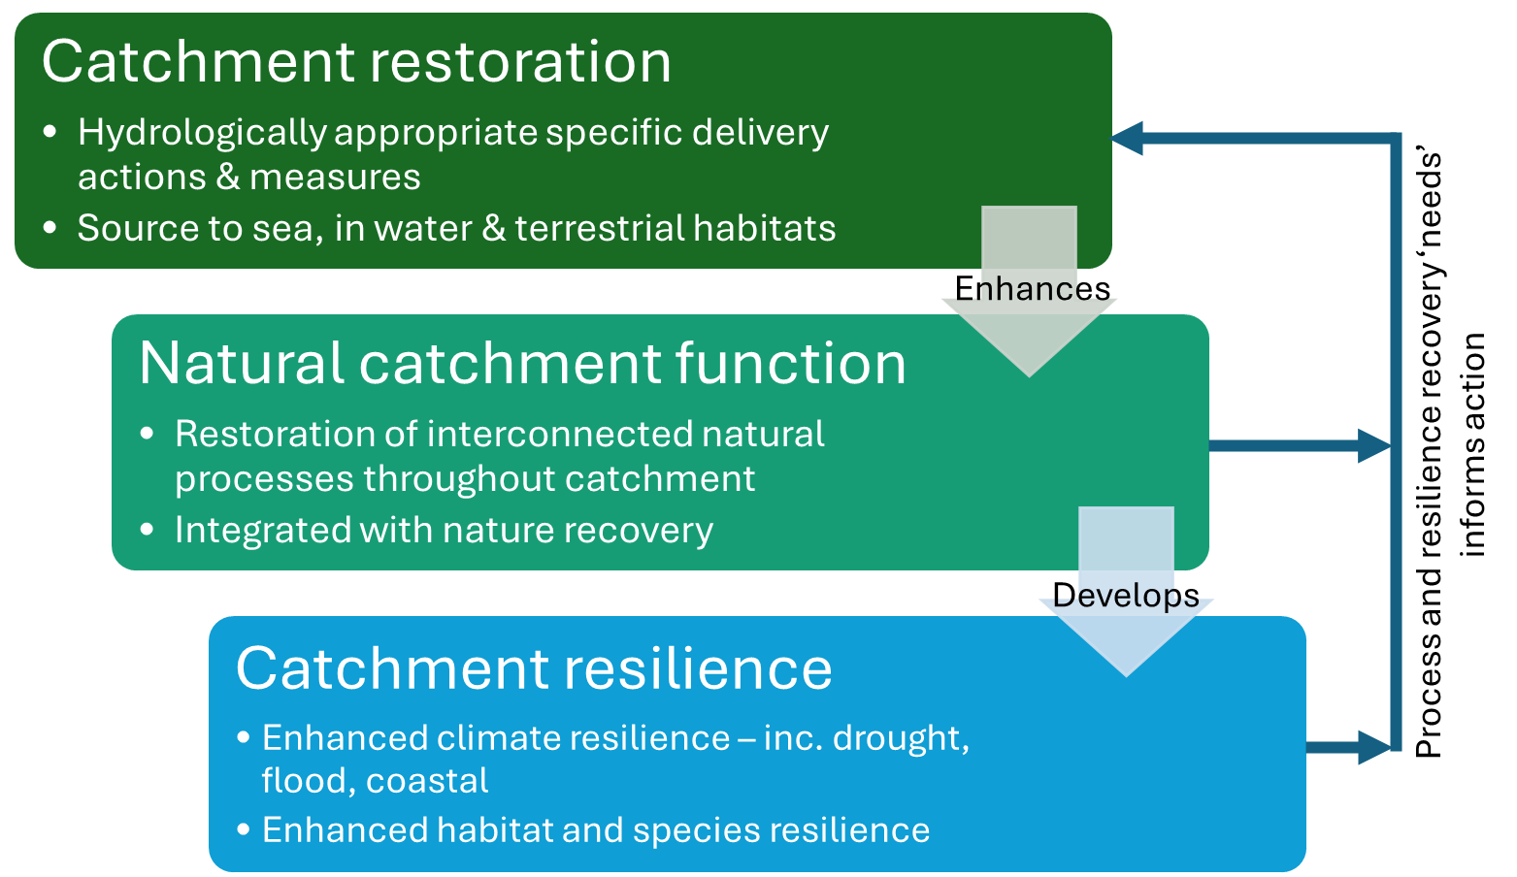

The diagram below illustrates the relationship between nature recovery and the restoration of natural processes to develop catchment resilience.

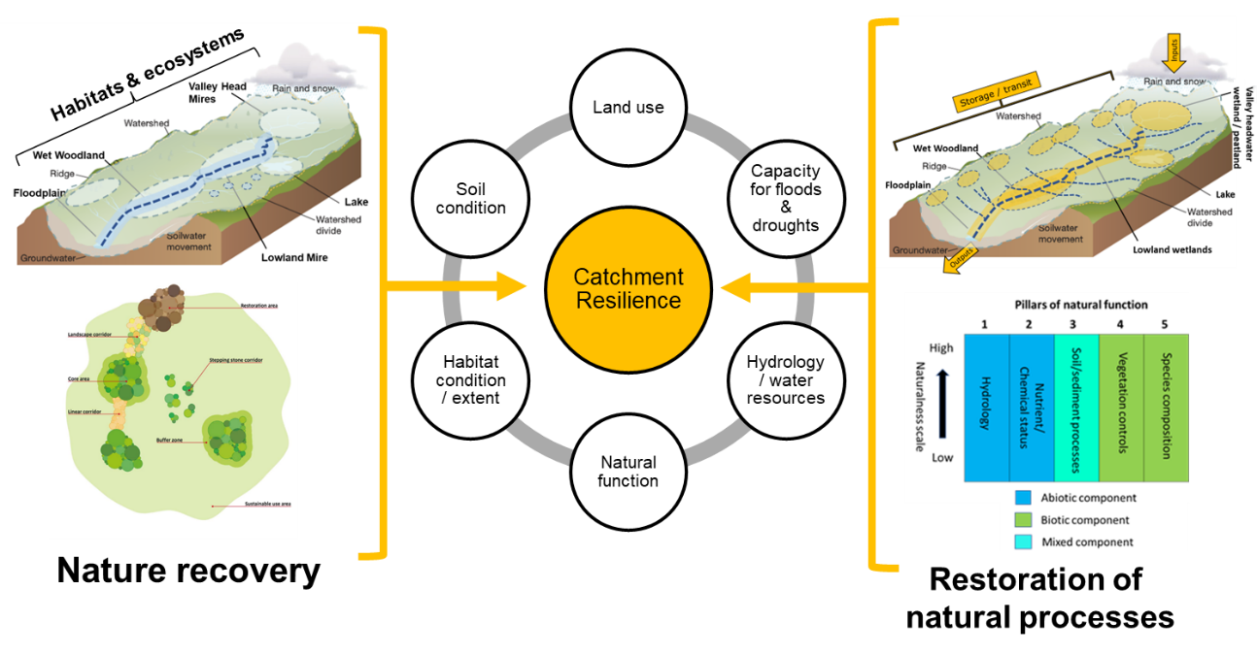

Catchment restoration is driven by a number of key considerations centred around restoring natural processes and building resilience into the wider landscape, including:
- Thinking at catchment scale and allowing space for water, including promoting natural dynamism and reconnecting/restoring degraded processes
- Slowing the movement of water throughout the catchment, by improving retention, flow pathways and the interaction with terrestrial soils and vegetation
- Ensuring where possible that restoration is natural process led, working with nature and the natural movement of water on and below the surface
- Understanding where water should be in a landscape (flow pathways, retention, storage) to determine the right habitat, in the right place
- Ensuring water is embedded in nature recovery, as a key way to ensure landscape resilience and sustainability in the face of the climate and biodiversity crises

Objectives

The objectives of the Wansbeck Case Study are eight fold:

- To critically assess the Wansbeck Nature Recovery Plan in light of new ‘water for nature recovery advice for LNRS’
- To identify and undertake further spatial data analysis in order to identify opportunities within water, the adjacent landscape, and the wider landscape (catchment) using a source-to-sea approach.
- To develop a research framework to address uncertainties and identify key questions to inform research and development in the Wansbeck catchment
- To identify local priorities for the Wansbeck catchment to be used in the North of Tyne LNRS
- To identify best practice examples of water dependent habitat restoration and creation and utilise these to build awareness and catalyse further action
- To demonstrate an integrated approach to habitat restoration and creation in the Wansbeck catchment in order to restore catchment function
- To define the criteria for catchment design optimisation, undertake a trial catchment design optimisation exercise and demonstrate processes / approaches used to assess a catchment in this manner
- To build understanding of the water advice amongst NE staff, partners and stakeholders

Outcomes

The outcomes of the Wansbeck Case Study are eight fold:

- The Wansbeck Nature Recovery Plan critically assessed in light of new ‘water for nature recovery advice for LNRS’
- Spatial data analysis undertaken in order to identify opportunities within water, the adjacent landscape, and the wider landscape (catchment) using a source-to-sea approach
- Research framework developed to address uncertainties and identify key questions to inform research and development in the Wansbeck catchment
- Local priorities are identified for the Wansbeck catchment to be used in the North of Tyne LNRS
- Best practice examples of water dependent habitat restoration and creation identified and utilised to build awareness and catalyse further action
- Integrated approach to habitat restoration and creation demonstrated in the Wansbeck catchment in order to restore catchment function
- Criteria for catchment design optimisation defined, spatial data outputs, reporting on approach and process used to undertake this assessment
- Understanding of the water advice amongst NE staff, partners and stakeholders enhanced

Requirement
In order to deliver the objectives and outcomes outlined above we have broken the project down into 3 work packages:

- Critically assess the Wansbeck Nature recovery plan and undertake further spatial analysis
- Case studies
- Research framework

We invite contractors to consider these 3 work packages and provide information on how they would approach this work, methodology, project management, proposed staff and a breakdown of the costs for delivering the required outputs.

1. Critically assess the Wansbeck Nature recovery plan and undertake further spatial analysis

Nature recovery will require an integrative approach across landscapes, bridging and combining restoration in terrestrial and water environments, considering restoration of processes, functioning and habitat/species connectivity. As such, catchments will need to be designed in a way that optimises land use, nature recovery and deliver multiple benefits, with water playing a key role in steering this optimisation.

1a – Evaluate and refine the Wansbeck Nature Recovery Plan

Working with partners delivering projects in the catchment alongside NE and EA colleagues, 1a will:

- Critically assess the Wansbeck Nature recovery Plan in light of new ‘water for nature recovery advice for LNRS’
- Identify and undertake further spatial analysis to identify opportunities within water, the adjacent landscape, and the wider landscape (catchment) using a source-to-sea approach (Part 1a Key water opportunities in spatial planning, Water nature recovery advice for LNRS)
- Create a GIS database of all geospatial outputs with associated metadata.
- Create a GIS storymap to be hosted as part of Northumberland Rivers Catchment Partnership storymap collection Northumberland Rivers Catchment Management Plan (arcgis.com) and mirrored as part of LNRS storymap collection LNRS (arcgis.com)

1b – Undertake a catchment design optimisation exercise

Using the catchment key considerations, water nature recovery advice for LNRS and spatial data layers from 1a, part 1b will consider spatial optimisation of measures in the Wansbeck catchment, by undertaking the following activities:

- Define the criteria, rationale and methodology for catchment design optimisation – using principles, water advice, wider nature recovery advice (e.g. LNRS guidance) and steer from NE/EA
- Use the spatial opportunities layers generated in part 1a, along with other data as necessary, to undertake further GIS analyses to optimise catchment design to deliver nature recovery opportunities and multiple environmental benefits
- Prioritise a nature-weighted approach, to maximise nature and environmental benefits, but pragmatically consider other land use in the catchment
- Append outputs to the GIS database and GIS storymap (created in 1a)
- Create a report on the criteria, rationale and process / approaches used to undertake catchment optimisation

2. Development of case studies

Working with partners delivering projects in the catchment alongside NE and EA colleagues:

- Undertake fieldwork to inform the development of restoration plans for case studies number 3. Wetland restoration - alkali fen and 4. Grassland restoration - purple moor grass and rush pasture
- Develop restoration plans for case studies number 3. Wetland restoration - alkali fen and 4. Grassland restoration - purple moor grass and rush pasture
- Develop 12 two page case studies illustrating planned/completed projects delivering habitat restoration and creation with information and steer from partners and NE/EA
- Case studies should be developed to catalyse further action in the catchment and have regard to the following key considerations:
  - catchment key considerations, water nature recovery advice to LNRS, wider nature recovery advice (e.g. LNRS guidance)
  - written with multiple audiences in mind including land managers, potential investors and environmental practitioners
  - include information on capital funding alongside signposting to relevant countryside stewardship actions and revenue payment rates
  - include information on restoration methods, management, best practice, innovation and lessons learned
- Apend case studies to the GIS storymap (created in 1a)

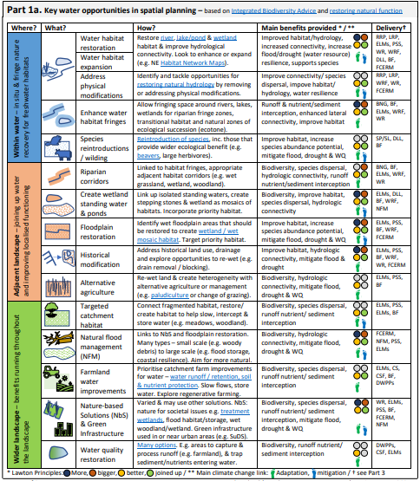

Where? |  | What? | How? | Key contacts
1 | Gallows Hill Farm | Water habitat restoration | River restoration | Michele.mccallam@groundwork.org.uk
2 | Ottercops | Water habitat restoration | Wetland restoration – peatland | Marjorie.davy@naturalengland.org.uk  Harriet.ogglesby@naturalengland.org.uk
3 | Blackhalls Farm | Water habitat restoration | Wetland restoration – alkali fen | Marjorie.davy@naturalengland.org.uk  Iain.diack@naturalengland.org.uk
4 | Blakelaw Farm | Water habitat restoration | Grassland restoration – purple moor grass and rush pasture | Marjorie.davy@naturalengland.org.uk  Iain.diack@naturalengland.org.uk
5 | Gallows Hill Farm | Species reintroduction | Beaver | Paul.hewitt@nationaltrust.org.uk  Zoe.allin@naturalengland.org.uk
6 | Dene House Farm | Floodplain restoration | Wetland/wet mosaic habitat creation | Lydia.nixon@naturalengalnd.org.uk  Michele.mccallam@groundwork.org.uk
7 | Harwood forest | Historical modification | Peat restoration | Giles.brockman@forestryengland.uk
8 | Catcherside | Historical modification | Blocking drainage | Michele.mccallam@groundwork.org.uk  Paul.hewitt@nationaltrust.org.uk  Harriet.ogglesby@naturalengland.org.uk
9 | Mitford Estate | Riparian corridors | Woodland creation | Mark.child@northumberland.gov.uk
10 | Fairnley Farm | Targeted catchment habitat | Woodland creation | Mark.child@northumberland.gov.uk
11 | Gallows Hill Farm | Targeted catchment habitat | Meadow creation | Paul.hewitt@nationaltrust.org.uk  Harriet.ogglesby@naturalengland.org.uk
12 | TBC | Farmland water improvements | TBC | Liam.armstrong@naturalengland.org.uk

3. Development of research framework

Using the Wansbeck Nature Recovery Plan, catchment restoration key considerations, water nature recovery advice for LNRS and spatial data layers from 1a and 1b and the case studies developed in part 2 consider the key uncertainties to nature recovery in the Wansbeck catchment. Develop a research framework by undertaking the following activities:

- Identify research already in train as part of projects and programs in the Wansbeck catchment
- Identify further key questions for research and development
- Identify how the research needs to be conducted in order to build evidence of what works and what doesn’t
- Consider knowledge exchange requirements of environmental practitioners in order to effectively inform local delivery
- Consider knowledge exchange to other audiences such as land managers and investors
- Identify key research projects emerging from initial discussions with partners and NE/EA

Information to be returned by the contractor
Approach and Methodology:
1. Identify proposed methodology and confirm deliverables and timescales.
2. Identify key project risks and how they will be mitigated. A summary risk table should be included in your reply.
Project Management (Including project plan)
3. Include reference to the milestone dates as outlined in outputs and contract management section below
Proposed Staff (including Pen Portraits and Contractor’s experience)
4. Demonstrate appropriate skill and competency.
5. Previous experience.
Proposal Costs:
6. The budget for this project is not unlimited. The approach to prioritising criteria for optimisation should be considered in the cost breakdown that is provided.

Required skills/experience from contractor and staff

The following experience and expertise is essential:
- Experience of habitat assessment
- Expertise in terrestrial and freshwater ecology
- Expertise in habitat restoration and creation techniques
- Experience of designing wetland restoration plans
- Experience in Project Management
The following experience and expertise is preferable:
- Previous experience of developing catchment scale habitat restoration and creation plans
Sustainability
Natural England protects and improves the environment and is committed to reducing the sustainability impacts of its activities directly and through its supply chains. We expect the Contractor to share this commitment and adopt a sound, proactive sustainable approach in keeping with the 25 yr environmental plan/our commitments compliant with all applicable legislation. This includes understanding and reducing direct and indirect sustainability impacts and realising opportunities, including but not restricted to; resilience to climate change, reducing greenhouse gas emissions, water use and quality, biosecurity, resource efficiency and waste, reducing the risk of pollution, biodiversity, modern slavery and equality, diversity & inclusion, negative community impacts.
As a delivery partner, the successful contractor is expected to pursue sustainability in their operations, thereby ensuring the Contracting Authority is not contracting with a supplier whose operational outputs run contrary to the Contracting Authority’s objectives. The successful contractor will need to approach the project with a focus on the entire life cycle of the project
Outputs and Contract Management
Reference | Deliverable | Responsible Party | Date of completion
WP1a & b GIS database | Work Package 1a and b -GIS database of geospatial outputs with associated metadata | Contractor | 30/8/24
WP 1b Optimisation report | Work Package 1b - Optimisation report | Contractor | 30/8/24
WP2 wetland restoration plans | Work package 2 -wetland restoration plans | Contractor | 30/8/24
WP2 case studies | Work Package 2- 12 case studies | Contractor | 30/8/24
WP 1a & b GIS Storymap | Work Package 1a and b - GIS storymap | Contractor | 13/9/24
WP3 Research framework | Work Package 3 -Research Framework | Contractor | 13/9/24

- W/C 1 July 2024 - Inception meeting between project officer and contractor (Weekly teleconferences thereafter)
- W/C 22 July 2024 - draft criteria, rationale, methods for optimisation
- W/C 29 July 2024 - final criteria, rationale, methods for optimisation
- W/C 19 August 2024 - teams workshop - demonstration of geospatial outputs
- W/C 19 August 2024 - 2 draft wetland restoration plans for review
- W/C 19 August 2024 - 12 draft case studies for review
- W/C 26 August 2024 - GIS database of geospatial outputs with associated metadata
- W/C 26 August 2024 - Optimistaion report
- W/C 26 August 2024 - 2 final wetland restoration plans
- W/C 26 August 2024 - 12 final case studies
- W/C 2 September 2024 - teams workshop - demonstration of GIS storymap
- W/C 9 September 2024 - final GIS storymap
- Contract to be completed 27 September 2024

Payment
The Authority will raise purchase orders to cover the cost of the services and will issue to the awarded supplier following contract award.
The Authority’s preference is for all invoices to be sent electronically, quoting a valid Purchase Order number. Invoices should be submitted once all the work is completed.
It is anticipated that this contract will be awarded for a period of three months to end no later than 27/09/2024. Prices will remain fixed for the duration of the contract award period. We may at our sole discretion extend this contract to include related or further work. Any extension shall be agreed in writing in advance of any work commencing and may be subject to further competition.
Evaluation Methodology
- Proposed approach and methodology
- Key personnel (including pen portraits)who will be directly involved with this contract and recent experience of carrying out similar contracts
- Project management (including project plan)
- Management of sustainability risk or social value opportunities
- Quality Assurance measures
- Management of Health and Safety
We will award this contract in line with the most economically advantageous tender (MEAT) as set out in the following award criteria:
Technical – 60%
Commercial – 40%

Evaluation criteria
Evaluation weightings are 60% technical and 40% commercial, the winning tenderer will be the highest scoring combined score.
Your response should:
1) Demonstrate a clear understanding of the nature of the requirements.
2) Be a clear, practical, achievable, and cost-effective methodology to deliver these requirements.
3) Have information in sufficient detail to allow a full appraisal of the suitability of the approach to deliver for the project.

Award Criteria | Weighting (%) | Evaluation Topic & Weighting | Sub-Criteria | Weighted Question
Technical | 60% | Service / Product Proposal | Methodology | 2 Questions (50%)  Q1.1 Does the proposed methodology adequately address the three work packages outlined in specification  Q1.2 Does the proposed methodology for the three work packages reflect best practice and innovation in the field of water and nature recovery
Technical | 60% | Service / Product Proposal | Key personnel | 1 Question (20%)  Q2 Do the proposed personnel have demonstrable skills and competency in the required areas of expertise and previous experience
Technical | 60% | Service / Product Proposal | Quality Assurance measures | 1 Questions (10%)  Q3 Does the quotation submitted by the contractor outline appropriate quality assurance processes
Technical | 60% | Service / Product Proposal | Management of sustainability and social value | 1 Question (10%)  Q4 Does the quotation submitted by the contractor outline appropriate sustainability and social value assurance measures
Technical | 60% | Service / Product Proposal | Health & Safety | 1 Question (10%)  Q5 Does the quotation submitted by the contractor outline appropriate health & safety measures
Commercial | 40% | Whole life cost of the proposed Contract | Commercial Model | 1 Question  Q6 (100%) Do the proposed costs of the project demonstrate good value for money

Technical (60%)
Technical evaluations will be based on responses to specific questions covering key criteria which are outlined below. Scores for questions will be based on the following:
Description | Score | Definition
Very good | 100 | Addresses all the Authority’s requirements with all the relevant supporting information set out in the RFQ. There are no weaknesses and therefore the tender response gives the Authority complete confidence that all the requirements will be met to a high standard.
Good | 70 | Addresses all the Authority’s requirements with all the relevant supporting information set out in the RFQ. The response contains minor weaknesses and therefore the tender response gives the Authority confidence that all the requirements will be met to a good standard.
Moderate | 50 | Addresses most of the requirements with most of the relevant supporting information set out in the RFQ. The response contains moderate weaknesses and therefore the tender response gives the Authority confidence that most of the requirements will be met to a suitable standard.
Weak | 20 | Substantially addresses the requirements but not all and provides supporting information that is of limited or no relevance or a methodology containing significant weaknesses and therefore raises concerns for the Authority that the requirements may not all be met.
Unacceptable | 0 | No response or provides a response that gives the Authority no confidence that the requirement will be met.

Commercial (40%)
The Contract is to be awarded as a fixed price which will be paid according to the completion of the deliverables stated in the Specification of Requirements.
Suppliers are required to submit a total cost to provide the deliverables stated in the Specification of Requirements. In addition to this the Commercial Response template must be completed to provide a breakdown of the whole life costs against key personnel used in the delivery of this requirement.
Calculation Method
The method for calculating the weighted scores is as follows:
Commercial
Score = (Lowest Quotation Price / Supplier’s Quotation Price ) x40% (Maximum available marks)
- Technical
Score = (Bidder’s Total Technical Score / Highest Technical Score) x 60% (Maximum available marks)
The total score (weighted) (TWS) is then calculated by adding the total weighted commercial score (WC) to the total weighted technical score (WT): WC + WT = TWS.
Information to be returned
Please note, the following information requested must be provided. Incomplete tender submissions may be discounted.
Please complete and return the following information:
- completed Commercial Response template
- separate response submission for each technical question (in accordance with the response instructions)
- completed Mandatory Requirements (Annex 1)
- completed Acceptance of Terms and Conditions (Annex 2)
Award
Once the evaluation of the Response(s) is complete all suppliers will be notified of the outcome via email. The successful supplier will be issued the contract, incorporating their Response, for signature. The Authority will then counter sign

Annex 1 Mandatory Requirements
Part 1 Potential Supplier Information
Please answer the following self-declaration questions in full and include this Annex in your quotation response.
Part 1.1 Potential Supplier Information:
Question no. | Question | Response
1.1(a) | Full name of the potential supplier submitting the information
1.1(b) | Registered office address (if applicable)
1.1(c) | Company registration number (if applicable)
1.1(d) | Charity registration number (if applicable)
1.1(e) | Head office DUNS number (if applicable)
1.1(f) | Registered VAT number
1.1(g) | Are you a Small, Medium or Micro Enterprise (SME)? | (Yes / No)
Note: See EU definition of SME https://ec.europa.eu/growth/smes/business-friendly-environment/sme-definition_en
Part 1.2 Contact details and declaration
By submitting a quotation to this RFQ I declare that to the best of my knowledge the answers submitted and information contained in this document are correct and accurate.
I declare that, upon request and without delay you will provide the certificates or documentary evidence referred to in this document.
I understand that the information will be used in the selection process to assess my organisation’s suitability to be invited to participate further in this procurement.
I understand that the authority may reject this submission in its entirety if there is a failure to answer all the relevant questions fully, or if false/misleading information or content is provided in any section.
I am aware of the consequences of serious misrepresentation.

Question no. | Question | Response
1.2(a) | Contact name
1.2(b) | Name of organisation
1.2(c) | Role in organisation
1.2(d) | Phone number
1.2(e) | E-mail address
1.2(f) | Postal address
1.2(g) | Signature (electronic is acceptable)
1.2(h) | Date

Part 2 Exclusion Grounds
Part 2.1 Grounds for mandatory exclusion
Question no. | Question | Response
2.1(a) | Please indicate if, within the past five years you, your organisation or any other person who has powers of representation, decision or control in the organisation been convicted anywhere in the world of any of the offences within the summary below.
 | Participation in a criminal organisation. | (Yes / No)  If yes please provide details at 2.1 (b)
 | Corruption. | ((Yes / No)  If yes please provide details at 2.1 (b)
 | Fraud. | (Yes / No)  If yes please provide details at 2.1 (b)
 | Terrorist offences or offences linked to terrorist activities | (Yes / No)  If yes please provide details at 2.1 (b)
 | Money laundering or terrorist financing | (Yes / No)  If yes please provide details at 2.1 (b)
 | Child labour and other forms of trafficking in human beings | (Yes / No)  If yes please provide details at 2.1 (b)
2.1(b) | If you have answered yes to question 2.1(a), please provide further details.  Date of conviction, specify which of the grounds listed the conviction was for, and the reasons for conviction.  Identity of who has been convicted  If the relevant documentation is available electronically please provide the web address, issuing authority, precise reference of the documents.
2.1 (c) | If you have answered Yes to any of the points above have measures been taken to demonstrate the reliability of the organisation despite the existence of a relevant ground for exclusion? (i.e. Self-Cleaning) | (Yes / No)
2.1(d) | Has it been established, for your organisation by a judicial or administrative decision having final and binding effect in accordance with the legal provisions of any part of the United Kingdom or the legal provisions of the country in which the organisation is established (if outside the UK), that the organisation is in breach of obligations related to the payment of tax or social security contributions? | (Yes / No)
2.1(e) | If you have answered yes to question 2.3(a), please provide further details. Please also confirm you have paid or have entered into a binding arrangement with a view to paying, the outstanding sum including where applicable any accrued interest and/or fines.

Part 2.2 Grounds for discretionary exclusion
Question no. | Question | Response
2.2(a) | The detailed grounds for discretionary exclusion of an organisation are set out on this webpage, which should be referred to before completing these questions.  Please indicate if, within the past three years, anywhere in the world any of the following situations have applied to you, your organisation or any other person who has powers of representation, decision or control in the organisation
2.2(b) | Breach of environmental obligations? | (Yes / No)  If yes please provide details at 2.2 (f)
2.2(c) | Breach of social obligations? | (Yes / No)  If yes please provide details at 2.2 (f)
2.2(d) | Breach of labour law obligations? | (Yes / No)  If yes please provide details at 2.2 (f)
2.2(e) | Shown significant or persistent deficiencies in the performance of a substantive requirement under a prior public contract, a prior contract with a contracting entity, or a prior concession contract, which led to early termination of that prior contract, damages or other comparable sanctions? | (Yes / No)  If yes please provide details at 2.2 (f)
2.2 (f) | If you have answered Yes to any of the above, explain what measures been taken to demonstrate the reliability of the organisation despite the existence of a relevant ground for exclusion? (Self Cleaning)

Annex 2 Acceptance of Terms and Conditions
I/We accept in full the terms and conditions appended to this Request for Quote document.
Company ____________________________________________________
Signature ____________________________________________________
Print Name ____________________________________________________
Position ____________________________________________________
Date ____________________________________________________



