SCHEDULE 2 – THE SERVICES

- Service Specification

Service Specification No.
Service | Wound Care Community Service
Commissioner Lead
Provider Lead
Period
Date of Review
Version | Version 8 16 June 2017

The full primary care pathway and associated resources are outlined in Appendix 1

1. Population Needs

  - National/local context and evidence base

A recent research study has estimated that the annual cost of managing wounds in the NHS and associated comorbidities is £5.3 billion. 1.5% of the UK population (with wounds) are estimated to have a leg ulcer and 19% of the leg ulcers in this research study were not characterised. To ensure the most appropriate treatment, the ‘character’ of leg ulcers needs to be diagnosed to determine the predominant cause, such as venous, arterial or mixed etiology.
Improved wound care including effective assessment, diagnosis, treatment and prevention of wound care complications can minimise treatment costs and importantly improve outcomes and experience for people with a wound.
It is also estimated that venous leg ulcers account for 1% of the UK’s total healthcare expenditure. The increasing age profile of the general population and the increase in prevalence of diabetes along with the continuing high prevalence of pressure ulcers means that wound healing problems will continue for the foreseeable future and tissue viability services will require further development, resources and support.
It is estimated that 40-50% of people with venous leg ulcers are not receiving compression therapy (O’Brien et al 2002, Moffatt 2003) this indicates that they are receiving sub-optimal care. The new service will work to the following policy guidance and evidence :
- National Institute for Clinical Excellence (NICE)
- Department of Health (DH) Royal College of Nursing (RCN)
- European Pressure Ulcer Advisory Panel (EPUAP)
- Health economic burden that wounds impose on the National Health Service in the Uk. Guest JF, Ayoub N, McIlwrait T, Uchegbu I, Gerrish A, Weidlich D, Vowden K, Vowden P. BMJ Open.2015;5(12):e009283. doi:10.1136/bmjopen-2015-009283,
- NHS RightCare scenario;The variation between sub-optimal and optimal pathways (Bettys story:Leg Ulcer wound care)

Barnet has one of the largest elderly populations in the country. An estimated 20,359 of the residents are over the age of 65 and this is predicted to increase by 20% within the next ten years. It is accepted that this population are more susceptible to a range of chronic health conditions, including wounds.
Patients with chronic leg wounds often require long term nursing care but often receive fragmented care with poor integration of services, so therefore the focus needs to move from service/disease-led commissioning decisions to population health/demand-led decisions
There is a lack of a patient centred pathway in Barnet for wound management. Clinical staff need to be able to step up and step down wound care when appropriate.
Locally, there is also a training need. The audit by the Tissue Viability Task and Finish Group in May 2016, also showed that 37% of Practice Nurses in Barnet were not trained and competent in chronic wound management.

2. Outcomes

2.1 NHS Outcomes Framework Domains & Indicators
Domain 1 | Preventing people from dying prematurely | YES
Domain 2 | Enhancing quality of life for people with long-term conditions | YES
Domain 3 | Helping people to recover from episodes of ill-health or following injury | YES
Domain 4 | Ensuring people have a positive experience of care | YES
Domain 5 | Treating and caring for people in safe environment and protecting them from avoidable harm | YES

2.2 Expected outcomes

It is intended the following outcomes will be achieved via commissioning of a community based wound care service:
- Improve quality of care through personalised care closer to home and with a coordinated holistic management approach
- Improved patient experience – monitored through patient surveys

- Improved understanding of healing timelines with an improved response to delayed healing
- Increased ability for patients to self-manage. Improved professional satisfaction both primary and secondary care
- Avoidance of admissions to hospitals for patients with complex tissue viability care needs Provision of a local cost-effective service
- Enhancement of the educational and professional development of roles within the specialist team
- Demonstrate that the patient is receiving the right treatment at the right time for the best possible outcome
- Data structure that will allow response to wound care CQUINS

3. Scope

3.1 Key aims and objectives of service

Aims
The aim is to provide a wound care service that will offer a two tier service, providing both specialist tissue viability services as well as moderate wound care for patients registered with a Barnet GP
The service aims to improve the health outcomes of the target populations and provide:
- Specialist Advice
- Named nurse responsible for coordinating a patients wound management
- High quality and safe care
- Evidence based interventions
- Good access to services
- Equity and fairness
- Responsive service user centered care
- Education
- Efficient use of resources
- Data structure allowing monitoring of healing and timelines for care
- Maintenance pathway for ‘healed wounds’ e.g. leg club
- Upstream prevention initiatives as part of the service

Objective
- Improve quality of care through personalised care closer to home
- Improve patient experience and access to other services for better outcomes by embedding a supportive/holistic element to needs assessment, as part of the follow-up service.
- Review and revise information given to patients about their follow-up care in order to enhance knowledge of wound care and promote self-management where possible.
- Provide specialist advice to healthcare professionals, service users and carers for the management of chronic wounds, wound healing problems and pressure ulcer prevention.
- To provide timely appointments and high quality care in a safe, clean environment, at a convenient time to service users, and in a location close to their homes. To facilitate early discharge from hospital;
- To ensure that there is continuity of care for service users with on-going dressings needs for chronic wound care.
- To provide self-management training and sign post service users into third sector services (where appropriate)To prevent inappropriate secondary care referrals;
- To contribute to policy, guidelines and care pathways ensuring delivery of equitable, evidence based care
- To ensure mechanisms are in place, promoting patient safety and clinical effectiveness
- To provide a resource for information
- To provide appropriate Education, Training and Development for healthcare professionals across as identified by CEPN
- To work collaboratively with other health and social care staff to ensure positive outcomes for service users
To work with commissioners to ensure high quality, effective and value for money services are delivered

3.2 Service description/care pathway
This specification outlines both the moderate/ chronic wound care requirements, as well as the more specialised care. It is expected that the service will provide advice and guidance to practices as required.

Moderate/Complex wound care is defined as
- advice on wound management
- pressure ulcer assessment and management
- leg ulcer assessment and management care
- wound management (non-healing over 4 weeks, unless in people with diabetes)
- foot ulcers of more than 4 weeks except in people with diabetes who will be accepted regardless of duration of wound
- Well leg clinic

Specialised wound care is defined as
- compression bandaging
- Negative Pressure Wound Therapy (NPWT)
- Fast track for sub-acute assessment/guidance
- Pilonidal Sinus
- Surgical appliances service
The specification details the requirement for providing wound care assessment, management, support for aftercare and prevention of reoccurrence of wounds. It also documents the requirement to provide educational advice to both primary care staff and patients in order to support patients in the appropriate care setting.

Figure 1: pathway diagram

Hospital Inpatients
Accident & Emergency
Sub Acute Vascular assessment Unit
Community wound care hub
GP Practice
Red arrow = escalation in level of care

Blue arrow = de-escalation in level of care
The specification seeks to ensure the provision of a comprehensive wound care service across the local health economy, delivered by competent staff that will jointly work and refer on to specialist clinics when appropriate and deliver improved and equitable services to patients
- The community wound care service will require collaboration with primary, community and secondary care colleagues using an agreed step up step down approach to ensure that all service users who are developing wounds will be managed in the appropriate setting as quickly, safely, and as geographically as close to their homes as possible.
- The community wound care service will support the General Practitioners to manage wounds, especially complex wounds, Offering practice nurses and district nurses the facility to refer into the wound care service either virtually or by sending a service user directly to a clinic as well as training sessions
- The community wound care service in turn will ensure that it has the arrangements in place to seek the opinion of the vascular on call surgical team (using telemedicine technology. This should enable the remote management of the complex wound interactively by a group of clinicians using a combined virtual clinic model.
- In reverse the community wound care service must ensure that it has sufficient capacity at all times to enable the discharge from hospital of patients with complex wounds who need to access community based care to ensure that healing continues.

The community wound care service will offer service users access to:
- Compression bandaging application and training
- NPWT dressing changes and training
- Clinical review of possibly infected wounds with antibiotic stewardship delivered by members of the Infectious diseases, vascular surgical, podiatric or diabetic foot teams using telemedicine delivered using mobile devices.

- The service will be responsible for all decisions made in relation to the patients wound whilst they are under their care. This will include:

  - Need for antibiotics,
  - Doppler assessment,
  - xray,
  - liaising with acute vascular team,
- Refer to dietician to address malnutrition as this will reduce risk and aid healing

3.2.1 Requirement for the service provider
The service will comprise of the following core service areas:
- Assessment Clinics
- Well leg Clinic
- Provision of ongoing sub-acute vascular assessment pathway
- Provision of a Surgical appliances service (phase two will be to consider inclusion of podiatry services and duplex scanning clinics)
- Training – Upskilling of community based staff
- Use of Barnet CCG approved formulary
- Required response times for both referral (routine/urgent) and treatment for example dressing response time for a failure in NPWT (VAC) is defined under the manufacturers guidelines and for most equipment is 2 hours.

Other requirements for providers to adhere to are as follows:
- The service needs to be patient-centred and accessible
- Services will be provided by trained and qualified practitioners with appropriate equipment.
- Provider will not discriminate between or against patients/carers on the grounds of age, ethnicity, disability, religion, or any other non-medical characteristics
- Reasonable adjustments and variations in service must be made for those with a disability – this may include reserving beginning or end of session appointments where suitable.
- Any significant issues relating to this service should be reported to the CCG and any complaints into the service will be investigated as outlined under quality contract.

3.2.2 Education & Training
- Health professionals must have a sufficient level of knowledge in wound management. They must have achieved the required level of competency to be able to assess and treat patients with a wound, develop their skills to enable the application of new technologies and therapies and provide safe effective treatment. This includes knowledge of European and national legislation, national guidelines, organisational policies and protocols.

- Provider to ensure that named clinical lead nurse will be competent and proficient in carrying out Doppler assessment and formulating treatment plans. Senior nurse will also be an independent prescriber and be able to assess wounds and prescribe treatment accordingly. All practitioners will adhere to the Barnet CCG approved Wound Care formulary.

- Provider to offer training to upskill staff in primary care. A minimum of one session to be available each quarter.

- The provider is responsible for ensuring that Competency based training.

- All health professionals will be required to undertake annual CPD to update knowledge and competencies on wound management.

- The provider is responsible for ensuring that the professionals providing the service are competent in resuscitation techniques, using resuscitation equipment and administering emergency drugs. Also Ensuring the professionals providing the service is aware of and able to apply standard precautions for infection prevention and control and take other appropriate health and safety measures

3.3 Population covered, Location and timing of services

- All patients registered with a Barnet GP
- Clinic times must cover the core hours of 9am – 6pm and 10% of services must be provided on a Saturday or Sunday (to be discussed in group
3.4 Acceptance and exclusion criteria

Acceptance
Patients meeting the acceptance criteria (see section 3.3) must be offered an appointment within 7 days of the provider receiving the referral.

Exclusion:
Patients that fall outside the criteria for the population covered in 3.3.
Patients requiring simple wound care management:
- Simple wounds
- Clip, suture or staple removal for surgery done in primary care
- Foot ulcer without diabetes less than 4 weeks
- Burns if simple

3.5 Onward referral for advice/ escalation/step down
- The provider will use the agreed pathway to step patients up or down appropriately. See diagram below.
- There is currently not a limit on the number of episodes allowable per patient. If wound does not heal after treatment and dressing, the patient can be referred to the vascular team for advice.
- Patients should only be referred on to an acute service following the advice from the sub-acute vascular service team
- The provider is responsible for assessing for signs of wound infection and managing appropriately (i.e. prescribe antibiotics). Except in exceptional circumstances resulting in an onward referral to the Vascular Service, the provider will take complete responsibility for the management of wound care and infection

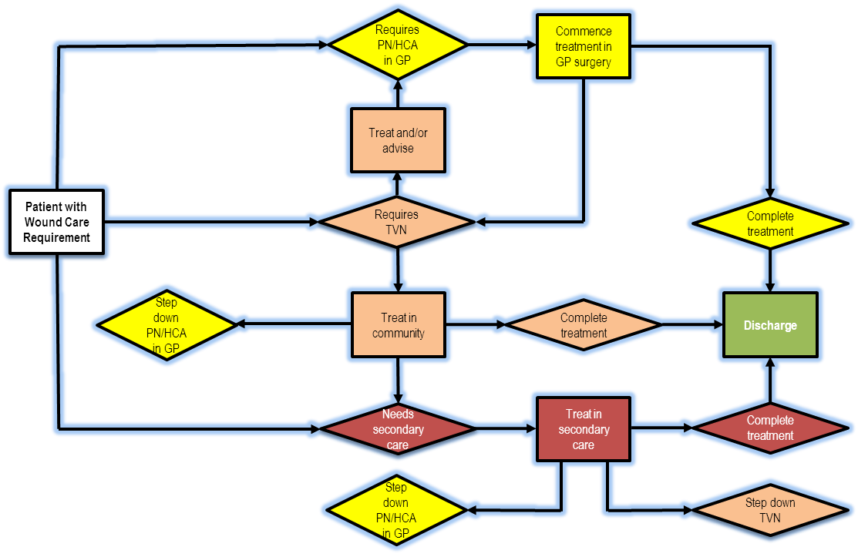
Figure 2: Referral Flow diagram

3.6 Interdependencies
Providers will need to work closely and in an integrated manner with a wide range of different health care professionals. This includes but is not limited to GPs, community health services (such as district nurses), local hospitals and walk in centres. Patient care notes will also need to be shared in a timely and reliable manner to the practice where the patient is registered

3.7 Equipment and supplies
Provider:
- Is required to provide all appropriate equipment and supplies.
- Supply all relevant dressings and appliances (including more specialists dressing if required).
- Is responsible for ensuring they purchase clinically appropriate supplies in line with locally agreed formulary and guidance
- Ensure that sufficient supplies are given to patients at discharge
- Management plans take account of different formularies in different settings where appropriate. Patients discharged back to GPs must be issued with dressings in line with Barnet CCG approved Wound Care formulary

3.8 Satisfactory Facilities
The provider should ensure:
- Facilities that service is delivered from follow national guidance on premises standards, including appropriate equipment for resuscitation
- Provider must ensure an appropriate room for providing the service is available for privacy and dignity requirements

3.9 Staff competence
Provider of the service should ensure:
- The professionals providing the service can provide evidence of the necessary skills, experience and qualifications in order to undertake the aspects of the service for which they are responsible, taking into consideration of their professional accountability and guidelines on the scope of professional practice.
- The professionals providing the service should demonstrate a continuing sustained level of activity, conduct regular audits, are appraised on what they do and take part in necessary supportive educational activities to ensure regular update of skills.
- The professionals providing the service should be competent in resuscitation techniques, using resuscitation equipment and administering emergency drugs.
- Staff have suitable medical defense indemnity

3.10 Sterilisation and Infection Control
Provider is responsible for the effective operation and maintenance of sterilising equipment. Provider must have infection control policies that are compliant with national guidelines including the handling of used instruments, excised specimens and the disposal of clinical waste.

3.11 Consent
Patients should be fully informed of wound care treatment being proposed and consent for photography and wound imaging requirements.

3.12 Medicines Management
- Provider of the service should ensure there are effective processes in place for the safe and secure handling of medicines, dressing and related appliances and that these are in line with the relevant guidance and legislation. Up-to-date medicines policy or standard operating procedure should be developed including the following principles:
- The storage and security of medicines will be according to the manufactures instructions, relevant guidance and legislation. The storage facilities will meet legal requirements where required e.g. cold chain maintenance and use of controlled drug cupboard, disposal of unwanted medicines
- Effective procedures to manage the risks of handling medicines, dressing and appliances and processes for:
- Completion of prescriptions and administration details
- Completion of allergy/sensitivity details
- Managing and reporting incidents and near misses relating to medicines system
All staff involved in any aspect of handling medicines will be trained and assessed as competent regarding the safe and secure handling of medicines, dressing and related appliances. This also includes the safe handling and disposal of wound dressing, as per the process set out in the wound care formulary

3.13 Audit
Full records of all treatments should be maintained in such a way that aggregated data and details of individual patients are readily accessible.
Details of all wound care treatment provided will be presented to the CCG on a quarterly basis:
- Treatment carried out or consultation
- Source of referral including referring GP where applicable and outcome, i.e. single visit or follow-up required (patients seen in service beyond 12 weeks)

Monitoring to be carried out by ongoing clinical audit measuring:
- Holistic wound assessment be carried out within first appointment
- All patients to have wound size documented within first appointment
- Treatment plan in place in accordance with wound assessment and wound care formulary
- All treatment plans and care regime to be communicated on transfer of care prior to discharge
- Annual audit to be provide assurance that all relevant staff training and competencies in line with local guidance has been achieved.

3.14 Patient monitoring/ record keeping
Provider will be required to utilise an electronic records keeping information exchange system. As a minimum, it will be required to record information on wound care services that have been provided and source of referral as part of the patient care notes.

Provider will record key performance activity to be reported to the CCG (see key KPI for the service in section 7). Patient care notes and care plans are to be provided in 48 hours to the practice where the patient is registered.

Wound Care documents must include:-
- Action for GPs
- Management plan and follow-up requirements
- Wound type
- Duration of wound
- Location of wound
- Measurement of wound size
- Wound description
- Exudate, odour, pain
- Wound assessments must document healing over time

Dressing choices must be documented with rationale or evidence.

4. Applicable Service Standards

The service will be delivered according to best practice and in line with the relevant local and national guidance

4.1 Applicable national standards

Providers should demonstrate to what extent they adhere to national standards
- Surgical Site Infection (prevention & treatment of Surgical Site Infection)- NICE (October 2008)

4.2 Applicable standards set out in Guidance and/or issued by a competent body (e.g. Royal Colleges)

4.3 Applicable local standards
Please see section 3

5. Location of the Service

The service needs to be local and assessable. A minimum of two hubs, one of which must be based in Finchley Memorial Hospital.
6. Activity levels for the Service

7. Key Performance Indicators

Performance indicators | Baseline Measure | Target Expected | Tolerance (+/-) | Method of Measurement
Service Performance
-Waiting Times
% of management plans dispatched with 48 hours
Quality - Provide assurance of relevant staff training and competencies in line with local and national standards. | Established prior to service commencement | 100% | 0 | Clinical audit.
Timeliness – Seen after referral  Rapid deterioration / Complex – 24hrs  Diabetic / Acute – 72hrs  / Static healing – 5 days | Established prior to service commencement | 98% | 0 | Monthly provider report
Effectiveness - Wound healing
Satisfaction  Service User Satisfaction survey | Established prior to service commencement |  |  | 6 monthly audit
Personalised  % with an individual care-plan for their wound agreed with the patient. Plan to include self-management. | Established prior to service commencement. | 100% |  | Clinical audit.

8. Key Service Outcomes & Tariffs

8.1 Tariff description
The tariff will be set at two levels, to reflect and recognize the need for both a specialized service, and a service dealing with non specialised wound care. These are set out below

Specialised wound care tariff: per patient per attendance
Moderate/complex wound care tariff: per patient per attendance

INSERT Appendixes

