Advocacy Service: Supporting Elder Care

Introduction

Kettering General Hospital NHS Foundation Trust (“the Authority”) provides acute healthcare services for the people of North Northamptonshire and South Leicestershire.
Our services are delivered from our main hospital site in Kettering, and satellite outpatient facilities at Nene Park in Irthlingborough, Corby Health Complex and Isebrook Hospital in Wellingborough.

We employ around 4,000 staff and are one of the largest employers in Northamptonshire.

Requirement
This winter (2018/2019) the Authority’s Emergency Department (ED) saw demand increase by 9.4% over the same time last year (22.3 extra patients per day) with an increase of over 75 year olds attending (6.3% - 48 patients per day). Over the same period the Authority collaborated with a national voluntary organisation for a six month pilot to support patients in ED, care of the elderly wards and the discharge lounge. The main aims of the pilot being to support discharge home, prevent readmissions and offer an improved patient experience whilst in hospital in order to prevent some deconditioning caused by lack of stimulation.

The aim of the Authority is to continue working with voluntary services with an enhanced focus in key areas (supporting transport, admission avoidance and discharge) and to provide support to patients in hospital via seven work streams as per Figure 1.

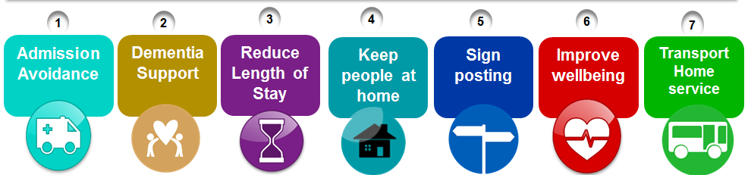
Figure 1: Work streams

This will require more resource than is currently in place. The Authority wishes to appoint and work with a voluntary sector provider to support this advocacy service and improve elder care.

National drivers and strategic aims

There is much to be gained through working in partnership. Trust and voluntary sector providers together have the potential to deliver innovative models of care at a local level, using their capabilities as experts within a defined population. The reforms underway at local and national levels offer a real opportunity for providers and commissioners to begin exploring more innovative approaches to the organisation. (Working Together to Deliver the Mandate. Rachel Addicott. 2018. Kings Fund). The NHS Plan aims for people to age well.

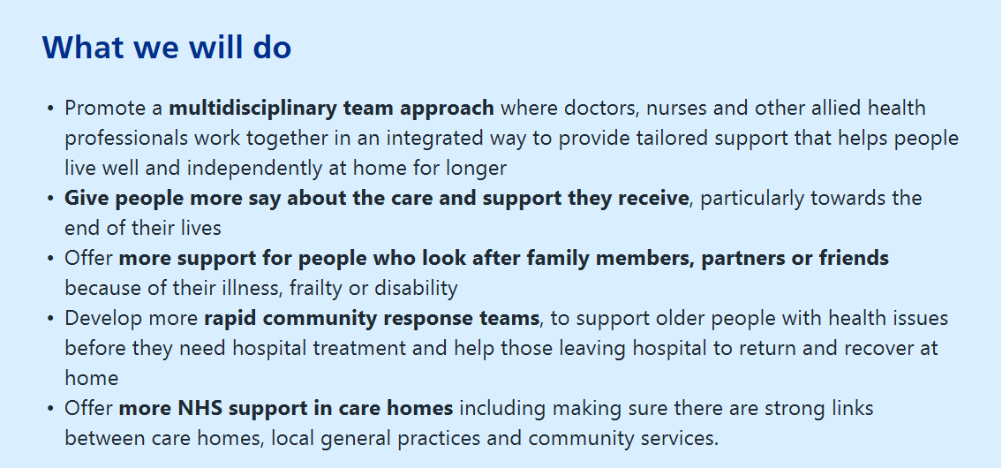

Local drivers and strategic aims

Central to the Authority’s strategy is the aim to be a strong and effective partner in the wider health and social care economy. With integrated out of hospital care and promotion of being an advocate for the Health and Social care partnerships as key areas of focus. The Long Term Clinical Strategy (Leadership Brief March 2019) recognised the significant financial and operational challenges we are facing in the future. The CEO discusses the need to consider our future through the lens of integrated care. To become truly sustainable and future-proof, we must explore options for horizontal integration with other acute trusts, and vertical integration with partners in our local community. To maximise these opportunities, we need to align our services with system working.

The STP for Northamptonshire lists it priorities going forward to include:

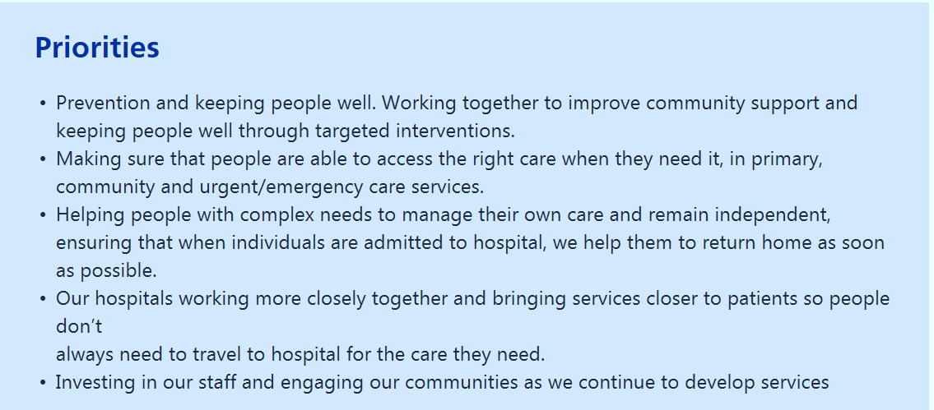

Service Requirements

5.1 Phase 1

Department | Hours per day/week | Service required
Emergency Department | 10 hours per day, 7 days per week | Supporting patients with anxiety, dementia, vulnerabilities etc. Staff to support patients in ED who need close monitoring due to a high falls risk etc. expected to reduce the needs for 1-2-1’s from bed watch.
Same Day emergency care | 10 hours per day, 7 days per week | Supporting patients with nutrition and hydration, providing someone to talk to etc. Use of bed watch would be reduced by staff supporting low risk patients that need enhanced support i.e. falls risk patients. Reduce the number of “Harry’s” admitted by early support and signposting and telephone follow ups. Improving well-being. Aim to increase this discharge rate of patients on the same day from 20% to 33%. The service will support taking patients’ home, resettling them back at home and ensuring they have food and drink, heating etc.
Across the medical and trauma & orthopaedic wards areas | 140 hours per week, 7 days per week: | Supporting older adults with dementia, Signposting to community services using the Directory of Services. Aim is to reduce the amount of readmissions by ensuring patients are supported in the community.
Management support | 37.5 hours per week | Provider support to the voluntary sector staff on site and recruitment of staff, attend key operational meetings and become a key stakeholder within the Authority.
Discharge Lounge | 10 hours per day, 7 days per week | Minibus service Mon-Fri to support transport home. Support with collecting patients, nutrition and hydration and company whilst waiting for discharge. Transport home via the minibus service - mileage only. The voluntary sector team would work to transfer patient’s home who do not need stretchers in the minibus allowing for better support with timed discharges.
Telephone call back service | 20 hours per week. | Commencement of a telephone call back service to support patients on discharge and prevent readmissions. 30 patients per week. A reduction of 20% readmission rate for this group of patients.

5.2 Phase 2

Department | Hours per day/week | Service required
Same Day Emergency Care Unit | 10 hours per day, 70 hours per week | Support to increase same day discharges from 20% to 33%.
Poplar, Pretty’s, Lamport & Twywell, Naseby A&B, and Barnwell. Will cover Orthopaedic wards. | Increase wards support per week by 120 hours, 40 hours per day across all these wards, 7 days per week. | Direct integration with CRT/ICT to support early bird discharges by transporting patient’s home with the minibus and staying with them until the services can perform the assessment. (Before 10am) Sitting service for equipment. This causes delay if family cannot be at home for equipment deliveries in order to safely discharge the patient. Promotion of #Endpjparalysis. Support use of the KGH clothing bank – Dragons Den bid. Handling money – this supports complex cases where social care need patient’s to have access to financial information. At times patient’s needs to go to sort this out at home or at the bank. Work with other services i.e. social care, frailty team, discharge team, KGH at home to reduce the amount of patients signposted to a pathway or minimal intervention. 45% of patient’s referred to Pathway 1 (DTA) need only a small amount support at home in the first three days. This is an opportunity for the voluntary sector to support such patients reducing the pressure and costs on other organisations.

Key Performance Indicators (KPIs)
- The service will need to have the basic services (Phase 1) covered by November 2019 with a clear strategy of up scaling to deliver on all of the service requirements by the end of February 2020.
- The service will aim to support independence in older adults, encouraging community support and wellbeing in both in the community and in hospital. The service provider must have a strong model and framework to support this.
- The service will assist patients to get home with a settling in service and use of a wheelchair friendly minibus to physically transport patients home. This will run 5 days per week and support a minimum of 10 patients per week home.
- The service will provide a support service to older adult patients in the Emergency Department, helping with orientation, distraction and company reducing the need for 1-2-1 staff. The ED department will use seven less bed watch shifts per week.
- The service will encourage the use of sign-posting to support and encourage patients and families to use services in order to promote independence, self-care and keeping people at home.
- The service will aim to increase the discharge rate in the same day emergency care from 20% to 33% or more.
- The service will partnership with internal and external services in order to support a reduction the use of simple care packages by signposting to community services for Hospital to Home schemes (5 per week).
- The service will support older adults in ward areas with nutrition and hydration, activity based interventions and interactions with an aim to prevent deconditioning in hospital.
- The service will provide a call back service for older adults discharged into the community within the last 72 hours at a rate of 30 per week. A reduced (20%) readmission rate in this group would be required.
- The service would recruit staff that can be trained to drive the minibus 5 days per week.
- There is a requirement within the proposal for a full time manager to be on site 5 days per week, appointing a deputy when off. The manager would be visible, attend the safety huddles and one capacity meeting per day. The manager would manage staff recruitment, leave, behaviours, etc. The manager will drive change and integrate the service into KGH by forming professional working relationships with key stakeholders.
- There will be monthly operational meetings with the Head of Operations and quarterly review meetings to review performance against the KPI’s
- The service will collect the following data:
- Patient stories
- Patient feedback
- Staff feedback
- Numbers of patient interventions
- Numbers of supported discharges
- Numbers of patients transported home
- Numbers of Patients escorted Home
- Number of patients provided with a 1-2-1 service.

