**Clarification Questions – BHE MCZ Acoustic Survey – LOT 4**

**Question 1:**

We have been looking at the Lot divisions and wondering if perhaps there is a typo in Lot 4 boundary coordinates?

I have overlain the new lots on the original survey boundary as you can see below.

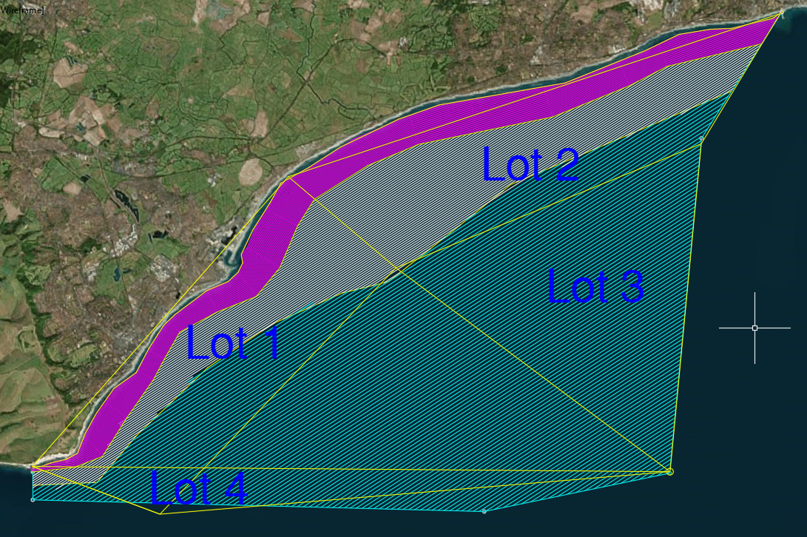

**Response 1:**

Thanks for getting in touch and for picking this up. I had very coarse access to GIS when providing the coordinates for the Lot areas. Please could you snap the boundaries of the Lot 4 area to the boundary of the MCZ – to include the section missed out and bringing in the boundary where it extends beyond the MCZ.

**Question 2:**

Can the client please confirm in Lot 4 RFQ pdf that OSGB coordinate 1 is incorrect as it does not tie in with the zones. Can we assume that for offshore west – 558259 E, 95235 N should read 569345 E, 101294 N to tie in with the Lot 3 offshore east zone boundary?

**Response 2:**

Please could you snap the boundaries of the Lot 4 area to the boundary of the MCZ and adjacent LOT areas – to include all of the MCZ in LOT 4 including coverage of the section missed out and bringing in the boundary where it extends beyond the MCZ.

**Question 3:**

Can we assume that all 4 lots will be awarded to one contractor?

**Response 3:**

It is possible that all four lots will be awarded to one supplier if overall cost savings and consistency can be demonstrated by doing this, and the proposal scores well on the RFQ requirements.