Isles of Scilly – Sea Defence and Dune Management Project
Tender for Environmental Impact Assessment for Sea Defence Works
REF: 2019 SD-EIA-1

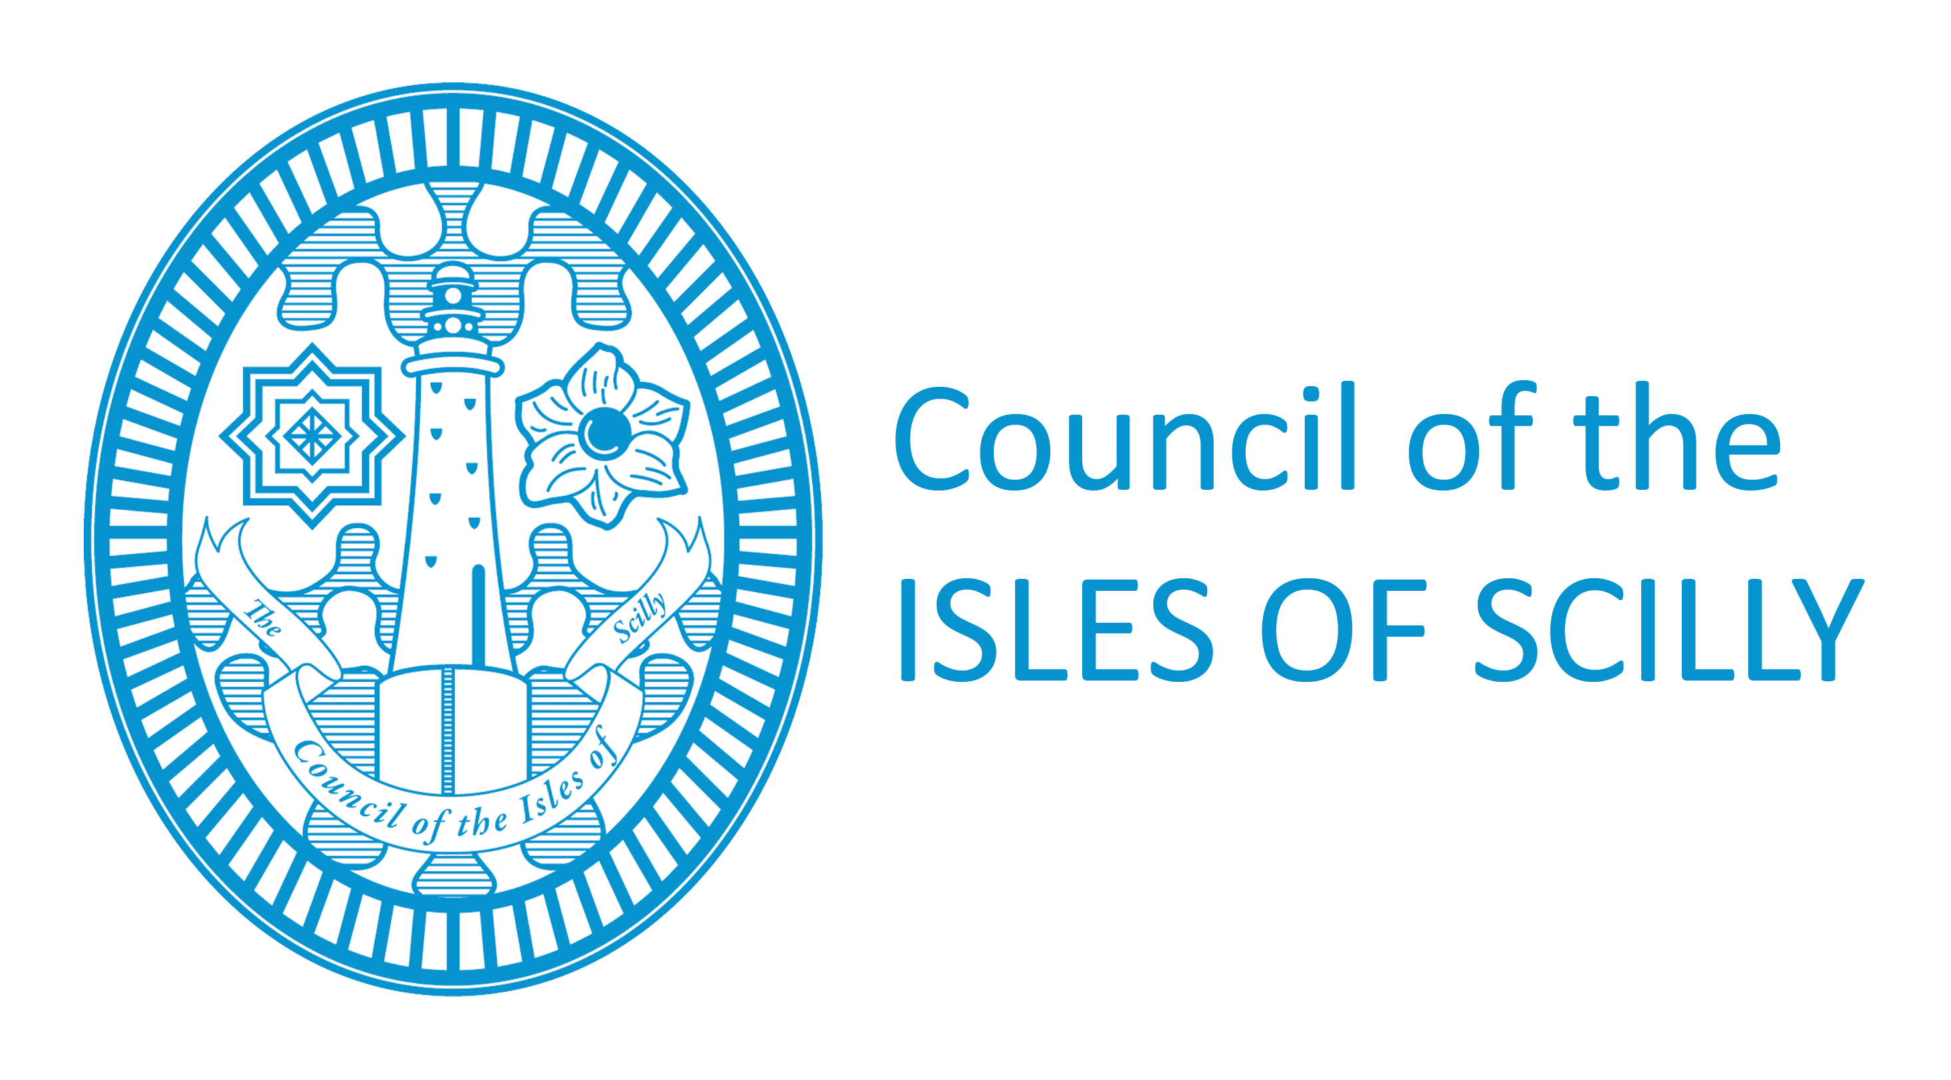
February 2019

Contents

- Introduction Page 4
- Environmental Background Page 5
- Background Information Page 6
- Proposed Works Requiring Assessment Page 7
- Project Specification Page 5
- Outputs and Objectives Page 6
- Programme and Costs Page 7
- Tender Process Page 10
Appendix 1 –
Appendix 2 –
Key Reference Material
Title | Source / Location of Document
Defra Report: Isles of Scilly Water Interests Survey – Report on Sea Defences. Arup 2011 | http://www.scilly.gov.uk/sites/default/files/document/planning/11%20ARUP%20IoS%20Flood%20Defences%20-%20Water%20Interests%20Report%20Defra.pdf
Cornwall and Isles of Scilly Shoreline Management Plan Revision 2, Ises of Scilly section, Royal Haskoning 2010 | http://www.scilly.gov.uk/sites/default/files/document/planning/smp2.pdf
Isles of Scilly SMP2 Mid Term Review, Royal Haskoning 2016 | http://www.scilly.gov.uk/sites/default/files/document/planning/Isles%20of%20Scilly%20SMP2%20Mid%20Term%20Review_Appendix%20A%20FINAL.pdf
LPA Scoping Opinion, 2018 | See section 5 of this report
Isles of Scilly Sea Defence and Dune Management Project, Business Case, 2018 | To be made available to successful tenderer on start of study
Stakeholder responses to LPA scoping opinion request | Responses to be made available to successful tenderer on start of project.
General information on the Natural Environment of the Isles of Scilly | http://www.scilly.gov.uk/planning/heritage-conservation-environment#Natural Environment

1. Introduction

The Council of the Isles of Scilly (“The Council”) is seeking tenders to produce an Environmental Statement (an Environmental Impact Assessment) for the proposed sea defence works as part of the Isles of Scilly Sea Defence and Dune Management project.

In recognition of the environmental sensitivity of the Isles of Scilly, the Council as the Local Planning Authority (LPA) has determined that the planning application for the works associated with the Isles of Scilly Sea Defence and Dune Management Project requires an Environmental Impact Assessment (EIA) in accordance with the Town and Country Planning (EIA) Regulations 2017. A scoping opinion has been received from the Local Planning Authority and is included as the Project Specification.

The Project identifies proposed sea defence works on four sites; three on St Mary’s and one on Tresco. The Environmental Statement should include a description of the physical characteristics and cumulative impact of the entire proposed works providing a context for the proposed development as well as containing a specific assessment for each individual site. Comment to responses received from statutory consultees and other stakeholders as part of the scoping opinion will be made available to the successful tenderer as the points made in these responses will need to be addressed as part of the EIA.

A summary of the proposed works being undertaken at each individual site is provided. The successful tenderer will receive a full copy of the business plan for the Isles of Scilly Sea Defence and Dune Management Project. This documents the strategic and economic case for the Project as well as providing an options review for each site detailing alternative “do nothing / do minimum / do more” scenarios. This business plan will be a key source of information for the EIA and also in addressing the comments on the issues raised by the stakeholders as part of the scoping opinion. Detailed plans for the proposed works along with design statements and designer hazard records have been produced for each site. These will be made available to the successful tenderer.

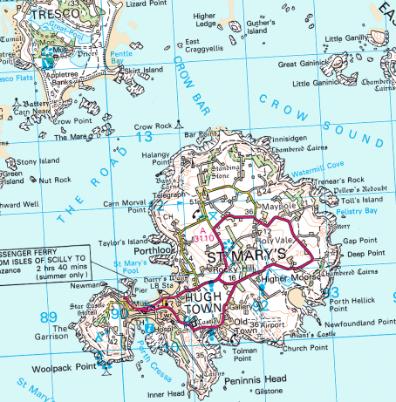
Location 4 – South Dunes
Location 1 - Porthloo
Location 2 – Porth Mellon
Location 3 – Porth Hellick

Location of proposed work sites

2. Environmental background

The Isles of Scilly have a population of 2,203 most of whom live on St Marys. The economy of the islands is dependent on tourism, which relies on the tranquil, unspoilt, high quality environment and is therefore sensitive to change and development.

The Isles of Scilly are designated and protected at international and national levels for a number of features, including:

• Presence of a number of nationally and internationally designated sites of interest for nature conservation (including Sites of Special Scientific Interest (SSSI), Special Area of Conservation (SAC) and Special Protection Area (SPA) designations);

• High landscape quality (including Area of Outstanding Natural Beauty designation);

• Archaeological and cultural heritage (the highest concentration of scheduled monuments within the UK;

• Important geological formations;

• Small scale local landscapes and seascapes;

• Low baseline noise levels; and

• The importance of near views.

Further details on the natural environment of the Isles of Scilly can be found at;
http://www.scilly.gov.uk/planning/heritage-conservation-environment#Natural Environment

2. Background Information

The Isles of Scilly are located to the south west of Land’s End, separated from the mainland by approximately 40km of open ocean. There are over 200 granite islands and islets within the archipelago. There are five inhabited islands with a population of 2203, living in 1388 dwellings (2011 census). The total land area is 16.37 km2, St. Mary’s is the largest island with a land mass of 6.29 km2 and 1723 inhabitants. The remainder of the population live on Bryher, St. Agnes, St. Martin’s and Tresco. The highest point on the islands is 49m above sea level and approximately 30% of the land area is at or below 5m elevation. Tourism is the principal economy and in the summer the population increases to around 6000. The Duchy of Cornwall owns most of the islands and as a result, most properties are leasehold; only the built up areas of Hugh Town and McFarlands Downs on St Mary’s are largely freehold. The island of Tresco is let in its entirety to the Tresco Estate whilst any uninhabited islands or untenanted land is leased to the Isles of Scilly Wildlife Trust.

The whole of the Isles of Scilly are an Area of Outstanding Natural Beauty, a Conservation Area and a Heritage Coast. Further designations applied to the islands include a RAMSAR site of global importance, Special Area of Conservation (SAC) EU Habitats Directive, Special Protection Area (SPA) EU Habitats Directive, a Marine Conservation Zone, 26 Sites of Special Scientific Interest along with 238 Scheduled Monuments, 129 Listed Buildings and one Grade 1 Registered Park and Gardens. The distinctive landscapes encompass lowland heathland, enclosed pasture, hedged bulb strips, small harbours and quays and scattered rural settlements punctuated by tiny townscapes.

The Isles of Scilly are vulnerable to the impact of climate change, rising sea level, inundation and coastal erosion. The islands bear the brunt of Atlantic storms and storm surges, their low lying character coupled with the fact that much of the housing stock, critical infrastructure, fresh-water resources and commercial property are located close to sea level on narrow isthmuses increases the vulnerability. The risks to the islands have been highlighted by recent storms, particularly those of 2014, 2004 and 1989, and the impact these have had on key cross island infrastructure including; fresh-water sources, housing, commercial property, roads, sewerage, electrical and telecommunications infrastructure (especially on Tresco) and damage to quays on the off islands.

This project is aligned to, and was driven by, the delivery of the Shoreline Management Plan (SMP2) and the Defra Isles of Scilly Water Interest Survey, a report on Flood Defences from 2011 undertaken by WRC and ARUP study which have been the basis for work on flood defences across the islands and FCERM funding allocations from the EA. The individual elements of the project have been identified on the Short to Medium Term plan in relation to Flood and Coastal Erosion Risk Management on the islands.

The proposed works meet the following aims of flood risk management on the islands;
- To protect critical economic, social and environmental infrastructure on the islands of Tresco and St Mary’s.
- To mitigate the impact of climate change, sea level rise, inundation and erosion on the islands and its communities.
- To manage risks to the islands communities from flooding and erosion, supporting their adaption and development of resilience.
- To help in the establishment of a long term action plan which helps minimise and reduce the reliance on defences in the future.
- To support the essential diverse character of the landscape and seascape of the islands.
- To support conservation values and minimise impacts on biodiversity and habitats while allowing adaptive response to natural change.
- To support the adaption and resilience of transport links between the islands as well as the mainland.

The reduction of risk to the islands’ freshwater supplies is a significant aspect of the project. The supply of water for St Mary’s comes from groundwater abstraction wells at Lower and Higher Moors (providing around 65% of the island’s needs) and from a desalination plant (providing around 35% of the island’s needs). One borehole in the Lower Moors area is particularly productive yielding around 50% of the freshwater supply. The water supply on Tresco comprises four abstraction boreholes which feed an island wide distribution system via a blending and treatment programme.

4. Proposed Works Requiring Assessment

The proposed works for each individual site are as follows;

Site 1 - Porthloo, St Mary’s

Porth Loo is located on the western side of St. Marys. The bay measures approximately 300m and is flanked to the north and south by rocky outcrops. At southern end of the beach is a boat yard which is protected from wave run-up by an engineered dune which extends half way along the beach. The northern extent of the beach is backed by an earth embankment which retains the road. The embankment is protected by an assortment of various size rocks and is currently susceptible to erosion and overtopping from wave events.

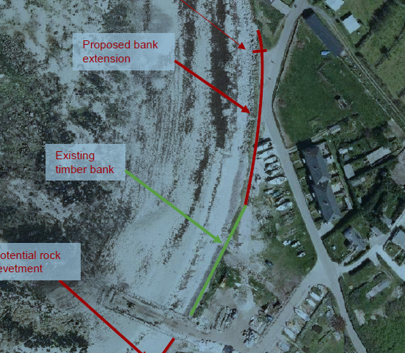

Proposed Works;
The aim is to reduce the vulnerability of Lower Moors SSSI (one of two freshwater source areas on St Mary’s and location of the most productive freshwater extraction borehole on the island) to saline intrusion by formalising the de-facto defence on the beach. The scheme will also aim to protect the access road at the northern end of the bay from being undermined and washed away. At the southern end of the beach, a commercial area is at risk of inundation during storm events.

This will be achieved by installing rock armour protection along the unprotected face of the bank which extends the existing sea defence from the boundary of the boat park to the boundary of the SSSI at the north end of the beach. The rock will be Cornish granite, similar in colour and type to the naturally occurring granite on the islands. This will increase the crest level of the bank by c.1m to reduce overtopping and absorb wave energy. The bank crest and face will be strengthened with geotextile and planted with marram grass. The proposed works are above the MHWS mark although the construction area could still be affected by storm events.

The stated approach in the SMP2 is for NAI despite the fact that it is more exposed to direct wave action than other bays along this part of the coastline, due to its westerly aspect. The SMP2 estimates that inland erosion may be as much as 30m by 2105. There was a recommendation in SMP2 for further topographic work and modelling to check over-topping impact on the Lower Moors SSSI and associated impact on the freshwater supply for the island. Although still in draft form, this work has been undertaken confirming the flood water drainage link from Porthloo to the Lower Moors and also indicating the elevated presence of heavy metals at the northern inlet for the Lower Moors which could have an origin from historic industrial works associated with the boat park at Porthloo.

Investment in the sea defences at Porthloo demonstrates that at a local level there is more value associated with this frontage than had been determined by the high level economic assessment undertaken by the SMP2. The area is the site of the only significant sized boat park on the island and is also the location of associated commercial marine workshops with the only slipway on the islands capable of managing the inter-island tripper boats. There is such limited development space on the islands that there is no alternative site for a commercial boat park. The inter-island tripper boats are central to the visitor experience on the islands, and are crucial in supporting inter-island travel and as such this area is central to the local economy and the sustainability of the communities on the islands.

Benefit of the works;
o protection of Lower Moors SSSI from saline intrusion
o protection of domestic property
o protection of the only road access to Porthloo
o protection of principal boatyard and associated maritime business on St Mary’s

Site 2 - Porthmellon, St Mary’s

Porth Mellon is located on the western coast of St. Marys. The bay measures approximately 240m and is flanked by rocky outcrops. Access to the beach is via a slipway at the south west end of the beach.

Proposed Works
The aim of the project is to formalise the de-facto defence along the beach and preserve the strategically important assets located behind the beach. These assets include domestic and commercial properties located in the Island’s only business park/industrial estate; the Island’s waste and recycling facility at Moorwell; the SSSI site at Lower Moors and the principal highway connecting Hugh Town (the administrative centre) with the rest of the island of St Mary's. This will principally be achieved by the construction a rock revetment to dissipate wave forces and to reduce overtopping.
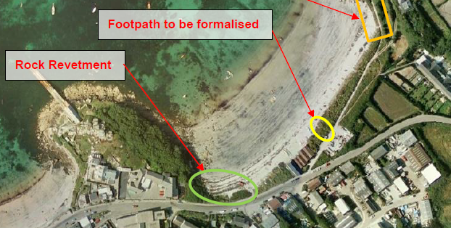

The proposed work is located above the MHWS tide mark, however, the construction area could still be effected by rising tide levels and storm events.

The area is identified for HTL during Epoch 1, with a realignment approach preferred for Epoch 2 beyond 2025. Although not a formal hard defence the sand dune protects the low lying hinterland behind the beach, which provides a route for flood water into the Lower Moors. Over much of its length there is sufficient space for the dune to roll back and increase both its height and width, however the south western corner of the bay is already undercutting the road and improving the defensive standard here needs to be considered as part of any overall realignment.

Benefits of the Works include;
- protection of the Lower Moors SSSI from saline intrusion
- protection of domestic property
- protection of the principal highway connecting Hugh Town (the administrative centre) to the rest of St Mary’s
- protection of the main business park on the islands, including emergency response stations (fire, ambulance and coastguard) and an electricity sub-station
- protection of islands waste management and recycling site.

Site 3 - Porth Hellick, St Mary’s

Porth Hellick is located on the south-east coast of St. Marys. The 250-m wide bay is flanked on both ends by rocky outcrops. The backshore dune is made of coarse sand (4-10 mm particle size) and vegetation is well established along its crest by exotic plant species, primarily Fascicularia bicolor and Hottentot Fig (C.edulis). There are gaps and low points in the bank due to the action of storm events during the past decade. It has been reported though that the dune is not particularly mobile. The eastern end of the dune suffers from severe human-induced erosion due to the action of boat launching. Additionally, the construction of the existing outfall required the excavation of dune which was not reinstated to match the existing dune levels. These low spots are potential paths for saline intrusion into the Higher Moors Pool, the main fresh water resource for St. Mary’s, hence the sand dune defence needs improvement to continue to protect this natural resource.

Porth Hellick is very exposed to south-easterly storms and waves and inundation would have significant implications for the freshwater supply to St Mary’s. SMP2 predicts up to 65m of erosion by 2105, which would cut through the existing dune/shingle backshore storm ridge. Flood mapping indicates salt water inundation of the whole area. The SMP2 identifies an approach of HTL for the first Epoch and then MR with consideration given to the realignment of the embankment to provide improved, robust natural defence to the Higher Moors Area.

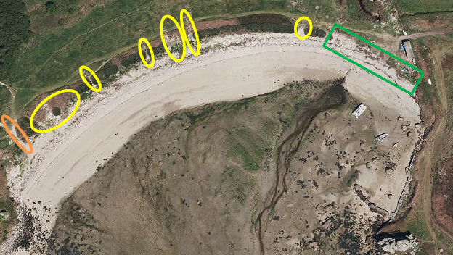

Proposed Works

This scheme aims to reduce saline intrusion into the Higher Moors Pool and the larger SSSI wetland area during storm events. The pool and the SSSI wetland are part of the main fresh water resource for St. Mary’s. The focus of the works is on the following three elements:

a. Replenish and re-vegetate the dune crest:
It is proposed that non-vegetated areas highlighted in yellow on the diagram above are replenished with crushed granite (of a size to replicate the existing composition of the bank) and revegetated with the same plant species found growing locally on the crest to provide a consistent and continuous line of defence against wave run-up and dune erosion.

The Fascicularia plants are firmly established on the bank and their removal would do irreparable damage to the integrity of the bank’s structure. Furthermore, their salt tolerance and development at this site has added a good metre of height to the bank and have helped stabilise and protect the bank during storm events. The Fascicularia are not encroaching on land beyond the bank and the use of the plant in selected areas will not extend its distribution beyond this site. Its use is with the aim to infill sections within the existing distribution and help provide those bare sections in the bank with a degree of protection that the rest of the bank already benefits from.

The Fascicularia plants also provide shelter on the landward side of the bank for other local vegetation. At present, some of these sheltered landward areas have been populated by Hottentot fig. None of this invasive species will be transported or propagated at this area. Where possible areas with little or no vegetation on the landward side will be planted with species such as Sea Campion, Sea Holly, Sea Kale and Sea Rocket etc to help prevent the opportunist spread of C.edulis.

b. Installation of an elevated timber boardwalk:
The section highlighted in orange on the figure above at the western end of the site, is primarily used by members of the public to access the beach. This is causing the dune to erode, facilitating a path for sea water to reach the water resource during storm events. In this case, it is proposed to install a timber boardwalk which will be elevated above the underlying beach material (circa 100mm). This should stop further deterioration of the dune from the pedestrian induced erosion.

c. Extending the dune:
The existing dune is to be extended along the section highlighted in green on the photograph above with its crest set to +5.00 ODN. To do so, the existing ground will be cleared to provide a suitable founding surface. The dune will be profiled in two sections, leaving a gap in between for the construction of a ramp for vehicular access to the beach. The slopes of the dune will match the existing (1V:6H approximately) and will be stabilised with 100% biodegradable geotextile mats (Coconet 800 or similar approved). The imported material is to be crushed Cornish granite 4-10 mm grading. The crest will be revegetated and the raised dune will require local profiling around the existing shed on the east end of the beach. The ramp will provide access to vehicles to carry out maintenance works on the outfall and any future repairs to the sea frontage of the bank. A concrete Armorflex mattress will follow the profile of the newly raised dune onto the beach and will be covered with topsoil and seeded with native grasses.

Benefits include;
- protection of the Higher Moors Pool and larger SSSI wetland area from saline intrusion
- protection of freshwater resource for St Mary’s.

Site 4 - South Dunes Complex, Tresco

South Beach is located on the southern coast of Tresco. Local observations suggest that the fore dune (the most seaward ridge of a coastal sand dune complex) at South Beach has been subject to erosion, causing it to retreat landward by ~8-10m over the past 9-10 years.
The Tresco Estate have built a wall of timber tree trunk piles around the incoming BT cable inspection chamber to protect it from continuing dune erosion.

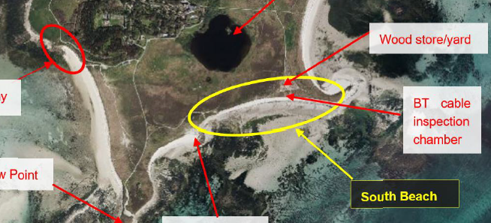
Proposed Works
The works involve installing a “rock-roll” defence where the fore dune is experiencing recession, 0.5m high, 100m wide to the west and 35m to the east of the existing timber defence. It is envisaged the defence will become buried with windblown sand and will only act as a toe defence during storm events. This is a trial defence and if the dune experiences adverse effects it will be removed.

The aim is for a scheme to protect specific vulnerable areas along the coastline of the southern part of the island to protect the critical infrastructure and important landscape and ecology of this part of the island. The SMP2 indicates that erosion of the shoreline may exceed 30m over the next 100yrs and that in certain areas possibly up to 75m. A NAI approach is preferred for the whole of the southern part of the island with the intent to maintain and allow enhancement of the natural environmental landscape. While this provides the main aspect of management, locally it is important to support the continued habitation of the island (which would not be possible without the freshwater supply and a low tide access point) where this can be achieved in a sustainable manner without incurring unacceptable disruption to natural processes. The regional coastal monitoring programme project illustrates the variable rate of change to the beach profiles along this frontage, highlighting the fact that the shoreline does not act like a typical linear beach frontage but is part of an overarching archipelago with multi-directional sediment dispersal patterns. In the more vulnerable areas there has been up to 22% erosion of the cross sectional beach area over the period from 2007 to 2017 with minor accretion occurring within 200yards along the same beach. The height of the dunes along the frontage show a similar variation at certain points and this increases the vulnerability at key locations, whilst also increasing the level of defence in other nearby areas.

The proposed structure is located above the 1 in 200year extreme water level including an allowance for climate change for up to 2066.

Benefits include

- protection of de facto defence at vulnerable areas reducing the risk of premature breaching and subsequent isolation of community from the only low tide access to the island.
- protection of saltwater inundation into the freshwater lakes at Great Pool and Abbey Pool which are central to the main aquifer for the islands.
- prevention of inundation of a SSSI area and the heritage gardens at Tresco Abbey, and protection of the landscape and ecology of this sensitive area.
- protection of the heliport site.
- protection of the site of the incoming telecommunications supply to the island and the associated BT cable junction box and the islands wood store/yard.

5. Project Specification

5a Environmental Impact Assessment Scoping Opinion

The EIA scoping opinion letter from the Local Planning Authority, see below, should be regarded as the specification for the Environmental Statement.

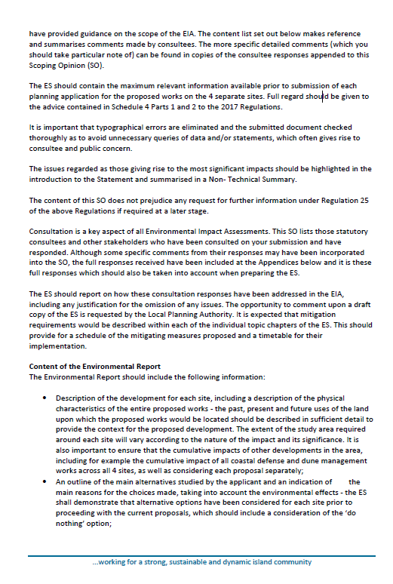

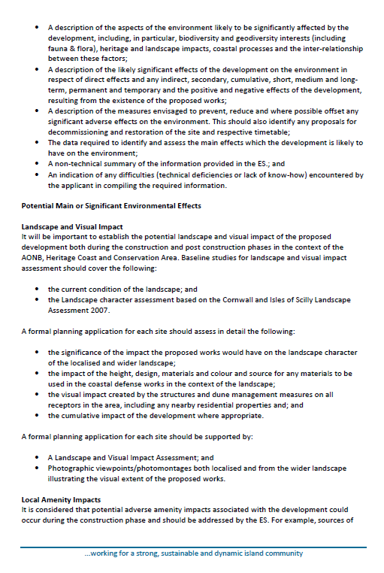

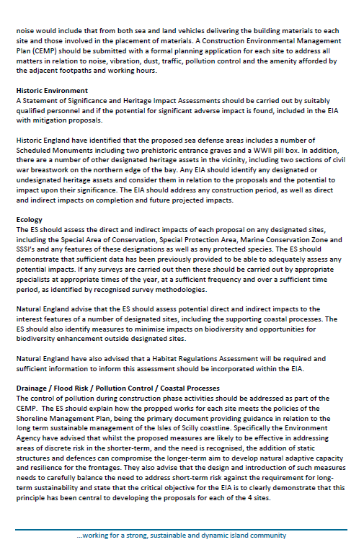

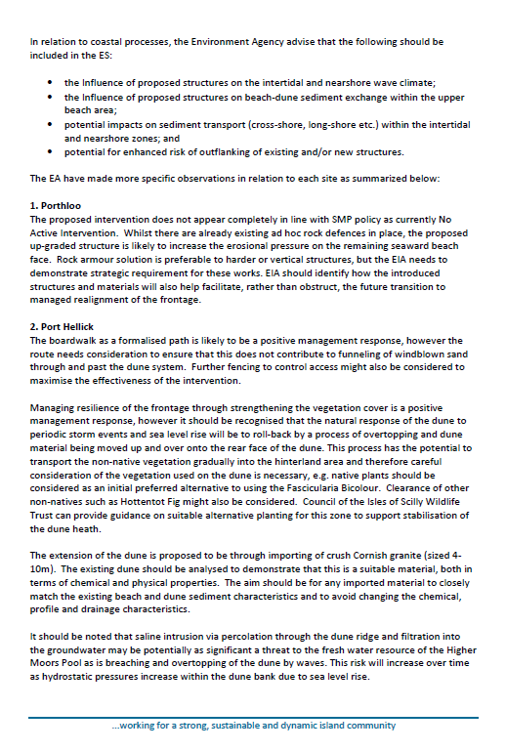

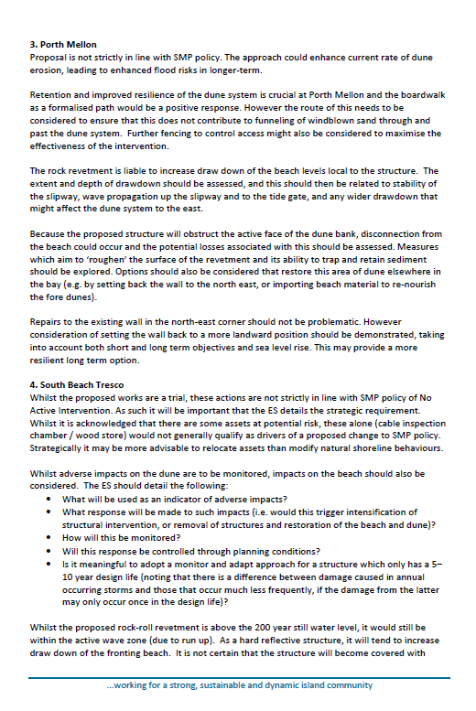

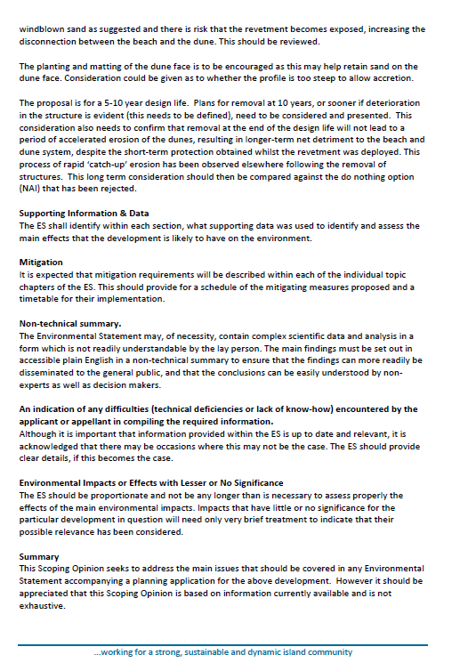

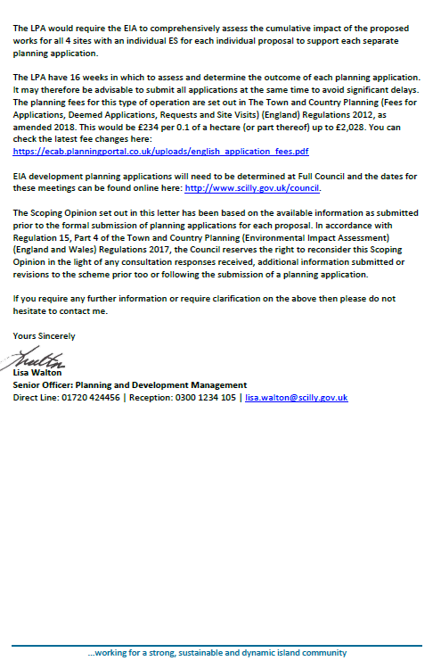

6. Outputs and Objectives

6a Scope of the Environmental Statement

As detailed in the project specification, Section 5, pages 13-21.

Work to be based on the EIA scoping opinion from the Local Planning Authority, a review of literature and field studies to incorporate at least one site visit to each works location.

The EIA will consider direct, indirect, cumulative, temporary and permanent impacts. Where necessary, mitigation measures will be recommended. Criteria should be developed to assist in the assessment of impacts as major, medium, negligible or positive. It should be noted that one of the Sea Defence and Dune Management Project outcomes will be the surface area of habitats supported to attain better conservation status will be approx. 20 hectares.

6b Structure of the Environmental Statement

The ES should contain, in no specific order the following sections;

A non-technical executive summary
The proposed project and construction methodology
The relevant planning context for the Project
The approach and methodology of the EIA study
The base line conditions
The potential effects and any proposed mitigations
The conclusions of the work

An initial draft report should be provided for discussion prior to the issue of a final report. Both reports should be in electronic format, both as a word and pdf document.

7. Programme & Costs

PROGRAMME

It is anticipated that the project would start immediately after receipt of the signed contract.
The ES is fundamental to the planning permission and the granting of MMO licences for the works. As such the production of the ES is on the critical pathway for the project and it is required to be completed in a timely fashion. It is hoped that the final report should be completed within 3 months.
COSTS
All submissions will be required to provide a final lump sum prices for the delivery of the final report on the study.
The lump sum prices will need to include any and all costs the potential providers feel are necessary for meeting the specification. Tenderers should include a narrative in their submissions laying out the basis of their costs.
- Site visits
- Literature review
- Number of personnel involved and associated day rates
- Interpretation and Reporting.

This will help the Council understand the basis of the tender. The pricing summary table in the Quotation Opportunity Form must be used to provide a summary breakdown of costs.

The Council will make payments to the appointed tenderer on an invoice basis for work completed.
Estimated Contract Value = £25,000

8. Tender Process

This is an open tender that shall be run under the terms described under the Quotation Opportunity document prepared for this project.
All quotation submissions are to be submitted as a paper copy by the deadline date to: Chief Executive, Council of the Isles of Scilly, Town Hall, St Mary's, TR21 0LW and should be titled “Quotation for Sea Defence EIA, SD-EIA-1; DO NOT OPEN AUTOMATICALLY ON RECEIPT”.

