CONTRACT ORDER FORM

This Contract Order Form is issued in accordance with the provisions of the Apprenticeship Training Provider Dynamic Marketplace (DMP) Agreement for the provision of Apprenticeship Training Services. 28th April 2025

The Supplier agrees to supply the Goods and/or Services specified below on and subject to the terms of this Contract.

For the avoidance of doubt this Contract consists of the terms set out in this Contract Order Form and the Contract Terms

Order Number | CCDE25A02
From | Home Office
To | QA Limited

1. CONTRACT PERIOD
1.1 | Commencement Date | 30th June 2025
1.2 | Expiry Date  (Apprenticeship programme completion date / End Point Assessment completion date) | 29th June 2029  There is an option to extend the contract by two periods of 12th months.  Extension Option 1  Commencement Date: 30th June 2029  Expiry date: 29th June 2030  Extension Option 2  Commencement Date: 30th June 2030  Expiry date: 29th June 2031

2. SERVICES REQUIRED
2.1 | Services Required.  APPRENTICESHIP TRAINING PROVIDER SERVICES / END POINT ASSESSOR SERVICES / BOTH.  LOCATION  APPRENTICESHIP TYPE AND SPECIFIC APPICABLE INSTITUTE FOR APPRENTICESHIPS STANDARD  NUMBER OF STUDENTS  CLASS BASED  ADDITIONAL SERVICES | As outlined in Attachment 3 – Statement of  Requirements

3. CONTRACT PERFORMANCE
3.1 | Required Apprenticeship Standard | 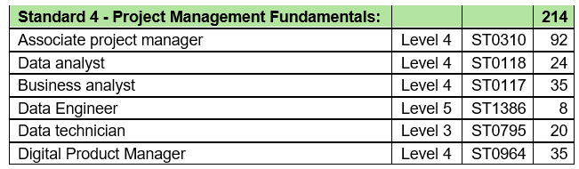

3.1 | Quality Standards | Continued adherence to the relevant Institute for Apprenticeships industry standard. (www.instituteforapprenticeships.org/)  Maintained ESFA registration and accreditation.  General industry good practice

4. PAYMENT
4.1 | Contract Charges | Total Forecasted Contract Charges £2,656,000.00 including any extensions (ex VAT) As this is a call off contract the maximum contract value is not an agreed sum.
4.2 | Payment terms/Profile | Payment to be made in accordance with the current in force ESFA funding rules.  Further additional terms in Annex 2 of Contract Schedule 3
4.3 | Customer billing address | REDACTED TEXT under FOIA Section 40, Personal Information

5. LIABILITY AND INSURANCE
5.1 | Suppliers limitation of Liability | In Clause 25 of the Contract Terms
5.2 | Insurance | (Clause 26 of the Contract Terms):  Cyber Essentials  Professional Indemnity Insurance cover of £1 million any one claim.  Public Liability Insurance cover of £1 million any one claim.  Employers Liability insurance cover of £5 million any one claim.

FORMATION OF CONTRACT
By signing and completing this Contract Order Form the Supplier and the Customer agree to enter into a binding contract governed by the terms of this Contract Order Form and the attached terms and conditions.

For and on behalf of the Supplier:
Name and Title | REDACTED TEXT under FOIA Section 40, Personal Information
Date | 19/06/2025

Name and Title | REDACTED TEXT under FOIA Section 40, Personal Information
Date | 19/06/2025

For and on behalf of the Customer:
Name and Title | REDACTED TEXT under FOIA Section 40, Personal Information
Date | 30/06/2025

